A Technical Report

On

Human Factors in AI-Driven Cybersecurity: Cognitive Biases and Trust issues

Submitted in partial fulfillment of the
requirements for the award of the degree of

Bachelor of Technology

In

Computer Science and Engineering

By

BARAD PRAKASH DEWASI
(22EG105K32)

Under the guidance of

Mr. Rajasekhar Gorthi, Assistant Professor

Department of Computer Science and Engineering


ANURAG UNIVERSITY
Venkatapur (V), Ghatkesar (M), Medchal (D)., T.S-500088 (2022-26)



DEPARTMENT OF COMPUTER SCIENCE AND ENGINEERING

CERTIFICATE

This is to certify that the Technical Report entitled “Future Directions in Safe Artificial General Intelligence” being submitted by BARAD PRAKASH DEWASI, bearing the Hall Ticket number 22EG105K32, in partial fulfillment of the requirements for the award of the degree of Computer Science and Engineering at Anurag University, is a record of bonafide work carried out by him under my guidance and supervision from Dec 2025 to March 2026.

Internal Guide
Mr. Rajasekhar Gorthi
Assistant Professor

ACKNOWLEDGEMENT

It is my privilege and pleasure to express profound sense of respect, gratitude and indebtedness to our guide Mr. Rajasekhar Gorthi, Assistant Professor, Computer Science and Engineering, Anurag University, for her/his indefatigable inspiration, guidance, cogent discussion, constructive criticisms and encouragement throughout this dissertation work.

We would like to express our sincere gratitude to Dr. Archana Mantri, Vice Chancellor, Anurag University for her encouragement and support.

We would like to express our special thanks to Dr. V. Vijaya Kumar, Dean School of Engineering, Anurag University, for his encouragement and timely support in our B. Tech program.

We gratefully acknowledge the support extended by Dr. G. Vishnu Murthy, Dean, Department of Computer Science and Engineering, Anurag University. We also express our deep sense of gratitude to Dr. V. Ramakrishna, Academic Coordinator, for his valuable support and guidance.

BARAD PRAKASH DEWASI
(22EG105K32)

DECLARATION

I hereby declare that the Seminar work entitled “Human Factors in AI-Driven Cybersecurity: Cognitive Biases and Trust issues”submitted to the Anurag University in partial fulfillment of the requirements for the award of the degree of Bachelor of Technology in Computer Science and Engineering is a record of an original work done by me under the guidance of Mr. Rajasekhar Gorthi , Assistant Professor and this Seminar work have not been submitted to any other university for the award of any other degree or diploma.

BARAD PRAKASH DEWASI
(22EG105K32)

ABSTRACT
Artificial Intelligence has become an important component in modern cybersecurity systems. AI-driven cybersecurity tools can detect threats, analyze large volumes of security data, and respond to attacks faster than traditional systems. However, despite the technological advancements, human factors still play a crucial role in the effectiveness of AI-based security systems.

Human analysts interact with AI systems for threat detection, decision-making, and incident response. During this interaction, psychological elements such as cognitive biases and trust issues can influence how security professionals interpret AI recommendations. If analysts trust AI outputs too much, they may overlook potential errors. On the other hand, if they distrust AI recommendations, they may ignore valuable insights that could prevent security breaches.

This report explores the role of human factors in AI-driven cybersecurity systems, focusing on cognitive biases that affect decision-making and trust issues between humans and AI technologies. The study discusses existing cybersecurity systems, technological frameworks used in AI-based security tools, and methods for improving human-AI collaboration. Understanding these factors is essential for building reliable and effective cybersecurity systems.

CONTENT
S. No | Topic | Page No
1 | Introduction  - Motivation | 01
2 | Literature Survey | 1-2
3 | Existing System and Limitations  3.1. Existing System  3.2. Limitations | 02  03
4 | Technology  4.1. Machine Learning for Threat Detection  4.2. Behavioral Analytics  4.3. Explainable Artificial Intelligence (XAI)  4.4. Security Information and Event Management  4.5. Automated Threat Response Systems  4.6. Human-AI Interaction Systems | 03  04  04  04  05  05
5 | Methodology  5.1. Data Collection  5.2. AI Model Training  5.3. Cognitive Bias Analysis  5.4. System Evaluation and Monitoring | 06  06  06  07
6 | Advantages | 07
7 | Disadvantages | 08
8 | Conclusion | 08
9 | Future Enhancement | 08
10 | Applications | 09
11 | Bibliography | 09

1. INTRODUCTION
Cybersecurity has become a critical concern in the digital era as organizations increasingly rely on interconnected systems and online platforms. Traditional security approaches often struggle to handle the enormous volume of cyber threats generated every day. Artificial Intelligence has emerged as a powerful solution to enhance cybersecurity by enabling automated threat detection, anomaly identification, and rapid response to security incidents. AI-driven cybersecurity systems analyze network traffic, user behavior, and system activities to detect suspicious patterns that may indicate cyberattacks. These systems can process large datasets much faster than human analysts, helping organizations respond quickly to potential threats.However, cybersecurity is not purely a technical challenge. Human decision-making remains an essential component of security operations. Security analysts often rely on AI recommendations to investigate threats, prioritize alerts, and respond to attacks.
1.1 Motivation
The motivation for studying human factors in AI-driven cybersecurity comes from the growing reliance on AI technologies in security operations. While AI systems provide powerful analytical capabilities, their effectiveness depends heavily on how humans interpret and trust their outputs. In many cybersecurity environments, analysts may experience cognitive biases that influence their judgment. These biases can cause individuals to misinterpret AI alerts or overlook important threats. Similarly, trust issues may arise when security professionals either rely too heavily on AI or fail to trust it at all. Understanding these psychological and behavioral factors is essential for designing AI systems that support human decision-making effectively.

2.LITERATURE SURVEY
- Research on AI-driven cybersecurity has grown rapidly over the past decade. Many studies focus on improving threat detection using machine learning algorithms and automated security monitoring systems.
- Early cybehaviority tools relied heavily on rule-based detection methods. These systems identified threats based on predefined patterns and signatures. However, as cyberattacks became more sophisticated, rule-based approaches proved insufficient.
- Machine learning techniques were later introduced to improve threat detection by identifying unusual patterns in network activity. Researchers developed anomaly detection models that could identify previously unknown threats.
- More recent studies focus on human-AI interaction in cybersecurity environments. Researchers have discovered that human analysts sometimes experience cognitive biases when interpreting AI outputs.
- For example, analysts may ignore AI warnings due to overconfidence in their own judgment or may blindly accept AI decisions without verification.
- These findings highlight the importance of designing cybersecurity systems that consider both technological capabilities and human behavior.

3. EXISTING SYSTEM AND LIMITATIONS
3.1 Existing System
At present, many organizations rely on AI-driven cybersecurity systems to detect and prevent cyber threats. This interaction between humans and AI systems introduces challenges related to human behaviors to analyze large volumes of security data. AI-based systems can detect unusual patterns in network traffic, identify malicious activities, and generate alerts for potential cyberattacks.

Modern cybersecurity platforms often integrate technologies such as intrusion detection systems (IDS), intrusion prevention systems (IPS), security information and event management (SIEM), and automated threat intelligence platforms. These systems continuously monitor network activity, user behavior, and system logs to detect suspicious activities. Machine learning models are trained on historical cybersecurity datasets to recognize patterns associated with malware, phishing attacks, and unauthorized access attempts. In many organizations, Security Operation Centers (SOCs) use AI-powered tools to assist human analysts in identifying and responding to cyber threats. The AI systems analyze data and generate alerts, while human analysts investigate these alerts and decide on the appropriate response. This collaboration between AI systems and human experts helps organizations detect threats more quickly and respond effectively to cyber incidents.

However, despite the advanced capabilities of AI-based cybersecurity tools, human involvement remains a critical part of the security process. Analysts must interpret AI-generated alerts, evaluate potential threats, and make final decisions. This interaction between humans and AI systems introduces challenges related to human behavior, cognitive biases, and trust in automated systems.

3.2 Limitations
- Cognitive Bias in Human Decision-Making:
Security analysts may be influenced by cognitive biases when interpreting AI-generated alerts. These biases can lead to incorrect threat assessments or delayed responses.
- Automation Bias:
In some cases, analysts may rely too heavily on AI recommendations without verifying the results, which can lead to missed errors or incorrect decisions.
- Lack of Trust in AI Systems:
Some security professionals may distrust AI-generated alerts and ignore them, especially if the system produces frequent false positives.
- Alert Fatigue:
AI systems may generate a large number of security alerts. When analysts receive too many alerts, they may become overwhelmed and start ignoring important warnings.
- Limited Explainability of AI Models:
Many AI models operate as complex black-box systems. Analysts may find it difficult to understand how the system arrived at a particular decision, which can reduce trust and transparency.
- Dependence on Human Expertise:
Even with advanced AI tools, cybersecurity systems still depend heavily on skilled analysts to interpret results and respond to threats. This dependence can slow response time and increase the possibility of human error.

4. TECHNOLOGY
Developing effective AI-driven cybersecurity systems requires integrating advanced artificial intelligence technologies with security monitoring frameworks. These technologies help detect cyber threats, analyze large volumes of data, and support human analysts in making security decisions. However, because human experts interact with these AI systems, the design of cybersecurity technologies must also consider transparency, reliability, and usability. The following technological components play an important role in modern AI-driven cybersecurity systems.
4.1 Machine Learning for Threat Detection: Machine learning algorithms form the core of many modern cybersecurity systems. These algorithms anaanalyzing data streams, these models help organizations detect malware, phishing attacks, and unauthorizederns that may indicate cyber threats. Unlike traditional rule-based systems, machine learning models can identify previously unknown attacks by learning from historical security data. By continuously analyzing data streams, these models help organizations detect malware, phishing attacks, and unauthorized access attempts more effectively.
4.2 Behavioral Analytics: Behavioral analytics focuses on understanding normal user and system behavior within a network environment. Behavioralitor activities such as login times, device usage patterns, and file access behavior. When significant deviations from normal behavior are detected, the system generates alerts for potential security threats. Behavioral analytics is particularly useful for detecting insider threats and compromised accounts, which are often difficult to identify using traditional security methods.
4.3 Explainable Artificial Intelligence (XAI): IExplainable AI plays a crucial role in improving trust between cybersecurity analysts and AI systems. Many AI models operate as complex black-box systems, making it difficult for analysts to understand how decisions are made.
Explainable AI techniques provide insights into the reasoning process of machine learning models by highlighting important features and decision factors. This transparency helps analysts verify AI recommendations and reduces the risk of incorrect decisions caused by blind trust in automated systems
4.4 Security Information and Event Management (SIEM):
Security Information and Event Management systems collect and analyze security data from multiple sources such as servers, firewalls, network devices, and applications. These systems help security teams monitor potential threats in real time and provide a centralized view of organizationaletworks. These systems help security teams monitor potential threats in real time and provide a centralized view of organizational security events
4.5 Automated Threat Response Systems:
AI-based cybersecurity systems can automatically respond to detected threats without waiting for human intervention. Automated response mechanisms help reduce the time required to contain cyberattacks and minimize potential damage. For example, AI systems may automatically block suspicious IP addresses, isolate infected devices, or trigger security alerts for further investigation. Automation improves efficiency but must be carefully designed to avoid incorrect actions caused by system errors.
4.6 Human-AI Interaction Systems:
Human-AI interaction systems focus on how security analysts interact with AI-based cybersecurity tools. Proper system design ensures that AI alerts are presented in a clear and understandable manner. Interactive dashboards, visual analytics tools, and decision-support systems help analysts interpret AI outputs and make informed decisions. Effective human-AI collaboration is essential for reducing cognitive biases and improving trust in AI-driven cybersecurity systems.

- METHODOLOGY

The methodology for studying human factors in AI-driven cybersecurity focuses on analyzing both the technical performance of AI systems and the interaction between human analysts and these systems. The process involves collecting cybersecurity data, training AI models to detect threats, analyzing human decision-making behavior, and evaluating system performance.
5.1 Data Collection Phase: In the first phase, cybersecurity data is collected from various sources such as network traffic logs, system activity records, firewall logs, and threat intelligence databases. These datasets provide valuable information about normal system behavior and known cyberattack patterns. Proper data preprocessing and filtering are necessary to remove irrelevant or incomplete information before training machine learning models.
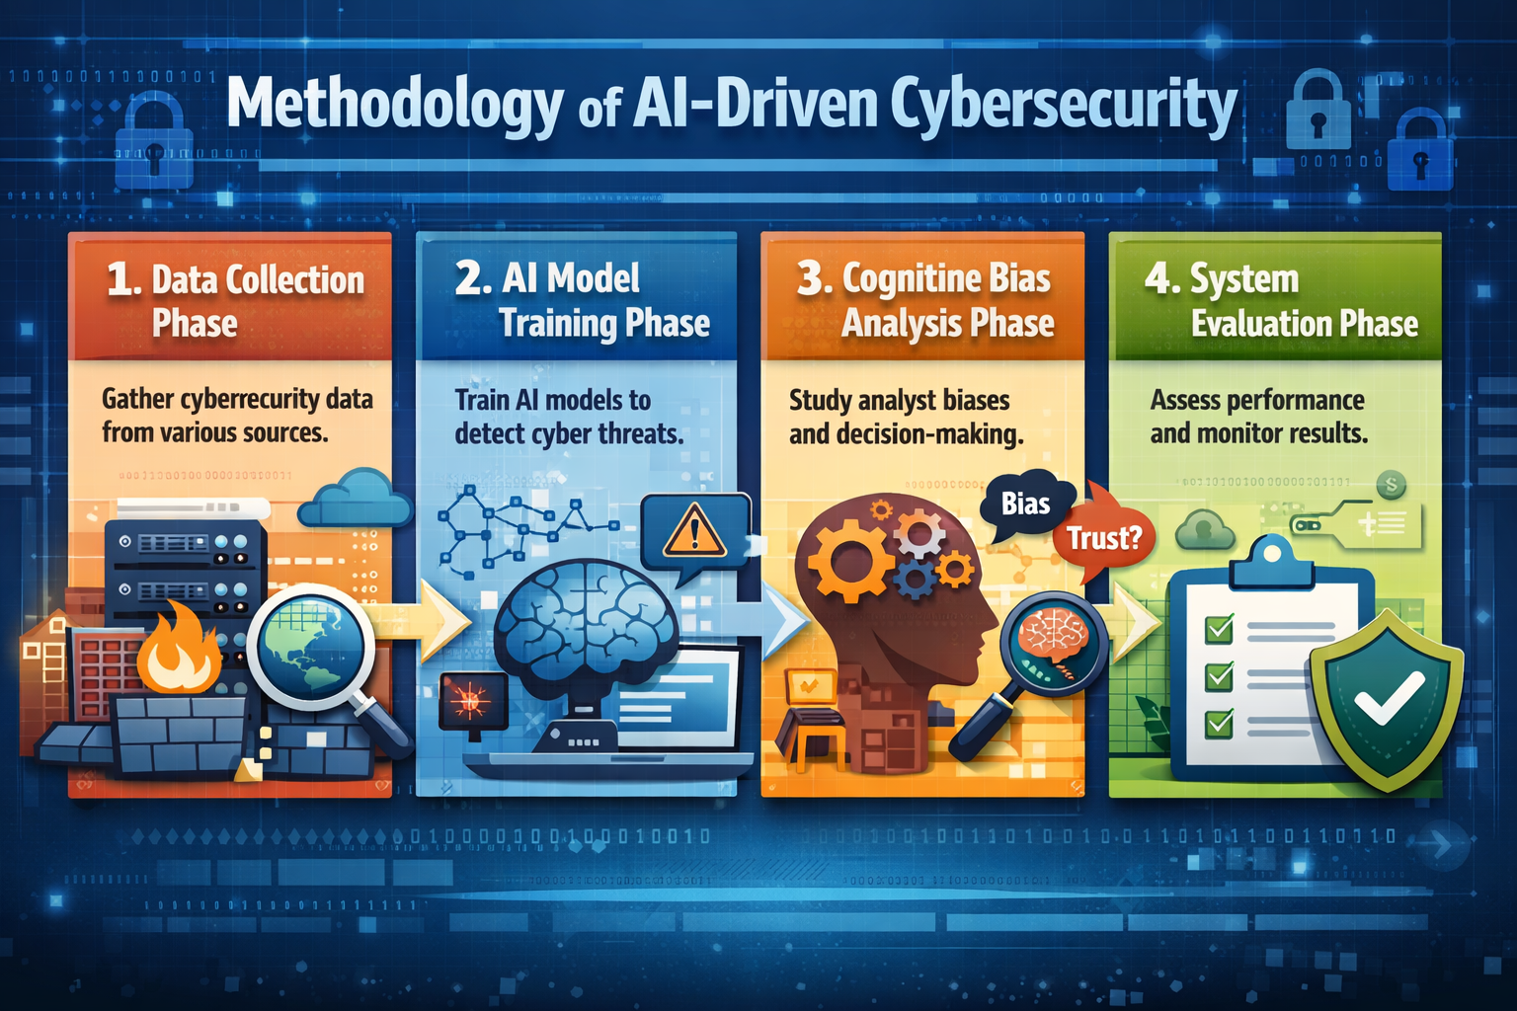
5.2 AI Model Training Phase: After data collection, machine learning models are trained using historical cybersecurity datasets. The models learn to identify patterns associated with maoptimizingtivities such as phishing attacks, malware infections, and unauthorized network access. Training involves selecting appropriate algorithms, optimizing model parameters, and validating the model’s ability to detect security threats accurately.
5.3 Cognitive Bias Analysis Phase: In this phase, the interaction between human analysts and AI systems is studied to identify cognitive biases that influence decision-making. Analystanalyzingher trust AI recommendations too much or ignore them due to personal judgment. By analyzing analyst responses to AI-generated alerts, researchers can identify patterns of automation bias, confirmation bias, and other psychological factors that affect cybersecurity decisions.
5.4 System Evaluation and Monitoring Phase: The final phase evaluates the overall performance of the AI-driven cybersecurity system and the effectiveness of human-AI collaboration. Performance metrics such as threat detection accuracy, false positive rates, and response time are analyzed. Continuous monitoring and feedback help improve both AI system performance and analyst decision-making, ensuring more reliable cybersecurity operations.
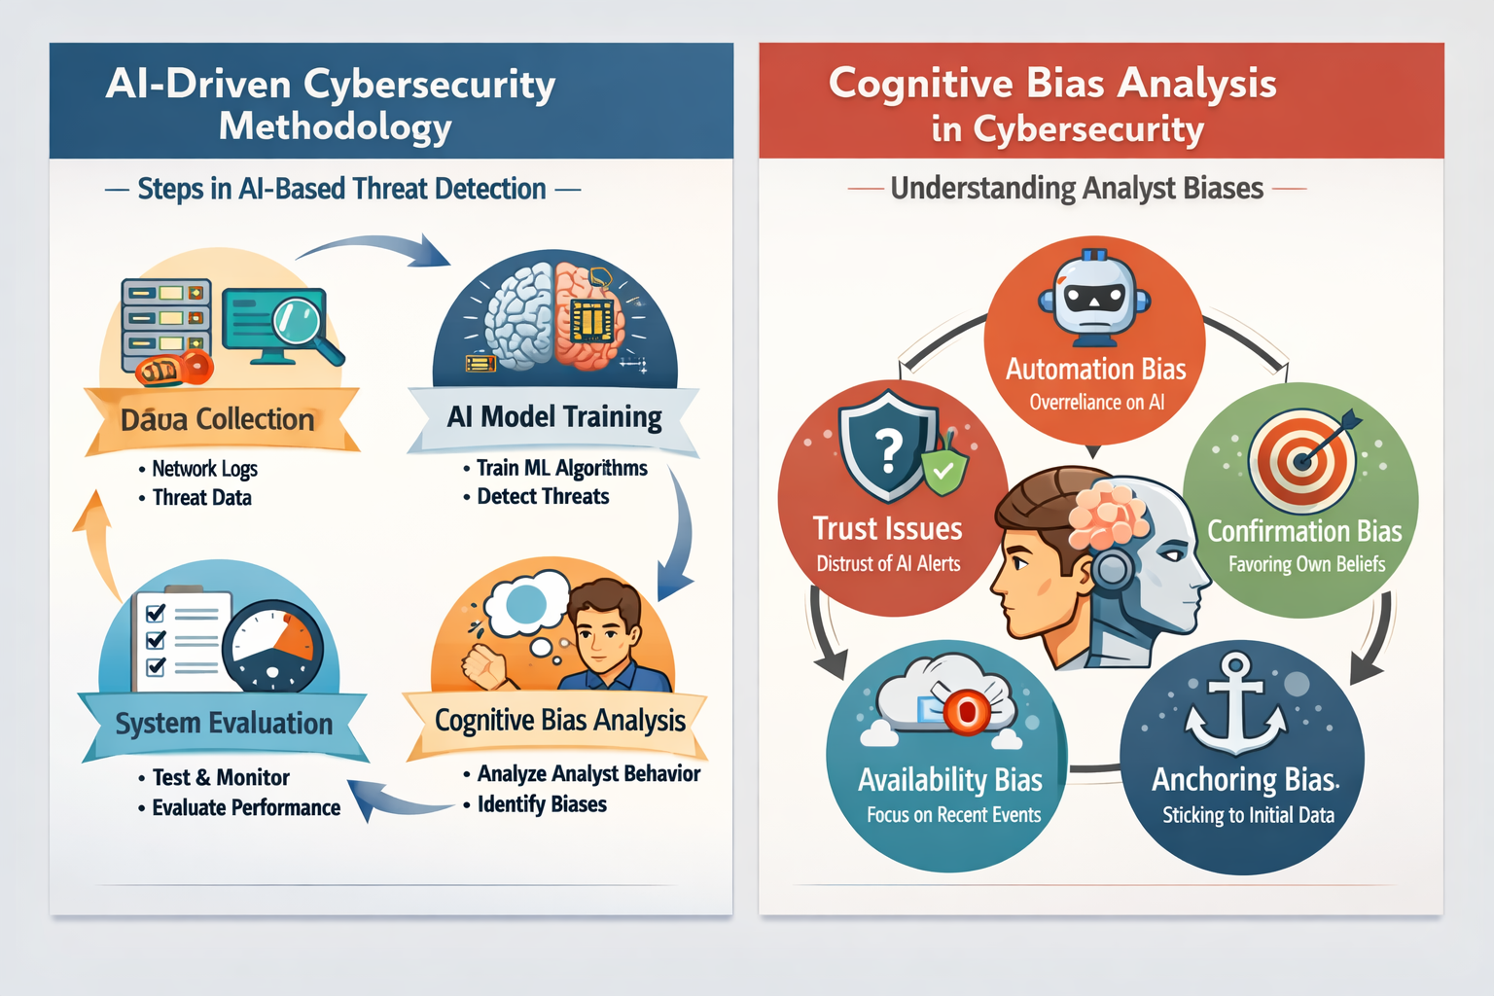

6. ADVANTAGES
- Improved Security Decision-Making: Understanding cognitive biases helps cybersecurity professionals make more accurate decisions while analyzing security alerts. AI-driven systems can assist analysts by highlighting unusual patterns and reducing errors caused by human judgment biases
- Enhanced Trust in AI Security Systems: When AI systems provide transparent explanations for their threat detection processes, security analysts and organizations develop greater trust in automated cybersecurity tools. This transparency improves acceptance and responsible usage of AI technologies.
- Reduced Human Error in Threat Analysis: AI-driven cybersecurity systems can process large volumes of network data and detect suspicious activities that humans may overlook. By supporting human analysts, AI reduces the chances of missed threats or incorrect responses.
- Faster Detection and Response to Cyber Attacks: AI systems can analyze network behavior and detect cyber threats in real time. This enables quicker responses to potential attacks, minimizing damage and improving overall security resilience.
- Improved Human-AI Collaboration: By addressing trust issues and cognitive biases, AI systems can work more effectively with cybersecurity professionals. This collaboration allows humans to focus on strategic decision-making while AI handles large-scale data analysis.
- Better Cybersecurity Awareness and Training: Studying human factors helps organizations design better training programs that educate employees about cyber risks, phishing attacks, and safe digital practices, ultimately strengthening the security posture of organizations.

7. DISADVANTAGES
- Overdependence on AI Systems: Excessive reliance on AI-driven cybersecurity tools may reduce human vigilance. Security analysts may trust automated decisions without proper verification, which can allow sophisticated attacks to go unnoticed.
- Persistence of Human Cognitive Biases: Even with advanced AI assistance, human analysts may still be influenced by biases such as confirmation bias or overconfidence, which can affect the interpretation of security alerts and threat assessments.
- Complexity in Building Trustworthy AI Models: Developing AI systems that are both accurate and transparent is technically challenging. If security professionals do not understand how the AI system makes decisions, trust issues may arise.
- Risk of False Positives and False Negatives: AI-driven cybersecurity systems may sometimes incorrectly identify threats or fail to detect real attacks. These errors can create confusion for analysts and reduce confidence in automated security systems
- High Implementation and Maintenance Cost: Deploying AI-based cybersecurity infrastructure requires significant investment in computing resources, skilled professionals, and continuous system updates.
8. CONCLUSION
Artificial General Intelligence represents a transformative step in the evolution of artificial intelligence, with the potential to solve complex global challenges and significantly enhance human capabilities. However, the same intelligence that makes AGI powerful also introduces serious safety concerns. As systems become more autonomous and capable of long-term reasoning, ensuring that they remain aligned with human values becomes essential. Safe Artificial General Intelligence is not only a technical challenge but also a societal responsibility. By prioritizing safety alongside capability, researchers and policymakers can work together to ensure that future AGI systems remain beneficial, controllable, and aligned with human well-being.

9. FUTURE ENHANCEMENT
Future research in AI-driven cybersecurity should focus on improving the interaction between human analysts and intelligent security systems. One major direction is the development of explainable AI models that clearly show how decisions are made. Transparent systems will help security professionals understand threat detection processes and reduce mistrust in automated security tools. Another important area is the integration of human behavior analysis into cybersecurity platforms. By studying how cognitive biases influence security decisions, future systems can provide smarter alert prioritization and decision-support mechanisms. This will help analysts respond more effectively to cyber threats. Additionally, adaptive learning systems can be developed that continuously improve by learning from both human feedback and evolving cyberattack patterns. These improvements will enable stronger collaboration between humans and AI systems, creating more reliable and resilient cybersecurity infrastructures.
10. APPLICATIONS
- AI-assisted Security Operations Centers for faster cyber threat detection and response
- Intelligent phishing detection systems for protecting users from email and social engineering attacks
- User behavior analytics systems for identifying insider threats and abnormal activities
- AI-powered fraud detection in banking and financial transactions
- Automated network intrusion detection and cyberattack monitoring systems
- Cybersecurity training platforms that simulate real-world cyber threats for employees
- Decision-support tools for cybersecurity analysts to reduce human errors and biases

11. BIBLIOGRAPHY
[1] S. Furnell and N. Clarke, Human Aspects of Information Security and Assurance, Springer, 2019.
[2] D. Kahneman, Thinking, Fast and Slow, Farrar, Straus and Giroux, 2011.
[3] B. Schneier, Click Here to Kill Everybody: Security and Survival in a Hyper-Connected World, W.W. Norton & Company, 2018.
[4] NIST, “Artificial Intelligence Risk Management Framework,” National Institute of Standards and Technology, 2023.
[5] M. Taddeo and L. Floridi, “How AI Can Be a Force for Good in Cybersecurity,” Science, vol. 361, no. 6405, 2018.
[6] ENISA, “Cybersecurity and Artificial Intelligence: Trust and Human Factors,” European Union Agency for Cybersecurity Report, 2022.[6] J.Ji et al., “AI Alignment: A Comprehensive Survey,” ACM Computing Surveys, 2025.

