Introduction:
The purpose of this article is to create a proof of concept to demonstrate the feasibility of one month old beta version of ASP.NET WebAPI.
Problems:
- Need to merge number of application using different technologies like Simple web application, Web-Services, Windows application or Mobile application etc.
- Don’t want to use Stored Procedure any more.
- Looking for Multiple database support
- Existing application is written using nHibernate or other ORM, now would like to convert it to MS-Technology.
- Should be open for any enhancement/modification

Useful links used for this Application:
- AdventureWorksLT2008R2
- ASP.Net WebAPI
- Autofac for Dependency Injection
- Log4Net
- EntityFramework 4.1
- jQuery Templates plugin (jquery-tmpl)

Architecture for this POC:
I am not following any specific Architecture Pattern, although while designing this POC, I try to follow some of the key design principles like:
Separation of concerns
Abstraction
Don't repeat yourself
KISS principle
Again I am repeating my word try to follow….. :). So, all comments/suggestions are more than welcome to discuss and I am always ready to adopt changes, or you can do it yourself by join @CodePlex. The initial Skeleton for this application is as per below diagram:

Model: Simple POCO Entities
.htm / .html
.aspx / .cshtml
.jsp / .php
API
Form 1

Service
DAL
Repository
Database 1
Database 2

Database..n

Accepting requests from any website, and also available as .dll to use in any windows/web application, than provide Responses based on that.
Accepting requests only from API’s, and provide Responses based on that.
ALL CRUD operations in Database are done through this layer only.
Extension of Repository Class defined in DAL Layer

Includes: DI, Filters, support for GET, POST, PUT and DELETE, Global and Local configuration etc.
Business Logic and database fetching methods should be written here.
Includes: Data Model ( .edmx ), Unit Of Work and Repository Pattern Implementation.
Complex database Queries.

Common

Step 1: In first step I am trying to create a basic structure for a Service Application as per above diagram
For more information on ASP.NET WebAPI, watch Videos and Tutorials Here

Add a blank Solution named as Application
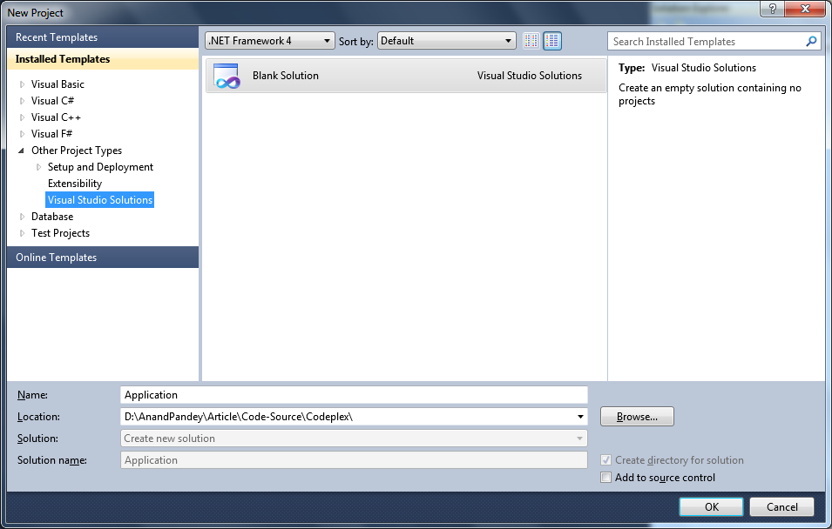
Add a new Project (Class Library) named as Application.DAL
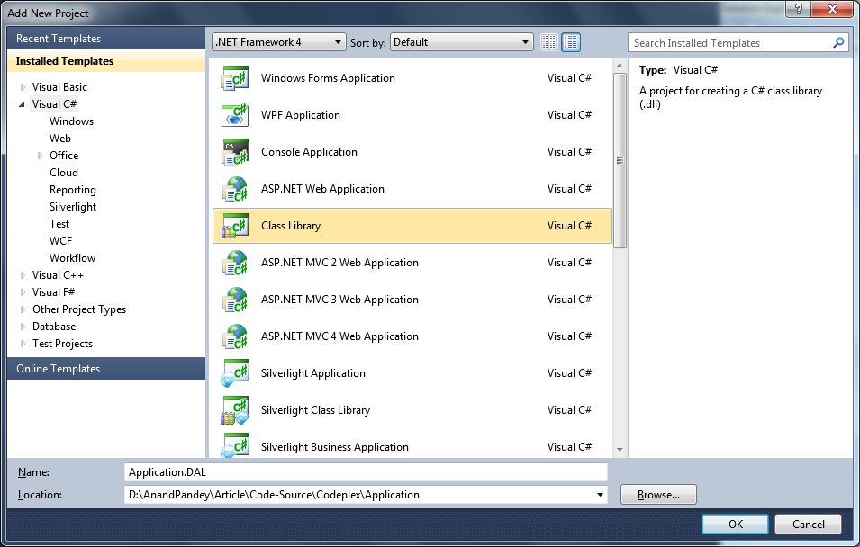
Repeat above process and create four more Class Library projects named as –
- Application.Model
- Application.Repository
- Application.Common
- Application.Service
Now, application will look like below screen-shot
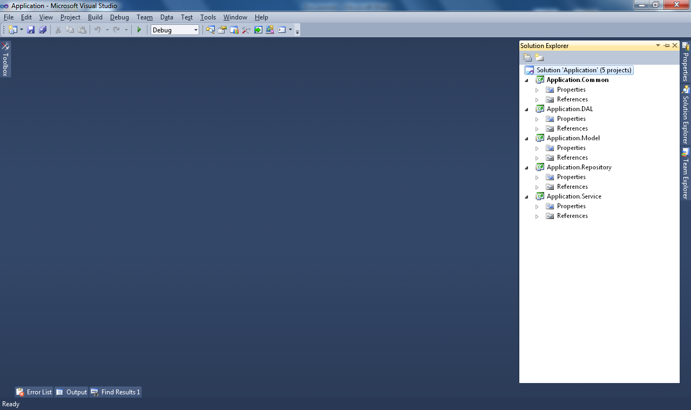
Again, add a new Project named as Application.API as ASP.Net MVC 4 Web Application. After clicking on OK, select template as Web API.
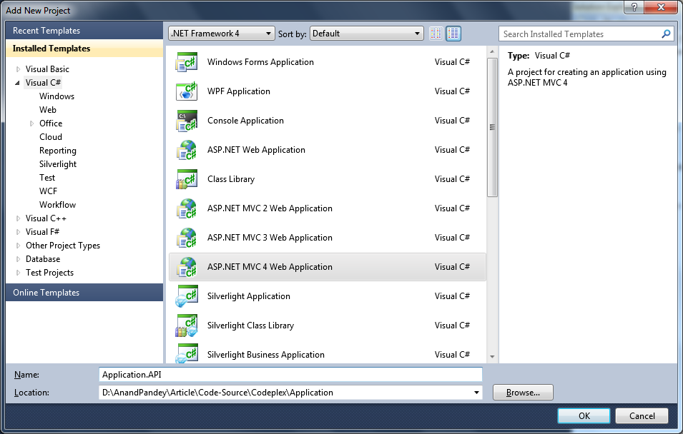
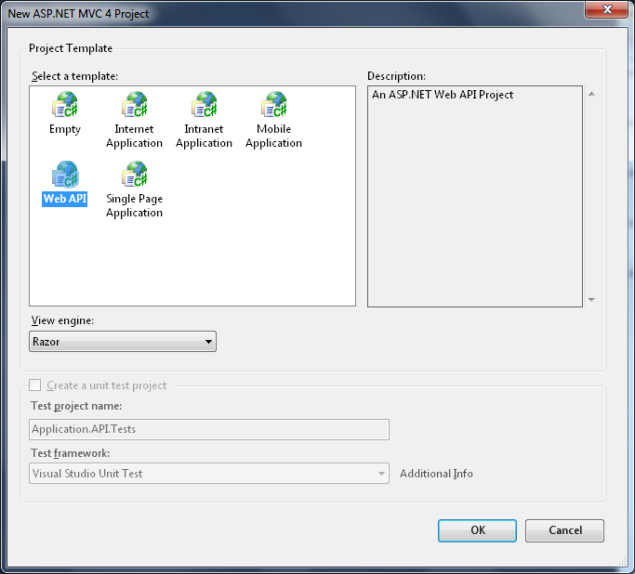
This will add a full functional Web API template Application into our main solution.
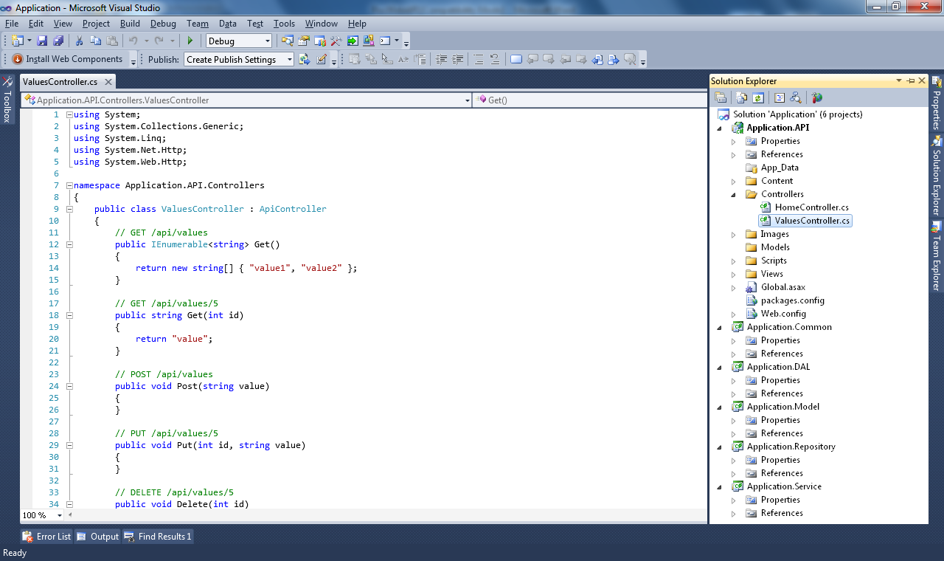
Right click on Application.API project in Solution Explorer and go to properties, than assign a port to be use by this service application ( In my case its 30000). Hit F5 and we are ready with a dummy data as below screen:
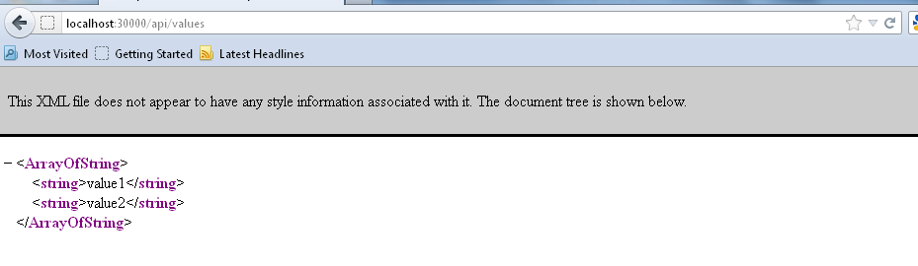
Step 2: Prepare Application.DAL, Application.Repository and Application.Model Layers
Check @MSDN for more information on Entity Framework
Add Entity Data Model to Application.DAL project. For this select ADO.NET Entity Data Model from the Data Templates list, and name it as AdventureWorks.edmx
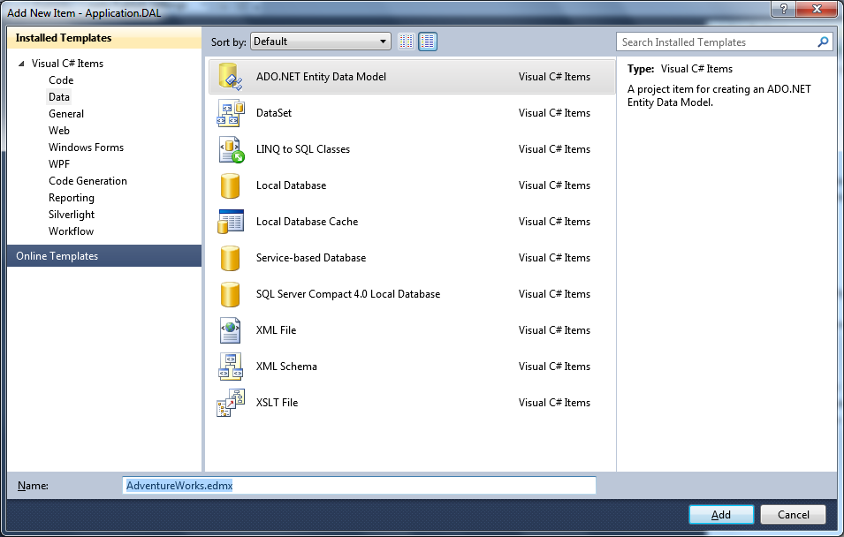
Choose “Generate from Database” and provide the connection string to read the database schema. This will add AdventureWorks.edmx into current project. Right click on the blank space in Entity Model surface and click on properties (or alternate press Alt +Enter on keyboard). Now set its Code Generation Strategy as None.
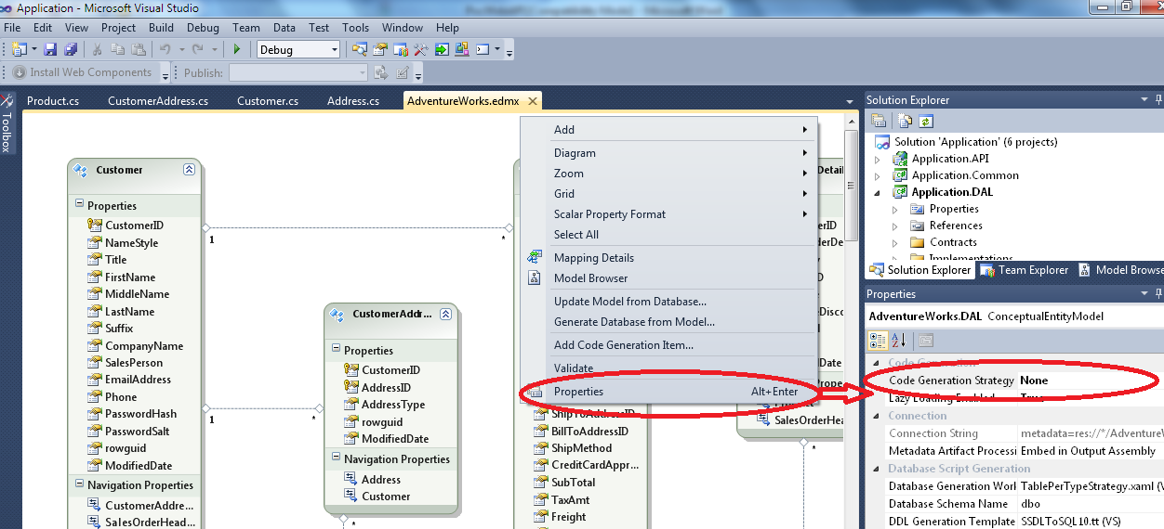
Now add POCO entities into Application.Model Solution. Check this article to do this job for you on MSDN to use T4 Templates and the Entity Framework
Then, create all required repositories under Application.Repositories.
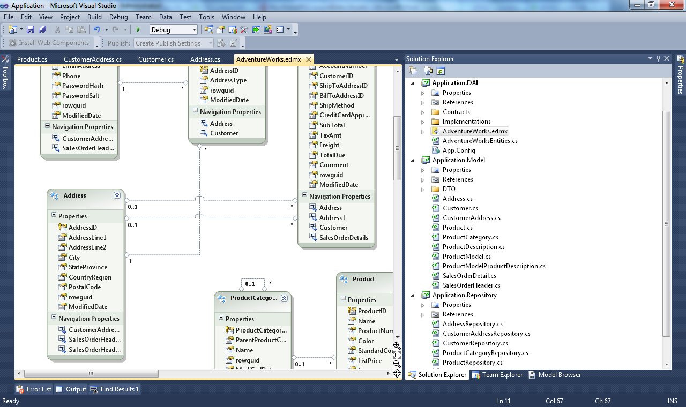
To build the solutions add reference of Application.Model.dll to Application.DAL and Application.Repository projects, and add reference of Application.DAL.dll to Application.Repository project. ( See below picture for reference )
Before proceeding to next step (designing Application.Service and Application.API Layer), let us see what we have designed yet:
CustomerAddressRepository
SalesOrderHeaderRepository
CustomerRepository
AddressRepository
ProductRepository
SalesOrderDetailRepository
ProductCategoryRepository

Application.DAL

IDatabaseFactory
IRepository
IUnitOfWork

DatabaseFactory
Repository
UnitOfWork

AdventureWorksEntities

Application.Model
Application.Repository

Product
CustomerAddress
ProductCategory
ProductDescription
Address
Customer
ProductModel
ProductModelProductDescription
SalesOrderDetail
SalesOrderHeader
AdventureWorksLT2008R2
Database

Step 3: Add files to Application.Service Layer
Before adding files to Service layer let us look at the Goals which we want to achieve.
- Any user should be able to view products
- Product will be filtered by Categories
- User should be able to add products in cart
- Only Registered user will be able to submit order
- User should be able to register into system
- User will get confirmation Invoice after successfully submitting order.
To achieve the above mention Goals, I add three service classes to Application.Service as per below image.
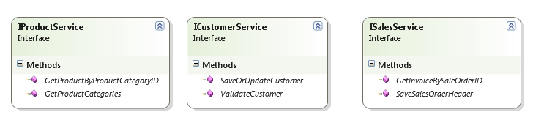
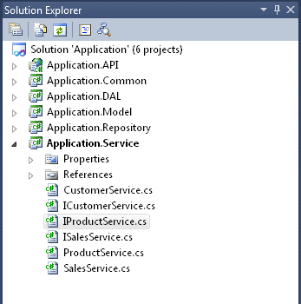
Step 5: Add files to Application.API Layer
To make this Web API accessed from a broad range of clients like any browsers which use JavaScript or any windows/Mobile platform which supports .dll files, we need to add Controllers with base class as ApiController. More details here
I removed the default controllers added by template (HomeController and ValuesController) and then added three new controllers as per below diagram:
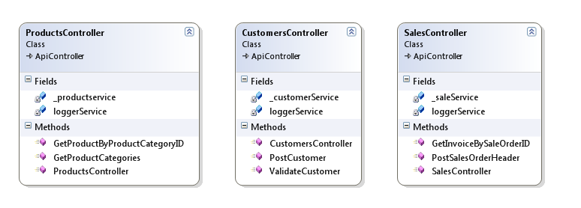
Step 6: Integration of Dependency Injection with WebAPI using Autofac
The implementation is very much straight forward and clear. Check Alex post here
The way I used it in my application is:
In Application.API Solution Explorer, right-click the References node and click Manage NuGet Packages
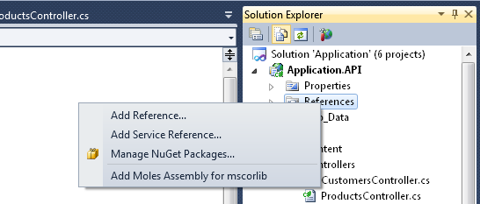
It will open the below screen.
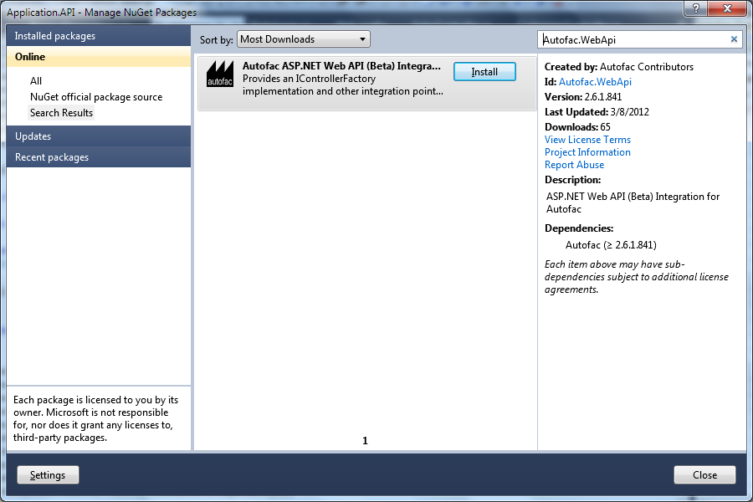
Click on install and it will add below three references in solution
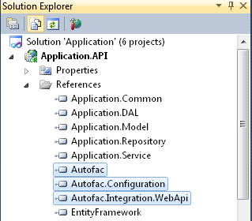
Now go to Global.asax.cs and create a method named as ResolveDependency()
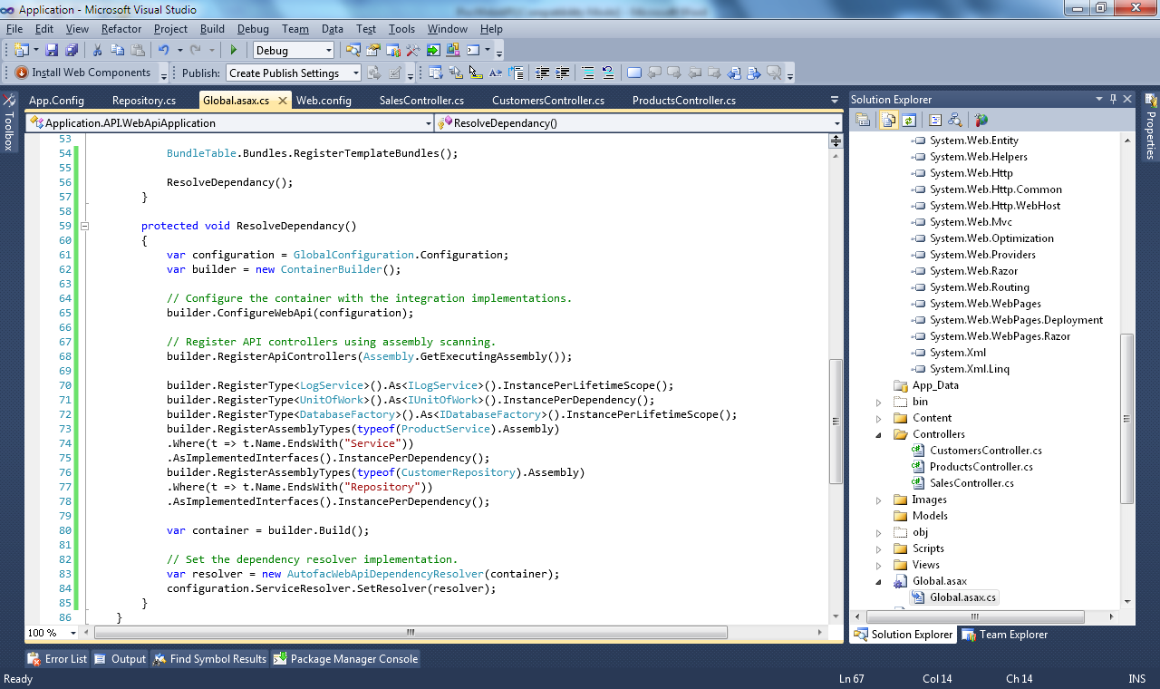
Now we are ready to test our application. Hit F5 and check the browser with following url’s:
http://localhost:30000/api/products : will result all Product Categories
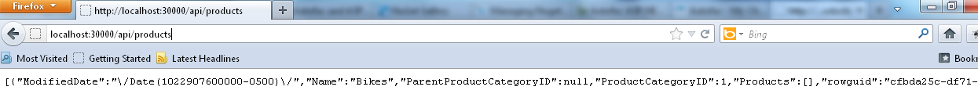
http://localhost:30000/api/products/2 : will result all Products with ProductcategoryID as 2
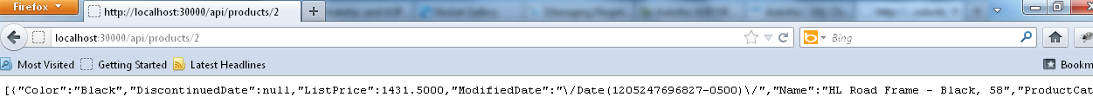
To check other methods let us add some Views in current solution.
Step 6: Add View to solution
Delete all default files and folders from Views Folder, and add three Html and their supportive Javascript File as. For this POC I am using
jquery.tmpl.js to create template based screen, and
jquery.validationEngine.js to validate form data

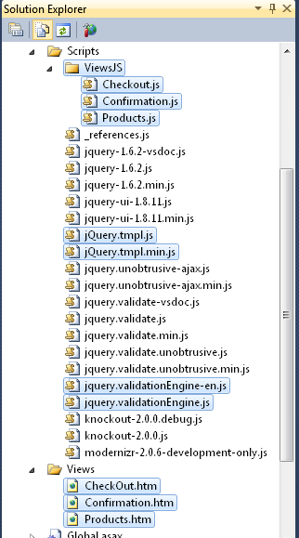
For details code in html and JS file please look into the code. In next step I am going to resolve problems.
Step 7: Resolve issues.
Before run the application Right Click on Products.htm and click on Set As start Page
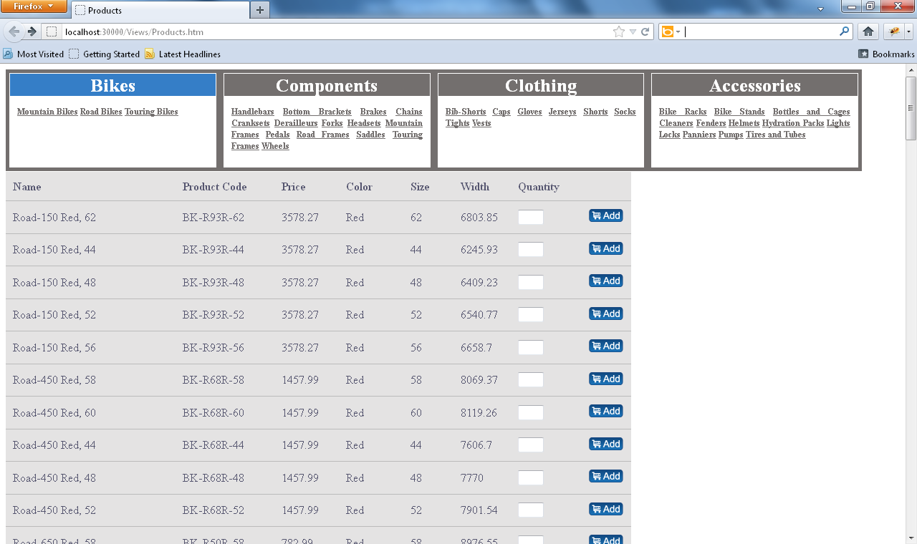
It means, two WebAPI method in ProductsController.cs are working perfectly, and are called. First as
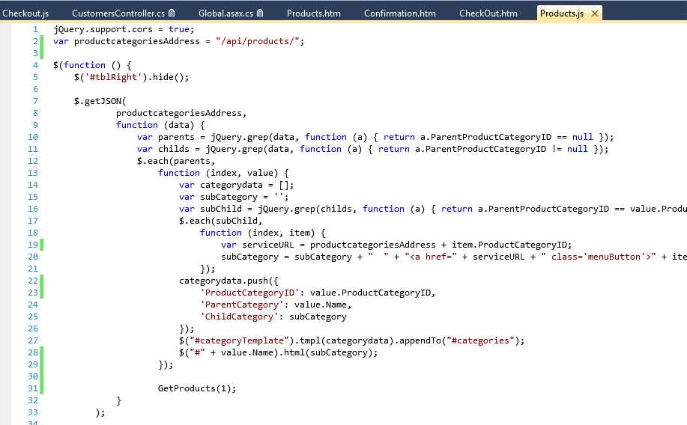
This call hits below method, and returns all Product Category to create the Upper Menu Part
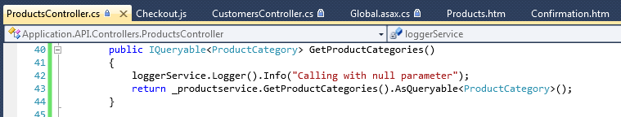
The another call to fetch all products depend on selected category
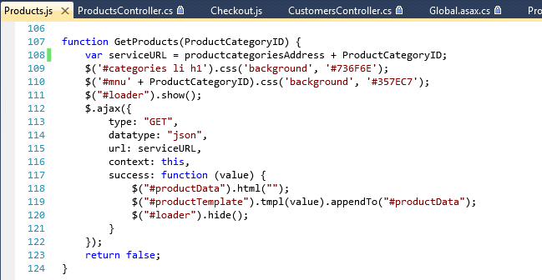
In WebAPI controller
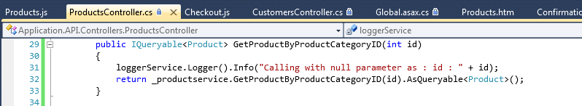
Now let us add some products to Cart and Checkout cart
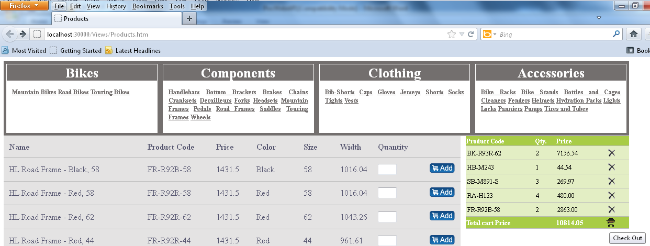
On clicking on checkout It redirect to Checkout.htm page and asking for either Login using existing CustomerID or Register for a new Customer.
Click on Register link to create a new Customer.
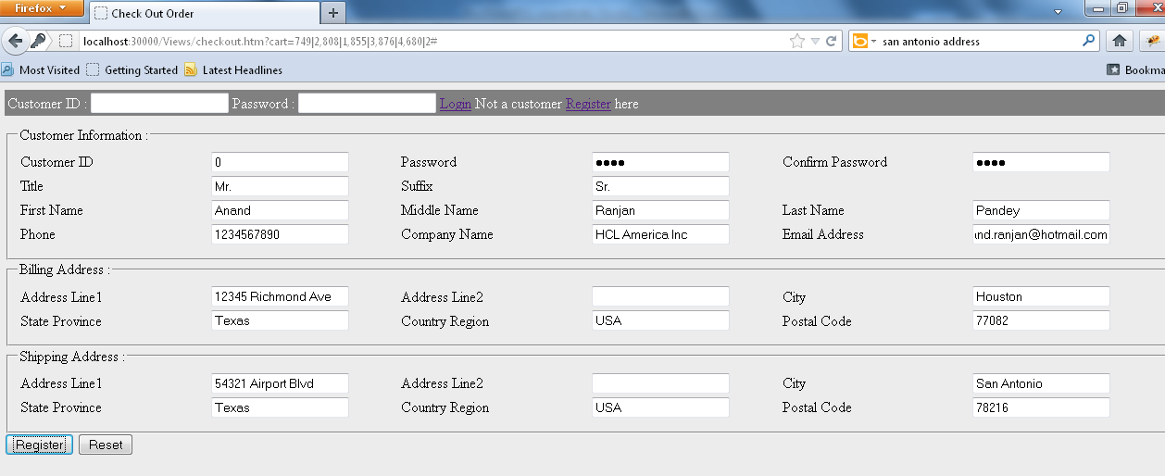
Submit form after clicking on Register button and see if Posting is working or not. Again its success !!!
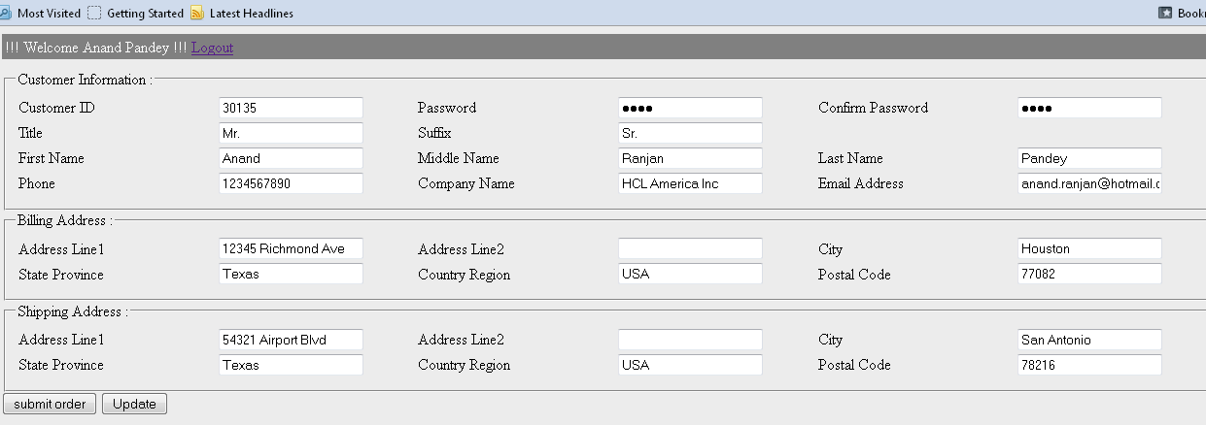
Now we will try to update records for AddressLine2. Update is also working fine!!!
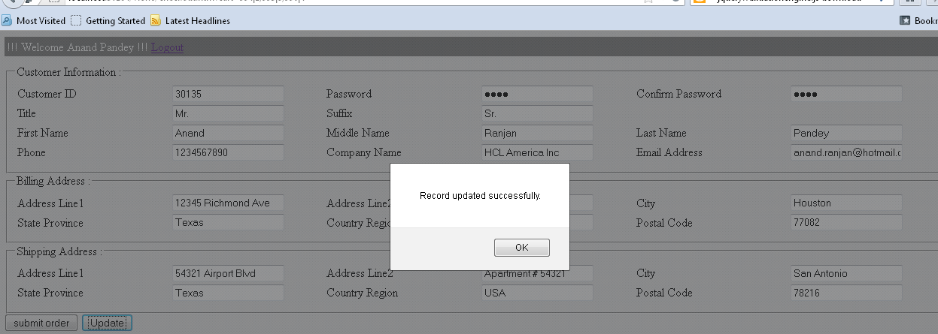
In both scenario (Add or Update Customer) we are calling below method of CutomerControllers.cs
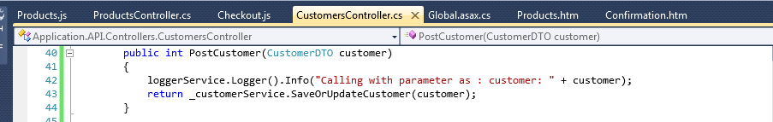
Next, click on Submit Order Button, to create previously selected products as an Order and to receive Order Invoice.
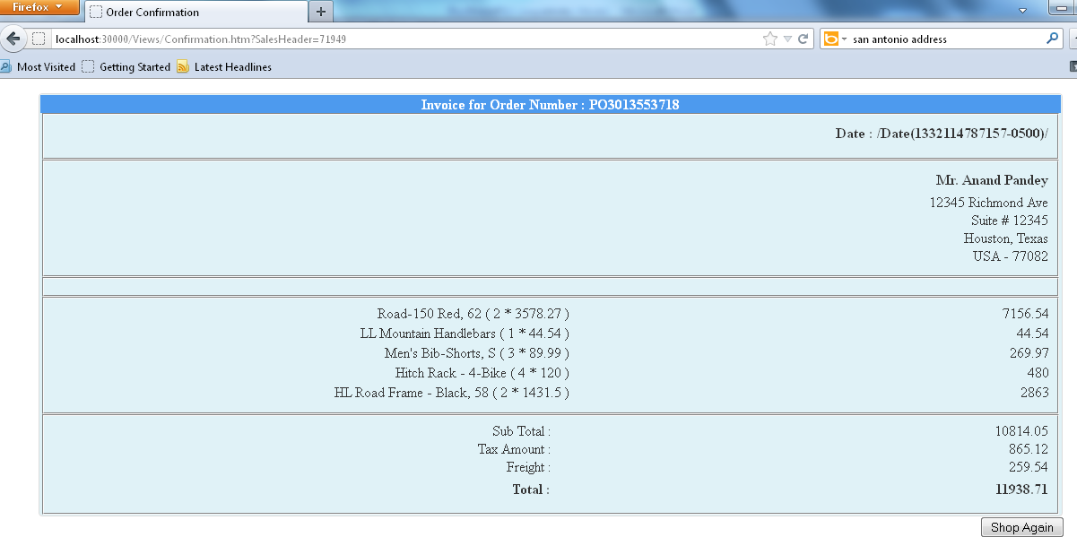
!!!Hurray!!! Order is created in system and invoice is generated with a new Purchase Order.
Issue 1: Here, I have found an issue with Date Format.
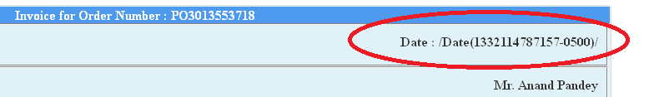
According to, Scott Hanselman’s post this is a bug and will resolve in next release of ASP.Net WebAPI. This issue is resolved using solution provided in Henrik's Blog.
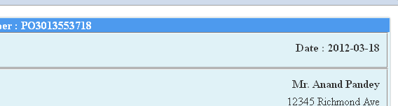
Issue 2: The another issue I found was when I try to Checkout Cart using the last created Customer. The error was:
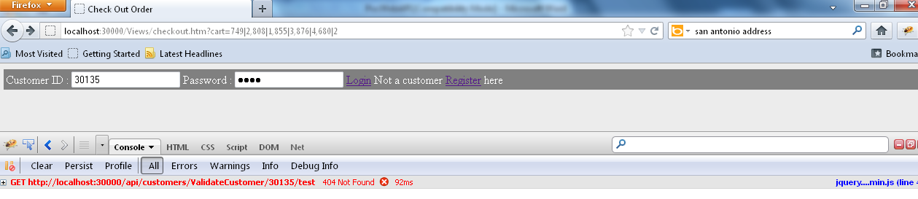
I cross-check CustomersController.cs and found that the method is already there. The reason behind the error was name of this method as ValidateCustomer():
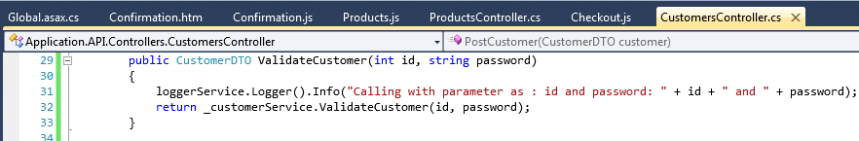
By default the route configuration of Asp.Net WebAPI follows RESTFUL conventions meaning that it will accept only the Get, Post, Put and Delete action names. So when we send a GET request to http://localhost:30000/api/customers/ValidateCustomer/30135/test we are basically calling the Get(int id) action and passing id=30135 which obviously crashes because we don’t have any method starting with Get which accept Id as parameter. To resolve this issue I need to add a new route definition in Global.asax file as:
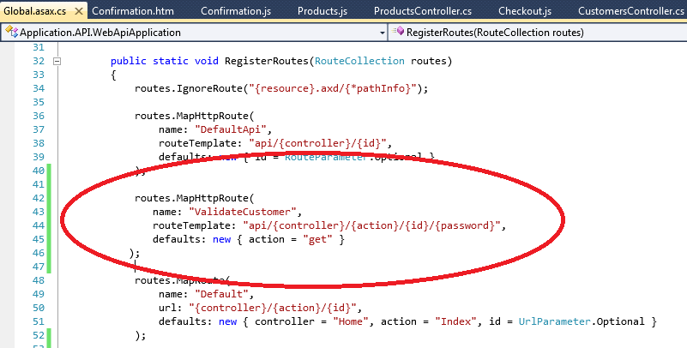
Adding this line works perfectly and we are able to Login …. :)
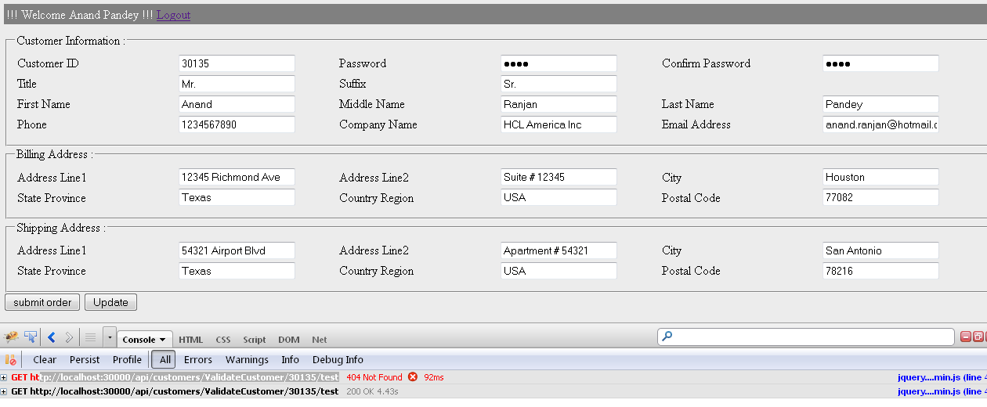
Step 8: Deploy on IIS
To deploy this API on IIS version 7.5, first, publish Application.API solution to a Folder.
Then, open IIS Manager and create a new website and set path to Publish folder.
Next, check whether page is opening or not, in my case initially, I got below error, which is self-explanatory, that this application is running on Asp.Net Framework Version 2.0, So we need to change it to Asp.Net Framework Version 4.0:
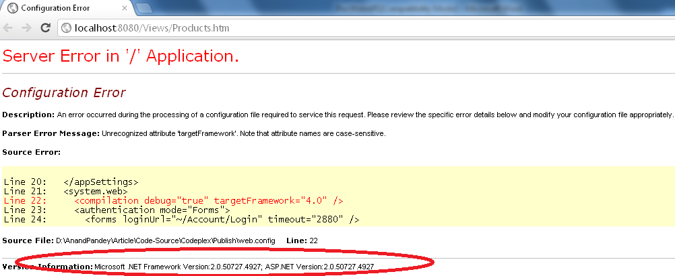
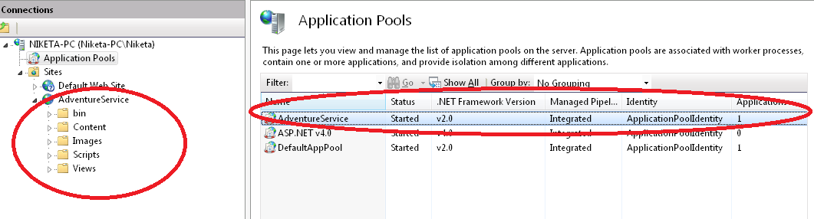
To change the Asp.Net Framework from 2.0 to 4.0, follow below steps.
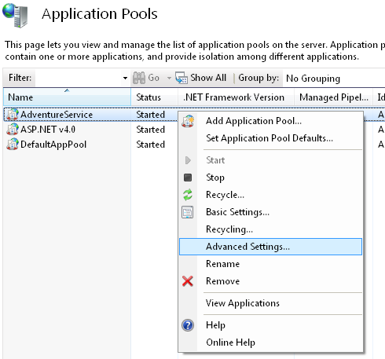
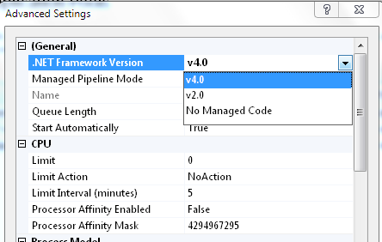
After made above change in Application pool when I run application I got below error:
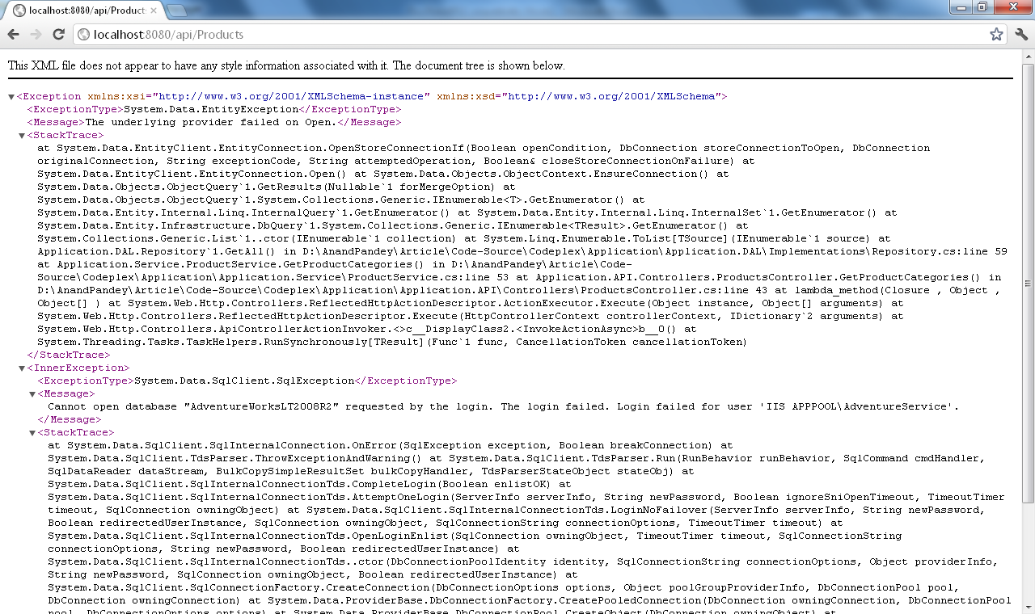
To resolve this error again go to Advance Settings of Application pool and change the identity to Local System from ApplicationPoolIdentity
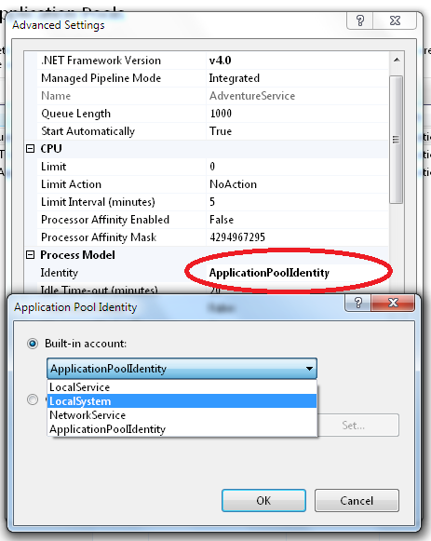
After making these changes Application is successfully deployed on IIS.
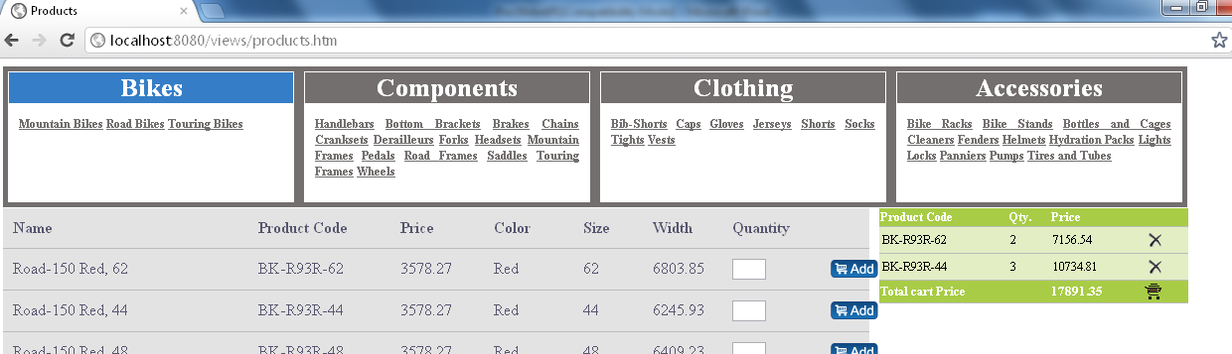
Although IIS errors are depending on servers/Firewall/Network or system to system, so it is very difficult to assume that you will also get the same error as mine. Check these links which help me to resolve some of the IIS issues in my work environment.
HTTP Error 500.19
Could Not Load Type ‘System.ServiceModel.Activation.HttpModule’
ASP.NET IIS Registration Tool
ServiceModel Registration Tool
Step 9: Cross Domain Support
The idea behind the Cross Domain Support comes when I try to remove all HTML pages from Application.API solution and created a new Empty Web Application (Adventure.Website) which includes only .html, .Js and .css files along with images. The structure for this application is as per below image:
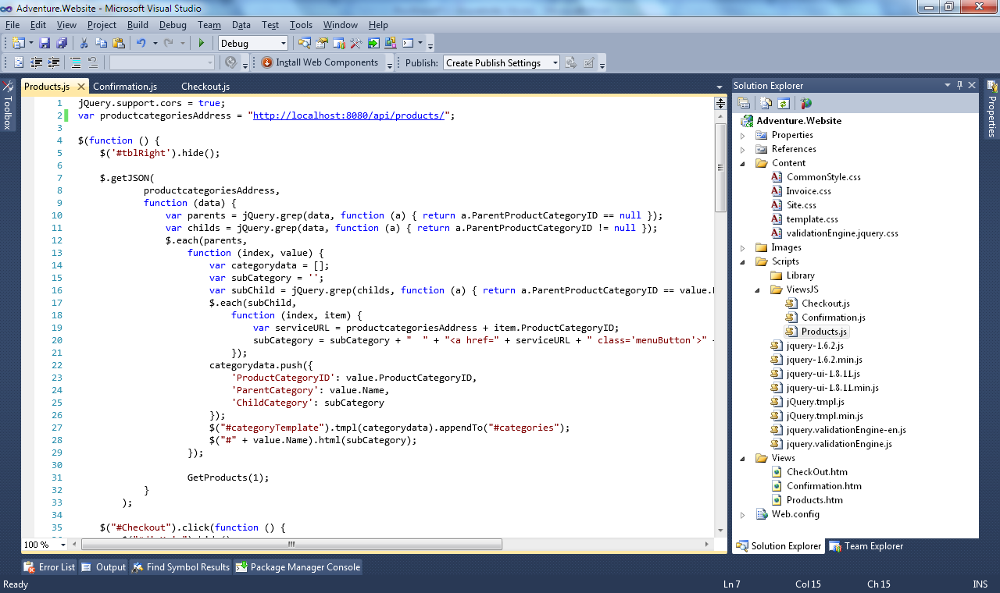
Point all URL address to deployed code on IIS, after build and run application, output was null.
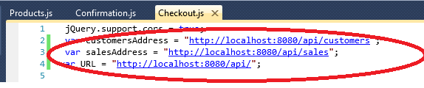
Special thanks to Carlos’ blog on MSDN Implementing CORS support in ASP.NET Web APIs
“By default, a web page cannot make calls to services (APIs) on a domain other than the one where the page came from. This is a security measure against a group of cross-site forgery attacks in which browsing to a bad site could potentially use the browser cookies to get data from a good site which the user had previously logged on (think your bank). There are many situations, however, where getting data from different sites is a perfectly valid scenario, such as mash-up applications which need data from different sources.”
Note: Hope you enjoy this article. I am not an expert, and also I have not followed the entire industry standard at the time of writing this article (time factor). So all comment and suggestions are more than welcome…. :), whenever, I will get time, I will try to modify this solution. I would also recommend to joining and contributing in this project on CodePlex.

