Nutritional Facts

CS 725/825, Fall 2017

Girish Kathireddy and Mohammed Shaaban

Department of Computer Science

Old Dominion University

Norfolk, VA 23529

[gkath001@odu.edu](mailto:gkath001@odu.edu), [mshaa001@odu.edu](mailto:mshaa001@odu.edu)

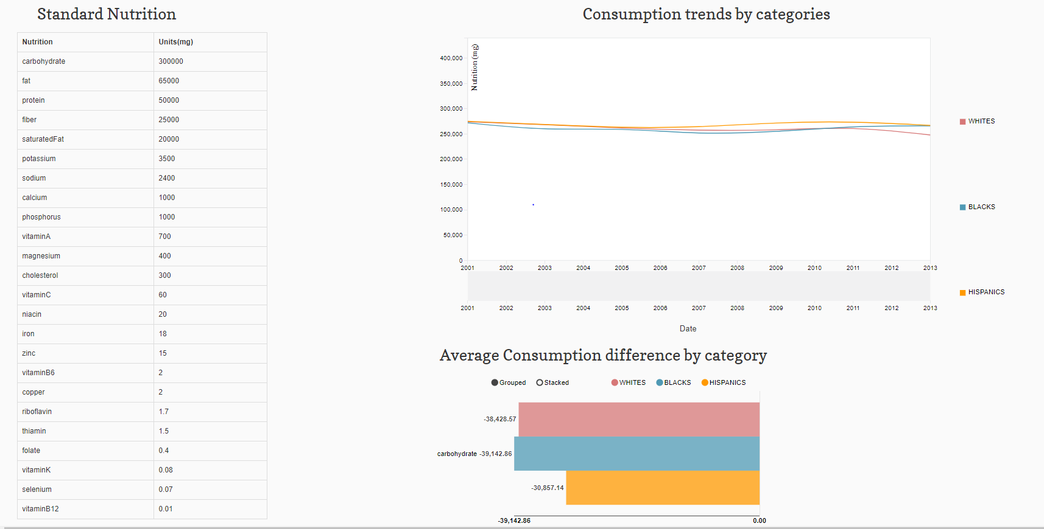

1.Introductiom.

Visualizations helps to analyze and understand patterns in limited amount of time. In general, one need to deal with huge data to derive absolute insight of the tasks. In this paper we aimed to analyze Nutrition intake of Hispanics(HIS), Non-Hispanic Blacks(NHB), Non- Hispanic Whites(NHW) by analyzing food consumption patterns. We want to compare the Nutrition intake to the Nutrition’s prescribed in the standard 2000 calorie diet and find out if there is any deficiency in Nutrients due to the food consumption habits. At the same time we want to analyze how much fruits can contribute to the nutrients which are deficient. This visualization was developed using D3.js, JQuery, CSS for styling.

Here are the questions that can be answered through the visualization.

1. Do the Non-Hispanic Blacks, Non-Hispanic Whites, Hispanics have deficiencies in the Nutrition intake due to food consumption habits.
2. What the Nutrients which are deficient across all the races.
3. What is the average deficiency at each Nutrient across various races
4. Can fruits contribute to fulfill the deficiencies.
5. What is the Nutrition value different fruits and how much can fruits contribute to fill the nutrition deficiency?

Visuals which we included to answer the research questions are

1. Table to represent the standard Nutrition.
2. Line chart to represent the average nutrition consumption patterns for the past 10 years across Non-Hispanic Blacks, Non-Hispanic Whites, Hispanics.
3. Horizontal bar chart to show nutrition’s which are consumed above and below the recommended levels of prescription across different races.
4. Vertical bar chart to show the average percentage deficiency of nutrients.
5. Parallel coordinates chart to show the standard nutrition of fruits per 100 grams.
6. Horizontal bar chart to show the contribution of fruits to the nutrients which are deficient.

Related work:

The article referred discusses the big picture on Nutrition quality, health status by considering different age groups, income levels, different races in US. The article claims that by 1995 many Americans are not getting the calcium they need to maintain optimal bone health and prevent age-related bone loss. Our analysis support that Americans are still having deficiency in Calcium. In this article we are concentrating particularly on HIS, NHB, NHW and analyzed the Nutritional deficiency. On top of it this article tries to analyze how fruits can contribute to fulfill the nutrition deficiency.

Data:

The data is available at United states department of agriculture(USDA) at what we eat in America (WWEIA) database and food composition database. The data which is in its raw format was modified as per requirements into CSV, JSON, TSV and consumed by the respective JavaScript libraries to create Visualizations.

At WWEIA we obtained data required to show Nutrition consumption patterns. The data was modified into attributes like Year and different Nutrition labels like carbohydrates, protein. The data required for charts like Horizontal bar chart to show nutrition consumption difference by category and Vertical bar chart to show the average percentage deficiency of nutrients was derived from this data. Food consumption database provides a search tool to look for fruits based on Nutrition. The data obtained was modified into attributes like Fruit, different Nutrition labels to support parallel coordinates chart. The data required for Horizontal bar to show the contribution of fruits to the deficient nutrients was derived from this data.

4. Visualizations

The Visualizations for the Nutritional facts has 6 charts divided into two categories: First categories include a Table, Line chart, Vertical bar chart, Horizontal chart used to represent Nutritional deficiency. Second categories include Parallel coordinated chart, Horizontal bar charts used to provide information about how fruits contribute to nutritional deficiency. As stated earlier the main purpose of this Visualization is to analyze the Nutritional deficiency across NHB, NHW, HIS for a period of 14 years from 2001-2014.

From the first category visualizations, the Nutrients in the table has impact on the Line chart and Horizontal bar chart. By selecting the row in the table for example the row which has carbohydrates data, the information in the Line chart and Horizontal bar chart will be modified. The line chart provides information about the Nutritional intake of carbohydrates by races like Hispanics, Non-Hispanic Blacks, Non-Hispanic Whites. The Horizontal bar chart helps to analyze if the Nutrients consumed are above and below the recommended level by comparing average intake of 14 years with standard values in the tables. Since the data can be expressed across positive and negative scale, it is easy analyze if the Nutrients are deficient or consumed in excess. The Vertical bar charts concentrates on the nutrients which are deficient and provides information about deficiency in percentages.

The second category visualizations are designed to understand how the fruits can contribute to Nutrients which are deficient. By clicking over fruits in the table the parallel coordinate charts highlights the line which indicates the amount of Nutrients present per 100 grams. By clicking over fruits in the table the Horizontal bar chart updates and provides information about the contribution of fruits to the nutrients which are deficient.

1.Design decisions:

The visualization was designed to analyze Nutrition deficiency and to show how fruits can contribute to nutrition deficiency. For better understanding we could divide the charts into two categories. One category to represent the Nutrition deficiency and the second to represent how fruits can contribute to the nutrients we observed as deficient in the first category.

Table:

Image Table

To represent the Nutrition deficiency through first category charts we used four different charts. Table was preferred to represent the 26 standard nutrients and its values. The data is expressed in milligrams. By Representing the data in milligrams in the table we can easily understand the difference in recommend levels across different prescribed nutrients. In the initial design we were confused if we need to consider different units for Vitamins since they were of small scale, but the National Institute of health provides conversion factors from one unit to other with the aim to compare among different Nutrients which supports our design decision.

Line chart:

Image:

Line chart was used to represent nutrition consumption patterns for the period of 14 years from 2010-2014 for three distinct categories Hispanics, Non-Hispanic Blacks, Non-Hispanic Whites. X axis defines the Year and Y axis was scaled in milligrams. Since line chart is best used to observe change in the patterns across distinct categories we selected Line chart for the design. The Line chart was interlinked with Table and the data in line chart represents different nutrition based on the selection of nutrients. For uniformity, the data is represented in milligrams. In this way the data can be comparable with standard values in the table. Since Y scale adjust automatically with the variation of data, it is easy to observe all the nutrients patterns through the design selection. Brushing provides a way to analyze the patterns at the particulate time in the data.

Horizontal bar chart:

Image

The Horizontal bar chart was used to analyze if the Nutrients consumed are above and below the recommended level by comparing average intake of 14 years with standard values in the table. The average intake was calculated across three distinct categories and color coding was used to represent each category. The color coding used is in sync with coding schema used in line chart to represent races. By scaling axes in the horizontal bar chart, it is possible to represent data in positive and negative scale which was a requirement for our design choice. The data in the chart varies with the selection of nutrients in the table providing a way to analyze if each Nutrient is consumed above or below the standard levels by different races by observing the data across positive and negative scale. In the initial design the x axis was scaled in percentages. We changed the scale to milligrams since expressing the deficiency of each nutrient in milligrams would be more useful to the user since the standard labeling across different food products follow the conventions of milligrams or grams.

Vertical bar chart:

pic

The vertical bar chart represents data related to nutrients which are deficient by combining nutrition intake all the races. Initially the data was scaled to milligrams, but the visualization was unable to pass required information due to huge variations of data and scaling in percentages by comparing to the nutrient standard values was observed as the best way to pass the required information of deficiencies. The tool tip was considered as the effective way to pass the information to the user and was used in the visualization. Single color coding channel was used to maintain uniformity.

Average Consumption difference to Standard Nutrition.

Citations:

Related work: https://www.ars.usda.gov/ARSUserFiles/80400530/pdf/tronm.pdf

Data:

https://www.ars.usda.gov/northeast-area/beltsville-md/beltsville-human-nutrition-research-center/food-surveys-research-group/docs/wweia-data-tables/

https://www.dsld.nlm.nih.gov/dsld/unitconversion.jsp