

STUDENT CASE STUDY EXECUTION REPORT

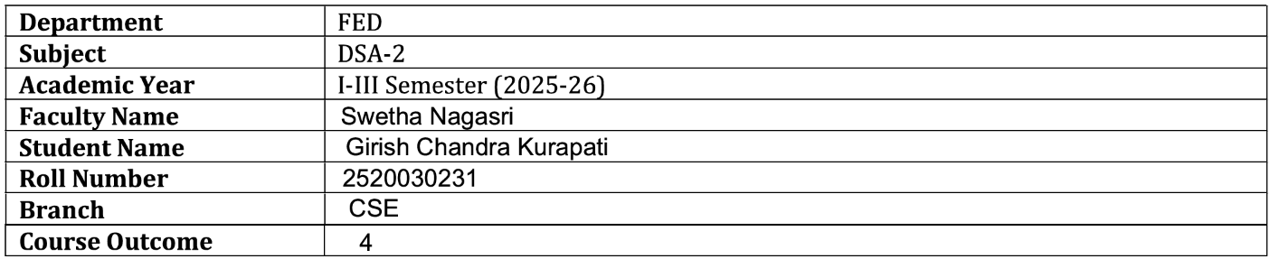
Case Study Topic: E-Commerce Product Ranking System using Heap Sort
Work Done Summary:

In this case study, Heap Sort was implemented to rank products in an E-Commerce platform based on customer ratings. Product ratings were stored in an array and sorted in descending order using Heap Sort. The system helps customers identify top-rated products quickly. Heap Sort efficiently handles large product datasets and provides stable performance for ranking applications.

Implementation Details:
- Stored product ratings in an integer array.
- Constructed a Max Heap from the ratings.
- Repeatedly extracted the maximum element.
- Sorted ratings in descending order.
- Generated product rankings.
- Displayed ratings before and after sorting.
- Identified the highest-rated product.
- Evaluated Heap Sort performance.

Result: Screenshots / Output
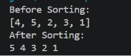

Time Complexity:
- Best Case: O(n log n)
- Average Case: O(n log n)
- Worst Case: O(n log n)

Conclusion:

The E-Commerce Product Ranking System using Heap Sort successfully ranked products based on customer ratings. Heap Sort efficiently managed large datasets and generated accurate rankings. This case study demonstrates the practical application of Heap Sort in online shopping and recommendation systems.

GitHub Link:

https://github.com/girishkurapati/DSA-2

