

STUDENT CASE STUDY EXECUTION REPORT
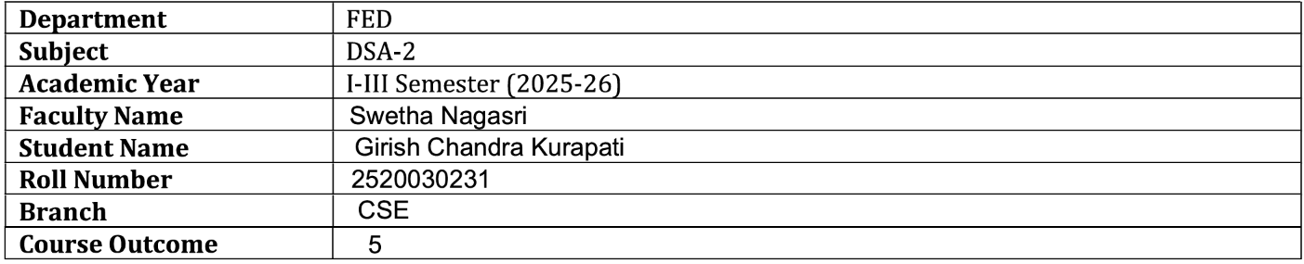

Case Study Topic: Smart Event Scheduling System using Activity Selection Algorithm
Work Done Summary:

Implemented a Smart Event Scheduling System using the Greedy Activity Selection Algorithm. Multiple events with start and finish times were provided, and the system selected the maximum number of non-overlapping events. The solution helps organizations efficiently utilize available resources and time slots

.Implementation Details:

- Stored event start and finish times.
- Sorted events based on finish times.
- Selected the first activity.
- Compared subsequent activities.
- Chose only non-overlapping activities.
- Generated the final event schedule.
- Displayed selected events.
- Analyzed algorithm efficiency.

Result: Screenshots / Output:

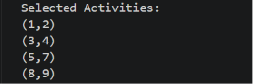

Time Complexity:

- Sorting: O(n log n)
- Selection: O(n)
- Overall: O(n log n)

Conclusion:

The Smart Event Scheduling System successfully selected the maximum number of non-overlapping events using the Greedy Activity Selection Algorithm. The solution optimized resource utilization and scheduling efficiency. This case study demonstrates the real-world application of Greedy Algorithms in event management and scheduling systems.

GitHub Link:

https://github.com/girishkurapati/DSA-2

