**PAGE DESIGN**

**HEALTH GOALS PAGE**

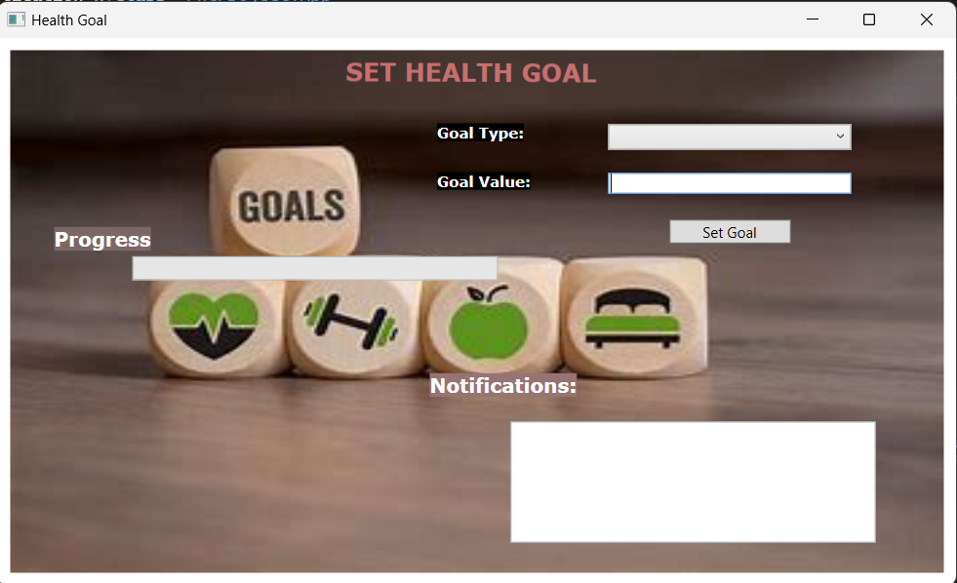

**PROFILE SETTINGS PAGE**

**DEVICE INTEGRATION AND SYNC PAGE**

