**CO1 PROGRAMS**

**2. Display future leap years from current year to a final year entered by user**

s=int(input("enter start year:"))

e=int(input("enter end year:"))

if(s<e):

print("leap years are:",end=" ")

for i in range(s,e):

if ((i % 400 == 0) or (i % 100 != 0) and (i % 4 == 0)):

print(i,end=" ")

**OUTPUT**

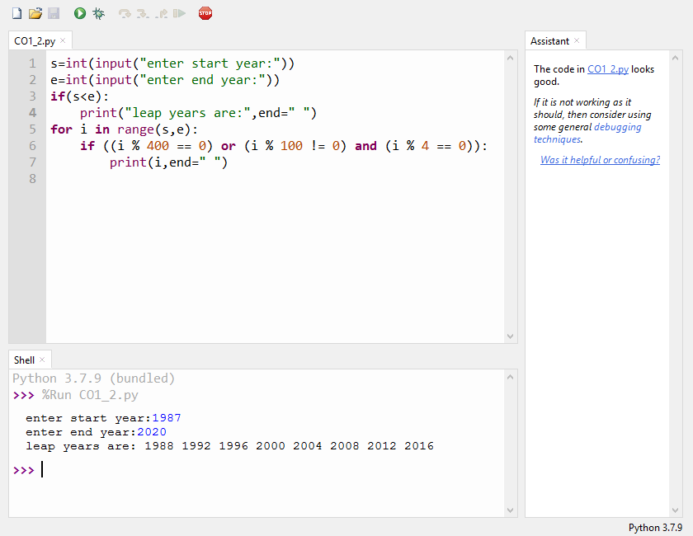

**3.List comprehensions:**

**3.1 -Generate positive list of numbers from a given list of integers**

lst =[-10,20,35,-67,70]

result=[num for num in lst if num>=0]

print(result)

**OUTPUT**

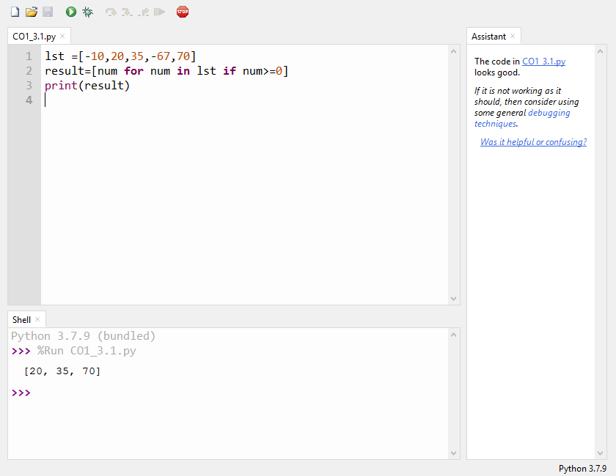

**3.2** -**Square of N number**

n=int(input("Enter The limit:"))

squarelist= [ i**2 for i in range(1,n+1)]

print("Square of N numbers : ", squarelist)

**OUTPUT**

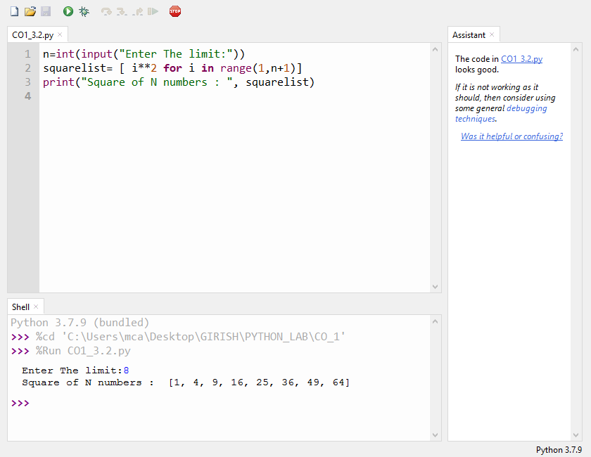

**3.3 -Form a list of vowels selected from a given word**

word =str(input("Enter the word :"))

print("The original string is : "+word)

print("The vowels are : ",end="")

for i in word:

if i in 'aeiouAEIOU':

print([i],end=" ")

**OUTPUT**

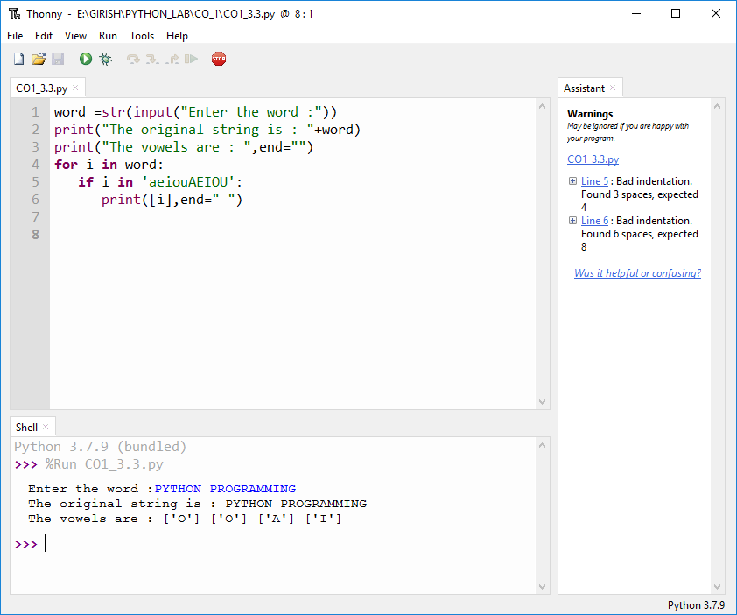

**3.4 List ordinal value of each element of a word (Hint: use ord() to get ordinal values)**

word=input("Enter a word:")

print("Ordinal values corresponding to each element is:")

for i in word:

print(i,end=":")

print(ord(i),end=" ")

**OUTPUT**

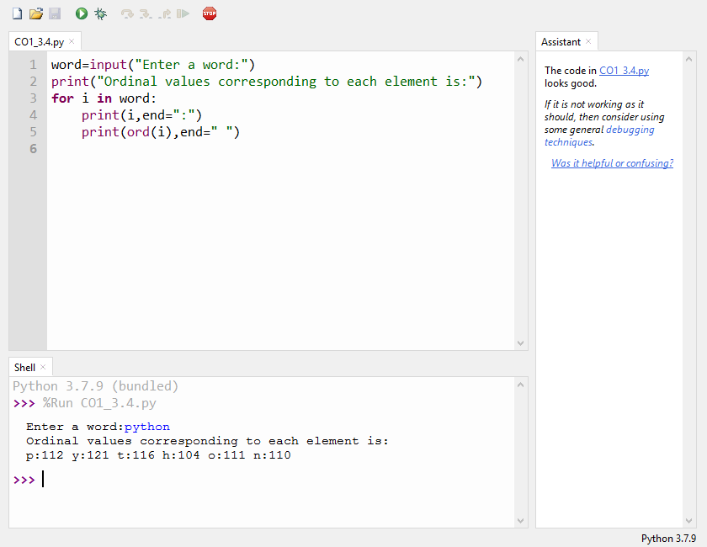**4. Count the occurrences of each word in a line of text.**

str1 = input("Enter a String :")

wordlist = str1.split()

count = []

for w in wordlist:

count.append(wordlist.count(w))

print("count of the occurrence:" + str(list(zip(wordlist, count))))

**OUTPUT**

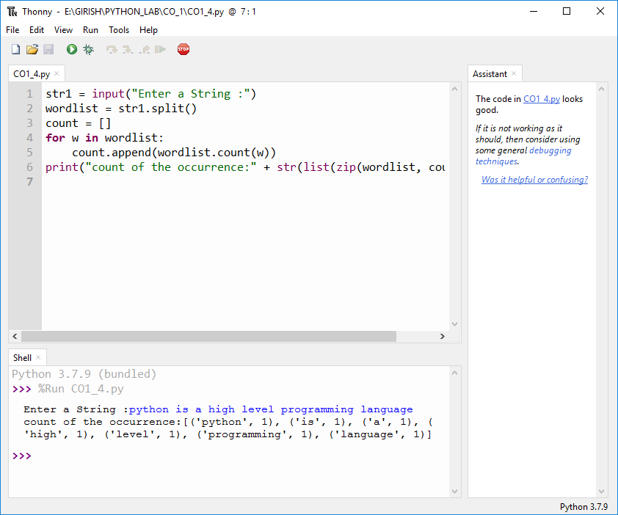 **5. Prompt the user for a list of integers. For all values greater than 100, store ‘over’ instead**

n=[]

s=int(input("Enter a limit:"))

print("Enter {s} values")

for i in range(0,s):

n.append(int(input()))

print("\nThe list after assinging:\n")

for i in range(0,len(n)):

if n[i]>=100:print("over")

else:print(n[i])

**OUTPUT:**

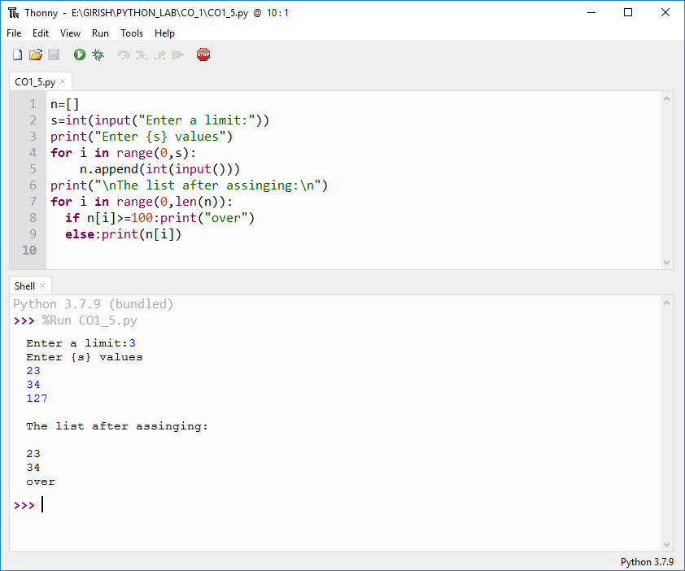

**6. Store a list of first names. Count the occurrences of ‘a’ within the list**

list = ["a","b","c"]

occ = list.count("a")

print("Count of occurances of a :",occ)

**OUTPUT**

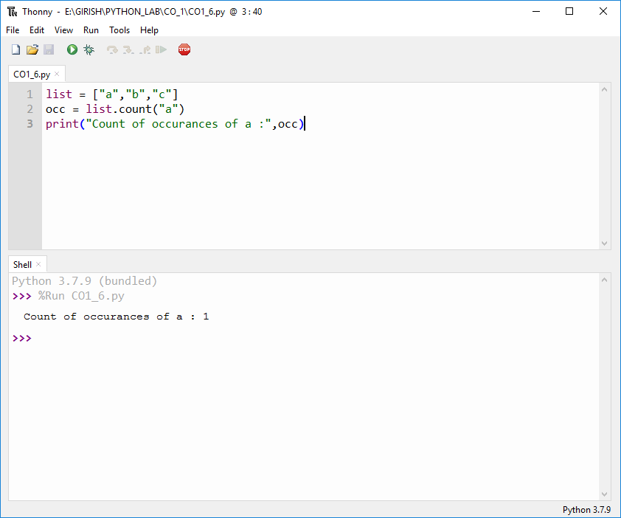

**7. Enter 2 lists of integers. Check (a) Whether list are of same length (b) whether list sums to same value (c) whether any value occur in both**

lst1=[12,3,4,3,6,7,9,11,23,5]

lst2=[32,3,35,7,5,20,65,1]

s=int(0)

c=int(0)

if len(lst1)==len(lst2):

print("Lists are of same length")

else:

print("Lists are of different length")

for i in range(0,len(lst1) and len(lst2)):

s = lst1[i]

c = c+lst2[i]

if(s==c):

print("equal sum")

else:

print("not same sum")

print("Elements that matched are:")

l=[]

for i in range(0,len(lst1)):

for j in range(0,len(lst2)):

if lst1[i]==lst2[j]:

l.append(lst1[i] and lst2[j])

else:

continue

print(l)

**OUTPUT**

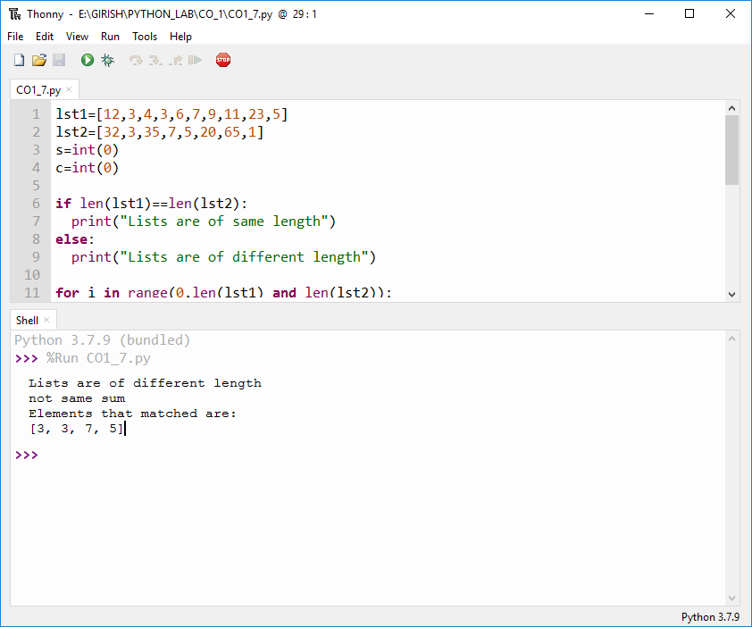

**8. Get a string from an input string where all occurrences of first character replaced with ‘$’, except first character.**

str1 = input("Enter a String :")

ch = str1[0]

str1 = str1.replace(ch, '$')

str1 = ch+ str1[1:]

print("New string is :",str1)

**OUTPUT**

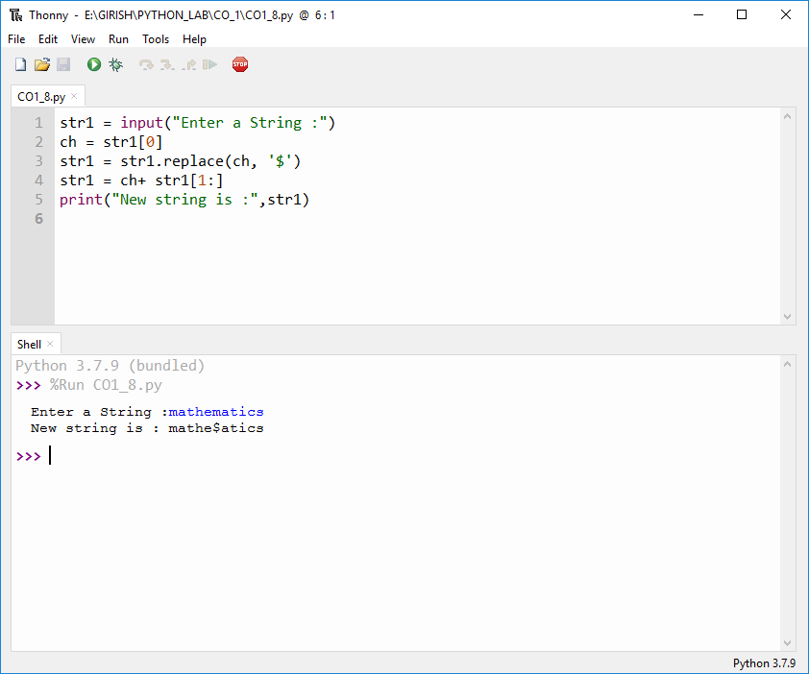

**9. Create a string from given string where first and last characters exchanged. [eg: python -> nythop]**

str = input("Enter a String :")

str1 =str[-1:]+str[1:-1]+str[:1]

print("NEW STRING :",str1)

**OUTPUT**

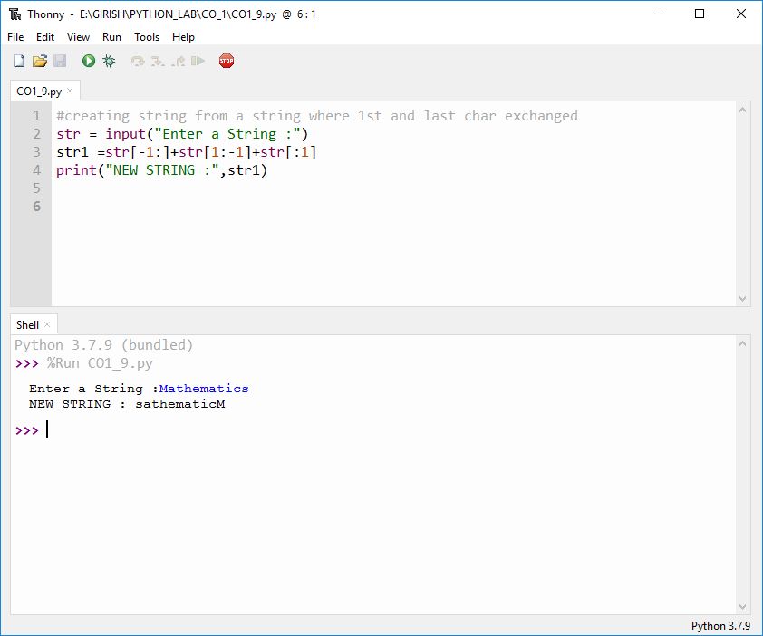

**10.Accept the radius from user and find area of circle.**

pi = 3.14

r = float(input ("Enter Radius of Circle: "))

Area = 3.14 * r**2

print ("Area of the circle is: ", Area)

**OUTPUT**

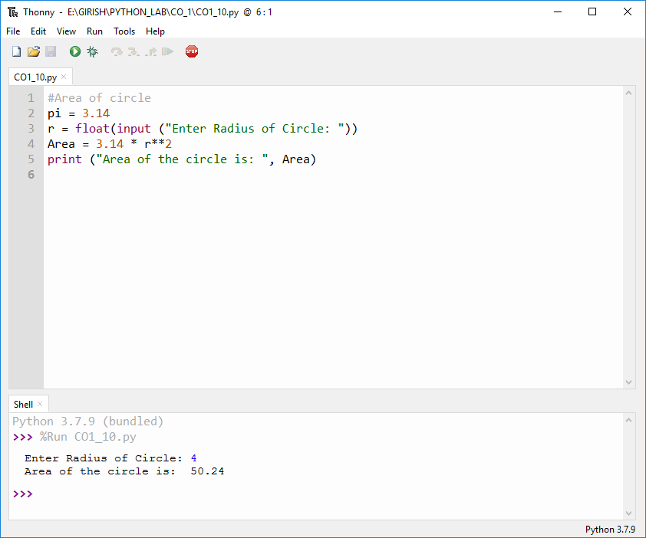

**11.** **Find biggest of 3 numbers entered**

x = int(input("Enter 1st number: "))

y = int(input("Enter 2nd number: "))

z = int(input("Enter 3rd number: "))

if (x > y) and (x > z):largest = x

elif (y > x) and (y > z): largest = y

else:largest = z

print("The largest number is",largest)

**OUTPUT**

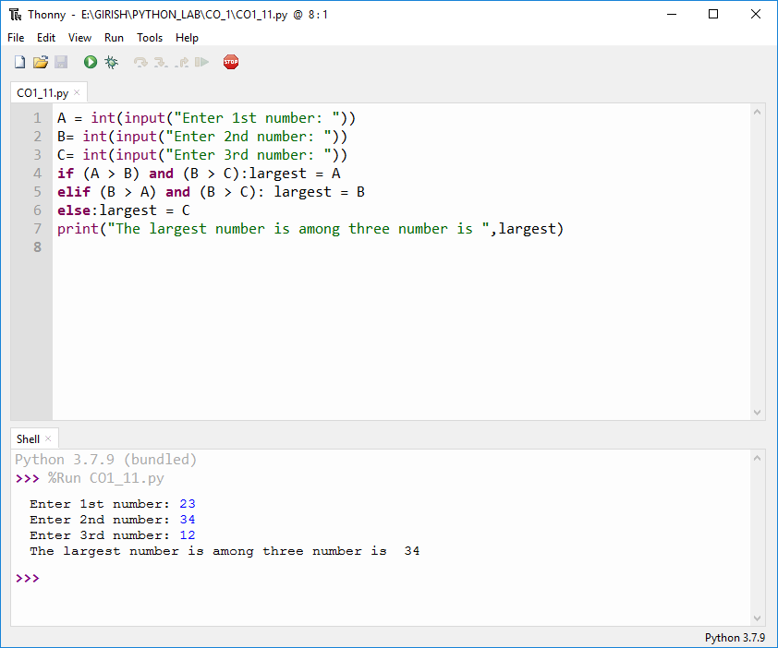**12. Accept a file name from user and print extension of that.**

file = input("Enter a Filename : ")

f = file.split(".")

print("Extension of the File is :"+f[-1])

**OUTPUT**

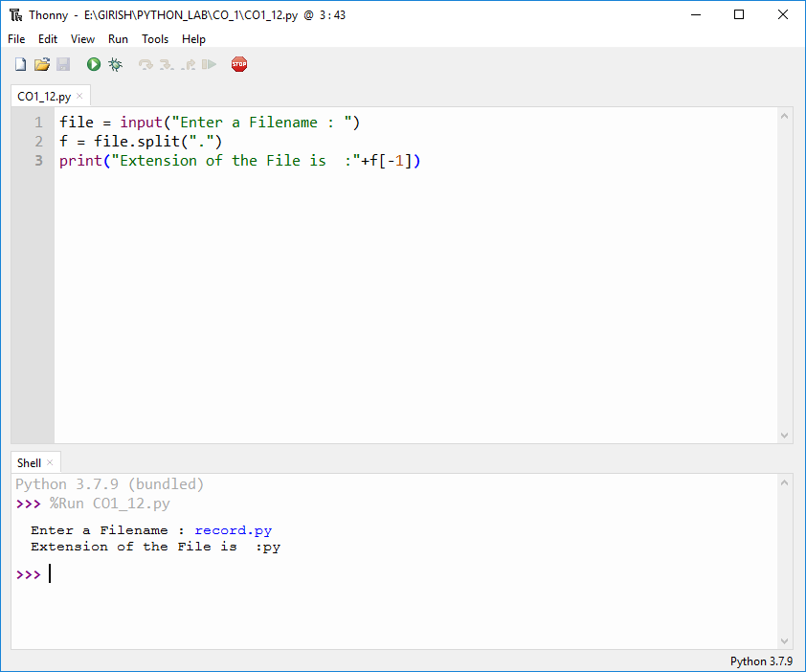

**13. Create a list of colors from comma-separated color names entered by user.Display first and last colors.**

a=[]

for i in range(3):

b=input("enter the color:")

a.append(b)

print(a)

print("First Color :",a[0])

print("Second Color:",a[2])

**OUTPUT:**

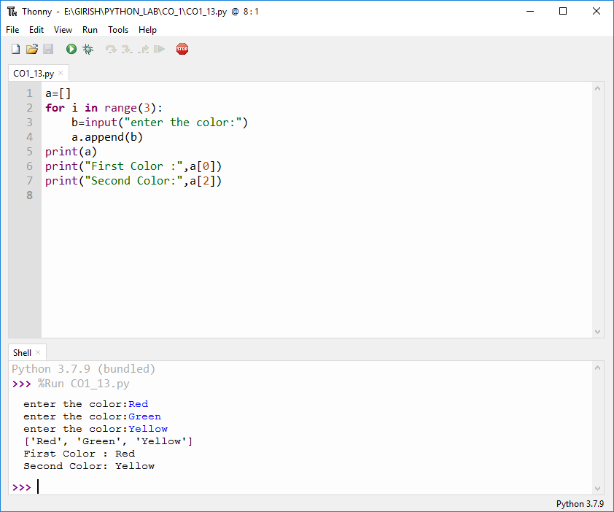

**14. Accept an integer n and compute n+nn+nnn**

n = int(input("Enter a number : "))

x = int( "%s" % n )

y = int( "%s%s" % (n,n) )

z = int("%s%s%s" %(n,n,n))

print("n+nn+nnn :",x+y+z)

**OUTPUT**

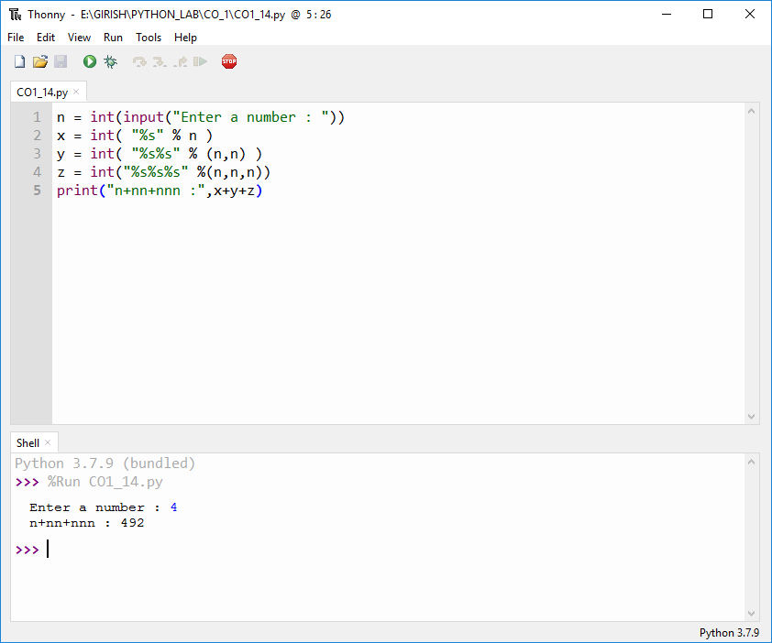

**15. Print out all colors from color-list1 not contained in color-list2.**

color_list_1 = set(["White", "pink", "Red","Blue"])

color_list_2 = set(["Red", "Green","pink"])

print(color_list_1.difference(color_list_2))

**OUTPUT**

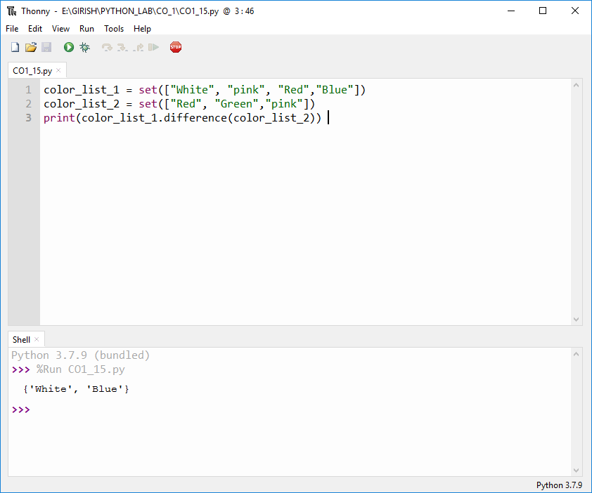

**16. Create a single string separated with space from two strings by swapping the character at position 1.**

a="python"

b="java"

p1=a[0]

p2=b[0]

c=b[0]+a[1:len(a)]+" "+a[0]+b[1:len(b)]

print(c)

**OUTPUT**

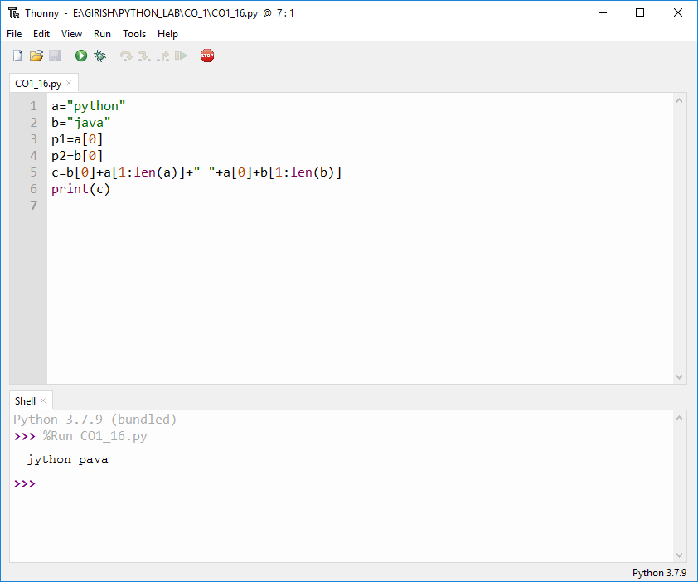

**17.** **Sort dictionary in ascending and descending order.**

import operator

d={1:2,3:4,4:3,2:1,0:0}

print('Original dictionary : ',d)

sorted_d = sorted(d.items(), key=operator.itemgetter(1))

print('Dictionary in ascending order by value ',sorted_d)

sorted_d = dict( sorted(d.items(), key=operator.itemgetter(1),reverse=True))

print('Dictionary in descending order by value : ',sorted_d)

**OUTPUT**

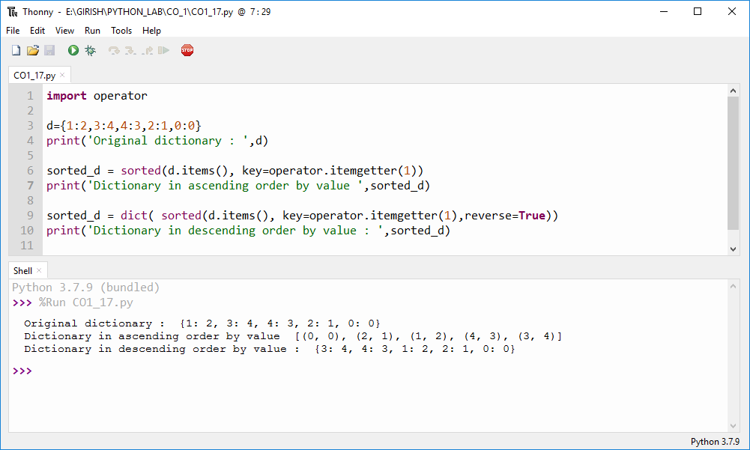

**18. Merge two dictionaries**

d1 ={ 'a': 100, 'b': 200}

d2 ={'x' : 300, 'y': 200}

print ("Dictionary 1=:", d1)

print ("Dictionary 2-: ", d2)

d =d1. copy ()

d.update (d2)

print ("Merged Dictionary : ", d)

**OUTPUT**

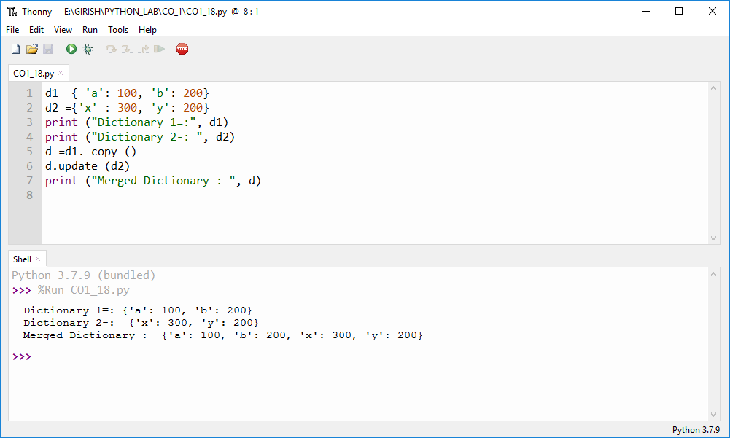

**19.Find GCD of Two Numbers**

x= int(input("Enter 1st number: "))

y= int(input("Enter 2nd number: "))

i = 1

while(i <= x and i <= y):

if(x % i == 0 and y% i == 0):

gcd = i

i = i + 1

print("GCD :", gcd)

**OUTPUT**

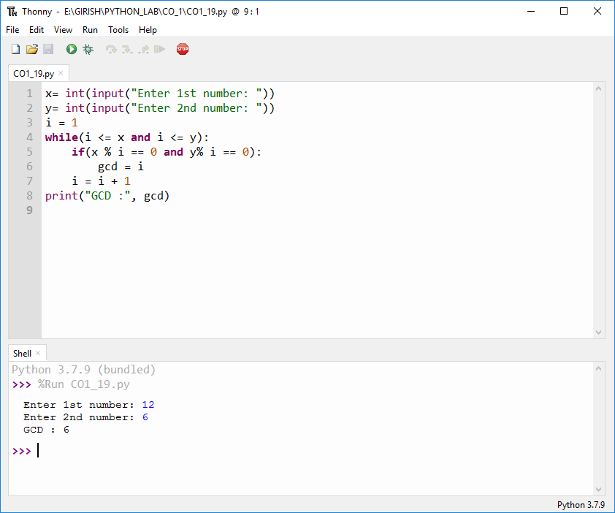

**20. From a list of integers, create a list removing even numbers.**

num = [7,11, 120, 25, 44, 20, 27,32,8]

print( "Original list:",num)

num = [x for x in num if x%2!=0]

print("list after removing Even numbers:",num)

**OUTPUT**



