**CO3 PROGRAMS**

1. **Work with built-in packages**

**A)MATH MODULE**

import math

print(math.pi)

import math as m

print("value of pi is",m.pi)

from math import pi,sqrt #imports only required

print("value of pi is",pi)

print("square root of 5 is",sqrt(5))

print(math.cos(90))

print(math.sin(60))

print(math.tan(30))

**OUTPUT**

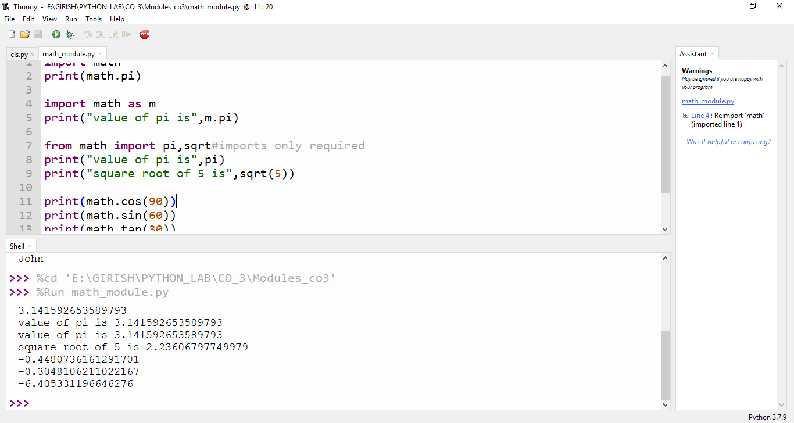

**B)CALANDER MODULE**

import calendar

mm = int(input("Enter month: "))

yy = int(input("Enter Year: "))

print(calendar.month(yy,mm))

print(calendar.calendar(yy))

**OUTPUT**

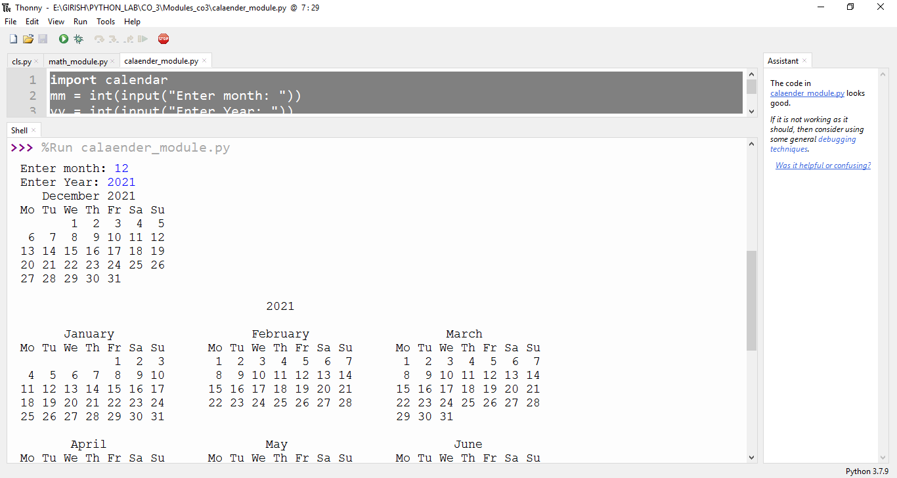

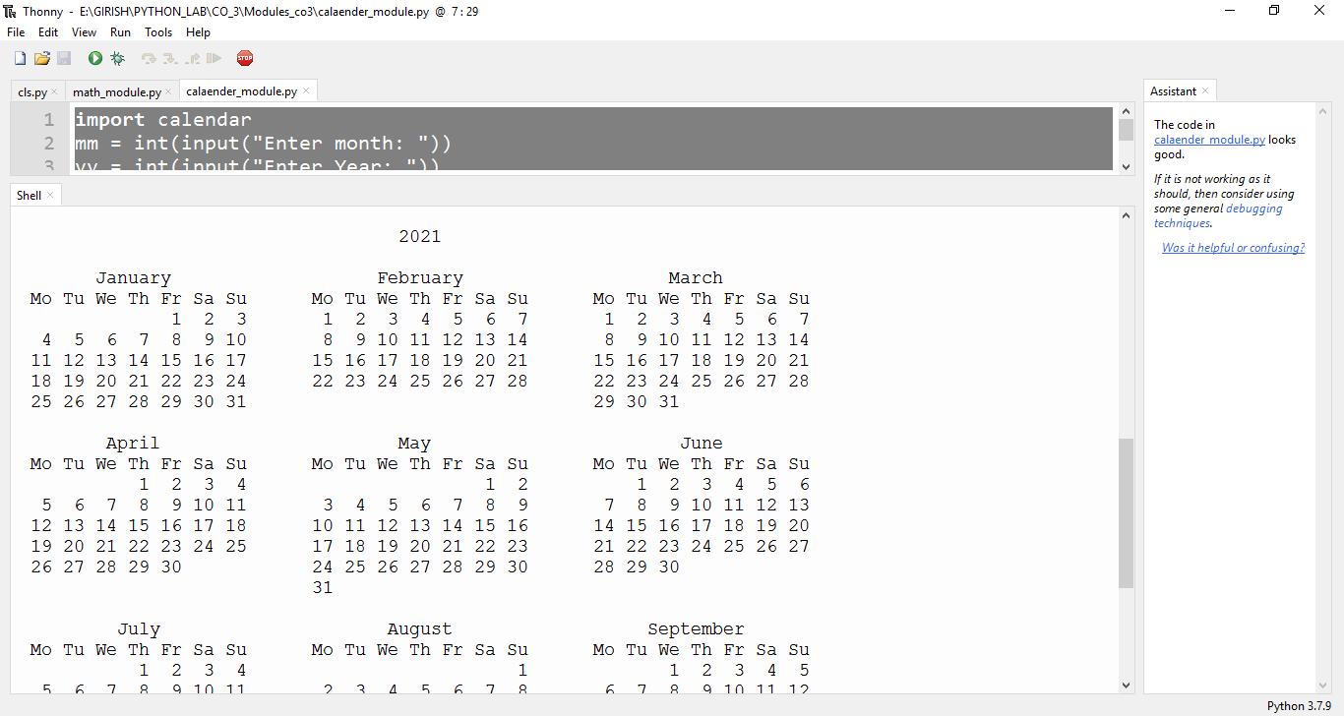

**C)DATE-TIME MODULE**

import datetime

t = datetime.time(22,57,44,23)

print(t)

print("Hour : ",t.hour)

print("Minute : ",t.minute)

print("Second : ",t.second)

print("Micro Second : ",t.microsecond)

print("----------------------------------------------")

d = datetime.date.today()

print(d)

print(" Year : ",d.year)

print("Month : ",d.month)

print("Day : ",d.day)

print("----------------------------------------------")

d1 = datetime.date.today()

print(d1)

td = datetime.timedelta(days=2)

print(td)

d2=d1+td

print(d2)

dt=datetime.datetime.combine(d,t)

print(dt)

**OUTPUT**

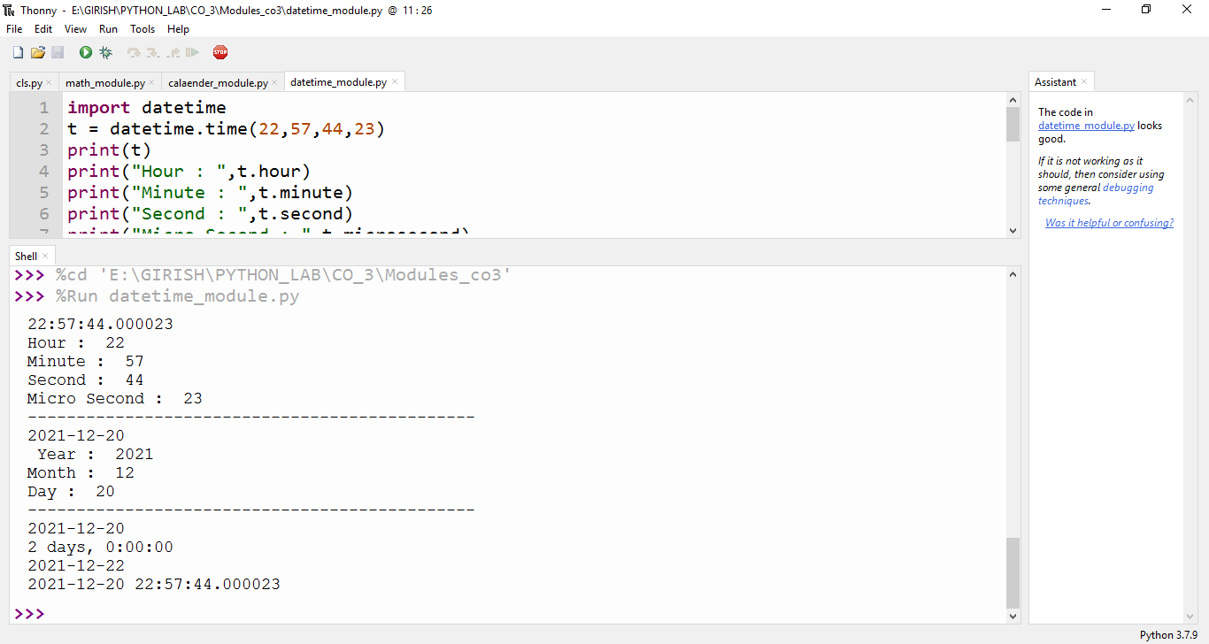

**D)TIME MODULE**

import time

print("Current time in sec :",time.time())

print("Current time :",time.ctime())

print("Current time after 30 sec :",time.ctime(time.time()+30))

t = time.localtime()

print("Time : ",t)

print("Current Year : ",t.tm_year)

print("Current Month : ",t.tm_mon)

print("Current Day : ",t.tm_mday)

print("Current Hour : ",t.tm_hour)

print("Current Minute : ",t.tm_min)

print("Current Second : ",t.tm_sec)

print("Current Weakday : ",t.tm_wday)

print("Current YearDay : ",t.tm_yday)

**OUTPUT**

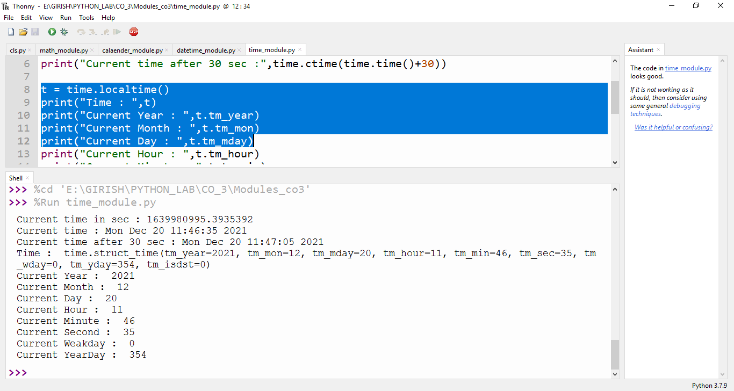

**E)STATISTICS MODULE**

import statistics

print(statistics.mean([1, 3, 5, 7, 9, 11, 13]))

print(statistics.median([1, 3, 5, 7, 9, 11, 13]))

print(statistics.pstdev([1, 3, 5, 7, 9, 11]))

print(statistics.variance([2, 2.5, 1.25, 3.1, 1.75, 2.8]))

print(statistics.median_high([-11, 5.5, -3.4, 7.1, -9, 22]))

**OUTPUT**

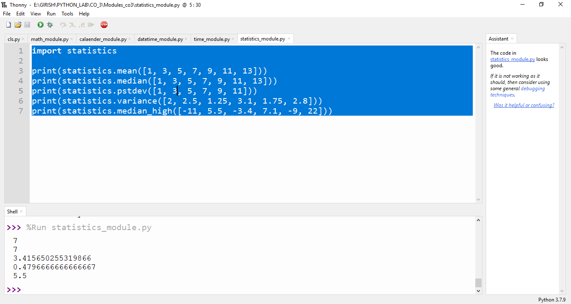

**F)RANDOM MODULE**

import random

l1 = [1, 2, 3, 4, 5, 6,7,8]

print(random.choice(l1))

random.seed(5)

print(random.random())

print(random.random())

r1 = random.randint(5, 15)

print(r1)

print("Original list",l1)

random.shuffle(l1)

print("Shuffled list",l1)

print ("Random number from 0-100 is : ",end="")

print (random.randrange(100))

**OUTPUT**

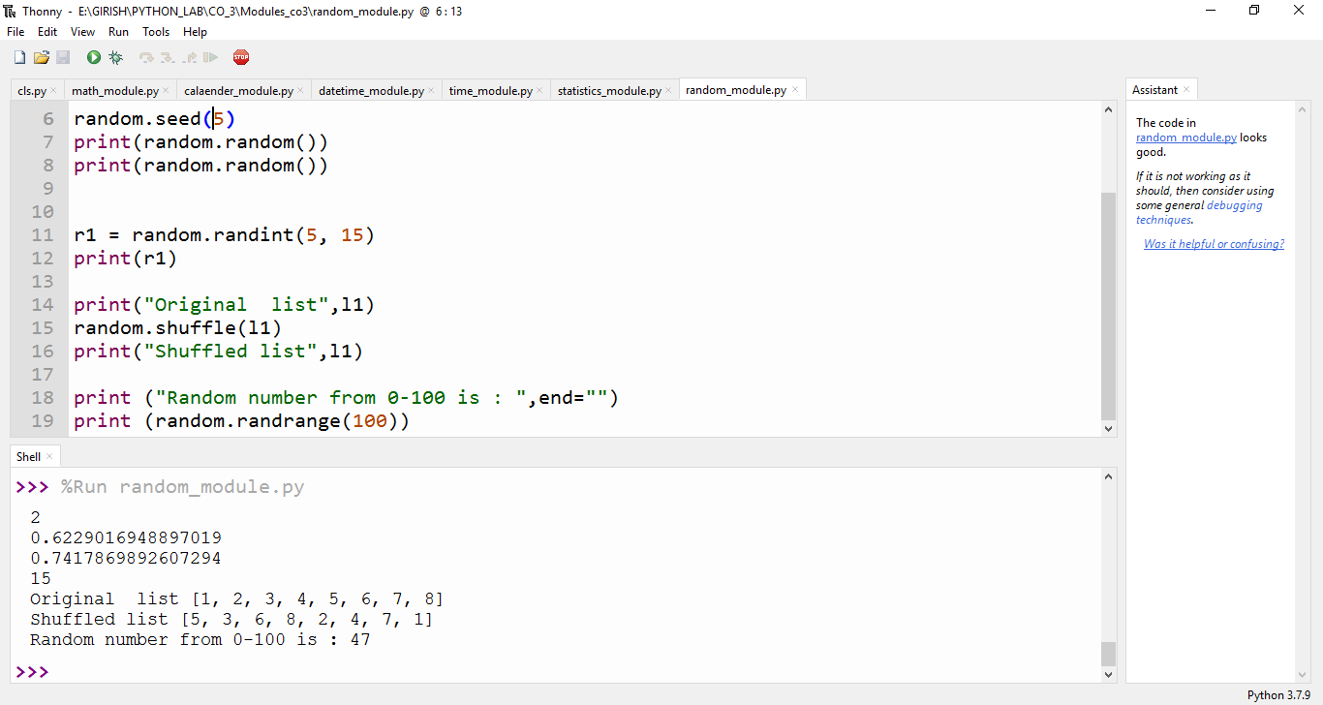

**2. Create a package graphics with modules rectangle, circle and sub-package 3D-graphics with modules cuboid and sphere. Include methods to find area and perimeter of respective figures in each module. Write programs that finds area and perimeter of figures by different importing statements. (Include selective import of modules and import * statements)**

**PACKAGE:Graphics**

**graphicsuse.py**

from graphics import rectangle

from graphics import circle

from graphics.ThreeD_graphics import cuboid

from graphics.ThreeD_graphics import sphere

l=int(input("Enter the length of rectangle: "))

b=int(input("Enter the breath of rectangle: "))

rectangle.area(l,b)

rectangle.perimeter(l,b)

print()

r=int(input("Enter the Radius of Circle: "))

circle.area(r)

circle.perimeter(r)

print()

l=int(input("Enter the length of Cuboid: "))

b=int(input("Enter the breadth of Cuboid: "))

h=int(input("Enter the height of Cuboid: "))

cuboid.area(l,b,h)

cuboid.perimeter(l,b,h)

print()

r=int(input("Enter the radius of Sphere: "))

sphere.area(r)

sphere.volume(r)

**Package : graphics**

**circle.py**

def area(r):

print("Area of Circle: ",3.14*r*r)

def perimeter(r):

print("Perimeter of Circle: ", 2*3.14*r)

**rectangle.py**

def area(l,b):

print("Area of Rectangle: ", l*b)

def perimeter(l,b):

print("Perimeter of Rectangle: ", 2*(l+b))

**Sub-Package : ThreeD_graphics**

**cuboid.py**

def area(l,b,h):

print("Area of Cuboid: ",(2*l*b)+(2*l*h)+(2*h*b))

def perimeter(l,b,h):

print("Perimeter of Cuboid: ", 4*(l+b+h))

**sphere.py**

def area(r):

print("Surface Area of Sphere: ",4*3.14*r*r)

def volume(r):

print("Volume of Sphere: ",(4/3)*3.14*r*r*r)

**OUTPUT**

