**CO4 PROGRAMS**

**1. Create Rectangle class with attributes length and breadth and methods to find area and perimeter. Compare two Rectangle objects by their area.**

class rectangle():

    def __init__(self,breadth,length):

        self.breadth=breadth

        self.length=length

    def area(self):

        return self.breadth*self.length

    def perimeter(self):

        return 2*self.breadth+self.length

a1=int(input("Enter length of rectangle: "))

b1=int(input("Enter breadth of rectangle: "))

obj1=rectangle(a1,b1)

print("Area of rectangle:",obj1.area())

print("perimeter of rectangle:",obj1.perimeter())

a2=int(input("Enter length of rectangle 2: "))

b2=int(input("Enter breadth of rectangle 2: "))

obj2=rectangle(a2,b2)

print("Area of rectangle:",obj2.area())

print("perimeter of rectangle:",obj2.perimeter())

if (obj1.area()>obj2.area()):

    print("obj1 is greater")

else:

    print("obj2 is greater")

**OUTPUT**

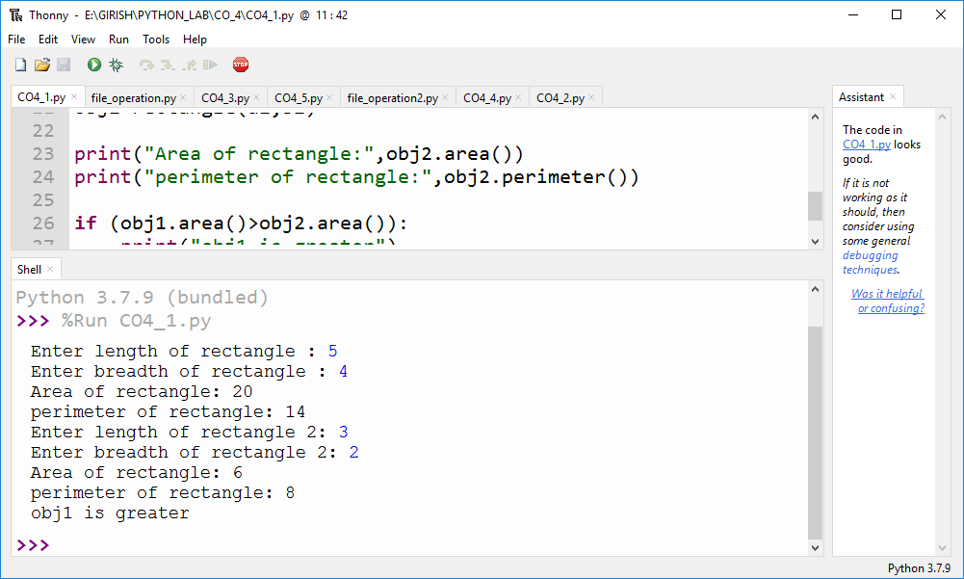

**2. Create a Bank account with members account number, name, type of account and balance. Write constructor and methods to deposit at the bank and withdraw an amount from the bank.**

class bank:

__acc_name=""

__acc_no = ""

__acc_type = ""

__acc_balance = 0

def __init__(self,a_name,a_no,a_type,a_balance):

self.__acc_name = a_name

self.__acc_no = a_no

self.__acc_type = a_type

self.__acc_balance = a_balance

def deposite(self,a_deposit):

print("Initial balance is : ",self.__acc_balance)

print("Deposite is : ",a_deposit)

self.__acc_balance += a_deposit

print("Current balance is : ",self.__acc_balance)

def withdraw(self):

print("Current balance is : ",self.__acc_balance)

self.amount = int(input("How much amount need to withdraw : "))

if self.amount > self.__acc_balance:

print("You don't have enough balance to withdraw !!")

print("Current balance is : ",self.__acc_balance)

else:

print(self.amount," is withrawed .")

self.__acc_balance -= self.amount

print("Current balance is : ",self.__acc_balance)

def acc_info(self):

print("\n\n.........................................................\n\n")

print("Account holder name : ",self.__acc_name)

print("Account number : ",self.__acc_no)

print("Account type : ",self.__acc_type)

print("Account Balance is : ",self.__acc_balance)

print("\n\n.........................................................\n\n")

def main():

name = input("Enter Account holder name : ")

no = input("Enter Account number : ")

atype = input("Enter Account type : ")

bal = int(input("Enter Account initial balance : "))

holder = bank(name,no,atype,bal)

while(True):

print("\n\n.........................................................\n\n")

opt = int(input("1)Deposite \n2)Withdraw \n3)Account info \n0)Exit\nChoose your option :: "))

print("\n\n.........................................................\n\n")

if opt == 1:

amount = int(input("Deposite amount : "))

holder.deposite(amount)

elif opt == 2:

holder.withdraw()

elif opt == 3:

holder.acc_info()

elif opt == 0:

break

else:

print("Invalid Option !")

if __name__ == "__main__":

while(True):

main()

**OUTPUT**

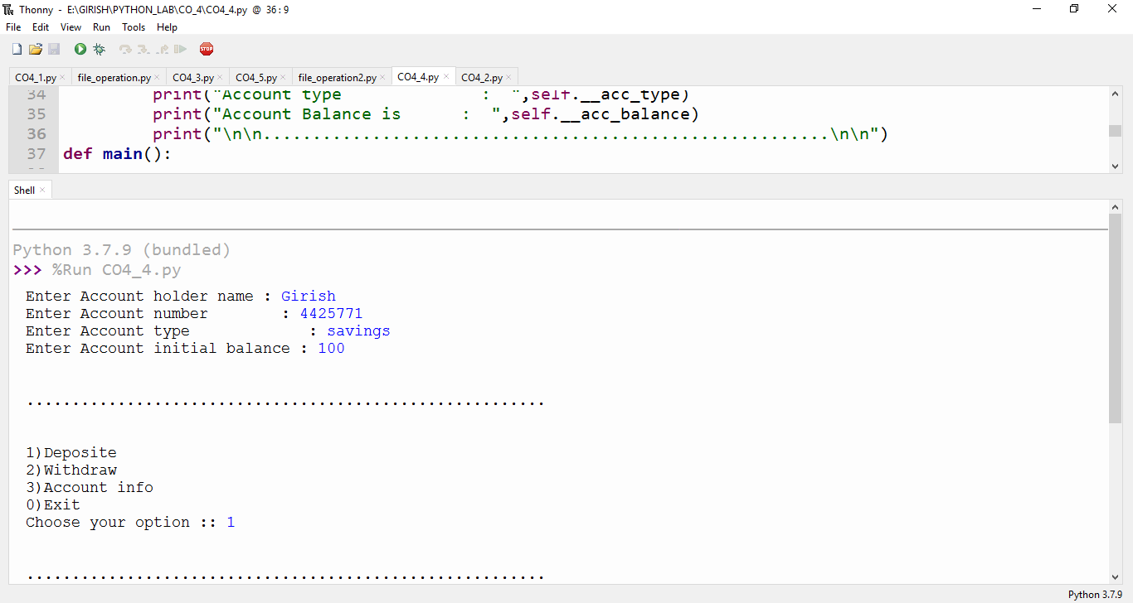

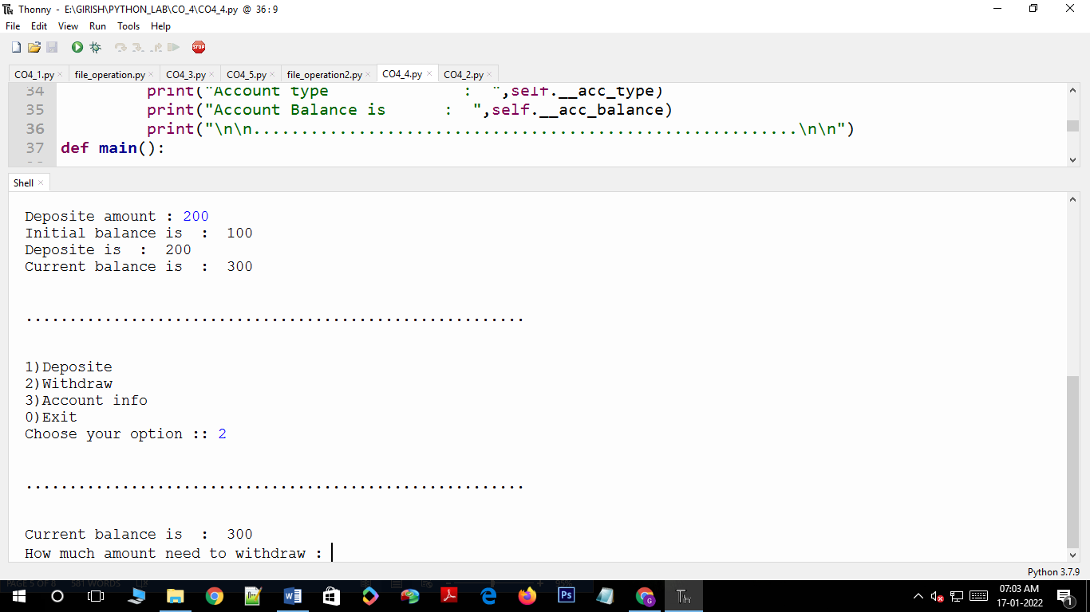

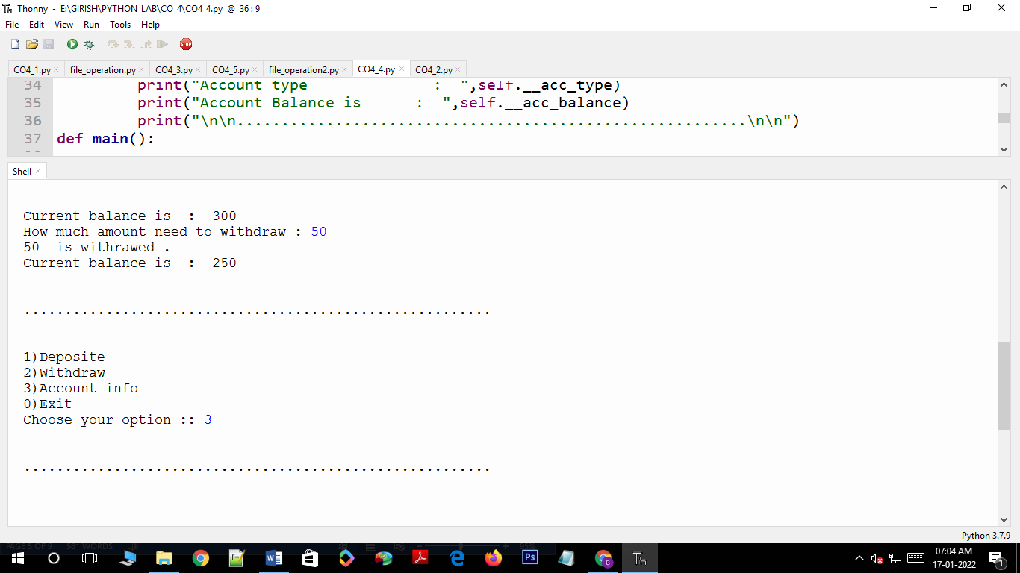

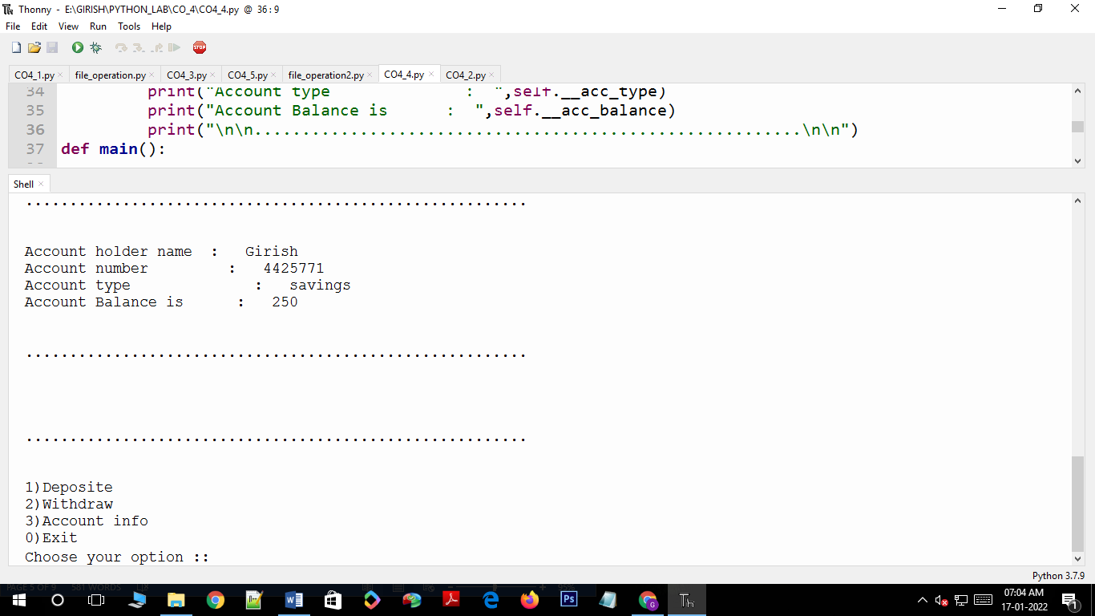

**3. Create a class Rectangle with private attributes length and width. Overload ‘<’ operator to compare the area of 2 rectangles.**

class rectangle:

def __init__(self,length,width):

self.__length=length

self.__width=width

def __lt__(self,a1):

area1=self.__length*self.__width

area2=a1.__length*a1.__width

if(area1<area2):

return(True)

else:

return(False)

a1=int(input("Length of first rectangle:"))

b1=int(input("width first rectangle:"))

r1=rectangle(a1,b1)

a2=int(input("Length second rectangle:"))

b2=int(input("width second rectangle:"))

r2=rectangle(a2,b2)

if(r1<r2):

print("Rectangle second is larger!!")

else:

print("Rectangle first is larger!!")

**OUTPUT**

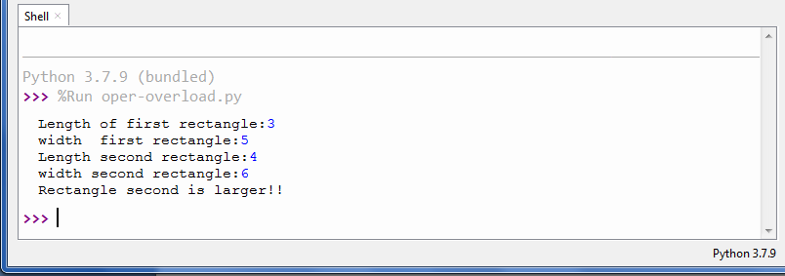

**4. Create a class Time with private attributes hour, minute and second. Overload ‘+’ operator to find sum of 2 time.**

class Time:

def __init__(self,hour,minute,second):

self.__hour=hour

self.__minute=minute

self.__second=second

def __add__(self,h):

second=self.__second+h.__second

minute=self.__minute+h.__minute

hour=self.__hour+h.__hour

if(second>60):

second=second-60

minute=minute+1

if(minute>60):

minute=minute-60

hour=hour+1

return hour,minute,second

print("Enter 1 time:")

h1=int(input("enter the hour:"))

m1=int(input("enter the minute:"))

s1=int(input(" enter the second:"))

t1=Time(h1,m1,s1)

print("Enter 2 time:")

h2=int(input("enter the hour:"))

m2=int(input("enter the minute:"))

s2=int(input("enter the second:"))

t2=Time(h2,m2,s2)

hr,min,sec=t1+t2

print(hr,end=":")

print(min,end=":")

print(sec,end=" ")

**OUTPUT**

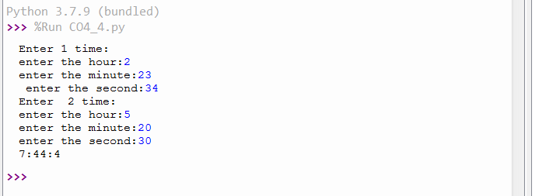

**5. Create a class Publisher (name). Derive class Book from Publisher with attributes title and author. Derive class Python from Book with attributes price and no_of_pages. Write a program that displays information about a Python book. Use base class constructor invocation and method overriding.**

class publisher:

def __init__(self,pname):

self.pname=pname

def display(self):

print("Publisher Name:",self.pname)

class book(publisher):

def get(self,title,author):

self.title=title

self.author=author

def display(self):

print("Title Name:",self.title)

print("Author Name:",self.author)

class python(book):

def __init__(self,price,nop,pname):

super().__init__(pname)

self.price=price

self.nop=nop

def details(self):

print("Price:",self.price)

print("No of pages:",self.nop)

s1=python(850,300,"K D")

s1.get("Dracula","SS")

s1.display()

s1.details()

**OUTPUT**

