Exercises

**Q1. Consider a database LOANS with the following tuples:**

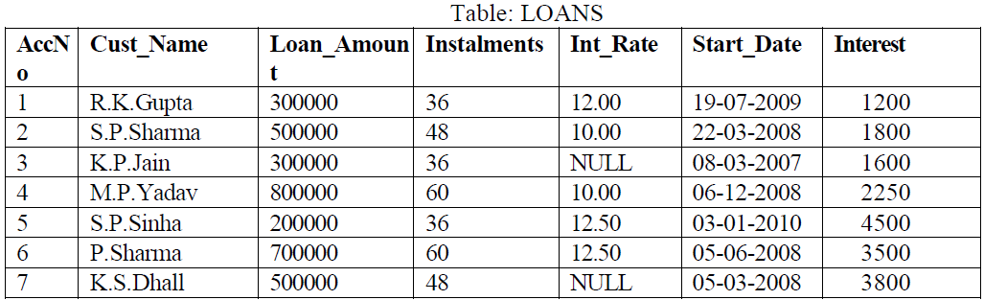

1. Create the table Loans and insert tuples in it.

create table loans(AccN integer,Cust\_Name varchar(25),Loan\_Amount integer,Instalments number,Int\_Rate number(5,2),Start\_Date date,Interest number);

desc loans;

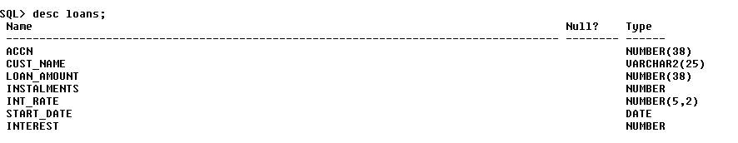

insert into loans values(1,'R.K. Gupta',300000,36,12.00,'19-JUL-09',1200);

insert into loans values (&accn,'&cust\_name',&loan\_amount,&instalments,&int\_rate,'&start\_date',&interest);

1. Display the details of all the loans.

select \* from loans;

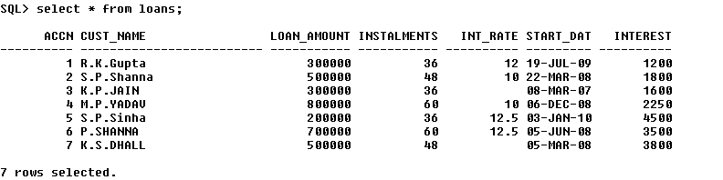

1. Display the AccNo, Cust\_Name, and Loan\_Amount of all the loans.

select accn,cust\_name,loan\_amount from loans;

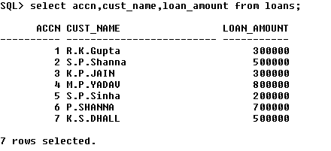

Conditional Select using Where Clause

1. Display the details of all the loans with less than 40 instalments.

select \* from loans where instalments<40;

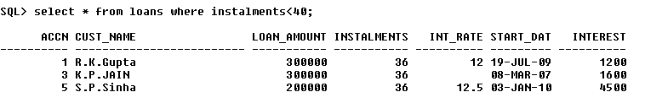

1. Display the AccNo and Loan\_Amount of all the loans started before 01-04-2009.

select accn,loan\_amount from loans where start\_date< '01-APR-09';

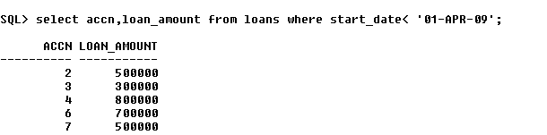

1. Display the Int\_Rate of all the loans started after 01-04-2009.

select int\_rate from loans where start\_date>'01-APR-09';

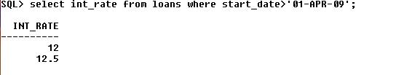

Using NULL

1. Display the details of all the loans whose rate of interest is NULL.

select \* from loans where int\_rate is NULL;

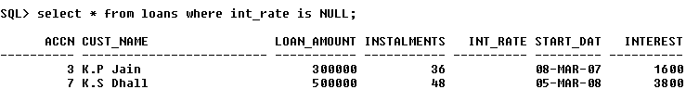

1. Display the details of all the loans whose rate of interest is not NULL.

select \* from loans where int\_rate is not NULL;

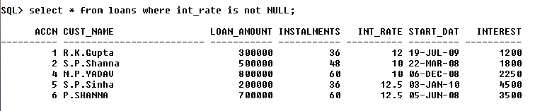

Using DISTINCT Clause

1. Display the amounts of various loans from the table LOANS. A loan amount should appear only once.

select distinct loan\_amount from loans;

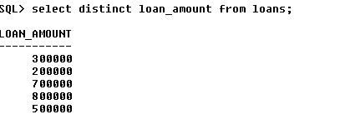

1. Display the number of installments of various loans from the table LOANS. An instalment should appear only once.

select distinct instalments from loans;

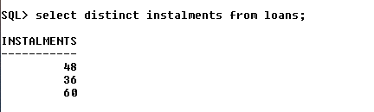

Using Logical Operators (NOT, AND, OR) and Between

1. Display the details of all the loans started after 31-12-2008 for which the number of instalments are more than 36.

select \* from loans where start\_date>'31-DEC-08' and instalments>36;

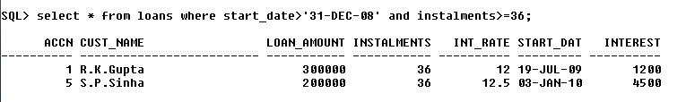

1. Display the Cust\_Name and Loan\_Amount for all the loans which do not have number of instalments 36.

select cust\_name,loan\_amount from loans where not ( instalments=36);

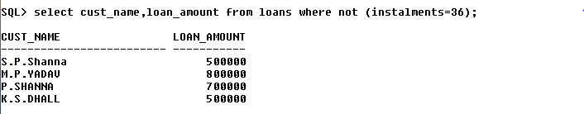

1. Display the Cust\_Name and Loan\_Amount for all the loans for which the loan amount is less than 500000 or int\_rate is more than 12.

select cust\_name,loan\_amount from loans where loan\_amount<500000 or int\_rate>12;

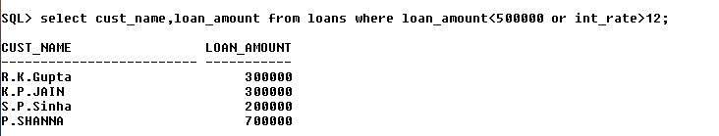

1. Display the details of all the loans whose Loan\_Amount is in the range 400000 to 500000.

select \* from loans where loan\_amount between 400000 and 500000;

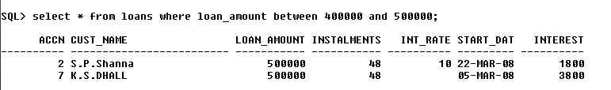

1. Display the details of all the loans whose rate of interest is in the range 11% to 12%.

select \* from loans where int\_rate between 11 and 12;

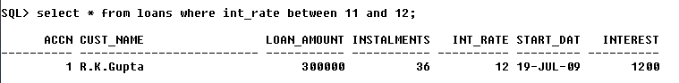

Using IN Operator

1. Display the Cust\_Name and Loan\_Amount for all the loans for which the number of installments are 24, 36, or 48. (Using IN operator)

select cust\_name,loan\_amount from loans where instalments in(24,36,48);

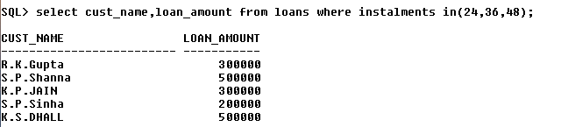

Using LIKE Operator

1. Display the AccNo, Cust\_Name, and Loan\_Amount for all the loans for which the Cust\_Name ends with 'Sharma'.

select accn,cust\_name,loan\_amount from loans where cust\_name like '%Sharma';

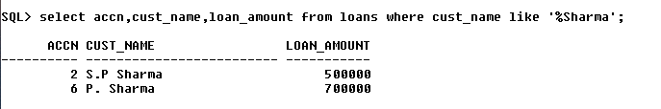

1. Display the AccNo, Cust\_Name, and Loan\_Amount for all the loans for which the Cust\_Name ends with 'a'.

select accn,cust\_name,loan\_amount from loans where cust\_name like '%a';

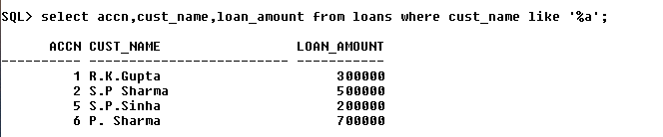

1. Display the AccNo, Cust\_Name, and Loan\_Amount for all the loans for which the Cust\_Name contains 'a'.

select accn,cust\_name,loan\_amount from loans where cust\_name like '%a%';

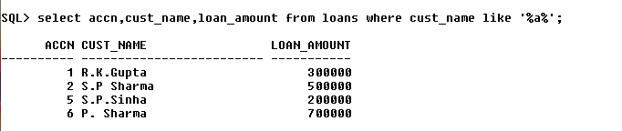

1. Display the AccNo, Cust\_Name, and Loan\_Amount for all the loans for which the Cust\_Name does not contain 'P'.

select accn,cust\_name,loan\_amount from loans where cust\_name not like '%p%';

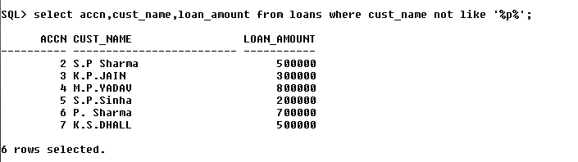

1. Display the AccNo, Cust\_Name, and Loan\_Amount for all the loans for which the Cust\_Name contains 'a' as the second last character.

select accn,cust\_name,loan\_amount from loans where cust\_name like '%a\_';

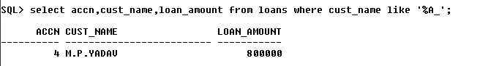

Using ORDER BY clause

1. Display the details of all the loans in the ascending order of their Loan\_Amount.

select \* from loans order by loan\_amount;

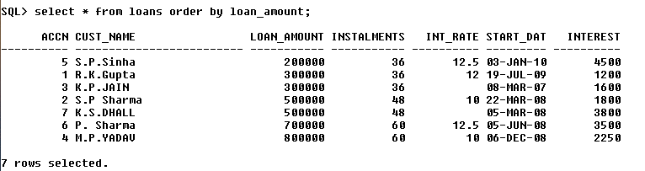

1. Display the details of all the loans in the descending order of their Start\_Date.

select \* from loans order by start\_date desc;

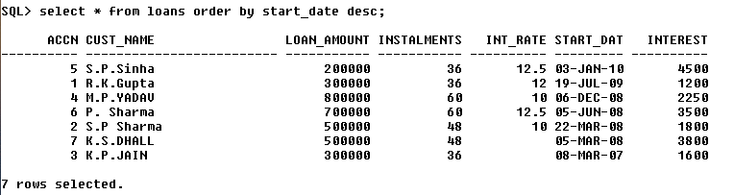

Using UPDATE, DELETE, ALTER TABLE

1. Put the interest rate 11.50% for all the loans for which interest rate is NULL.

update loans set int\_rate=11.50 where int\_rate is NULL;

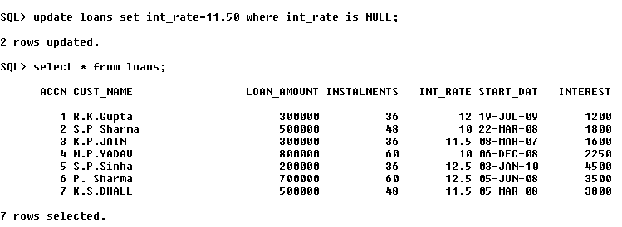

1. Increase the interest rate by 0.5% for all the loans for which the loan amount is more than 400000.

update loans set int\_rate=int\_rate+0.5 where loan\_amount>400000;

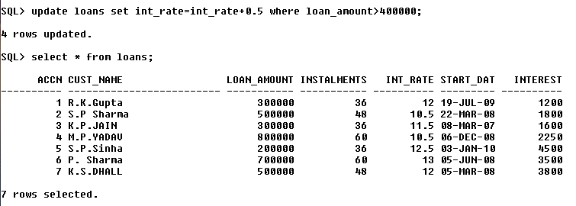

1. For each loan replace Interest with (Loan\_Amount\*Int\_Rate\*Instalments) /12\*100.

update loans set interest=(loan\_amount\*int\_rate\*instalments)/12\*100;

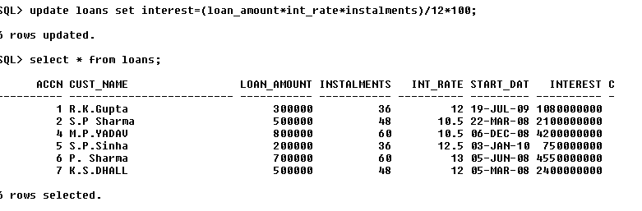

1. Delete the records of all the loans of 'K.P. Jain'

delete from loans where cust\_name='K.P.JAIN';

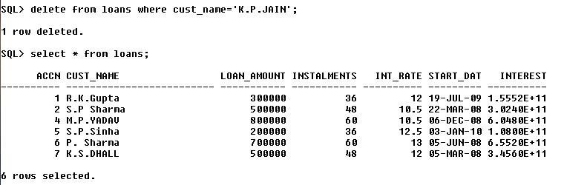

1. Add another column Category of type CHAR(1) in the Loan table.

alter table loans add category char(1);

H:\MCA S2\ADBMS\SCREENSHOTS\q29_1.PNG

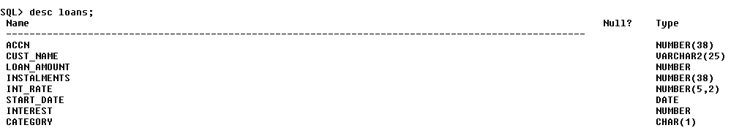

Using Aggregate Functions

1. Display the sum of all Loan Amount for whose Interest rate is greater than 10.

select sum(loan\_amount) from loans where int\_rate>10;

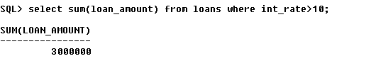

1. Display the Maximum Interest from Loans table.

select max(int\_rate) from loans;

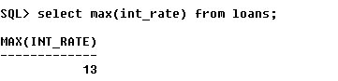

1. Display the count of all loan holders whose name is ending with ‘Sharma’.

select count(cust\_name) from loans where cust\_name like '%Sharma';

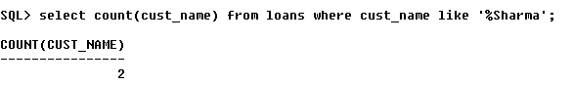

1. Display the count of all loan holders whose Interest is Null.

select count(cust\_name) from loans where interest is NULL;

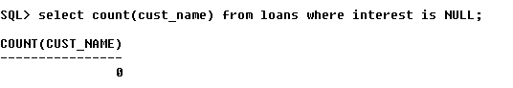

Using Group By Clause

1. Display the Interest wise details of Loan Account Holders.

SELECT int\_rate from loans group by int\_rate;

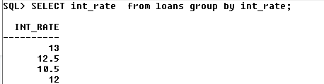

1. Display the Interest wise details of Loan Account Holders with at least 50 installments remaining.

select int\_rate,instalments from loans group by int\_rate,instalments having instalments>50;

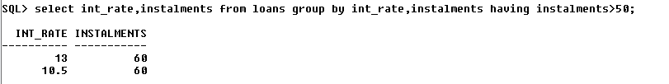

1. Display the Interest wise count of all loan holders whose Installment due is more than 50 in each group.

select count(\*) from loans group by interest,instalments having instalments>50;

