**PL/SQL**

Q1: Write a PL/SQL program to find the factorial of a given number

declare

n number;

fact number:= 1;

begin

n:=&n;

for i in 1..n

loop

fact:=fact*i;

end loop;

dbms_output.put_line(chr(10)|| 'factorial of ' ||n ||' is '||fact);

end;

OUTPUT

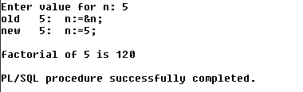

Q2: Write a PL/SQL program to check whether the given no is prime or not

declare

n number;

temp number:= 1;

begin

n:=&n;

if n=1

then

dbms_output.put_line(chr(10)|| 'not a prime number');

else

for i in 1..n/2

loop

if mod(n,i)=0

then

temp:=temp+1;

end if;

end loop;

if temp=2

then

dbms_output.put_line(chr(10)|| ' prime number');

else

dbms_output.put_line(chr(10)|| ' not a prime number');

end if;

end if;

end;

OUTPUT

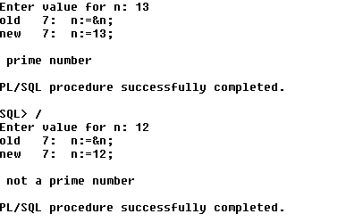

**Functions**

1. Write a PL/SQL program to Check whether a number is Armstrong or not using functions
2. Create table that contains itemid,item_name & price of several items sold in a grocery shop, Using functions retrieve the item name & price from table when itemid is given as input.
3. Write a PL/SQL function called POW that takes two numbers as argument and return the value of the first number raised to the power of the second .