**Cursors**

**1**.**Calculate Interest for Fixed Deposit Amount Using Cursors.**

**set intrest as 0 and then update it using the program.**

**set 10% intrest for amount less than or equal to 1000.**

**20% for more then 1000 to 5000.**

**30% for above 5000.**

create table FD(accno int primary key,year int,amount int,interest int);

insert into fd values (1001,2020,800,0);

insert into fd values (1002,2021,700,0);

insert into fd values (1003,2022,2000,0);

insert into fd values (1004,2022,6000,0);

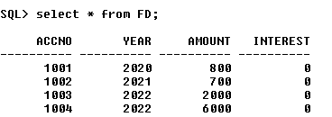

declare

cursor c1 is select * from fd;

begin

for i in c1

loop

if i.amount<=1000

then

update fd set interest=i.amount*0.1 where accno=i.accno;

elsif i.amount>1000 and i.amount<=5000

then

update fd set interest=i.amount*0.2 where accno=i.accno;

else

update fd set interest=i.amount*0.3 where accno=i.accno;

end if;

end loop;

end;

**OUTPUT**

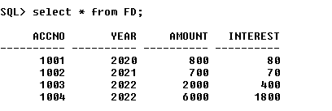

1. **Calculate Electricity Bill Using Cursors**

create table EB(billno int primary key,name varchar(20),unit int,charge float);

insert into EB values (1,'AMALESH',210,0);

insert into EB values (2,'GIRISH',180,0);

insert into EB values (3,'SREERAG',70,0);

insert into EB values (4,'NAVEEN',90,0);

insert into EB values (5,'ALAN',101,0);

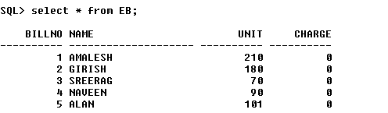

declare

cursor EBCURS is select * from Eb;

begin

for i in EBCURS

loop

if i.unit<=100

then

update EB set charge=100+unit*0.1 where billno=i.billno;

elsif i.unit>100 and i.unit<=200

then

update EB set charge=100+unit*0.2 where billno=i.billno;

else

update EB set charge=100+unit*0.3 where billno=i.billno;

end if;

end loop;

end;

**OUTPUT**

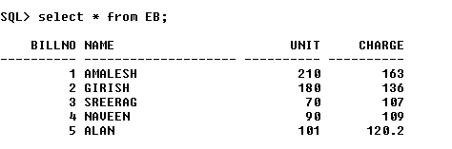

1. **Write PL/SQL code to UPDATE values in created tables by using Implicit Cursors.**

create table item (item_id int primary key,item_name varchar(50),item_price int);

insert into item values(1,'RICE',50);

insert into item values(2,'BANANA',70);

insert into item values(3,'TOMATTO',45);

insert into item values(4,'BREAD',30);

insert into item values(5,'OIL',90);

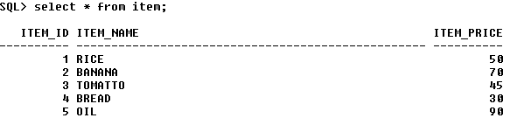

declare

r int;

begin

update item set item_price=item_price+100;

if sql%notfound

then

dbms_output.put_line('not updated');

else

r:=sql%rowcount;

dbms_output.put_line(chr(10)||'price for ' ||r|| ' items updated');

end if;

end;

**OUTPUT**



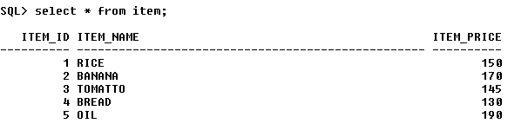

**4.Given the table works(emp_id,company_name,salary).write a cursor to**

**select the three highest paid employees from the table**.

create table works1 (emp_id int primary key,emp_name varchar(50),salary int);

insert into works1 values(1,'AMALESH',50000);

insert into works1 values(2,'GIRISH',70000);

insert into works1 values(3,'SREERAG',45000);

insert into works1 values(4,'NAVEEN',30000);

insert into works1 values(5,'ALAN',90000);

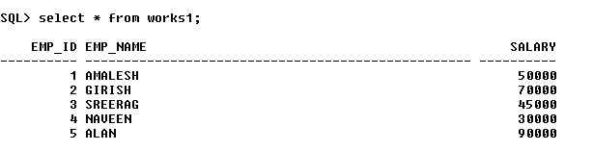

declare

i int:=0;

cursor c3 is select * from works1 order by salary desc;

r c3%rowtype;

begin

dbms_output.put_line('3 HIGHEST PAID EMPLOYEES ARE');

open c3;

loop

exit when i=3;

fetch c3 into r;

dbms_output.put_line(chr(10)||r.emp_id||' '||r.emp_name||' '||r.salary);

i:=i+1;

end loop;

close c3;

end;

**OUTPUT**

