PROCEDURE

1.Write a PL/SQL program to perform banking operations using procedures.

create table account(account_no number,accountholder_name varchar(20),balance number);

insert into account values(101,'AMALESH',5000);
insert into account values(102,'SREERAG',2500);
insert into account values(103,'GIRISH',3000);
insert into account values(104,'NAVEEN',4000);
insert into account values(105,'ALAN',2000);

Program

#procedure for withdrawal

create or replace procedure withdraw(acno int,amnt int) is

begin

update account set balance=balance-amnt where account_no=acno;

end;

#procedure for deposit

create or replace procedure deposit(acno int,amnt int) is

begin

update account set balance=balance+amnt where account_no=acno;

end;

#procedure for display

create or replace procedure display is
cursor c is select * from account;
begin
for i in c
loop
dbms_output.put_line(i.account_no||' '||i.accountholder_name||' '||i.balance);
end loop;
end;

declare

choice number;
acno int;
amnt int;

begin
acno:=&acno;
amnt:=&amnt;
choice:=&choice;
if choice=1
then
deposit(acno,amnt);
elsif choice=2
then
withdraw(acno,amnt);
elsif choice=3
then
display();
end if;
end;

Output

Initial table

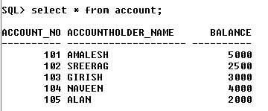

After deposit

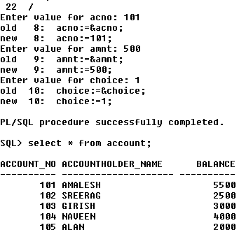

After withdraw

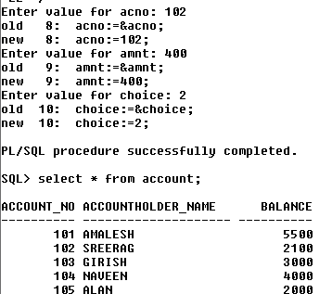

Display

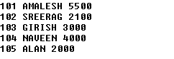

2.Selected record's price is incremented by 100, executing the procedure created & displaying the updated table(use user defined Exception).

create table product(product_id int,product_name varchar(20),price int);

insert into product values(101,'MOBILE',18000);
insert into product values(102,'LAPTOP',48000);
insert into product values(103,'HEADPHONE',3000);
insert into product values(104,'PENDRIVE',600);
insert into product values(105,'SMART WATCH',12000);

Program

create or replace procedure record(pi number,pr number) is
ex exception;
begin
update product set price=price+pr where product_id=pi;
if sql%notfound then
raise ex;
end if;
exception
when ex then
dbms_output.put_line('product id invalid');
end;

declare
pid int:=&pid;
price int:=&price;
begin
record(pid,price);
end;
/

Output

Table

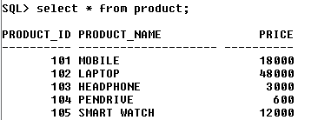

Updating price

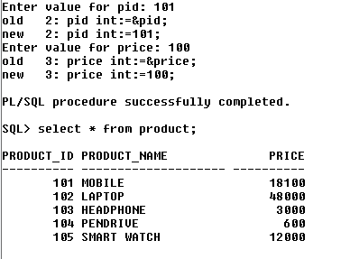

Exception

