Triggers

- Write a PL/SQL trigger to restrict the insert/update/delete operations on a table.

Program

create table sample(sid number,sname varchar(20));
insert into sample values(&sid,'&sname');

create or replace trigger t1
before insert or update or delete on sample for each row
begin
raise_application_error(-20000,'you are not permitted to do insert/update/delete');
end;
/

Output

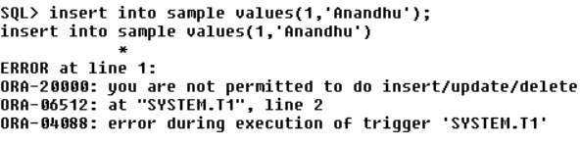

- Assume our DB has a relation schema :Pfessor (pNum, pName, salary).
Create a trigger to ensure that any new professor inserted has salary >= 60000.

Program

create table prof(pnum number,pname varchar(20),salary number);
insert into prof values(&pnum,'&pname',&salary);

create or replace trigger minsalary
before insert on prof for each row
begin
if(:new.salary<60000)
then raise_application_error(-20004,'Violation of minimum professor salary');
end if;
end;
/

Output

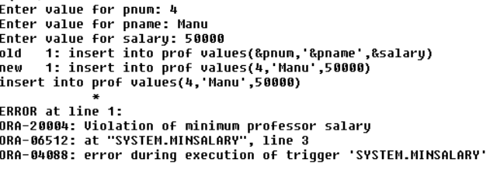

- Create a backlog table for professor to store deleted professor details. Manage the operation using trigger.

Program

create table prof(pnum number,pname varchar(20),salary number);
insert into prof values(&pnum,'&pname',&salary);

create table profbacklog as select * from prof;

create or replace trigger backlog
after delete on prof for each row
begin
insert into profbacklog values(:old.pnum,:old.pname,:old.salary);
end;
/

delete from prof where pnum=1;

Output

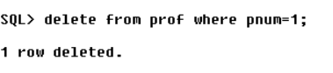

- Maintain a Gold Price History table using trigger.

Program

create table gprice(cdate date,price int);
insert into gprice values(sysdate,&price);
create table pold(cdate date,price int);

update gprice set price=price+2000;

create or replace trigger gold
after update on gprice for each row
begin
insert into pold values(:old.cdate,:old.price);
end;
/

Output

