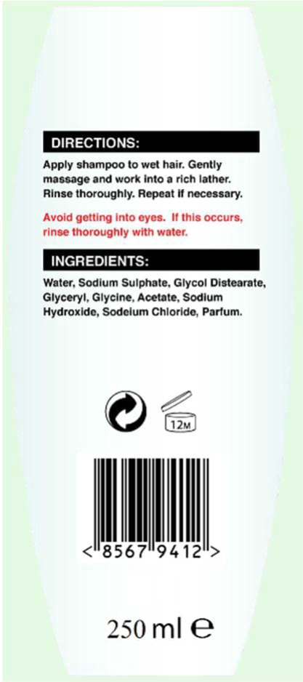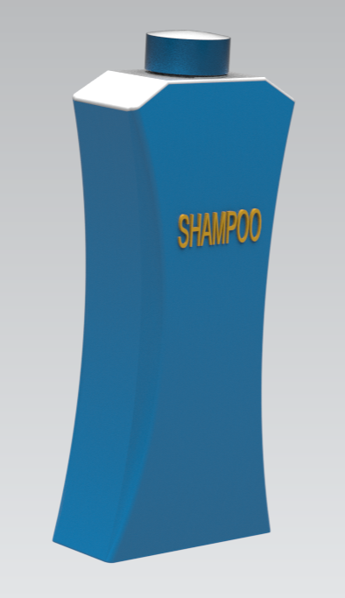

Requirement Specification.

The expected shampoo volume is 250ml.

The height of the shampoo bottle should be not more than 180mm.

When bottle is in inverted cap should be able to withstand force of 5N.

The width of the shampoo bottle should be between 60mm and 80mm.

The depth of the shampoo bottle should be between 30mm and 50mm.

The plastic thickness of the shampoo bottle should be greater than or equal to 1mm.

The tilt angle should be greater than 10degrees.

The pitch of the thread for cap should be 3mm maximum.

The cap height should be 10mm maximum.

Dispensing hole diameter should be 5mm minimum.