Name: Girish Nagaraj Nayak
USN: 1RF25MC033
Synopsis

Explainable Medical Image Diagnosis Using Transfer Learning, Grad-CAM and SHAP

Problem Statement
Medical image analysis plays an important role in detecting diseases from medical images such as chest X-rays. Deep learning models, particularly Convolutional Neural Networks (CNNs), can achieve effective image classification performance, but their decision-making process is often difficult to understand because they operate as black-box models.
A deep learning model may focus on irrelevant image regions, background artifacts, or other non-clinical features while making a prediction. Therefore, there is a need for an explainable chest X-ray classification system that can not only classify chest X-ray images but also provide understandable visual explanations for its predictions.
The proposed project aims to develop an explainable deep learning framework for chest X-ray image classification using transfer learning and Explainable AI techniques such as Grad-CAM and SHAP. The system will classify chest X-ray images and identify the image regions that contribute to the model's prediction.

Objectives
- To develop a deep learning-based system for classification of medical images from organs and imaging modalities.
- To utilize transfer learning models such as ResNet50 or EfficientNet for effective medical image classification.
- To perform appropriate image preprocessing, normalization, augmentation, and data quality checking before model training.
- To integrate Explainable AI techniques such as Grad-CAM and SHAP to visualize the regions contributing to model predictions.
- To analyze the generated explanations and identify whether the model is focusing on relevant medical regions rather than irrelevant background features.
- To evaluate the classification model using Accuracy, Precision, Recall, F1-score and Confusion Matrix.

Research Gaps
- Shortcut Learning and Irrelevant Features:
Deep learning models may sometimes learn irrelevant background patterns, borders, artifacts, or other non-clinical features instead of focusing on the actual pathological region. Traditional evaluation metrics such as accuracy may not reveal this problem.
- Limited Use of Explainability for Model Verification:
Explainable AI techniques such as Grad-CAM, SHAP and LIME are often used mainly as post-hoc visualization tools after prediction. There is a need to use these explanations as a quality-check mechanism to examine whether the model's attention is focused on medically relevant regions.

Methodology
1.Data Collection:
Publicly available medical image datasets will be collected for different organs and imaging modalities, such as chest X-ray images.
2. Data Preprocessing:
Images will be checked for corrupted and duplicate samples and converted into a standardized format. Images will be resized to a common input dimension and normalized. Appropriate preprocessing will be applied according to the imaging modality.
3. Data Augmentation:
Suitable transformations such as rotation, zooming, flipping and contrast adjustment will be applied where medically appropriate to improve model generalization and reduce overfitting.
4. Model Development:
Transfer learning models such as ResNet50 or EfficientNet will be used as the main classification models. The pretrained network will be adapted with a task-specific classification layer and fine-tuned using the medical image dataset.
5. Model Training:
The model will be trained using an appropriate loss function and optimizer such as categorical cross-entropy and Adam. Techniques such as dropout, learning-rate reduction and model checkpointing will be used to improve training stability.
6. Explainable AI:
Grad-CAM will be used to generate visual heatmaps showing the image regions that influenced the prediction. SHAP will be used to provide feature-level contribution explanations. LIME may additionally be used for local explanation comparison.
7. Explanation-Based Analysis:
The generated explanations will be examined to determine whether the model is focusing on relevant anatomical or pathological regions rather than irrelevant background features.
8. Evaluation:
The trained models will be evaluated using Accuracy, Precision, Recall, F1-score and Confusion Matrix.
9. Deployment:
The final model will be integrated into application where users can upload a medical image and view the predicted class, confidence score and corresponding explanation visualizations.

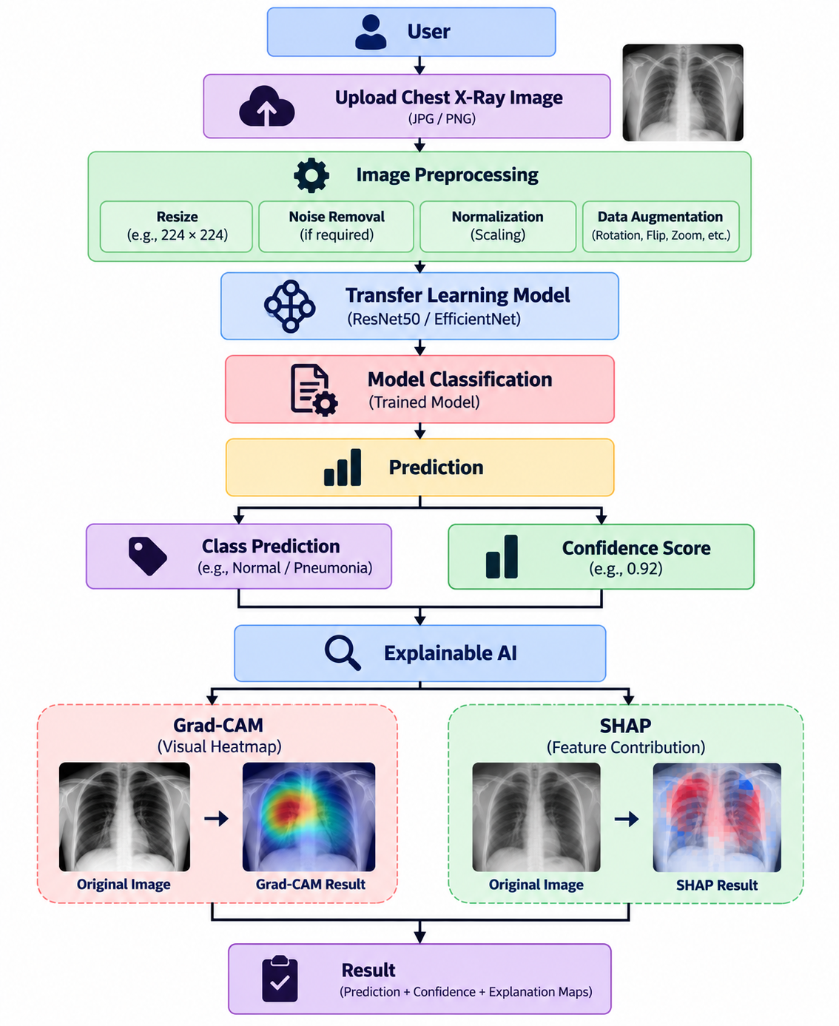
Workflow

Algorithms/Technologies Used
Category | Algorithm / Technique
Image Classification | CNN
Transfer Learning | ResNet50
Optional Model | EfficientNet
Optimization | Adam
Loss Function | Categorical Cross-Entropy
Explainable AI | Grad-CAM
Explainable AI | SHAP
Image Processing | Image normalization, resizing, augmentation
Evaluation | Accuracy, Precision, Recall, F1-score
Visualization | Confusion Matrix

Tech Stacks Used
Component | Technology
Programming Language | Python
Development Environment | Vs code / Google Colab
Deep Learning Framework | TensorFlow / Keras
Classification Model | ResNet50 / EfficientNet
Image Processing | OpenCV, Pillow
Machine Learning | Scikit-learn
Explainable AI | SHAP, Grad-CAM, LIME
Data Visualization | Matplotlib
Web Application | Streamlit
Dataset | Public Medical Image Datasets

Expected Outcome
Automated classification of medical images from different organs and imaging modalities.
Prediction probabilities or confidence scores for the identified class.
Visual explanations using Grad-CAM showing the regions that influenced the model's prediction.
SHAP-based feature contribution explanations to improve the interpretability of predictions.
Identification of cases where the model may be focusing on irrelevant image regions or background artifacts.
Quantitative evaluation of model performance using Accuracy, Precision, Recall, F1-score and Confusion Matrix.
An interactive application that allows users to upload medical images and view predictions together with explainable visualizations.

