Network Docs Release Architecture
Architecture guide for the split content and release packaging model
Source: network-docs-releases/ARCHITECTURE.md Generated: 2026-04-27
This solution separates canonical documentation content from release packaging. The content repository owns reusable topic source files and validation, while the release repository owns release selection, metadata, static site generation, and publishing.

Repository Responsibilities
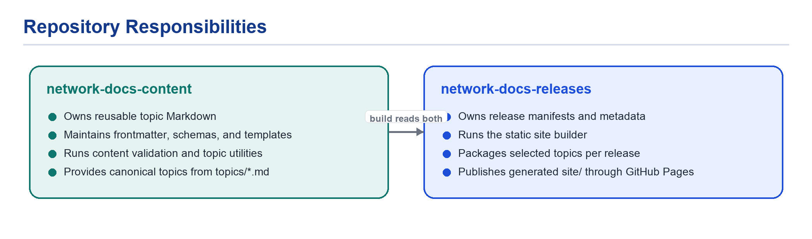
Figure 1. Repository ownership and build-time relationship.
- A topic appears in a release only when the manifest lists its topic_id and the topic frontmatter says the release applies.
- The release builder reads both repositories from sibling checkout paths in the GitHub Actions workspace.
- Pull requests run the release build; deploys happen from non-PR events such as main pushes, manual dispatch, or content update dispatch.

System Diagram
The full workflow keeps authoring, release packaging, validation, and publication as separate responsibilities.
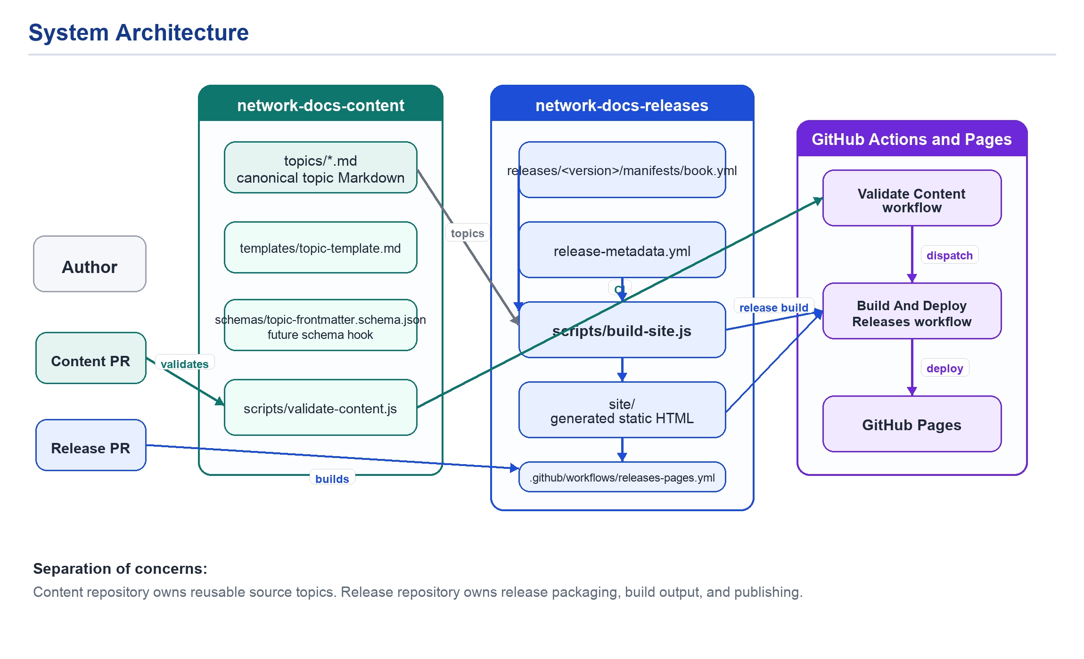
Figure 2. Repository boundaries and workflow responsibilities.

Build Flow
During the release build, GitHub Actions checks out both repositories, then passes their paths to the static site builder.
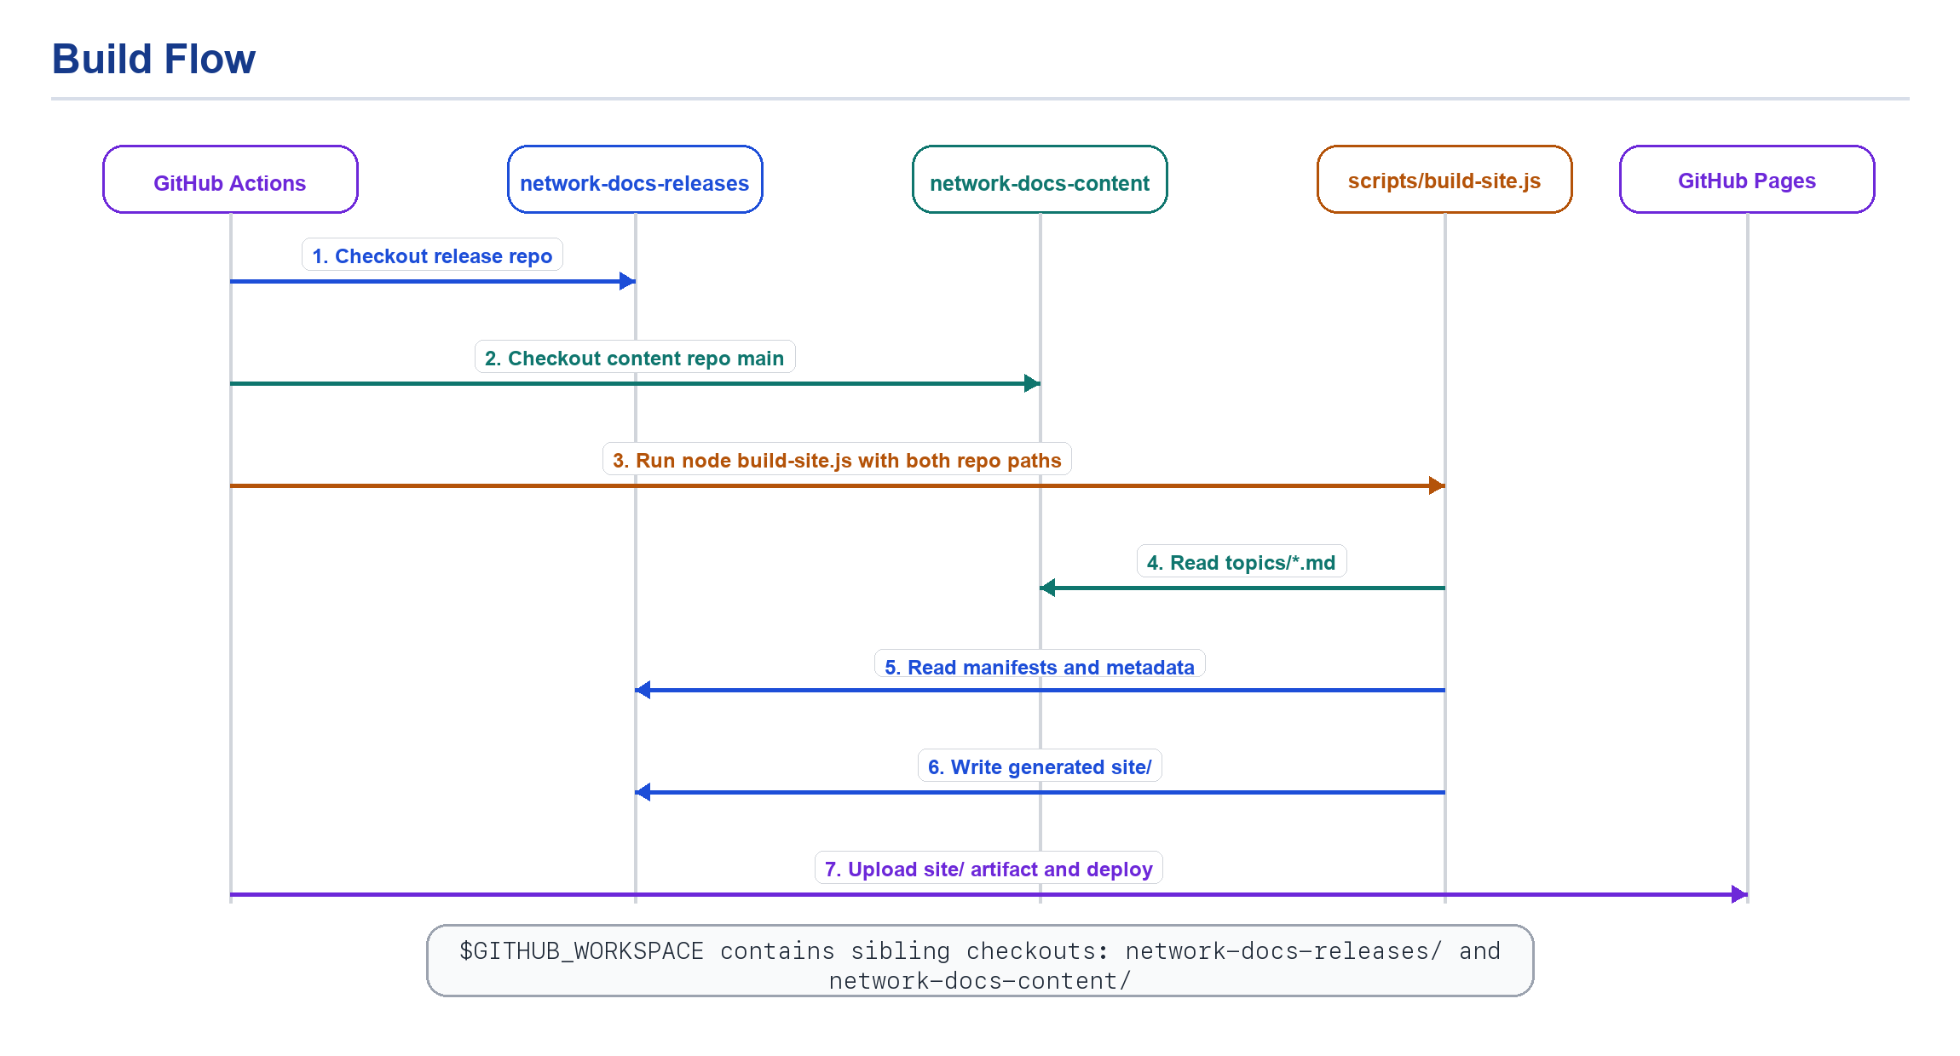
Figure 3. Build-time repo checkout and site generation flow.

Topic Inclusion Rules
A topic must satisfy both content applicability and release manifest selection before it becomes part of a release page set.
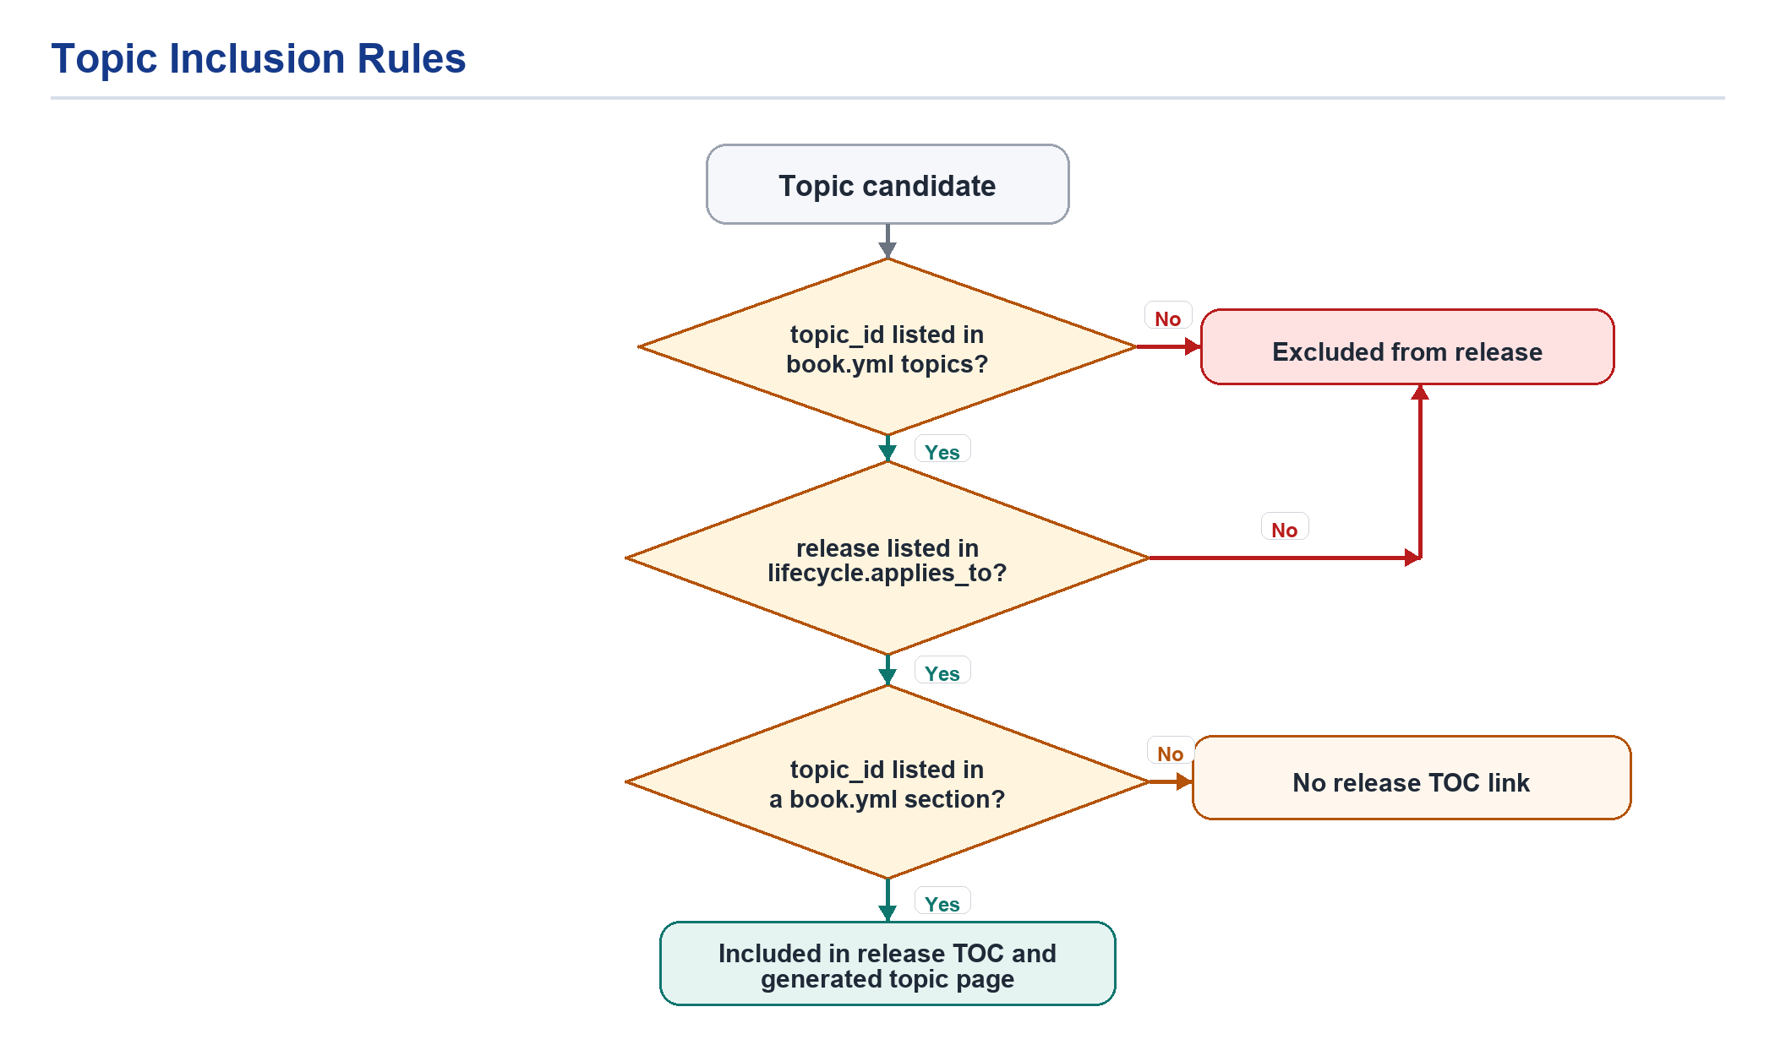
Figure 4. Decision path for including a topic in a release.

Version-Specific Content
Topics can contain version blocks such as exact matches, open-ended ranges, or inclusive release ranges. The build script resolves those blocks for each release before Markdown is converted to HTML.
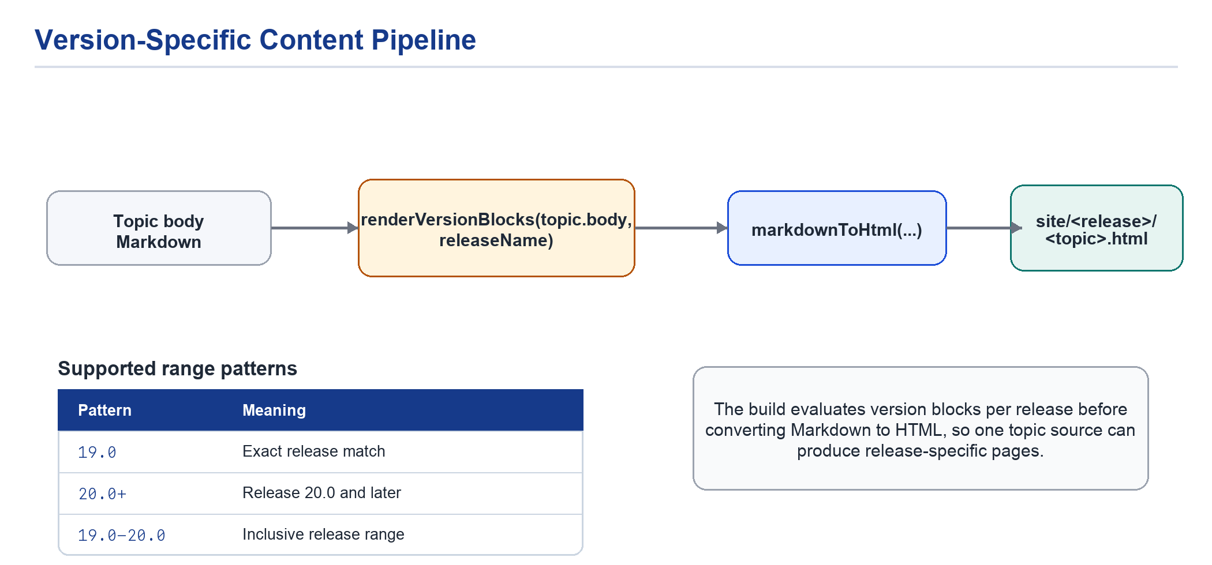
Figure 5. Version-block filtering before Markdown rendering.

Deployment Triggers
The release workflow can be reached from content changes, release repository changes, pull requests, or manual dispatch.
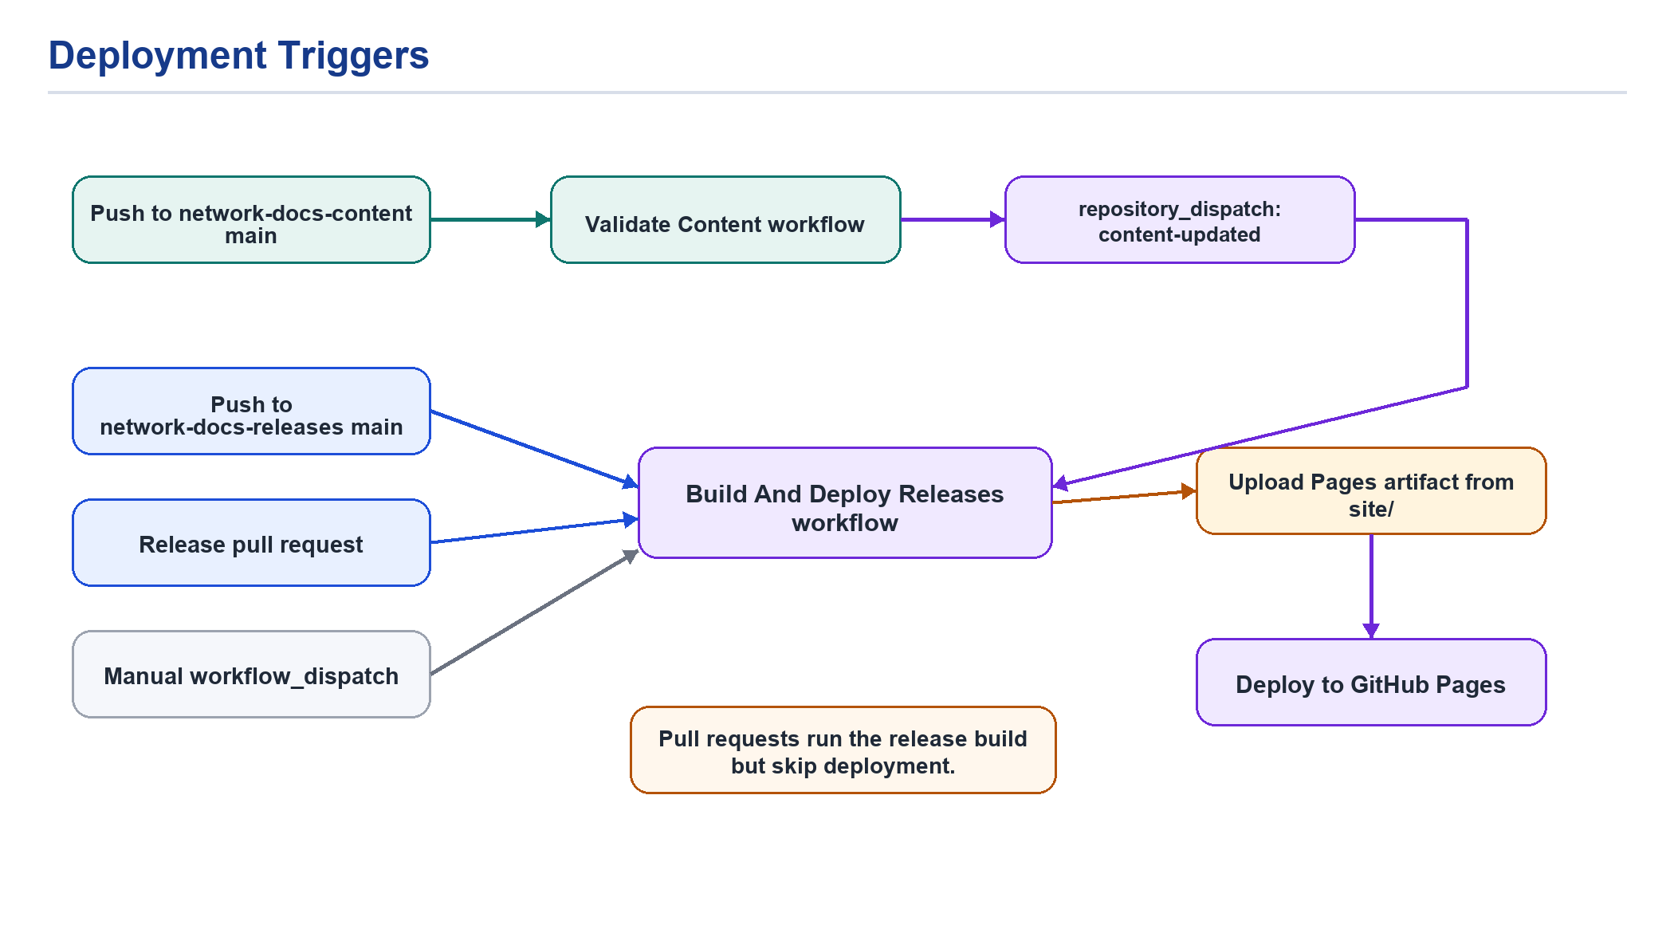
Figure 6. Events that run the release workflow and publish to GitHub Pages.
Pull requests exercise the release build but skip deployment. Pushes to network-docs-releases/main, manual workflow_dispatch events, and content update dispatches can deploy the generated site artifact.

