Assignment 1

- How do you use the “cp” command to copy a file named “file.txt” from the current directory to a directory named “backup”?
--> cp -r home/vboxuser/Desktop/original/file.txt home/vboxuser/Desktop/backup

- What is the difference between the “rm” and “rm -r” commands in Linux?
--> rm - Remove file or directories
Rm -r Remove directories and there contains recursively

- How do you use the "mv" command to rename a file named "oldname.txt" to "newname.txt"?
--> mv oldname.txt newname.txt

- What does the "pwd" command do in Linux?
--> Print name of current directory

- How do you create a new empty file named "newfile.txt" in the current directory using the command line?
--> touch newfile.txt

- How do you rename a file named "oldname.txt" to "newname.txt" using the command line?
--> mv oldname.txt newname.txt

- How do you remove a file named "file.txt" from the current directory using the command line?
--> rm file.txt

- Use a command to show the current working directory
--> pwd

- List the directory contents in the short and long format
--> Short Format - ls
Long format - ls -l

- Explore attributes given in long format e.g. file type, file permissions, file size, file owner etc.
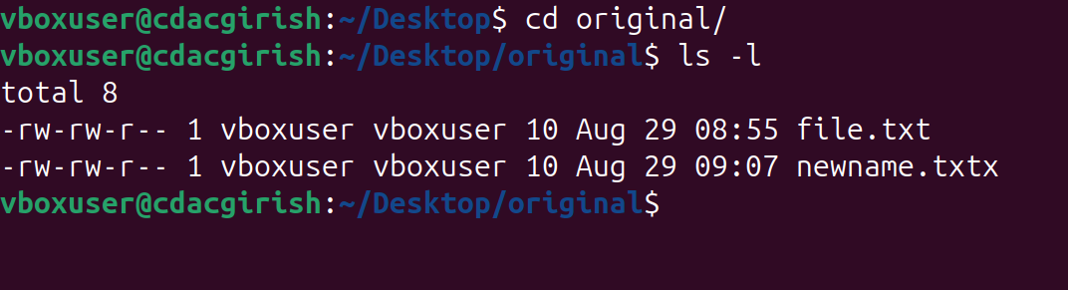

- List all files along with hidden files in the current working directory.
--> ls -a
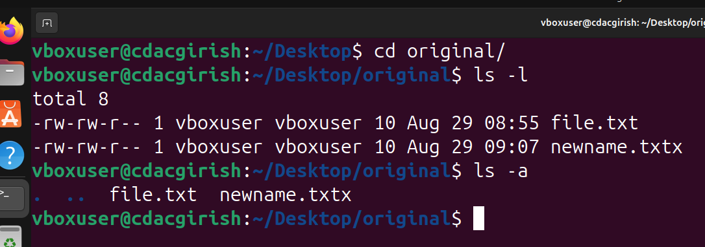
- list only hidden files in the directory

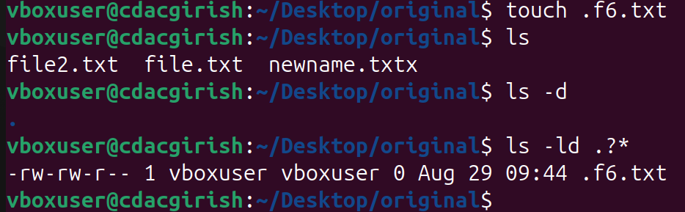

- Make a directory and name it as cdac-dir ​and change the current working directory to the new directory.(Hint : use mkdir,cd​ commands). 3. Create following nested directories inside the current directory by invoking a single command for only one time

- List the directories(folders), then remove the cdac-dir directory and list the folders again to show that it is no longer present.

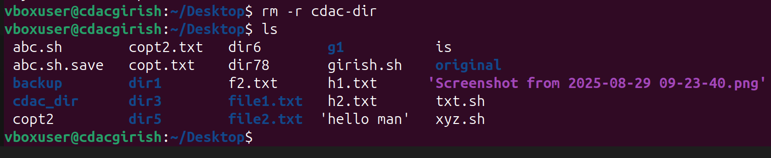

- st the directories(folders), then remove the cdac-dir ​directory and list the folders again to show that it is no longer present.

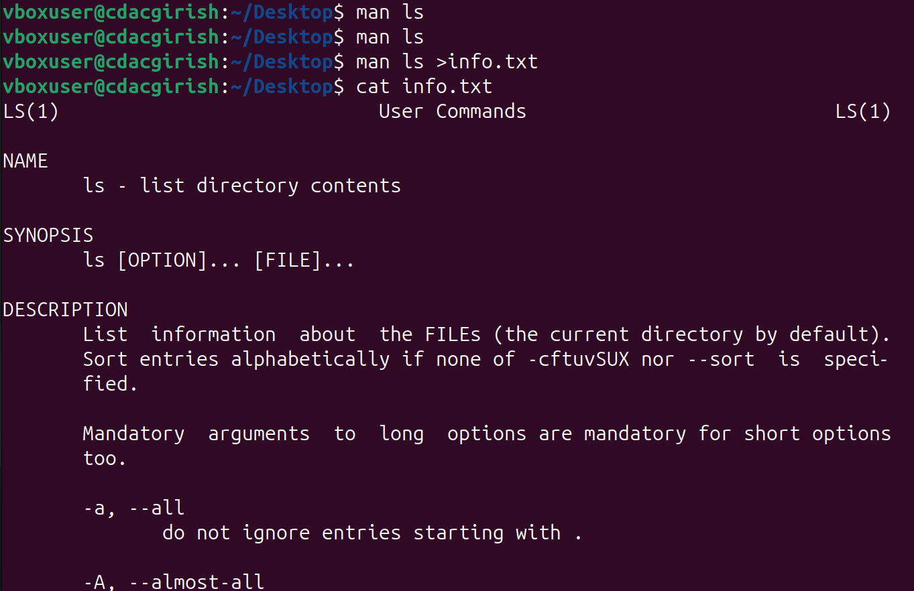

- Display the initial 10 lines and final 5 lines of temp.txt​ with the obvious Linux commands.(Hint: use head​ and tail​ commands).

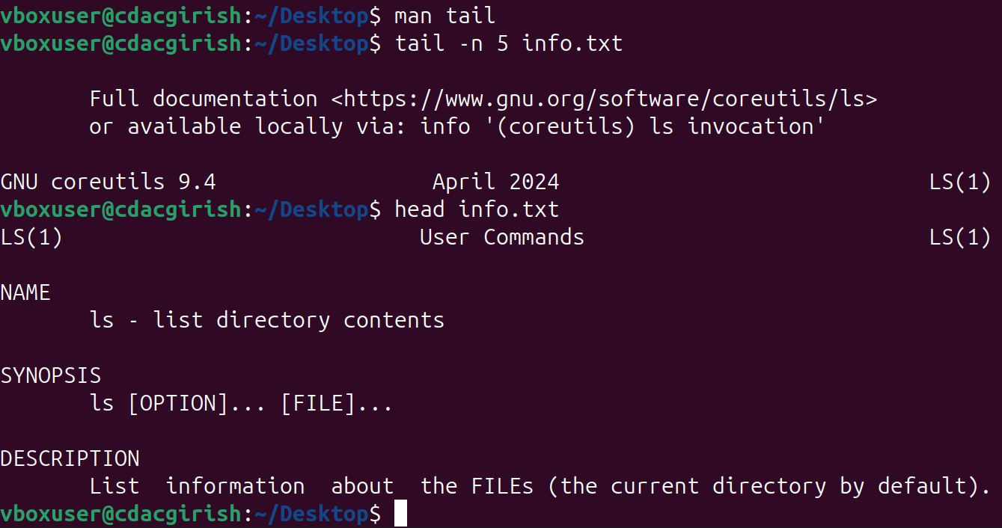

- Copy temp.txt to another directory and rename it there.
--> 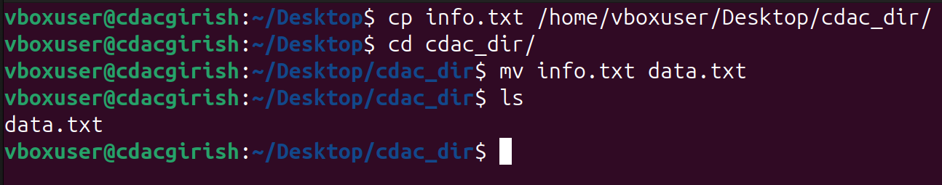

- Display the number of lines, words and characters in file using Linux command
--> wc data.txt
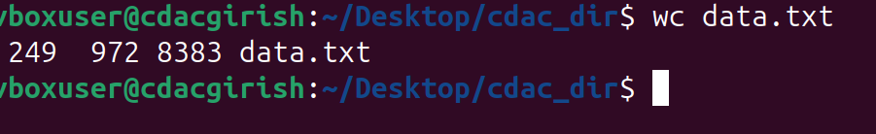

- Use history command to display the last 10 commands used
-->
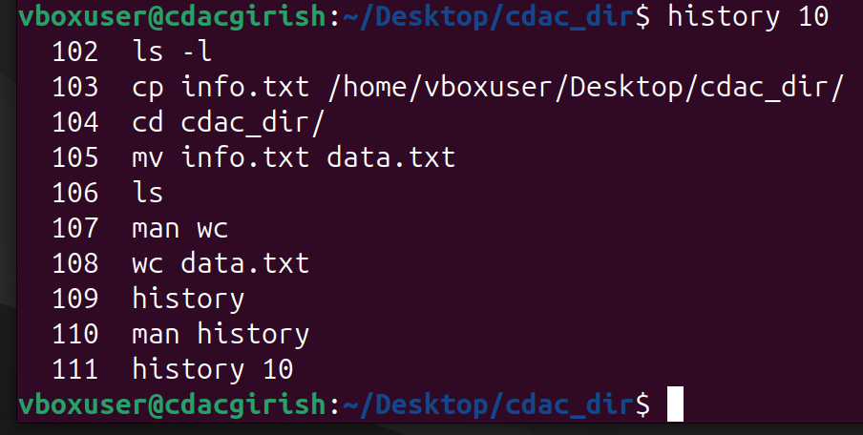
- Create a tar archive file of any directory present in your home directory
--> 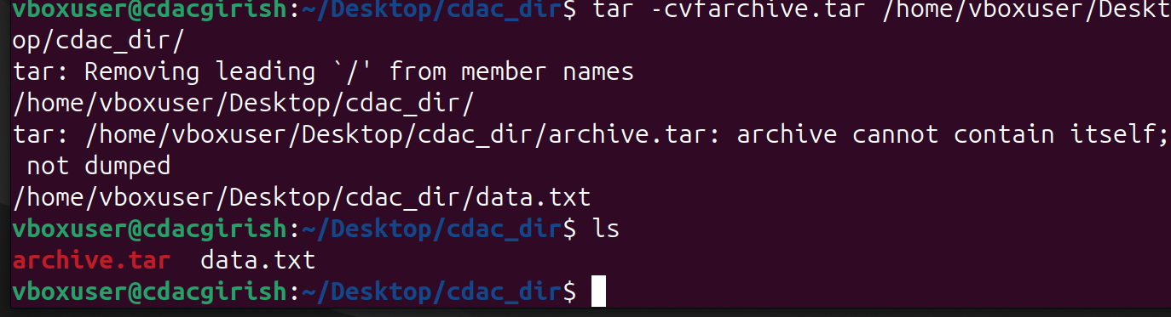

- Create a zip file of another directory. list the contents of the zip file without extracting.
--> 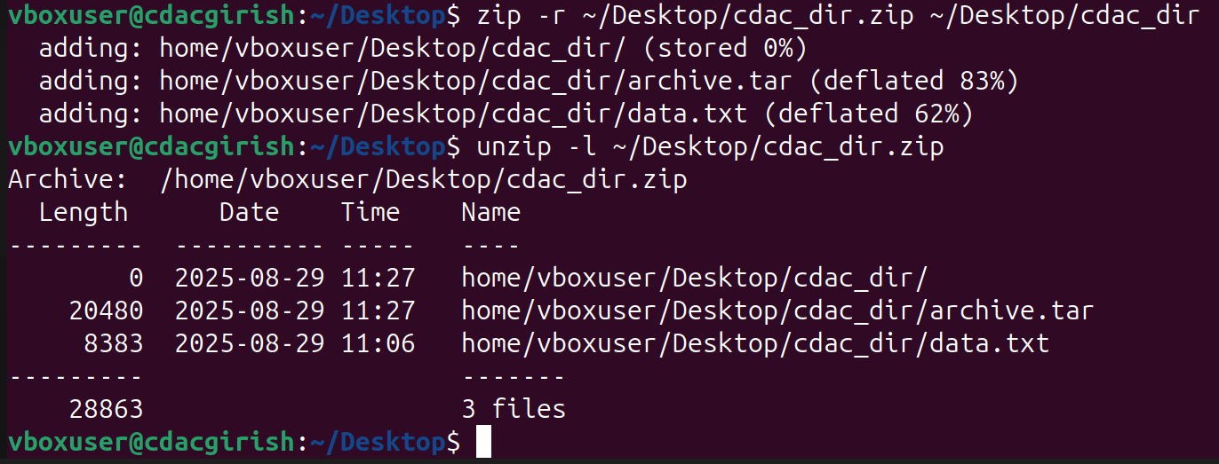

- Give read, write & execute permissions to your file.
--> chmod - Change file mode bit

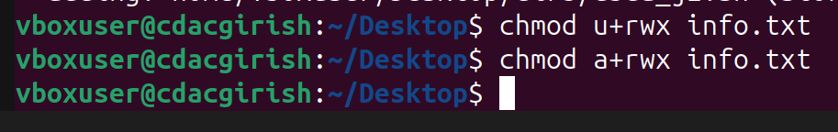

- Change ownership of that file
--> 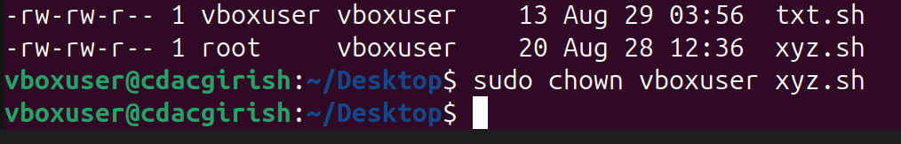

- List processes running in shell, all running processes(Hint: use man page of ps command) and show top processes in decreasing order of their resource utilization.(Hint:use top command).
--> ps -> this command helps to display all process in running shell
Ps -e -> this command helps to display all process which is running
top -> Display linux process

- 1) Display current time and calendar (Hint: use date, cal commands)

-->
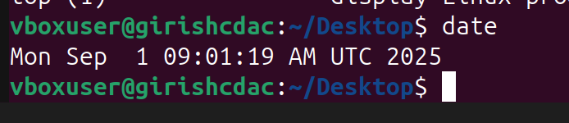

- Change the current date and time of the system to following 14th March 2024, 10:10 AM
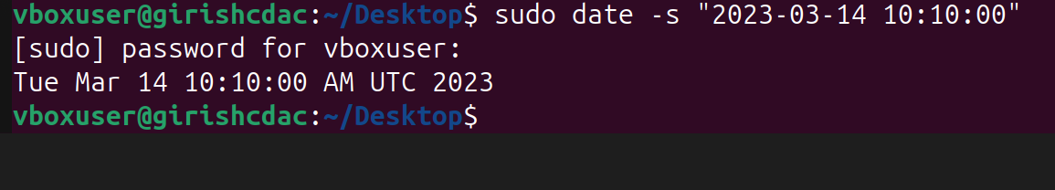

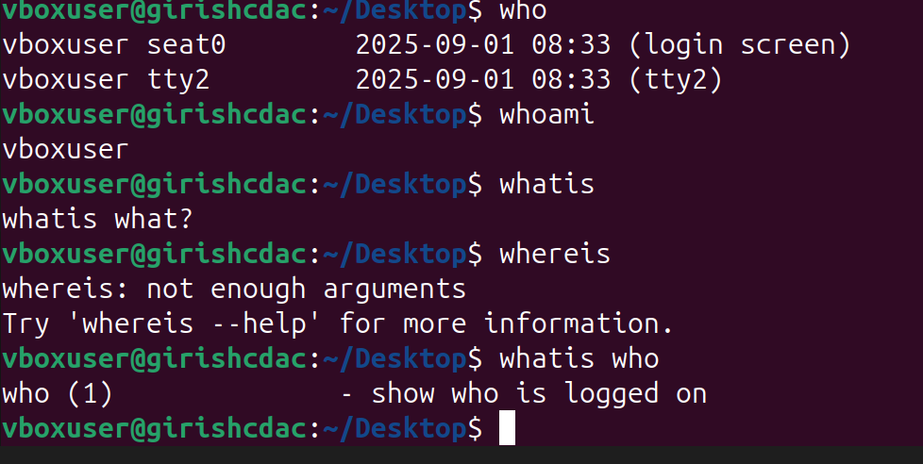
- Explore following command

- Create one directory named linux. cd to that directory and create one file named testperms.txt. Check the permissions of that file. Check the value of umask. Change the value of umask and create one new file newtestperms.txt ​and check its permissions.Note down the difference.(Hint: use umask, ls command )
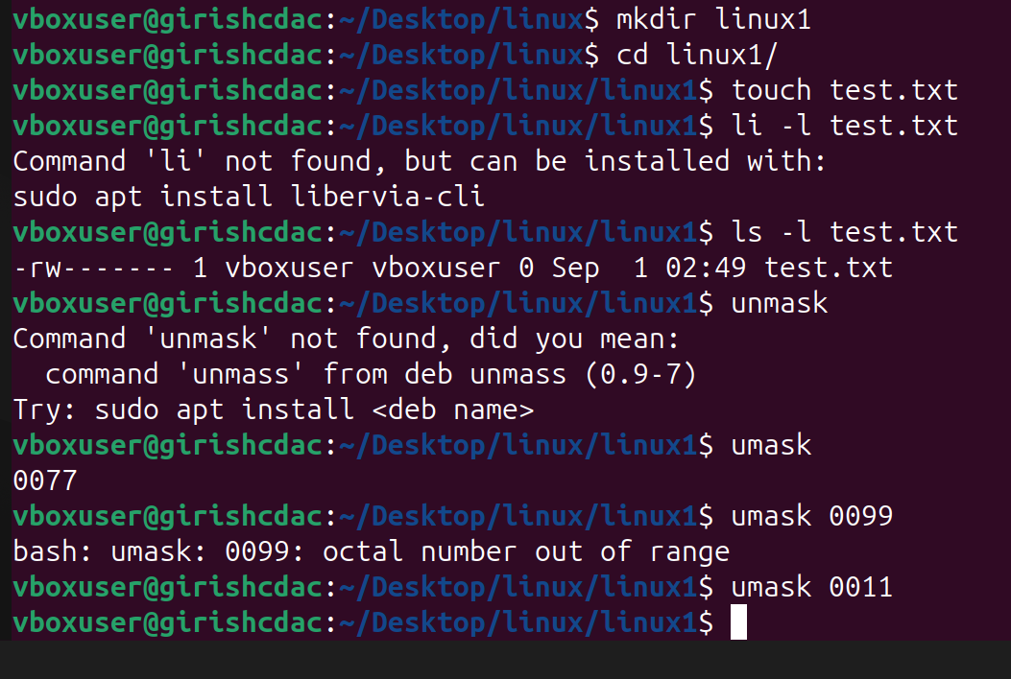
-->

- Create a file and name it as file1.txt and create a hardlink to this file. (Hint: use ln command).
--> 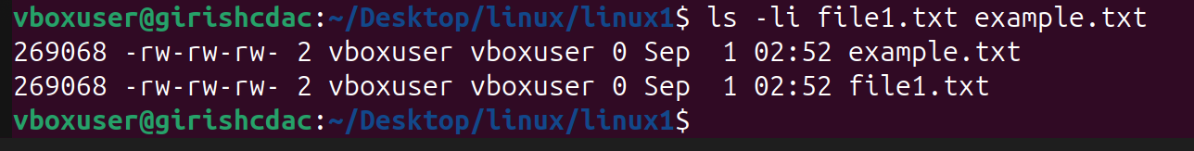

- Create a file and name it as file2.txt and create a softlink to this file. (Hint:use ln command).

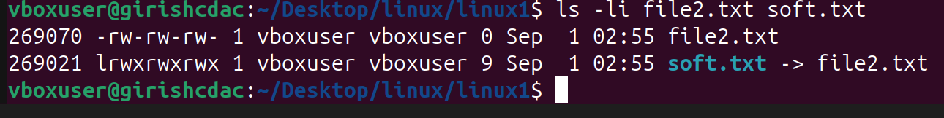

- Use ssh​ to connect to your friend&#39;s shell by specifying port number​ in the ssh command.use exit ​command to come out of your friends shell.(Hint: use ssh command)
-->

- Use scp​ using your friend&#39;s credentials to copy a file​ into a directory owned by your friend, ​inside his home directory, specify port number in scp command.
-->

- Use scp​ using your friend&#39;s credentials to copy directory​ into a directory owned by you​, inside your home directory, specify port number in scp command
-->

- Use scp​ using your friend&#39;s credentials to copy directory​ into a directory owned by you, inside your home directory, specify port number in scp command
-->

- Connect to any publicly available ftp​ server from the terminal and try to download,
upload and delete files. If you get error in any process (connect, upload, download or
delete), justify the reasons behind them.(Hint: use ftp​ command) Example:
Try to access ftp.netbsd.org
username : anonymous
password : anonymous
-->

- How do you remove a directory named &quot;mydir&quot; and all of its contents using the command line?
-->
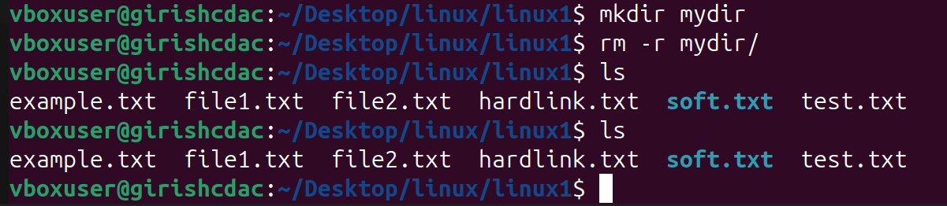

- How do you use the &quot;ls&quot; command to list all files and directories in the current directory?
-->

- How do you create a new file named &quot;myfile.txt&quot; in the director &quot;/home/user/documents&quot; using the command line?

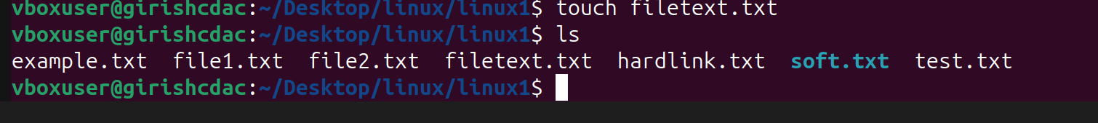

- How do you use the &quot;grep&quot; command to search for a specific word or phrase in multiple files at once?
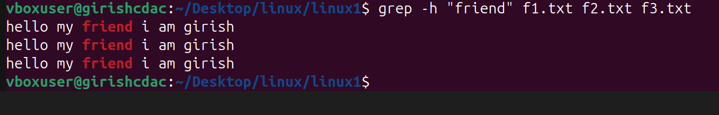

- How do you create a new directory named &quot;mydir&quot; and set its permissions to read, write,and execute for the owner and read and execute for everyone else?
--> mkdir -m 755 mydir
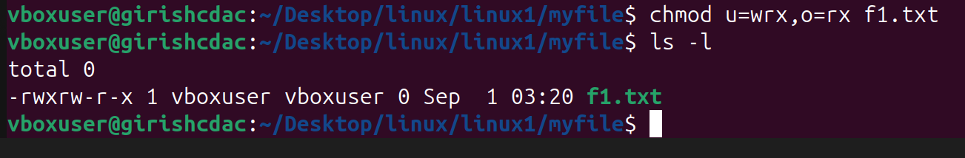

- How do you use the &quot;tar&quot; command to create a compressed archive of all files in the
current directory and its subdirectories?
-->

- How do you use the &quot;chmod&quot; command to give read and write permissions to the owner and group for a file named &quot;file.txt&quot;?
--> 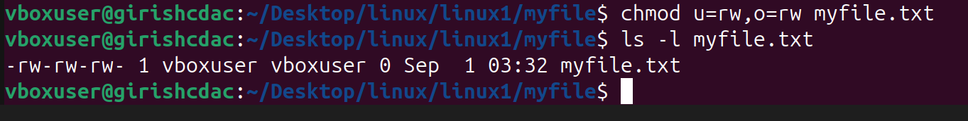

- How do you find the size of a file named &quot;file.txt&quot; in bytes, kilobytes, and megabytes
using the command line?
> free -h , free -g, free -m, free -k

- How do you use the &quot;awk&quot; command to extract a specific column from a comma-
separated value (CSV) file and sort it in reverse order?
-->

- How do you use the &quot;sed&quot; command to replace all occurrences of a word or phrase in a
file with a different word or phrase?
--> 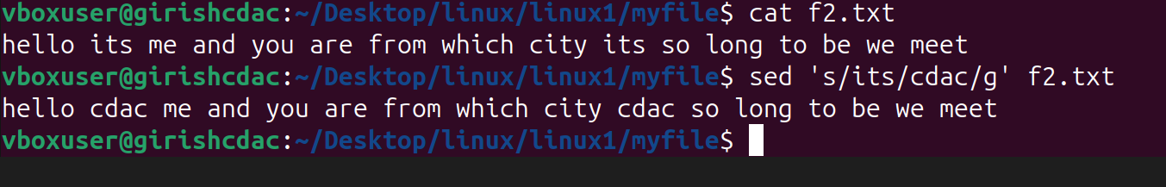

- How do you use the &quot;find&quot; command to search for all files in a directory and its
subdirectories that were modified within the last 24 hours?
--> 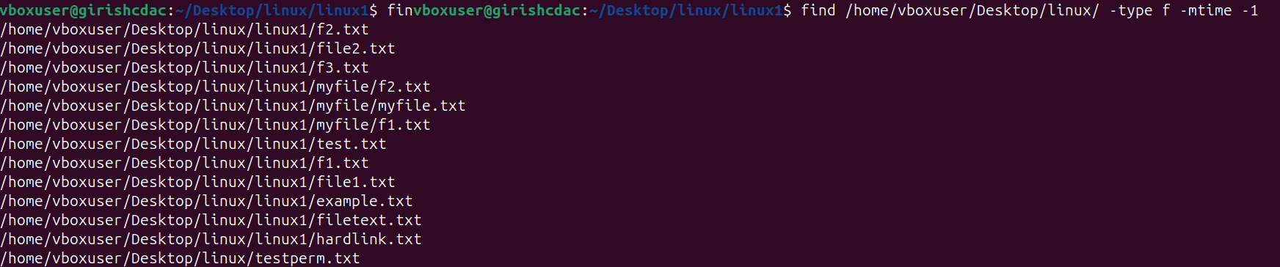

- How do you use the &quot;diff&quot; command to compare two files and show only the lines that
are different between them?
-->

- How do you use the &quot;rsync&quot; command to synchronize the contents of two directories,
including all subdirectories and files, while preserving file permissions and ownerships?
-->

- How do you use the &quot;cut&quot; command to extract a specific range of characters or bytes
from a file?
--> 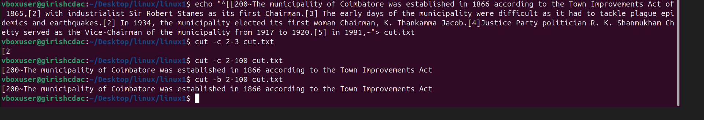

- How do you use the &quot;tar&quot; command to extract a specific file or directory from a
compressed archive without extracting the entire archive?

-->

- How do you use the &quot;awk&quot; command to count the number of occurrences of a specific
word or phrase in a file?

