INT-404(project)

# **Handwritten Digit Recognition using Python**

**Index:**

1.What is Handwritten Digit Recognition?

2.What is CNN?

3.Libraries used

4.Team Responsibilty

5.code sample

6.pupose of the project

7.conclussion

What is Handwritten Digit Recognition?

The handwritten digit recognition is the ability of computers to recognize human handwritten digits. It is a hard task for the machine because handwritten digits are not perfect and can be made with many different flavors. The handwritten digit recognition is the solution to this problem which uses the image of a digit and recognizes the digit present in the image.

## What is CNN?

Convolutional Neural Networks are a type of Deep Learning Algorithm that take the image as an input and learn the various features of the image through filters. This allows them to learn the important objects present in the image, allowing them to discern one image from the other. For example, the convolutional network will learn the specific features of cats that differentiate from the dogs so that when we provide input of cats and dogs, it can easily differentiate between the two. One important feature of Convolutional Neural Network that sets it apart from other Machine Learning algorithms is its ability to pre-process the data by itself

## Libraries used:

Numpy:

NumPy, which stands for Numerical Python, is a library consisting of multidimensional array objects and a collection of routines for processing those arrays. UsingNumPy, mathematical and logical operations on arrays can be performed. ... It also discusses the various array functions, types of indexing, etc.

Keras:

Keras is an open-source neural-network library written in Python. It is capable of running on top of TensorFlow, Microsoft Cognitive Toolkit, R, Theano, or PlaidML. Designed to enable fast experimentation with deep neural networks, it focuses on being user-friendly, modular, and extensible.

Tensorflow:

TensorFlow is a Python library for fast numerical computing created and released by Google. It is a foundation library that can be used to create Deep Learning models directly or by using wrapper libraries that simplify the process built on top of TensorFlow.

Pillow:

Python Imaging Library (Fork). Pillow is the friendly PIL fork by Alex Clark and Contributors.PIL is the Python Imaging Library by Fredrik Lundh and Contributors.

Team Responsibilty:

i have developed the tarininng model and implemented various libraireis and colloected the mnist datadset from diffterent resources and my teammate has developed the gui of the model to capture the handwriten image and setup the environment to develop the treaining module.

**Code Sample:**

*try:*

*from PIL import Image*

*except ImportError:*

*import Image*

*import pytesseract*

*def ocr_core(filename):*

*"""*

*This function will handle the core OCR processing of images.*

*"""*

*text = pytesseract.image_to_string(Image.open(filename)) # We'll use Pillow's Image class to open the image and pytesseract to detect the string in the image*

*return text*

*print(ocr_core('images/ocr_example_1.png'))*

this code is for import the images to be captured and whole code of the project would be sent in

zip file and along with its usage and dependecies reqired to be installed in the system for

protability.

**purpose of the project:**

to make the machine more intelligent about the picture digit recongnition.

**Conclussion:**

we have successfully built a Python deep learning project on handwritten digit recognition app. We have built and trained the Convolutional neural network which is very effective for image classification purposes. Later on, we build the GUI where we draw a digit on the canvas then we classify the digit and show the results.

**Refererences:**

1. <https://medium.com/@himanshubeniwal/handwritten-digit-recognition-using-machine-learning-ad30562a9b64>

2. <https://towardsdatascience.com/understanding-neural-networks-from-neuron-to-rnn-cnn-and-deep-learning-cd88e90e0a90>

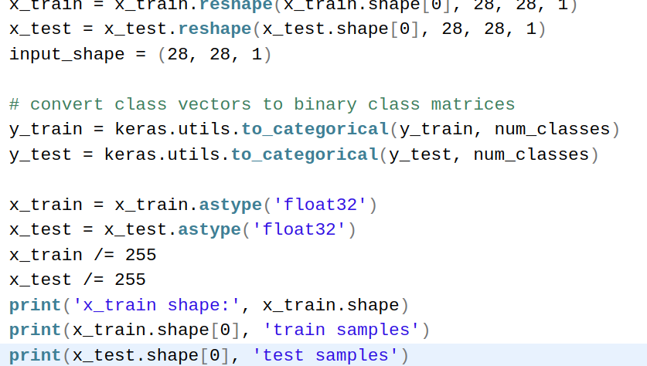

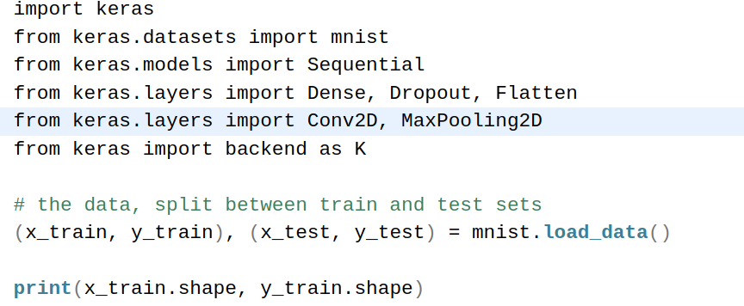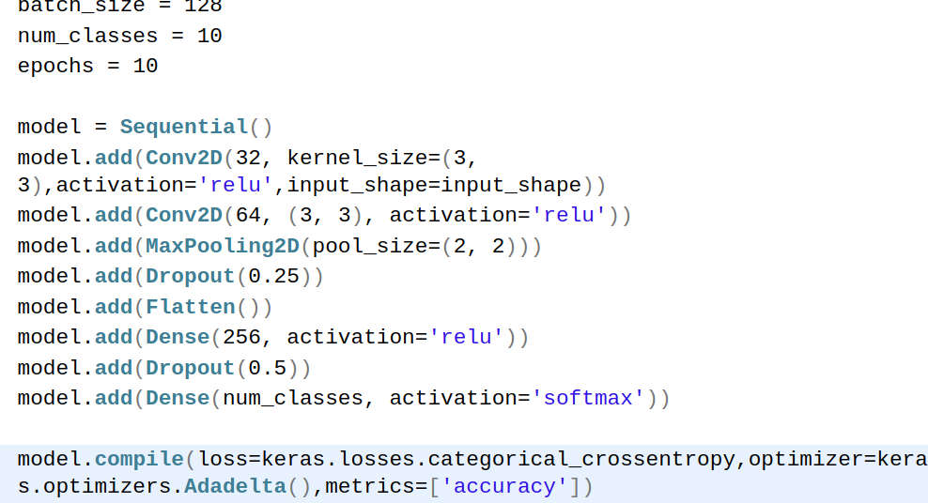

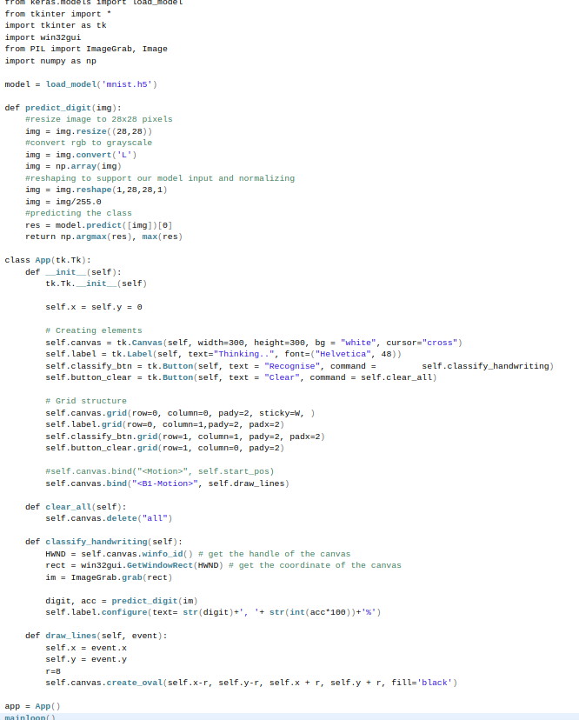

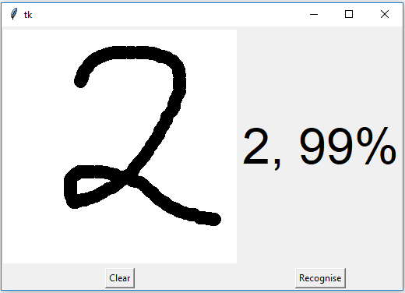

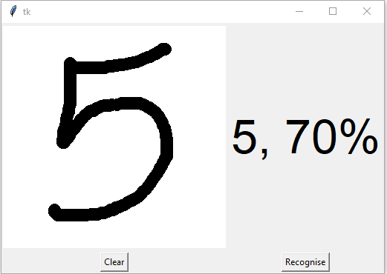

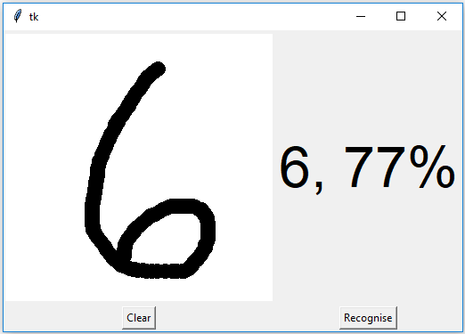

***Submitted by:***

***Name: Girish Kumar Rajput***

***Roll.no : 04***

***Reg.no : 11802233***

***Name: waqas Manjoor***

***Roll.no : 14***

***Reg.no : 11802211***

***Maill: girishrajput910@gmail.com***