**GitHub link:-** [**https://github.com/girishsuri15/nagp-assginment-kubernetes.git**](https://github.com/girishsuri15/nagp-assginment-kubernetes.git)

**Workflow diagram for the task: -**

* Deploy aggregator is communicate with the order and user deployment both are exposed via Cluster IP Service.
* Deploy aggregator is service exposed via Load Balancer.
* User data is store in MYSQL Database.
* Password and username for the MYSQL access is store in the secrets.
* Jaeger in deploy is Kubernetes can Jaeger UI can be access by the Its public IP address.

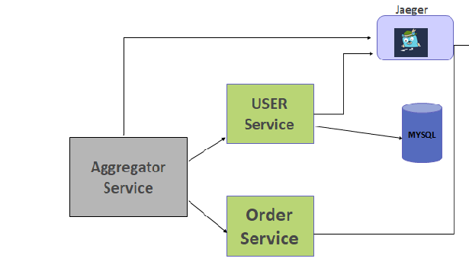

**Screenshot for the deployment of jaeger deployment, service,pods**

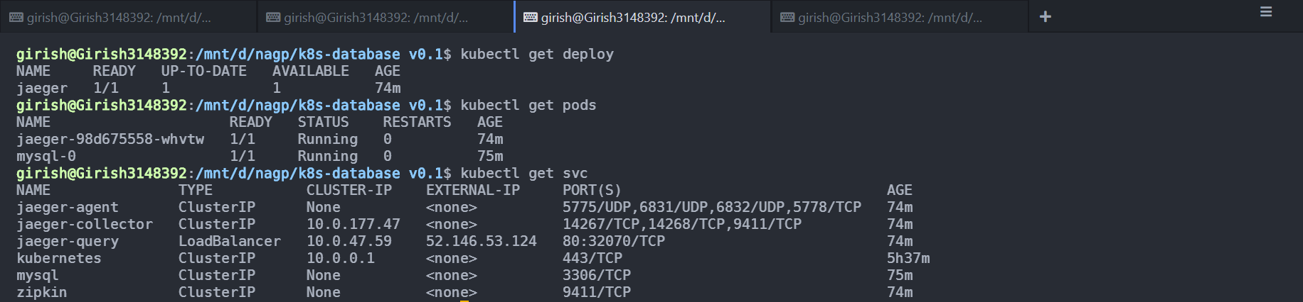

**Jaeger UI Dashboard in action**

**Service can be seen aggregator, order, user**

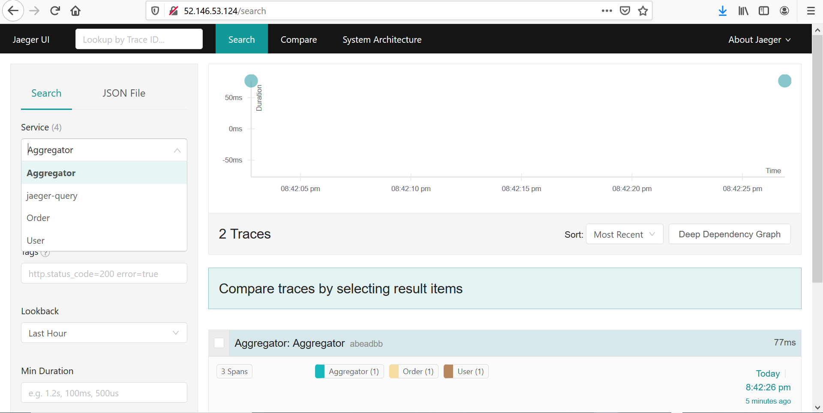

**Traces Can be seen for Aggregator**

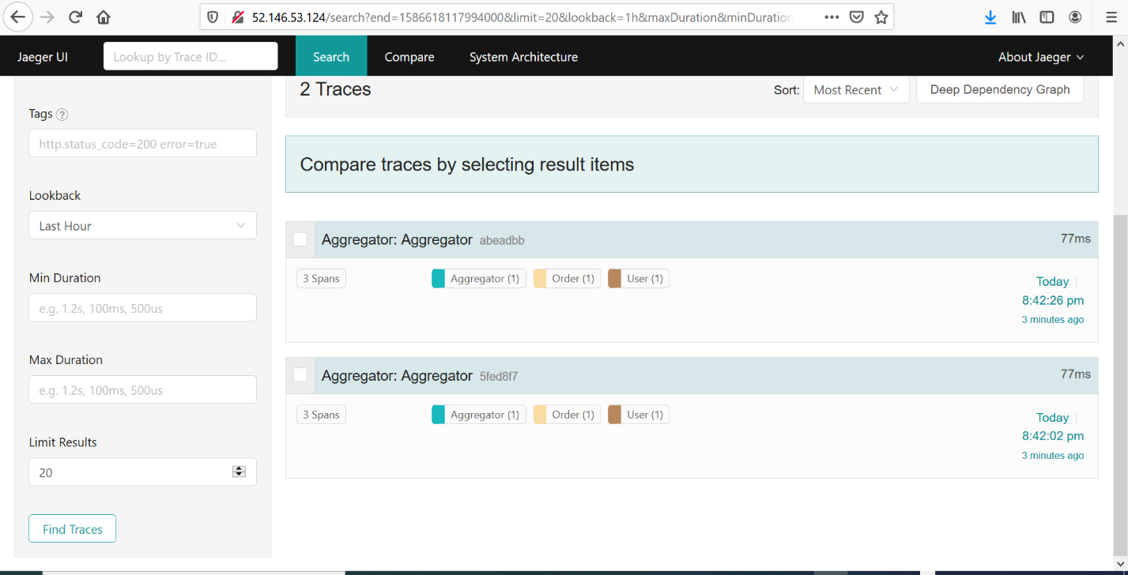

**Traces can be seen for User and Order**

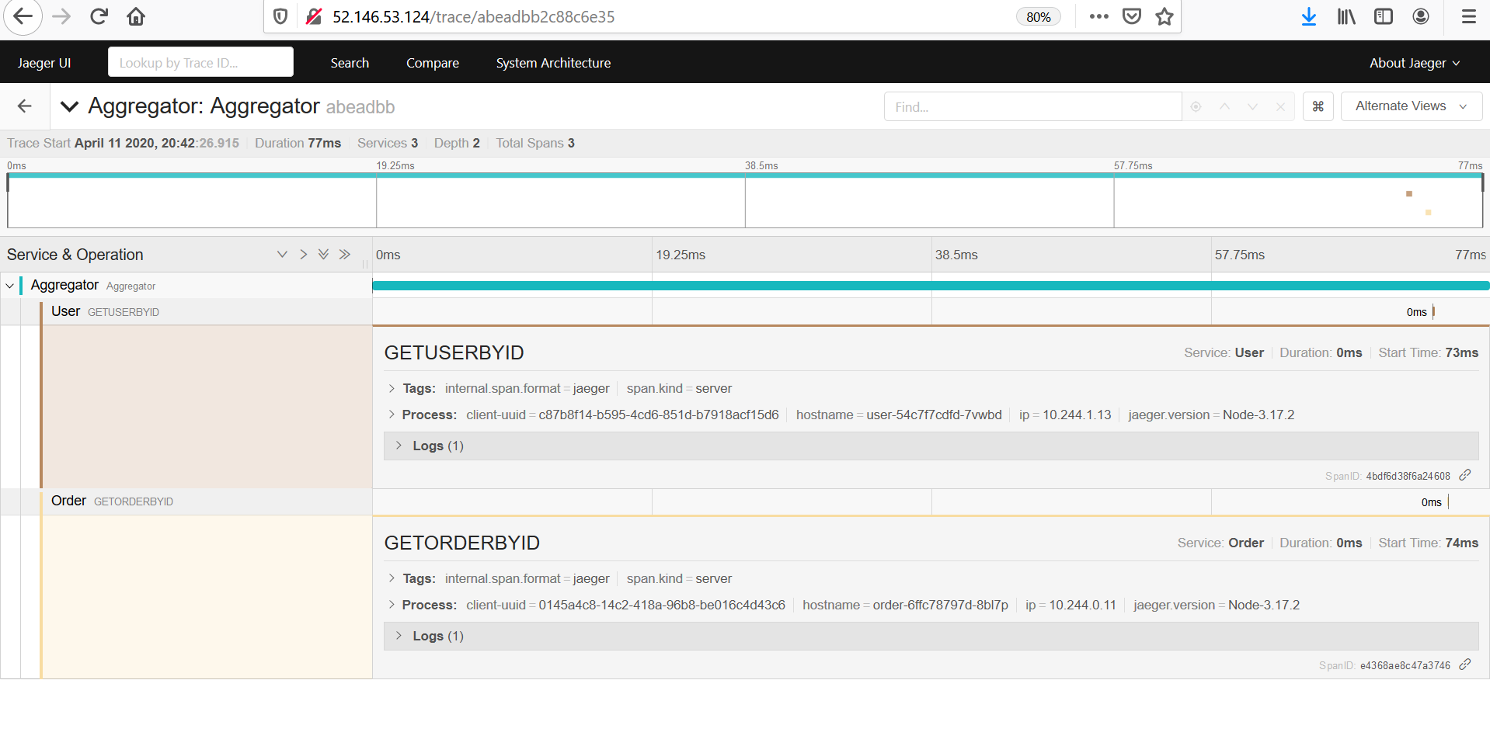

**Directed Acyclic Graph System Architecture**

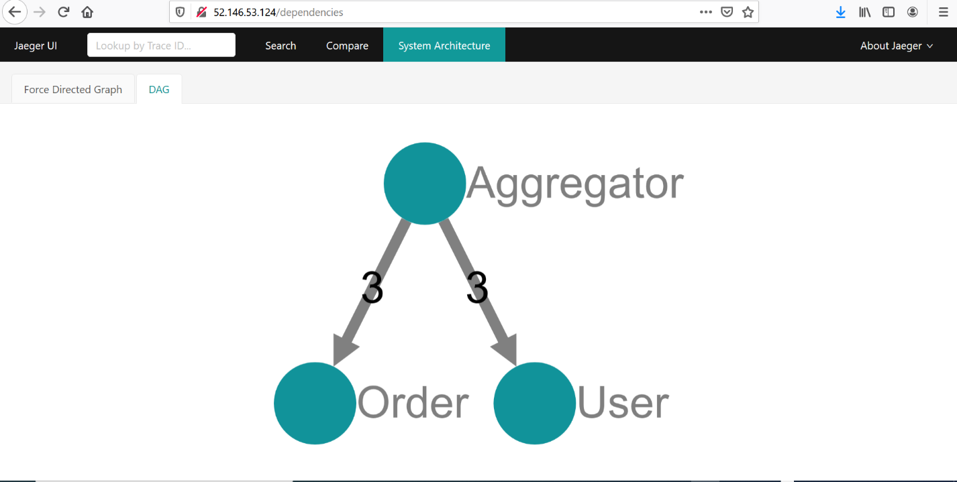

**Screenshot for the deployment of MYSQL Stateful sets, service, secrets, pods**

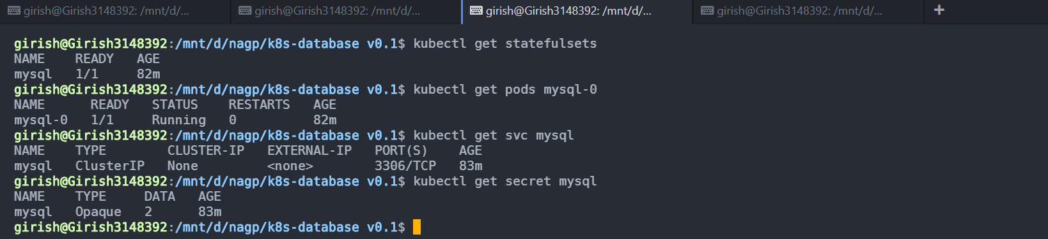

**Screenshot for the Aggregator deployment, service, pods, configmaps**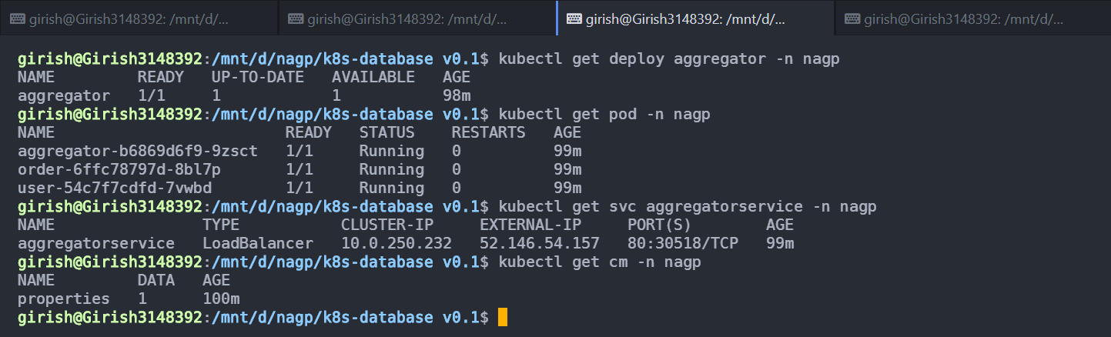

**Screenshot for the Userservice deployment, service, pods, secrets**

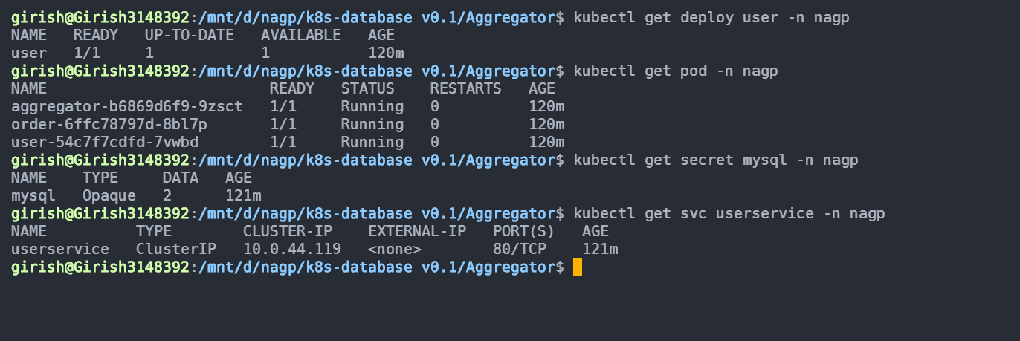

**Screenshot for the Order deployment, service, pods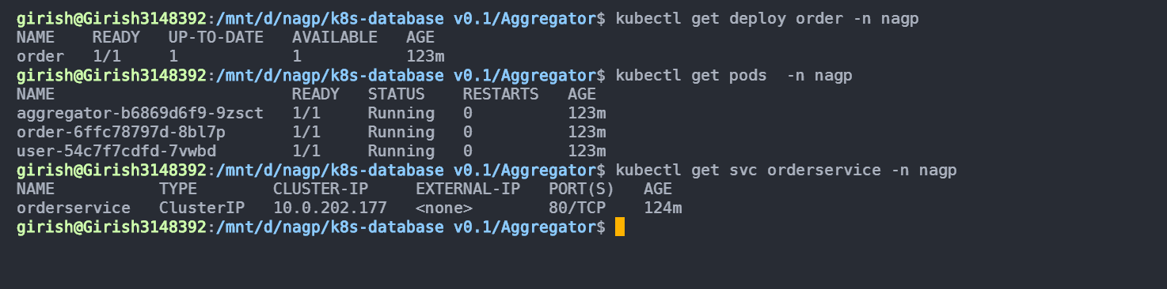Aggeragator service in action**