Application URL: [http://travelappweb.s3-website.ap-south-1.amazonaws.com](http://travelappweb.s3-website.ap-south-1.amazonaws.com/)

To access either register user or use credentials admin/admin

(NOTE: URL not accessible currently as the account access has been revoked)

**Micro service Architecture for Travel Management System**

Travel App Web (Angular)

Gateway Service

(Spring Boot)

Eureka Service

(Spring Boot)

User Service

(Spring Boot)

Booking Service

(Spring Boot)

Mongo (NoSQL)

JWT Authentication

Config Server

Mongo (NoSQL)

**Installation Steps:**

Java 8/ Maven 3.6.3

**Build**

Run *mvn clean install* or *mvn package* for all java services.

**Run**

Start config server first

java -jar ConfigServer-0.0.1-SNAPSHOT.jar

Then DiscoveryService -> UserService -> Booking Service -> GatewayService

java -jar -DPROFILE=local <jar name>

For angular web application TravelAppUI

npm install (Rerun the command in case of any errors encountered)

npm run start

**Sonar – For code quality and vulnerability**

Jacoco is used for code coverage run mvn install and refer target/site folder for results.

Screenshot

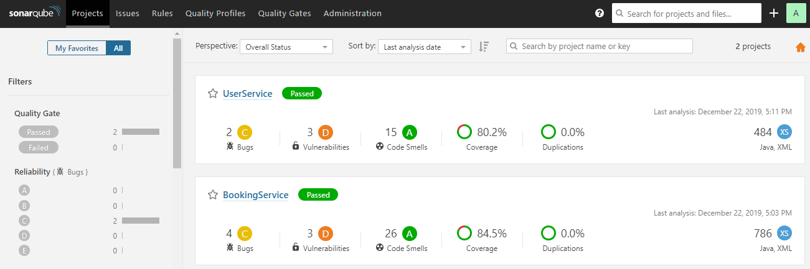

**JMeter for performance test**

Refer JMeter attachments.

**Java VisualVM for code profiling:**

Refer VisualVM attachments.

**PMD for code quality**



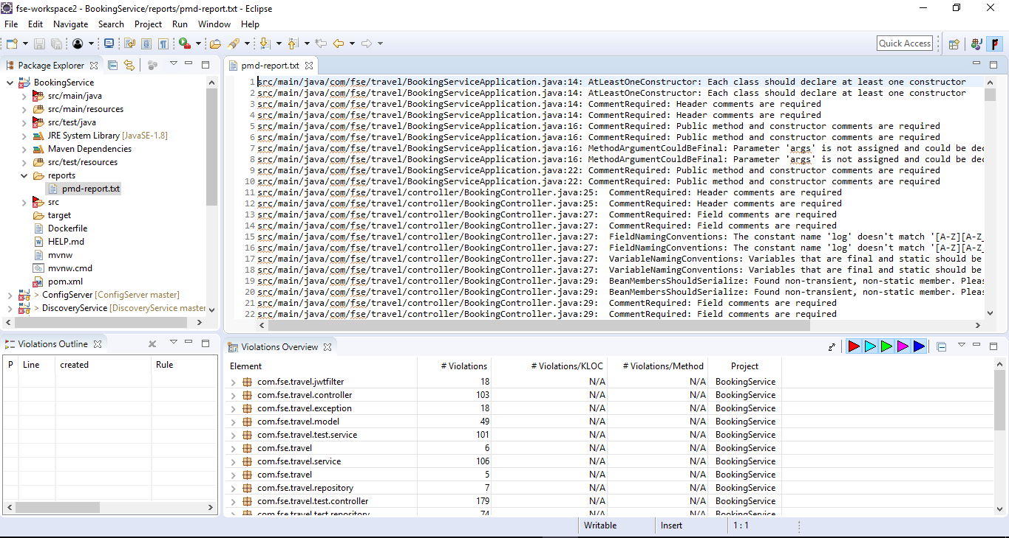

**Jenkins CI/CD Pipeline (Jenkins pipeline files available in source code)**

Multiple pipelines are created for independent microservice build and deployment.

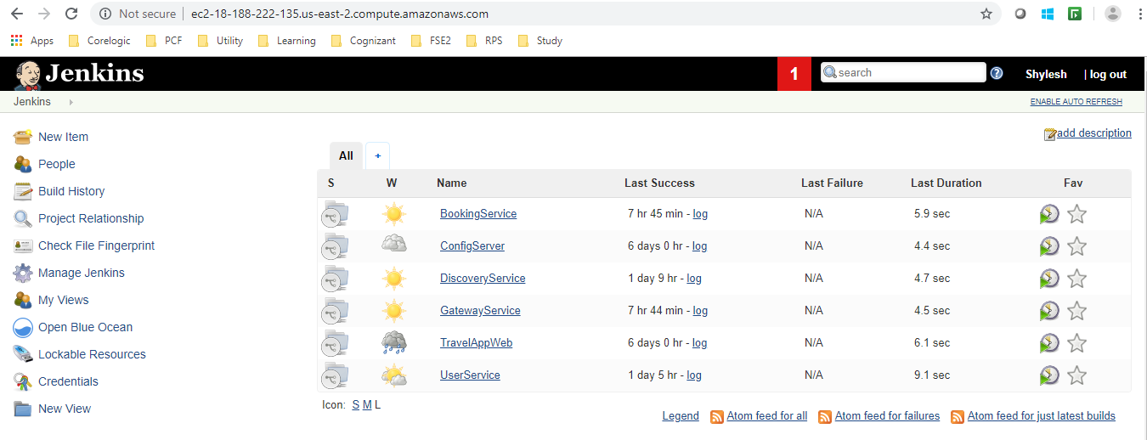

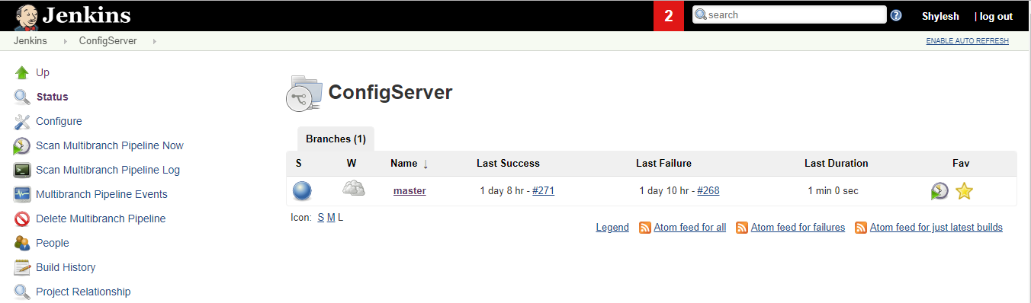

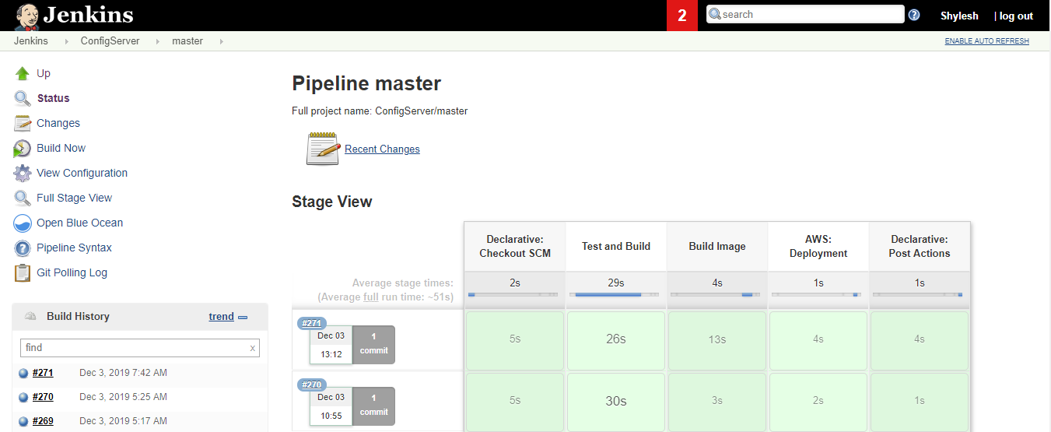

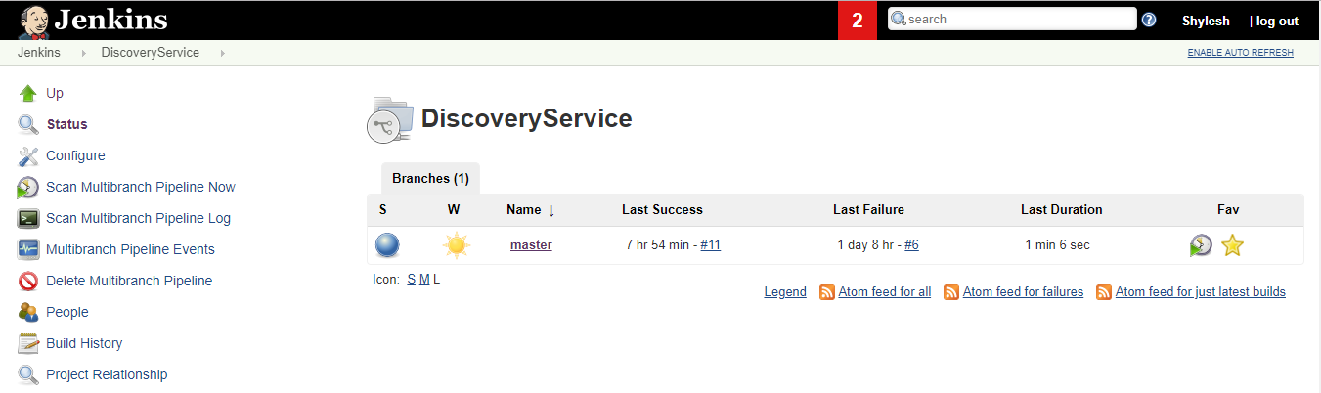

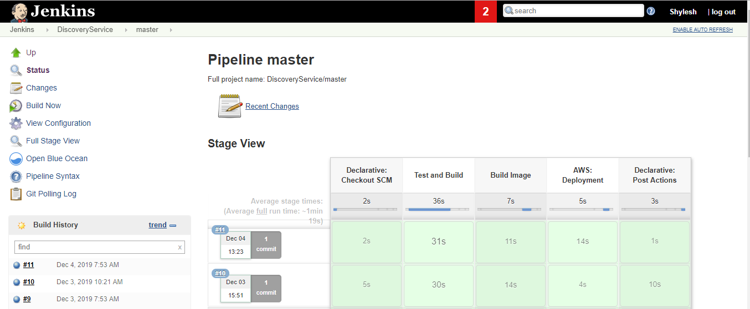

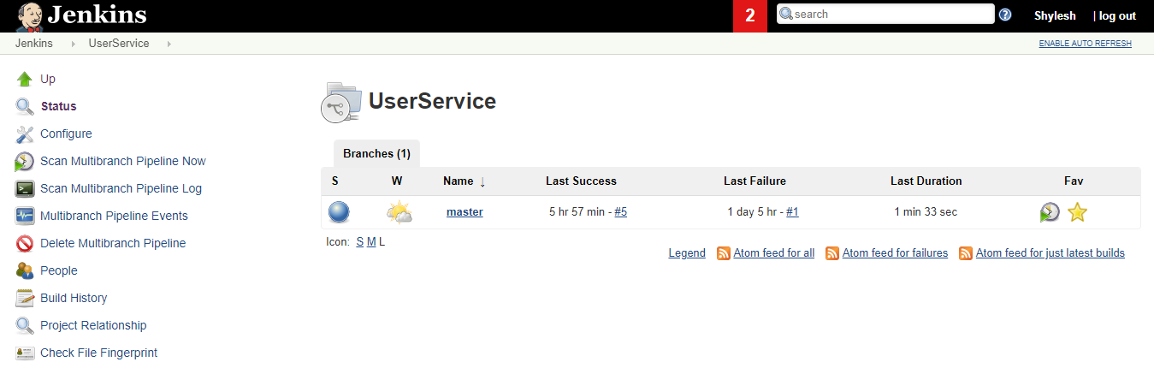

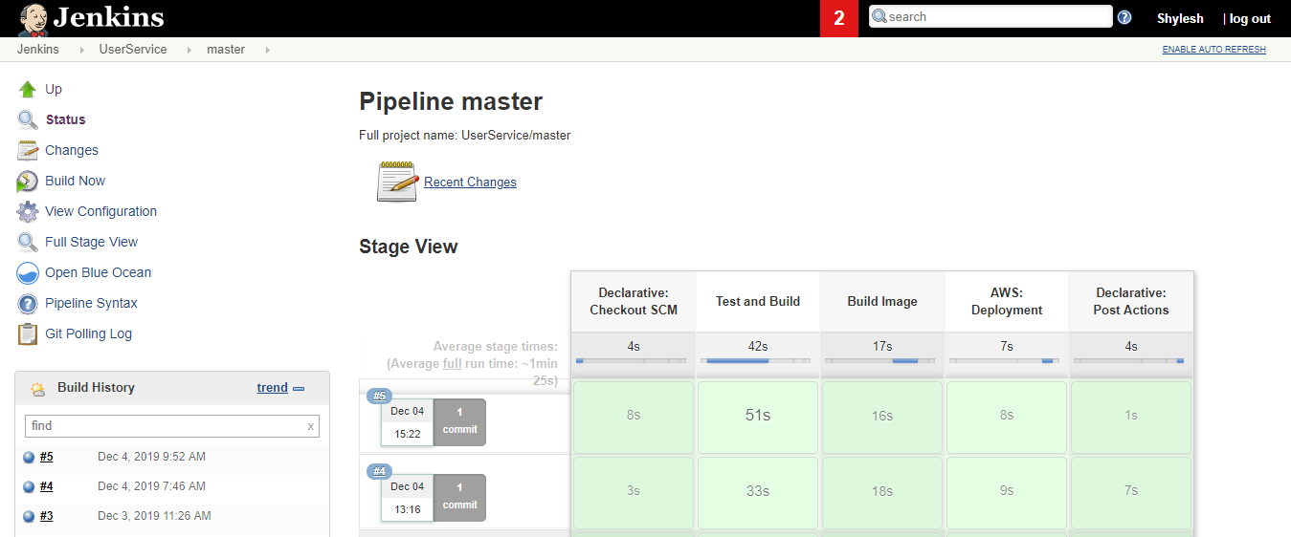

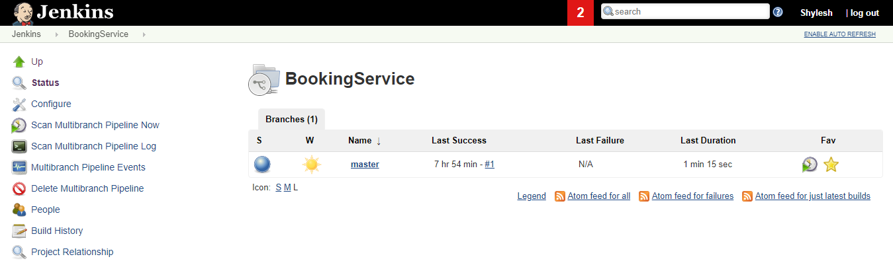

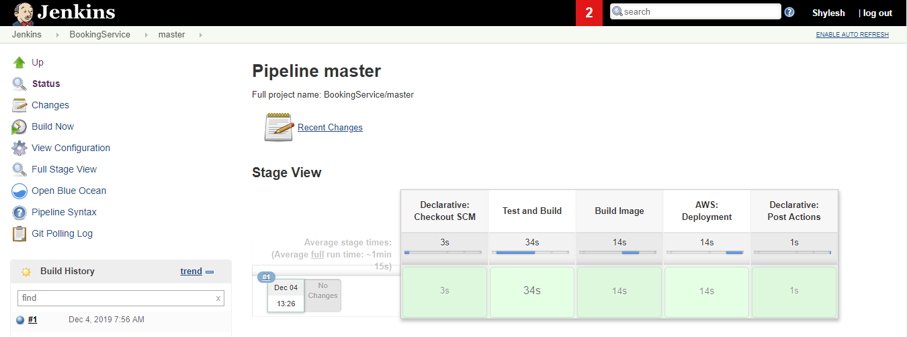

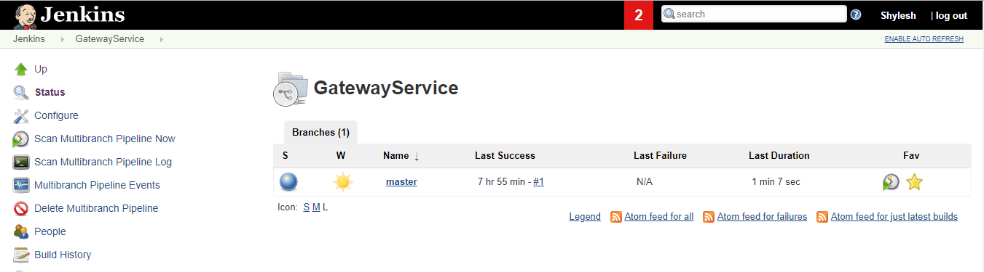

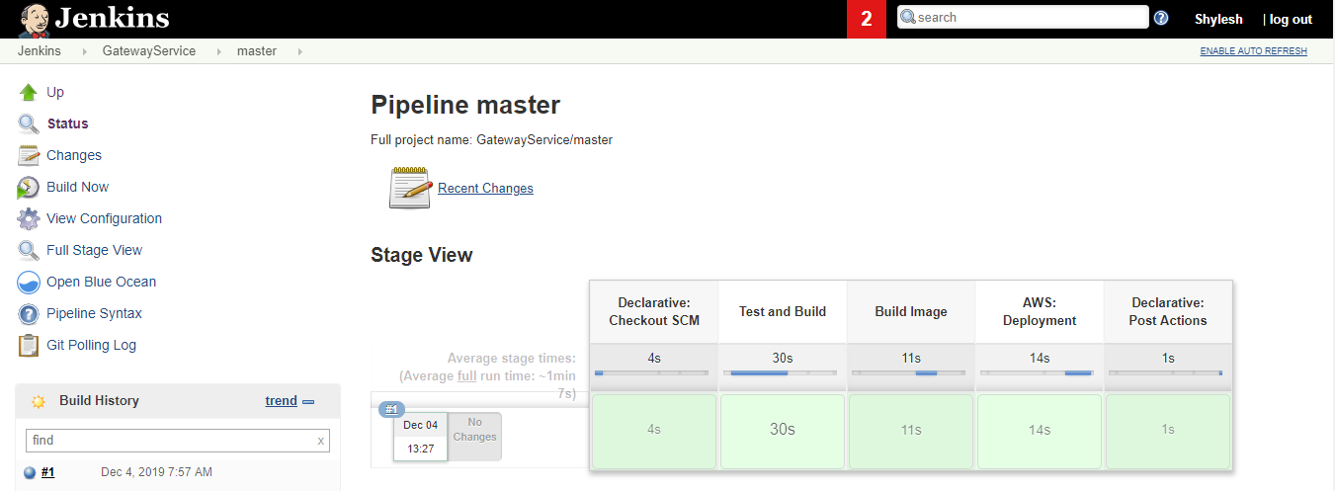

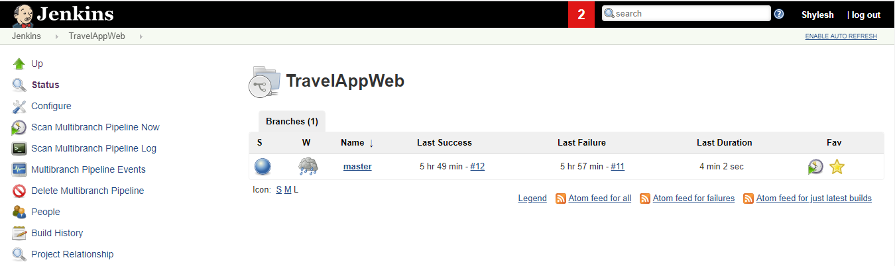

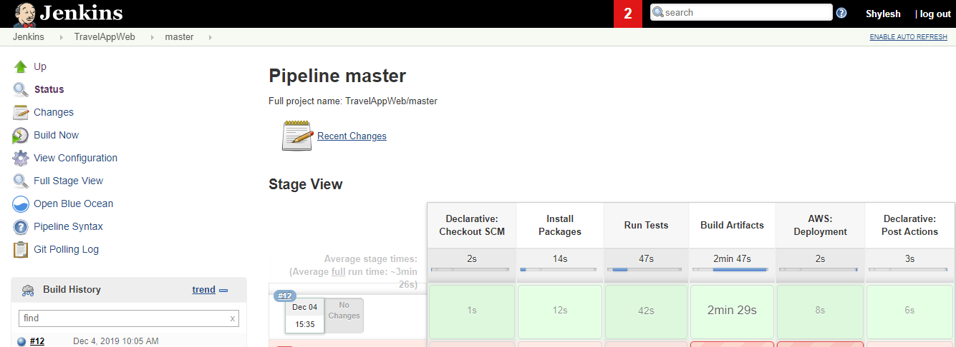

**Application Screenshots - Usage**

**Initial Page:**

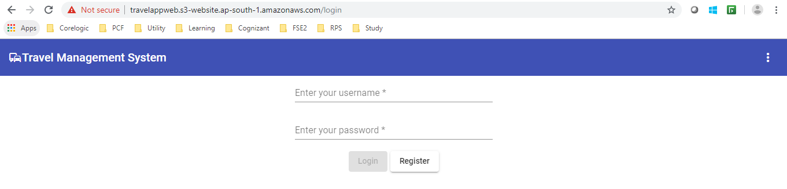

Register User:

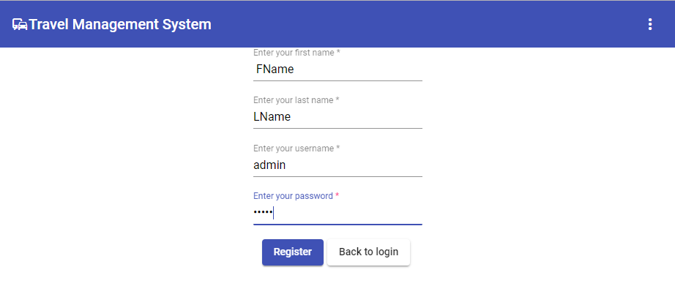

**Login:**

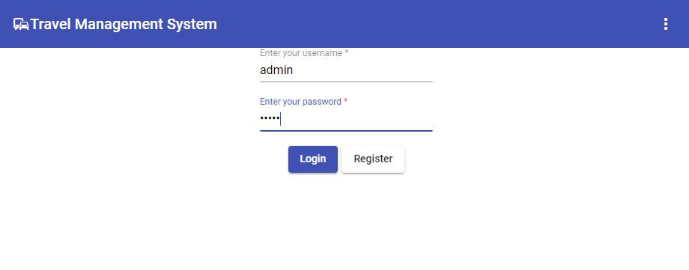

**Dashboard:**

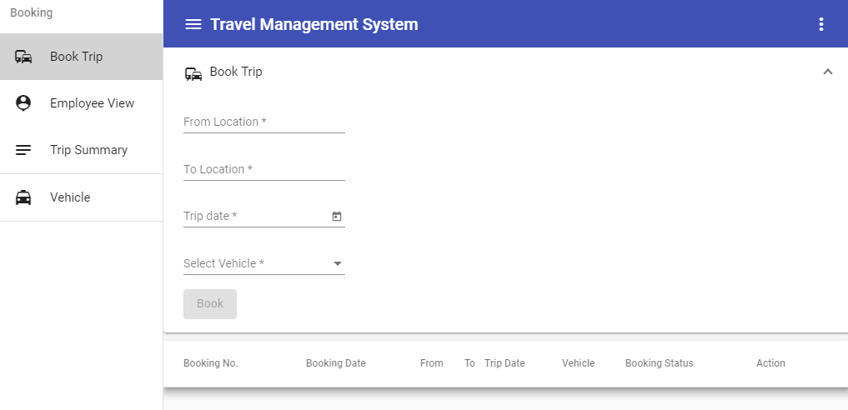

**Register Vehicle:**

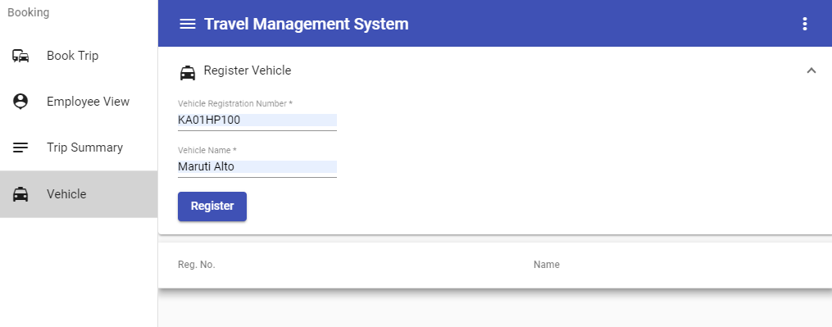

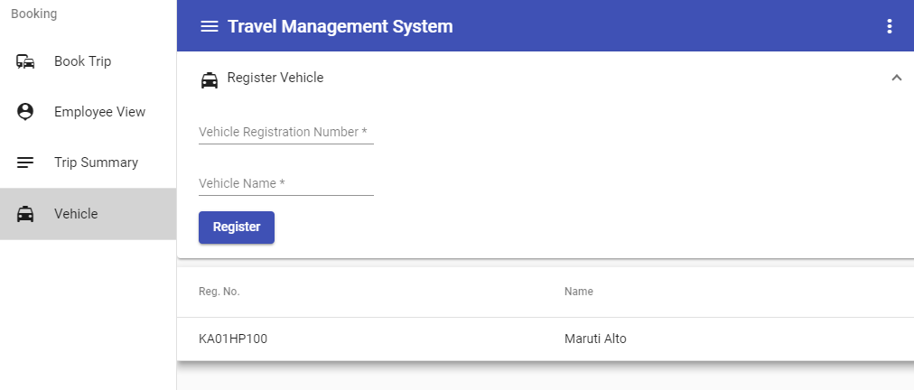

**Book Trip:**

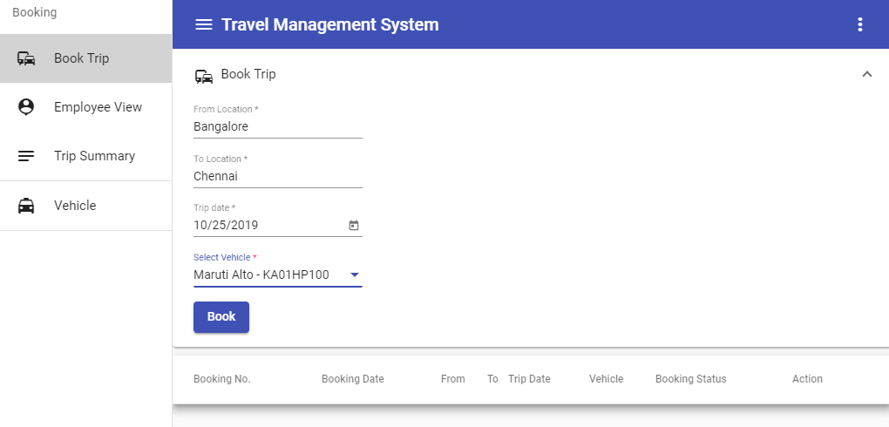

**View/Cancel Trip**

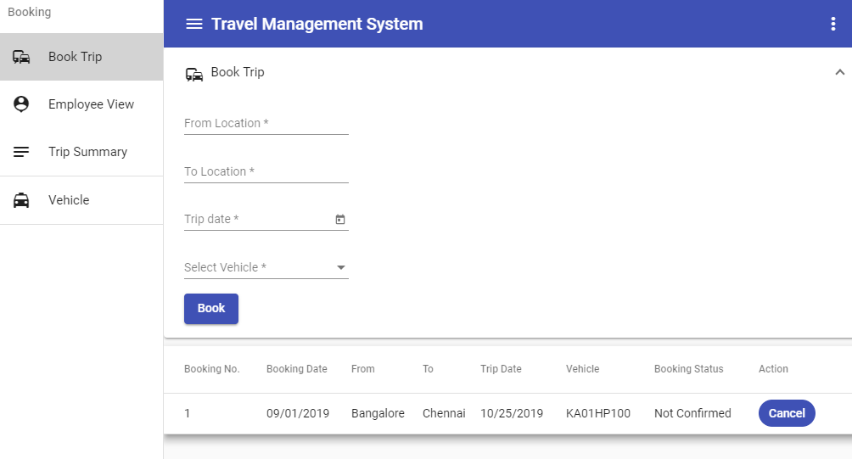

**Employee View / Confirm Trip / Complete Trip**

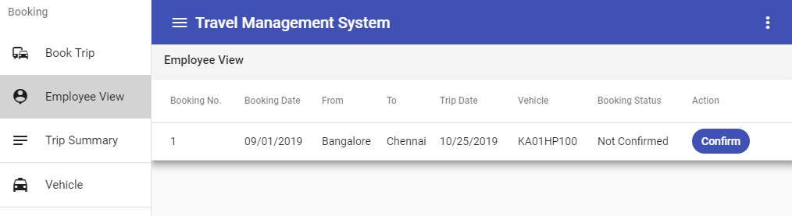

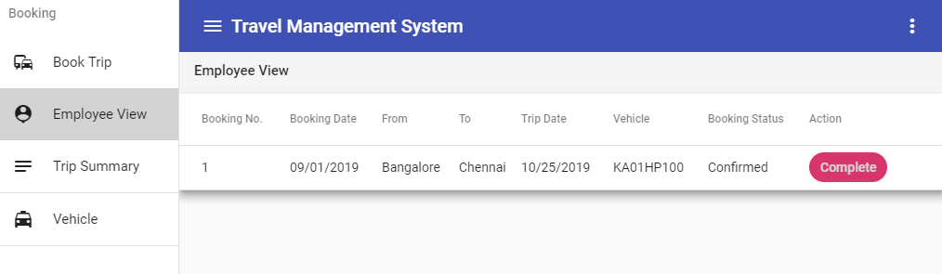

**Trip Summary:**

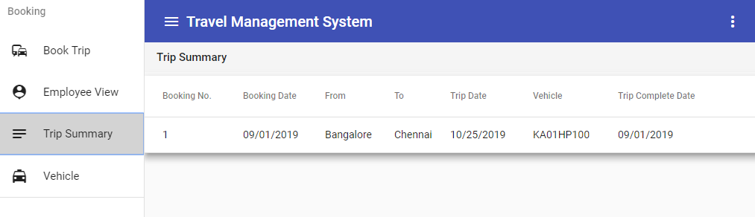

**User Profile/Logout**

