GOVERNMENT OF ANDHRA PRADESH
ANDHRA PRADESH CAPITAL REGION DEVELOPMENT AUTHORITY
BUILDING PERMISSION APPROVAL SYSTEM
(BBAS)
ZONAL JOINT DIRECTOR (JD) PORTAL
END-TO-END WORKFLOW & USER INSTRUCTION MANUAL
Administrative Persona: Mr. K Praveena, Zonal Joint Director (JD)
Jurisdictional Authority: APCRDA / Urban Development Directorate
System URL: https://bbas.ap.gov.in/SWC.Admin/Home.aspx
Standard Reference: AP Building Rules 2017 & APCRDA Building Regulations
Document Version: Release 2026.1 | Comprehensive Operational Workflow Guide

Table of Contents
1. Document Purpose and Administrative Scope
2. Portal Navigation & Dashboard Interface
3. Module: Registration — Developer Verification
4. Module: Registration — Technical Professional Licensing
4.1 In Process queue & credential review (Reg No: 840024592)
4.2 Rejected registration applications register
4.3 Approved registration queue & Council of Architecture review (Reg No: ca/20008/42604)
4.4 All Approved master register & Structural Engineer review (Reg No: SE/GR-1/2019/03/063)
5. Module: Application Status Monitoring
5.1 Review Proceeding console
5.2 Proceeding Issued archive
5.3 Revoke Proceeding cancellation register
6. Module: Proceeding Status & Notice Administration
6.1 Verified proposals adjudication queue
6.2 Shortfall notices queue
6.3 Review Shortfall Submission queue
6.4 Show Cause statutory notices queue
6.5 Review Show Cause Submission queue
7. Module: Change of Technical Professional Request
8. Module: Outward Register Console
9. Proposal Scrutiny Walkthrough 1: Application 1168/0001/BP/10/020/2025
9.1 General Information verification
9.2 Applicant Information verification
9.3 Plot Details & land reservation
9.4 Statutory Application Checklist evaluation
9.5 Document Checklist & previous recommendations
9.6 Others Tab (solar, environmental, special parameters)
9.7 Site Inspection verification & ground reality
9.8 Draft Building Permit Order (BPO1.pdf) preview
9.9 Architectural Drawings & BIM Scrutiny
9.10 Treasury Payment Realization
10. Proposal Scrutiny Walkthrough 2: Application 1168/0026/BP/10/020/2025
10.1 General Information (Draft Mode Shortfall Scrutiny)
10.2 Applicant Information & submitting professional particulars
10.3 Plot Details, road widening, and existing road widths
10.4 Application Checklist responses
10.5 Document Checklist & Directorate Shortfall items
10.6 Registered Mortgage Deed & CAR Policy validation
10.7 Site Inspection Review: Physical construction progress (Slabs Laid)
10.8 Draft Permit Order Endorsement Preview
10.9 Apply for NOCs: External Fire Services clearance
10.10 Drawing scrutiny & recommendation history
10.11 Payment Reconciliation (Total Fees: Rs. 36,552.00)
11. Proposal Scrutiny Walkthrough 3: Application 1168/0002/BP/10/020/2025
11.1 General Information (Low Risk Category, Proceeding Verified)
11.2 Applicant & Technical Professional credentials
11.3 Plot Details, compound wall, and TDR verification
11.4 Application Checklist & remarks
11.5 Document Checklist: Primary and additional title deeds
11.6 Others Tab: Registered Mortgage Deed No. & solar panel status
11.7 Letter Preview: Building Permit Order (BPO1.pdf)
11.8 Apply for NOCs: External Fire clearance validation
11.9 Drawing & BIM Scrutiny: Final BIMDCR verification
11.10 Payment Realization: Total Fees Rs. 32,669.00
12. End-to-End Operational Lifecycle & Decision Matrix

Chapter 1: Document Purpose and Administrative Scope
The Building Permission Approval System (BBAS) is the unified spatial e-governance platform of Andhra Pradesh, integrating the Andhra Pradesh Capital Region Development Authority (APCRDA), Directorate of Town and Country Planning (DTCP), and Urban Local Bodies (ULBs).
The Zonal Joint Director (JD) portal workspace functions as the apex regional regulatory and supervisory console. In this role, the Zonal Joint Director (Mr. K Praveena) exercises statutory powers to:
- Developer Registration: Supervise developer and builder credentials across the capital region and urban zones.
- Technical Professional Licensing: Verify, approve, and maintain the professional register of Architects, Engineers, Structural Engineers, and Town Planners.
- High-Tier Building Sanction: Adjudicate complex, commercial, high-rise, and institutional proposals escalated from lower scrutiny tiers.
- Quasi-Judicial Notice Administration: Issue formal Shortfall Letters and statutory Show Cause notices for deviations, unauthorized works, or title ambiguities.
- Change of Technical Professional: Review and authorize owner requests to transfer active building proposals between technical professionals.
- Statutory Outward Dispatch: Maintain an official statutory log of all dispatched sanction orders and formal communications.

Chapter 2: Portal Navigation & Dashboard Interface
The Zonal Joint Director workspace provides a secure, intuitive dashboard designed for high-throughput scrutiny and administrative decision-making.
1. Open the Browser: Access the secure administration gateway URL: https://bbas.ap.gov.in/SWC.Admin/Home.aspx.
2. User Header Block: Confirm the active session displays: Mr. K Praveena [Last Login on: 09/09/2026 PM] [Zonal Joint Director] and the APCRDA emblem.
3. Sidebar Navigation Hierarchy: The left panel contains collapsible operational modules: Registration, Application Status, Proceeding Status, Change of Technical Professional, and Outward.
4. Global Keyword Search: Use the search bar at the top of tables to filter proposals by Application Number, Applicant Name, Mandal, Survey Number, or Status.

Chapter 3: Module: Registration — Developer Verification
The Developer Verification sub-module enables the Zonal Joint Director to evaluate and verify developer/builder credentials, real estate companies, and firms undertaking group housing and commercial layouts.
1. Navigate to Module: Expand the Registration menu on the left sidebar and click Developer Verification.
2. Console Overview: The console presents tabbed registries: Registration Pending and Registered.
3. Search & Verification Fields: Filter applications using Type of Firm, PAN Card No., Name of Firm, Contact Number, and Certificate Number.
4. Credential Validation: Inspect incorporation certificates, partnership deeds, RERA registration numbers, and financial track records prior to granting development licenses.
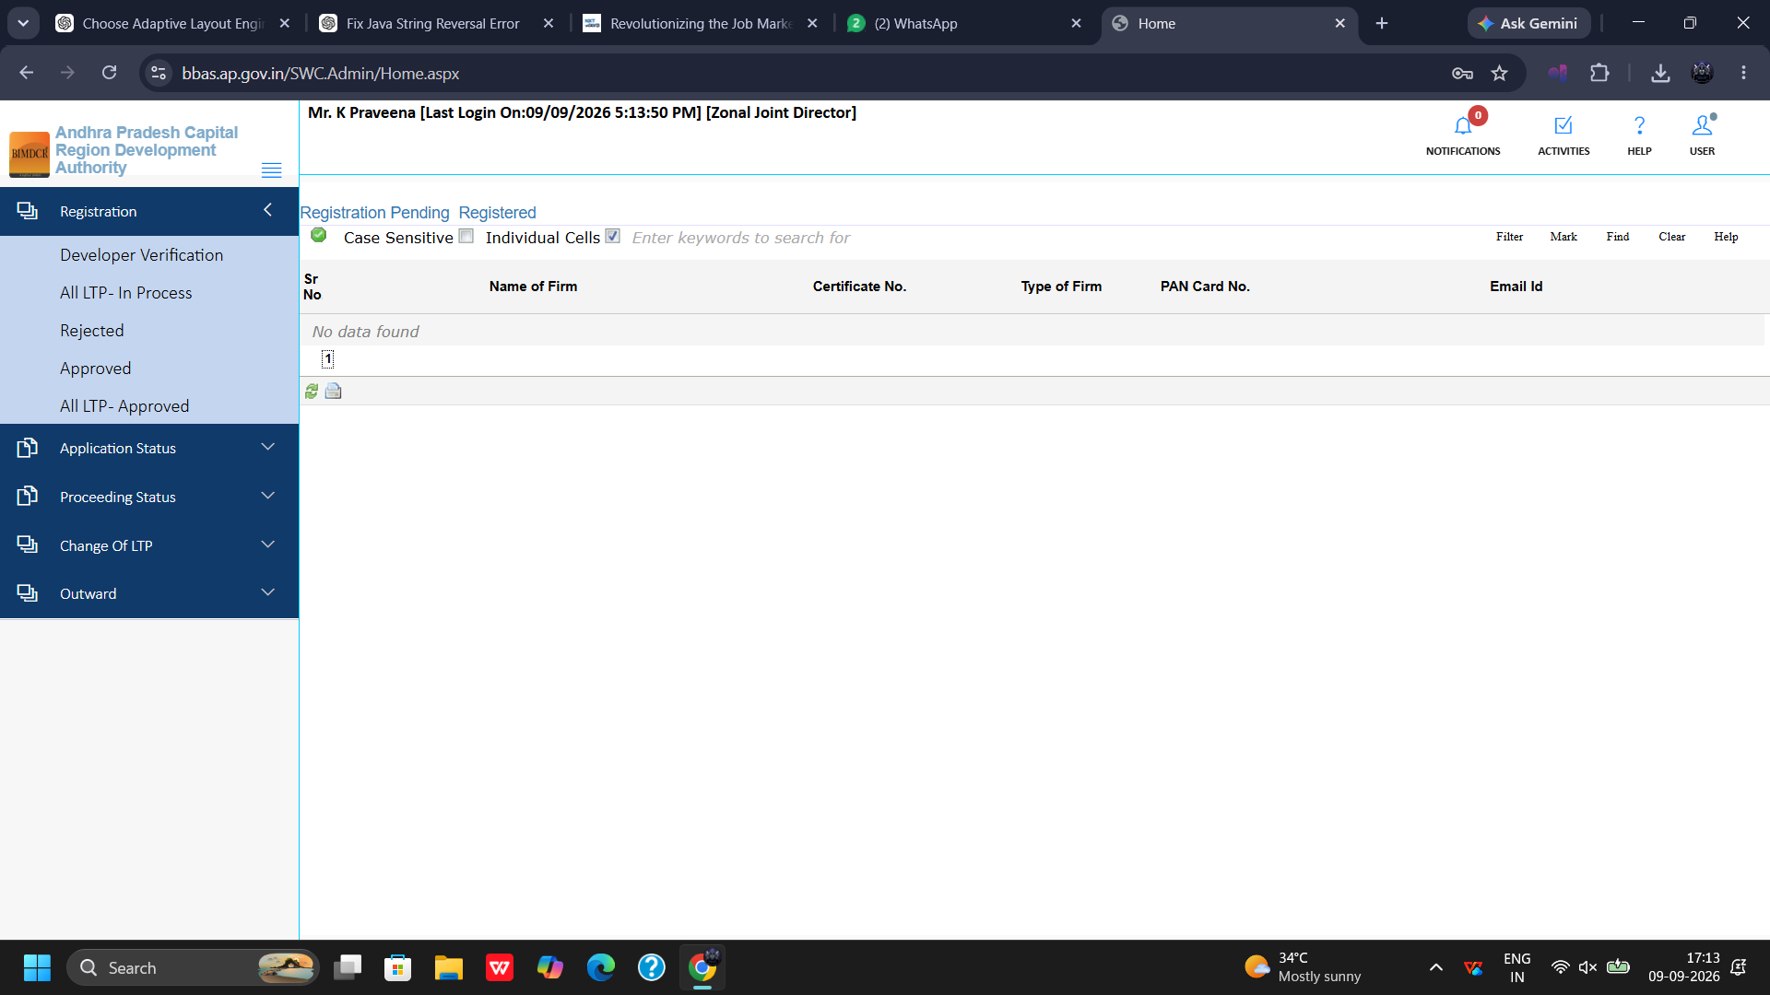
Figure 3.1 — Registration >> Developer Verification: Pending and Registered Developer Overview

Chapter 4: Module: Registration — Technical Professional Licensing
The Zonal Joint Director is the licensing authority for technical professionals (Architects, Engineers, Structural Engineers, and Supervisors) practicing within the urban jurisdiction.

4.1 In Process Queue & Candidate Credential Verification
The In Process queue displays technical professional license applications pending senior administrative verification:
1. Open Queue: Click Registration >> In Process to review pending dossiers.
2. Application Grid: Review Initial Registration Number, Person Name, Registration Type, Email ID, and Contact Number.
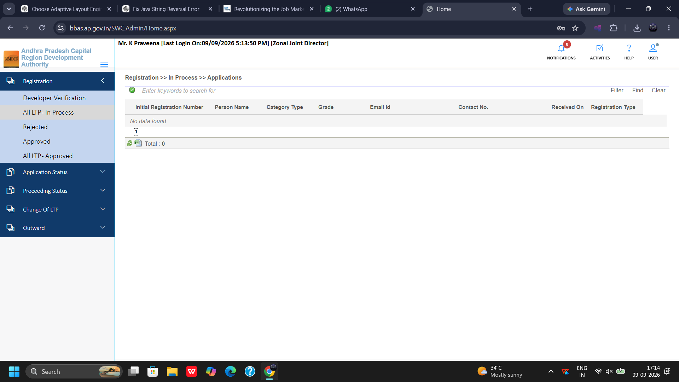
Figure 4.1 — Registration >> In Process: Technical Professional Applications Queue
3. Open Candidate Dossier: Click the candidate row to launch the Professional / Consultant Registration Portal for applicant Abhijeet Manohar (Registration Number: 840024592).
4. Verify Personal Particulars: Check Full Name, Total Professional Experience (in years), Firm Name (Employed or Self Registered), PAN Number, and Aadhaar Number.
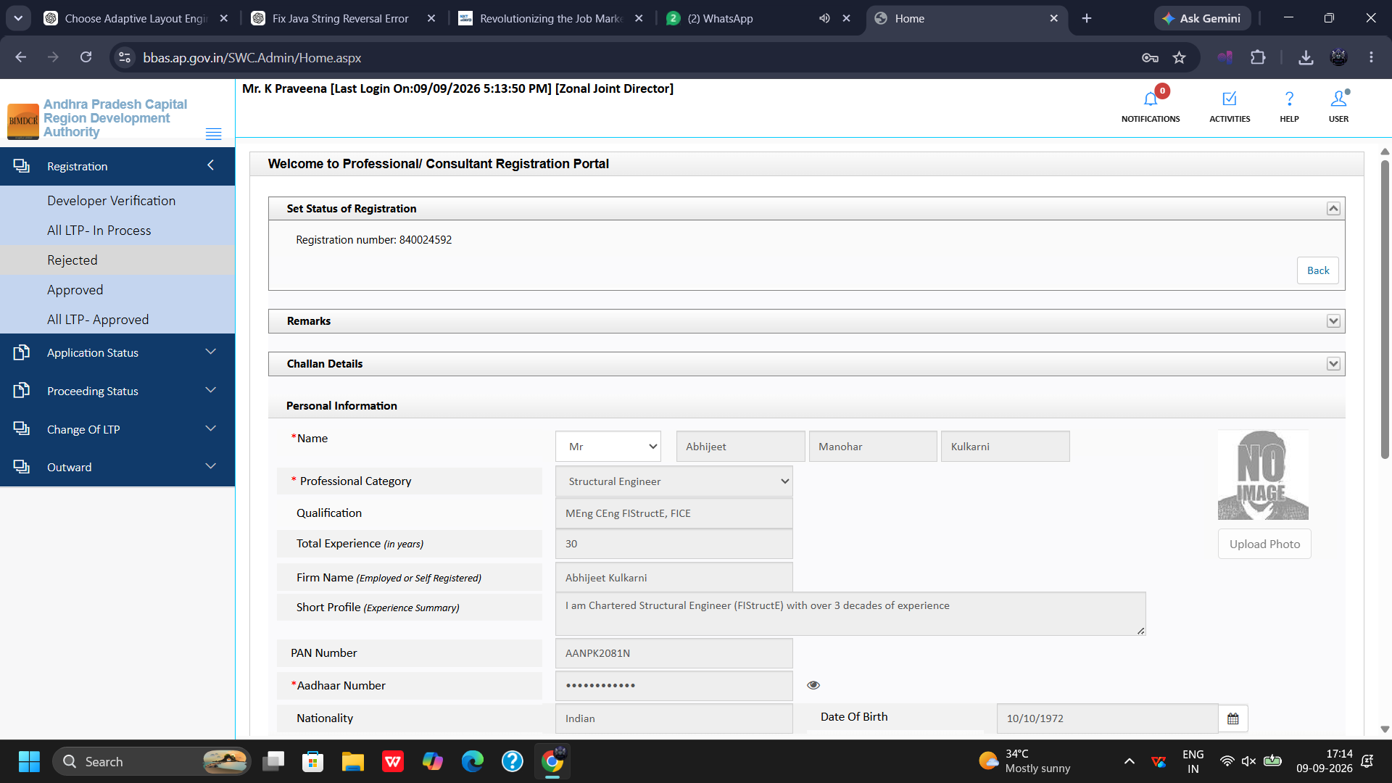
Figure 4.2 — Professional/Consultant Portal: Experience, PAN, and Aadhaar Verification (Reg No: 840024592)
5. Verify Contact & Postal Details: Scroll down to inspect Date of Birth, Gender, Mobile Number, Email ID, Postal Address, City, State, and Pin Code.
6. Adjudication Decision: Select Set Status of Registration, input administrative remarks, and click Submit to grant or hold the registration.
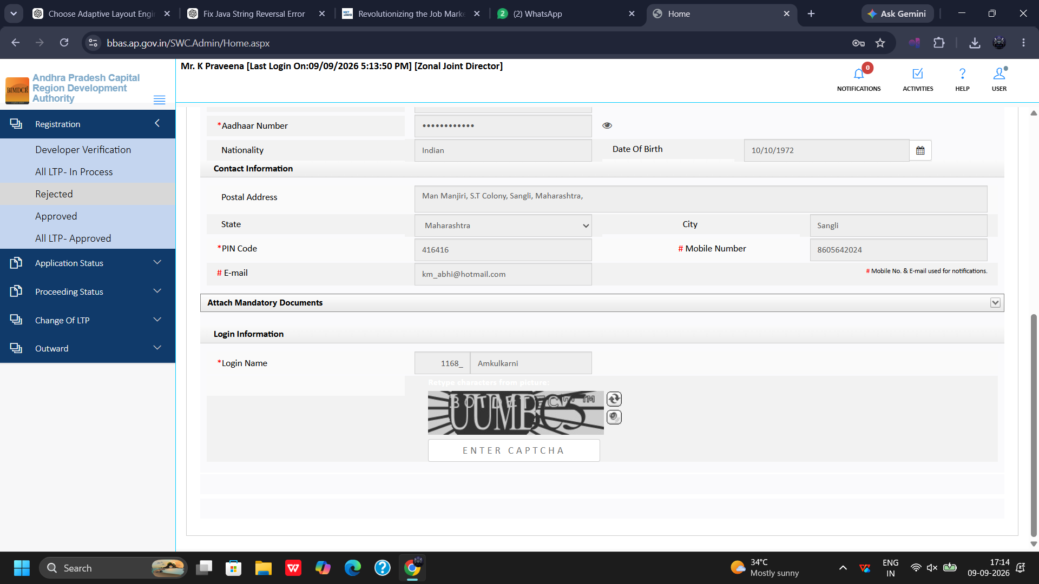
Figure 4.3 — Professional/Consultant Portal: Postal Address, City, State, and Identification Details

4.2 Rejected Registration Applications Register
The Rejected sub-module maintains an official statutory record of registration applications returned or rejected due to insufficient qualifications, invalid Council certificates, or documentation discrepancies:
1. Open Register: Click Registration >> Rejected to view rejected files.
2. Registry Attributes: Inspect Person Name, Initial Registration Number, Email ID, Mobile Number, and specific grounds for rejection.
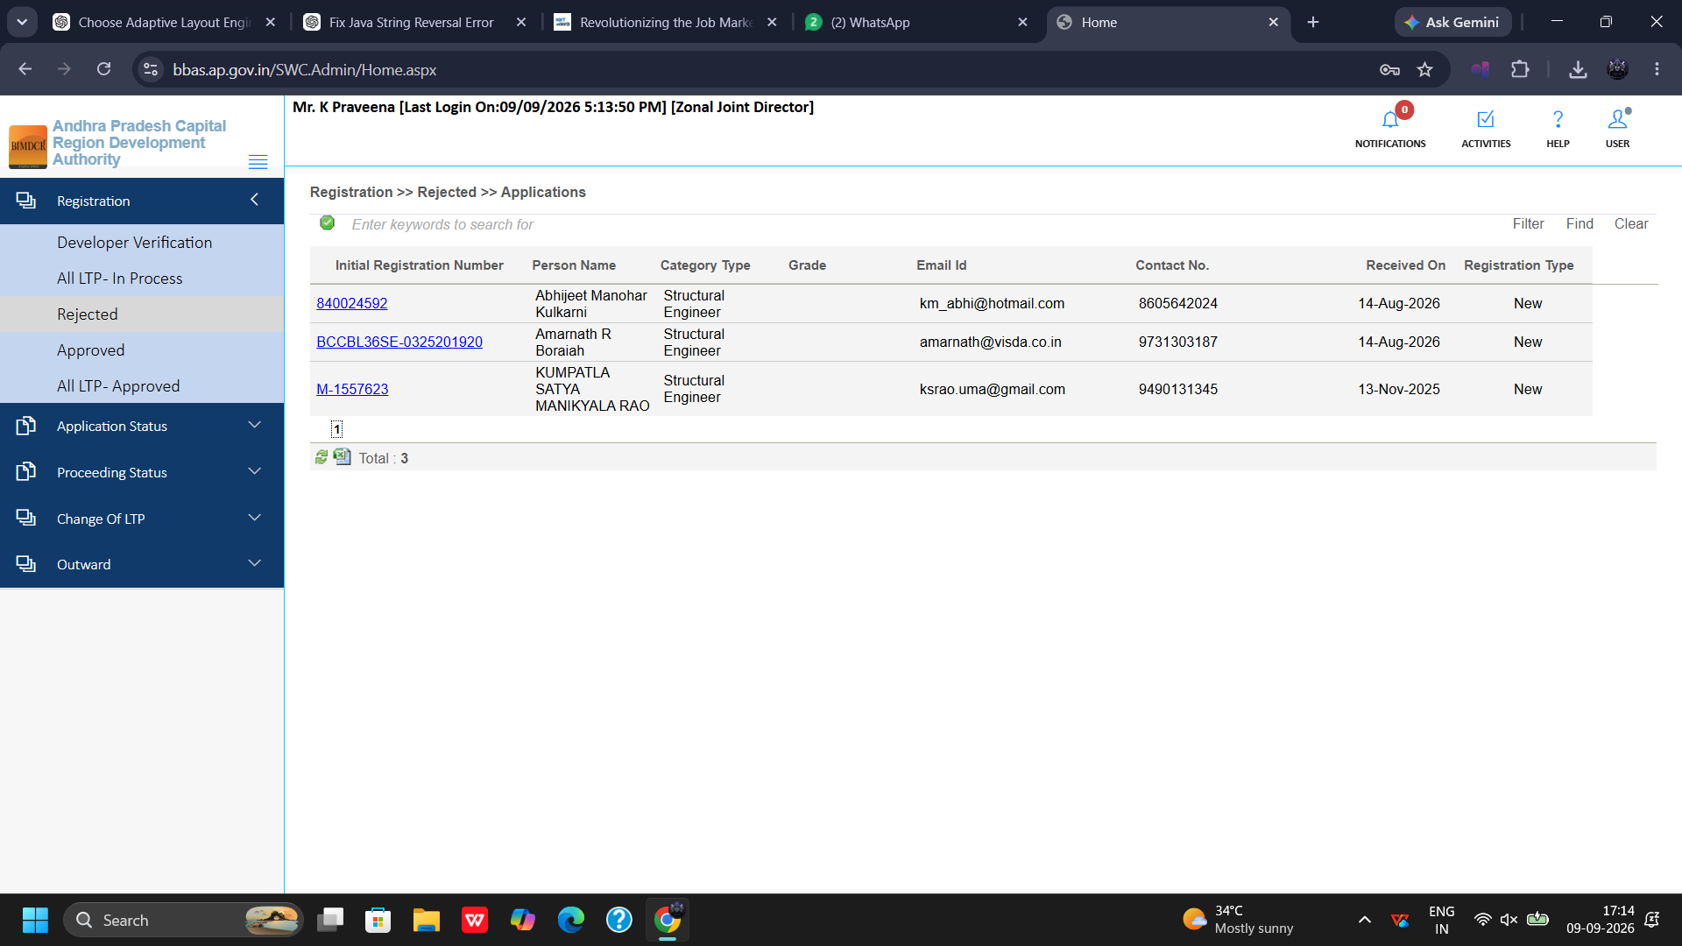
Figure 4.4 — Registration >> Rejected: Rejected Professional Applications Register

4.3 Approved Registration Queue & Council of Architecture Review
The Approved queue records granted technical professional licenses. The JD can open active dossiers to verify Council of Architecture credentials:
1. Open Approved Queue: Click Registration >> Approved to view currently active registrations (Total 4 in current batch).
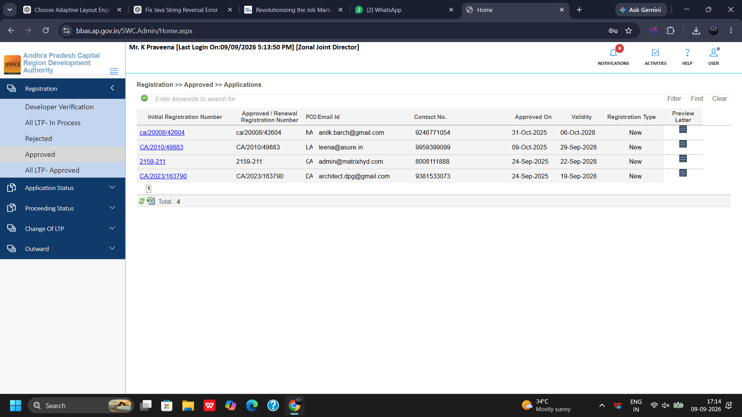
Figure 4.5 — Registration >> Approved: Approved Technical Professionals Queue
2. Review Council Credentials: Open registration dossier for NAGANJANEYULU KOTHAPUDI (Registration Number: ca/20008/42604). Verify statutory Council of Architecture registration number, validity dates, and professional experience.
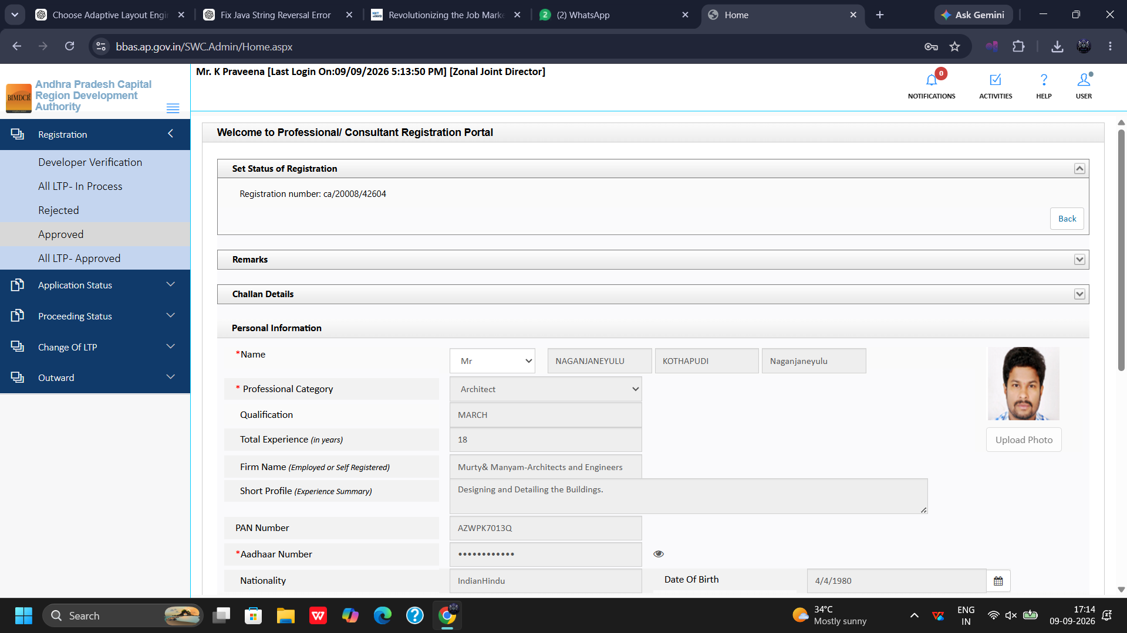
Figure 4.6 — Professional/Consultant Portal: Council of Architecture Credentials Review (Reg No: ca/20008/42604)
3. Verify Contact Records: Inspect postal address, registered mobile number, email address, and institutional affiliation.
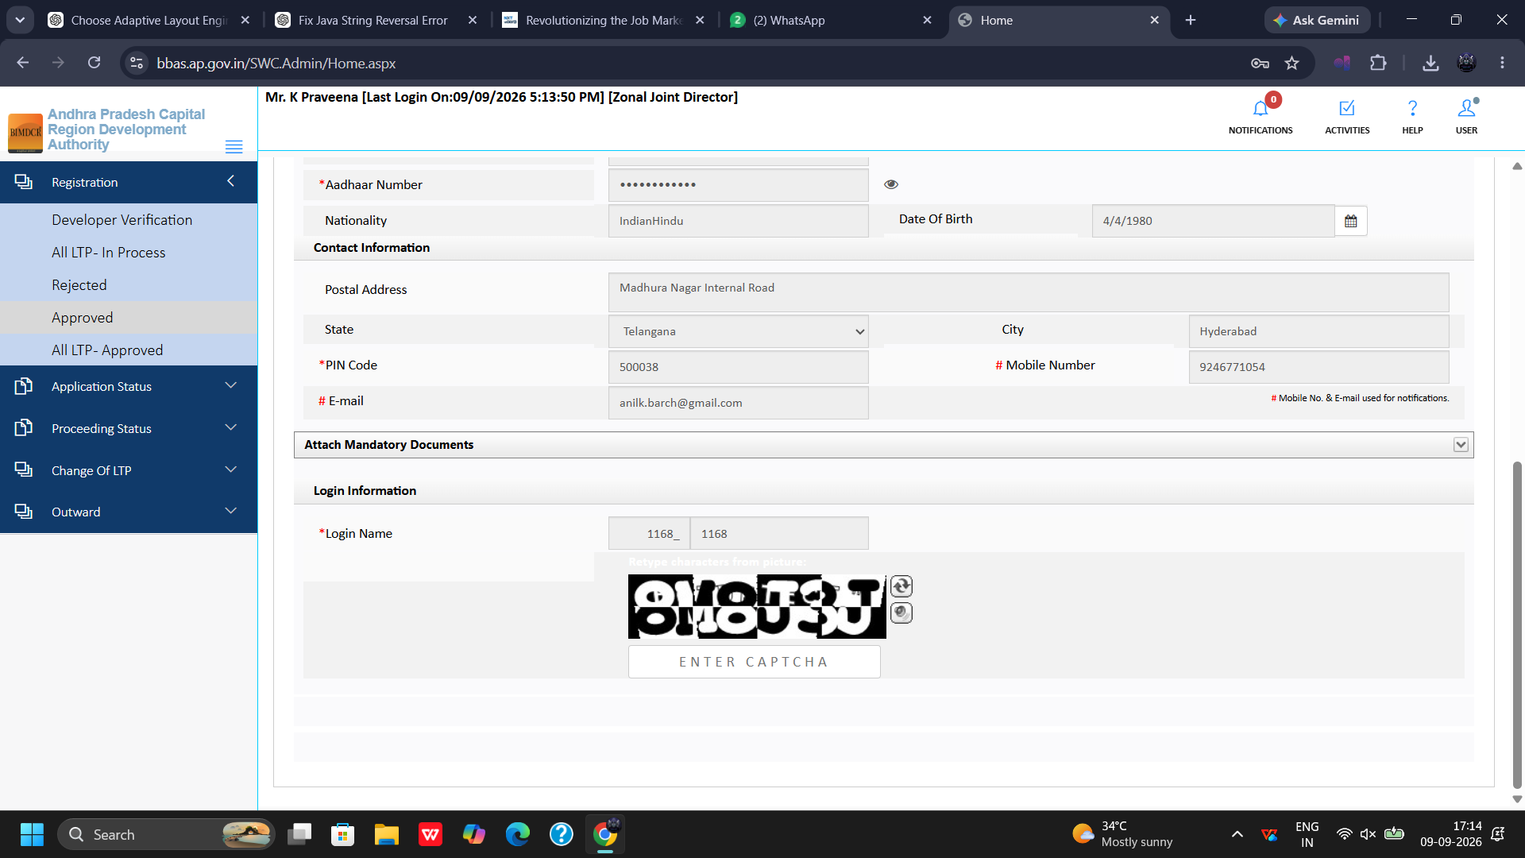
Figure 4.7 — Professional/Consultant Portal: Contact Information and Communication Verification

4.4 All Approved Master Register & Structural Engineer Dossier
The All Approved register serves as the complete master directory of certified technical professionals (26 registered professionals):
1. Open Master Directory: Click Registration >> All Approved to view the comprehensive roster.
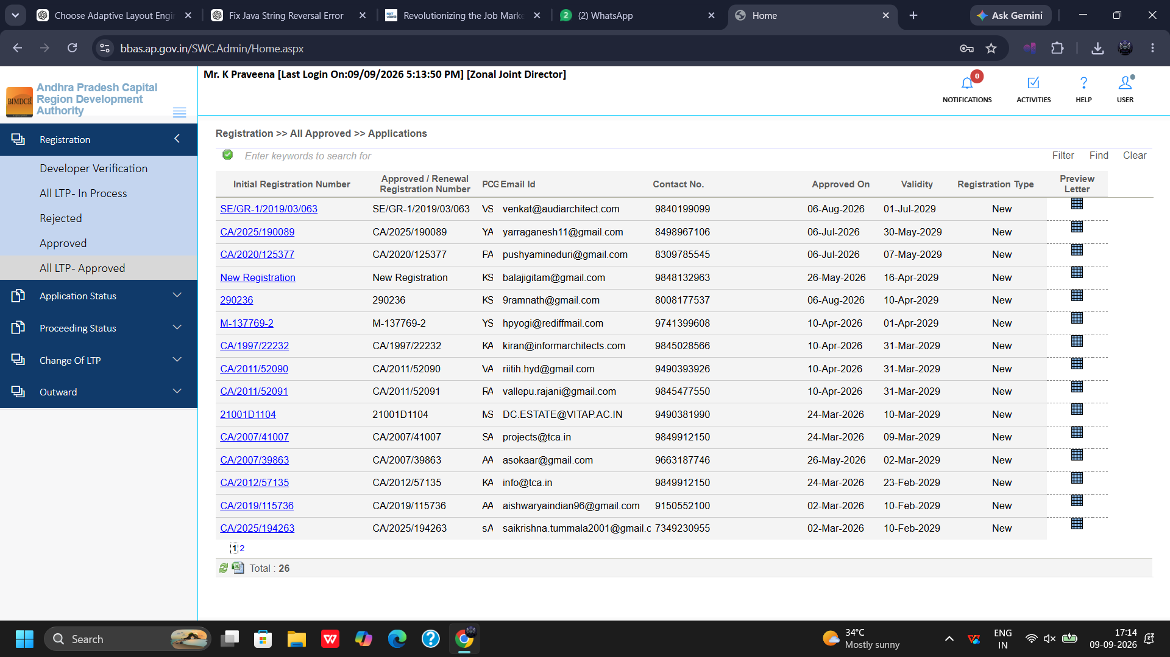
Figure 4.8 — Registration >> All Approved: Master Register of Approved Technical Professionals (26 Records)
2. Review Structural Engineer Grade-1 Dossier: Inspect registration dossier for Structural Engineer Venkatasubbarao (Registration Number: SE/GR-1/2019/03/063). Verify structural engineering degree, institutional vetting qualifications, and competency certificate.
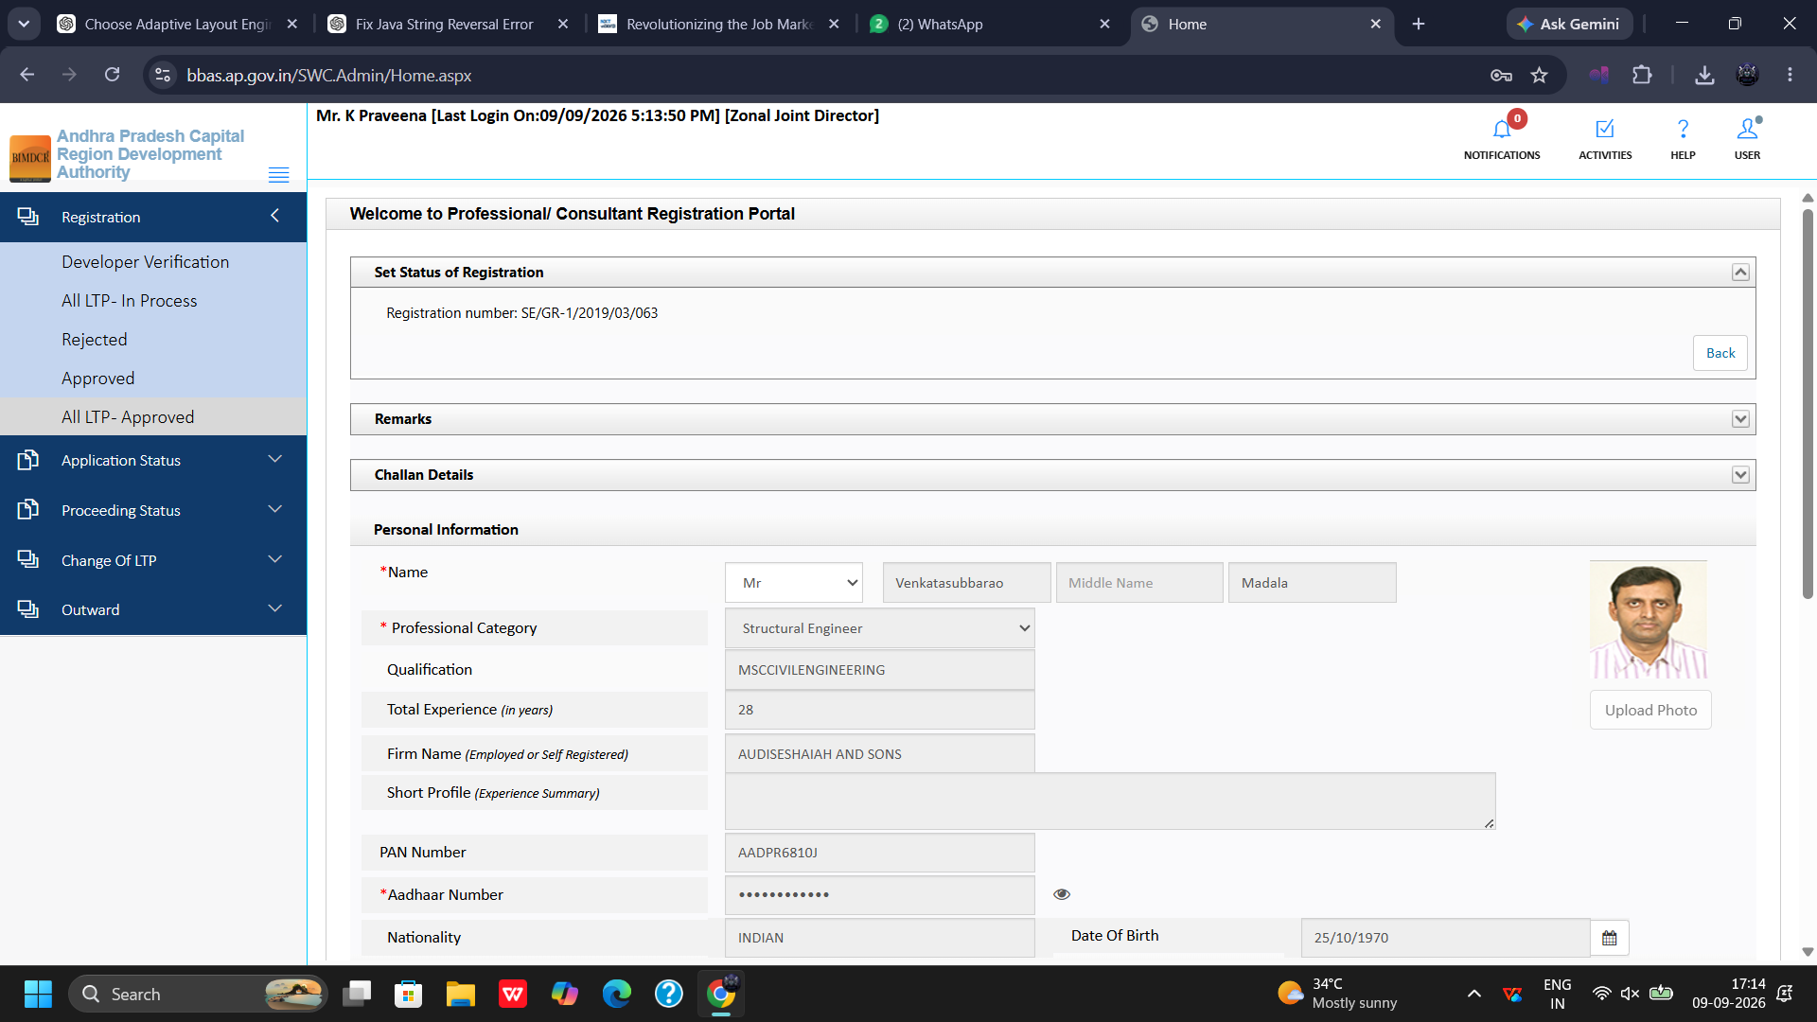
Figure 4.9 — Professional/Consultant Portal: Structural Engineer Grade-1 Dossier (Reg No: SE/GR-1/2019/03/063)
3. Verify Structural Engineer Identity Records: Cross-check Aadhaar verification, PAN validation, postal address, and active municipal jurisdiction.
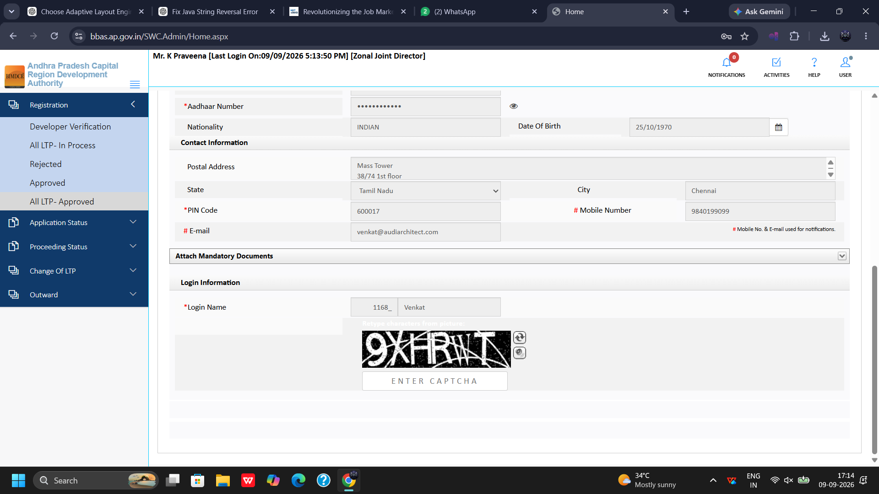
Figure 4.10 — Professional/Consultant Portal: Identity, Nationality, and Address Verification

Chapter 5: Module: Application Status Monitoring
The Application Status module provides high-level administrative tracking of proposals across the regional development directory.

5.1 Review Proceeding Console
Tracks building proposals currently undergoing active review across various zonal desks:
1. Navigate: Click Application Status >> Review Proceeding.
2. Operational Columns: Displays File Number, Assigned Officer, Submission Date, Current Status, and Action controls.
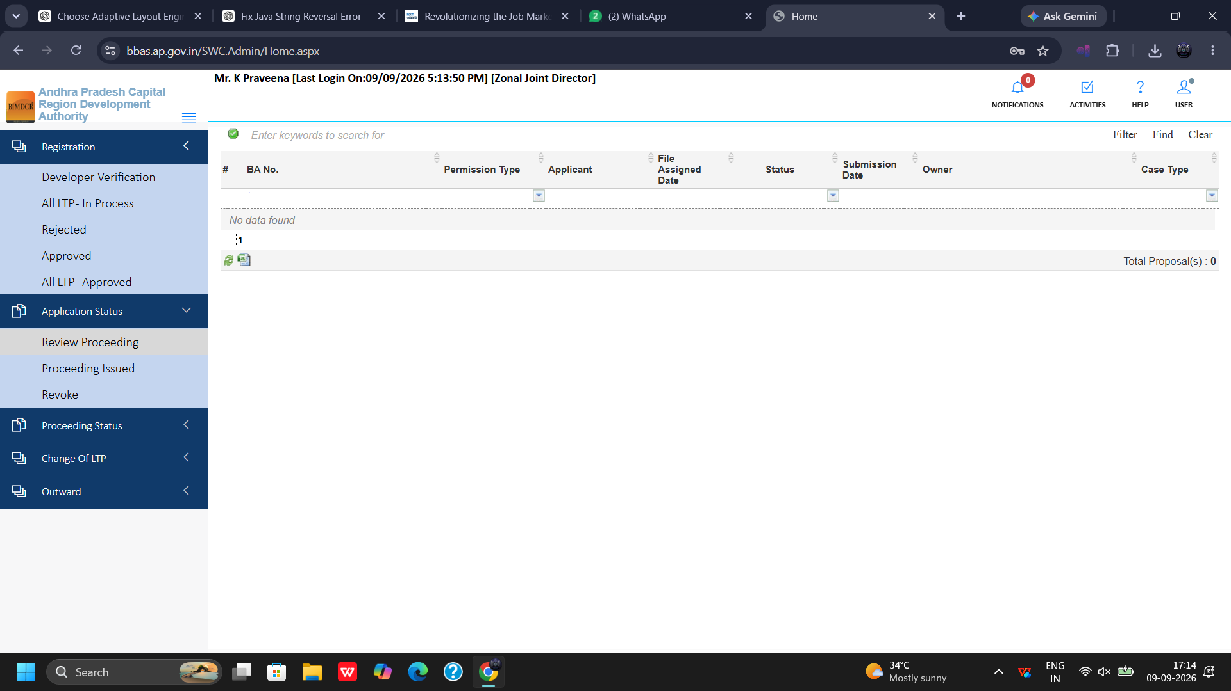
Figure 5.1 — Application Status >> Review Proceeding: Assigned Proposals Queue

5.2 Proceeding Issued Archive
Archives all building permission proposals where formal Building Permit Orders have been approved and sanctioned:
1. Navigate: Click Application Status >> Proceeding Issued.
2. Repository Access: Allows instant retrieval of sanctioned plans, approval proceedings, and receipt vouchers.
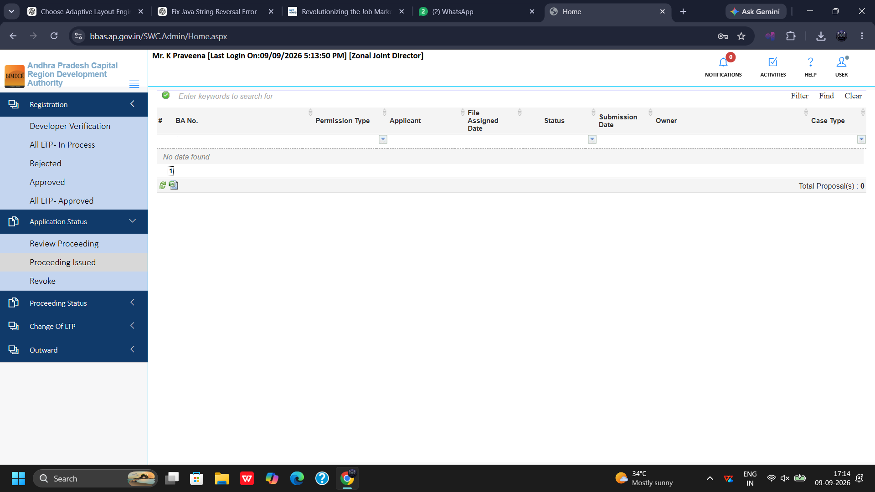
Figure 5.2 — Application Status >> Proceeding Issued: Approved Building Sanctions Archive

5.3 Revoke Proceeding Cancellation Register
Maintains an official registry of building permissions revoked or cancelled due to statutory violations, court injunctions, or fraudulent representations:
1. Navigate: Click Application Status >> Revoke Proceeding.
2. Revocation Details: Contains revocation order numbers, legal grounds, and dispatch acknowledgments.
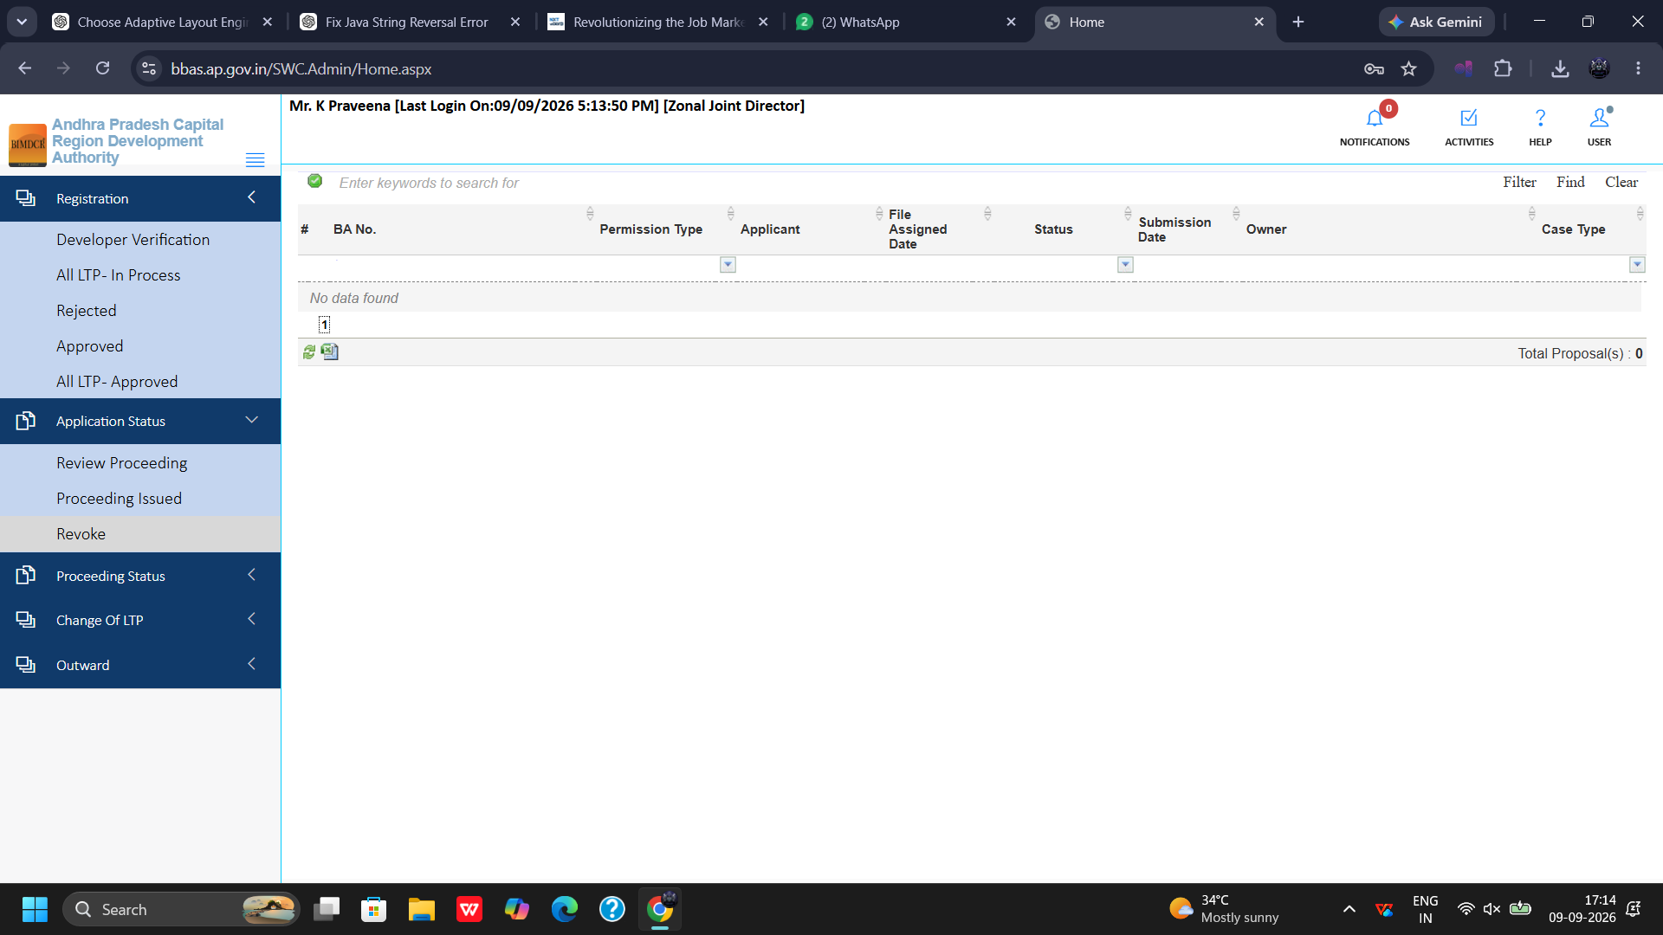
Figure 5.3 — Application Status >> Revoke Proceeding: Cancelled and Revoked Proposals Registry

Chapter 6: Module: Proceeding Status & Notice Administration
The Proceeding Status module represents the core operational console where the Zonal Joint Director adjudicates verified building proposals, issues statutory shortfall notices, and oversees enforcement proceedings.

6.1 Verified Proposals Adjudication Queue
Building proposals that have passed preliminary scrutiny by Town Planning Assistants and Planning Officers arrive in the Verified queue for senior sanction:
1. Navigate: Click Proceeding Status >> Verified.
2. Review Action: Click the proposal row (e.g., 1168/0001/BP/10/020/2025) to launch the comprehensive scrutiny console.
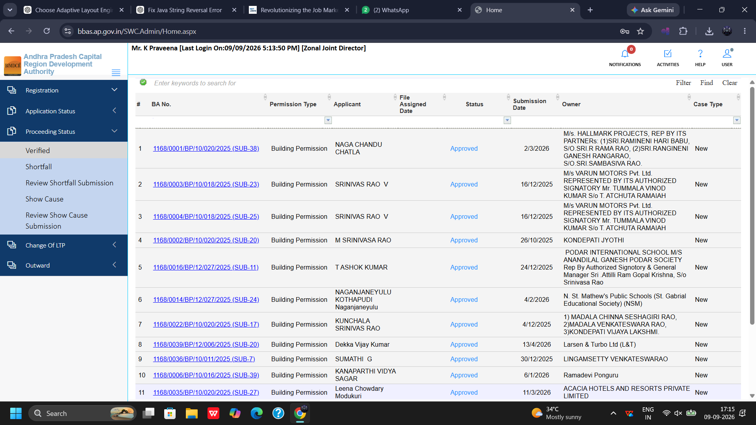
Figure 6.1 — Proceeding Status >> Verified: Escalated Proposals Awaiting JD Sanction

6.2 Shortfall Notices Queue
When a proposal exhibits documentation gaps, missing NOCs, or design discrepancies, the JD issues a formal Shortfall Letter:
1. Navigate: Click Proceeding Status >> Shortfall to view proposals returned to applicants.
2. Tracking Columns: Monitor File Number, Applicant Name, Shortfall Dispatch Date, and Rectification Window.
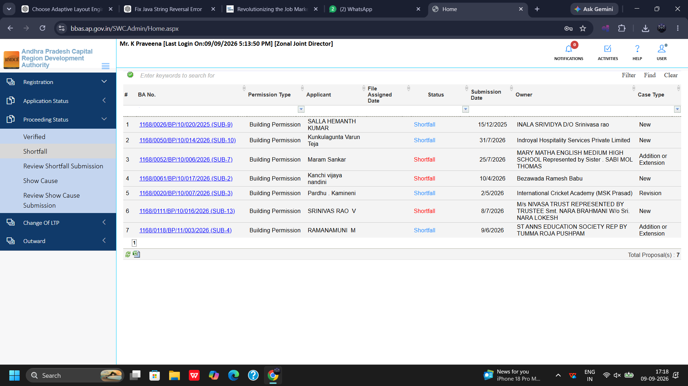
Figure 6.2 — Proceeding Status >> Shortfall: Returned Proposals Awaiting Applicant Rectification

6.3 Review Shortfall Submission Queue
When an applicant addresses shortfall remarks and uploads revised plans or documents, the file re-enters this queue:
1. Navigate: Click Proceeding Status >> Review Shortfall Submission.
2. Scrutiny Workflow: Review applicant's point-by-point compliance statements and revised attachments.
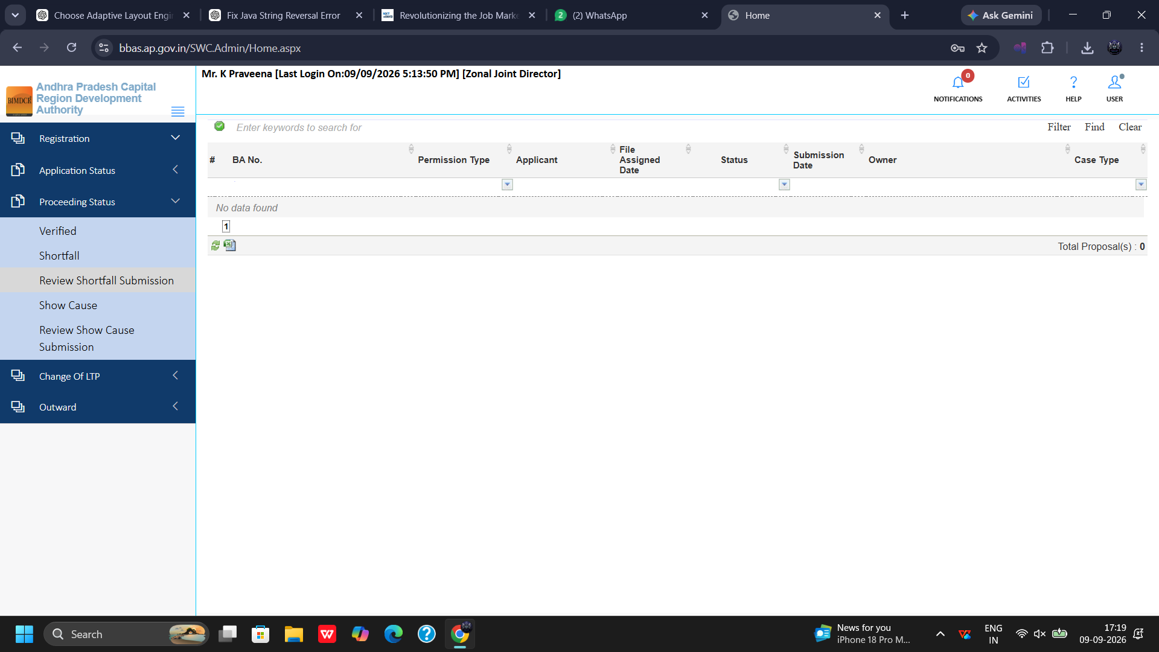
Figure 6.3 — Proceeding Status >> Review Shortfall Submission: Resubmitted Proposals Queue

6.4 Show Cause Statutory Notices Queue
For severe infractions, unauthorized construction, or major zoning violations, the JD issues statutory Show Cause notices:
1. Navigate: Click Proceeding Status >> Show Cause.
2. Legal Tracking: Displays formal notice references, issuance dates, and statutory response deadlines.
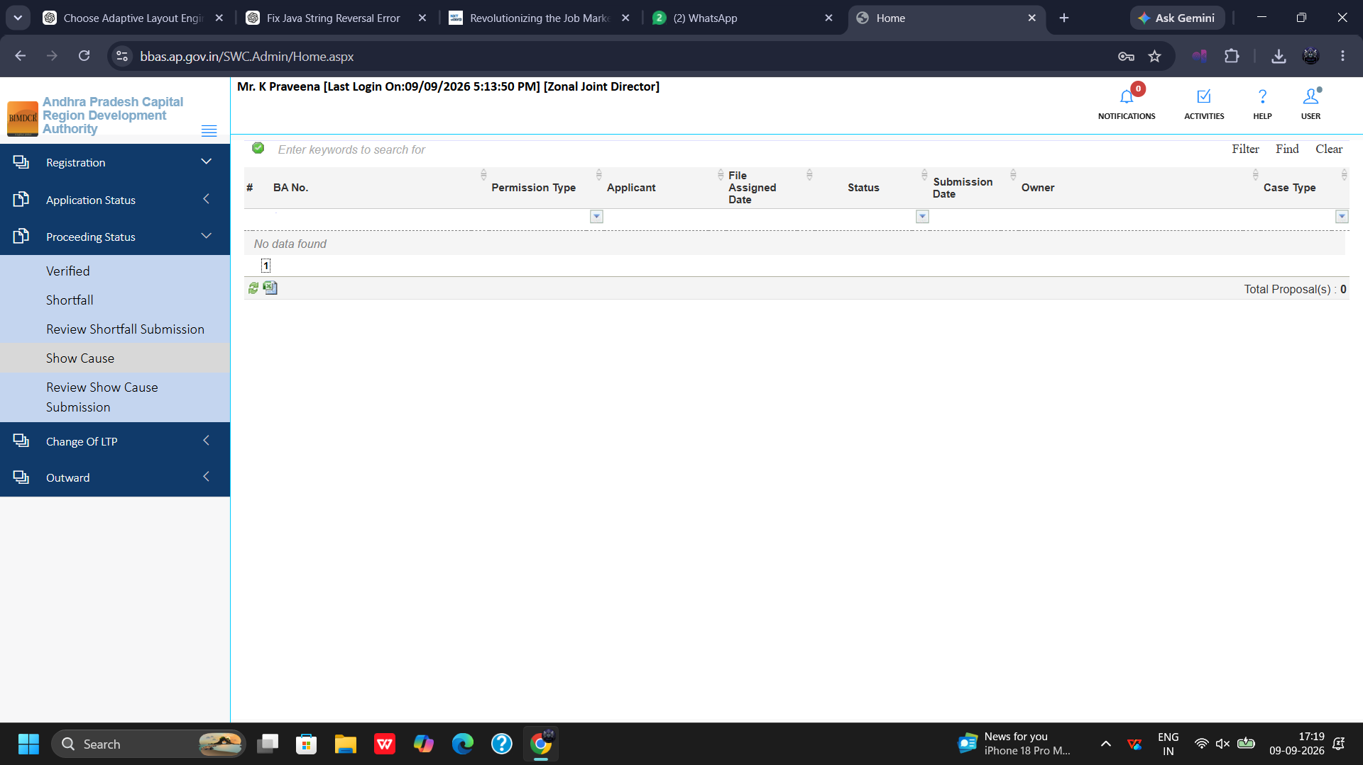
Figure 6.4 — Proceeding Status >> Show Cause: Enforcement Notices Registry

6.5 Review Show Cause Submission Queue
Receives formal legal explanations submitted by applicants in response to Show Cause notices:
1. Navigate: Click Proceeding Status >> Review Show Cause Submission.
2. Adjudication: Evaluate applicant defenses, legal submissions, and schedule personal hearings if required.
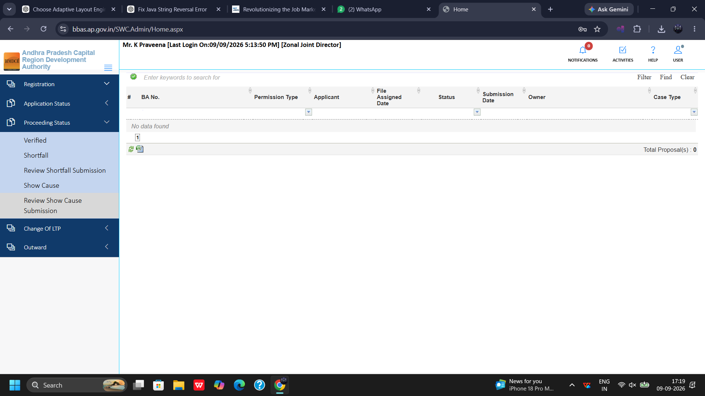
Figure 6.5 — Proceeding Status >> Review Show Cause Submission: Legal Replies Queue

Chapter 7: Module: Change of Technical Professional Request
The Change of Technical Professional module is a dedicated regulatory console in the Zonal Joint Director workspace. It governs the formal transfer of building permission files from one technical professional to another upon property owner request.
1. Access Module: Expand Change of Technical Professional on the left navigation tree and click Change Technical Professional Request.
2. Console Attributes: Review File Number, Assigned Technical Professional, Proposed New Technical Professional, Submission Date, and Owner Request Letter.
3. Mandatory Verification: Confirm submission of No Objection Certificate (NOC) from previous professional or formal notice of termination, professional fee settlement indemnity, and structural responsibility handover.
4. Approval & Reassignment: Upon validation, the JD approves the transfer, re-keying digital drawing submission rights to the newly appointed professional.
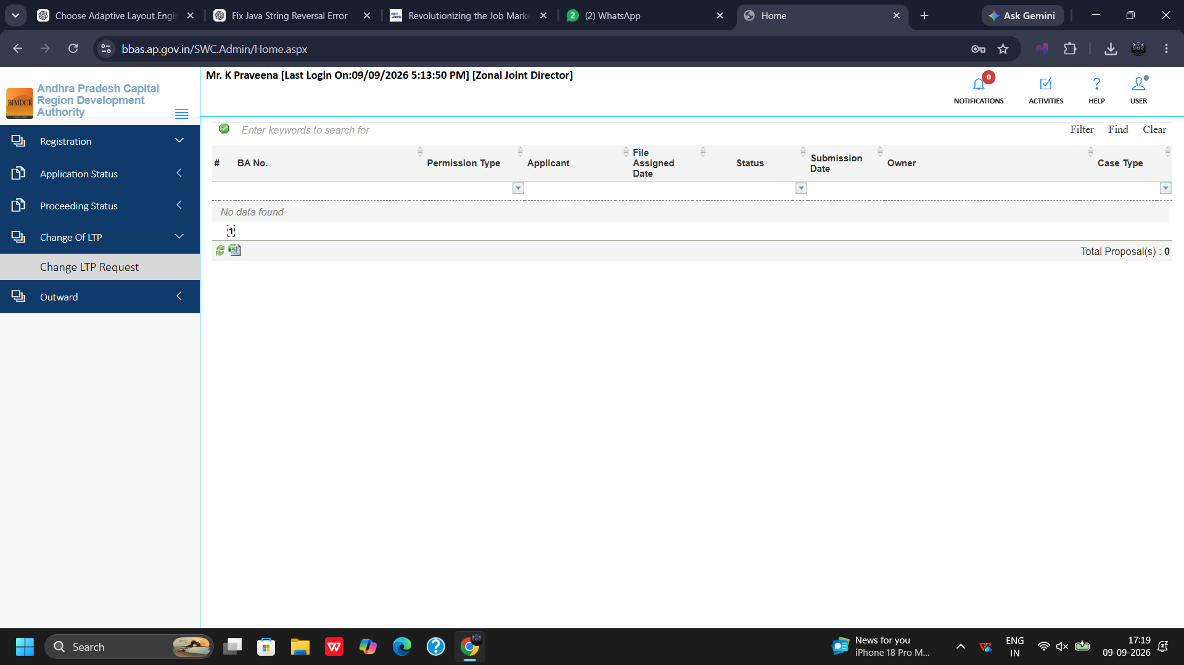
Figure 7.1 — Change of Technical Professional >> Transfer Request Queue

Chapter 8: Module: Outward Register Console
The Outward module provides the statutory dispatch registry of the Zonal Directorate, recording every official communication, sanction proceeding, shortfall letter, and show cause notice dispatched from the office.
1. Open Register: Click Outward >> Outward from the navigation tree.
2. Dispatch Records: The register contains 48 detailed dispatch records tracking File Number, Assigned Date, Dispatch Date, Recipient Particulars, and Mode of Delivery.
3. Statutory Proof: Enables retrieval of digital dispatch receipts, Speed Post tracking references, and physical delivery acknowledgments.
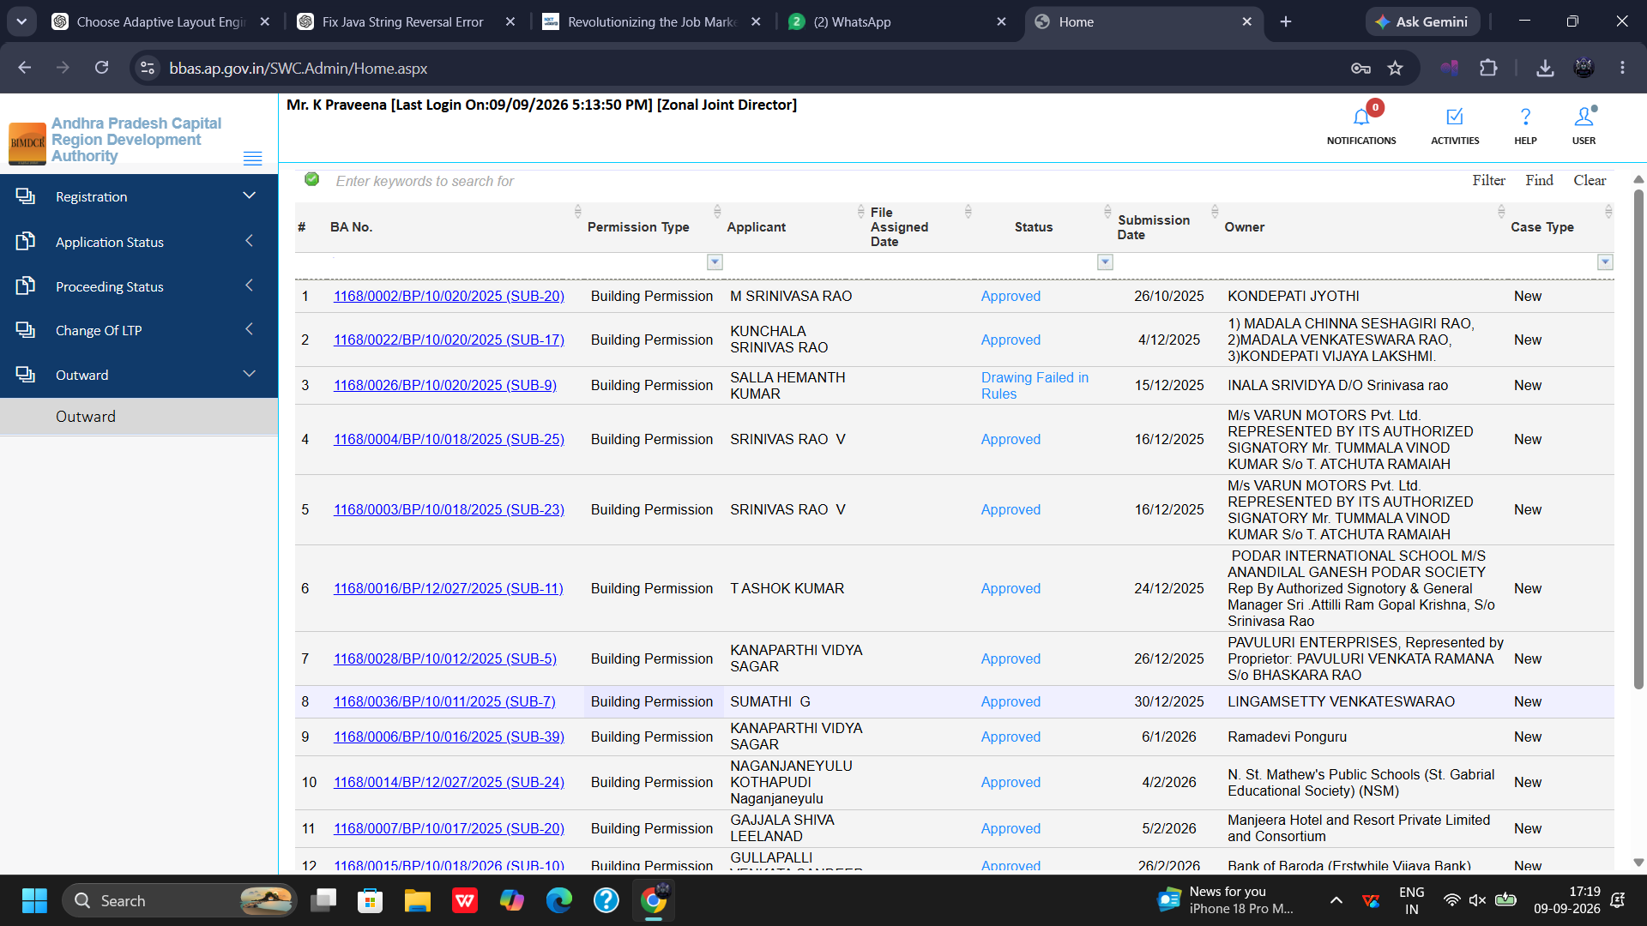
Figure 8.1 — Outward >> Outward: Statutory Dispatch Registry (48 Records)

Chapter 9: Proposal Scrutiny Walkthrough 1: Application 1168/0001/BP/10/020/2025
This chapter details the comprehensive 10-tab technical evaluation of Proposal 1168/0001/BP/10/020/2025 (Proposal Status: Proceeding Verified).

9.1 General Information Verification
The General Information tab establishes the administrative, spatial, and zoning parameters of the proposal:
1. Administrative Demarcation: Verify District, Mandal, Gram Panchayat / Municipality, Ward, and Revenue Village.
2. Project Parameters: Check Case Type (Building Permission), Project Type (Residential / Commercial), Layout Endorsement details, and Master Plan Land Use Zone.
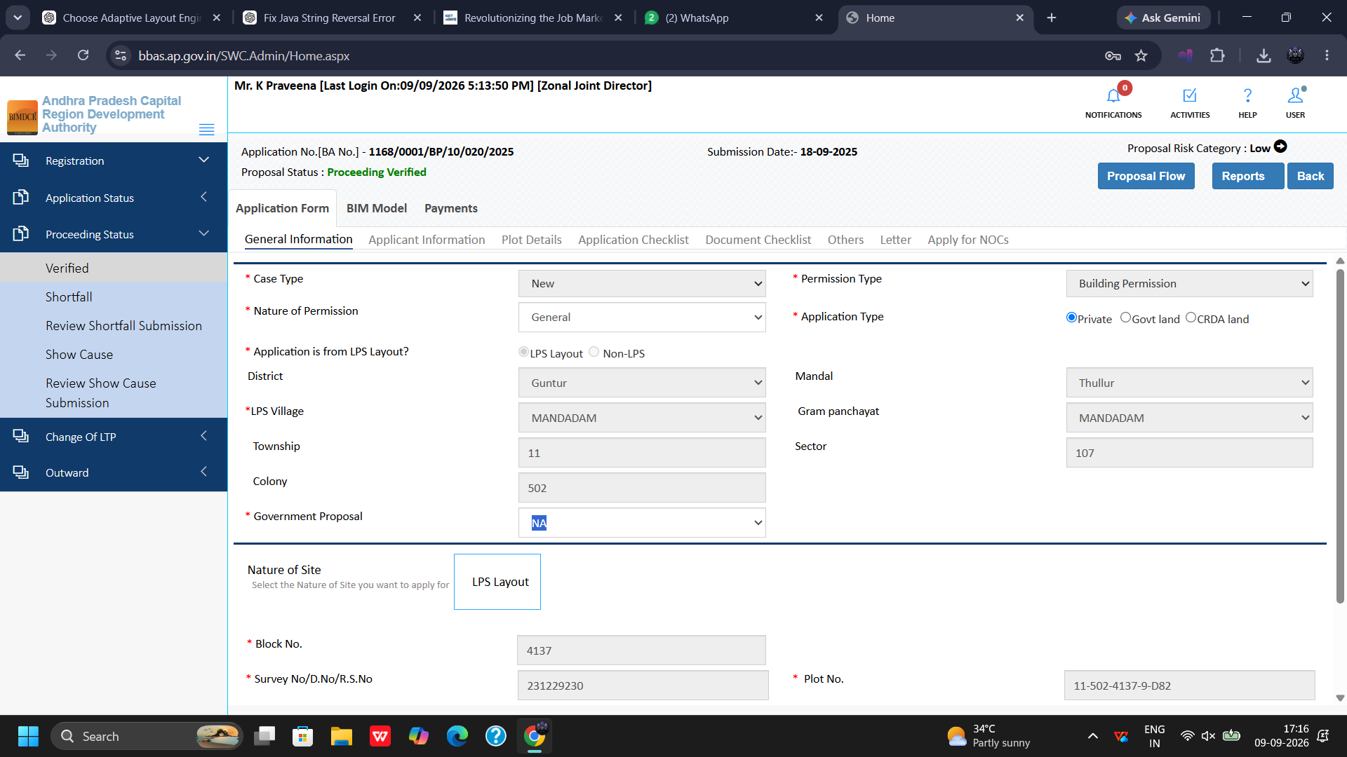
Figure 9.1 — Proposal 1168/0001: General Information & Administrative Demarcation

9.2 Applicant Information Verification
Verifies owner credentials and professional affiliations:
1. Owner Credentials: Verify Applicant Name, Father's/Husband's Name, Registered Mobile Number, and Email Address.
2. Identity Proof: Validate PAN Card Number and Aadhaar identification.
3. Technical Professional Particulars: Verify License Number, Professional Body registration, and authorized contact details of the submitting Architect/Engineer.
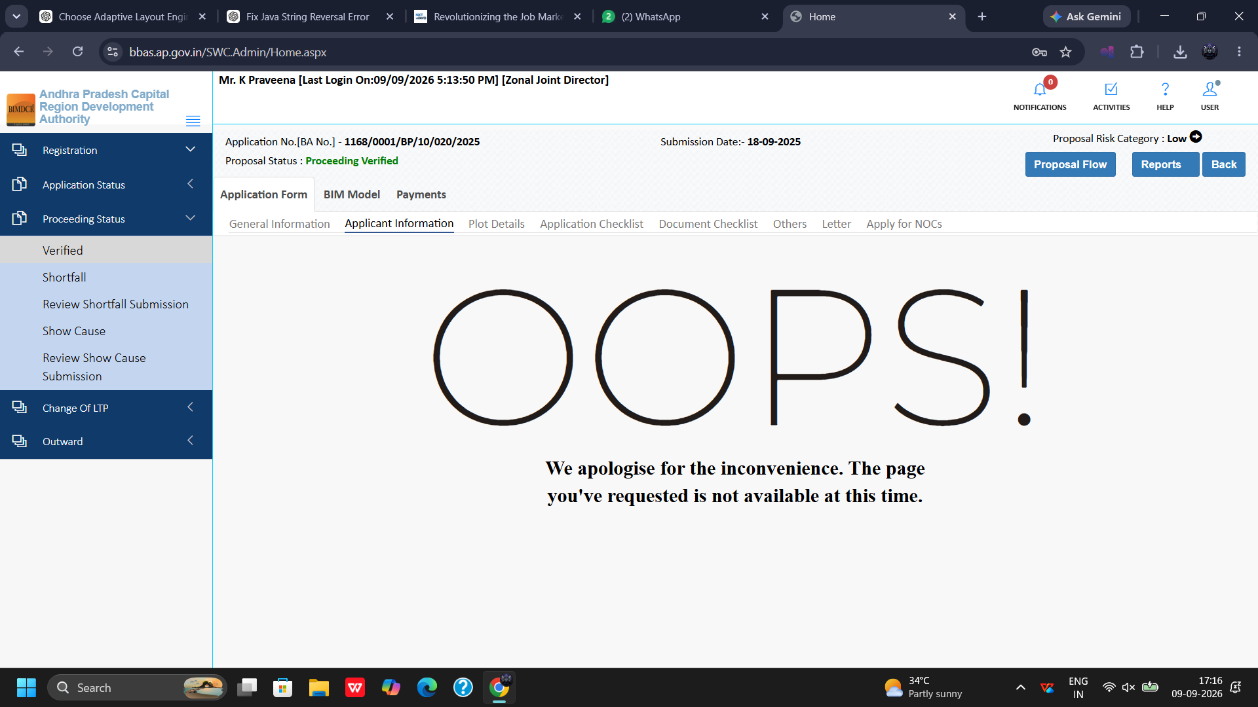
Figure 9.2 — Proposal 1168/0001: Applicant & Technical Professional Particulars

9.3 Plot Details & Land Reservation
Verifies plot geometry, boundaries, and statutory deductions:
1. Plot Dimensions: Check Gross Plot Area, North/South/East/West boundary dimensions, and abutting road widths.
2. Master Plan Reservations: Verify land affected by road widening or green buffer reservations, calculate Net Plot Area, and verify gift deed surrender to the local authority.
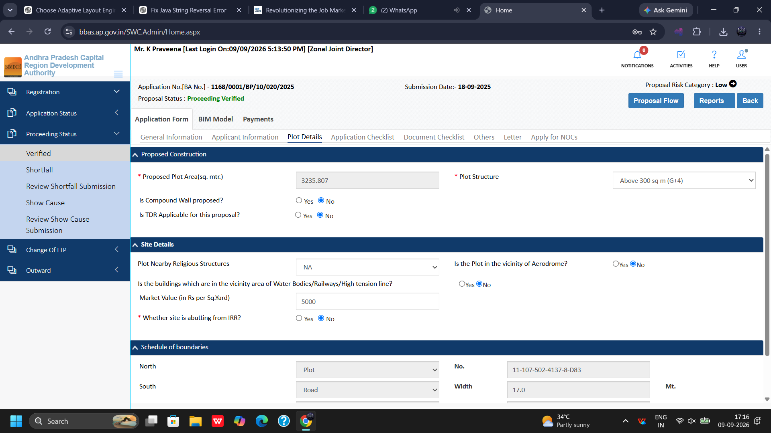
Figure 9.3 — Proposal 1168/0001: Plot Dimensions, Net Area, and Road Reservations

9.4 Statutory Application Checklist Evaluation
The Application Checklist tab contains mandatory statutory questions under the AP Building Rules:
1. Bylaw Compliance: Verify answers to Questions 1 through 19 covering plot status, approved layout validity, setback distances, FSI/FAR compliance, height restrictions, and vehicular parking provisions.
2. Review Remarks: Inspect annotations entered by preliminary scrutiny officers.
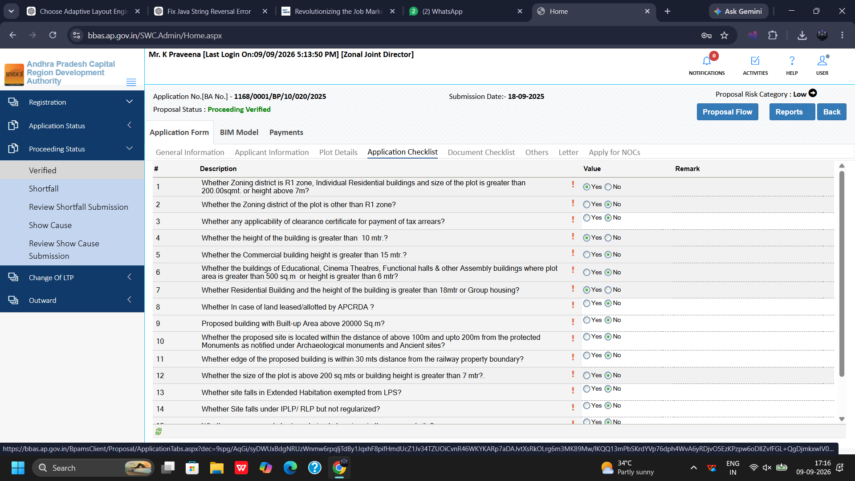
Figure 9.4 — Proposal 1168/0001: Statutory Compliance Checklist Evaluation

9.5 Document Checklist & Previous Recommendations
Evaluates mandatory title deeds and structural stability reports:
1. Document Verification: Inspect uploaded registered sale deed, approved layout plan, 33-year Encumbrance Certificate, property tax receipt, and structural stability certificates.
2. Previous Directorate Recommendations: Review past scrutiny notes and verify applicant compliance.
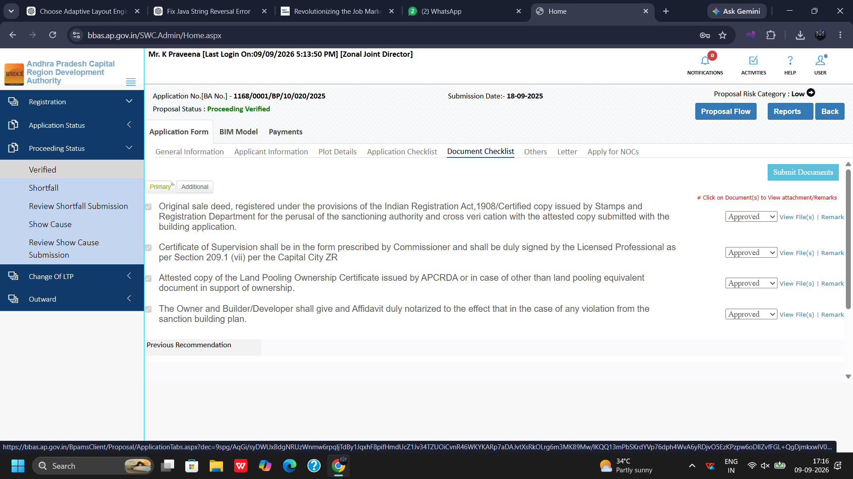
Figure 9.5 — Proposal 1168/0001: Uploaded Mandatory Documents & Directorate Recommendations

9.6 Others Tab (Environmental & Special Parameters)
Verifies environmental, energy, and conservation bylaws:
1. Rainwater Harvesting: Verify design dimensions and location of rainwater percolation pits.
2. Solar Energy Provisions: Check rooftop solar photovoltaic or solar water heating installations.
3. Greening Standards: Verify tree plantation commitments (minimum 1 tree per 100 sq.m of site).
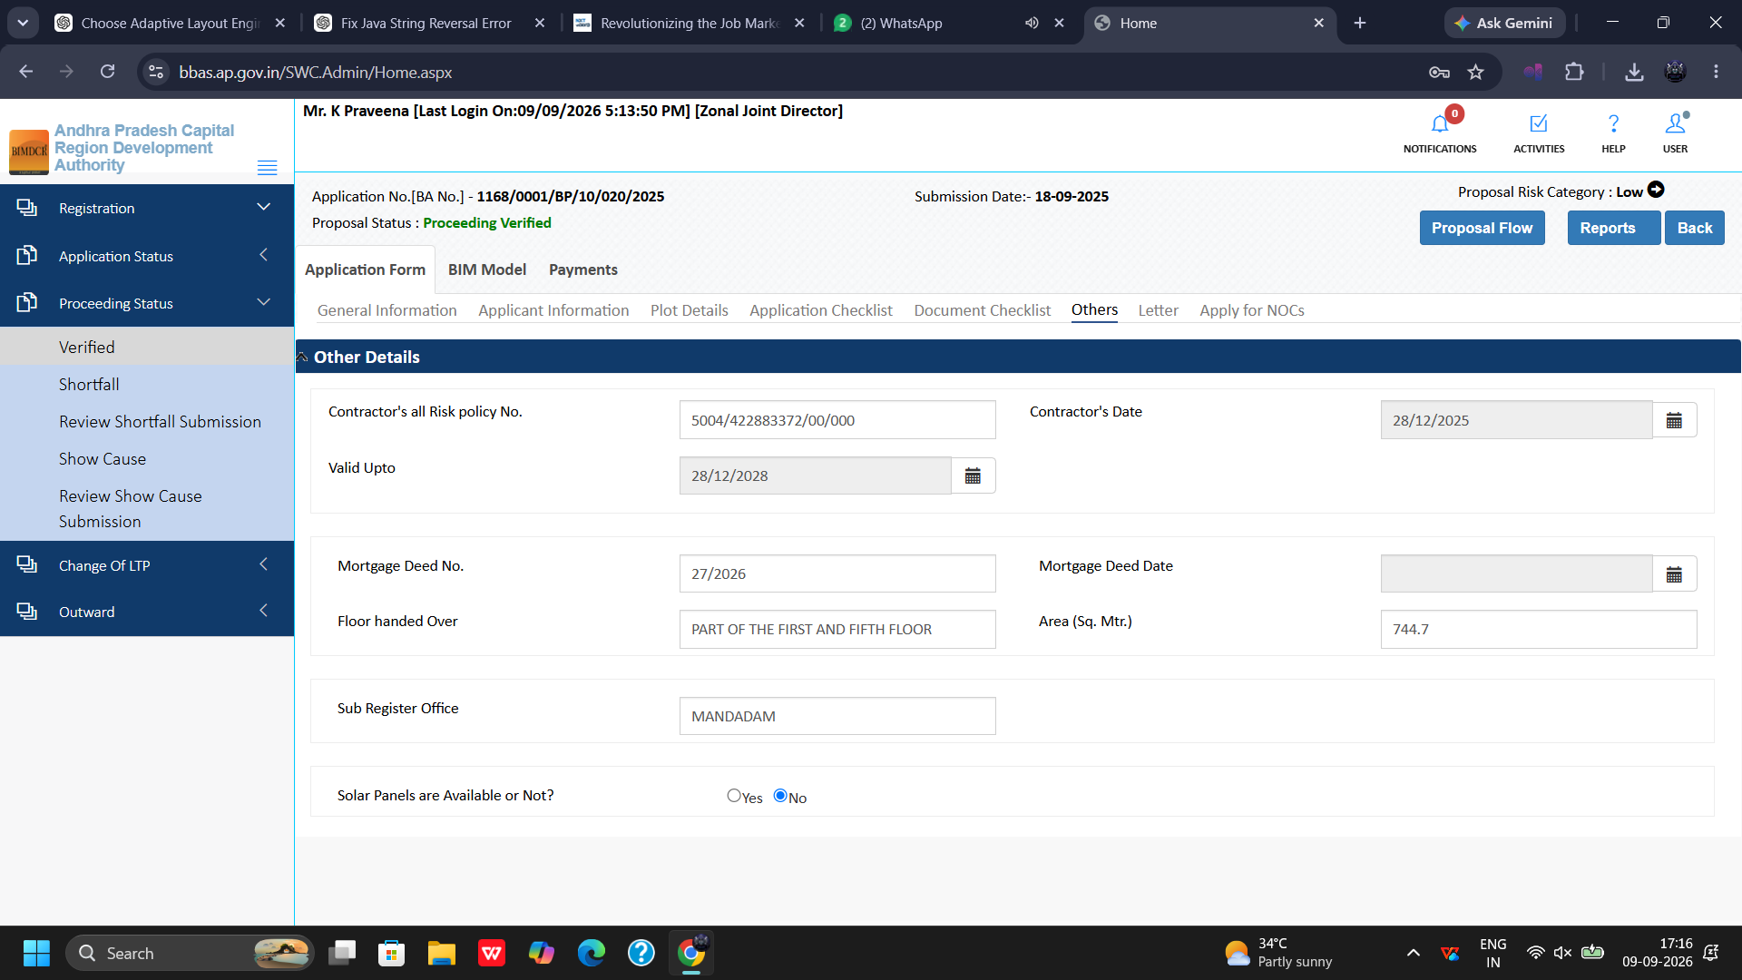
Figure 9.6 — Proposal 1168/0001: Environmental Provisions, Solar Panels, and Special Parameters

9.7 Site Inspection Verification & Ground Reality
Evaluates field observations recorded by the site planning officer:
1. Physical Road Width: Verify physical road width measured on ground against Master Plan specifications.
2. Site Status: Confirm site status (Vacant / Construction Initiated) and inspect geo-tagged site photographs and coordinates.
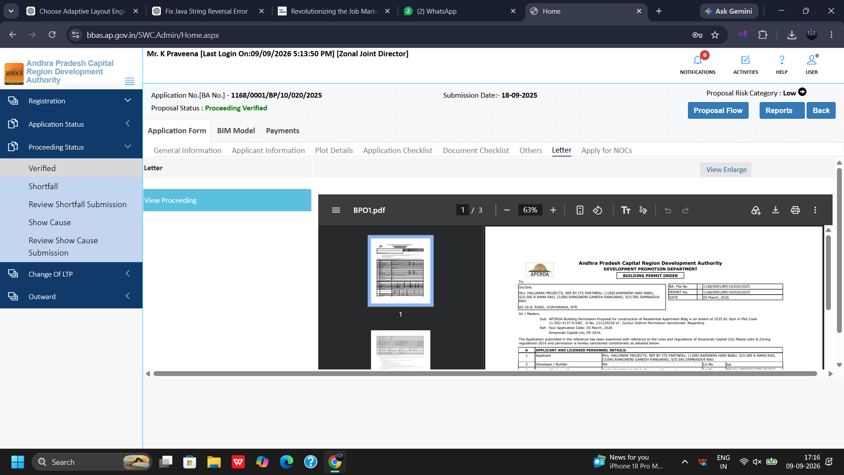
Figure 9.7 — Proposal 1168/0001: Field Site Inspection Observations & Boundary Verification

9.8 Draft Building Permit Order (BPO1.pdf) Preview
Prior to final sanction, the JD previews the draft Building Permit Order:
1. Open Letter Tab: Click the Letter tab to render the live PDF preview of BPO1.pdf.
2. Sanction Clauses: Review sanction terms, validity duration (3 years), approved built-up area schedule, and statutory conditions.
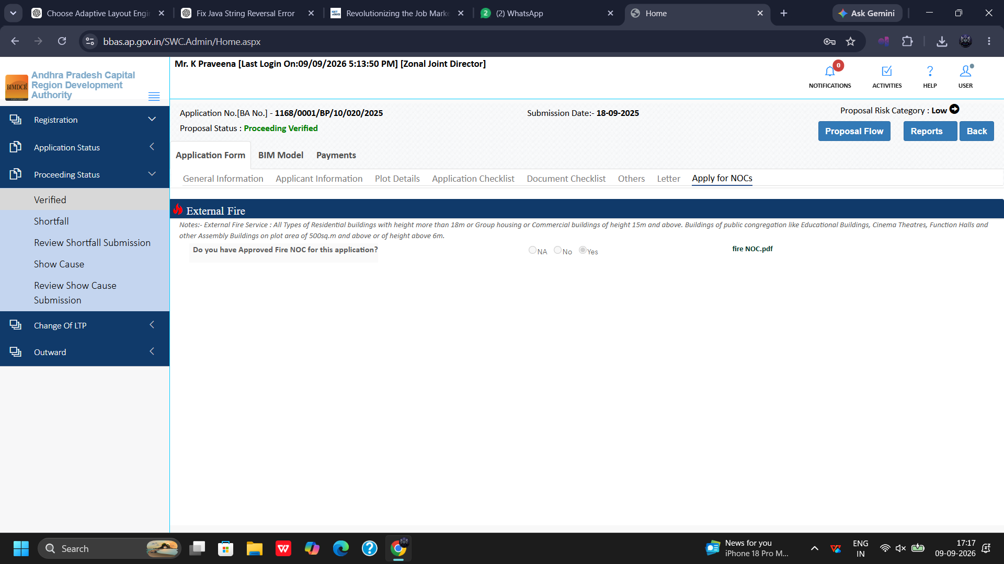
Figure 9.8 — Proposal 1168/0001: Draft Building Permit Order (BPO1.pdf) Preview

9.9 Architectural Drawings & BIM Scrutiny
Examines submitted CAD drawings and automated BIMDCR validation:
1. Drawing Scrutiny: Inspect Applicant Drawing, Drawing Name, and Drawing PDF.
2. Norms Confirmation: Confirm status: Drawing submitted as per norms.
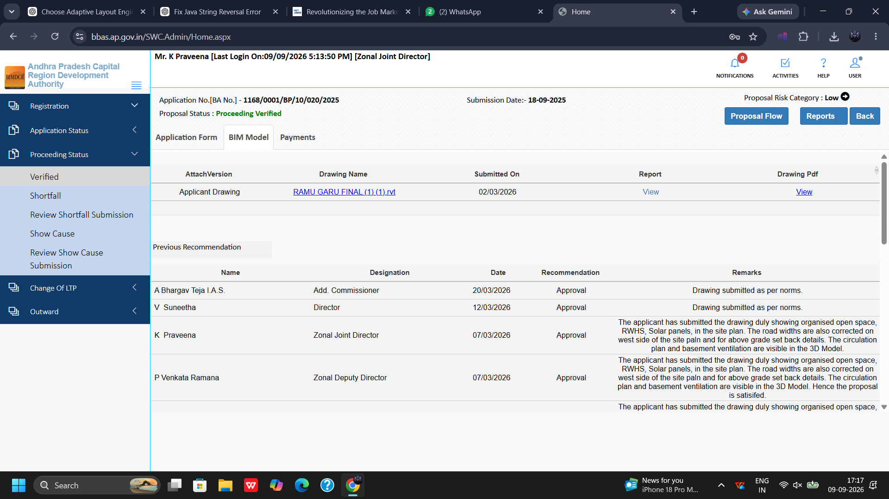
Figure 9.9 — Proposal 1168/0001: Architectural Drawings & BIM Scrutiny Verification

9.10 Treasury Payment Realization
Confirms statutory fee reconciliation in government treasury accounts:
1. Fee Components: Verify Scrutiny Fee, Development Charges, Betterment Charges, and Open Space Regularization Fees.
2. Treasury Realization: Verify CFMS Challan Reference Number and confirmed bank realization status.
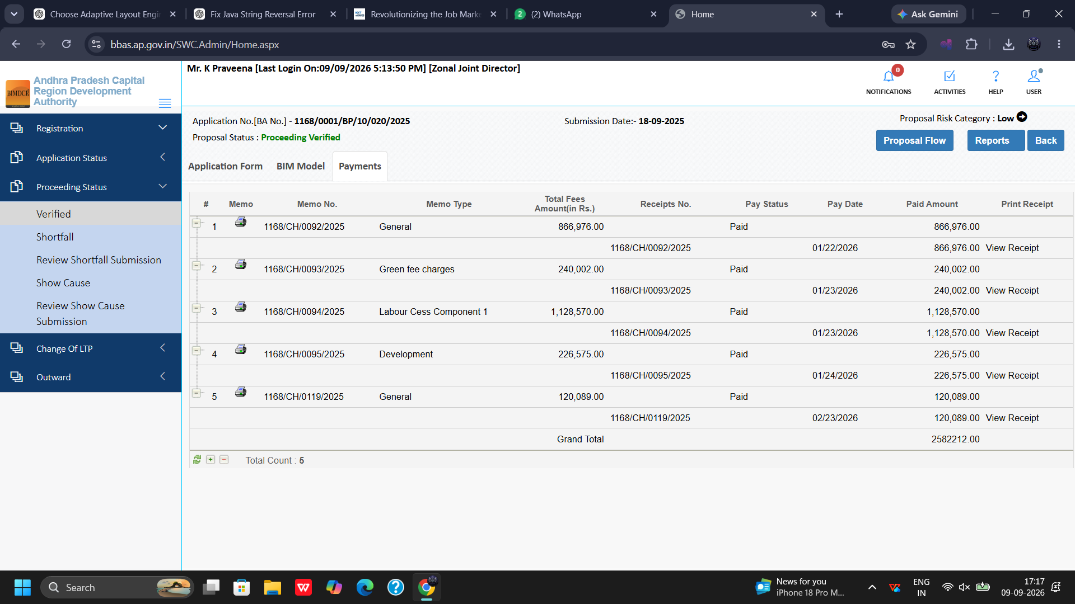
Figure 9.10 — Proposal 1168/0001: Fee Computation & Treasury Realization Verification

Chapter 10: Proposal Scrutiny Walkthrough 2: Application 1168/0026/BP/10/020/2025
Proposal 1168/0026/BP/10/020/2025 illustrates a complex scrutiny scenario in Draft Mode involving shortfall items, road widening dedications, registered mortgage deeds, on-site construction verification, and external Fire NOC integration.

10.1 General Information (Draft Mode Shortfall Scrutiny)
Access the proposal from the Shortfall queue. Note that Proposal Status displays Draft Mode:
1. Administrative Particulars: Check Mandal, Gram Panchayat, and jurisdictional zoning.
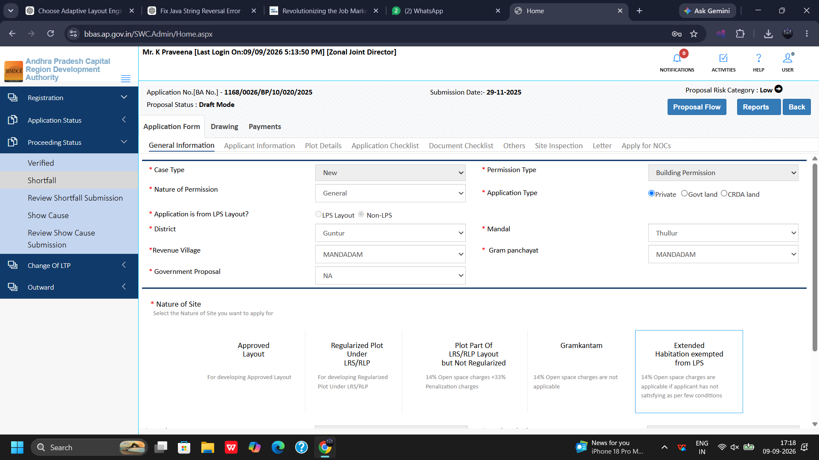
Figure 10.1 — Proposal 1168/0026: General Information (Draft Mode Shortfall Scrutiny)

10.2 Applicant Information & Submitting Professional Details
Review primary applicant details, co-applicants, and submitting technical professional identity records:
1. Identity & Contacts: Verify contact numbers, registered address, and professional license validity.
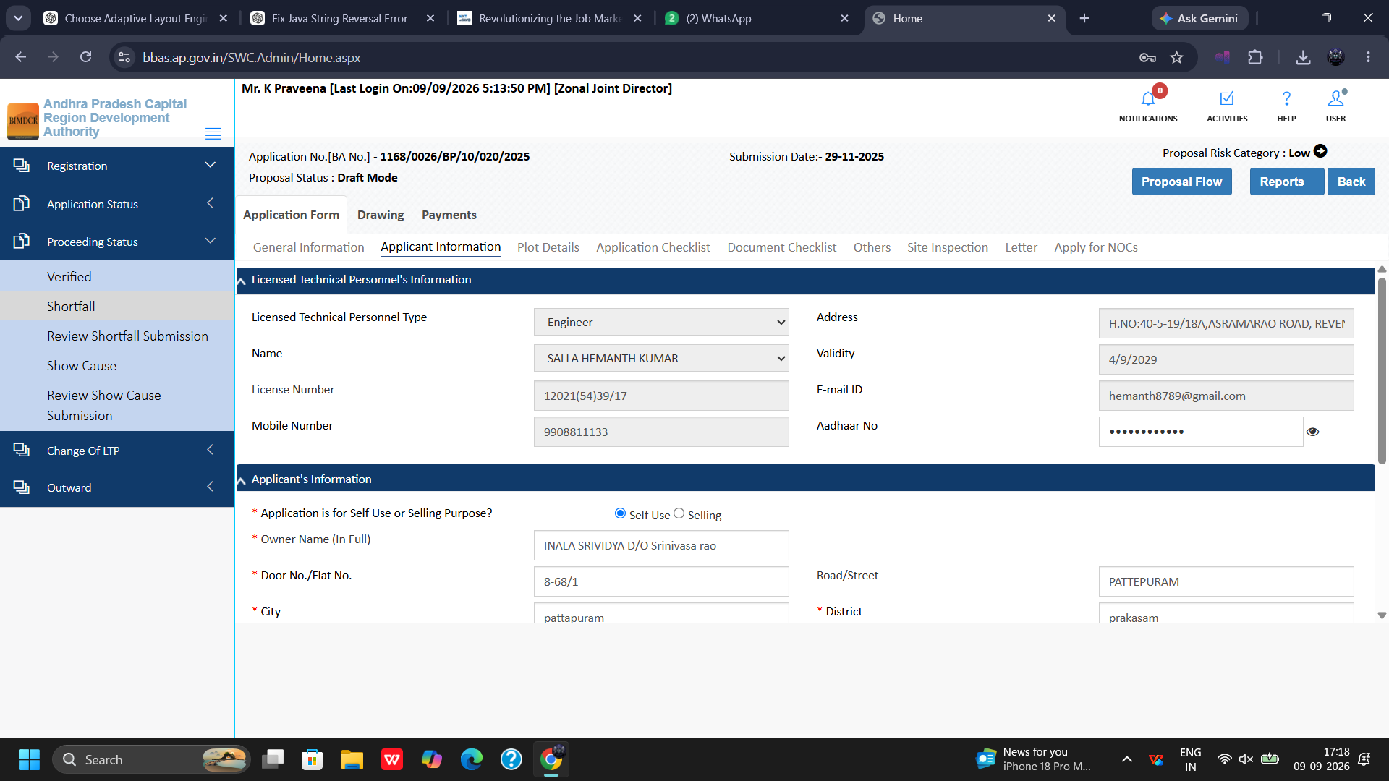
Figure 10.2 — Proposal 1168/0026: Applicant & Submitting Professional Details

10.3 Plot Details, Road Widening, and Existing Road Widths
Critical evaluation of plot parameters and road widening reservations:
1. Total Area As per Documents: Verify gross document area against physical site measurements.
2. Road Widening Area: Inspect road widening area (sq. mtr.) required to be surrendered.
3. Existing vs Proposed Road Width: Verify Existing Road Width (mtr), Proposed Road Width (mtr), and Status of Road.
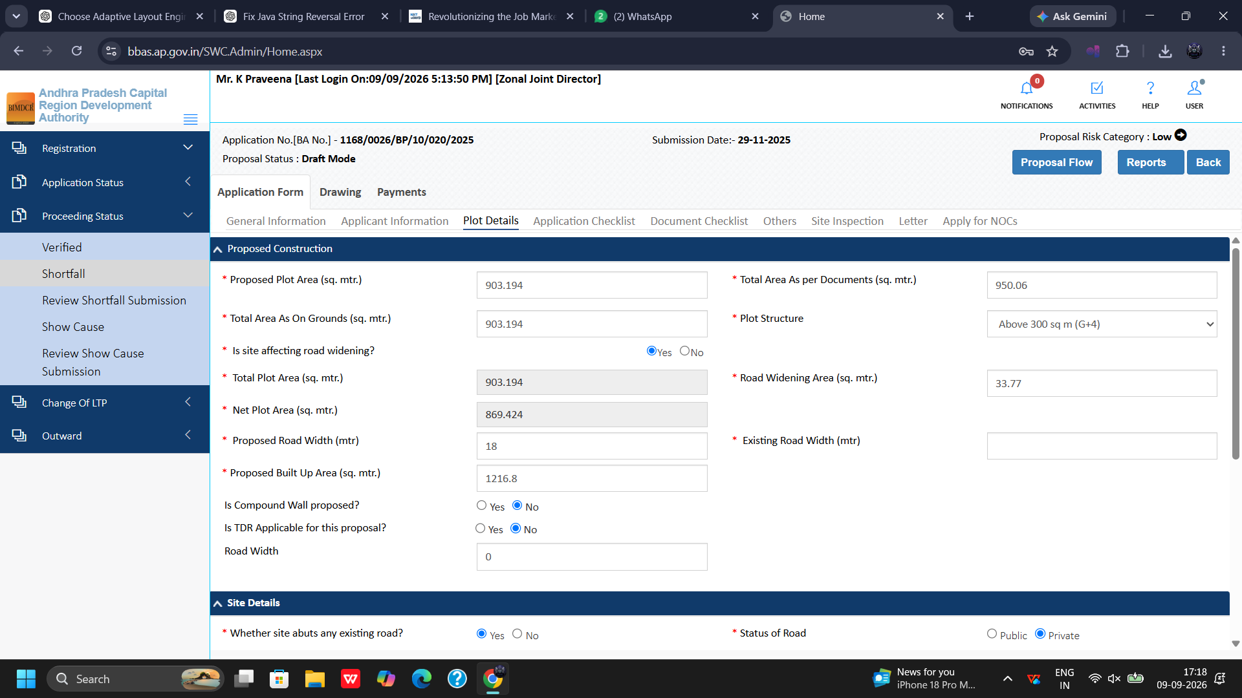
Figure 10.3 — Proposal 1168/0026: Existing vs. Proposed Road Width & Widening Dedication

10.4 Application Checklist Responses
Verify applicant checklist responses regarding building bylaws, parking allocations, and structural safety provisions:
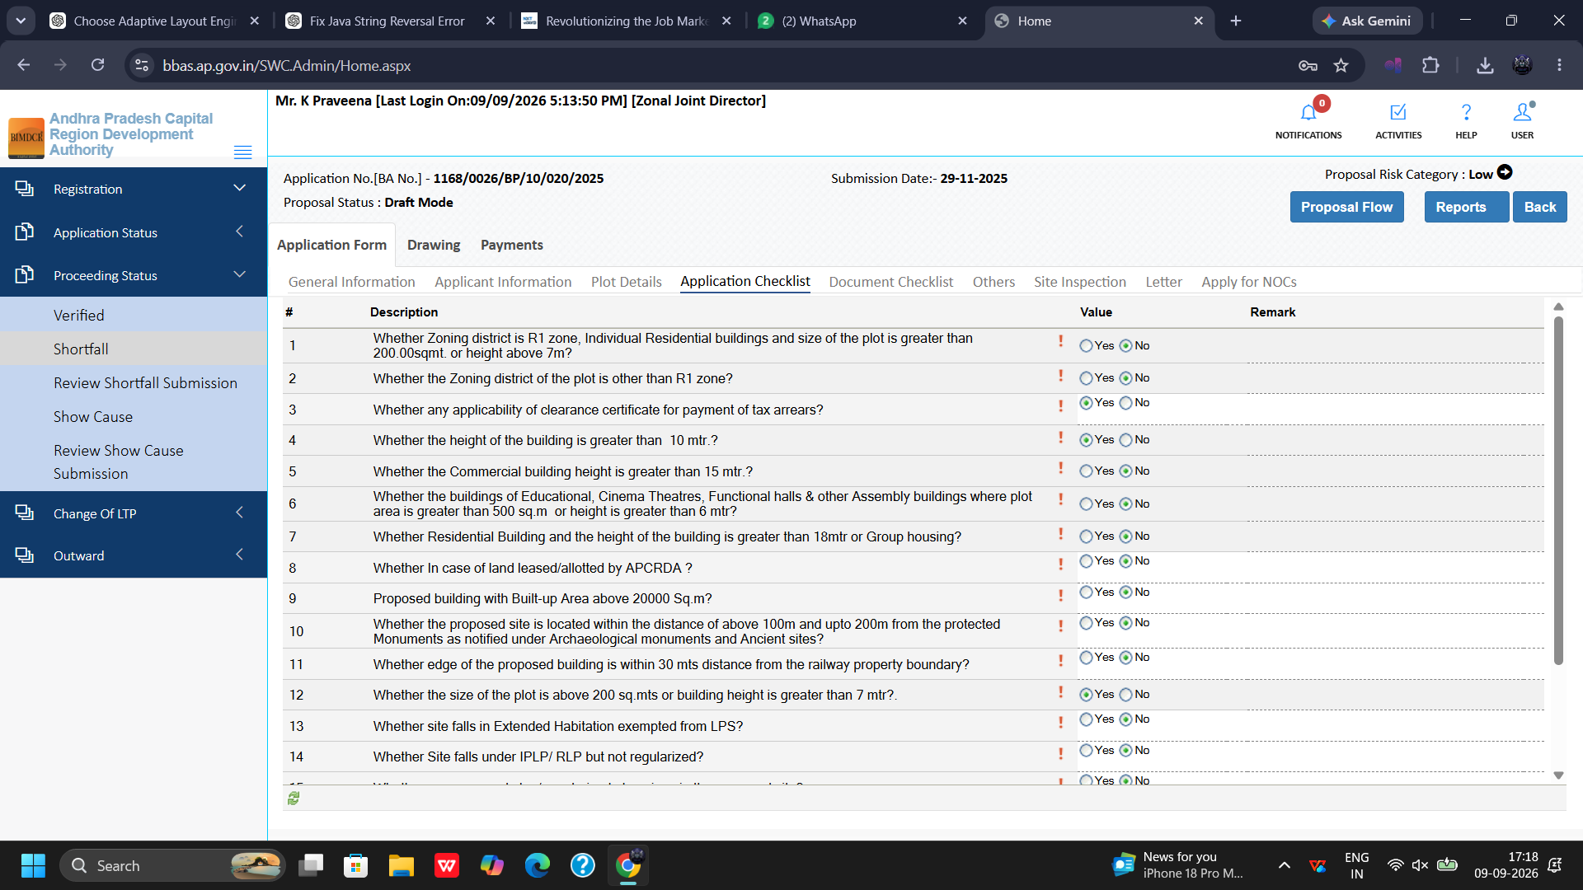
Figure 10.4 — Proposal 1168/0026: Bylaw Compliance Checklist Responses

10.5 Document Checklist & Directorate Shortfall Items
Review the recorded Directorate recommendations and shortfall items:
1. Document Repository: Inspect uploaded deeds and certificates.
2. Shortfall Records: Verify applicant compliance with previous shortfall items raised by Planning Director V Suneetha.
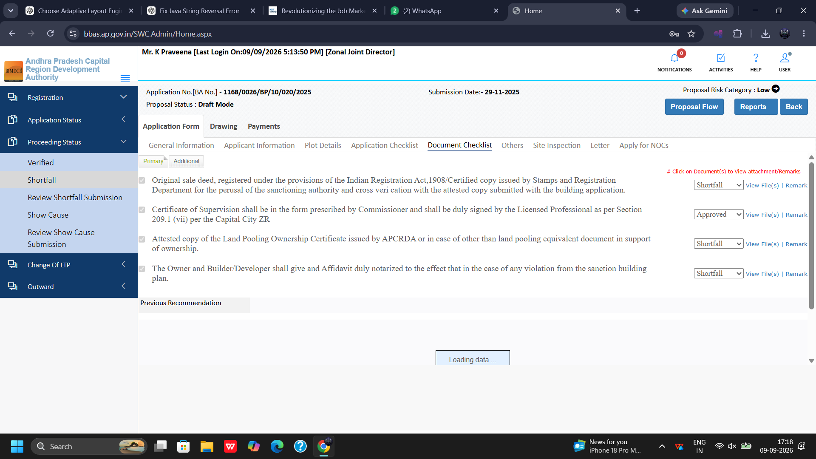
Figure 10.5 — Proposal 1168/0026: Document Repository & Directorate Shortfall Record

10.6 Registered Mortgage Deed & CAR Policy Validation
Validation of statutory mortgage deed and contractor insurance:
1. Registered Mortgage Deed No.: Verify Mortgage Deed Number (e.g., registered in favor of the competent authority).
2. Mortgage Deed Date & Sub-Registrar Office: Verify registration date, jurisdictional Sub-Registrar Office, and mortgaged floor area.
3. Contractor's All Risk (CAR) Policy: Verify CAR insurance policy number, validity period, and third-party coverage.
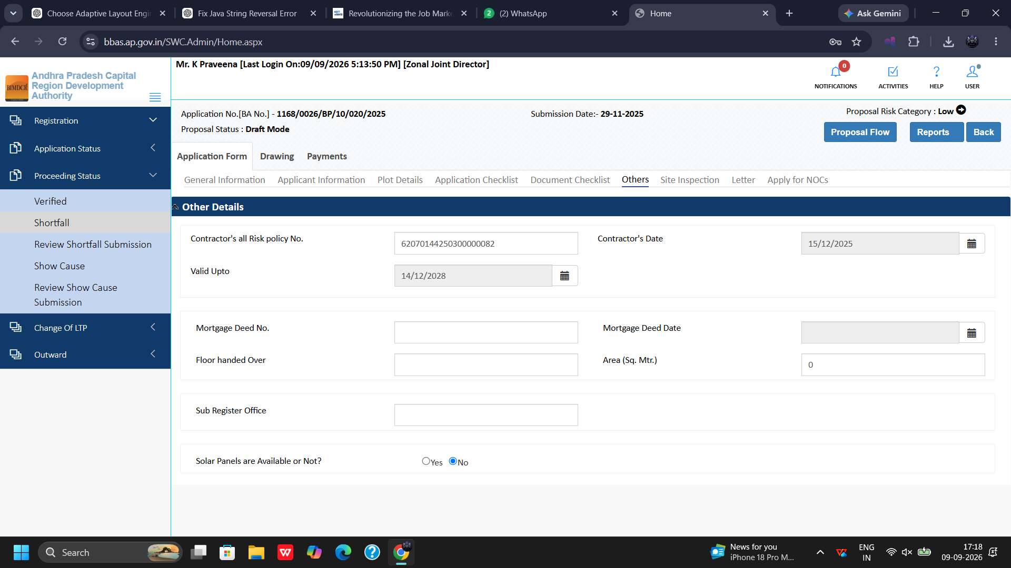
Figure 10.6 — Proposal 1168/0026: Registered Mortgage Deed & CAR Policy Validation

10.7 Site Inspection Review: Physical Construction Progress
Review on-site physical inspection observations:
1. Abutting Road Width: Inspect measured road width on ground: Road (5.47m).
2. Work Commenced on Site: Check status: Work Commenced = Yes.
3. Status of Construction: Inspect on-ground construction stage: Slabs laid; verify ground footprint area (903.19 sq.m).
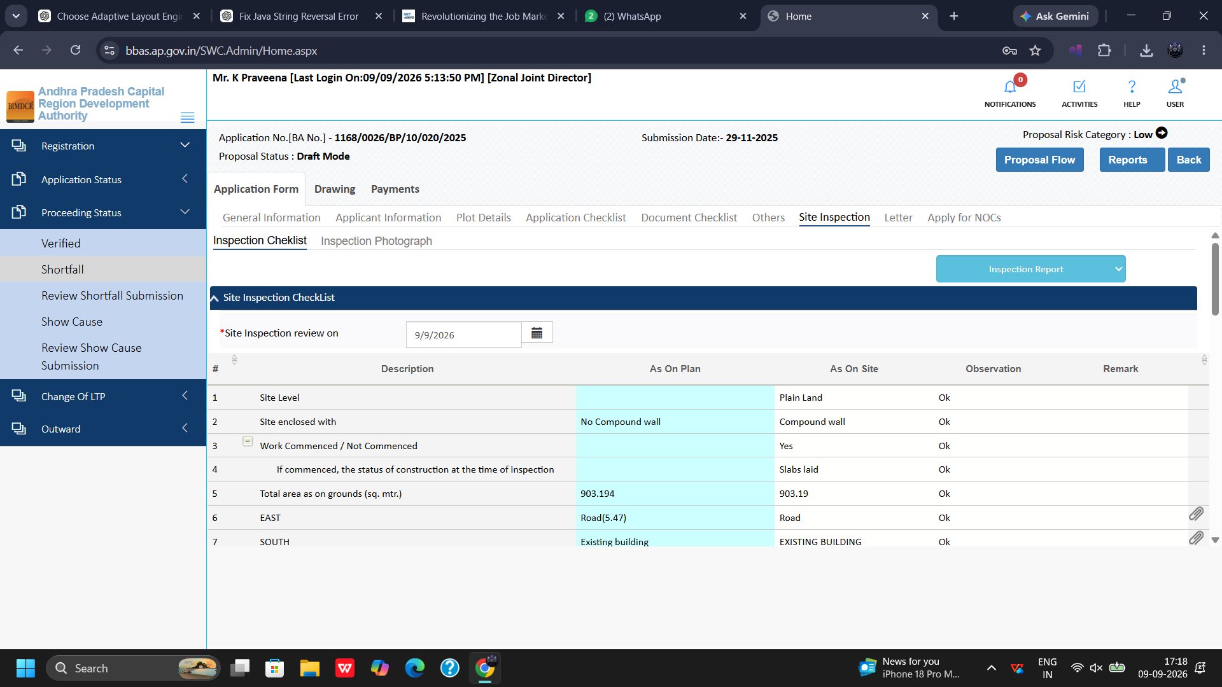
Figure 10.7 — Proposal 1168/0026: Physical On-Site Construction Inspection (Slabs Laid, Road 5.47m)

10.8 Draft Permit Order Endorsement Preview
Preview the draft Building Permit Order and Endorsement Letter:
1. Letter Tab: Open the Letter tab to examine the draft sanction order and endorsement letter conditions.
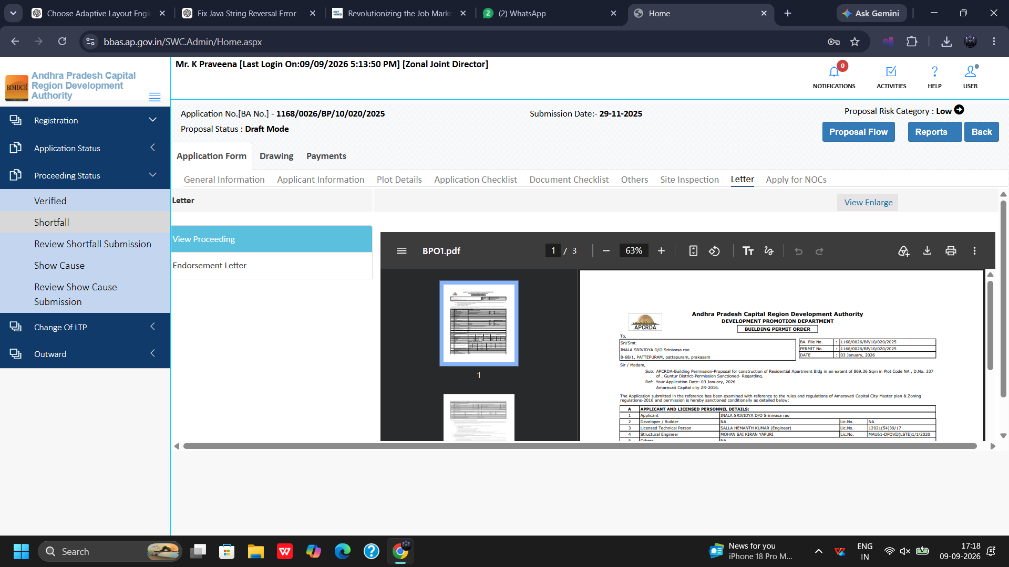
Figure 10.8 — Proposal 1168/0026: Draft Building Permit Order (BPO) Endorsement Preview

10.9 Apply for NOCs: External Fire Services Clearance
Integration console for external departmental clearances:
1. External Fire Services Criteria: Notes specify: All Types of Residential buildings with height more than 18m or Group Housing or Commercial buildings of height 15m and above, and public congregation buildings require Fire NOC.
2. NOC Validation: Verify question: Do you have Approved Fire NOC for this application? and inspect clearance certificate.
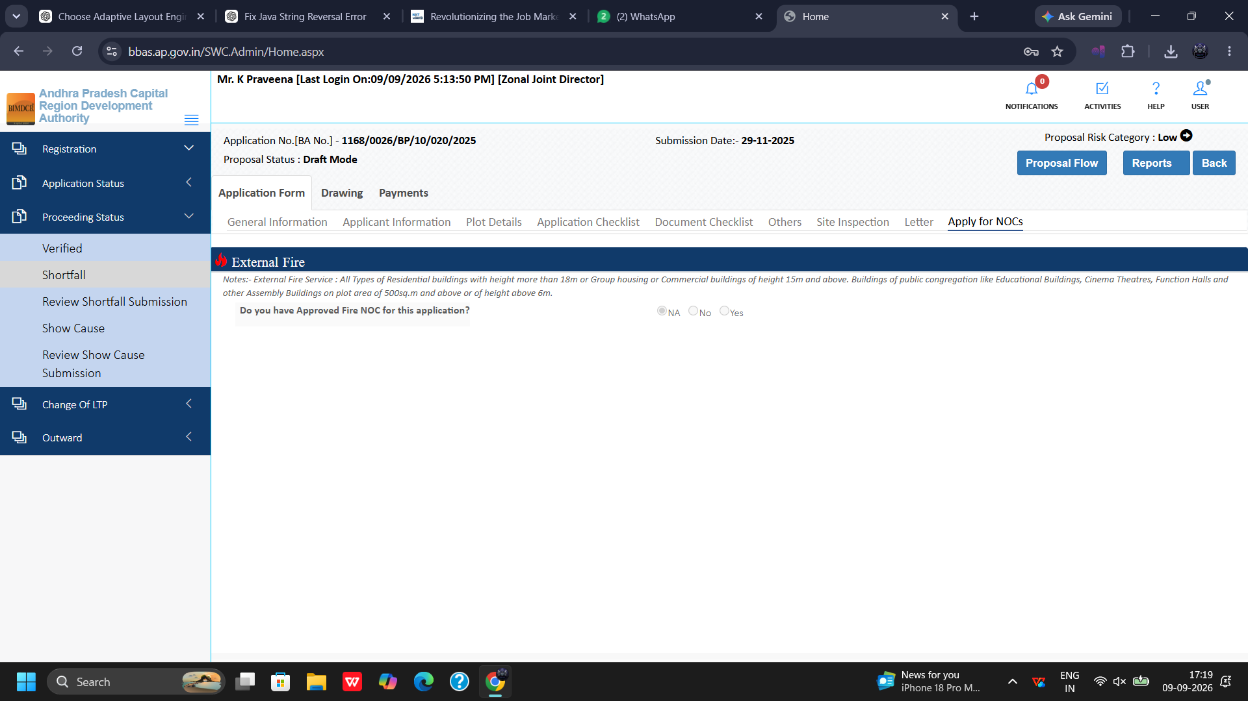
Figure 10.9 — Proposal 1168/0026: External Fire Department NOC Clearance Console

10.10 Drawing Scrutiny & Recommendation History
Inspect submitted architectural drawings and review history:
1. Drawing Details: Check Applicant Drawing, Drawing Name, and Drawing PDF.
2. Recommendation History: Review previous technical officer recommendations and timestamps.
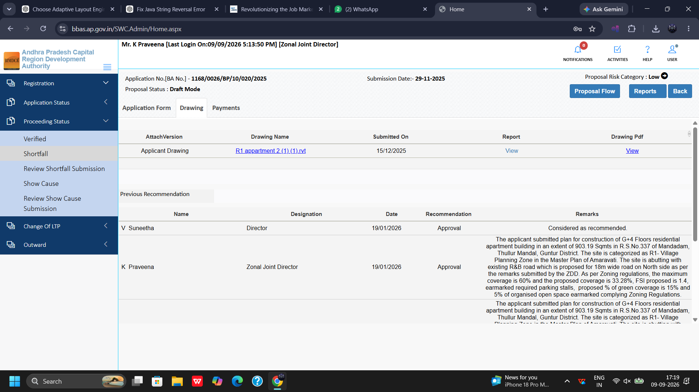
Figure 10.10 — Proposal 1168/0026: Architectural Drawing Plan & Previous Recommendation History

10.11 Payment Reconciliation
Verify statutory fees computed for Proposal 1168/0026:
1. Total Fees: Verify computed total fee: Rs. 36,552.00.
2. Pay Status: Confirm payment realization via CFMS treasury memo.
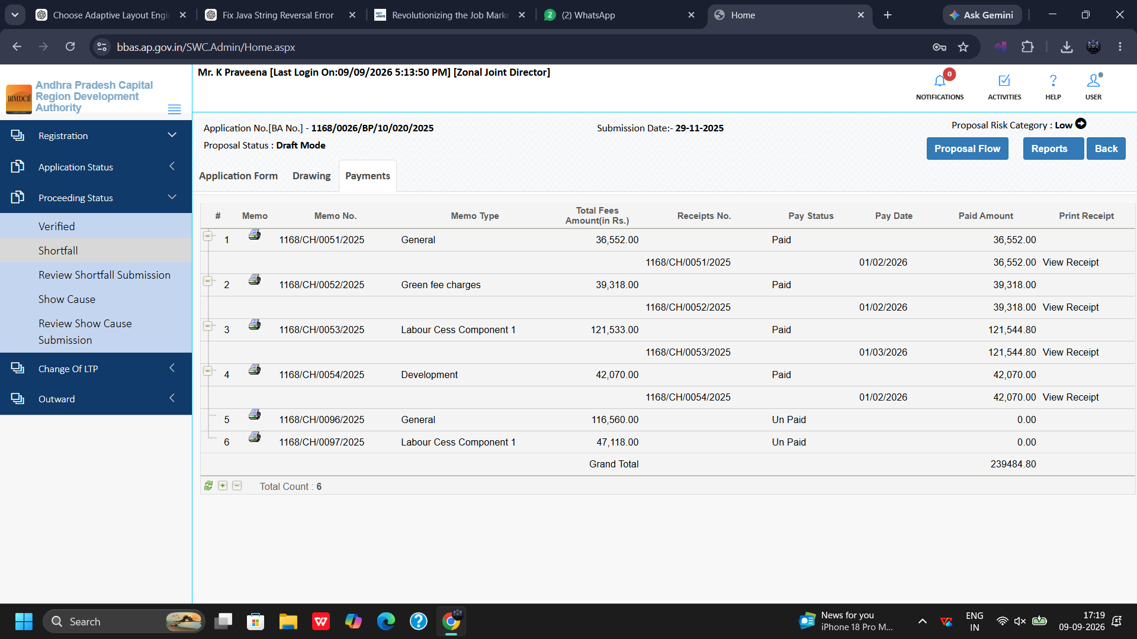
Figure 10.11 — Proposal 1168/0026: Fee Reconciliation (Total Fees: Rs. 36,552.00)

Chapter 11: Proposal Scrutiny Walkthrough 3: Application 1168/0002/BP/10/020/2025
Proposal 1168/0002/BP/10/020/2025 provides an exemplary end-to-end scrutiny of a Low Risk Category proposal with Proposal Status: Proceeding Verified.

11.1 General Information (Low Risk Category, Proceeding Verified)
Evaluate basic application metadata:
1. Risk Classification: Proposal Risk Category: Low.
2. Application Status: Proposal Status: Proceeding Verified; Submission Date: 15-10-2025.
3. Land Demarcation: Verify Private / Govt land / CRDA land demarcation.
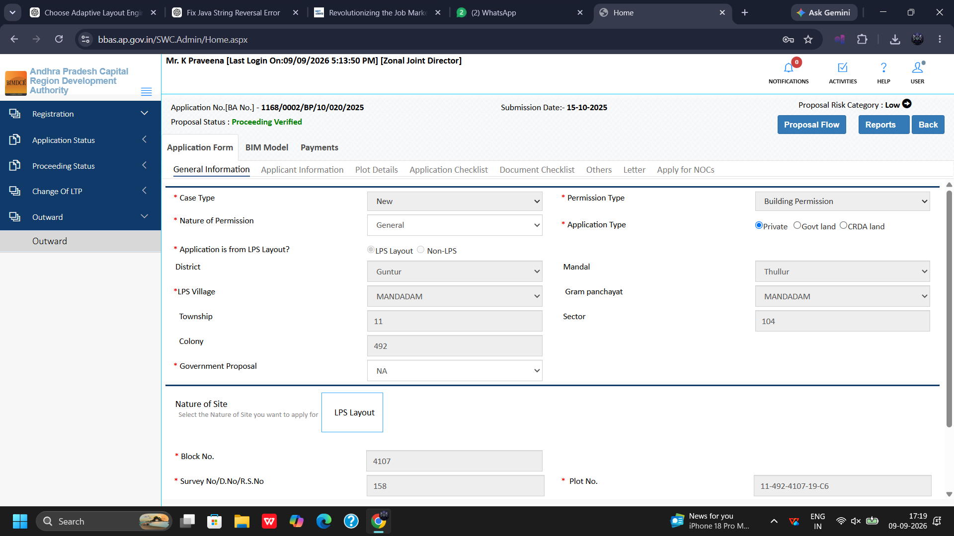
Figure 11.1 — Proposal 1168/0002: General Information (Proceeding Verified Scrutiny)

11.2 Applicant & Technical Professional Credentials
Verifies applicant ownership and submitting technical professional licensing:
1. Technical Professional's Information: Verify Technical Professional Type, Name, License Number, and Mobile Number.
2. Applicant's Information: Verify Application is for Self Use or Selling Purpose, Firm Name, and Owner Name (In Full).
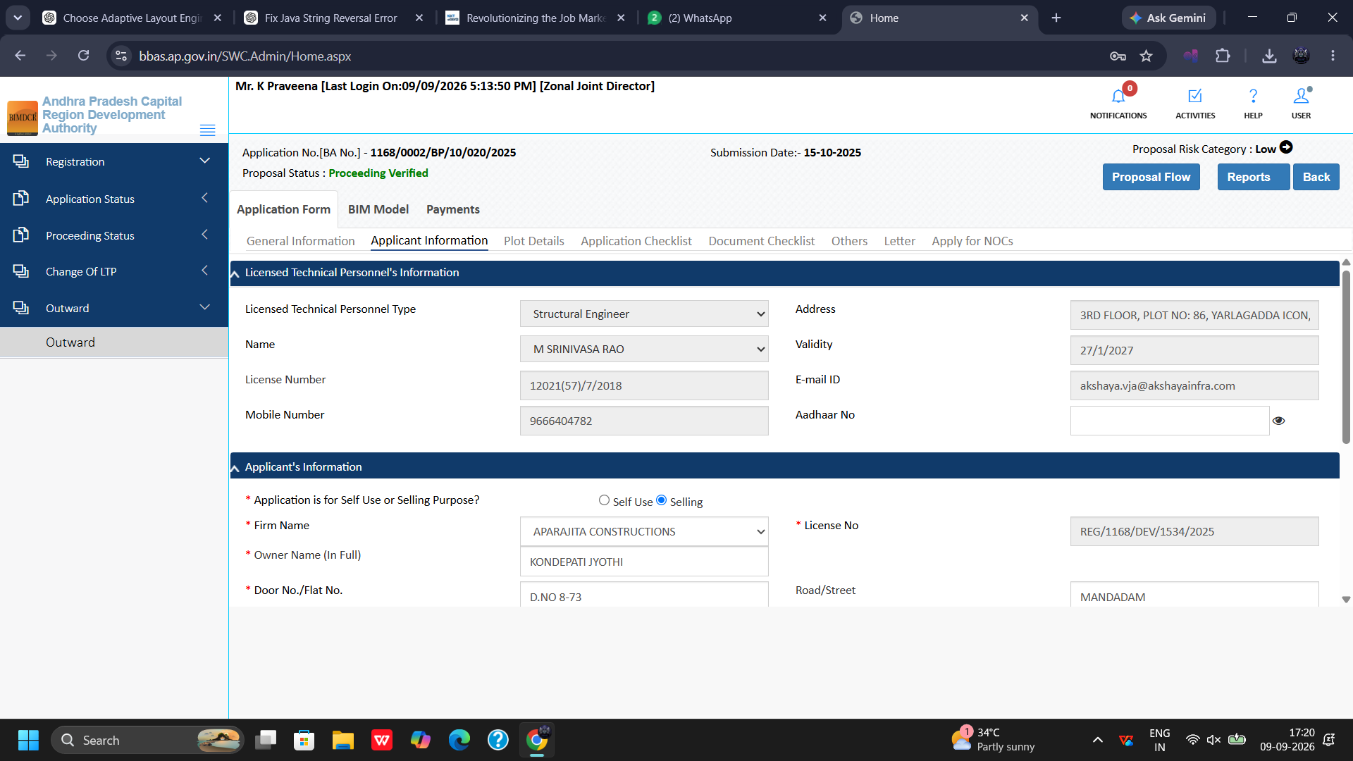
Figure 11.2 — Proposal 1168/0002: Applicant and Technical Professional Credentials

11.3 Plot Details, Compound Wall, and TDR Verification
Scrutinizes site boundary parameters and special planning instruments:
1. Proposed Construction: Verify Proposed Plot Area (sq. mtr.).
2. Compound Wall Details: Check Is Compound Wall proposed? and Width of Compound Wall (mtr).
3. TDR Applicability: Verify Is TDR Applicable for this proposal? and check Plot Nearby Religious Structures.
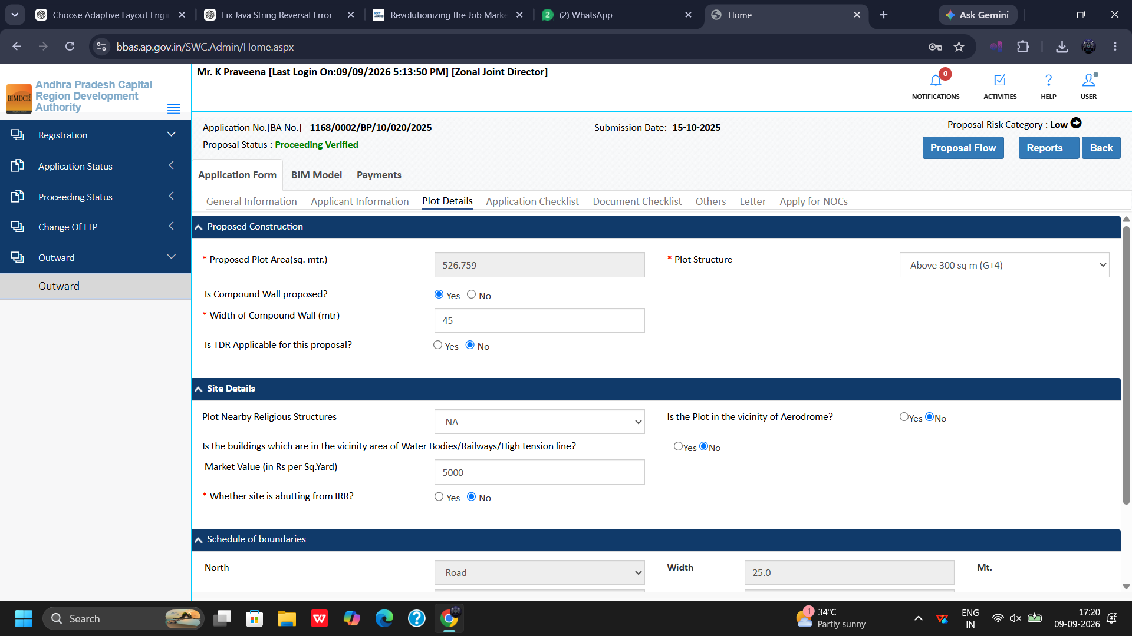
Figure 11.3 — Proposal 1168/0002: Proposed Plot Area, Compound Wall, and TDR Verification

11.4 Application Checklist & Remarks
Review statutory compliance items and technical scrutiny remarks:
1. Checklist Table: Inspect statutory questions, applicant responses, and officer remarks.
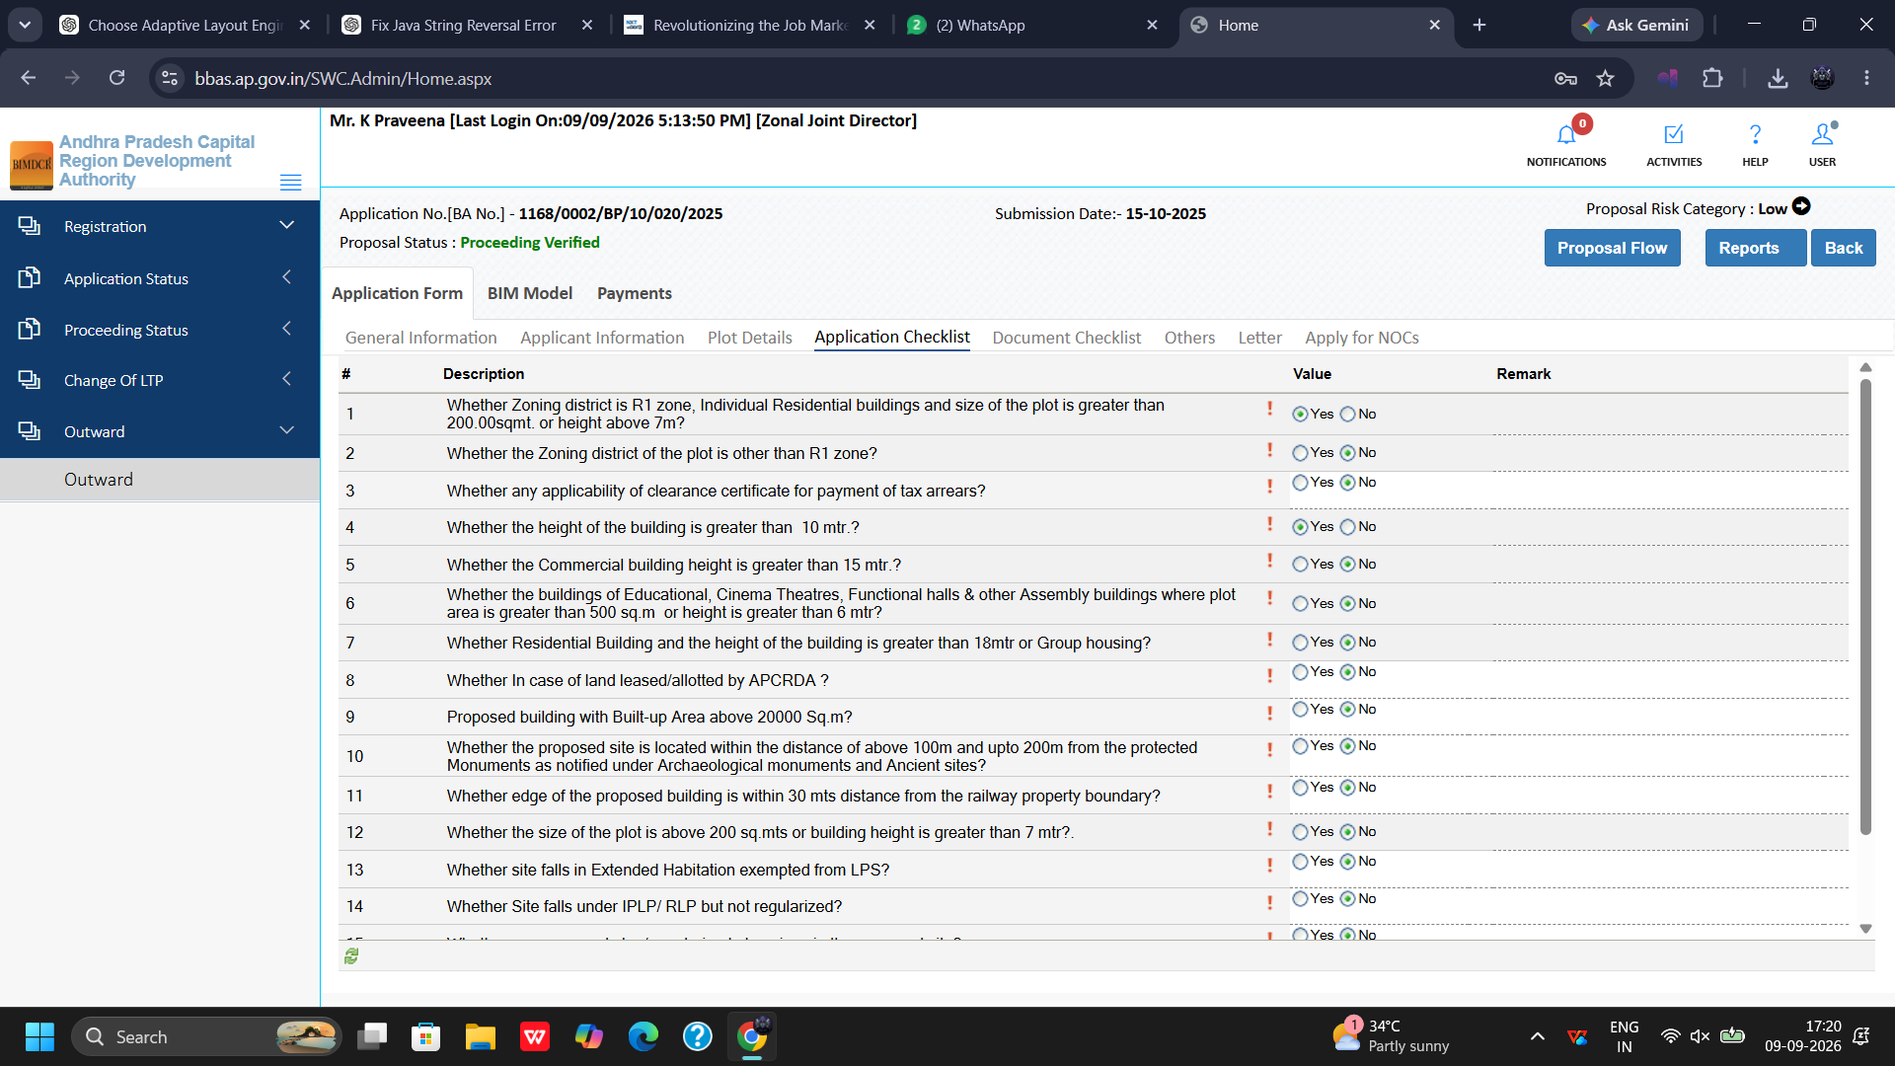
Figure 11.4 — Proposal 1168/0002: Statutory Compliance Checklist & Remarks

11.5 Document Checklist: Primary & Additional Documents
Verify primary and additional uploaded documents:
1. Document Categories: Review Primary and Additional uploaded files.
2. Inline Inspection: Click on documents to view attachments, encumbrance certificates, and layout endorsements.
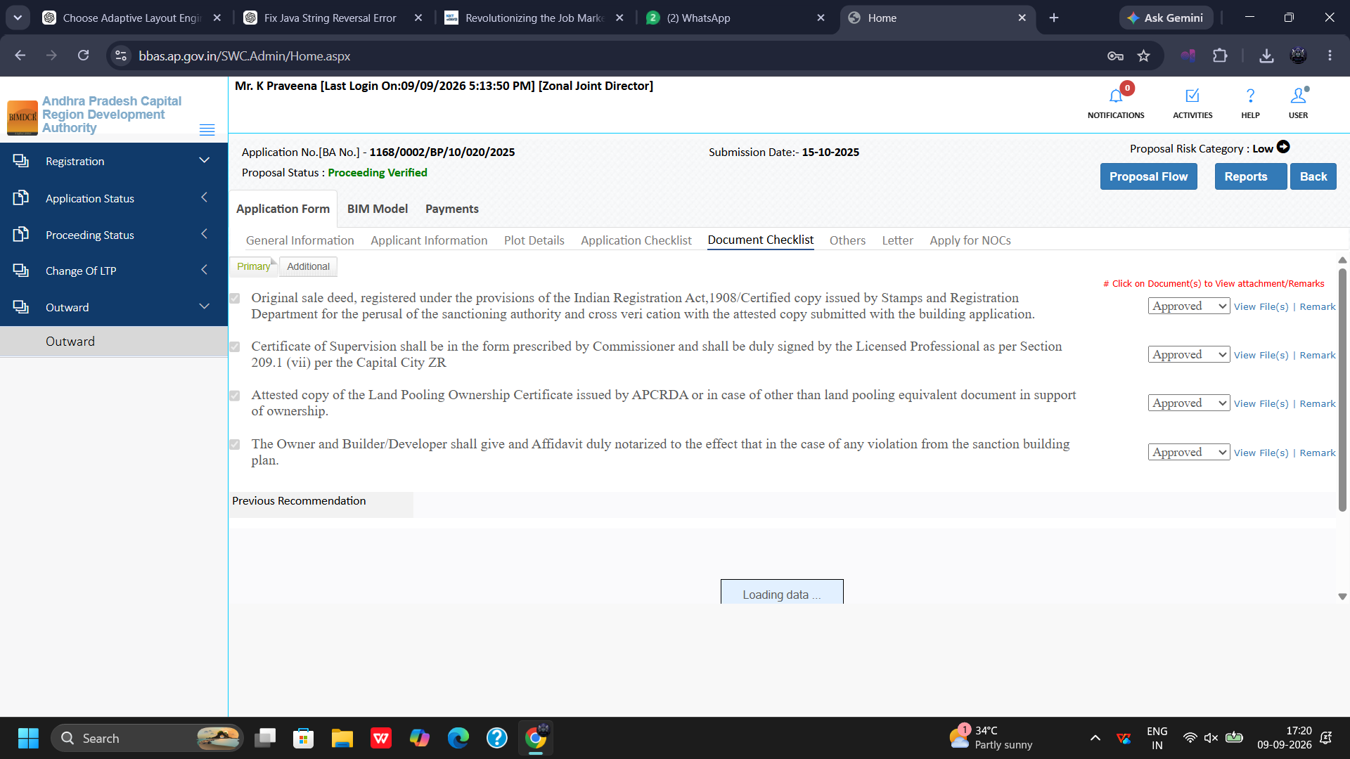
Figure 11.5 — Proposal 1168/0002: Primary and Additional Title Documents Verification

11.6 Others Tab: Registered Mortgage Deed No. & Solar Panels
Validation of statutory conditions under the Others tab:
1. Insurance & Mortgage: Verify Contractor's All Risk policy No. and Valid Upto date.
2. Mortgage Registration: Verify Mortgage Deed No., Floor Handed Over, and Sub-Registrar Office.
3. Solar Compliance: Verify Solar Panels are Available or Not?.
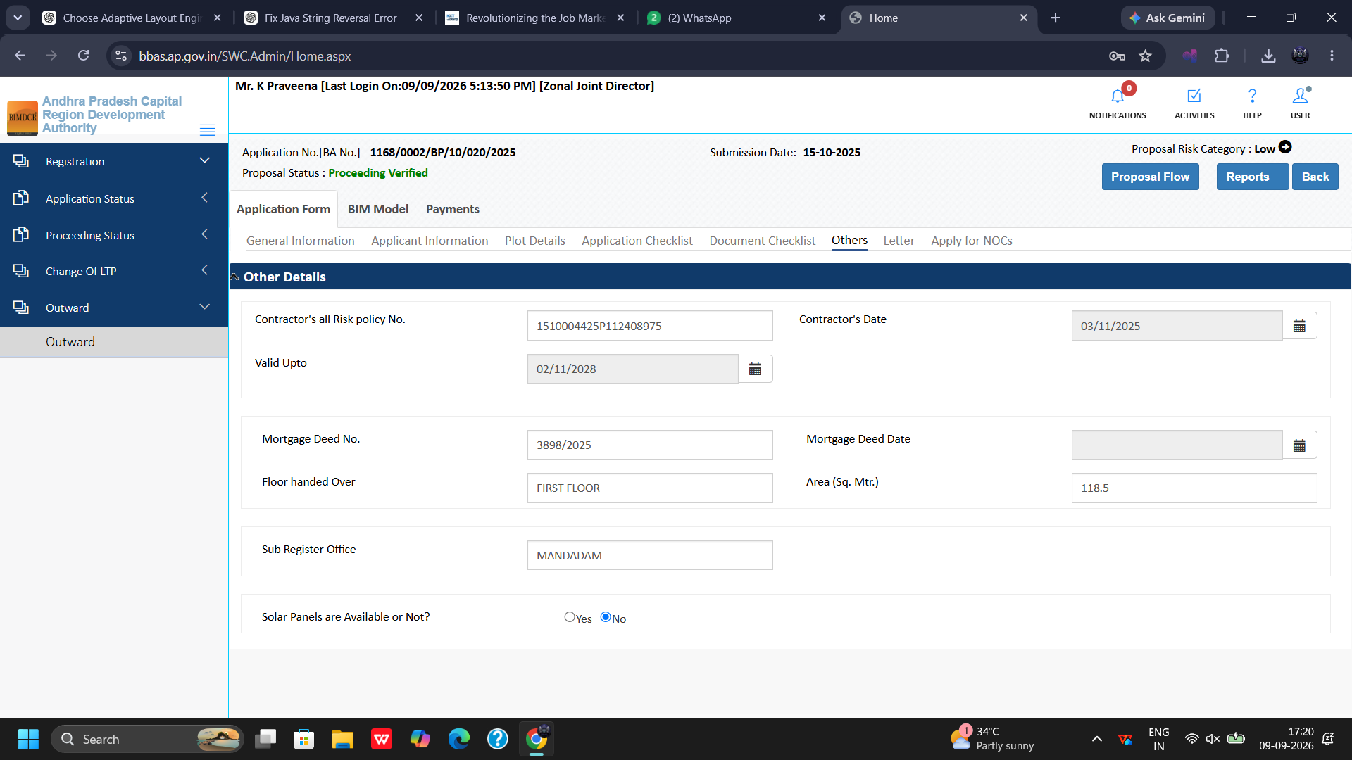
Figure 11.6 — Proposal 1168/0002: Registered Mortgage Deed, CAR Policy, and Solar Panel Status

11.7 Letter Preview: Building Permit Order (BPO1.pdf)
Examine the final draft Building Permit Order:
1. View Proceeding: Click View Proceeding / View Enlarge to review BPO1.pdf.
2. Sanction Verification: Confirm schedule of setbacks, permitted heights, and municipal conditions.
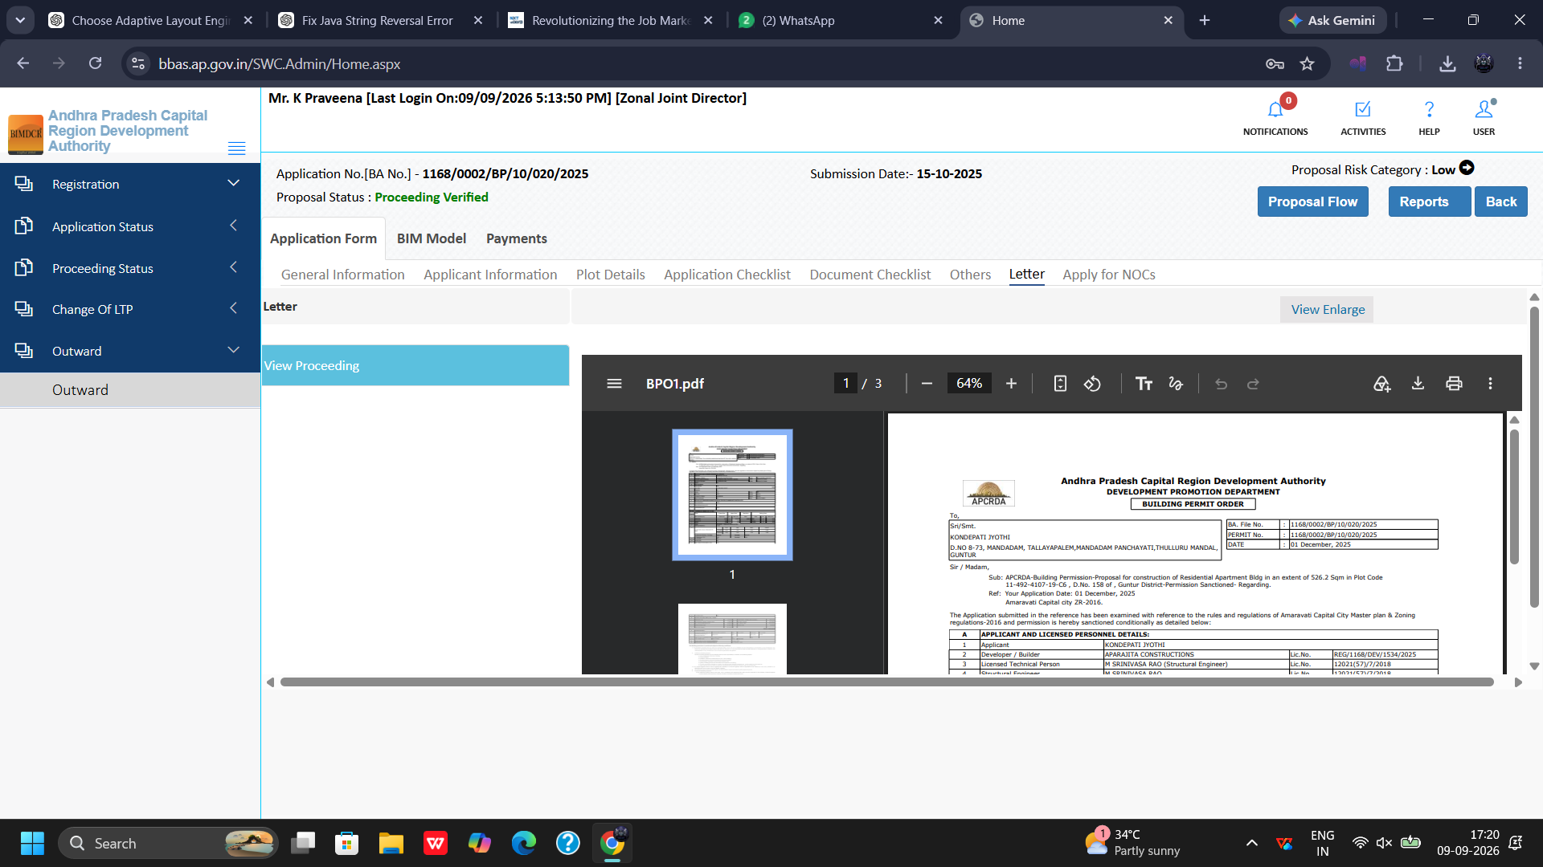
Figure 11.7 — Proposal 1168/0002: Building Permit Order (BPO1.pdf) Preview

11.8 Apply for NOCs: External Fire Clearance
Inspect external Fire Services Department NOC status:
1. Fire Clearance Criteria: Verify external fire service requirements for residential, commercial, or congregation buildings.
2. Clearance Status: Confirm receipt of approved Fire NOC.
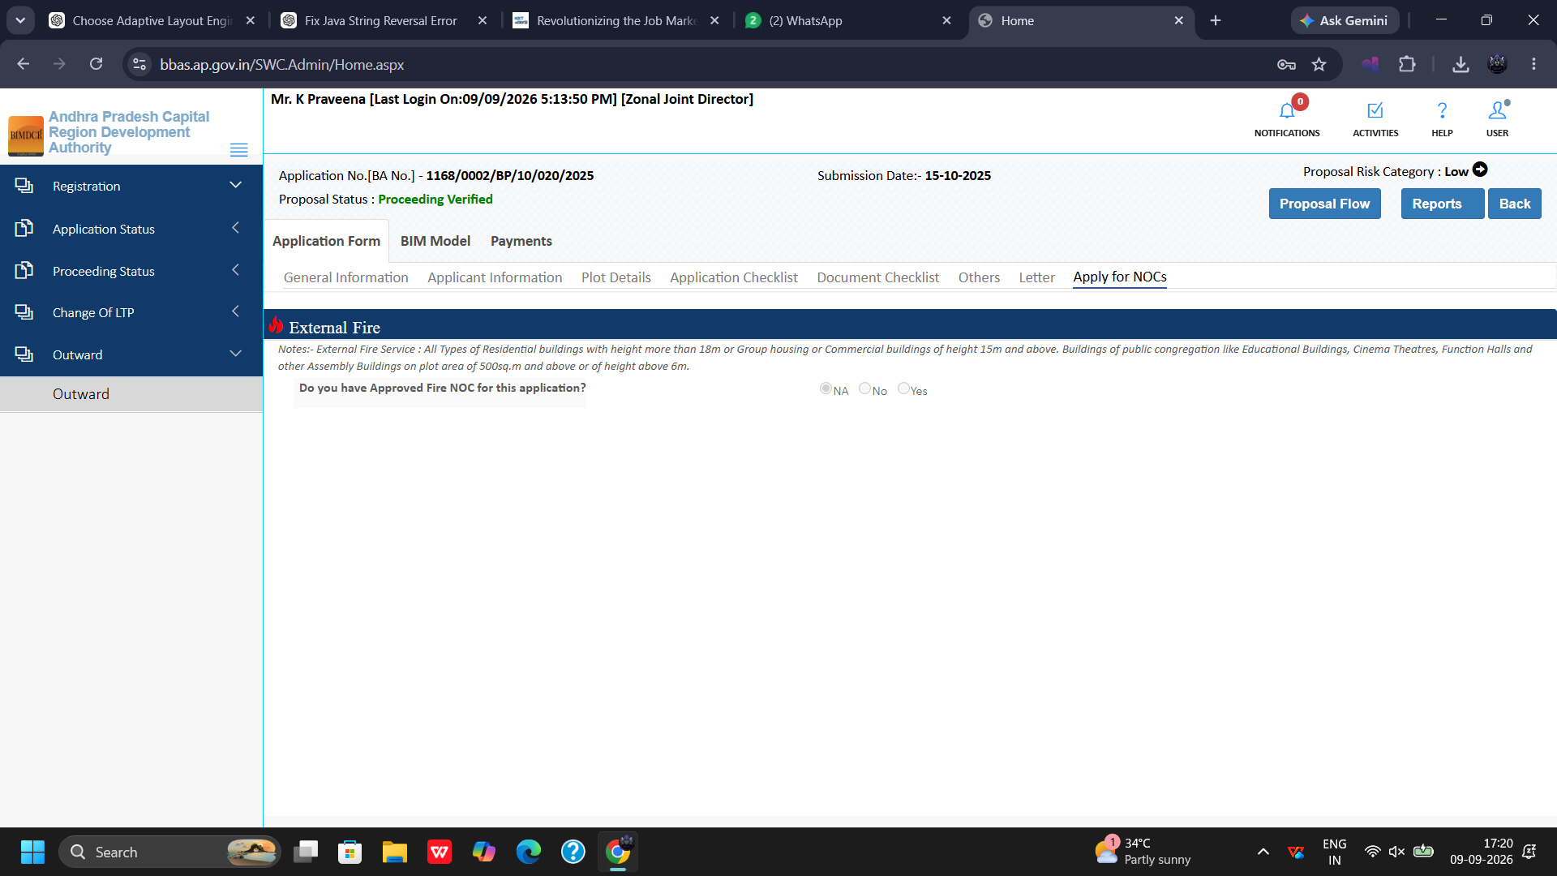
Figure 11.8 — Proposal 1168/0002: External Fire Clearance Validation

11.9 Drawing & BIM Scrutiny: Final BIMDCR
Review final CAD and BIM model verification:
1. Drawing Details: Inspect Applicant Drawing, Drawing Name (Final Bimdcr), Version, and Report.
2. Automated Validation: Verify that all 3D BIM-DCR automated rules have passed successfully.
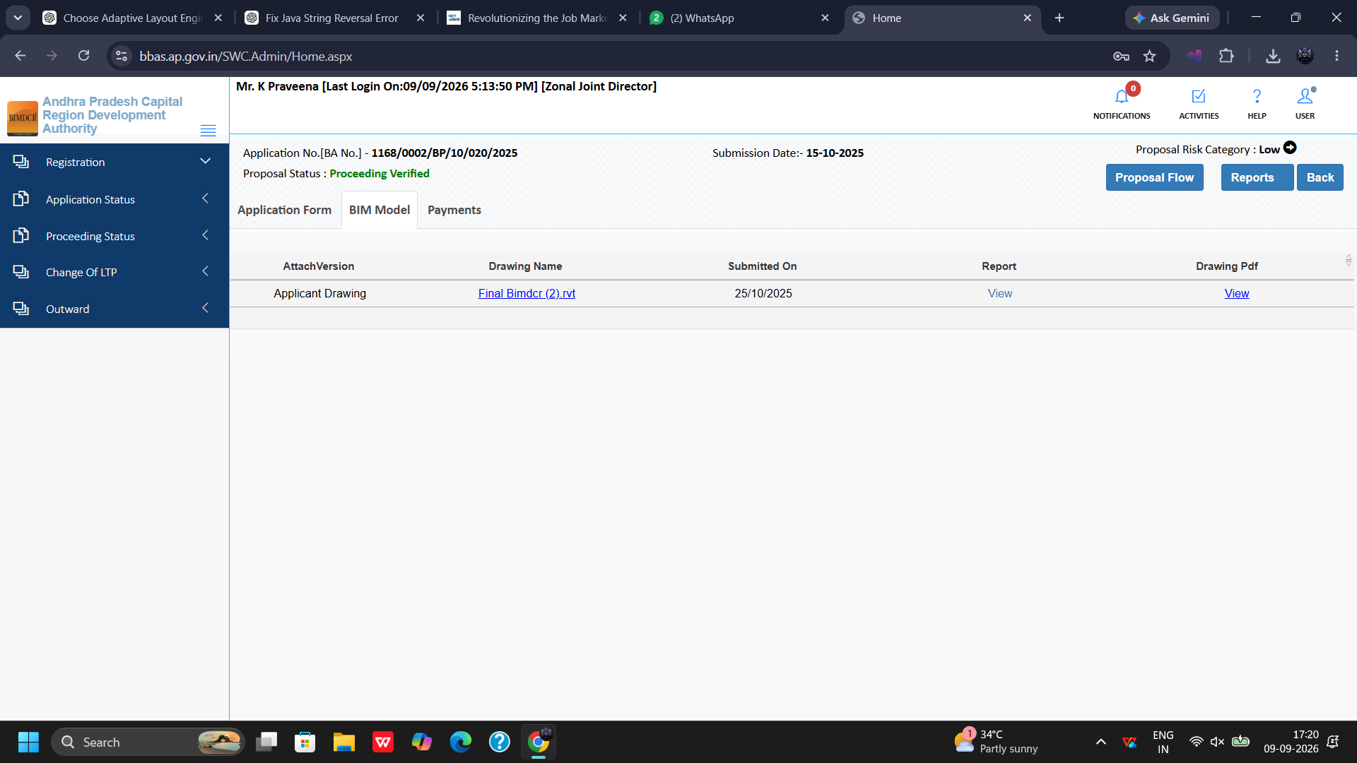
Figure 11.9 — Proposal 1168/0002: Final BIMDCR Drawing Model Scrutiny

11.10 Payment Realization: Total Fees Rs. 32,669.00
Verify final fee realization for Proposal 1168/0002:
1. Total Fees Computed: Verify Total Fees: Rs. 32,669.00.
2. Treasury Realization: Verify Paid Amount, Challan Memo, and payment transaction status.
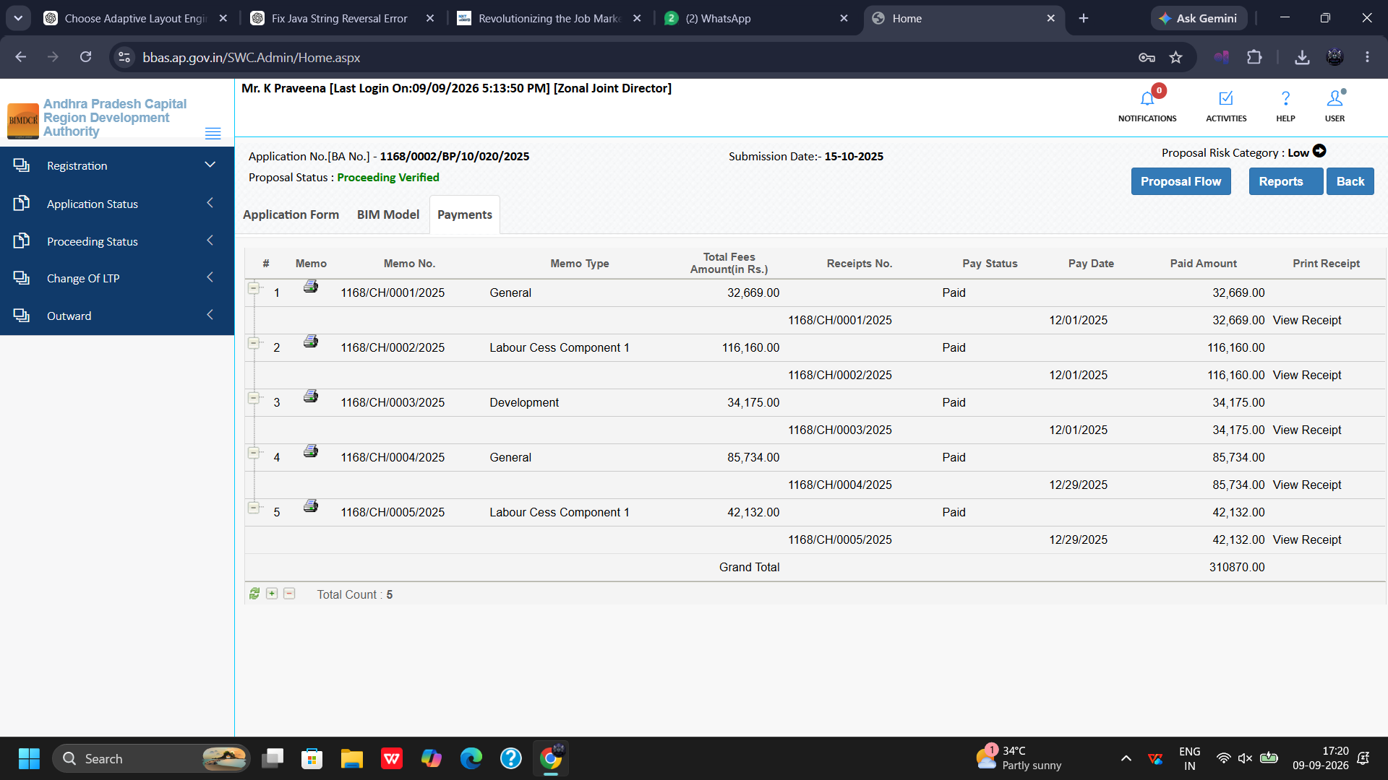
Figure 11.10 — Proposal 1168/0002: Treasury Fee Reconciliation (Total Fees: Rs. 32,669.00)

Chapter 12: End-to-End Operational Lifecycle & Decision Matrix
The following matrix synthesizes the complete operational scope, procedural workflows, and statutory responsibilities of the Zonal Joint Director (JD):
Lifecycle Stage | Portal Module / Tab | Screen / Figure | Administrative Actions & Decision Outputs
1. Developer Registration | Registration >> Developer Verification | Figure 3.1 (Screen 707) | Review developer firm credentials, RERA registrations, PAN details, and financial capabilities.
2. Professional Licensing | Registration >> In Process / Approved / Rejected | Figures 4.1 - 4.10 (Screens 708 - 717) | Verify Council of Architecture and Structural Engineer Grade-1 credentials; approve, hold, or reject professional licenses.
3. Application Tracking | Application Status >> Review / Issued / Revoke | Figures 5.1 - 5.3 (Screens 718 - 720) | Monitor active review proposals, access issued permit archives, and maintain cancellation registers.
4. Proposal Scrutiny & Sanction | Proceeding Status >> Verified (Proposals 1168/0001, 1168/0002) | Figures 6.1, 9.1-9.10, 11.1-11.10 | Complete 10-tab technical evaluation (General, Applicant, Plot, Checklist, Documents, Others, Site Insp, BIM, Payments); endorse Building Permit Order (BPO1.pdf).
5. Shortfall Administration | Proceeding Status >> Shortfall / Review Shortfall (Proposal 1168/0026) | Figures 6.2, 6.3, 10.1-10.11 | Issue formal Shortfall Letters for missing deeds, road dedications, or Fire NOCs; review applicant compliance resubmissions.
6. Enforcement Proceedings | Proceeding Status >> Show Cause / Review Show Cause | Figures 6.4, 6.5 (Screens 746 - 747) | Issue statutory Show Cause notices for major deviations; evaluate applicant legal replies and schedule personal hearings.
7. Professional Transfer | Change of Technical Professional >> Transfer Request | Figure 7.1 (Screen 748) | Validate owner transfer requests, verify NOC from outgoing professional, and reassign digital drawing rights.
8. Statutory Dispatch | Outward >> Outward Register | Figure 8.1 (Screen 749) | Maintain official statutory outward dispatch log for all permit orders, shortfall notices, and show cause communications.

