Andhra Pradesh Capital Region Development Authority
LTP User Manual
BIM Based Building Permit System (BBAS)
Licensed Technical Person portal
Portal: bbas.ap.gov.in
Audience: Architects, Structural Engineers, and other LTPs
Module-wise user guide with live portal screenshots. Share this Word file as-is, or use File → Save As → PDF.
Contents
1. Introduction
2. Portal access and login
3. Public dashboard
4. Role entry points
5. LTP portal overview
6. Application Submission
7. Application Status
8. Proceeding Status
9. Commencement Certificate
10. Change of LTP
11. Occupancy
12. Common actions
13. End-to-end lifecycle

1. Introduction
BBAS is APCRDA’s online system for building permission in the Amaravati Capital Region. An LTP prepares the application, attaches the BIM / drawing files, pays fees where required, and tracks the file until a Building Permit Order is issued. After approval, the same login is used for commencement, work-start notification, change of LTP, and occupancy.
Who | What they do in BBAS
Citizen | Pay fees and search application status without a full LTP login.
Developer / TPA | Register, renew, give consent, and view registered lists.
LTP | Register / renew the licence, then submit and manage building permission files.
APCRDA officers | Scrutiny, objections, shortfall, show-cause, and issue of proceedings.

Note: Fields marked with a red asterisk (*) are mandatory. Save each tab with Save & Continue before moving on.

2. Portal access and login

2.1 Open the BBAS home page
- 1. In a browser, go to https://bbas.ap.gov.in (page: Default.aspx).
- 2. Confirm the header shows BIM Based Building Permit System under APCRDA.
- 3. Use Home, Dashboard, Downloads, or Login from the top bar.
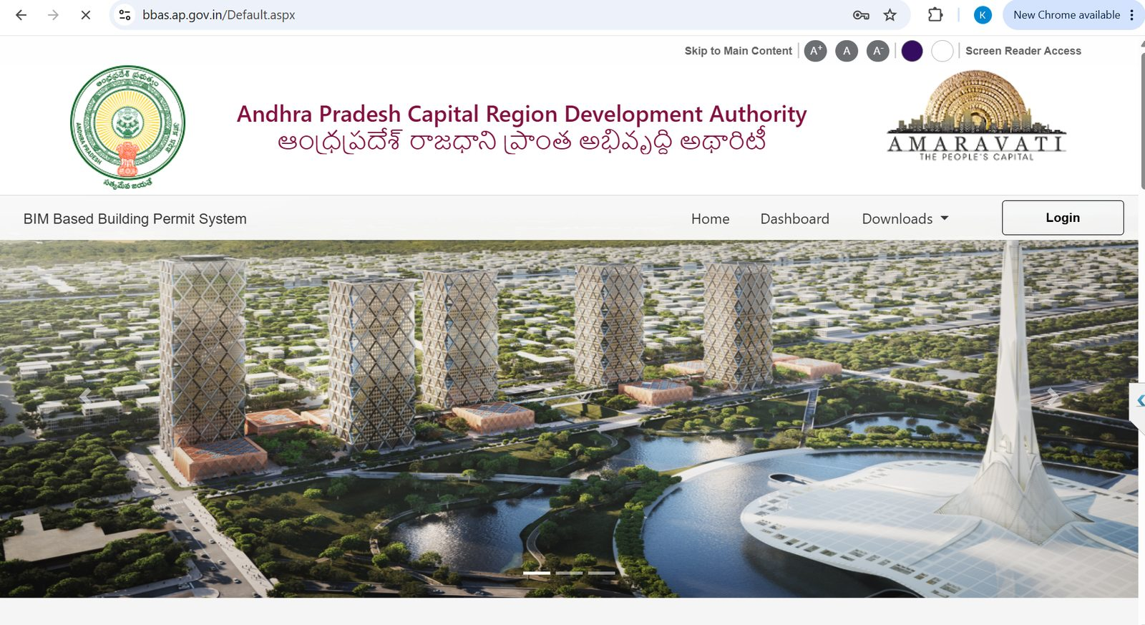
Figure 2.1 — BBAS home page (bbas.ap.gov.in/Default.aspx)

2.2 Downloads (orders, manuals, plugin)
- 1. Click Downloads on the top menu.
- 2. Under Documents, open Govt orders, Amaravati Zoning Plan and Regulations, Qualification of Licensed Technical Personnel, or the BIM Model Builder Plugin.
- 3. Under Help manuals, open How to Apply, BIM Modeling Help Manual, or the BIM Modeling Guide video before you start a new file.
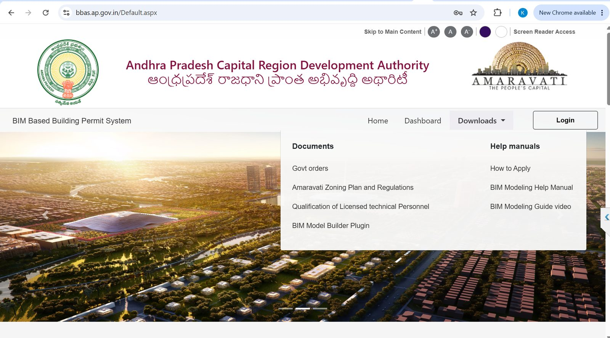
Figure 2.2 — Downloads menu: documents and help manuals

2.3 Login to BIMDCR (LTP / officer login)
- 1. Click Login. The BIMDCR login page opens (BPAMSClient/login.aspx).
- 2. Enter Username and Password.
- 3. Type the captcha shown in the image. Use the refresh icon if it is unreadable, or the speaker icon for audio captcha.
- 4. Click Login.
- 5. If you forgot the password, use Forgot password on this page.
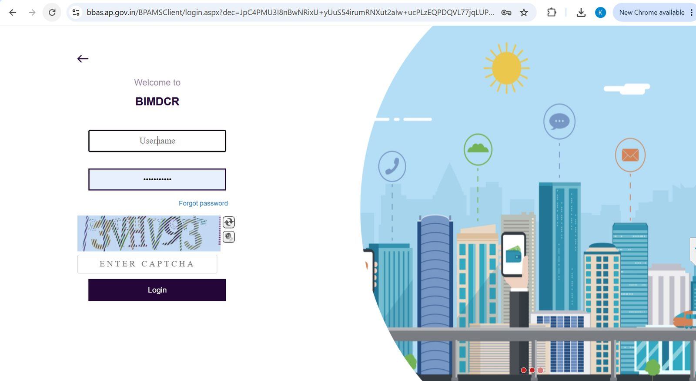
Figure 2.3 — BIMDCR login: username, password, captcha, Login
Important: Do not share your LTP credentials. The header after login shows your name, last login, role (for example Structural Engineer), and licence validity date.

3. Public dashboard
Anyone can open Dashboard from the home page to see aggregate Pre Proceeding / Post Proceeding statistics. This is a read-only public view, not your personal file list.
- 1. Click Dashboard.
- 2. Select Pre Proceeding or Post proceeding.
- 3. Use the Abstract tab for charts, or Application(s) for the list view.
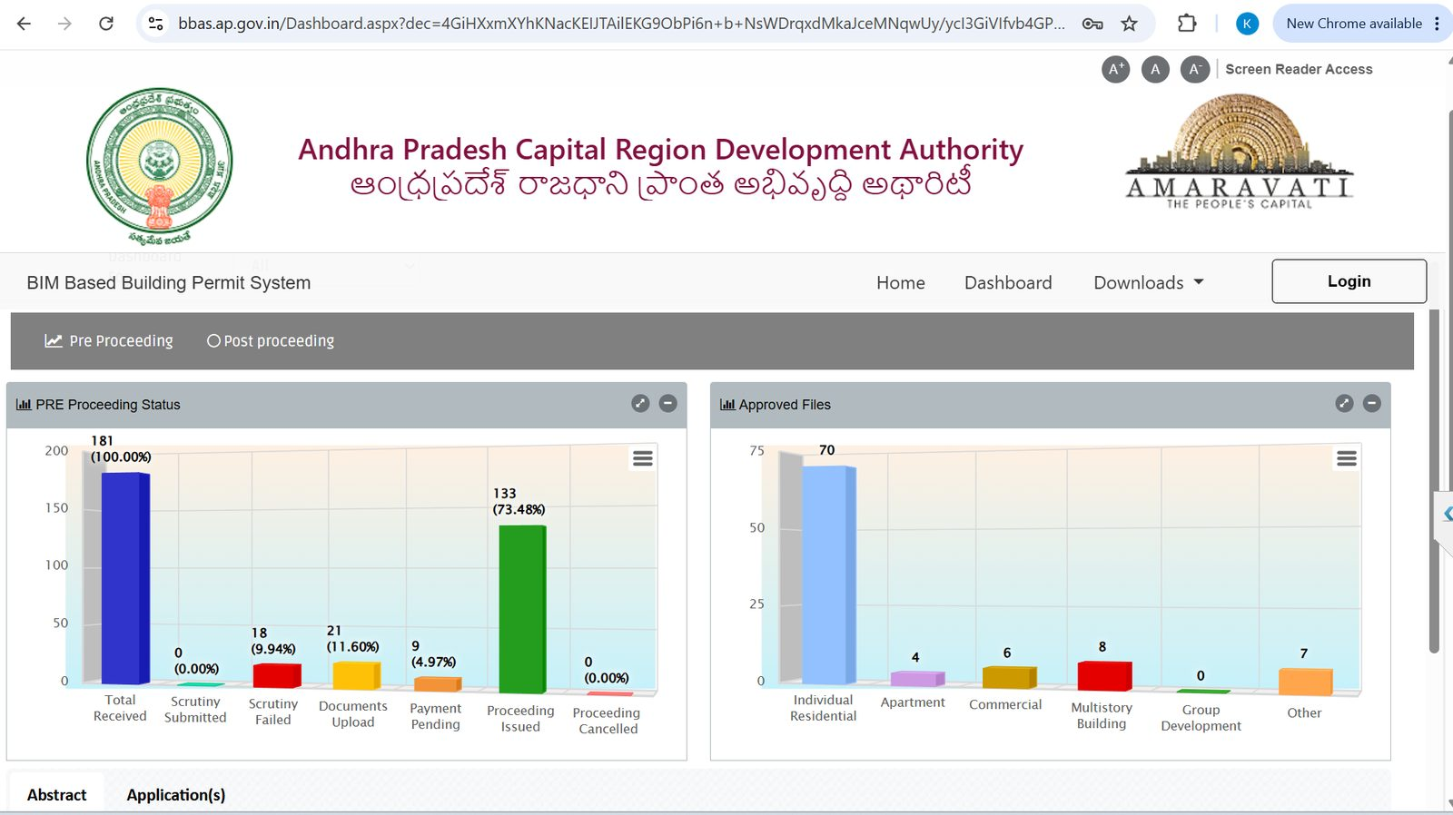
Figure 3.1 — Pre Proceeding abstract: received, scrutiny, documents, payment, proceeding issued
Typical Pre Proceeding stages shown on the abstract:
Stage | Meaning
Total Received | Applications that have entered the system.
Scrutiny Submitted / Failed | Automated / technical scrutiny result.
Documents Upload | File is waiting for remaining documents.
Payment Pending | Fee memo is generated but not fully paid.
Proceeding Issued | Building permit proceeding has been issued.
Proceeding Cancelled | Issued proceeding was cancelled.

4. Role entry points (before / without LTP workspace)
From the public site you can also open role-specific services. These tiles sit on the landing area used for citizen, developer/TPA, and LTP self-service.
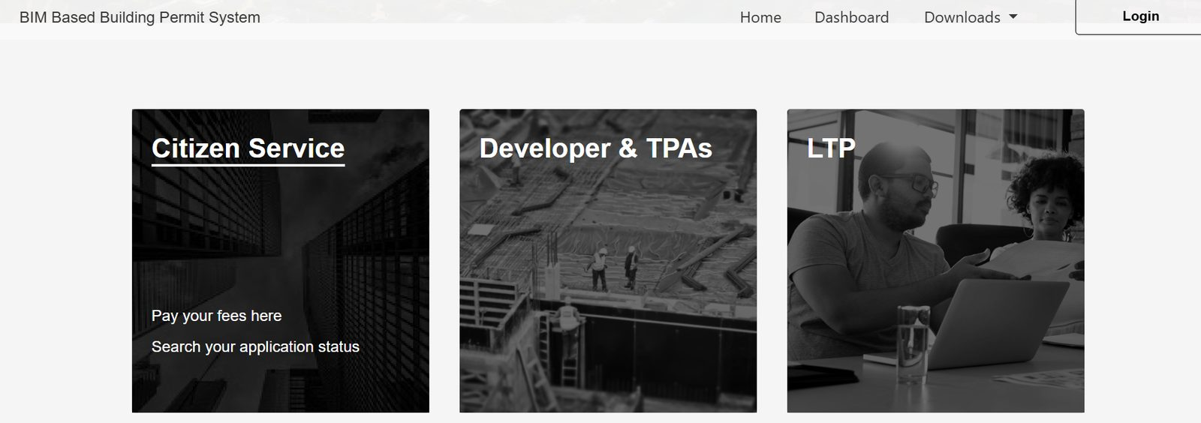
Figure 4.1 — Citizen Service, Developer & TPAs, and LTP entry tiles

4.1 Citizen Service
- 1. Open the Citizen Service tile.
- 2. Use Pay your fees here to pay a generated fee memo.
- 3. Use Search your application status with the BA number to see the current stage.

4.2 Developer & TPAs
- 1. Open the Developer & TPAs tile.
- 2. Choose the required link:
Link | Use it to
Developer Registration | Apply as a new developer.
Developer Registration Status | Track a registration already filed.
Developer Renewal | Renew an existing registration.
List of Registered developer | See approved developers.
Developer Consent Link | Give / record developer consent on a file.
TPAs Consent Link | Give / record TPA consent.
List of Registered TPAs | See approved third-party agencies.

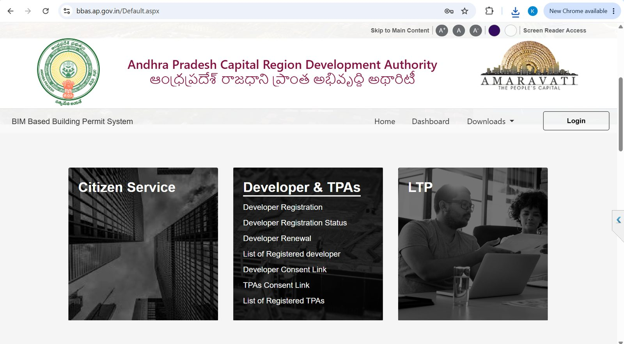
Figure 4.2 — Developer & TPAs tile with registration, renewal, lists, and consent links

4.3 LTP public services (registration and renewal)
Use these links if you are not yet registered, or you need to renew / pay / view your LTP record. After you have a valid licence, use Login (Section 2.3) to work on building files.
- 1. Open the LTP tile.
- 2. Select the required service:
Link | Use it to
New Registration | Apply for a new LTP licence.
List of Registered LTPs | Confirm a licence is on the published list.
LTP Renewal | Start licence renewal.
Payment and Renewal | Pay renewal / registration fees.
LTP View | View your LTP profile.
LTP Consent Link | Accept appointment as LTP on a file.

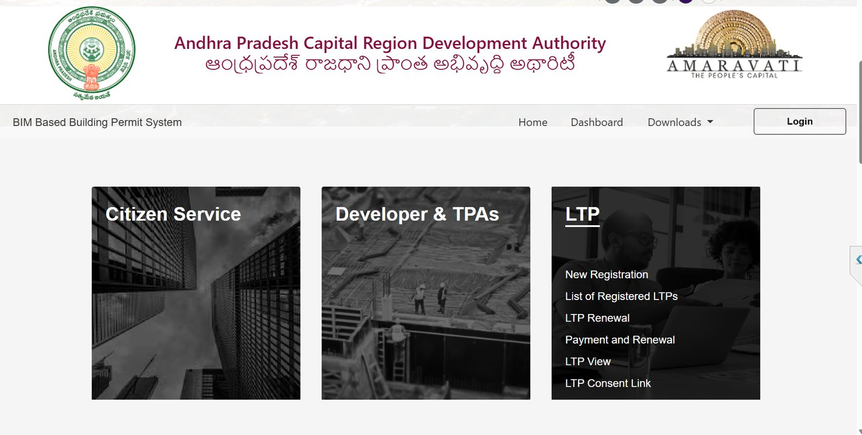
Figure 4.3 — LTP tile: New Registration, list, renewal, payment, view, consent

5. LTP portal overview (after login)
After a successful login, the LTP workspace (SWC Admin) opens. The left sidebar is the module list. The header shows your name, last login, role, and licence validity (example: Structural Engineer, valid to 30-03-2027).
Sidebar module | When you use it
Application Submission | Create a draft and send it to scrutiny.
Application Status | Track review, objections, approval, and issued proceeding.
Proceeding Status | Handle verified files, shortfall, and show-cause.
Commencement Certificate | See CC issued files and notify work start.
Change Of LTP | Change the licensed technical person on a file.
Occupancy | Intimate completion and track occupancy applications.

Header icons on every screen: Notifications, Activities, Help, and User (profile / logout).
Tip: List screens share the same tools: keyword search, Filter / Find / Clear, column filters, refresh, and Excel export. The footer shows Total Proposal(s) .

6. Module: Application Submission
This is where a new building permission file is created. Menu path: Application Submission → Draft Application or Submitted Applications.

6.1 Draft Application — start and General Information
- 1. Open Application Submission → Draft Application.
- 2. A temporary application number is allotted (example: Temp/1168/0014/BP/2025). Status is Draft Mode. Risk category is shown (example: Low).
- 3. Stay on tab Application Form → General Information.
- 4. Fill Case Type (New), Permission Type (Building Permission), Nature of Permission (General).
- 5. Select Application Type: Private / Govt land / CRDA land.
- 6. Choose LPS Layout or Non-LPS. Use Change Plot if the plot must be switched.
- 7. Select District, Mandal, LPS Village, Gram panchayat, then Township, Sector, Colony as applicable.
- 8. Enter Nature of Site, Block No., Survey No / D.No / R.S.No, Plot No., Land Use Zone, Zoning District, Proposed Use, Proposed Activity, Road/Street, and Building Height.
- 9. Click Save & Continue.
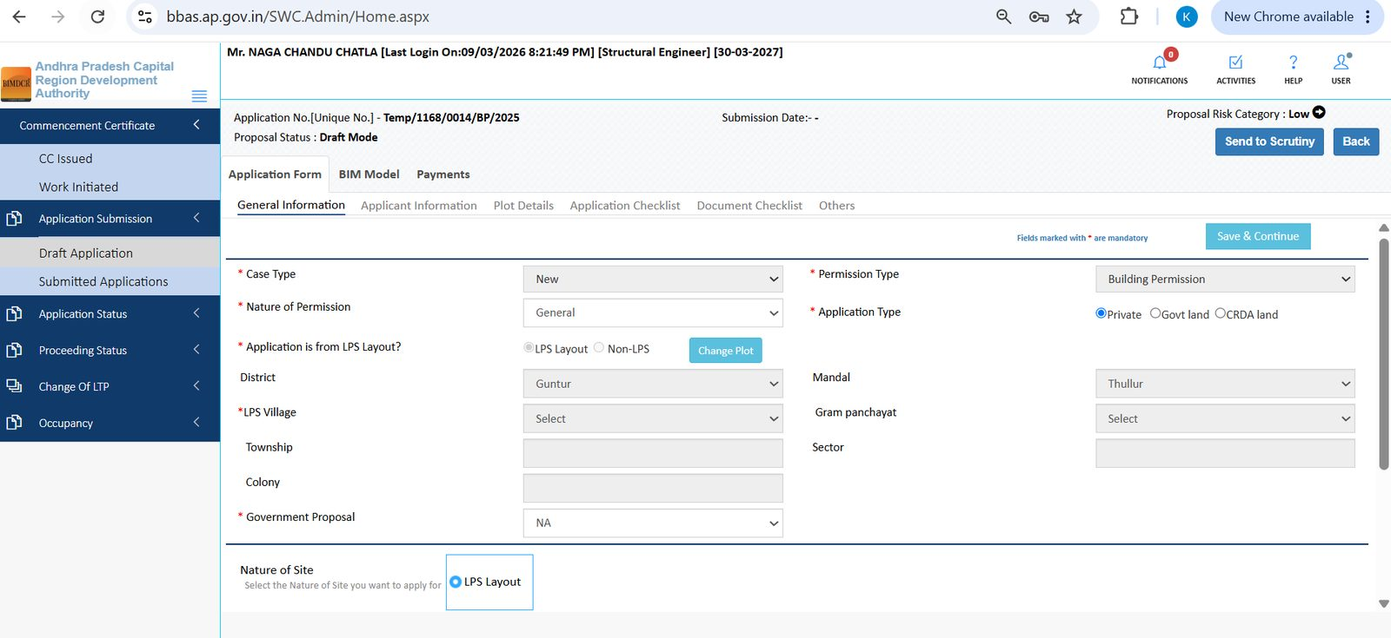
Figure 6.1 — Draft Application: General Information (case type, LPS, location)
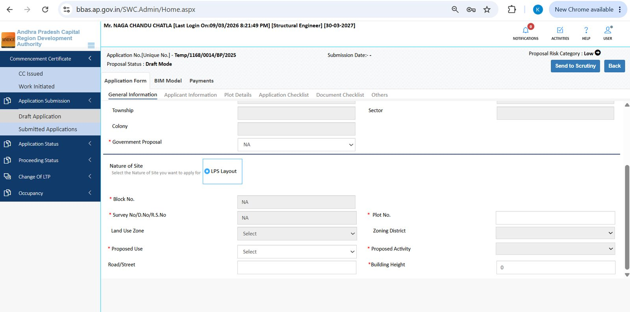
Figure 6.2 — General Information continued: site identifiers, zone, proposed use, height

6.2 Applicant Information
- 1. Open Applicant Information.
- 2. Check Licensed Technical Personnel’s Information (pre-filled from your login: type, name, licence number, mobile, validity, email, Aadhaar).
- 3. Under Applicant’s Information, choose Usage Purpose: Self Use or Selling.
- 4. Enter Owner Name, Door / Flat No., Road/Street, City, District, PinCode, Email, Mobile, and Aadhaar.
- 5. Confirm the Structural Engineer name in the dropdown and the licence validity date.
- 6. Click Save & Continue.
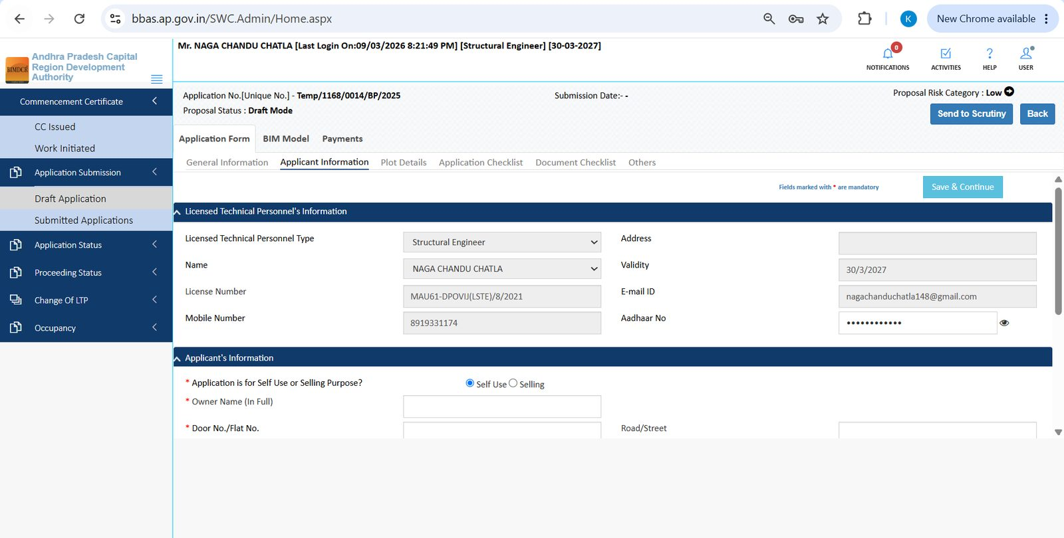
Figure 6.3 — Applicant Information: LTP block (read-only) and owner start
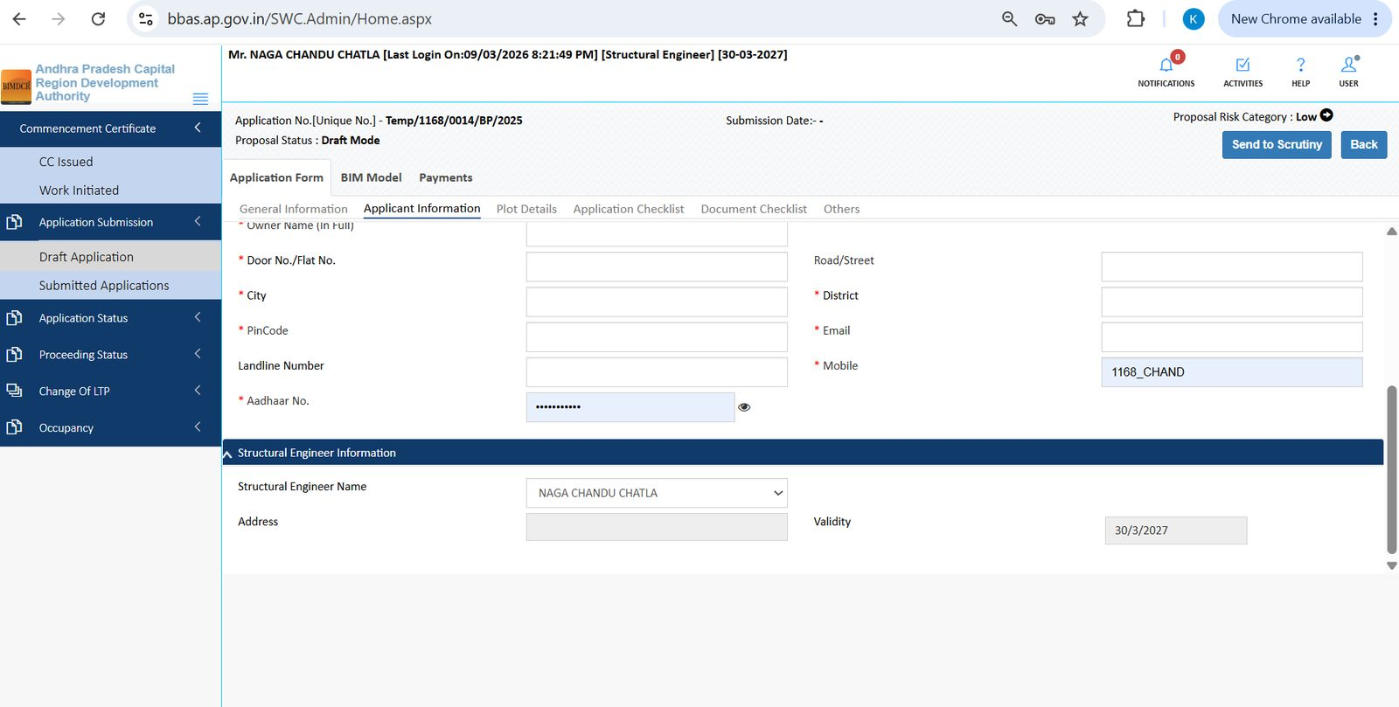
Figure 6.4 — Applicant Information: owner address, contact, Aadhaar, structural engineer

6.3 Plot Details
- 1. Open Plot Details.
- 2. Under Proposed Construction, enter Proposed Plot Area (sq. mtr.) and Plot Structure. Answer Compound Wall and TDR (Yes/No).
- 3. Under Site Details, set nearby religious structures, aerodrome, water bodies / railways / HT lines, market value (Rs per sq. yard), and whether the site abuts the IRR.
- 4. Under Schedule of Boundaries, set North, South, West, and East (Plot / Road / Others) with plot numbers or road widths.
- 5. Click Save & Continue.
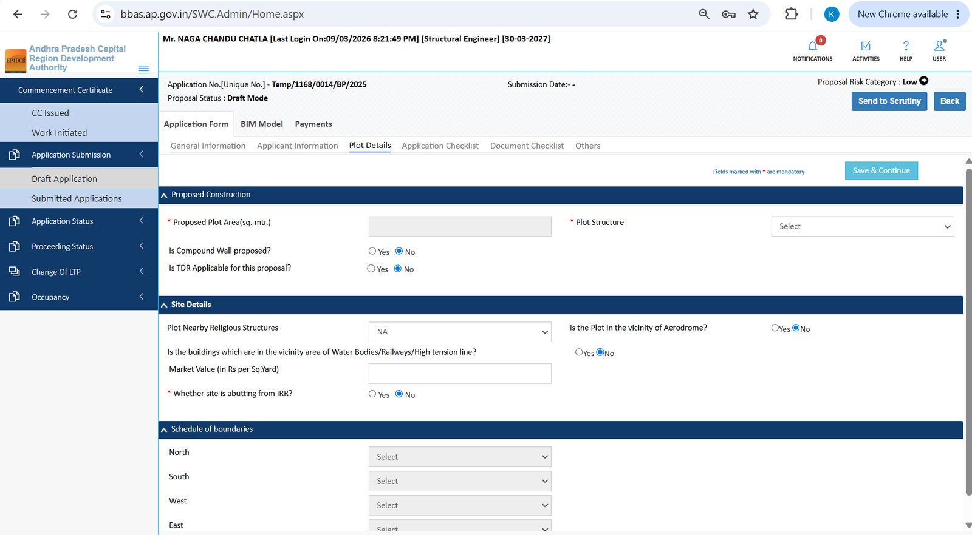
Figure 6.5 — Plot Details: proposed construction, site details, schedule of boundaries

6.4 Application Checklist
Answer every Yes/No item. These answers drive NOC needs and risk category (height, zoning, monuments, railway buffer, built-up area, and similar rules).
- 1. Open Application Checklist.
- 2. For each row, select Yes or No and add a Remark if needed.
- 3. Typical checks include height greater than 10 m / 15 m (commercial) / 18 m (residential or group housing), monument buffer 100–200 m, railway 30 m, built-up area above 20,000 sq. m.
- 4. Click Save & Continue.
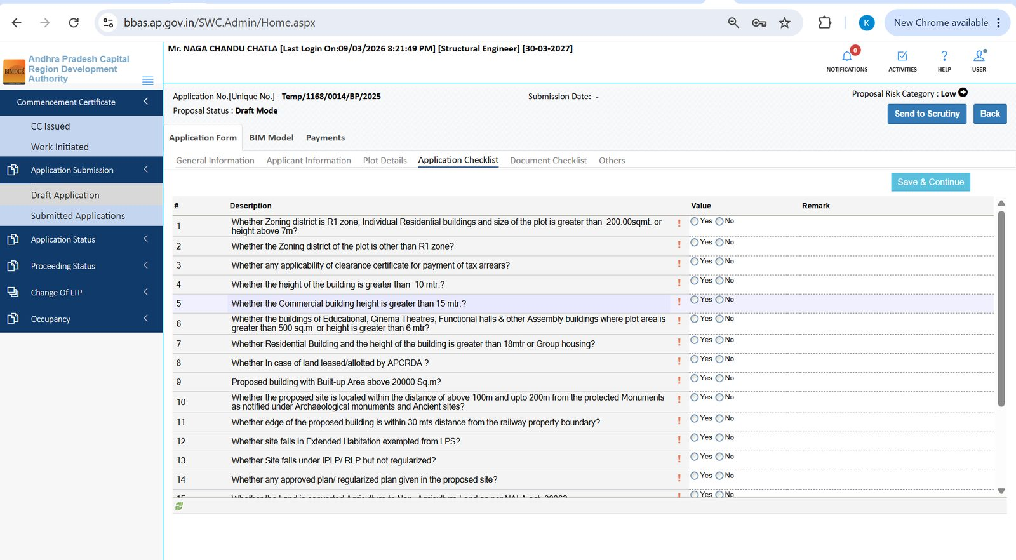
Figure 6.6 — Application Checklist: regulatory Yes/No questions

6.5 Document Checklist
- 1. Open Document Checklist. Use Primary first, then Additional if shown.
- 2. For each required document, click Attach Files.
- 3. Typical primary documents:
# | Document
1 | Original sale deed / certified copy (Indian Registration Act, 1908)
2 | Certificate of Supervision signed by the Licensed Professional (Capital City ZR Sec. 209.1 (vii))
3 | Attested Land Pooling Ownership Certificate issued by APCRDA (or equivalent)
4 | Notarised Owner and Builder/Developer affidavit on sanctioned-plan compliance
5 | Certification of appointment to New LTP (when applicable)

Click a document name later to view the attachment or remarks.
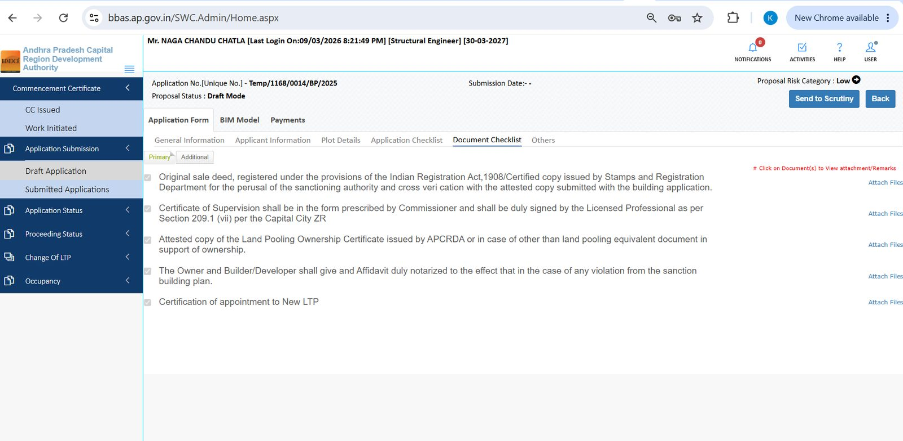
Figure 6.7 — Document Checklist (Primary) with Attach Files on each row

6.6 Others
- 1. Open Others.
- 2. Enter Contractor’s all Risk policy number, Contractor’s Date, and Valid Upto.
- 3. Enter Mortgage Deed No. (mandatory), Mortgage Deed Date, Floor handed Over, Sub Register Office, and Area (sq. mtr.).
- 4. Answer Solar Panels are Available or Not?
- 5. Click Save & Continue.
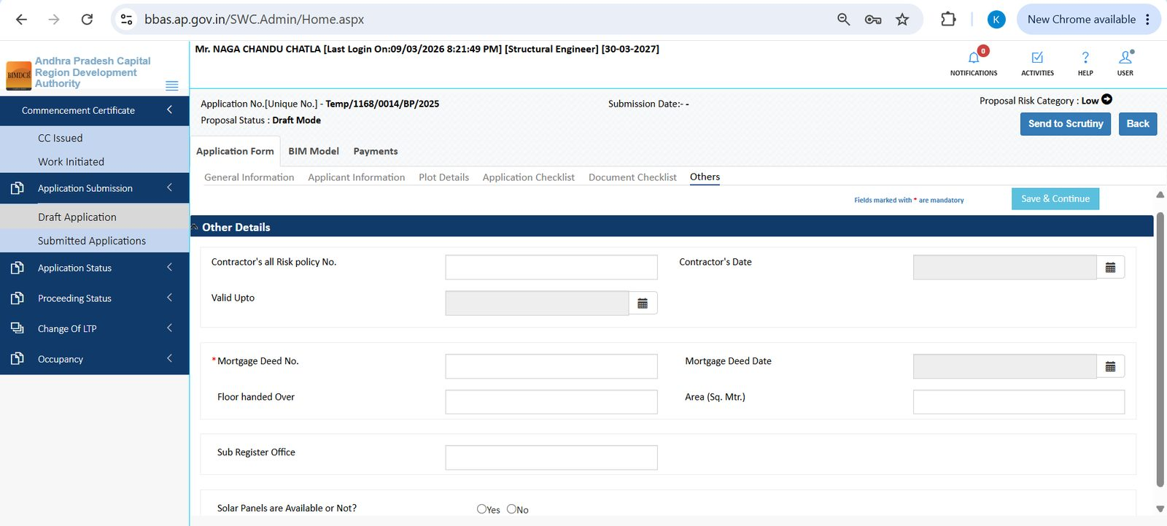
Figure 6.8 — Other Details: CAR policy, mortgage deed, solar panels

6.7 BIM Model (Revit .rvt)
- 1. Open the top tab BIM Model.
- 2. Under Attach Model, click Select Files.
- 3. In the Attachments window, read the instruction: Please Attach only .rvt files.
- 4. Click Select, choose the Revit model, and upload.
- 5. After upload, the file appears in the list with a Download link and date.
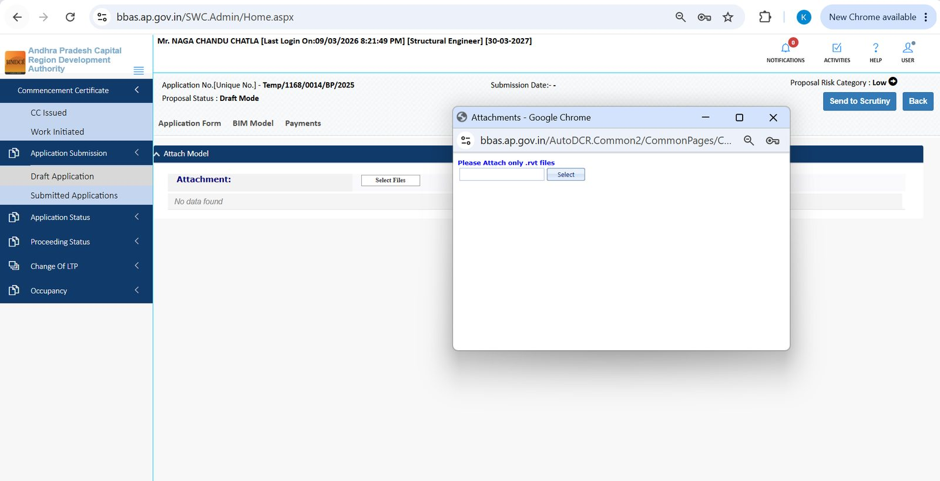
Figure 6.9 — BIM Model: system accepts only .rvt (Revit) files
Important: Do not upload Excel, Word, or PDF on the BIM tab. Those belong on Document Checklist. BIM upload is .rvt only.

6.8 Drawing tab (AutoCAD .dwg) — when shown
Some files show a Drawing tab instead of (or in addition to) BIM Model.
- 1. Open Drawing.
- 2. Under AutoCAD File, click Select Files.
- 3. Attach .DWG files only.
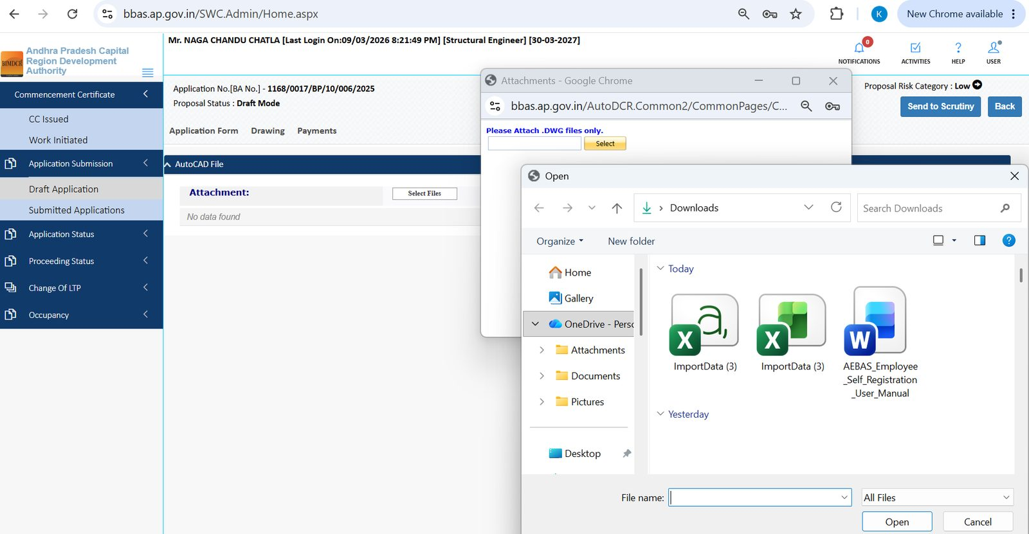
Figure 6.10 — Drawing tab: attach AutoCAD .dwg only

6.9 Payments (draft)
- 1. Open the Payments tab.
- 2. Fee memos appear here after scrutiny generates them. A new draft often shows No data found and Grand Total 0.00.
- 3. When memos exist, check Memo Type, Total Fees, Pay Status, and use Print Receipt / View Receipt after payment.
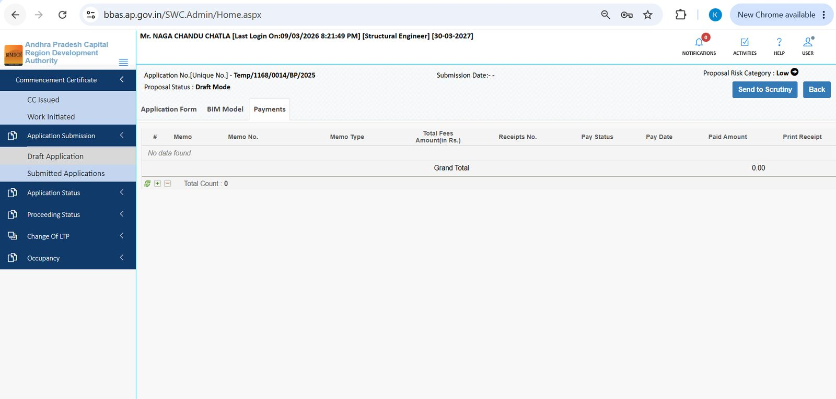
Figure 6.11 — Payments tab on a draft (no memo until scrutiny / fee generation)

6.10 Send to Scrutiny
- 1. Complete Application Form, BIM/Drawing, and any required documents.
- 2. Click Send to Scrutiny at the top right.
- 3. Use Back if you need to return to the draft list without submitting.
Note: Until you send to scrutiny, Proposal Status stays Draft Mode and Submission Date stays blank.

6.11 Submitted Applications
- 1. Open Application Submission → Submitted Applications.
- 2. Search or filter by BA No., Permission Type, Status, Submission Date, Owner, or Case Type.
- 3. Click a BA number to open the file.
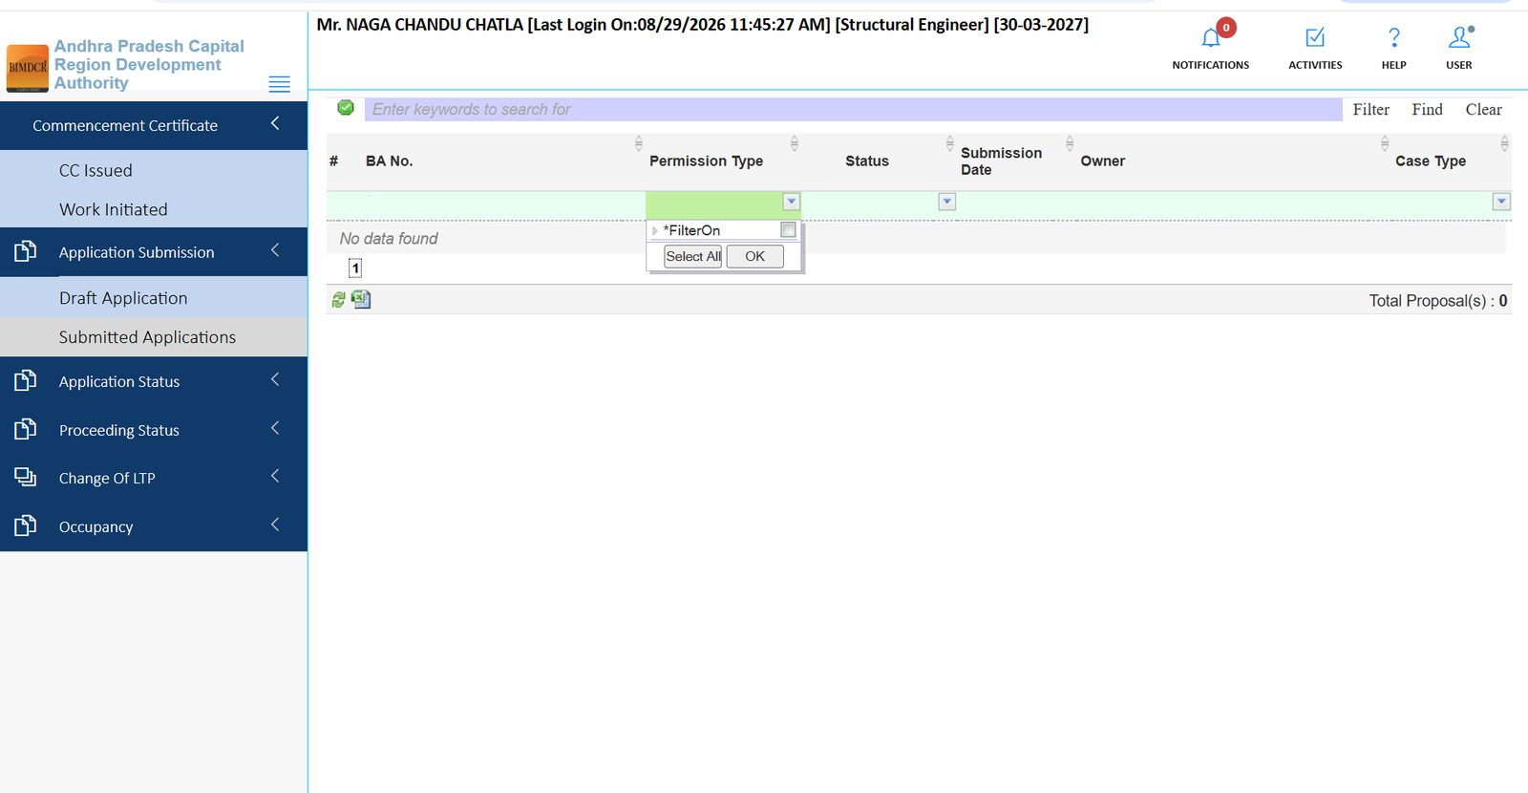
Figure 6.12 — Submitted Applications list (search, filter, Excel export)

7. Module: Application Status
Menu path: Application Status. Use this module after the file has left your draft tray. Each sub-menu is a queue.
Sub-menu | What you do
Review Proceeding | Open files that are under official review.
Objected Files | Correct scrutiny / document issues and resubmit.
Approved Files | Open approved files; view letter, NOCs, reports.
Proceeding Issued | See files for which the proceeding has been issued.

7.1 Review Proceeding
- 1. Open Application Status → Review Proceeding.
- 2. Use search / column filters if the list is long.
- 3. Click the BA No. to open the application in read or limited-edit mode.
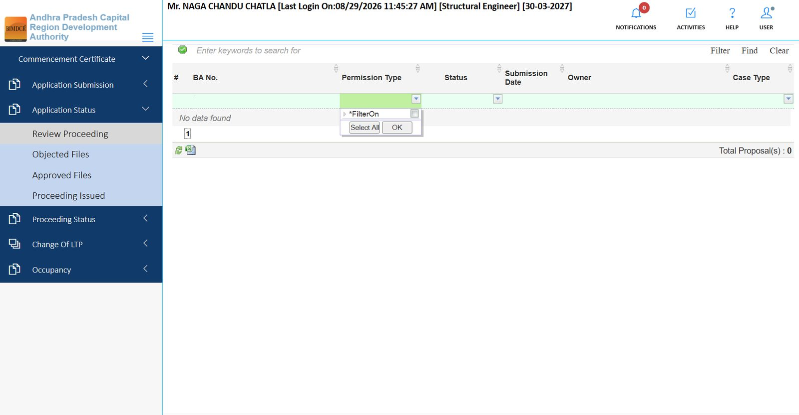
Figure 7.1 — Review Proceeding queue with Permission Type filter

7.2 Objected Files — find the file
- 1. Open Application Status → Objected Files.
- 2. Note Status (example: Scrutiny Can Not Done in red).
- 3. Click the BA No. (example: 1168/0156/BP/10/020/2026 (SUB-6)).
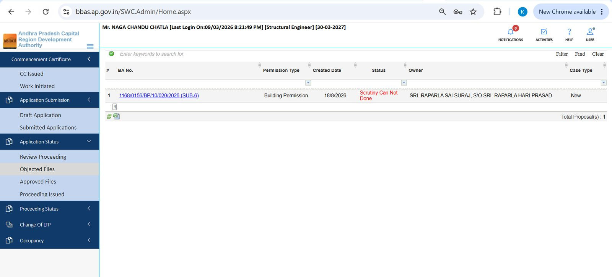
Figure 7.2 — Objected Files: one record with status Scrutiny Can Not Done

7.3 Objected Files — correct and resubmit
The file reopens in Draft Mode so you can edit. Extra buttons appear: Proposal Flow, Action, Reports, Back.
- 1. Walk the same tabs as a new draft: General Information, Applicant Information, Plot Details, Application Checklist, Document Checklist, Others.
- 2. Fix the objected data (plot, height, checklist answers, missing attachments).
- 3. Re-attach or replace the BIM .rvt if the model was the cause.
- 4. Check Payments if a new memo was raised.
- 5. Use Action / Send to Scrutiny (as available on that screen) to return the file to APCRDA.
- 6. Use Proposal Flow to see where the file sat in the office chain.
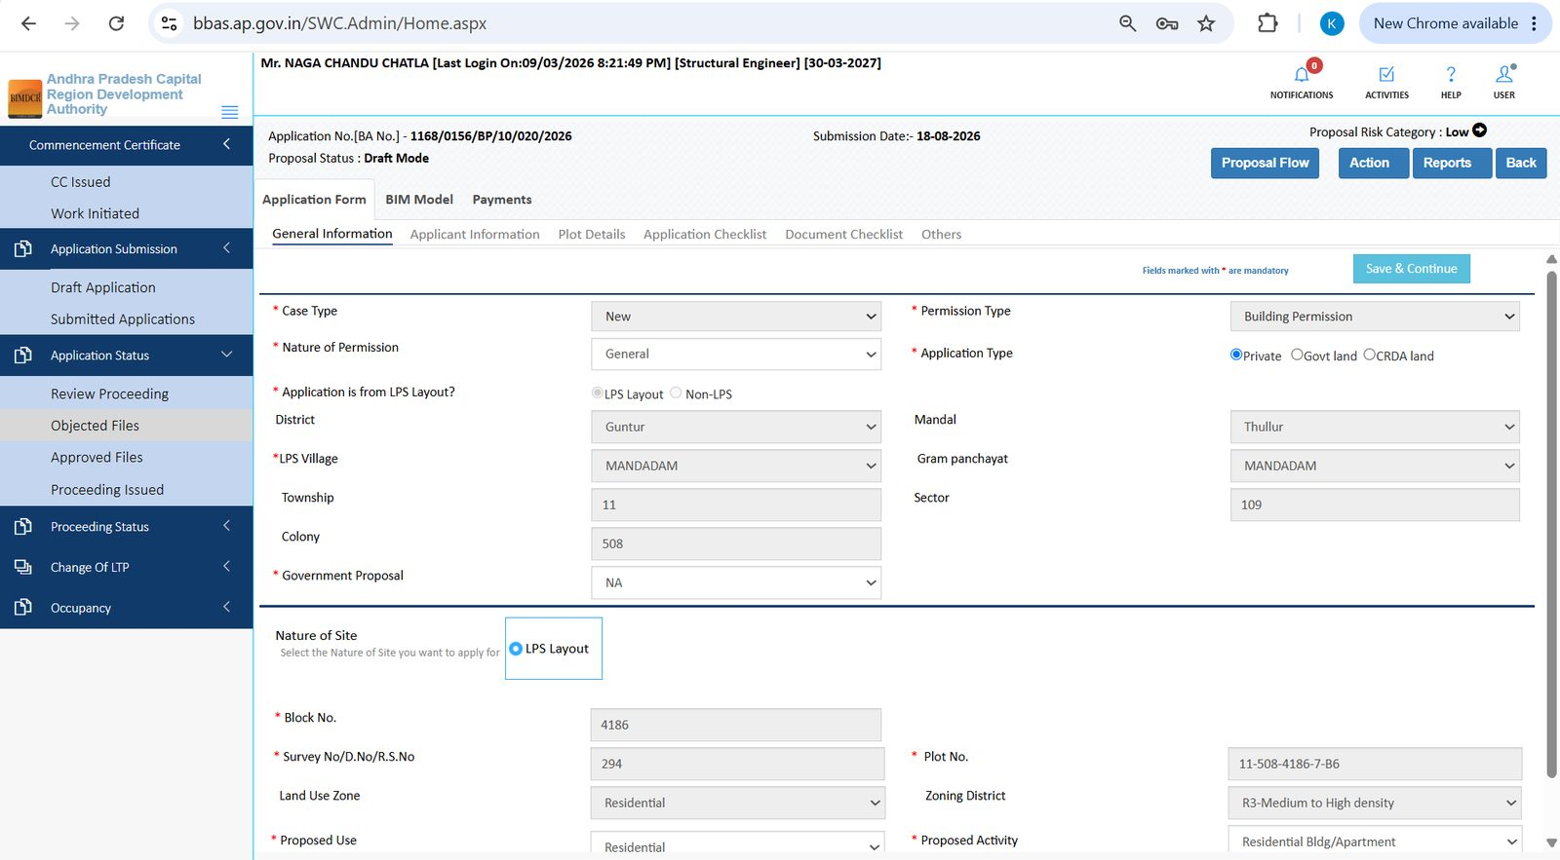
Figure 7.3 — Objected file opened: General Information with Proposal Flow / Action / Reports
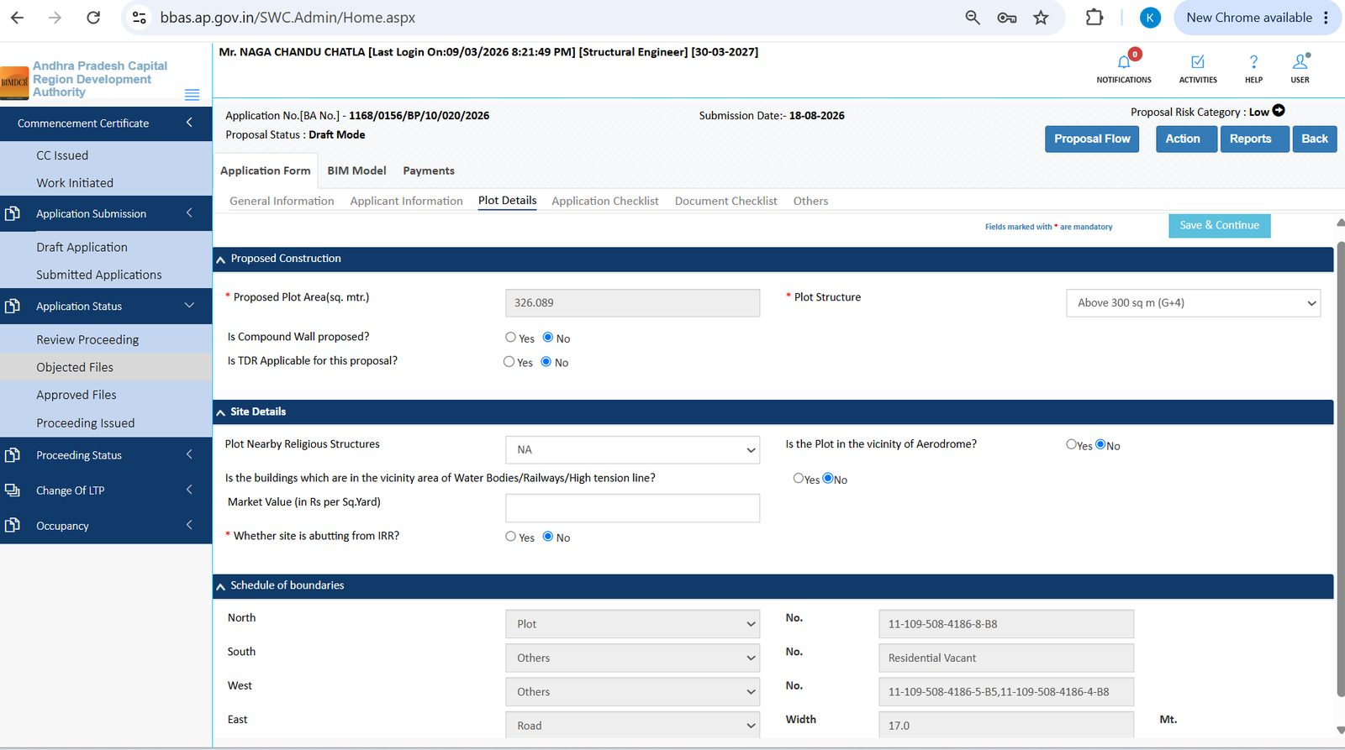
Figure 7.4 — Objected file: Plot Details (area, structure G+4, boundaries)
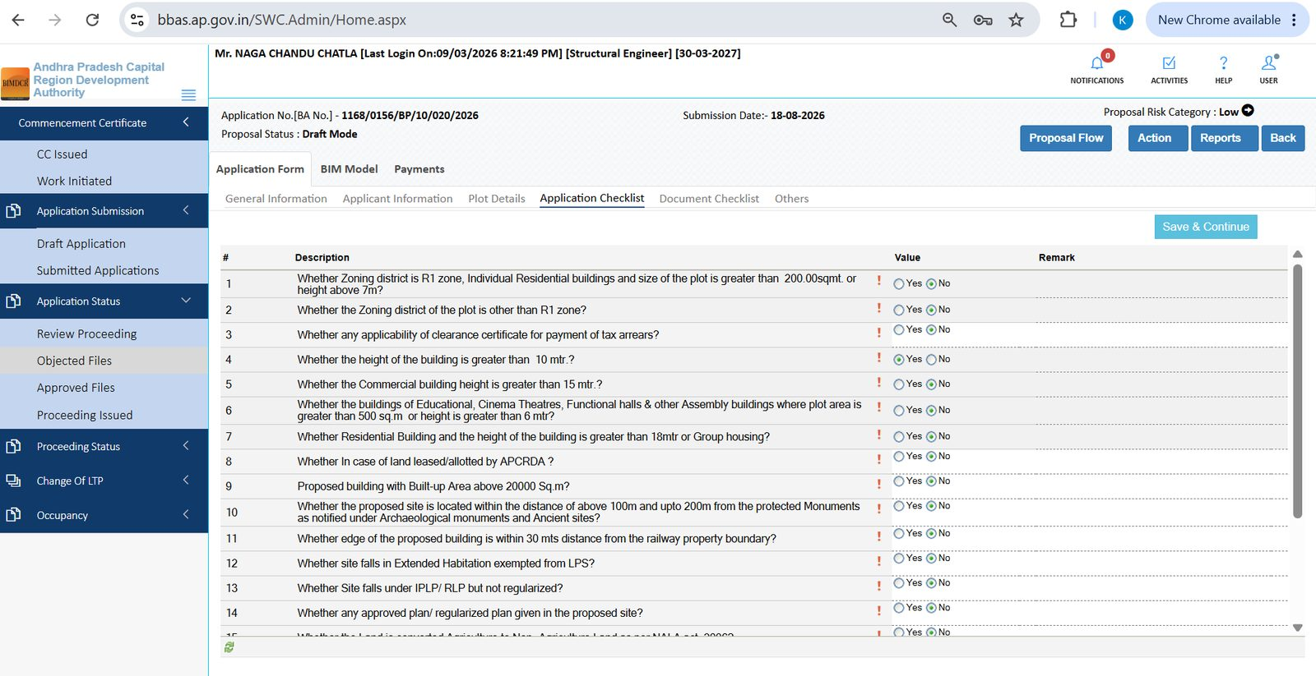
Figure 7.5 — Objected file: Application Checklist (example: height > 10 m = Yes)
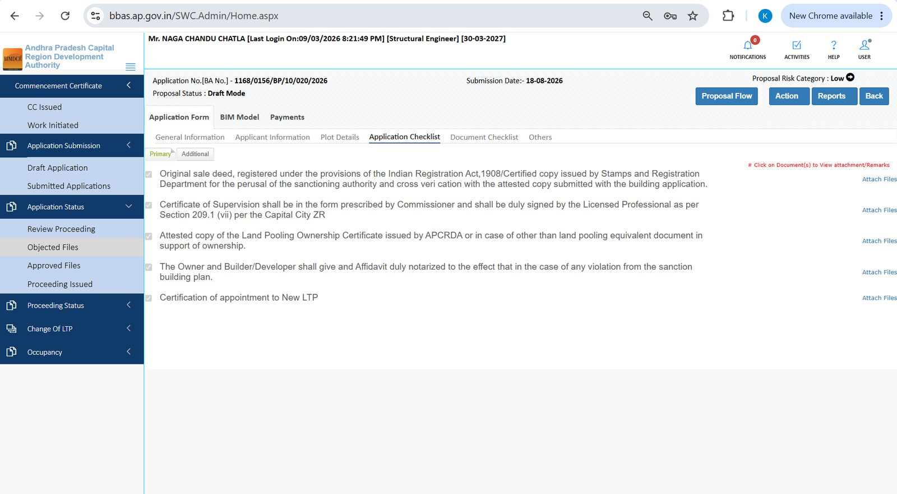
Figure 7.6 — Objected file: Document Checklist — attach or replace missing papers
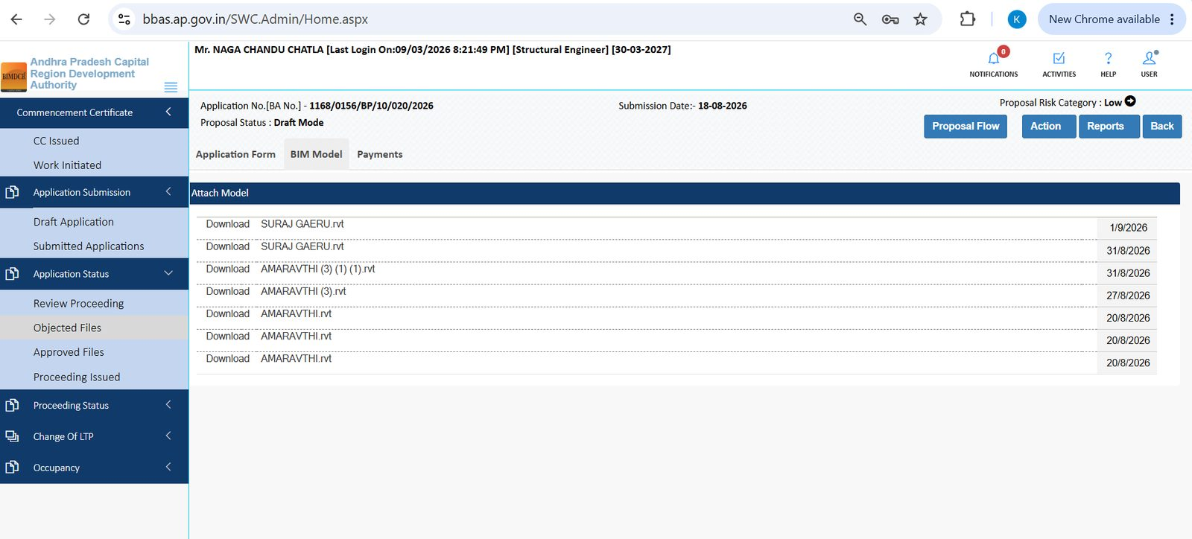
Figure 7.7 — Objected file: BIM Model list with Download and upload dates

7.4 Approved Files
- 1. Open Application Status → Approved Files.
- 2. Click the BA No. Status shows Approved. Proposal Status inside the file is often Proceeding Verified.
- 3. Review form tabs in read mode. After approval, two extra form tabs appear: Letter and Apply for NOCs.
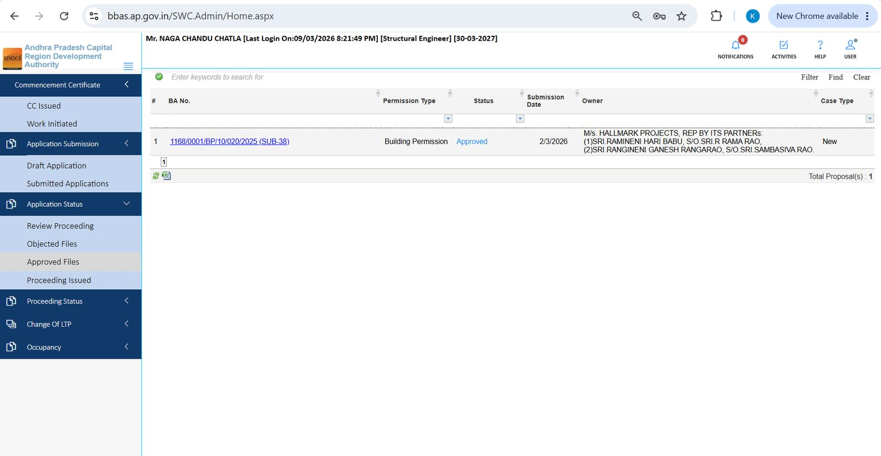
Figure 7.8 — Approved Files list (example BA 1168/0001/BP/10/020/2025)
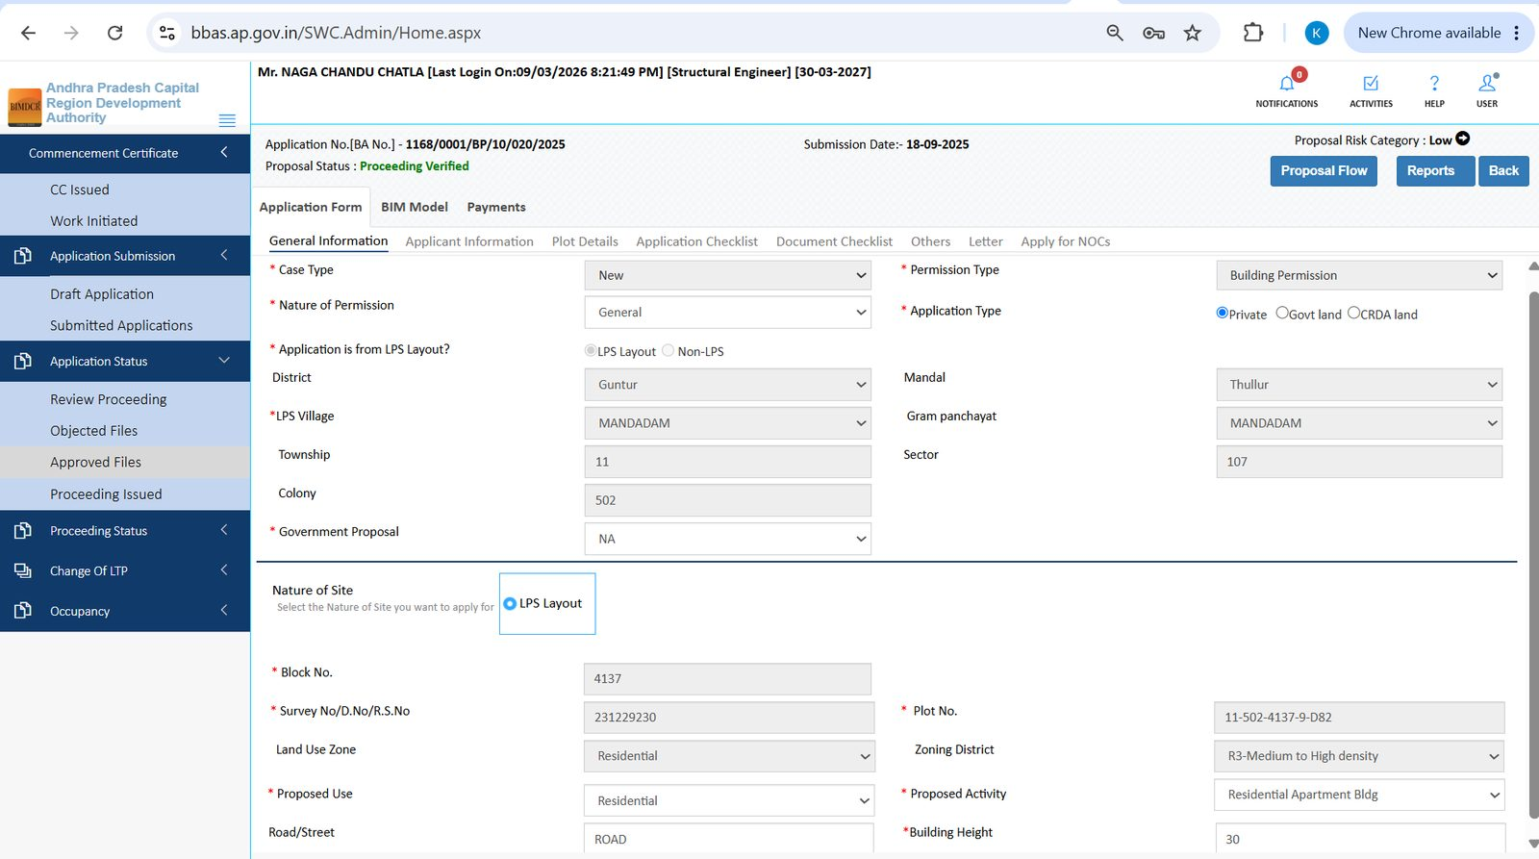
Figure 7.9 — Approved file: General Information (LPS Mandadam, residential apartment, height 30)

7.5 Letter — Building Permit Order
- 1. On an approved / verified file, open Application Form → Letter.
- 2. The Building Permit Order PDF (example: BPO1.pdf) opens in the viewer.
- 3. Zoom, print, or download the order for the owner and site file.
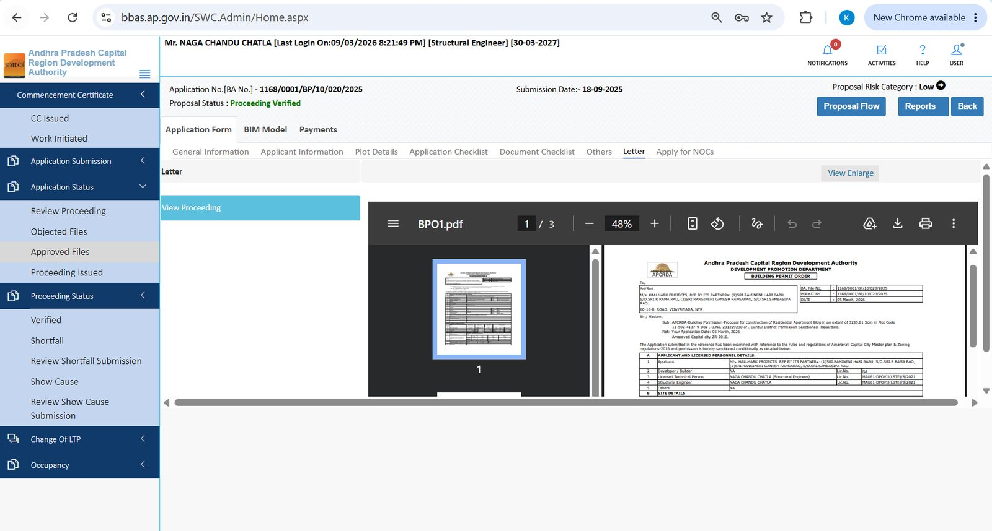
Figure 7.10 — Letter tab: APCRDA Building Permit Order (BPO)

7.6 Apply for NOCs (External Fire example)
- 1. Open Apply for NOCs.
- 2. Read the on-screen rule. External Fire NOC is typically required for residential height > 18 m, commercial / group housing > 15 m, or public assembly > 6 m or > 500 sq. m.
- 3. Answer Do you have Approved Fire NOC for this application?
- 4. If Yes, attach the Fire NOC PDF (example: fire NOC.pdf).
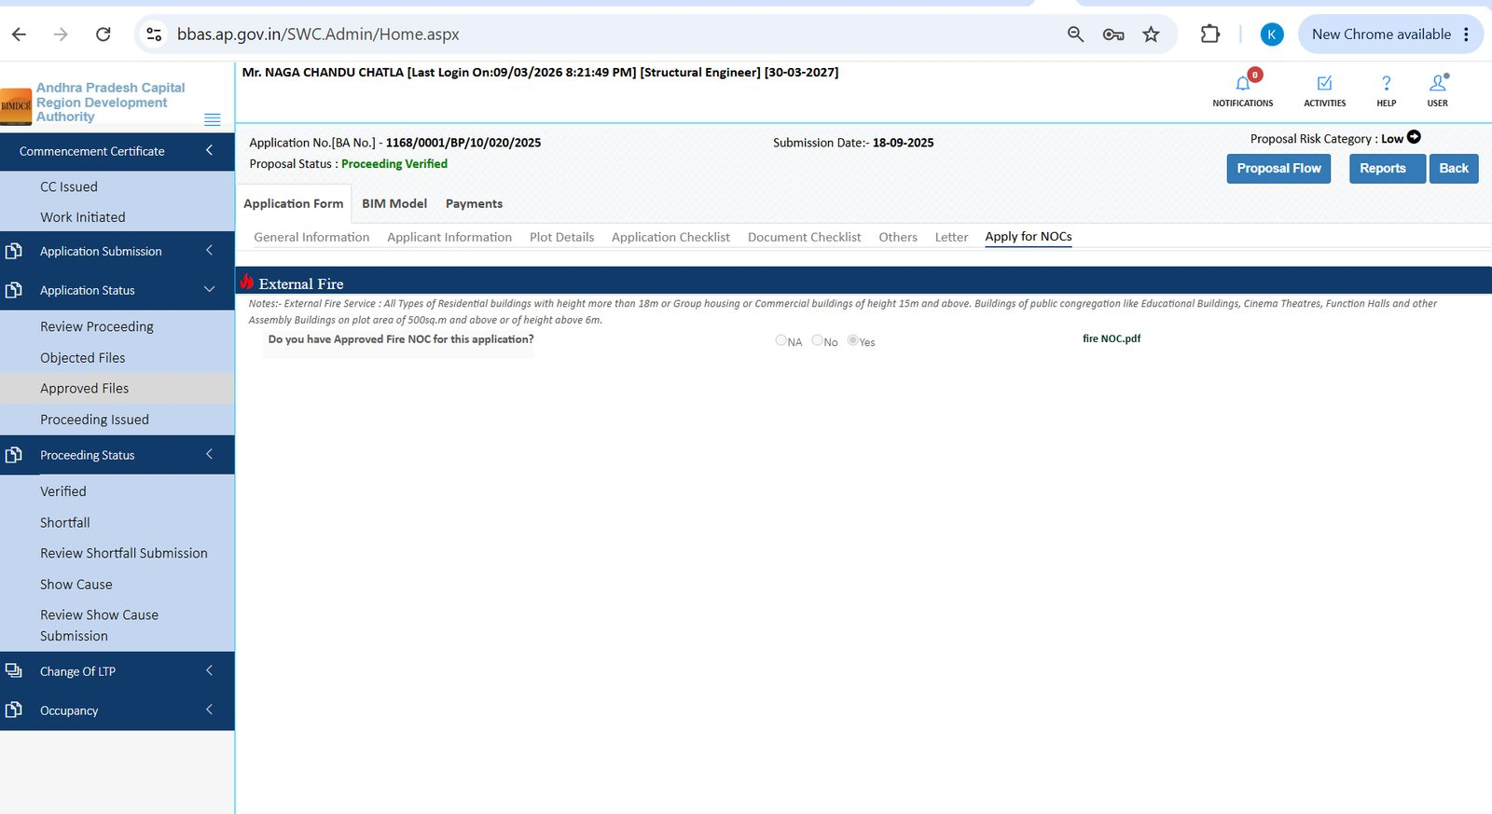
Figure 7.11 — Apply for NOCs: External Fire, Yes selected, fire NOC.pdf attached

7.7 Proceeding Issued
- 1. Open Application Status → Proceeding Issued.
- 2. Search the BA No. to confirm the proceeding is on your list.
- 3. Open the row to view reports, drawing plan, scrutiny report, and proceeding letter when those icons are shown.
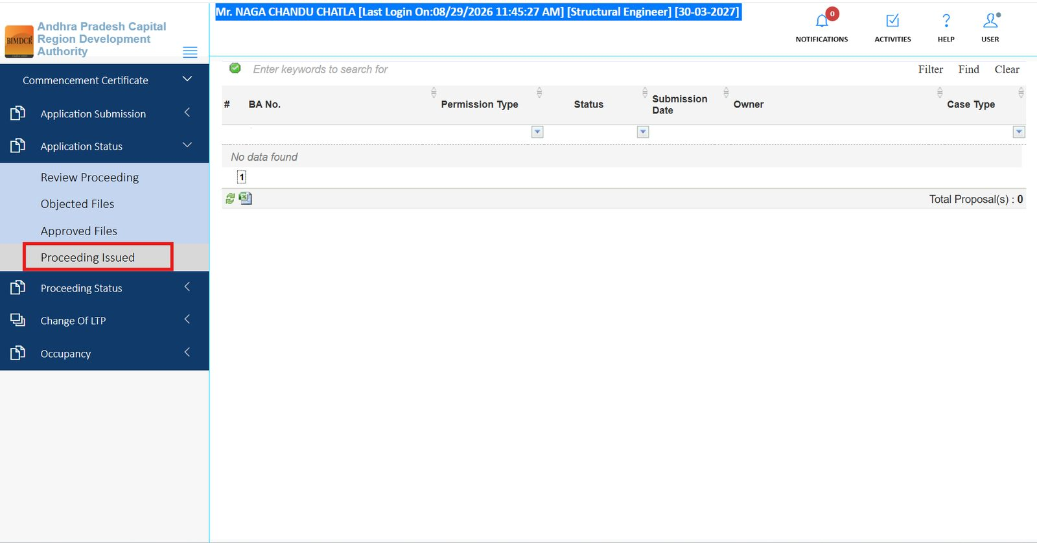
Figure 7.12 — Proceeding Issued queue (empty in this example)

8. Module: Proceeding Status
Menu path: Proceeding Status. Use this after a proceeding exists and APCRDA is verifying, raising shortfall, or issuing show-cause.
Sub-menu | What you do
Verified | Open files whose proceeding is verified (status often Approved / Proceeding Verified).
Shortfall | See files with missing information or documents.
Review Shortfall Submission | After you re-submit shortfall replies, track APCRDA’s review.
Show Cause | Open formal show-cause notices.
Review Show Cause Submission | Track review of your show-cause reply.

8.1 Verified
- 1. Open Proceeding Status → Verified.
- 2. Click the BA No. Proposal Status should read Proceeding Verified (green).
- 3. Use Proposal Flow and Reports as needed.
- 4. Confirm Payments: memos such as General, Green fee charges, Labour Cess, and Development should show Paid with View Receipt.
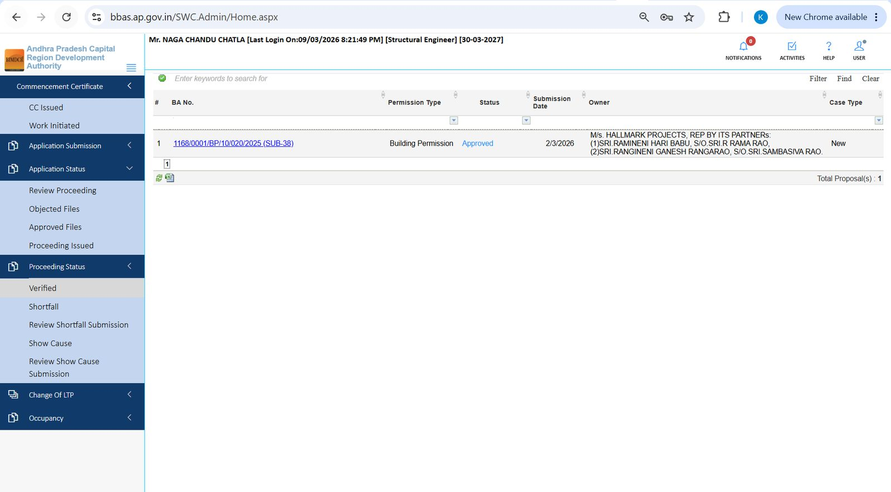
Figure 8.1 — Proceeding Status → Verified list
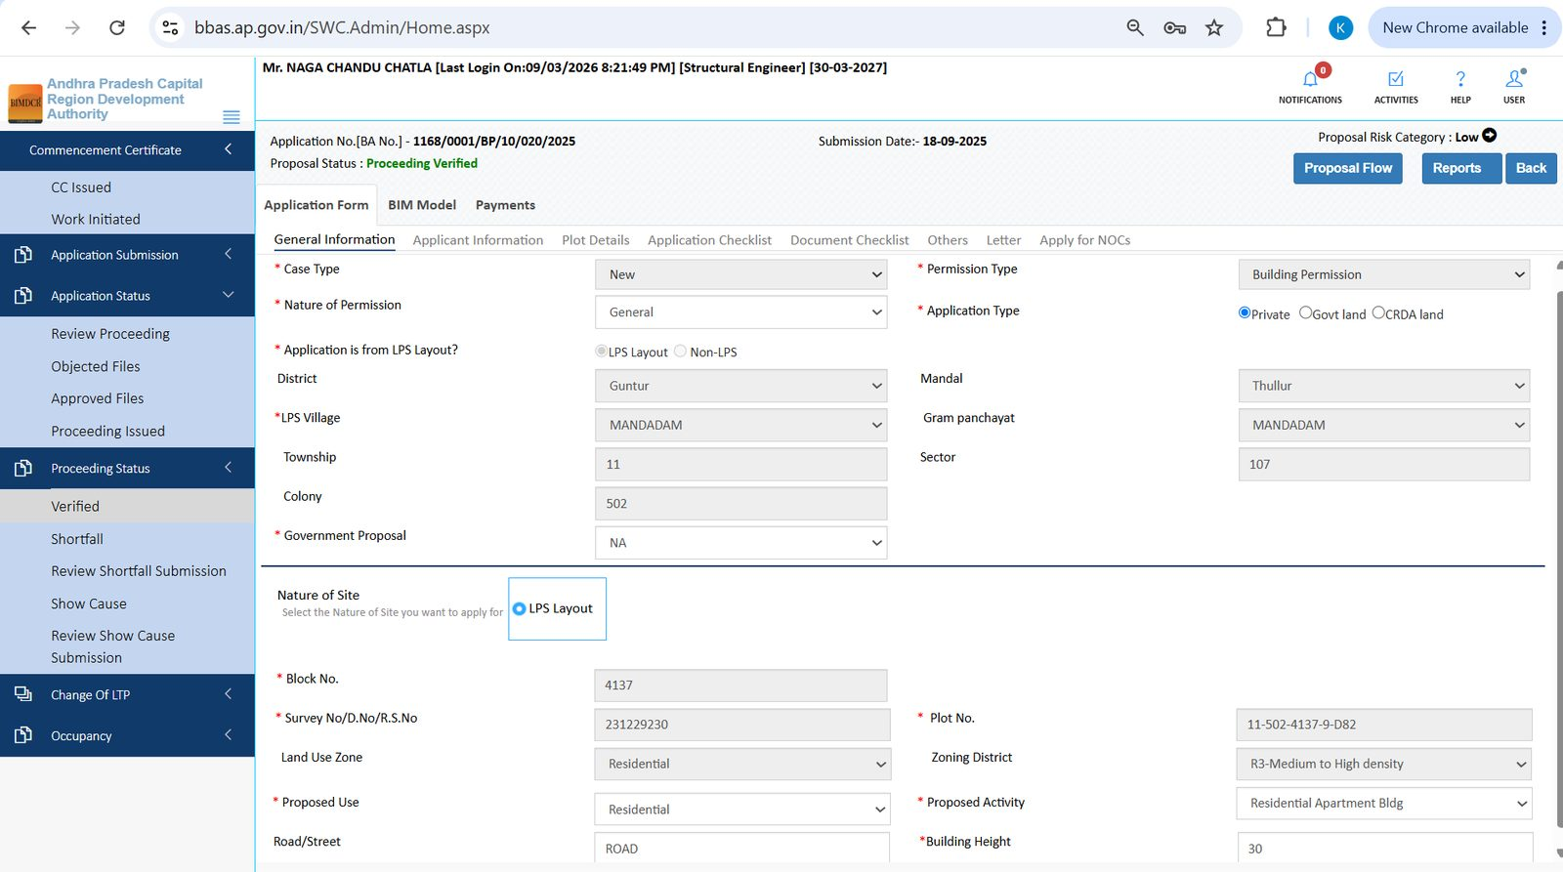
Figure 8.2 — Verified file: General Information (Proceeding Verified)
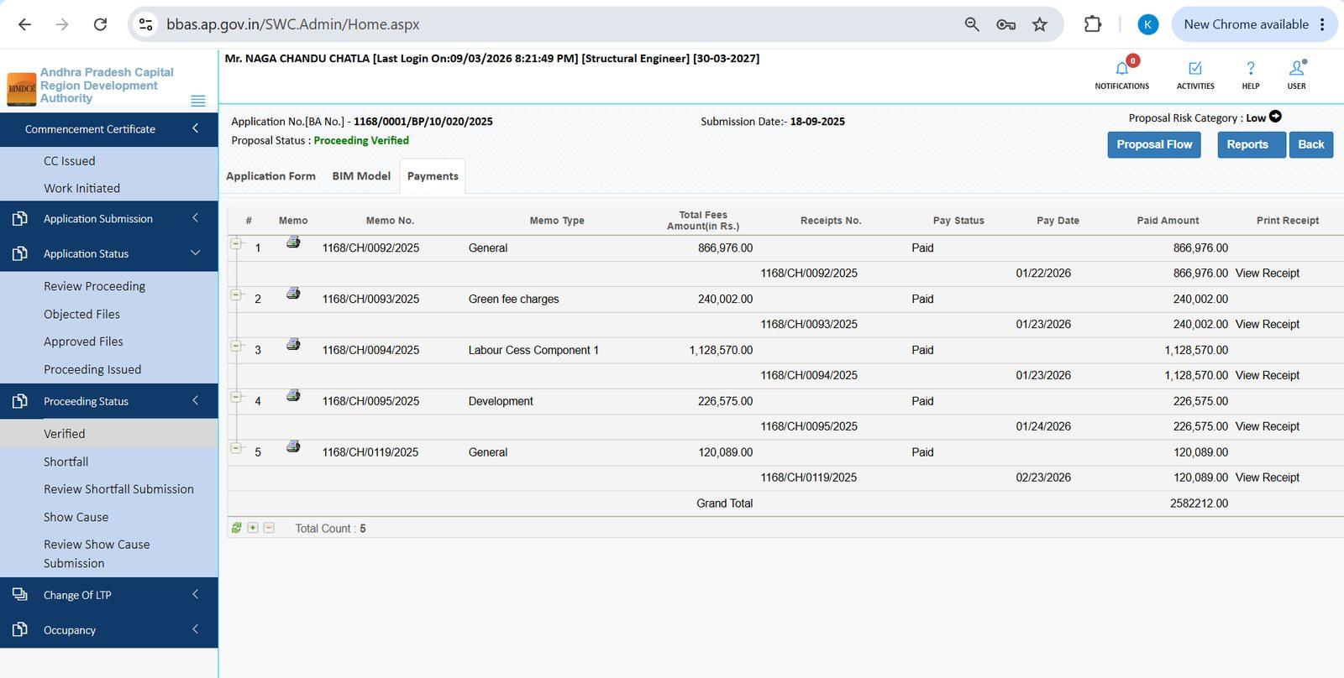
Figure 8.3 — Payments on a verified file: General, Green fee, Labour Cess, Development — all Paid
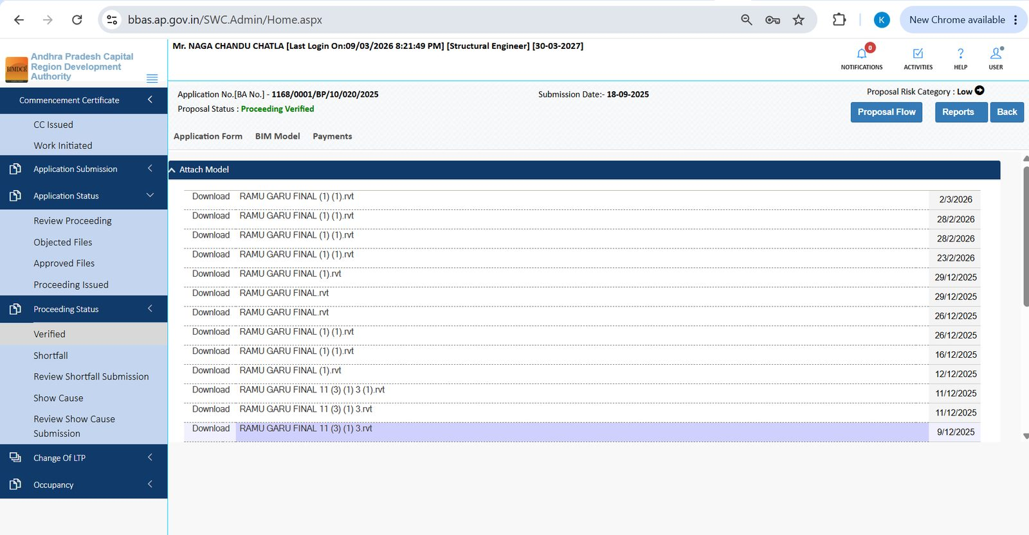
Figure 8.4 — BIM Model history on a verified file (revision dates and Download)

8.2 Shortfall and Review Shortfall Submission
- 1. Open Proceeding Status → Shortfall to see files with pending deficiencies.
- 2. Open the BA No., complete the missing items, and submit the shortfall reply.
- 3. Then open Review Shortfall Submission to confirm APCRDA has received / is reviewing the reply.
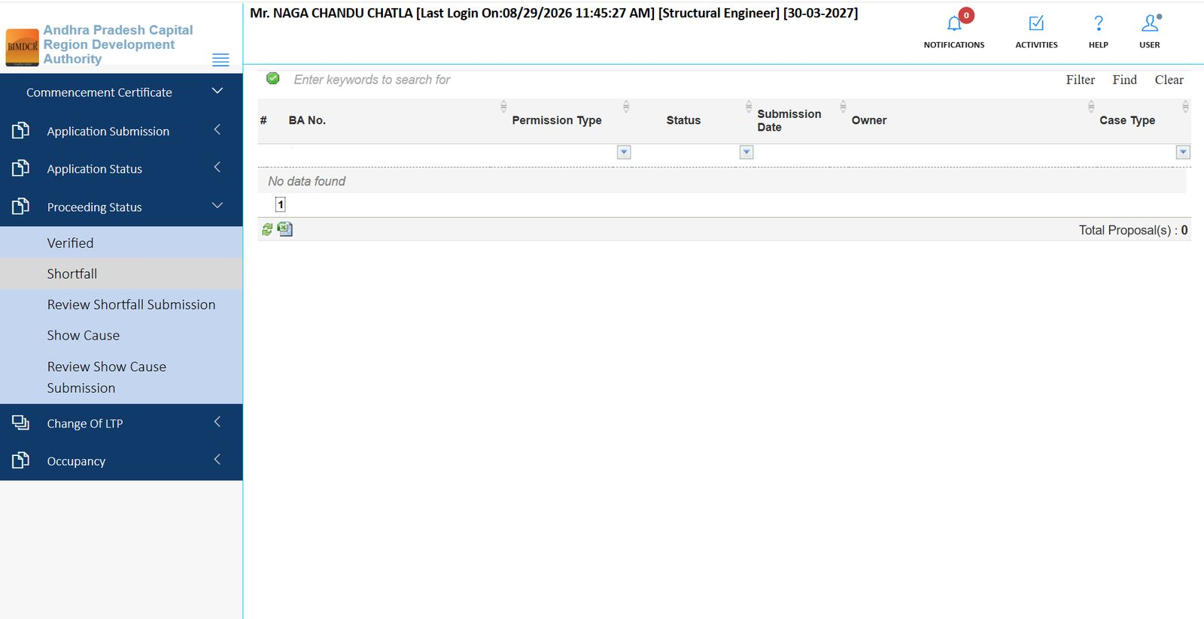
Figure 8.5 — Shortfall queue
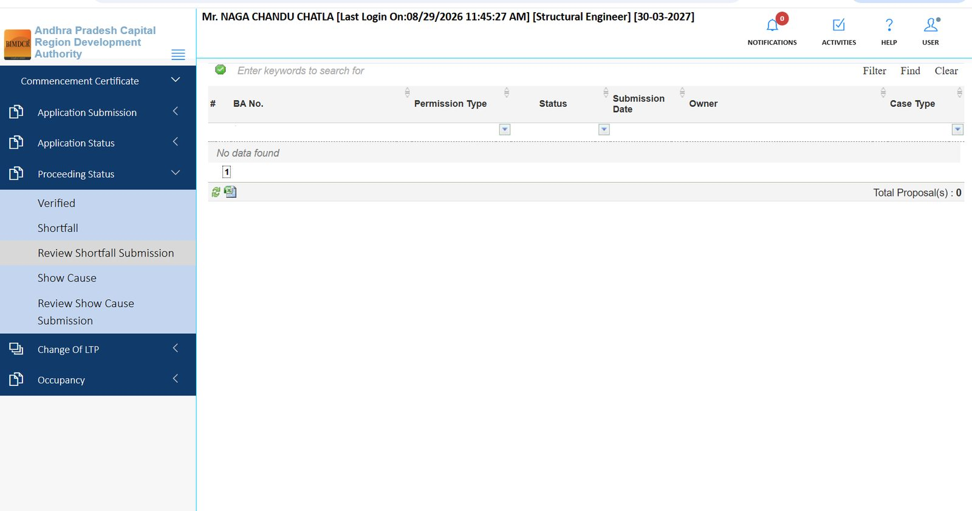
Figure 8.6 — Review Shortfall Submission queue

8.3 Show Cause and Review Show Cause Submission
- 1. Open Proceeding Status → Show Cause if a notice has been issued.
- 2. Open the file, read the notice, attach the reply and supporting documents, and submit.
- 3. Track the reply under Review Show Cause Submission.
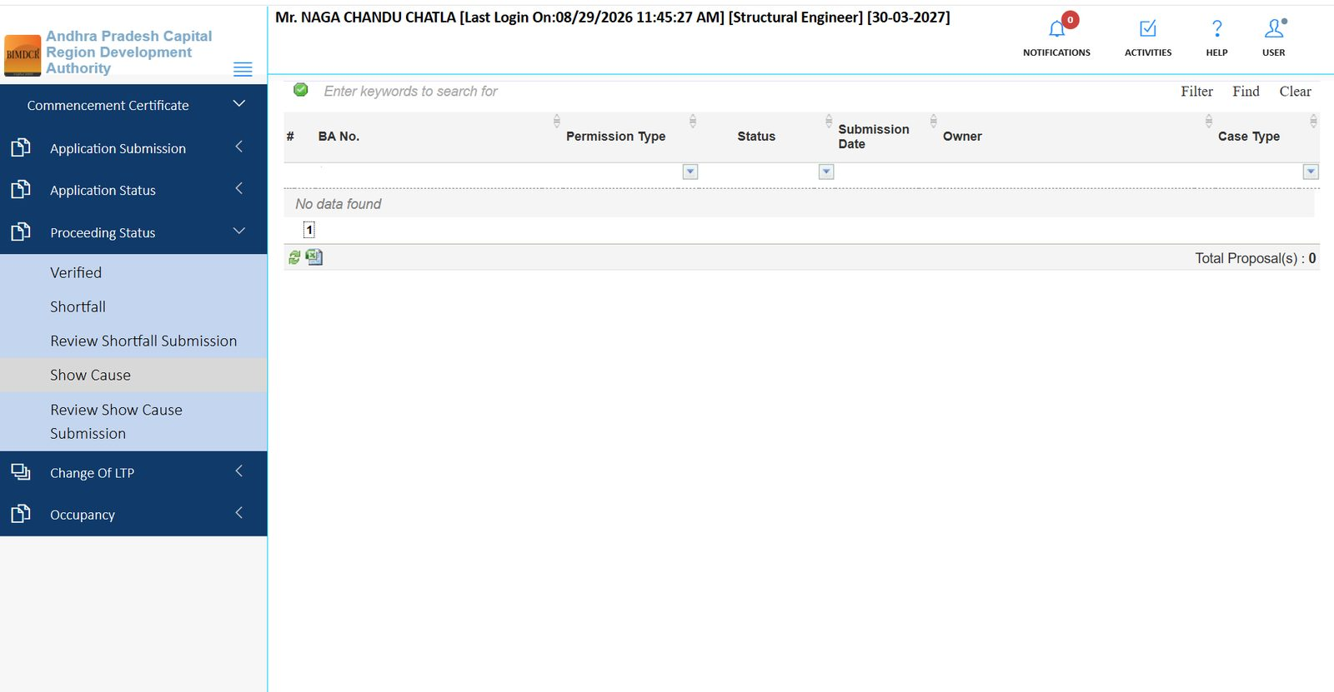
Figure 8.7 — Show Cause queue
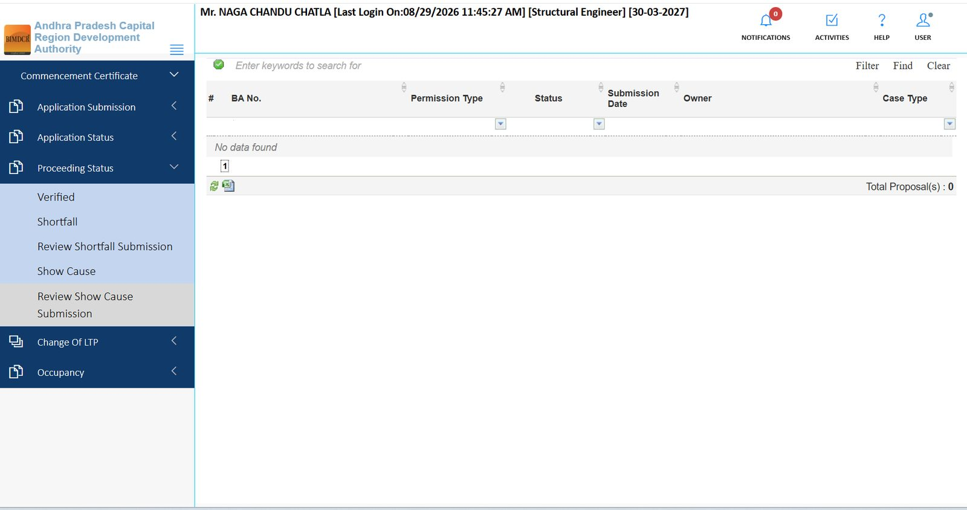
Figure 8.8 — Review Show Cause Submission queue

9. Module: Commencement Certificate
Menu path: Commencement Certificate → CC Issued or Work Initiated. Use this after the building permission proceeding is in force and construction is about to start.

9.1 Work Initiated — open the file
- 1. Open Commencement Certificate → Work Initiated (or CC Issued if you only need the issued certificate list).
- 2. Find the BA No. (example: 1168/0001/BP/10/020/2025 (SUB-38)).
- 3. Click the BA No. or Status link.
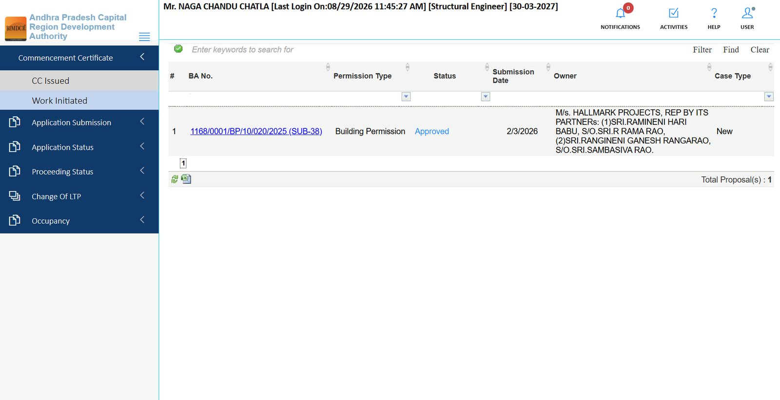
Figure 9.1 — Work Initiated list: approved building permission ready for commencement notify

9.2 Notify commencement date
- 1. On the Work Initiation screen, confirm Application No., Submission Date, and Proposal Status (Proceeding Verified).
- 2. Note Proceeding Issued On Date and Proceeding Issued By.
- 3. Enter Commencement Date using the calendar.
- 4. Click Notify.
- 5. Use footer links if you need Drawing plan, Scrutiny Report, or Proceeding Letter.
- 6. Use Reports or Back as required.
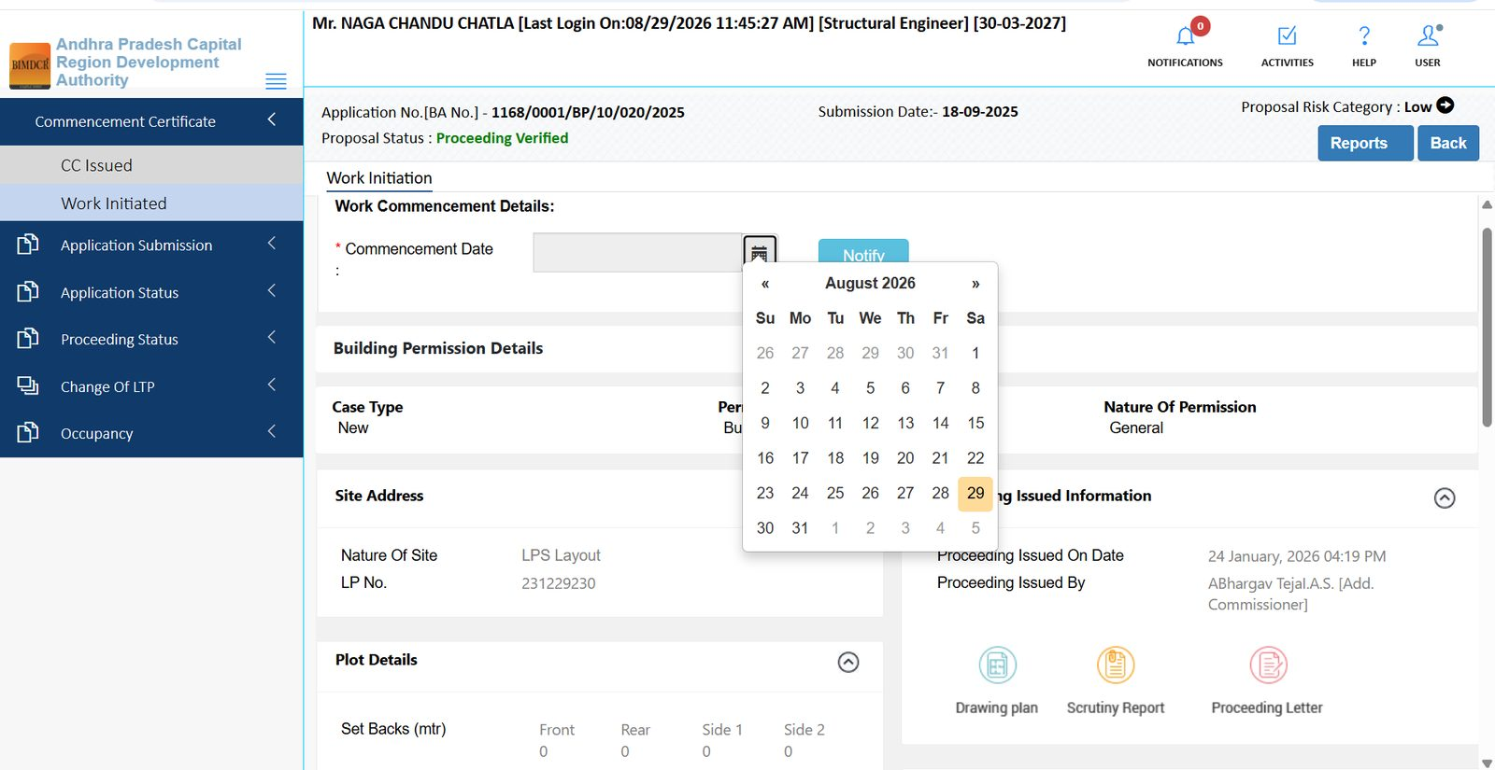
Figure 9.2 — Work Initiation: pick Commencement Date and click Notify

9.3 Work initiation summary (site and persons)
After opening a work-initiated file you can also review setbacks, height, building use, LTP contacts, and owner contacts on the summary panels.
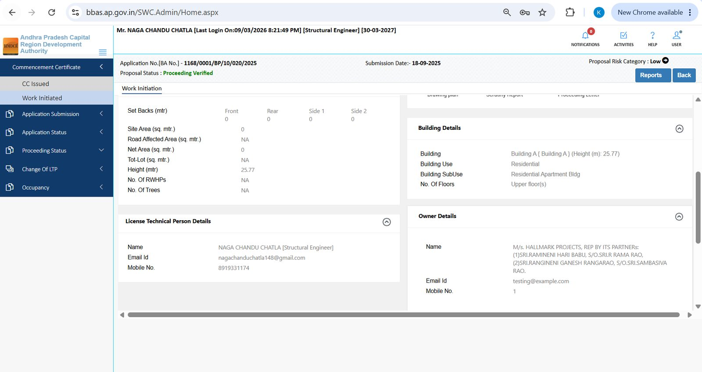
Figure 9.3 — Work Initiation summary: setbacks / height, building use, LTP details, owner details

10. Module: Change of LTP
Menu path: Change Of LTP → Change LTP. Use this when the licensed technical person on an existing file must be replaced.
- 1. Open Change Of LTP → Change LTP.
- 2. Enter the File No. (mandatory).
- 3. Click the search (magnifying glass) icon.
- 4. Complete the on-screen change / consent steps for the new LTP. The incoming LTP must also complete LTP Consent Link from the public LTP tile if the system asks for it.
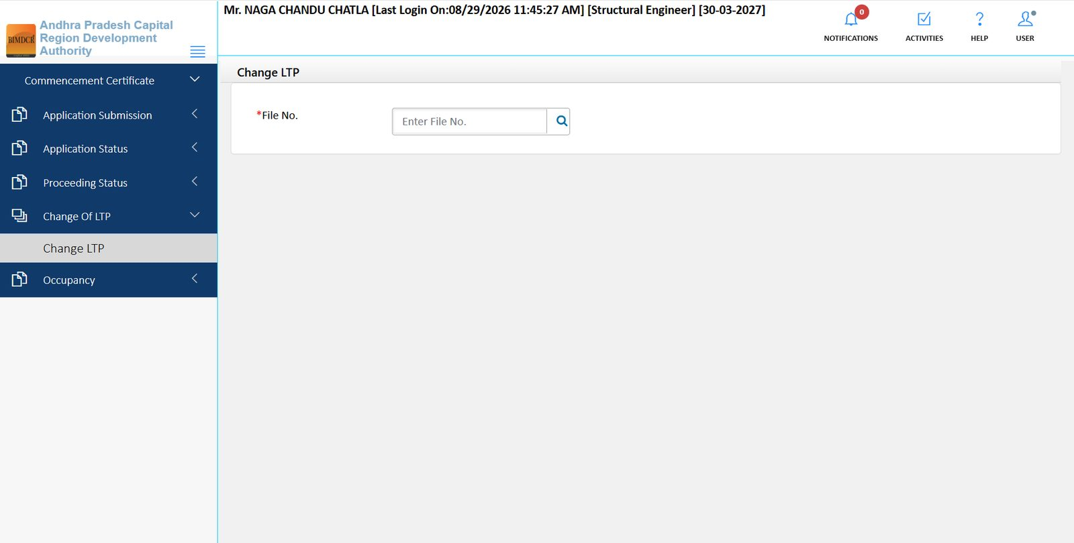
Figure 10.1 — Change LTP: enter File No. and search

11. Module: Occupancy
Menu path: Occupancy → Occupancy List or Submitted Application. Use this after construction is complete and you need to intimate completion / apply for occupancy.
- 1. Open Occupancy → Occupancy List.
- 2. Click INTIMATE COMPLETION (top right) to notify APCRDA that the building is complete and ready for occupancy process.
- 3. Use search, Filter, Find, and Clear to locate a BA No. on the list.
- 4. Open Submitted Application to see occupancy applications already filed.
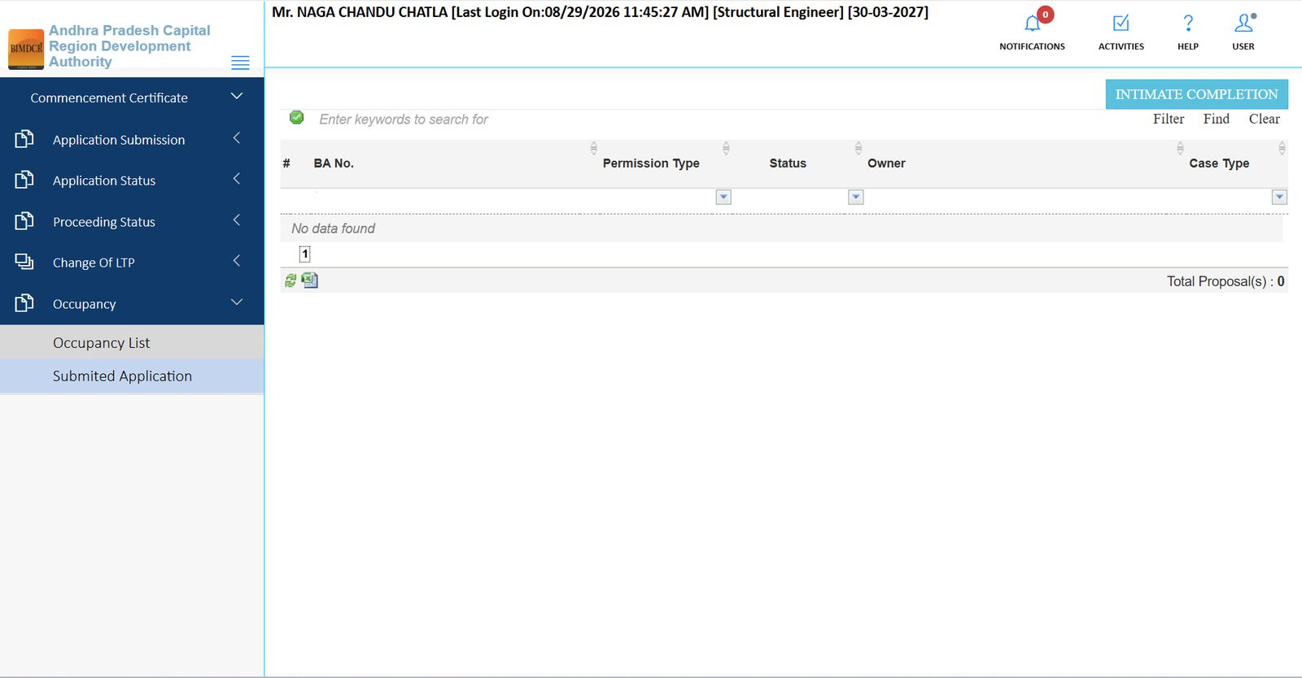
Figure 11.1 — Occupancy List with INTIMATE COMPLETION action

12. Common actions on every list and file
Control | What it does
Enter keywords to search for | Finds a BA No., owner name, or other text on the current list.
Filter / Find / Clear | Applies, runs, or resets list filters.
Column filter icons | Filter Permission Type, Status, or Case Type.
Excel icon | Exports the current list.
Save & Continue | Saves the current form tab and moves forward.
Send to Scrutiny | Submits a completed draft for official scrutiny.
Proposal Flow | Shows the office workflow path of the file.
Action | Opens allowed workflow actions (objected / draft files).
Reports | Opens generated reports for the file.
Back | Returns to the previous list.
Drawing plan / Scrutiny Report / Proceeding Letter | Opens those documents from commencement / issued screens.

Important: If a form tab shows “OOPS! The page you've requested is not available at this time,” use Back and retry, or open the same file from another queue (Approved Files vs Verified). This was seen on Applicant Information for some verified files.

13. End-to-end lifecycle (LTP view)
- 1. Register / renew LTP on the public LTP tile; then Login.
- 2. Application Submission → Draft Application: fill form tabs, attach .rvt / .dwg and documents, then Send to Scrutiny.
- 3. Watch Submitted Applications and Application Status → Review Proceeding.
- 4. If returned: Objected Files → correct → resubmit.
- 5. Pay fee memos on the Payments tab or via Citizen Service → Pay your fees.
- 6. When approved: Approved Files / Proceeding Issued → download Letter (BPO) and complete Apply for NOCs.
- 7. Handle Proceeding Status (Verified, Shortfall, Show Cause) until the proceeding is clean.
- 8. Commencement Certificate: after CC, open Work Initiated and Notify the commencement date.
- 9. Use Change Of LTP only if the professional on the file must change.
- 10. On completion: Occupancy → INTIMATE COMPLETION, then track Submitted Application.
Source: live BBAS screens captured from bbas.ap.gov.in (LTP login as Structural Engineer). Share this .docx as-is, or use File → Save As → PDF.

