Andhra Pradesh Capital Region Development Authority
Town Planning Assistant (TPA) User Manual
BIM Based Building Permit System (BBAS)
Town Planning Assistant Scrutiny Portal
Portal: bbas.ap.gov.in / SWC.Admin
Audience: Town Planning Assistants (TPAs) and Scrutiny Officers
Module-wise user guide with live portal screenshots. Share this Word file as-is, or use File → Save As → PDF.

Contents
1. Introduction
2. Portal access and login
3. TPA portal overview and navigation tree
4. Module: Registration Scrutiny
5. Module: Application Scrutiny & Verification
5.1 Review Proceeding intake
5.2 General Information tab
5.3 Applicant Information tab
5.4 Plot Details and Area verification
5.5 Application Checklist verification
5.6 Document Checklist and primary verification
5.7 Others tab (Environmental and Green Building parameters)
5.8 Site Inspection Subsystem (Checklist, Photographs, Report & Digital Signature)
5.9 Letter — Draft Building Permission Order review
5.10 Apply for NOCs (Fire Safety clearance verification)
5.11 Drawing Scrutiny (AutoDCR CAD scrutiny & interactive 3D BIM model viewer)
5.12 Payments tab (Calculated fee breakdown, Memos, and CFMS Challans)
5.13 Land Pooling Scheme (LPS) institutional proposal walkthrough
5.14 Gramkantam non-LPS proposal walkthrough
6. Module: Proceeding Status Workflow & File Routing
6.1 Verified queue
6.2 Shortfall queue and Shortfall Letter issuance
6.3 Review Shortfall Submission queue
6.4 Show Cause queue and formal notice issuance
6.5 Review Show Cause Submission queue
6.6 Proceeding Issued queue and approved permit orders
7. Common actions on every list and proposal
8. End-to-end TPA scrutiny lifecycle

1. Introduction
BBAS is APCRDA's comprehensive online platform for building permission scrutiny, site inspection, and regulatory approvals across the Amaravati Capital Region. While external applicants and technical professionals prepare building files and submit architectural drawings, the Town Planning Assistant (TPA) serves as the primary technical gatekeeper within the authority.
Using the TPA portal workspace, the Town Planning Assistant reviews applicant submissions, audits professional credentials, verifies title and land-use records, conducts on-ground physical site inspections with geo-tagged photographs, inspects automated building rule validations in 2D CAD and 3D BIM formats, reconciles government fee payments via the AP Treasury CFMS gateway, and routes proposals toward final sanction or regulatory rectification.

2. Portal access and login
Town Planning Assistants access the scrutiny workspace through the central BIMDCR authentication gateway.
1. Open the browser and navigate to the official portal URL: https://bbas.ap.gov.in/BPAMSClient/login.aspx.
2. Confirm the header displays 'Welcome to BIMDCR' under the Andhra Pradesh Capital Region Development Authority banner.
3. Enter your User ID into the Username field (for example, official officer ID TPA002).
4. Enter your Password into the Password field.
5. Type the Captcha code exactly as displayed in the security image. If the text is unclear, click the refresh icon to generate a new captcha.
6. Click Sign In to authenticate and launch the TPA administrative workspace (SWC.Admin/Home.aspx).
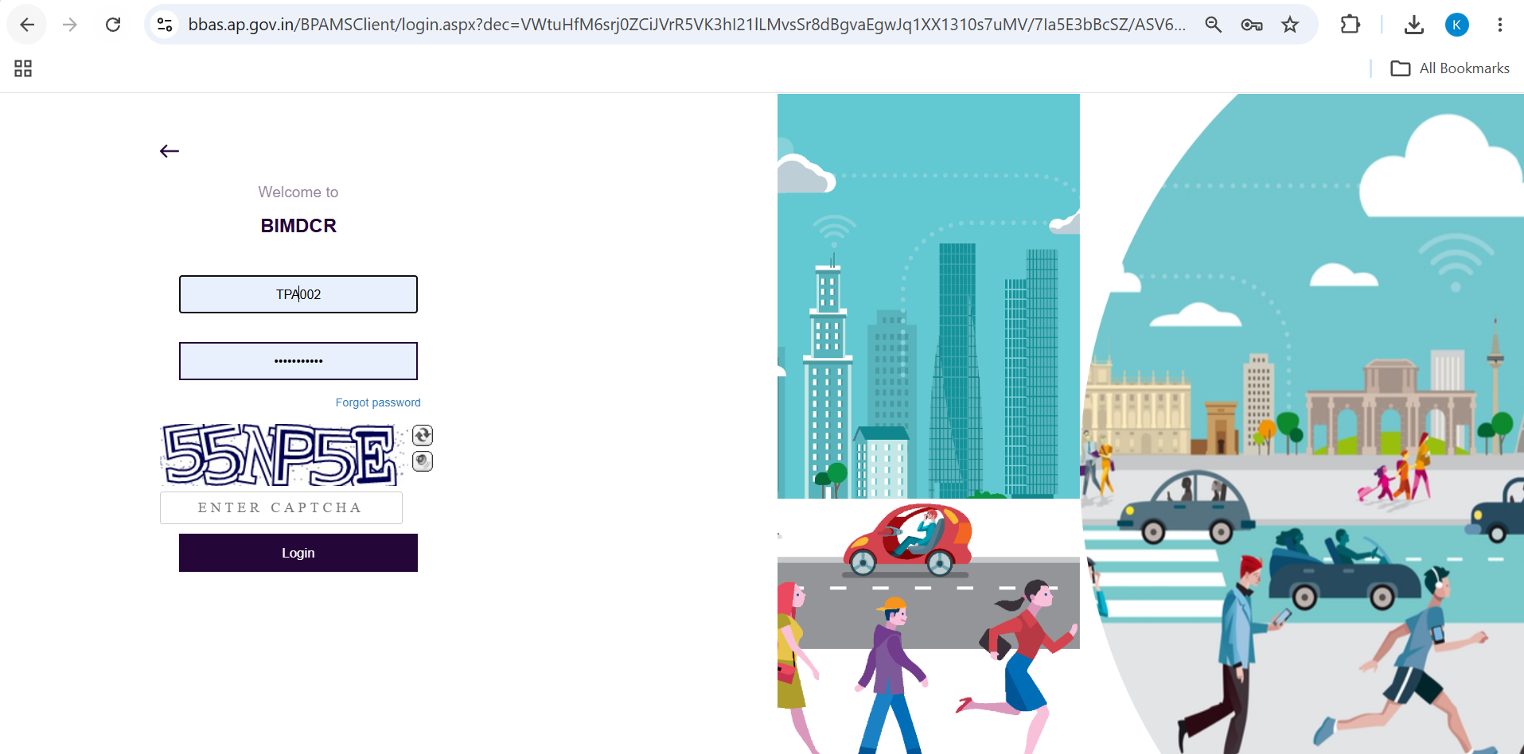
Figure 2.1 — BIMDCR Portal Login screen (BPAMSClient/login.aspx) with officer credentials and captcha

3. TPA portal overview and navigation tree
Upon successful authentication, the TPA administrative dashboard launches. The interface is optimized for regulatory review and file tracking:
- Header Area: Displays the Andhra Pradesh state emblem, APCRDA corporate banner, active officer name (Mr. MNV Hari Srilekha), official role (Town Planning Assistant), and a secure Logout action.
- Left Sidebar Navigation: Organized into four primary administrative menus that structure the TPA's daily work queue:
1. Registration — Manages technical professional registrations (In Process >> Applications, Set Status of Registration).
2. Application Status — Primary queue for assigned proposal scrutiny (Review Proceeding) and sanctioned permits (Proceeding Issued).
3. Proceeding Status — Multi-tier staging lifecycle for active files (Verified, Shortfall, Review Shortfall Submission, Show Cause, Review Show Cause Submission).
4. Outward — Tracks finalized dispatch and outward communication records.

4. Module: Registration Scrutiny
The Registration module enables the Town Planning Assistant to review incoming technical professional applications (Architects and Engineers) before granting them authorization to submit proposals in the BBAS system.

4.1 Reviewing Applications in Process
1. Navigate to Registration in the sidebar menu and select In Process >> Applications.
2. The data table displays all pending registrations with Application No, Applicant Name, Category, Mobile No, Registration Fee Paid, and Current Status.
3. Use the search bar to filter by Application Number or Professional Name, or apply Date filters to isolate specific submissions.
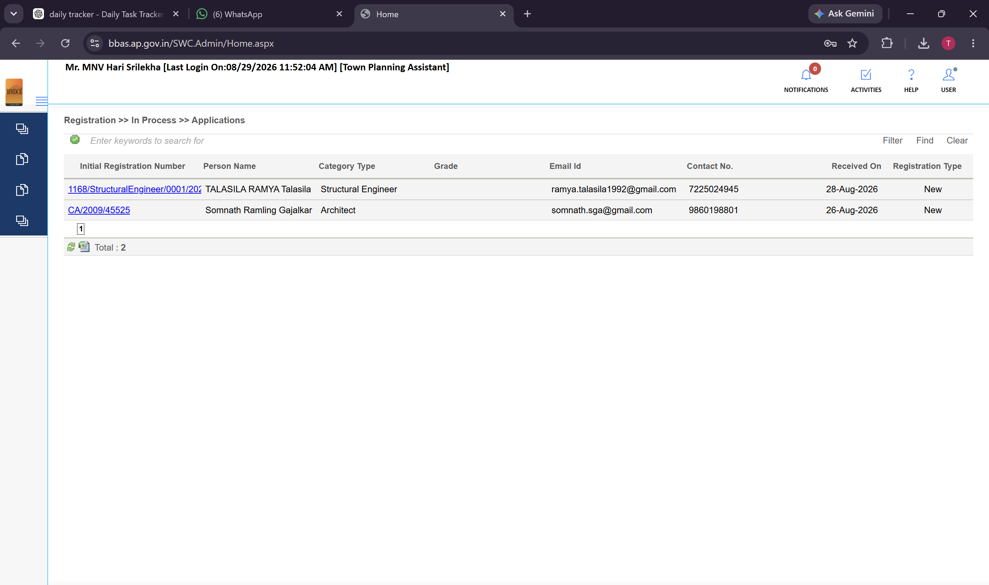
Figure 4.1 — Registration >> In Process >> Applications queue listing pending registrations for officer scrutiny
When no new registration files match the selected filter, the portal displays a clean empty state as shown below:
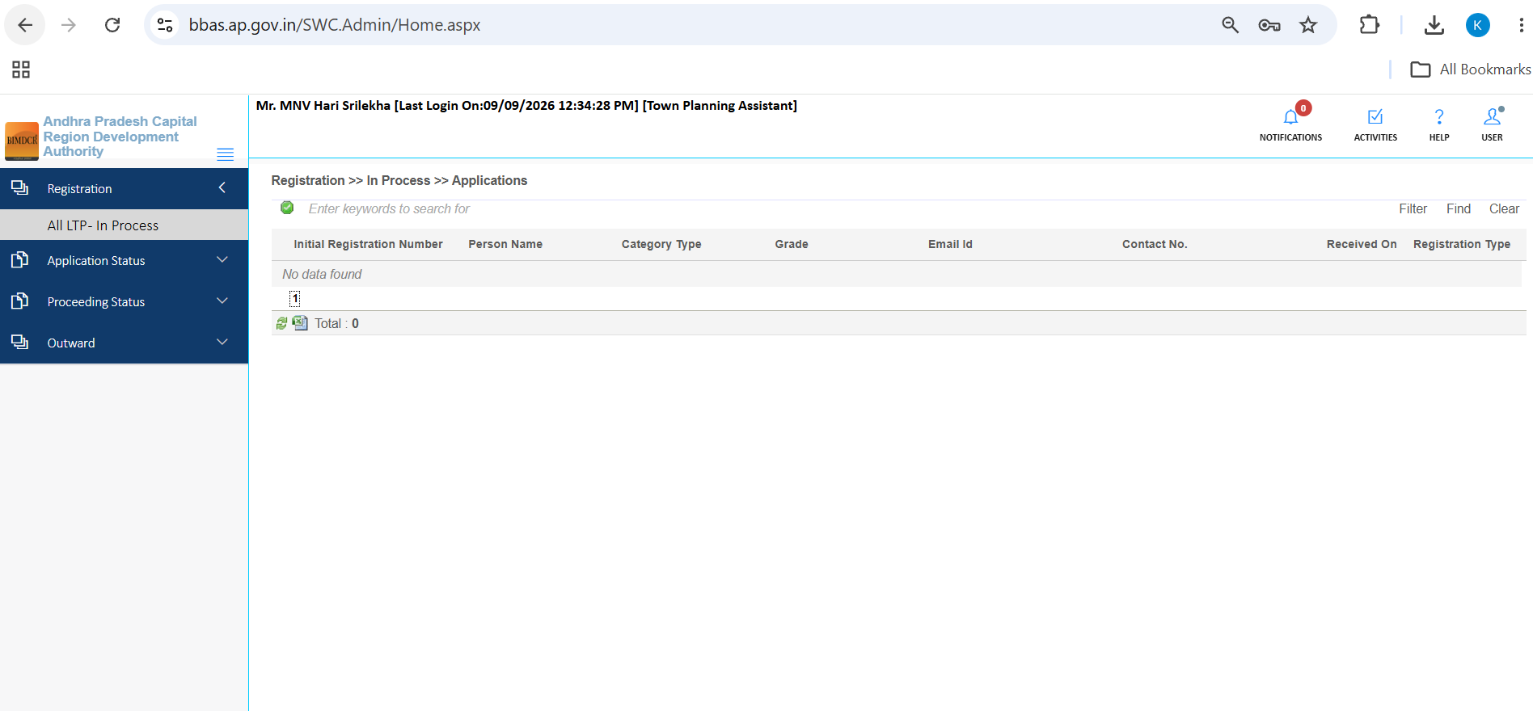
Figure 4.2 — Registration queue empty state with date range and application number search filters

4.2 Executing 'Set Status of Registration'
1. Click the Action icon on the registration row to launch the 'Set Status of Registration' scrutiny dialog.
2. Review applicant personal details including Full Name, Address, Mobile Number, and Email Address.
3. Verify statutory council credentials such as Council of Architecture (COA) registration number (e.g., CA/2009/45525) and professional qualification.
4. Audit registration fee challan payment confirming realization in the government treasury account.
5. Assign the adjudication status by selecting one of the three standard decision radio buttons:
- Verified: Approves the technical professional and activates their BBAS proposal drafting privileges.
- Shortfall: Returns the registration to the applicant for document or certificate rectification.
- Reject: Formally rejects the registration based on invalid credentials or statutory disqualification.
6. Enter scrutiny remarks in the 'Enter Remarks' textarea explaining the findings.
7. Click Save Status to record the decision and notify the applicant.
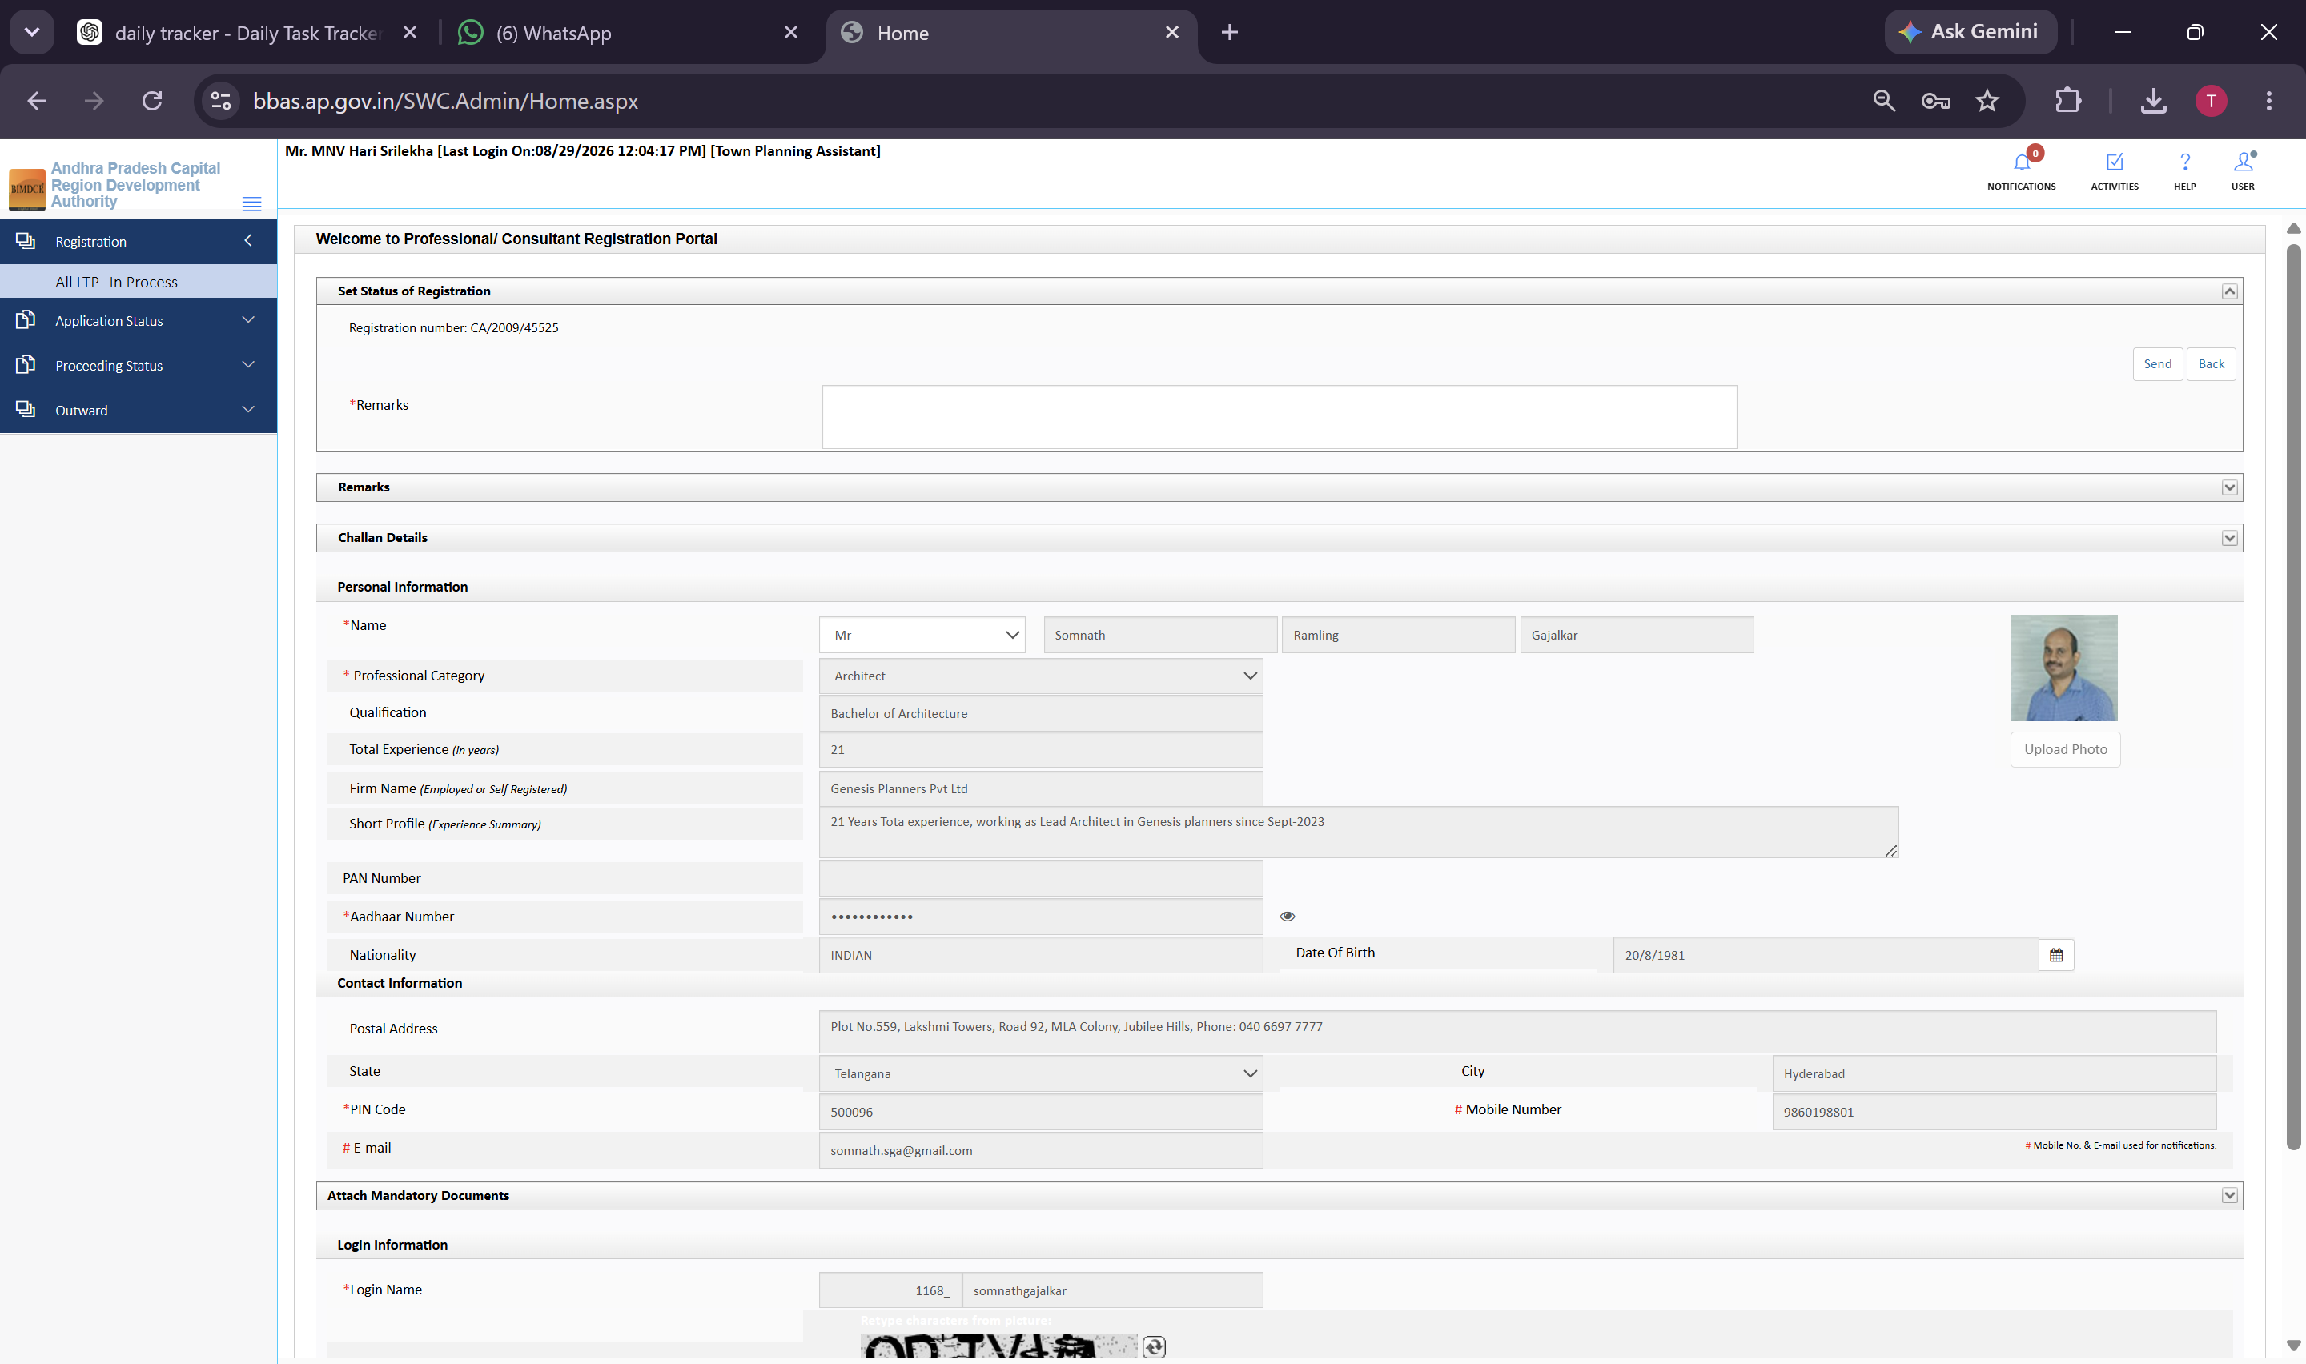
Figure 4.3 — Set Status of Registration dialog showing professional credential verification (CA/2009/45525) and decision radios

5. Module: Application Scrutiny & Verification
The core operational duty of the Town Planning Assistant is technical file scrutiny. Applications assigned to the TPA appear under Application Status >> Review Proceeding.

5.1 Review Proceeding Intake Queue
1. Click Application Status >> Review Proceeding in the sidebar.
2. The data table displays all proposals assigned to the TPA for review, detailing S.No, Proposal No, File No, Case Type, Applicant Name, Status, and Action.
3. Click the Review Action icon adjacent to the proposal (for example, Proposal No: 1168/0145/BP/10/006/2026) to open the multi-tab scrutiny workspace.
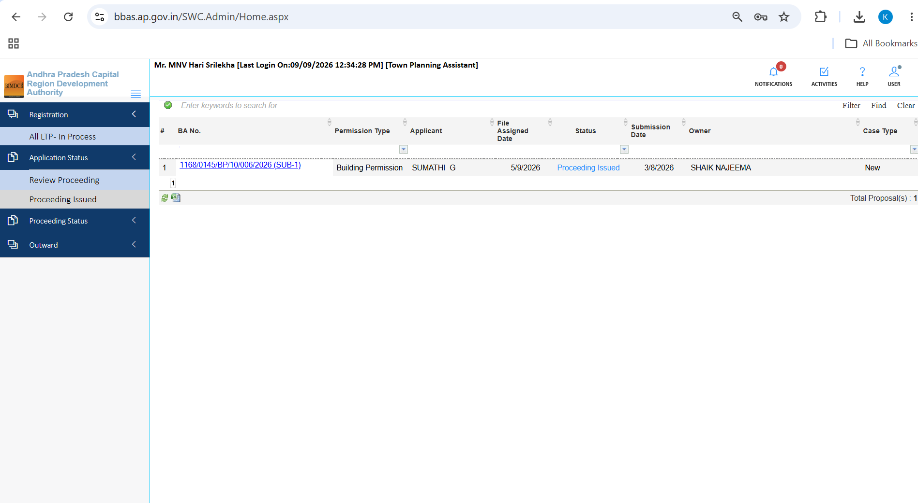
Figure 5.1 — Application Status >> Review Proceeding queue showing assigned proposal 1168/0145/BP/10/006/2026
When all assigned files have been processed, the Review Proceeding queue displays 'No data found':
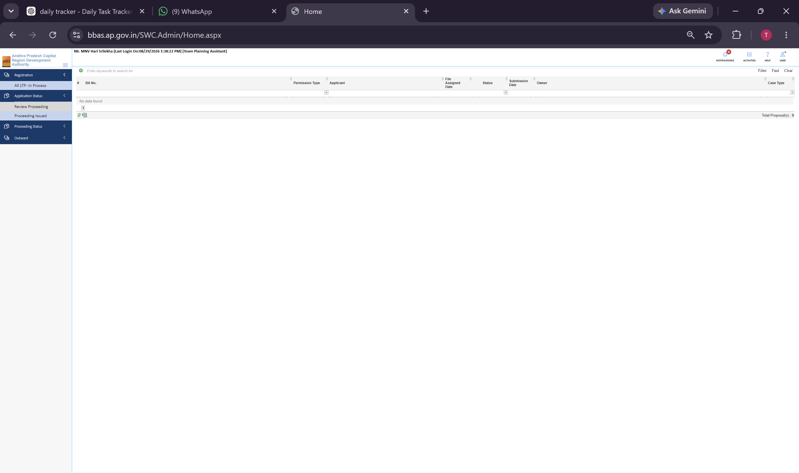
Figure 5.2 — Review Proceeding queue empty state display

5.2 General Information Tab
The General Information tab presents foundational administrative metadata for the building proposal:
1. Review Case Type and Project Type confirming whether the proposal is for Building Permission, Layout, or Addition/Alteration.
2. Verify Revenue Jurisdiction confirming District, Mandal, and Village records.
3. Inspect Geo-Spatial Boundary by clicking the 'PLOT KML file' link to visualize the geo-referenced boundary polygon on the GIS map.
4. Check Government Proposal flag to determine if the application involves public agency infrastructure.
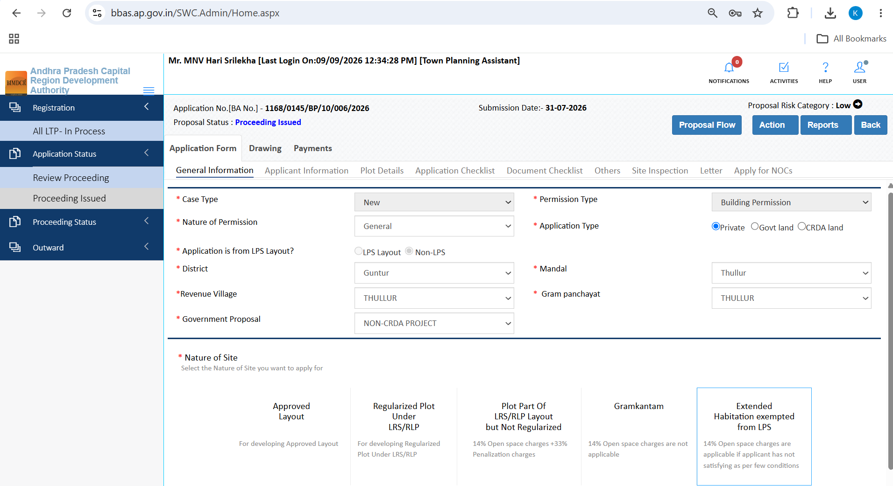
Figure 5.3 — General Information scrutiny tab for proposal 1168/0145/BP/10/006/2026 with PLOT KML file link

5.3 Applicant Information Tab
The Applicant Information tab allows the TPA to audit applicant identity and appointed consultants:
1. Verify Applicant Particulars including Full Name, Father's/Spouse's Name, Address, Mobile, and Email.
2. Audit Developer Information if the proposal is executed under a registered development agreement.
3. Check Third Party Assessors Information to confirm the name, mobile number, and council registration number of any appointed private technical consultant.
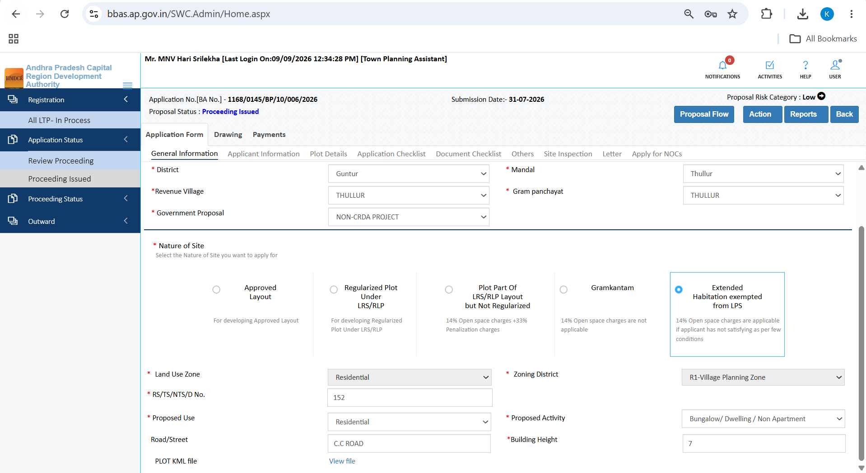
Figure 5.4 — Applicant Information scrutiny tab showing applicant, developer, and Third Party Assessor details

5.4 Plot Details & Area Verification
Accurate land area accounting is critical to prevent site encroachments. The TPA portal incorporates an enhanced area bifurcation model:
1. Verify Survey Number and Sub-Division against the revenue village master map.
2. Audit Total Area As per Documents confirming the legal land extent registered in the title deed.
3. Audit Total Area As On Grounds confirming the actual physical boundary area measured during survey.
4. Verify Road Widening Deduction confirming the exact area surrendered to APCRDA for proposed master plan road widening.
5. Confirm Net Plot Area which serves as the statutory base for permissible coverage, Floor Space Index (FSI), and parking calculations.
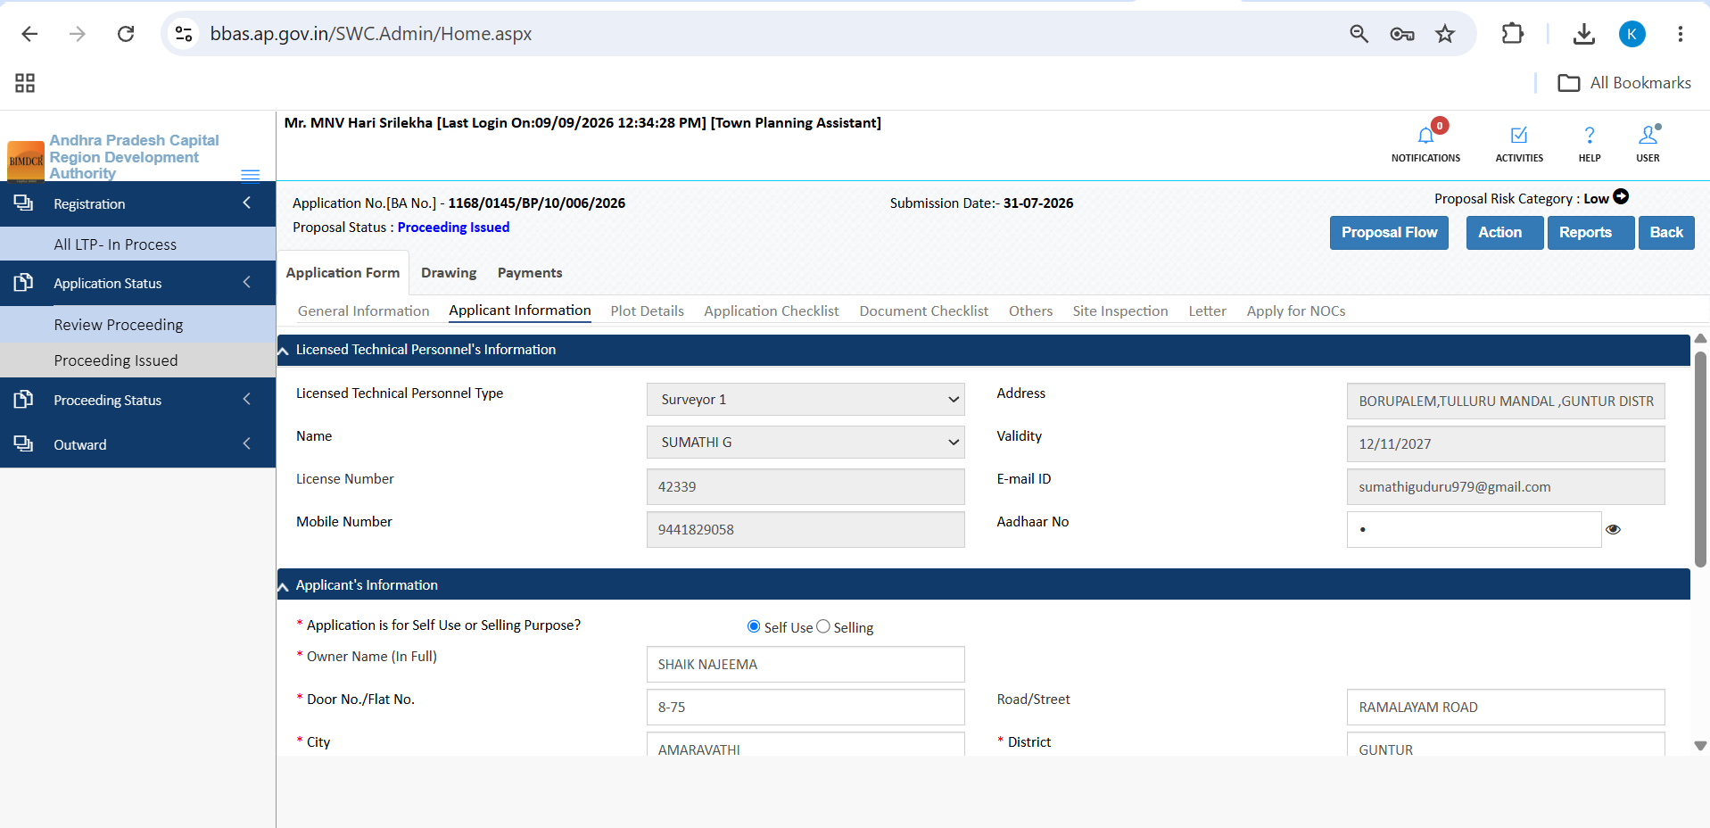
Figure 5.5 — Plot Details scrutiny tab displaying Document Area, Ground Area, and Road Widening deductions

5.5 Application Checklist Verification
The Application Checklist requires applicants to answer 19 standardized statutory questions regarding title ownership, encumbrance, and planning adherence. The TPA verifies these declarations:
1. Open Questions 1 to 10 covering ownership validity, encumbrance status, master plan zoning, and layout compliance.
2. Cross-reference applicant 'Yes/No' answers against submitted revenue documents.
3. Verify Questions 11 to 19 covering building height limits, setback clearances, structural safety, and seismic design standards.
4. Confirm officer verification checkmarks ensuring all declarations comply with Andhra Pradesh Building Rules (GO 119).
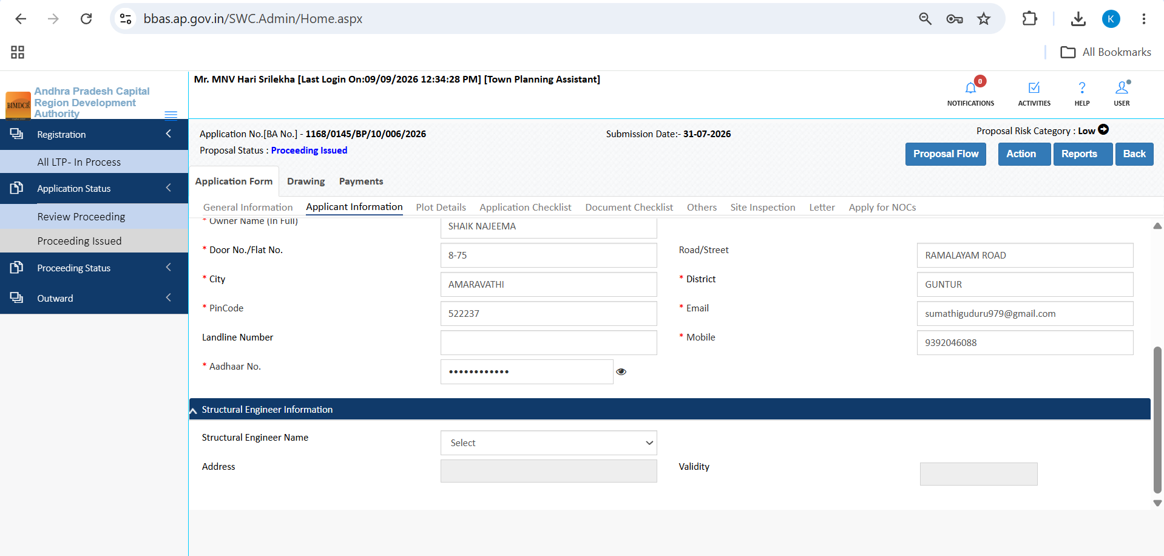
Figure 5.6 — Application Checklist Questions 1 to 10 displaying ownership and zoning compliance declarations
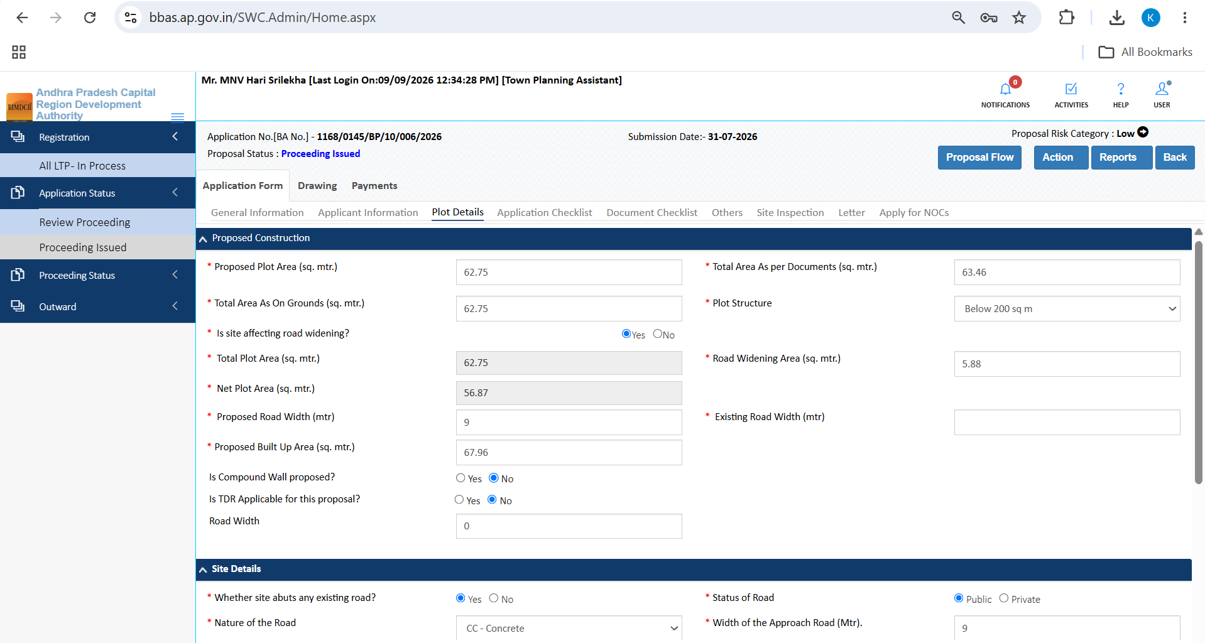
Figure 5.7 — Application Checklist Questions 11 to 19 displaying setback, height, and structural safety declarations

5.6 Document Checklist & Primary Verification
The Document Checklist tab provides tools to audit mandatory deed attachments, certificates, and plans:
1. Click 'Verify Primary' to batch-verify core ownership documents (Title Deed, Latest Encumbrance Certificate, Possession Certificate).
2. Review individual document rows by clicking the document view link to inspect the uploaded PDF file.
3. Assign document-level status using the status dropdown on each row (options: 'Yet to Verify', 'Verified', 'Rejected', 'Shortfall').
4. Record Scrutiny Recommendations using the docked panel: choose an overall recommendation, enter observations in 'Any other observation (Remarks)', and click 'Save Recommendation'.
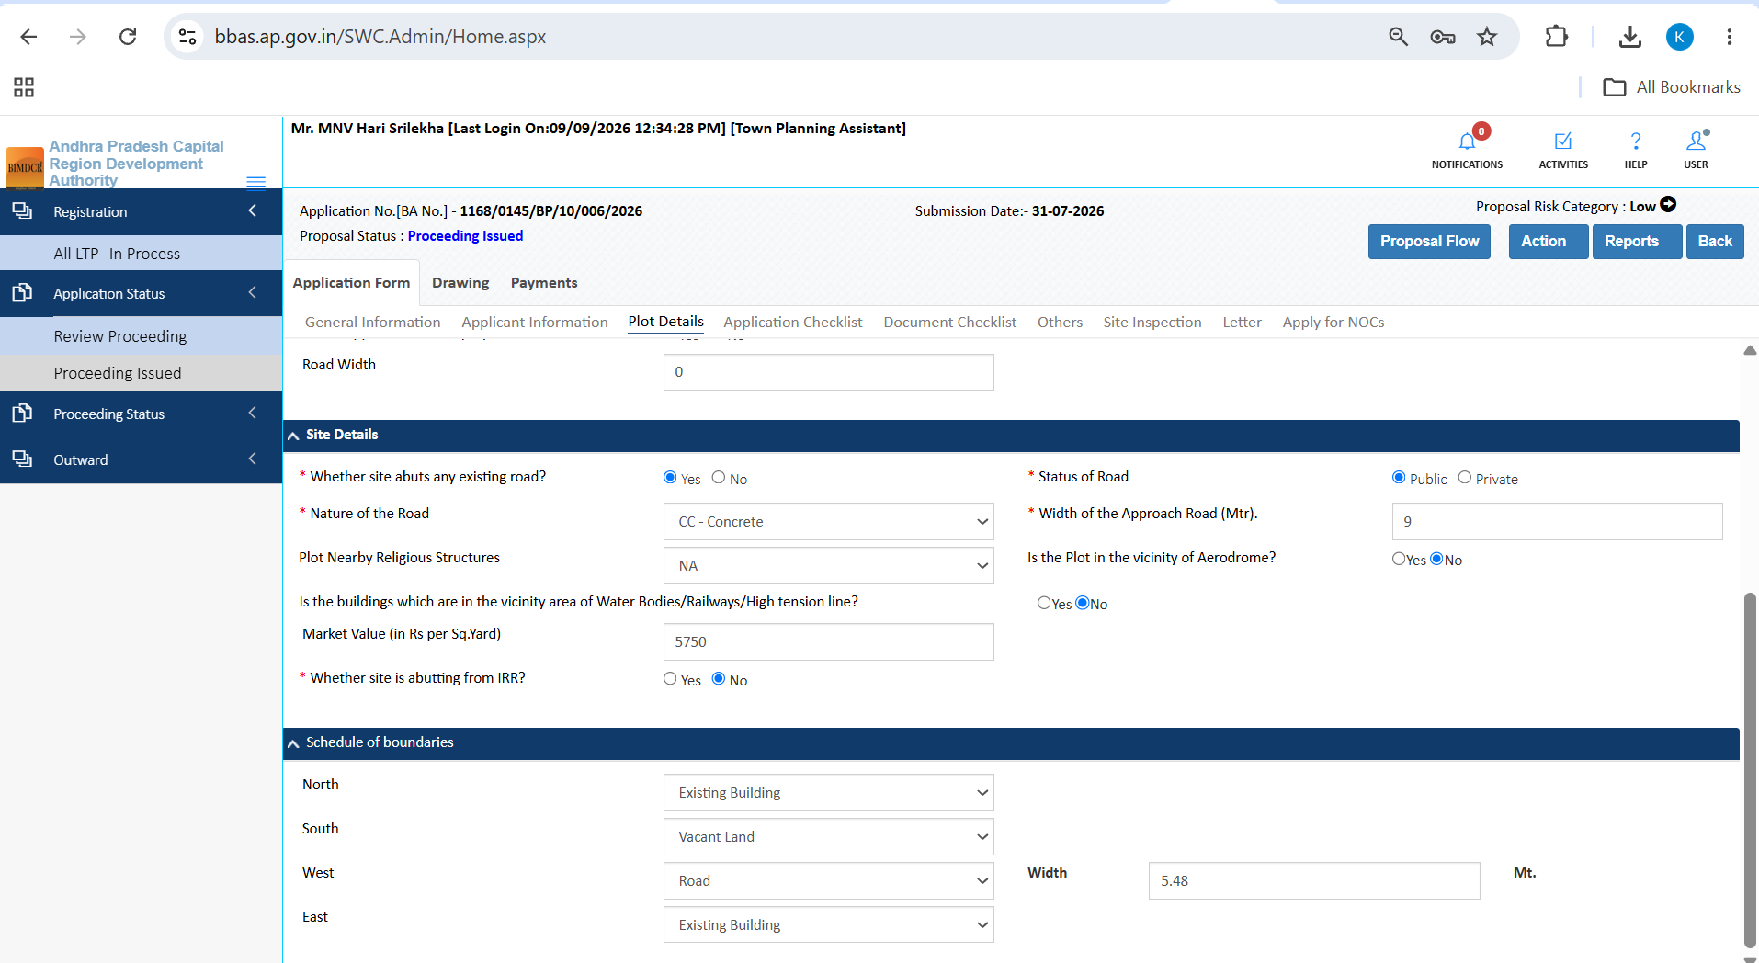
Figure 5.8 — Document Checklist top view showing 'Verify Primary' button and Scrutiny Recommendation panel
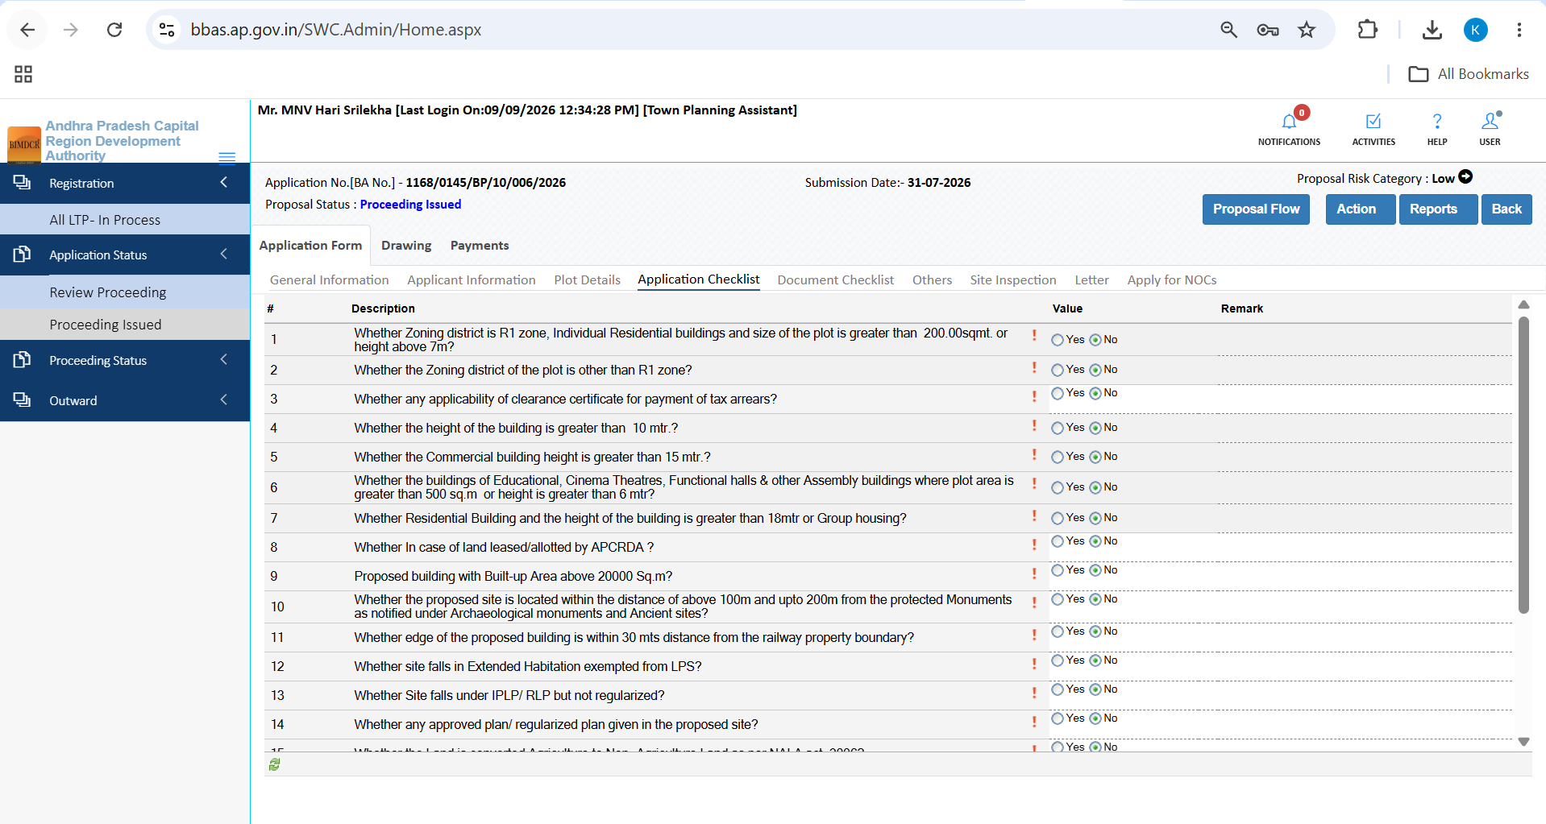
Figure 5.9 — Document Checklist scrolled view showing individual document rows and 'Yet to Verify' status selectors

5.7 Others Tab
The Others tab allows the TPA to verify environmental and sustainability provisions:
1. Verify Rainwater Harvesting Structures confirming pit volume and recharge borewells.
2. Verify Solar Water Heating / Rooftop Solar confirming capacity for mandatory thresholds.
3. Audit Tree Planting Undertakings confirming green belt reservation.
4. Enter any special condition remarks in the officer notes field.
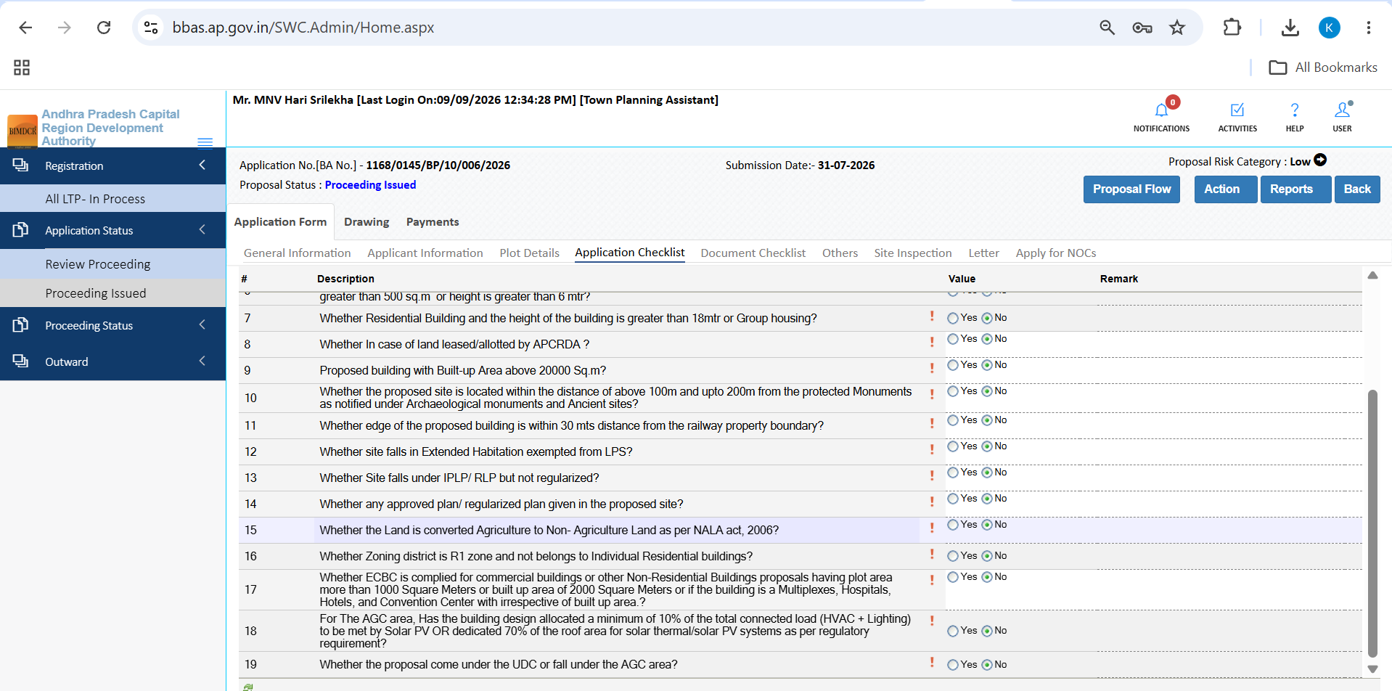
Figure 5.10 — Others tab displaying rainwater harvesting, solar heating, and green building parameters

5.8 Site Inspection Subsystem (Field Verification)
Physical site inspection is a mandatory statutory responsibility of the Town Planning Assistant. The TPA portal incorporates an integrated 3-part field inspection subsystem:

5.8.1 Site Inspection Checklist (27 Questions)
1. Open the Site Inspection tab and select the Site Inspection CheckList subtab.
2. Complete Questions 1 to 12 on-site, verifying actual site boundaries, road width on ground, encroachment status, high-tension power line proximity, and natural water bodies.
3. Complete Questions 13 to 27 recording physical site topography, presence of existing structures, tree preservation, and adherence to approved layout boundaries.
4. Click Save to persist all 27 inspection responses.
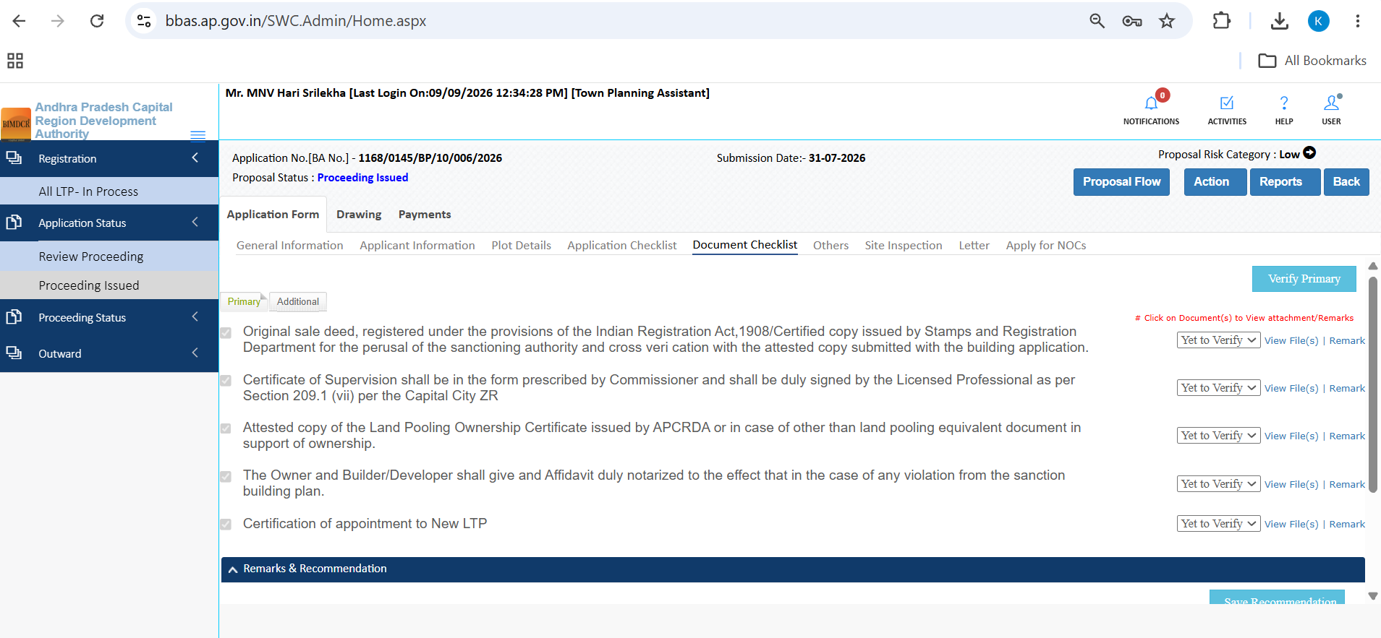
Figure 5.11 — Site Inspection Checklist Questions 1 to 12 covering road width on ground and site boundary verification
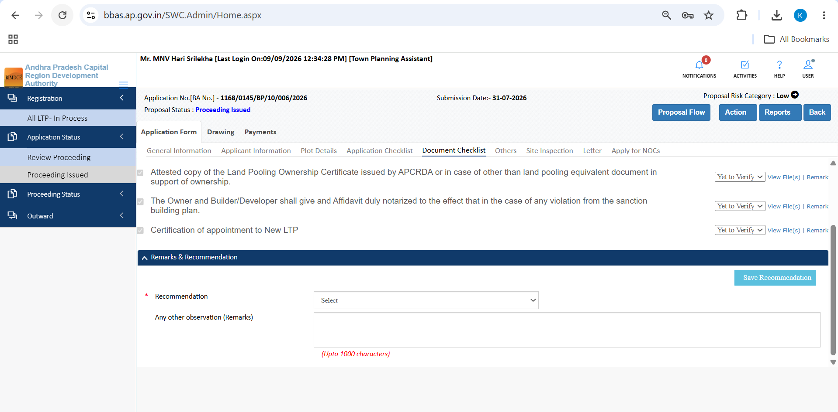
Figure 5.12 — Site Inspection Checklist Questions 13 to 27 covering existing structures and layout conformity

5.8.2 Inspection Photographs
1. Select the Inspection Photograph subtab while on site.
2. Upload geo-tagged field photos captured from the four cardinal orientations (North, South, East, West).
3. Upload detail photos of access roads, boundary markers, and any site encumbrances.
4. Confirm photo thumbnails are rendered in the inspection gallery.
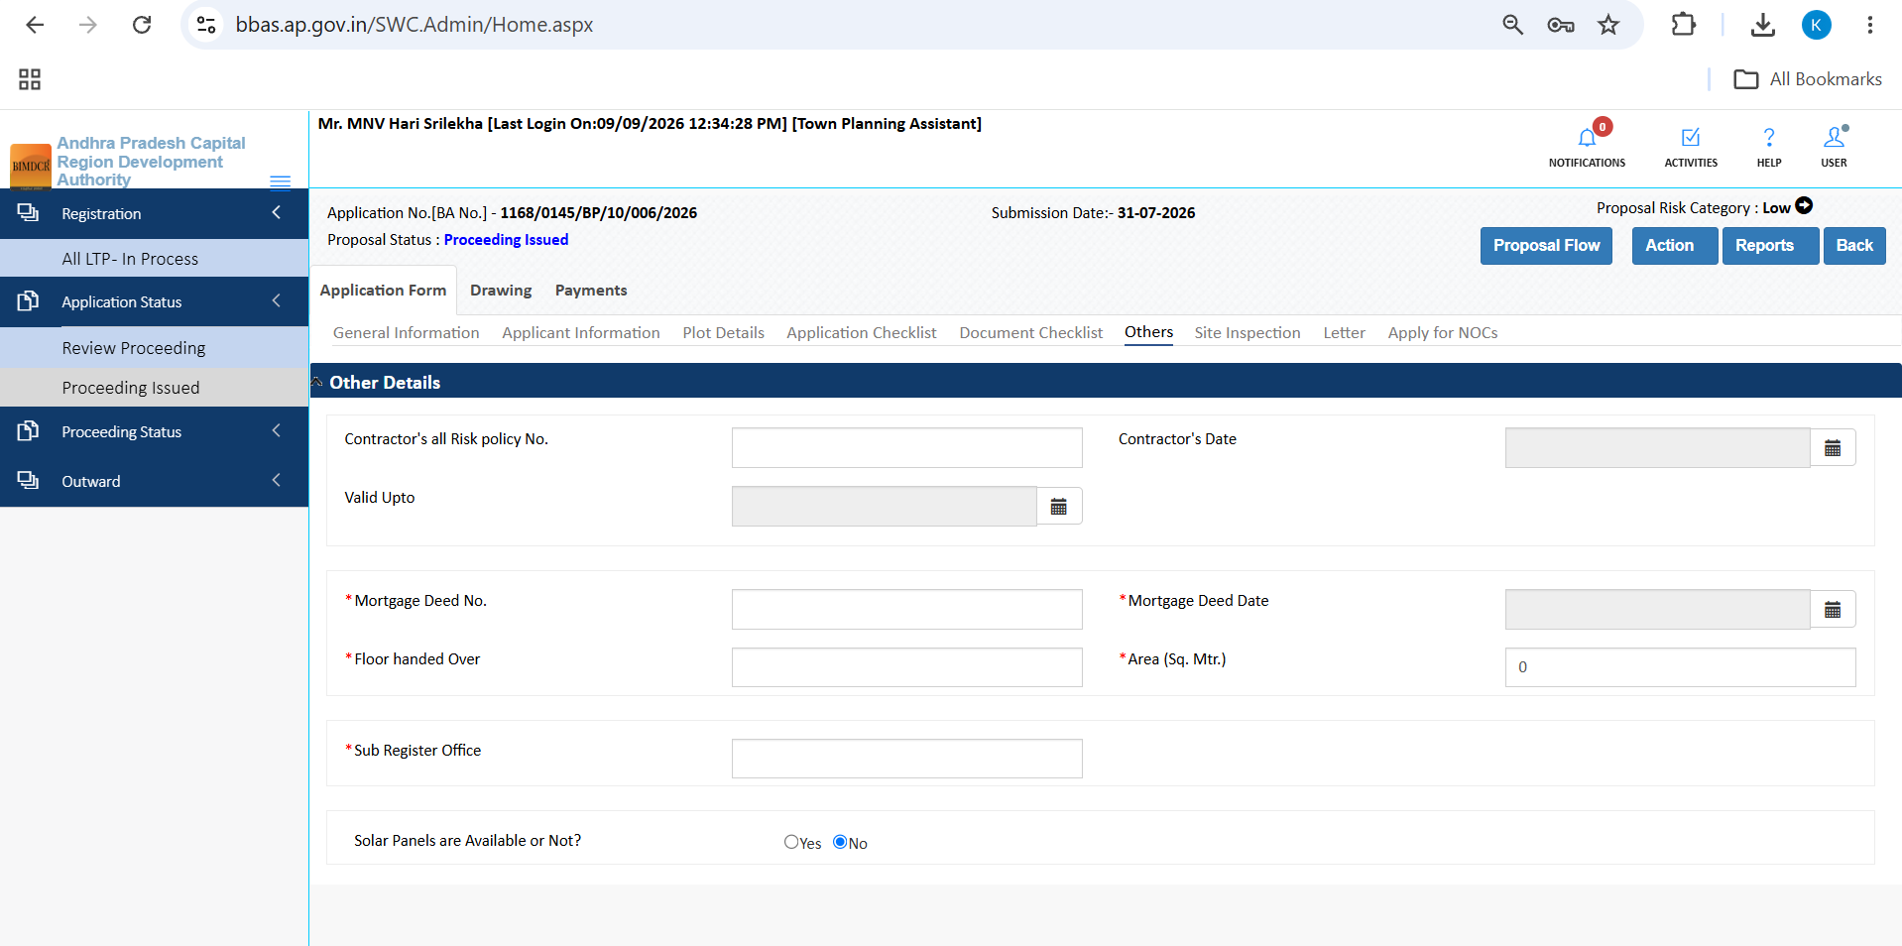
Figure 5.13 — Inspection Photograph gallery displaying geo-tagged ground photos uploaded by the TPA

5.8.3 Inspection Report & Digital Signature ('Sign & Submit')
1. Select the Inspection Report subtab to view the compiled inspection summary.
2. Select formal Recommendation from the dropdown (Recommended for Approval / Shortfall / Reject).
3. Enter comprehensive site inspection remarks detailing field findings.
4. Click 'Save' to draft the report.
5. Click 'Sign & Submit' to apply your official digital signature (USB token or Aadhaar e-Sign) and finalize the field inspection dossier.
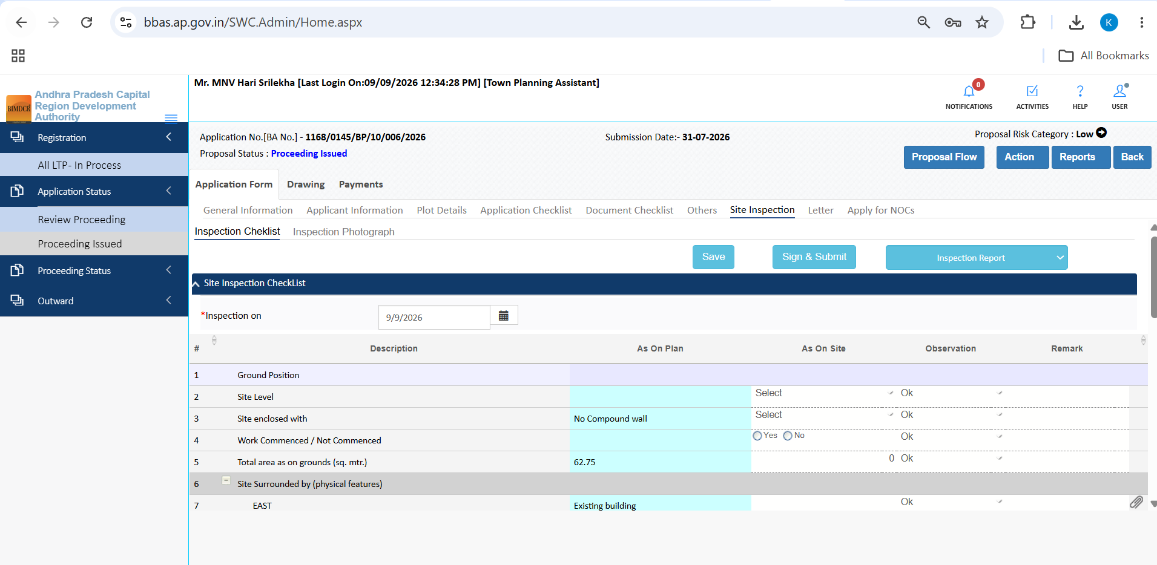
Figure 5.14 — Inspection Report subtab showing Recommendation selector, remarks, and 'Sign & Submit' action

5.9 Letter Tab (Draft Building Permission Order)
The Letter tab provides an embedded PDF viewer displaying the draft Building Permission Order (BPO1.pdf):
1. Open the Letter tab to preview the draft sanction proceeding.
2. Review sanction terms including plot area, sanctioned built-up area, Floor Space Index, and building height.
3. Audit general and special conditions to ensure all site-specific covenants are included.
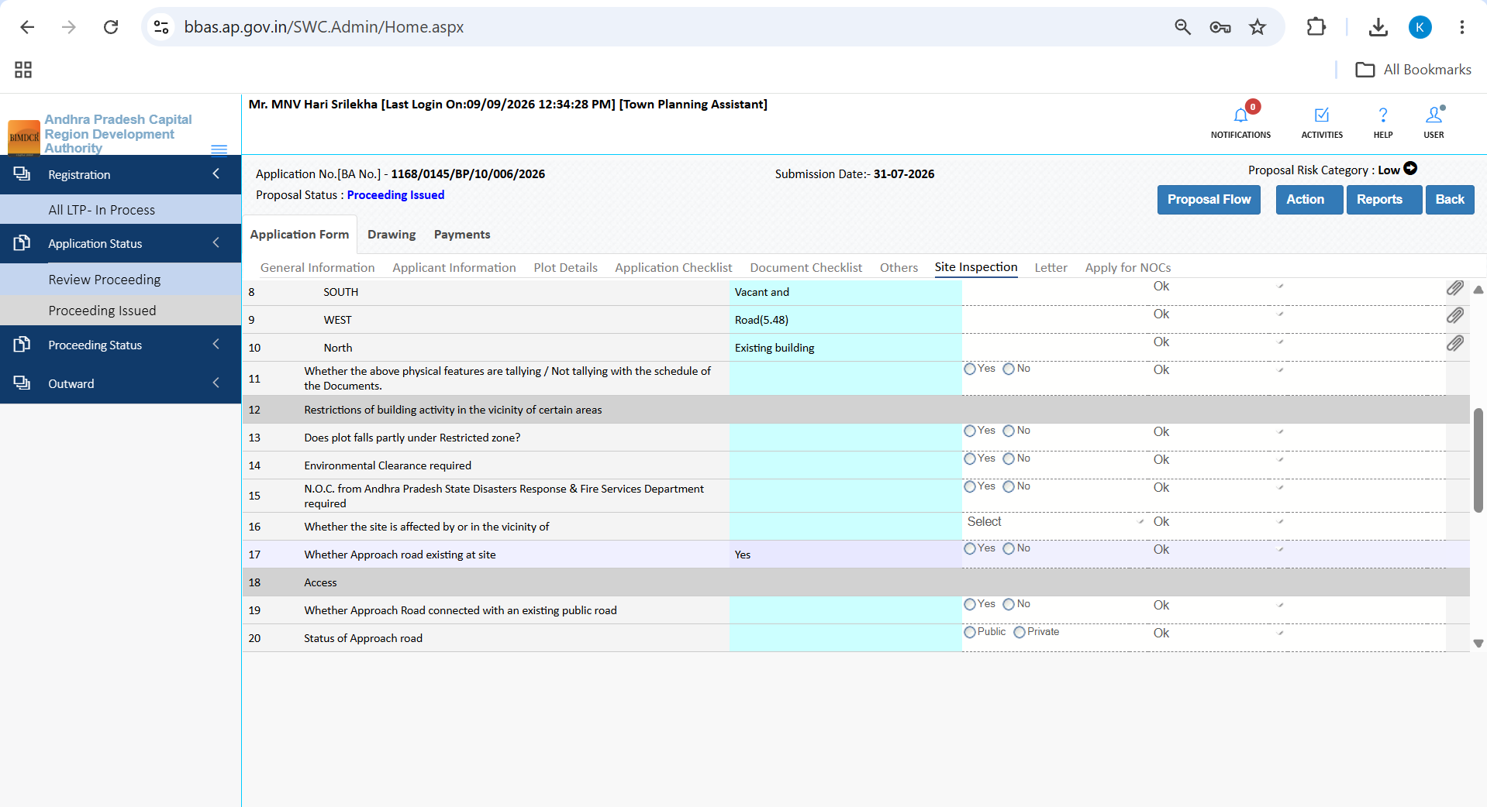
Figure 5.15 — Letter tab displaying embedded draft Building Permission Order PDF (BPO1.pdf)

5.10 Apply for NOCs Tab (Fire Services Clearance)
The Apply for NOCs tab enables the TPA to verify statutory clearances from external government departments:
1. Review Fire Services NOC section to check if the building proposal requires an external Fire NOC.
2. Select the applicable status radio:
- Yes: Applicant has submitted a valid Fire Services Provisional / Final NOC.
- No: NOC is mandatory but has not been furnished.
- NA (Not Applicable): Building height is below statutory threshold (under 15m residential / under 6m non-residential) and exempt from Fire NOC.
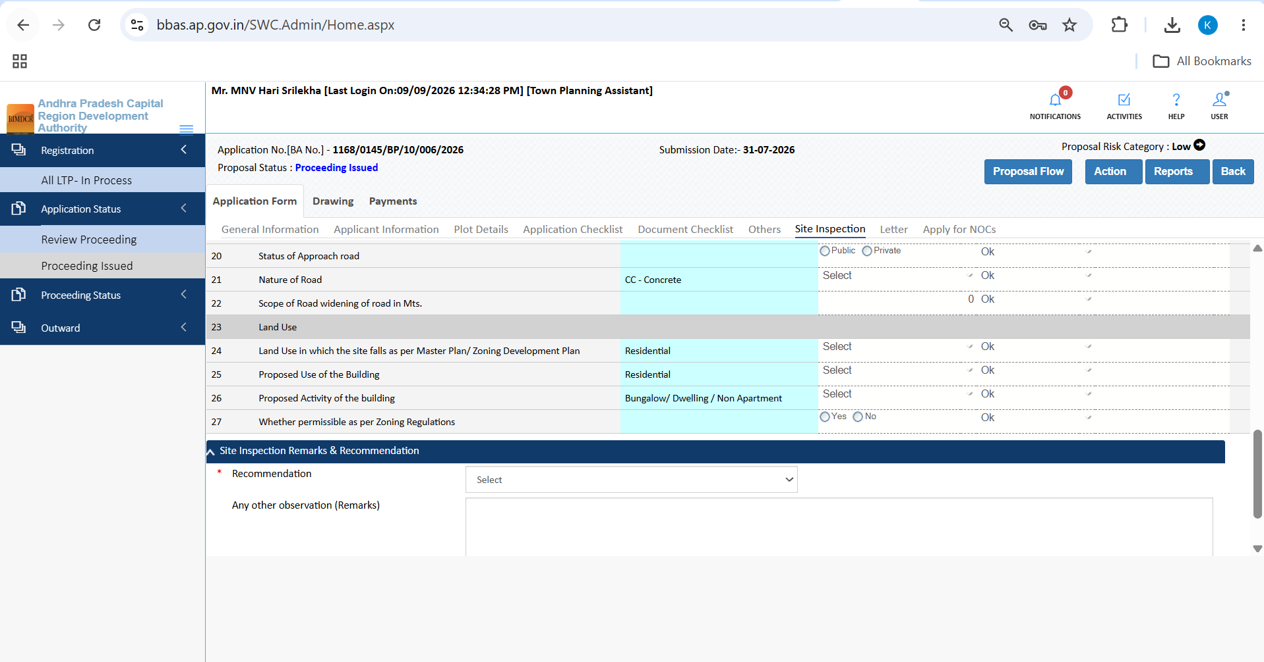
Figure 5.16 — Apply for NOCs tab showing Fire Services NOC tracking and NA selection

5.11 Drawing Scrutiny (AutoDCR CAD Scrutiny & 3D BIM Viewer)
The Drawing tab provides automated building bylaw verification results:
1. Review CAD Layer Scrutiny in the AutoDCR viewer, verifying building footprint, setbacks, and parking layouts.
2. Audit rule verification results table confirming compliance with maximum permissible height, FSI, ground coverage, and road setbacks.
3. Interact with 3D BIM Model using the integrated BIM viewer to rotate, slice floor-by-floor, and inspect spatial objects.
4. Record Drawing Recommendation in the docked recommendation panel and click 'Save Recommendation'.
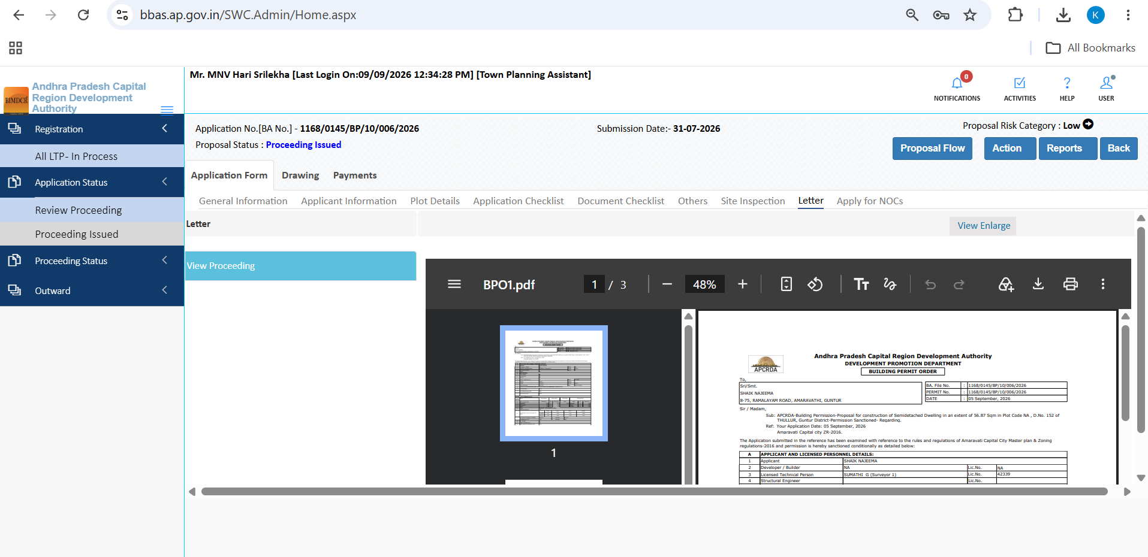
Figure 5.17 — Drawing scrutiny tab showing AutoDCR CAD layer viewer and Scrutiny Recommendation panel

5.12 Payments Tab (Fee Breakup & Treasury Reconciliation)
The Payments tab enables the TPA to audit all government fees and verify treasury realization:
1. Review calculated fee breakdown auditing Development Charges, Betterment Charges, Publication Fee, and City Level Infrastructure Charges.
2. Click 'Payment Memo' to download the official APCRDA fee assessment memo.
3. Click 'Generate Challan' to inspect the AP Treasury CFMS payment breakdown, Head of Account codes, and DDO Code.
4. Audit Payment Receipt log verifying transaction ID, payment date, and realized amount.
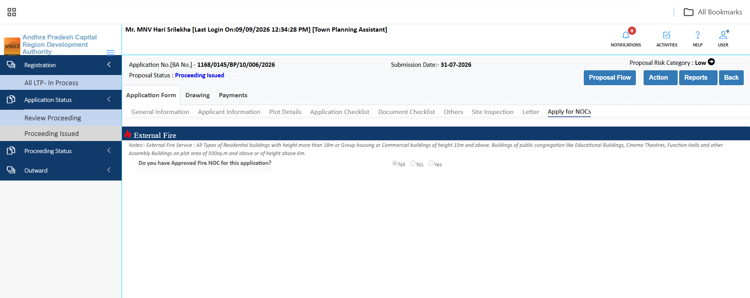
Figure 5.18 — Payments tab displaying itemized fee assessment table and Payment Memo triggers
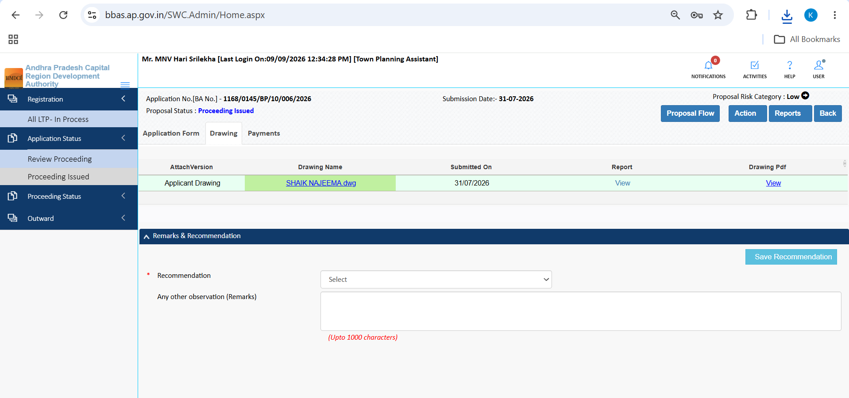
Figure 5.19 — Payments modal showing AP Treasury CFMS challan details and Head of Accounts
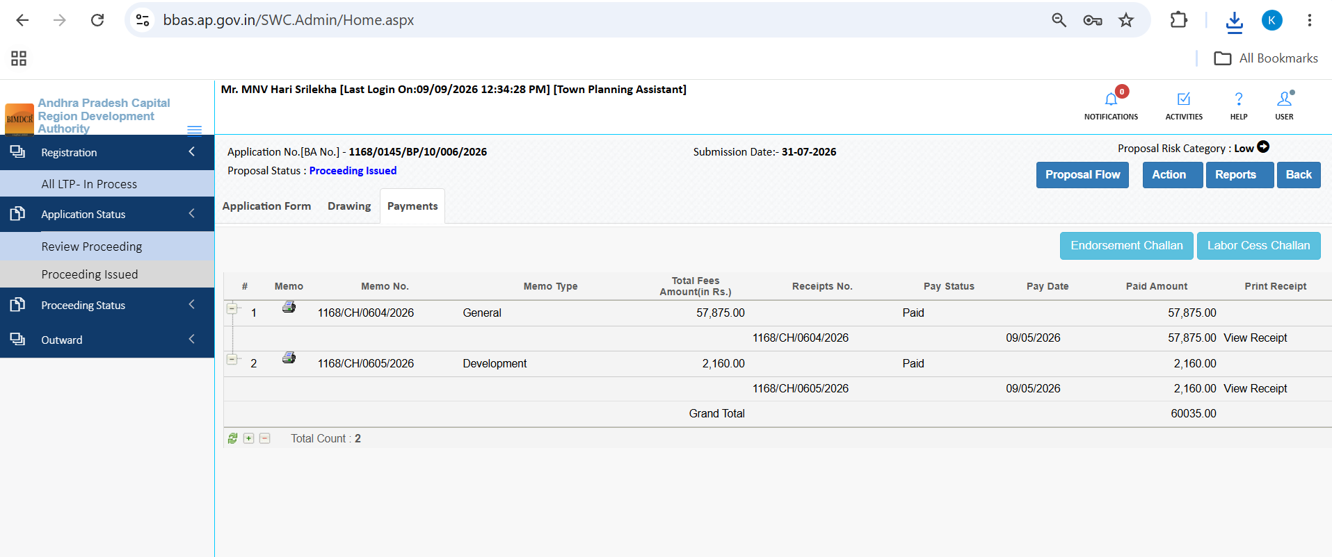
Figure 5.20 — Payments tab transaction log showing payment receipts and reconciliation status

5.13 Land Pooling Scheme (LPS) Institutional Proposal Walkthrough
The portal seamlessly supports complex Land Pooling Scheme (LPS) layouts. Below is the step-by-step scrutiny walkthrough for an institutional G+4 School Building proposal (File No: 1168/0014/BP/12/027/2025, Mandadam / Nekkallu village):
1. General Information: Verifies institutional proposal classification under LPS layout pooling schemes:
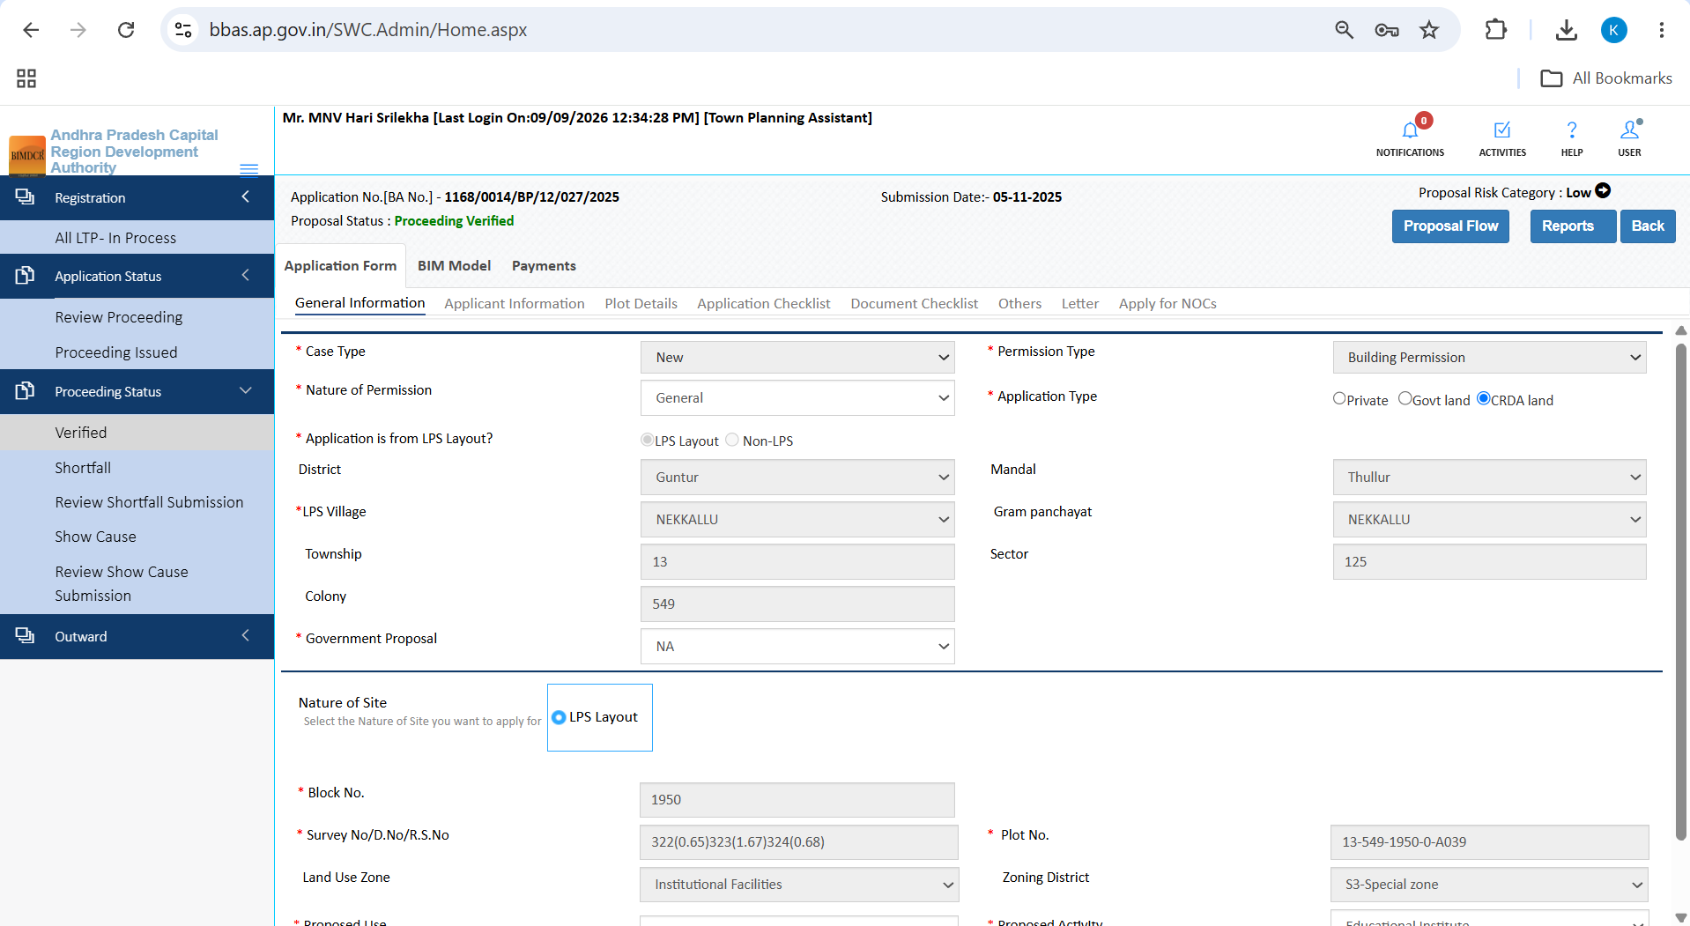
Figure 5.21 — General Information for LPS school proposal 1168/0014/BP/12/027/2025 in Mandadam/Nekkallu
2. Applicant & Third Party Assessor: Audits educational society particulars and registered technical assessors:
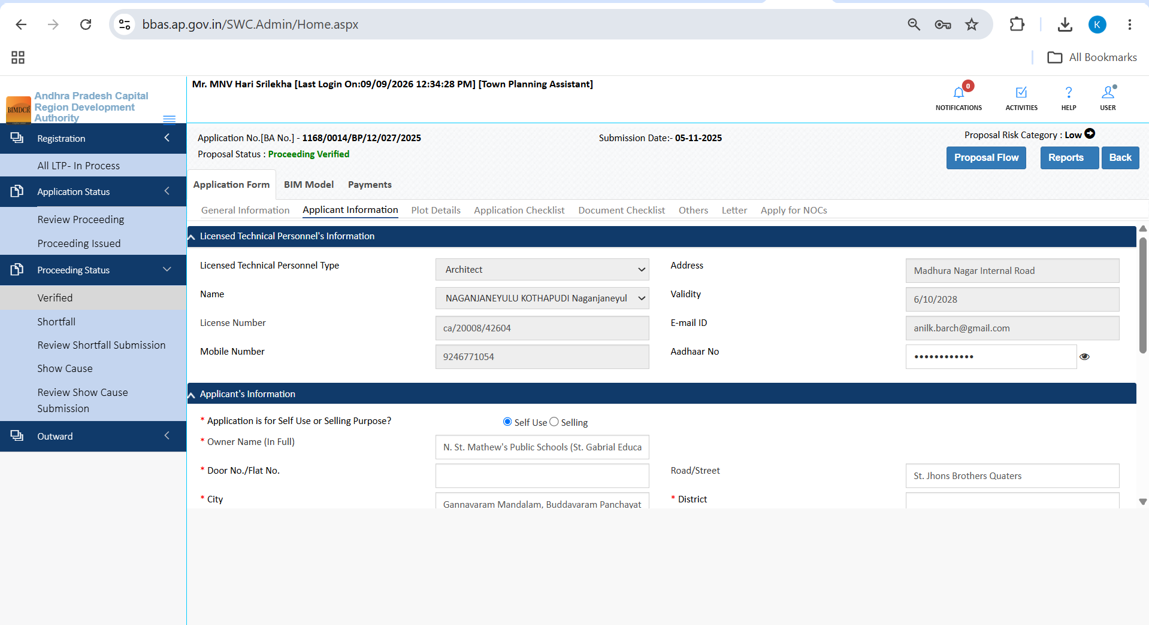
Figure 5.22 — Applicant Information tab for institutional proposal showing Third Party Assessor details
3. Plot Details: Verifies LPS Sector and Plot Number, Document Area, and Road Widening deduction area:
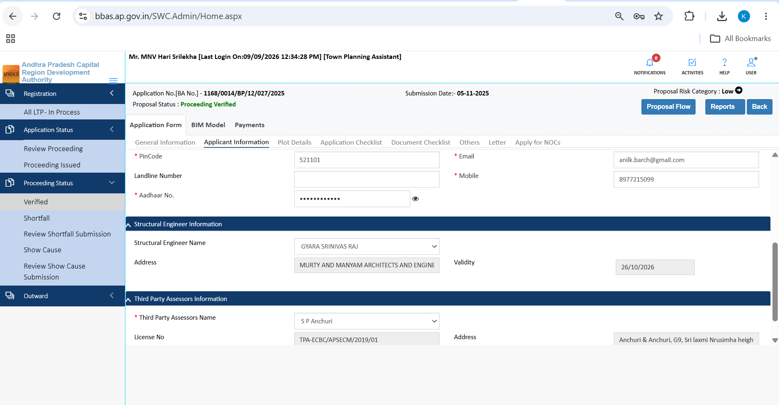
Figure 5.23 — Plot Details tab for LPS school proposal displaying exact road widening deduction
4. Institutional Checklist: Audits statutory compliance questions 1-10 and 11-19:
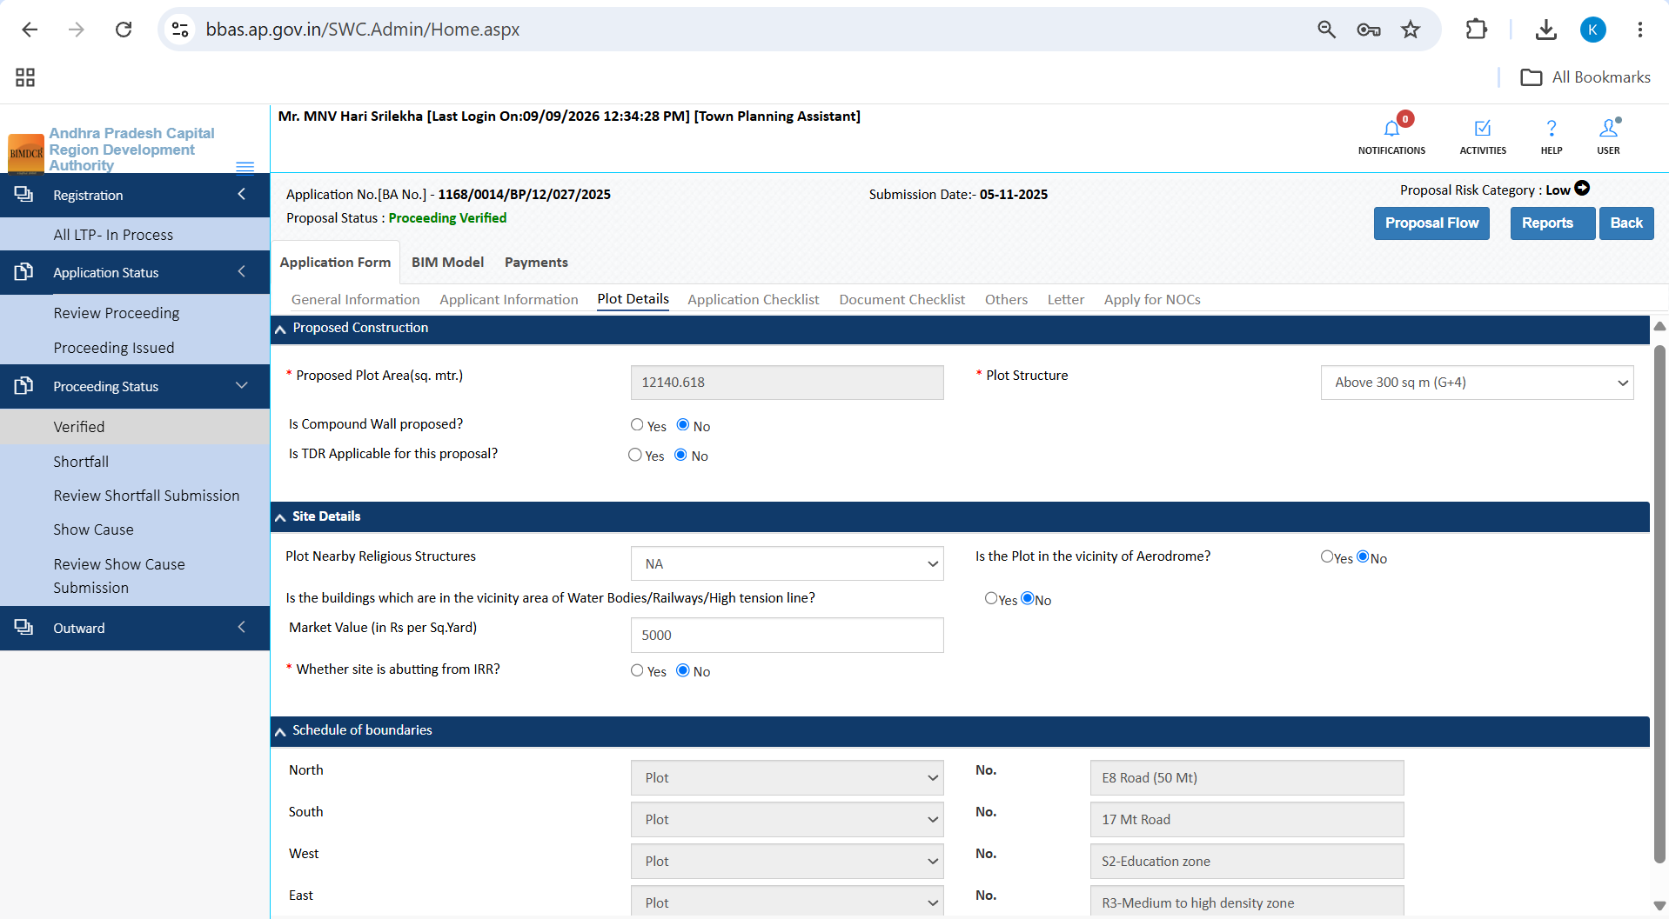
Figure 5.24 — Institutional Application Checklist Questions 1 to 10
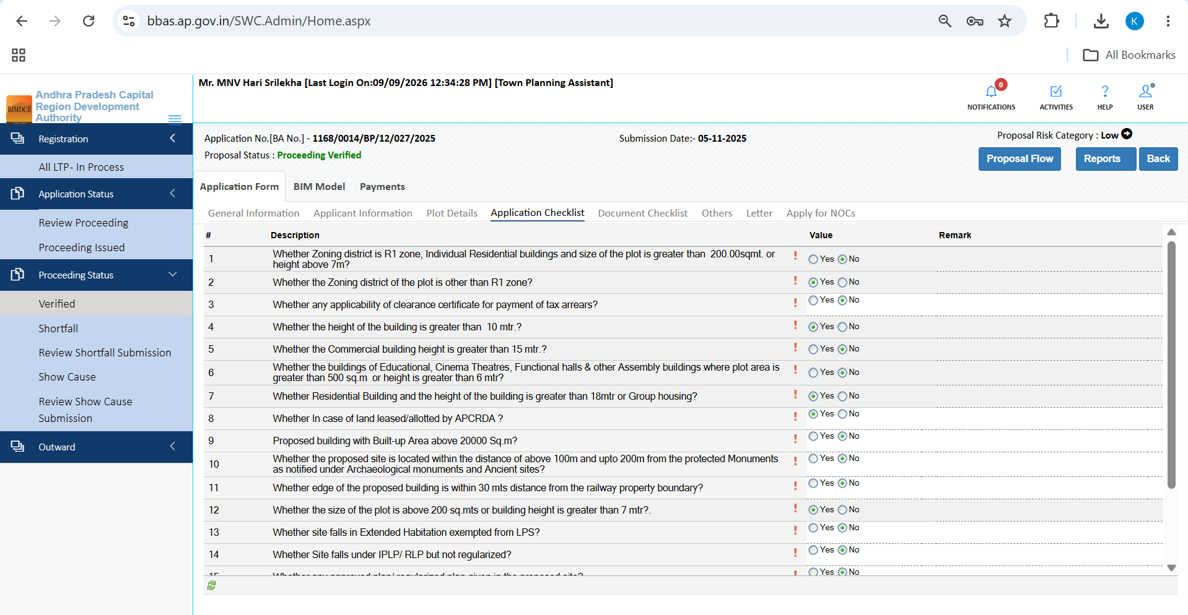
Figure 5.25 — Institutional Application Checklist Questions 11 to 19
5. Document Checklist & Primary Verification: Audits LPS allotment orders, title deeds, and structural certificates:
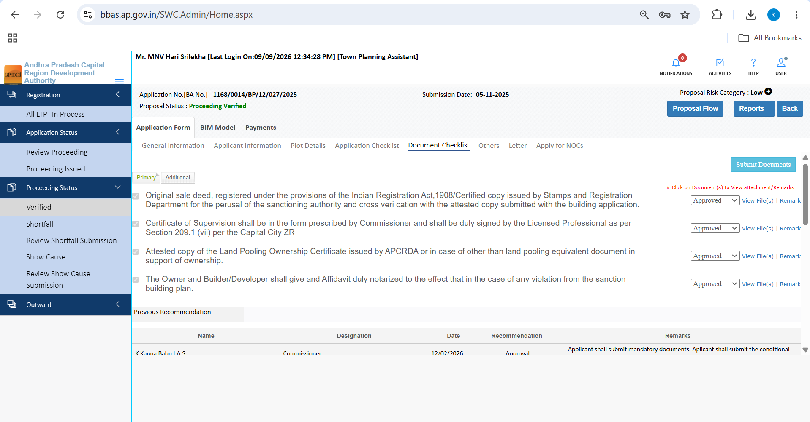
Figure 5.26 — Uploaded document inventory for institutional school proposal
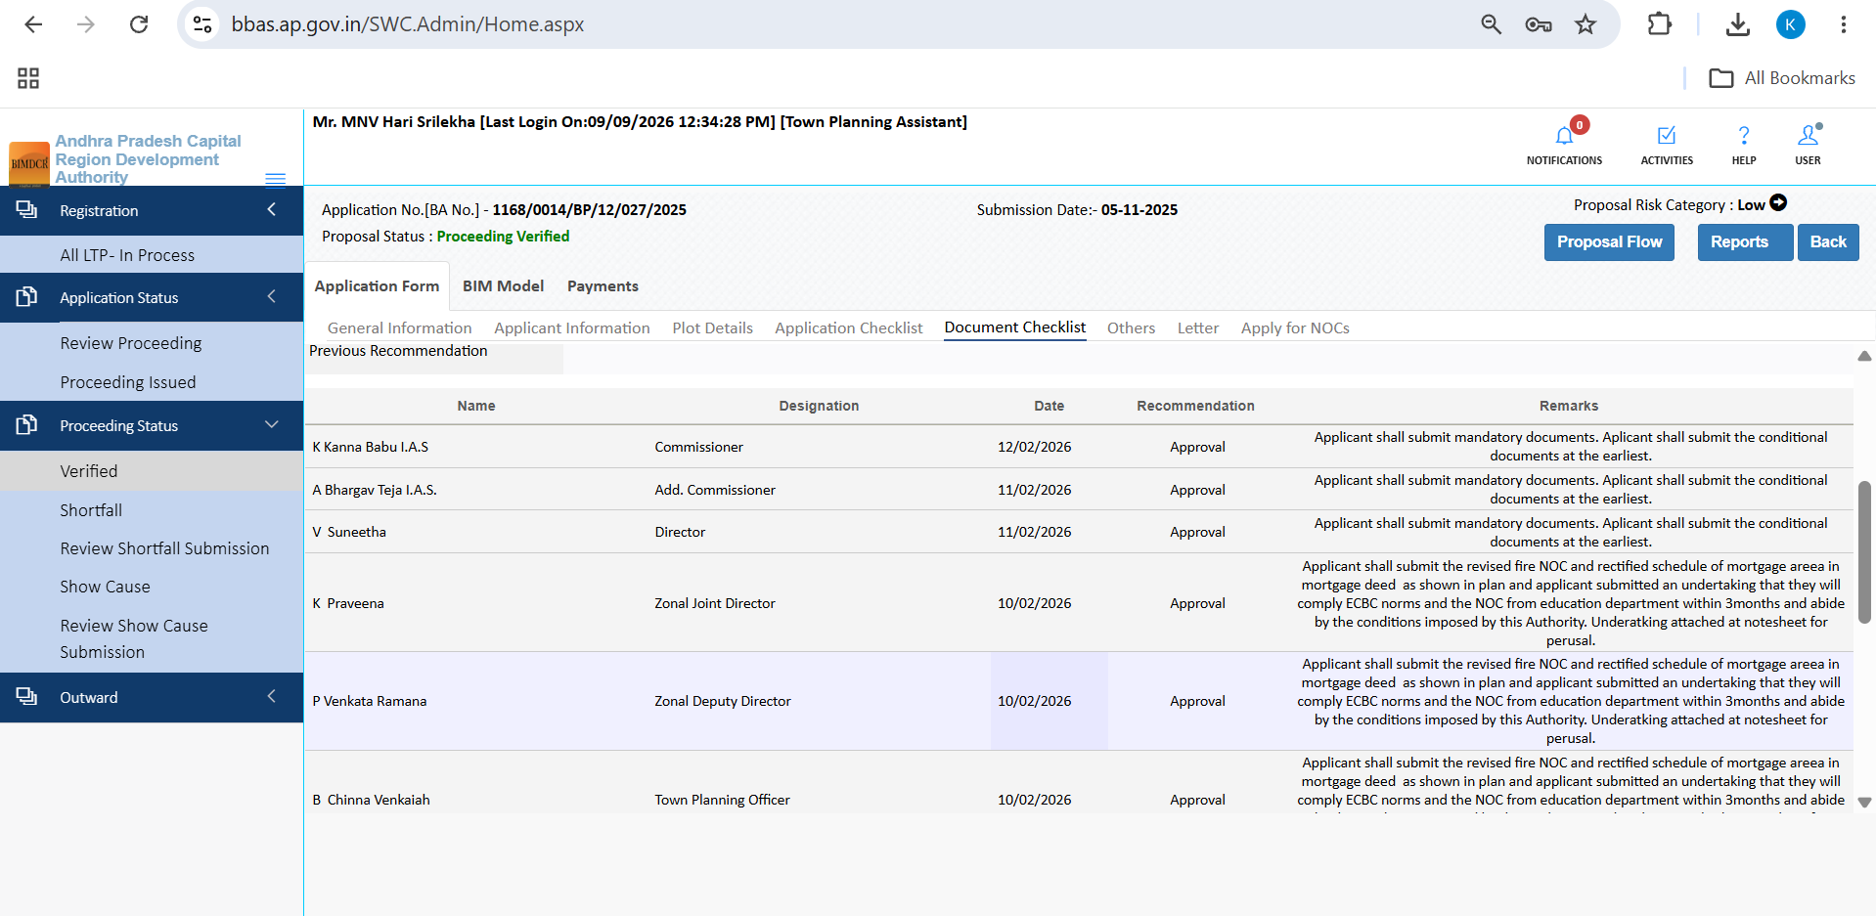
Figure 5.27 — Document Checklist scrutiny controls with 'Verify Primary' and recommendation panel
6. Institutional Others Tab & Draft Sanction: Audits green building standards and school sanction conditions:
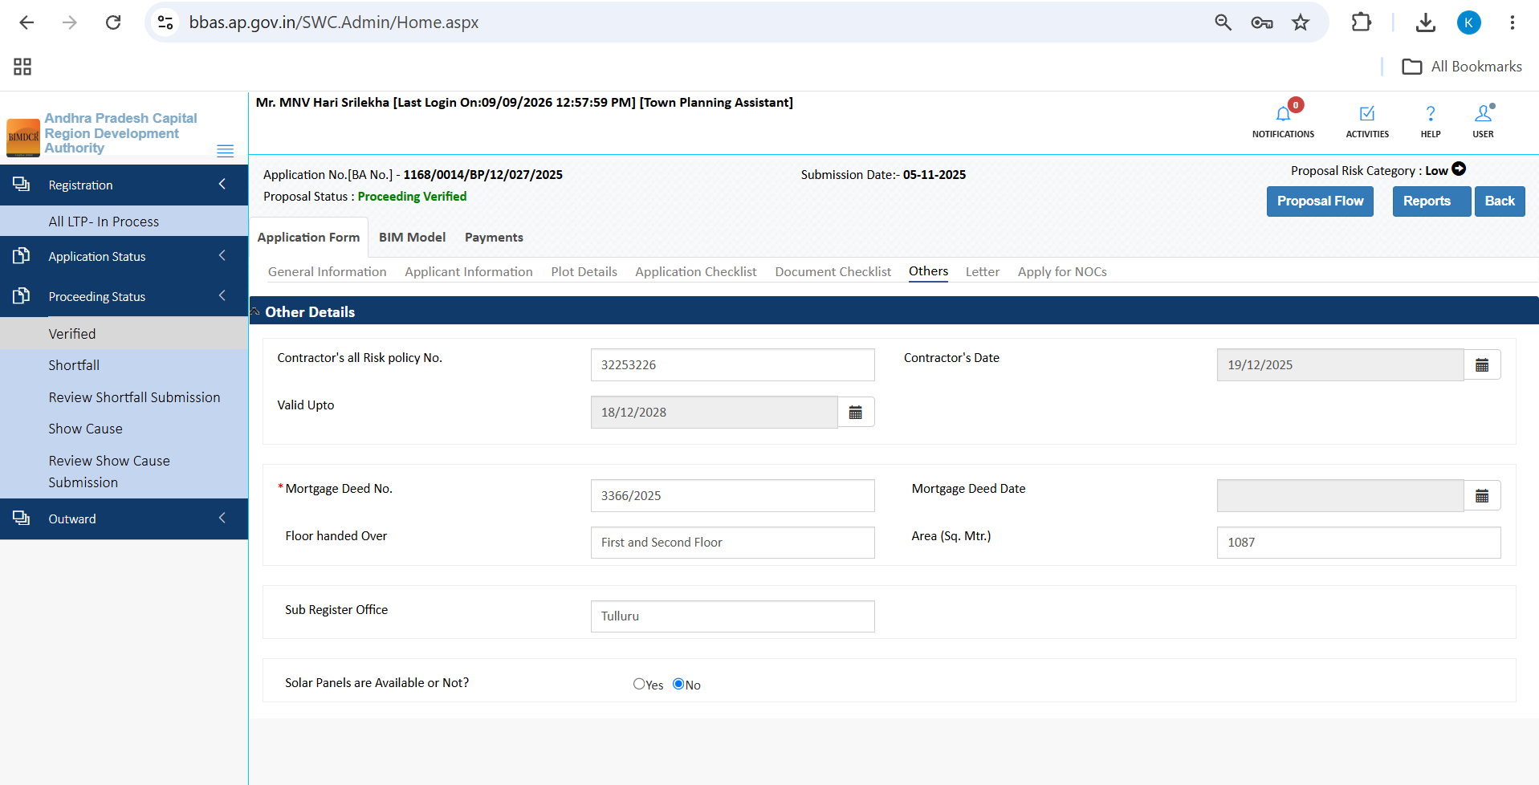
Figure 5.28 — Others tab displaying institutional environmental and accessibility conditions
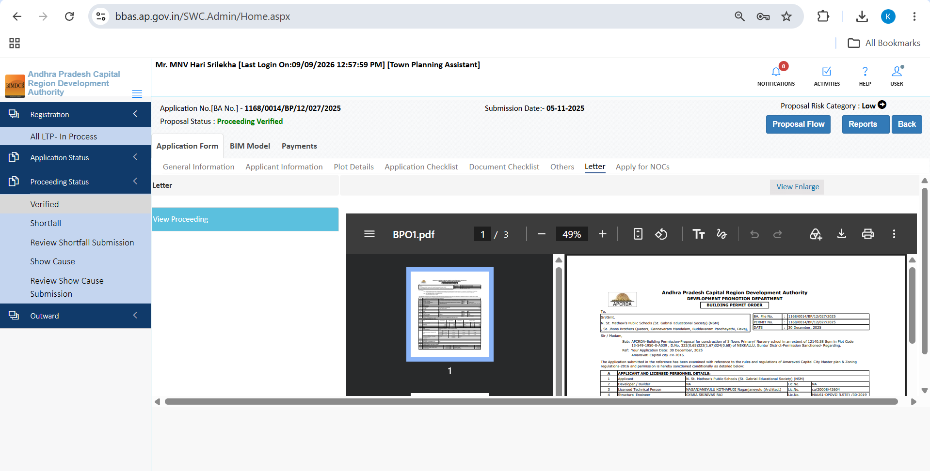
Figure 5.29 — Draft proceeding letter preview (BPO1.pdf) for institutional school building
7. Fire NOC & Interactive 3D BIM Scrutiny: Shows Fire NOC exemption and interactive 3D BIM model scrutiny:
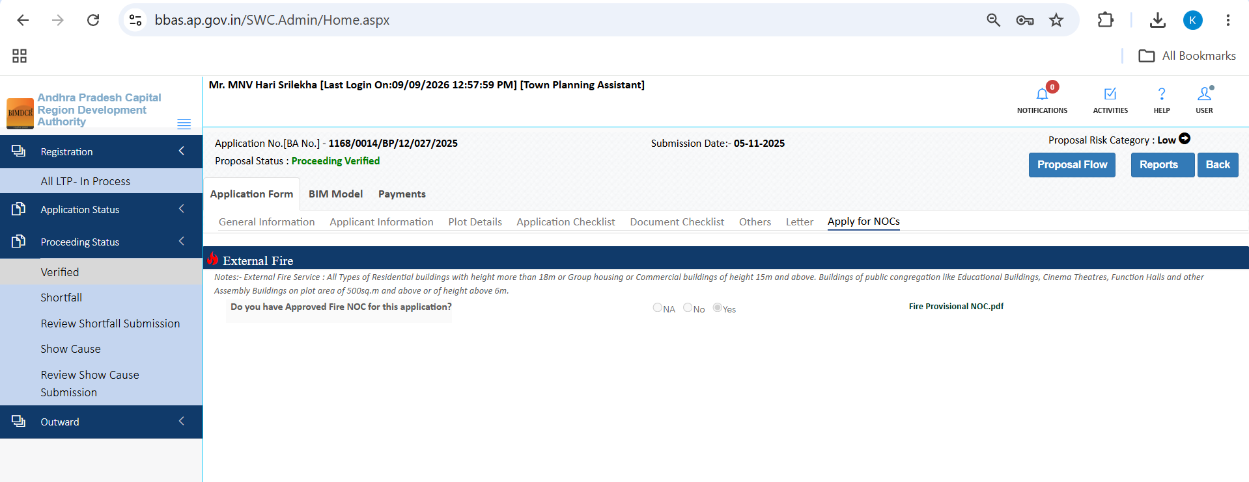
Figure 5.30 — Apply for NOCs tab showing Fire NOC clearance status for school proposal
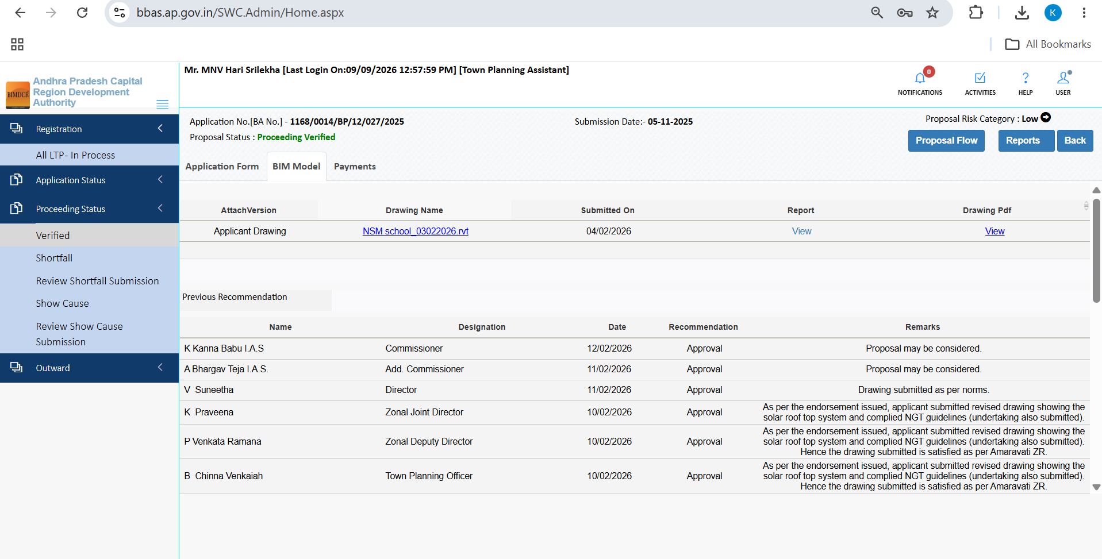
Figure 5.31 — Drawing tab with interactive 3D BIM model viewer for institutional building scrutiny
8. Payments: Confirms full fee payment realization in government accounts:
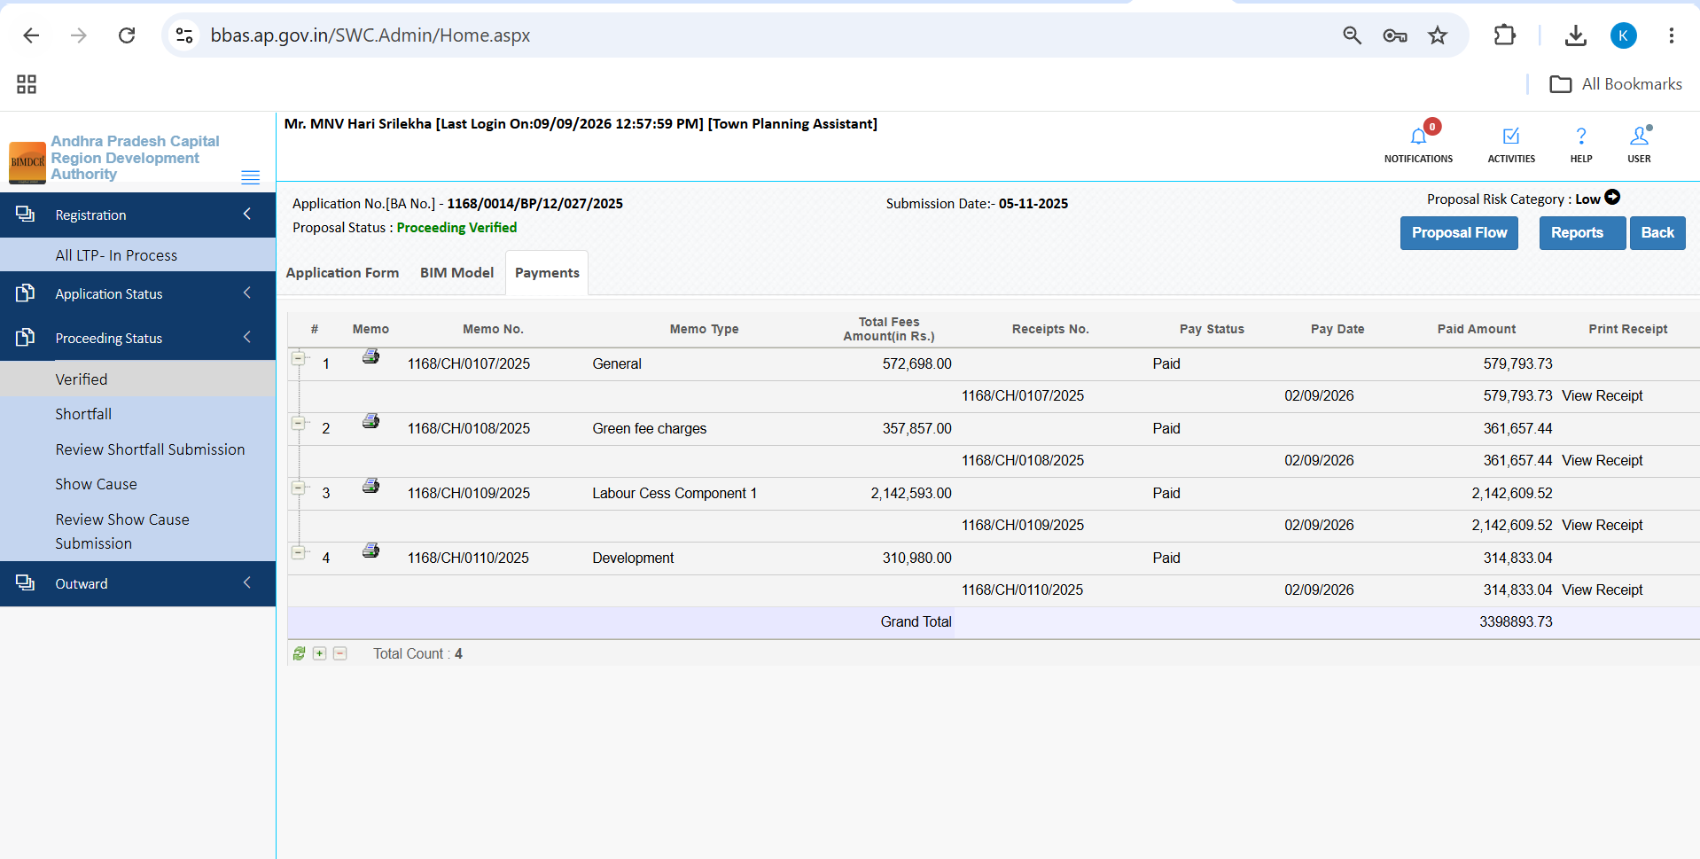
Figure 5.32 — Payments tab showing paid fee receipt and treasury challan reconciliation

5.14 Gramkantam Non-LPS Proposal Scrutiny
For ancestral village settlements (Gramkantam), the TPA portal provides specialized land verification tools:
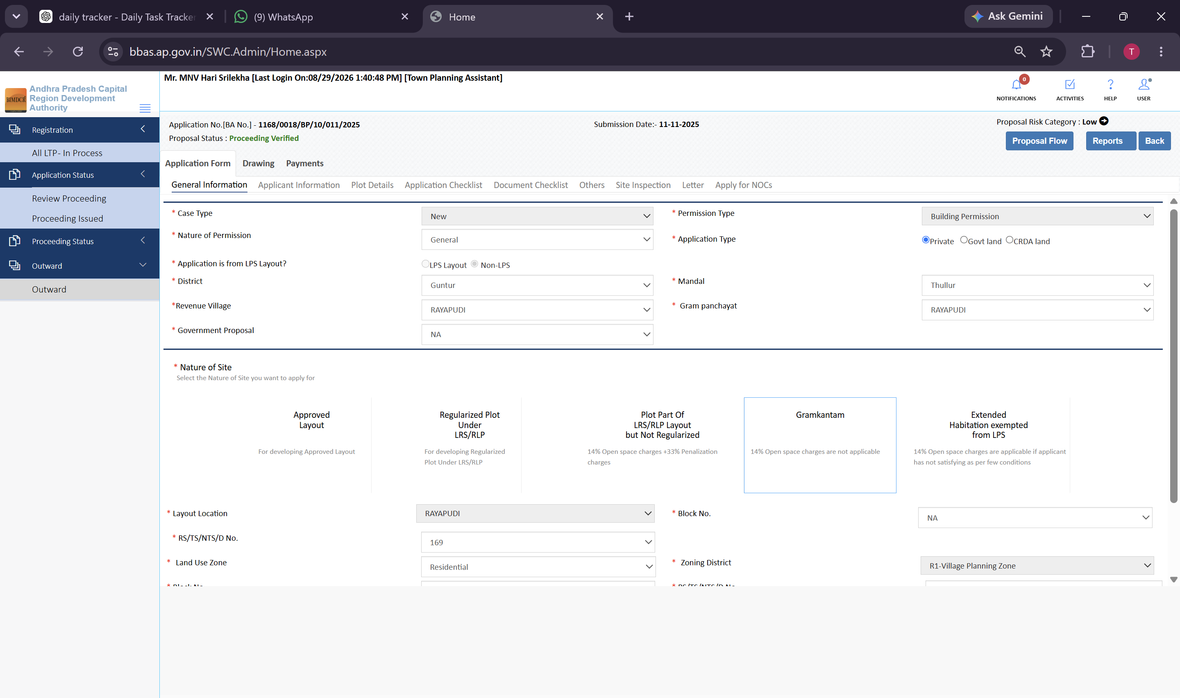
Figure 5.33 — General Information for Gramkantam non-LPS proposal 1168/0018/BP/10/011/2025 with PLOT KML link

6. Module: Proceeding Status Workflow & File Routing
Once technical scrutiny, site inspection, and fee audit are complete, the TPA routes the file through the Proceeding Status lifecycle:

6.1 Verified Queue
Proposals where all technical checks, site inspections, and fee reconciliations are satisfactory are placed in the Verified queue:
1. Open Proceeding Status >> Verified from the sidebar.
2. The table displays all verified proposals with File Assigned Date, Proposal No, File No, and Applicant Name.
3. The TPA forwards verified proposals to the Planning Officer (PO) for final sanction endorsement.
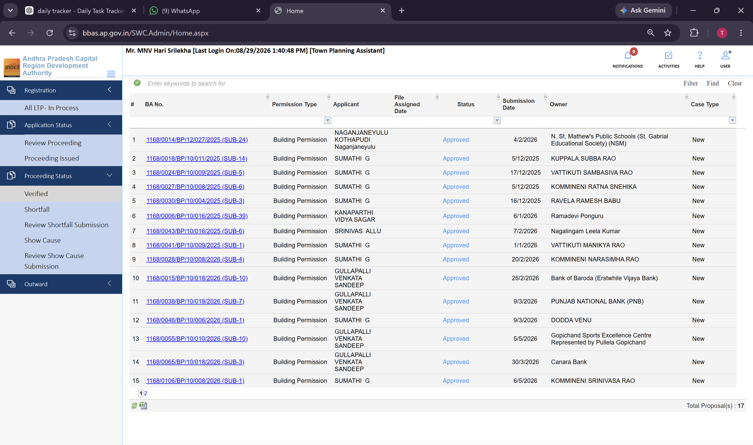
Figure 6.1 — Proceeding Status >> Verified queue listing proposals verified by the TPA officer
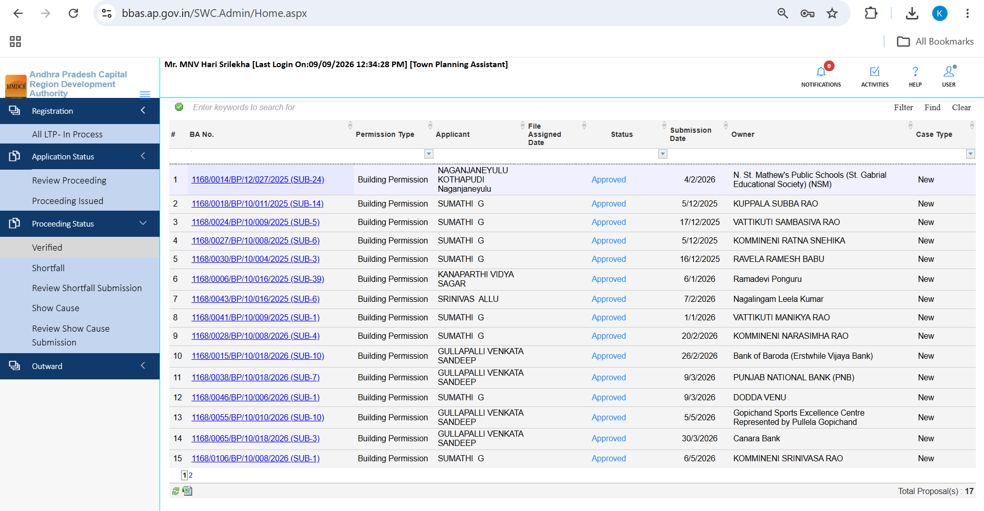
Figure 6.2 — Proceeding Status >> Verified queue (Page 1 of 2 showing 17 proposals)

6.2 Shortfall Queue & Shortfall Letter Issuance
When documents are deficient or drawing revisions are required, the TPA routes the file to Shortfall:
1. Open Proceeding Status >> Shortfall in the sidebar.
2. View proposals pending applicant compliance along with assigned shortfall parameters.
3. Click the Shortfall Letter action to view or download the formal shortfall notice dispatched to the applicant.
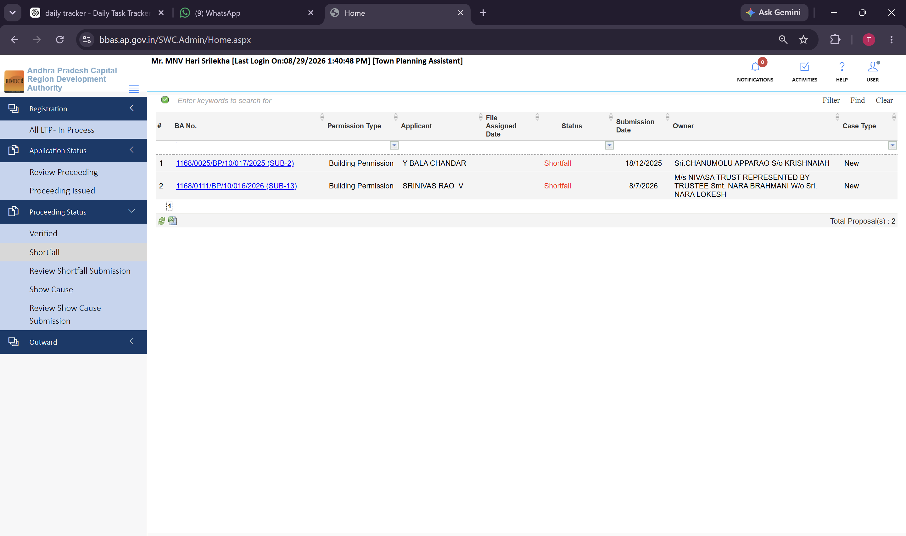
Figure 6.3 — Proceeding Status >> Shortfall queue managing proposals returned for rectification
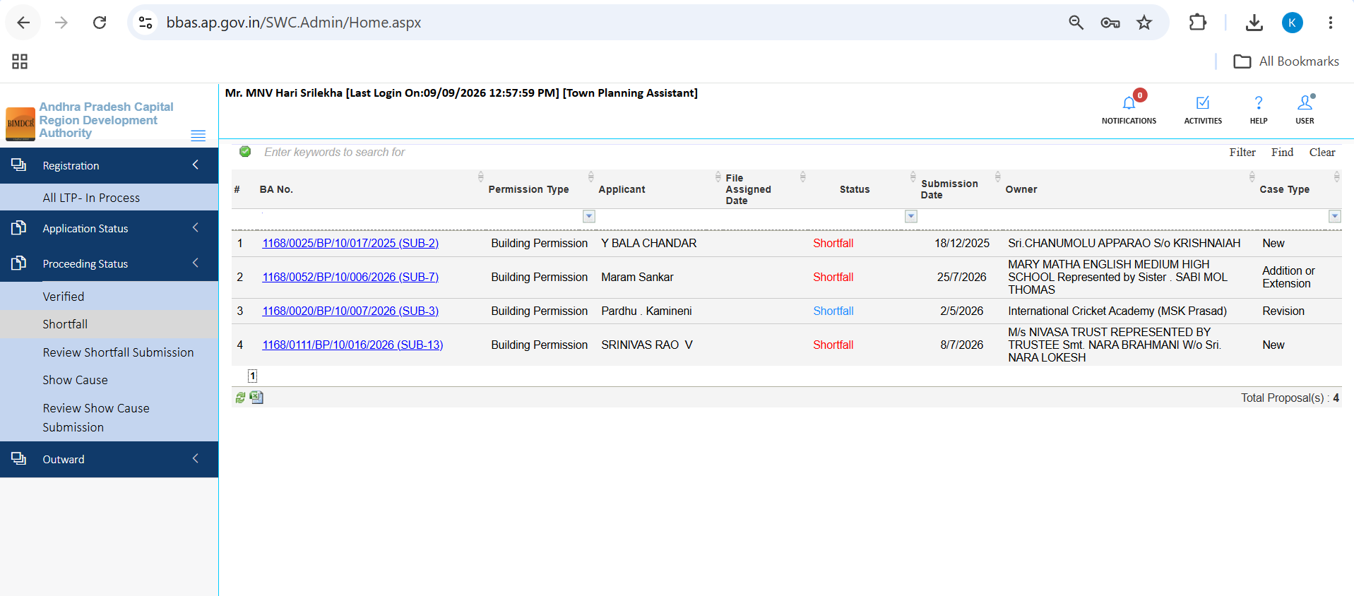
Figure 6.4 — Proceeding Status >> Shortfall queue showing 4 active proposals pending applicant response

6.3 Review Shortfall Submission Queue
When an applicant uploads revised drawings or rectified documents in response to a shortfall, the file appears in this queue:
1. Open Proceeding Status >> Review Shortfall Submission in the sidebar.
2. Inspect the resubmitted proposal (for example, File No: 1168/0149/BP/10/003/2026).
3. Click the Review action to audit only the resubmitted items without repeating the entire inspection.
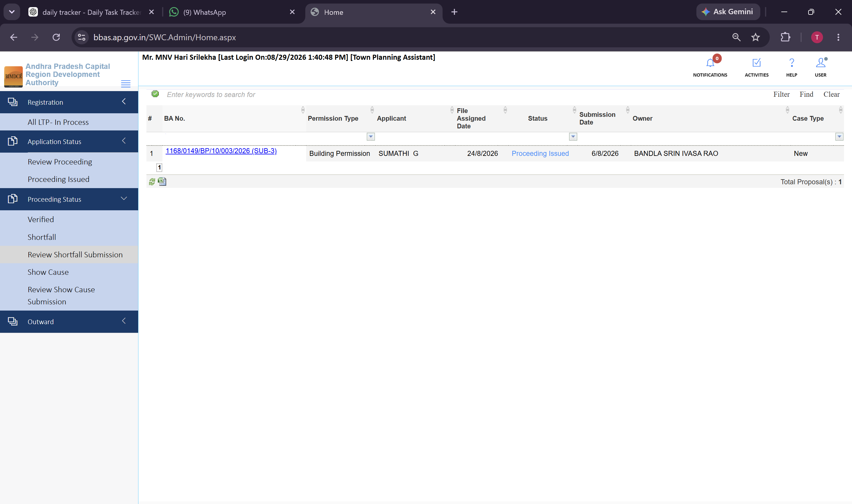
Figure 6.5 — Review Shortfall Submission queue displaying resubmitted proposal 1168/0149/BP/10/003/2026
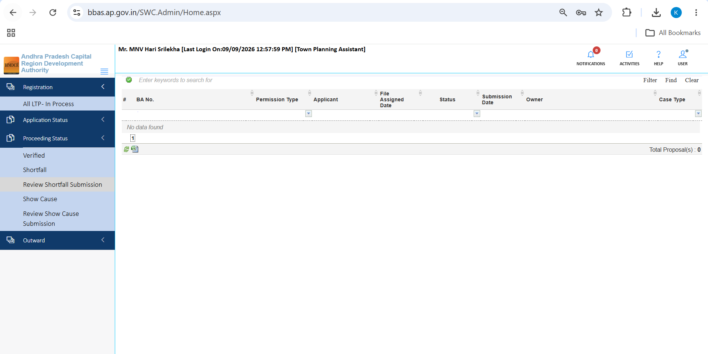
Figure 6.6 — Review Shortfall Submission queue empty state display

6.4 Show Cause Queue & Formal Notice Issuance
For severe bylaw violations or misrepresentation, the TPA initiates formal administrative enforcement:
1. Open Proceeding Status >> Show Cause in the sidebar.
2. The queue manages active Show Cause notices issued by APCRDA.
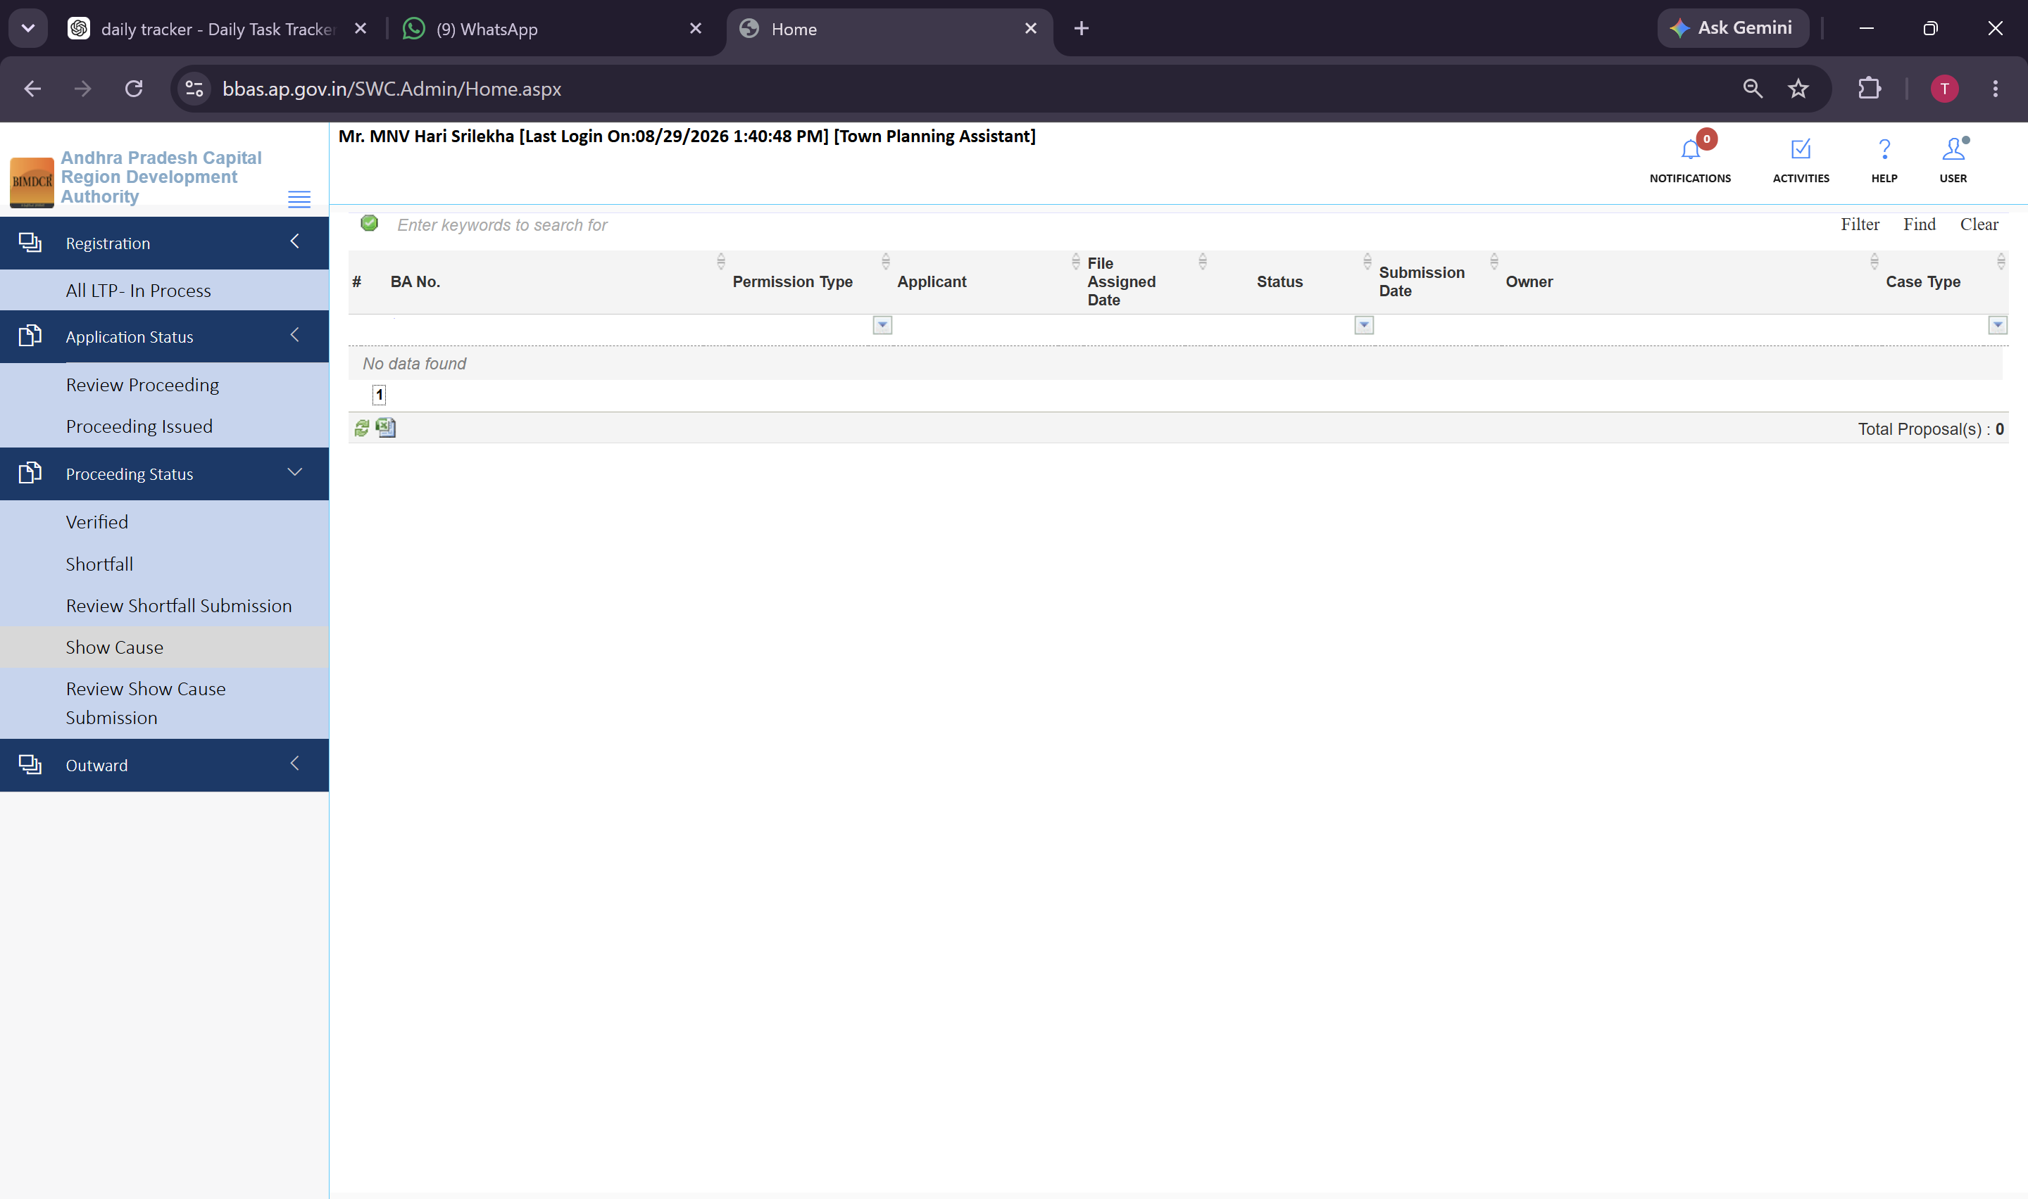
Figure 6.7 — Proceeding Status >> Show Cause queue for statutory enforcement tracking
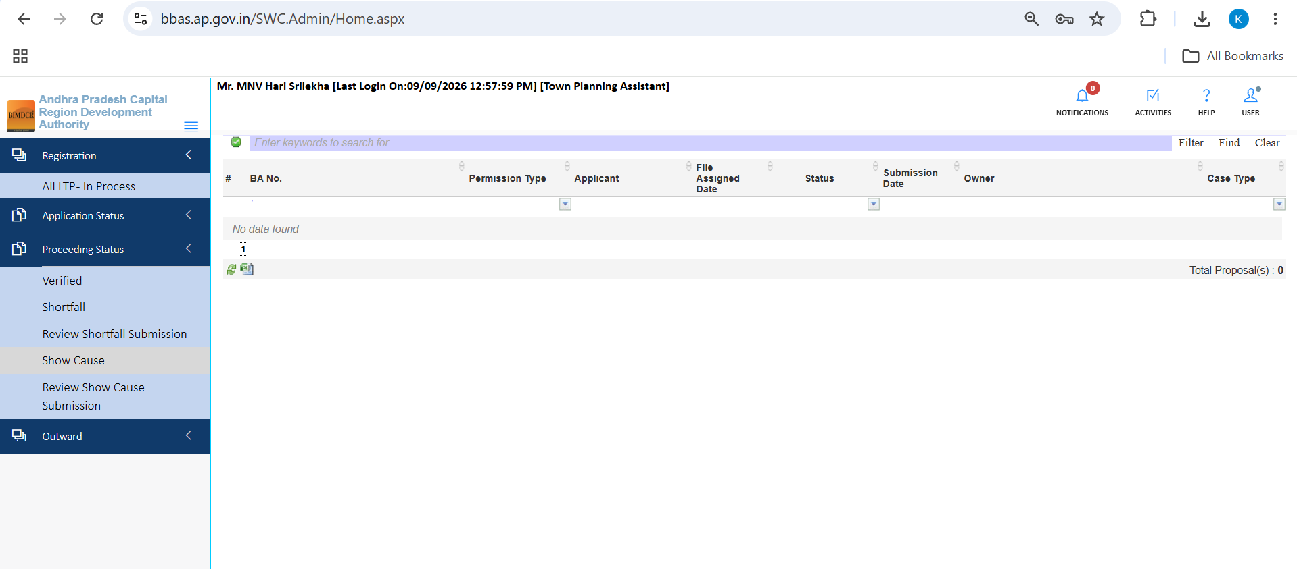
Figure 6.8 — Show Cause queue empty state display

6.5 Review Show Cause Submission Queue
When an applicant submits a formal legal or technical explanation to a Show Cause notice, the file routes here for TPA review:
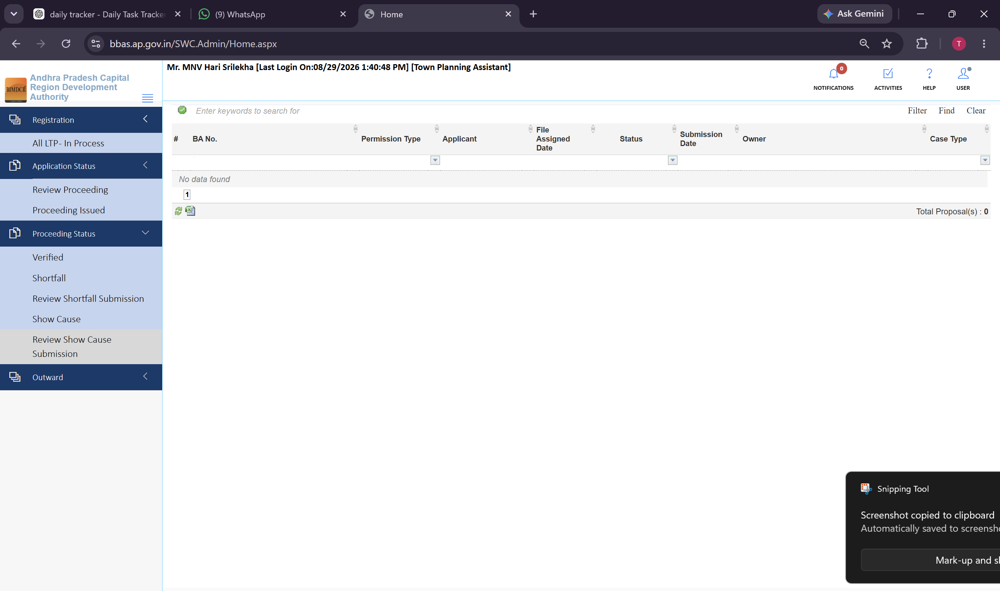
Figure 6.9 — Proceeding Status >> Review Show Cause Submission queue for legal explanation scrutiny
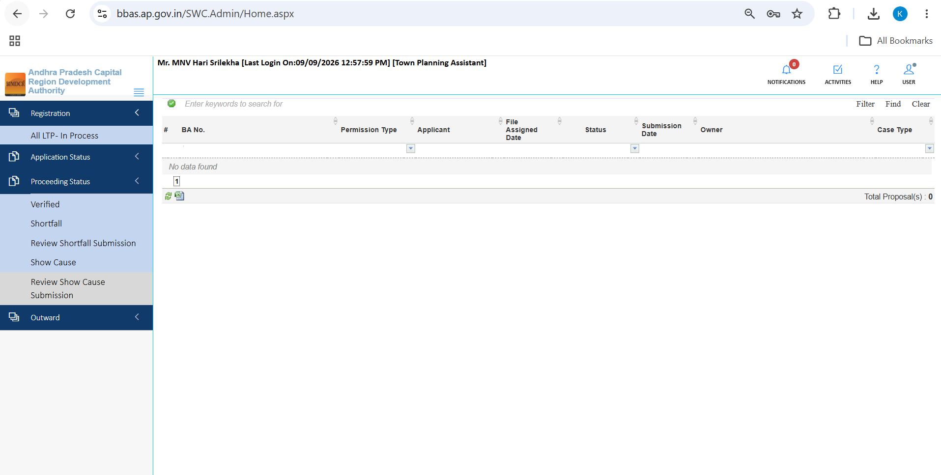
Figure 6.10 — Review Show Cause Submission queue empty state display

6.6 Proceeding Issued Queue
Once final approval is granted by the competent authority, the sanctioned file moves to Proceeding Issued:
1. Open Application Status >> Proceeding Issued in the sidebar.
2. The table lists all sanctioned proposals with File No, Applicant Name, and Status 'Approved'.
3. The TPA can download approved sanction orders and approved drawings for official records.
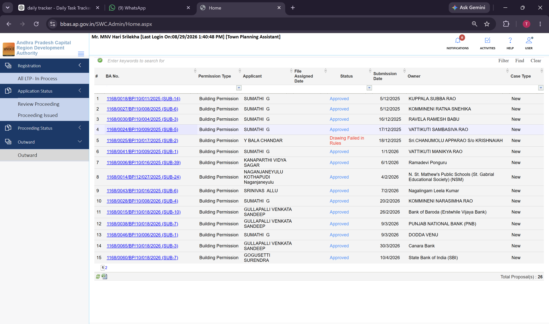
Figure 6.11 — Application Status >> Proceeding Issued queue displaying sanctioned building permits
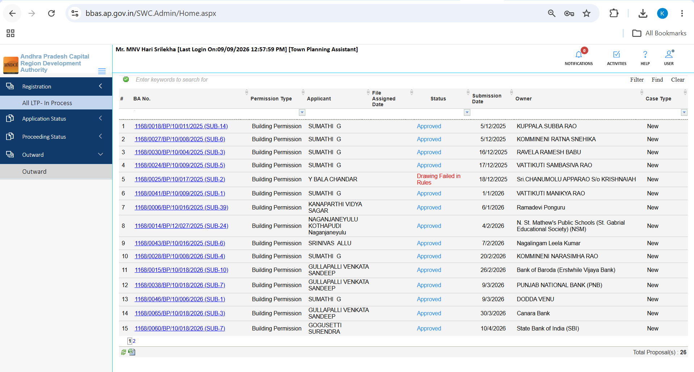
Figure 6.12 — Proceeding Issued queue showing 26 proposals across multiple pages

7. Common actions on every list and proposal
Across all TPA data tables and review forms, the following standardized actions are available:
Action Icon / Button | Location in Portal | Operational Function & Guidance
Review (Pencil Icon) | Action column on all proposal queues | Opens the full multi-tab technical scrutiny form for the selected proposal.
Search Bar | Top of every data table | Filters the active list in real-time by Proposal Number, File Number, or Applicant Name.
Date Filter (From / To) | Table filter headers | Restricts the queue view to proposals submitted or assigned within a specific date range.
Verify Primary | Document Checklist tab | One-click batch verification that marks primary ownership documents as verified.
Document Status Dropdown | Each document row | Granular selector setting document state to Yet to Verify, Verified, Rejected, or Shortfall.
Save Recommendation | Docked panel on Docs, Drawing, Inspection | Mandatory action that records TPA technical findings before a file can be routed.
Sign & Submit | Site Inspection Report subtab | Applies official digital signature to the completed site inspection report.

8. End-to-end TPA scrutiny lifecycle
The complete end-to-end workflow executed by the Town Planning Assistant follows this systematic sequence:
Step 1: Intake. TPA logs into BIMDCR (BPAMSClient/login.aspx) and opens assigned files in Review Proceeding.
Step 2: Metadata Audit. Verifies General Information, revenue jurisdiction, and inspects GIS boundary via PLOT KML.
Step 3: Ownership & Plot Audit. Audits Applicant particulars, compares Document Area vs Ground Area, and verifies Road Widening deductions.
Step 4: Checklist & Document Verification. Verifies 19-point statutory checklist, executes 'Verify Primary', and sets individual document statuses.
Step 5: Physical Field Inspection. Conducts site inspection, completes 27-item checklist, uploads cardinal geo-tagged photos, and executes 'Sign & Submit'.
Step 6: Drawing & BIM Audit. Audits automated rule checks in AutoDCR, examines CAD layers, inspects 3D BIM model, and logs drawing recommendations.
Step 7: NOC & Payment Audit. Verifies Fire NOC clearance, audits fee breakdown, verifies CFMS treasury challan, and reconciles payment receipts.
Step 8: File Routing. Routes compliant proposals to 'Verified' for Planning Officer endorsement, or issues 'Shortfall' / 'Show Cause' notices where deficiencies exist.

