Andhra Pradesh Capital Region Development Authority
Zonal Deputy Director (ZDD) User Manual
BIM Based Building Permit System (BBAS)
Zonal Deputy Director Approving Authority Portal
Portal: bbas.ap.gov.in / SWC.Admin
Audience: Zonal Deputy Directors, Planning Directors, and Competent Sanctioning Authorities
Module-wise user guide with live portal screenshots. Share this Word file as-is, or use File → Save As → PDF.

Contents
1. Introduction
2. Portal access and login
3. ZDD portal overview and full navigation tree
4. Module: Commencement Certificate
4.1 CC Issued queue
4.2 Work Initiated queue
5. Module: Professional Registration Scrutiny
5.1 In Process registration list
5.2 Professional credential verification
6. Module: Application Status
6.1 Review Proceeding queue
6.2 Proceeding Issued queue
6.3 Revoke Proceeding queue
7. Module: Proceeding Status & Multi-Tier Technical Adjudication
7.1 Verified queue and file forwarding
7.2 Shortfall queue and Shortfall Letter issuance
7.3 Review Shortfall Submission queue
7.4 Show Cause enforcement queue
7.5 Review Show Cause Submission queue
8. Module: Proposal Technical Scrutiny & Sanction Walkthrough
8.1 General Information verification
8.2 Applicant Information Verification
8.3 Plot Details and area deductions
8.4 Application Checklist verification (Questions 1 to 19)
8.5 Document Checklist & Previous Directorate Recommendations
8.6 Others tab (Mortgage Deed, CAR Policy, and Solar)
8.7 Site Inspection Review (Construction Status, Ground Boundaries, Road Width)
8.8 Letter — Building Permit Order endorsement
8.9 Apply for NOCs (External Fire Services clearances)
8.10 Drawing Scrutiny (AutoDCR CAD & 3D BIM Viewer)
8.11 Payments & Treasury Reconciliation
9. Module: Occupancy Certificate
9.1 Occupancy List
9.2 Submitted Applications (Completion Intimations)
10. Module: Outward Register & Dispatch Tracking
11. Common actions on every list and proposal
12. End-to-end ZDD sanctioning lifecycle

1. Introduction
BBAS is APCRDA's comprehensive online platform for building permission scrutiny, site inspection, and regulatory approvals across the Amaravati Capital Region. Within the authority's administrative hierarchy, the Zonal Deputy Director (ZDD) functions as a senior approving authority and competent sanctioning official.
The ZDD portal workspace equips the Zonal Deputy Director with end-to-end regulatory oversight across the complete development lifecycle: adjudicating verified building proposals escalated from Town Planning Assistants and Planning Officers, issuing formal Shortfall and Show Cause notices, inspecting on-ground construction progress for Commencement Certificates, reviewing technical professional registrations, approving completion notices for Occupancy Certificates, and monitoring outward dispatch registers.

2. Portal access and login
Zonal Deputy Directors authenticate through the unified BIMDCR administrative gateway:
1. Open your web browser and navigate to the official portal login URL: https://bbas.ap.gov.in/BPAMSClient/login.aspx.
2. Confirm the header displays 'Welcome to BIMDCR' under the Andhra Pradesh Capital Region Development Authority banner.
3. Enter your User ID into the Username field (for example, official officer ID ZDD001).
4. Enter your Password into the Password field.
5. Type the Captcha code exactly as displayed in the security image. Use the refresh icon if the characters are unclear.
6. Click Sign In to authenticate and open the ZDD administrative workspace (SWC.Admin/Home.aspx).
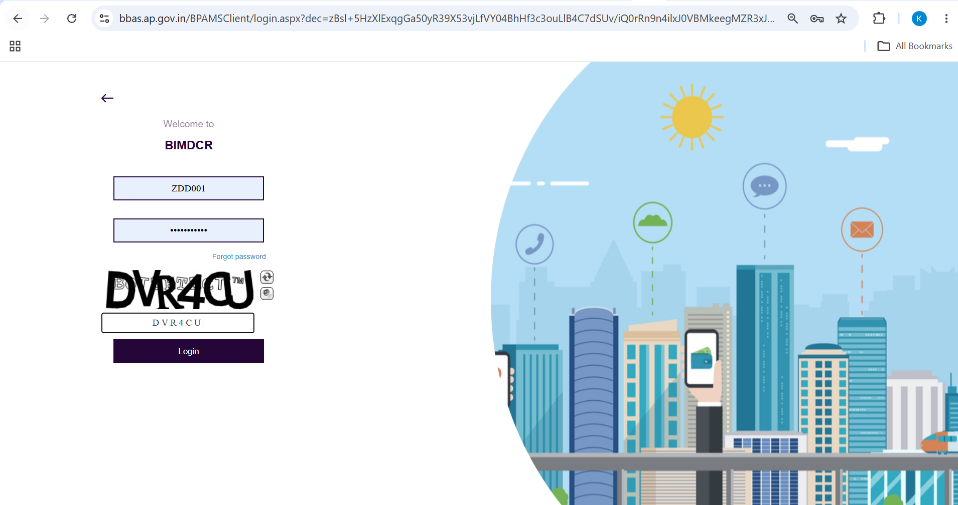
Figure 2.1 — BIMDCR Portal Login screen (BPAMSClient/login.aspx) with ZDD credentials and captcha validation

3. ZDD portal overview and full navigation tree
Upon logging in, the ZDD workspace launches. The top banner displays official APCRDA branding, active user details ('Mr. P Venkata Ramana [Last Login On: 09/09/2026 3:03:03 PM] [Zonal Deputy Director]'), and quick access tools.
The ZDD workspace features the authority's complete, unconstrained administrative menu hierarchy spanning the entire pre-sanction, post-sanction, and post-construction lifecycle:
- 1. Commencement Certificate: Tracks post-sanction construction notices: CC Issued and Work Initiated.
- 2. Registration: Reviews professional registrations: All In Process.
- 3. Application Status: Tracks core building applications: Review Proceeding, Proceeding Issued, and Revoke Proceeding.
- 4. Proceeding Status: Manages multi-tier file adjudication: Verified (37 proposals), Shortfall (4 proposals), Review Shortfall Submission, Show Cause, and Review Show Cause Submission.
- 5. Occupancy: Oversees building completion intimations: Occupancy List and Submitted Application.
- 6. Outward: Monitors official dispatched orders: Outward Register (48 proposals).
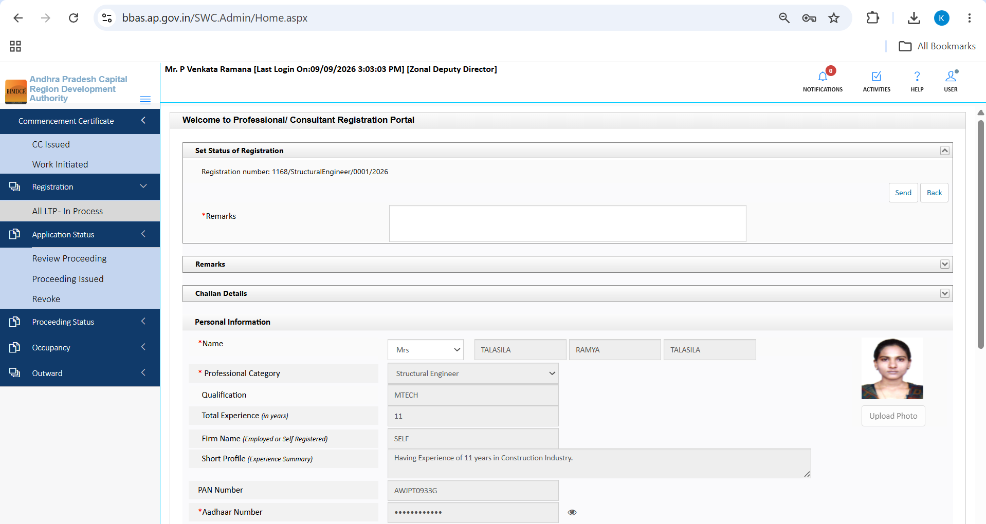
Figure 3.1 — ZDD administrative workspace (SWC.Admin/Home.aspx) showing full navigation hierarchy under Mr. P Venkata Ramana

4. Module: Commencement Certificate
The Commencement Certificate module empowers the Zonal Deputy Director to monitor on-ground construction commencement following building permit sanction.

4.1 CC Issued Queue
1. Click Commencement Certificate in the sidebar and select CC Issued.
2. The data grid displays all proposals where Commencement Certificates have been formally generated and issued.
3. Use the search bar to locate specific files by BA Number or Owner Name.
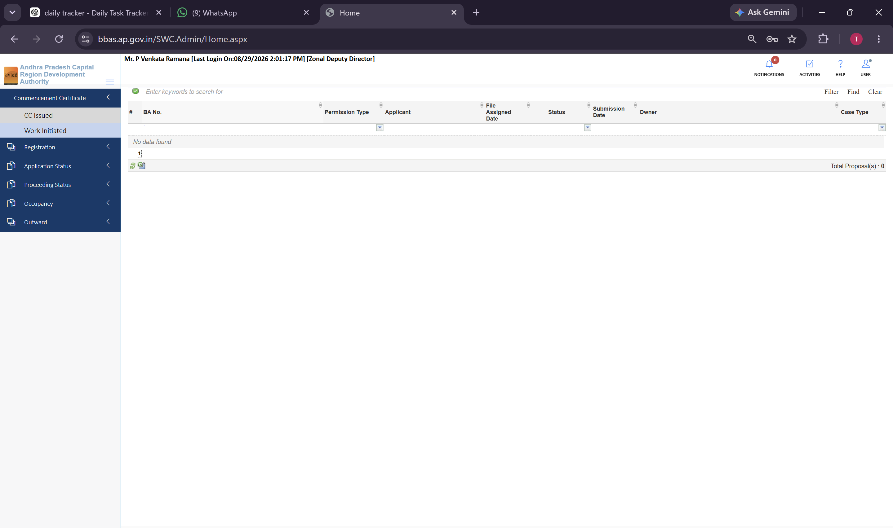
Figure 4.1 — Commencement Certificate >> CC Issued queue for tracking issued commencement authorizations

4.2 Work Initiated Queue
1. Click Commencement Certificate >> Work Initiated in the sidebar.
2. The queue lists all building sites where applicants have submitted their official work commencement notice, intimating foundation demarcation readiness.
3. Click the file action icon to inspect site readiness details and review the site inspection schedule.
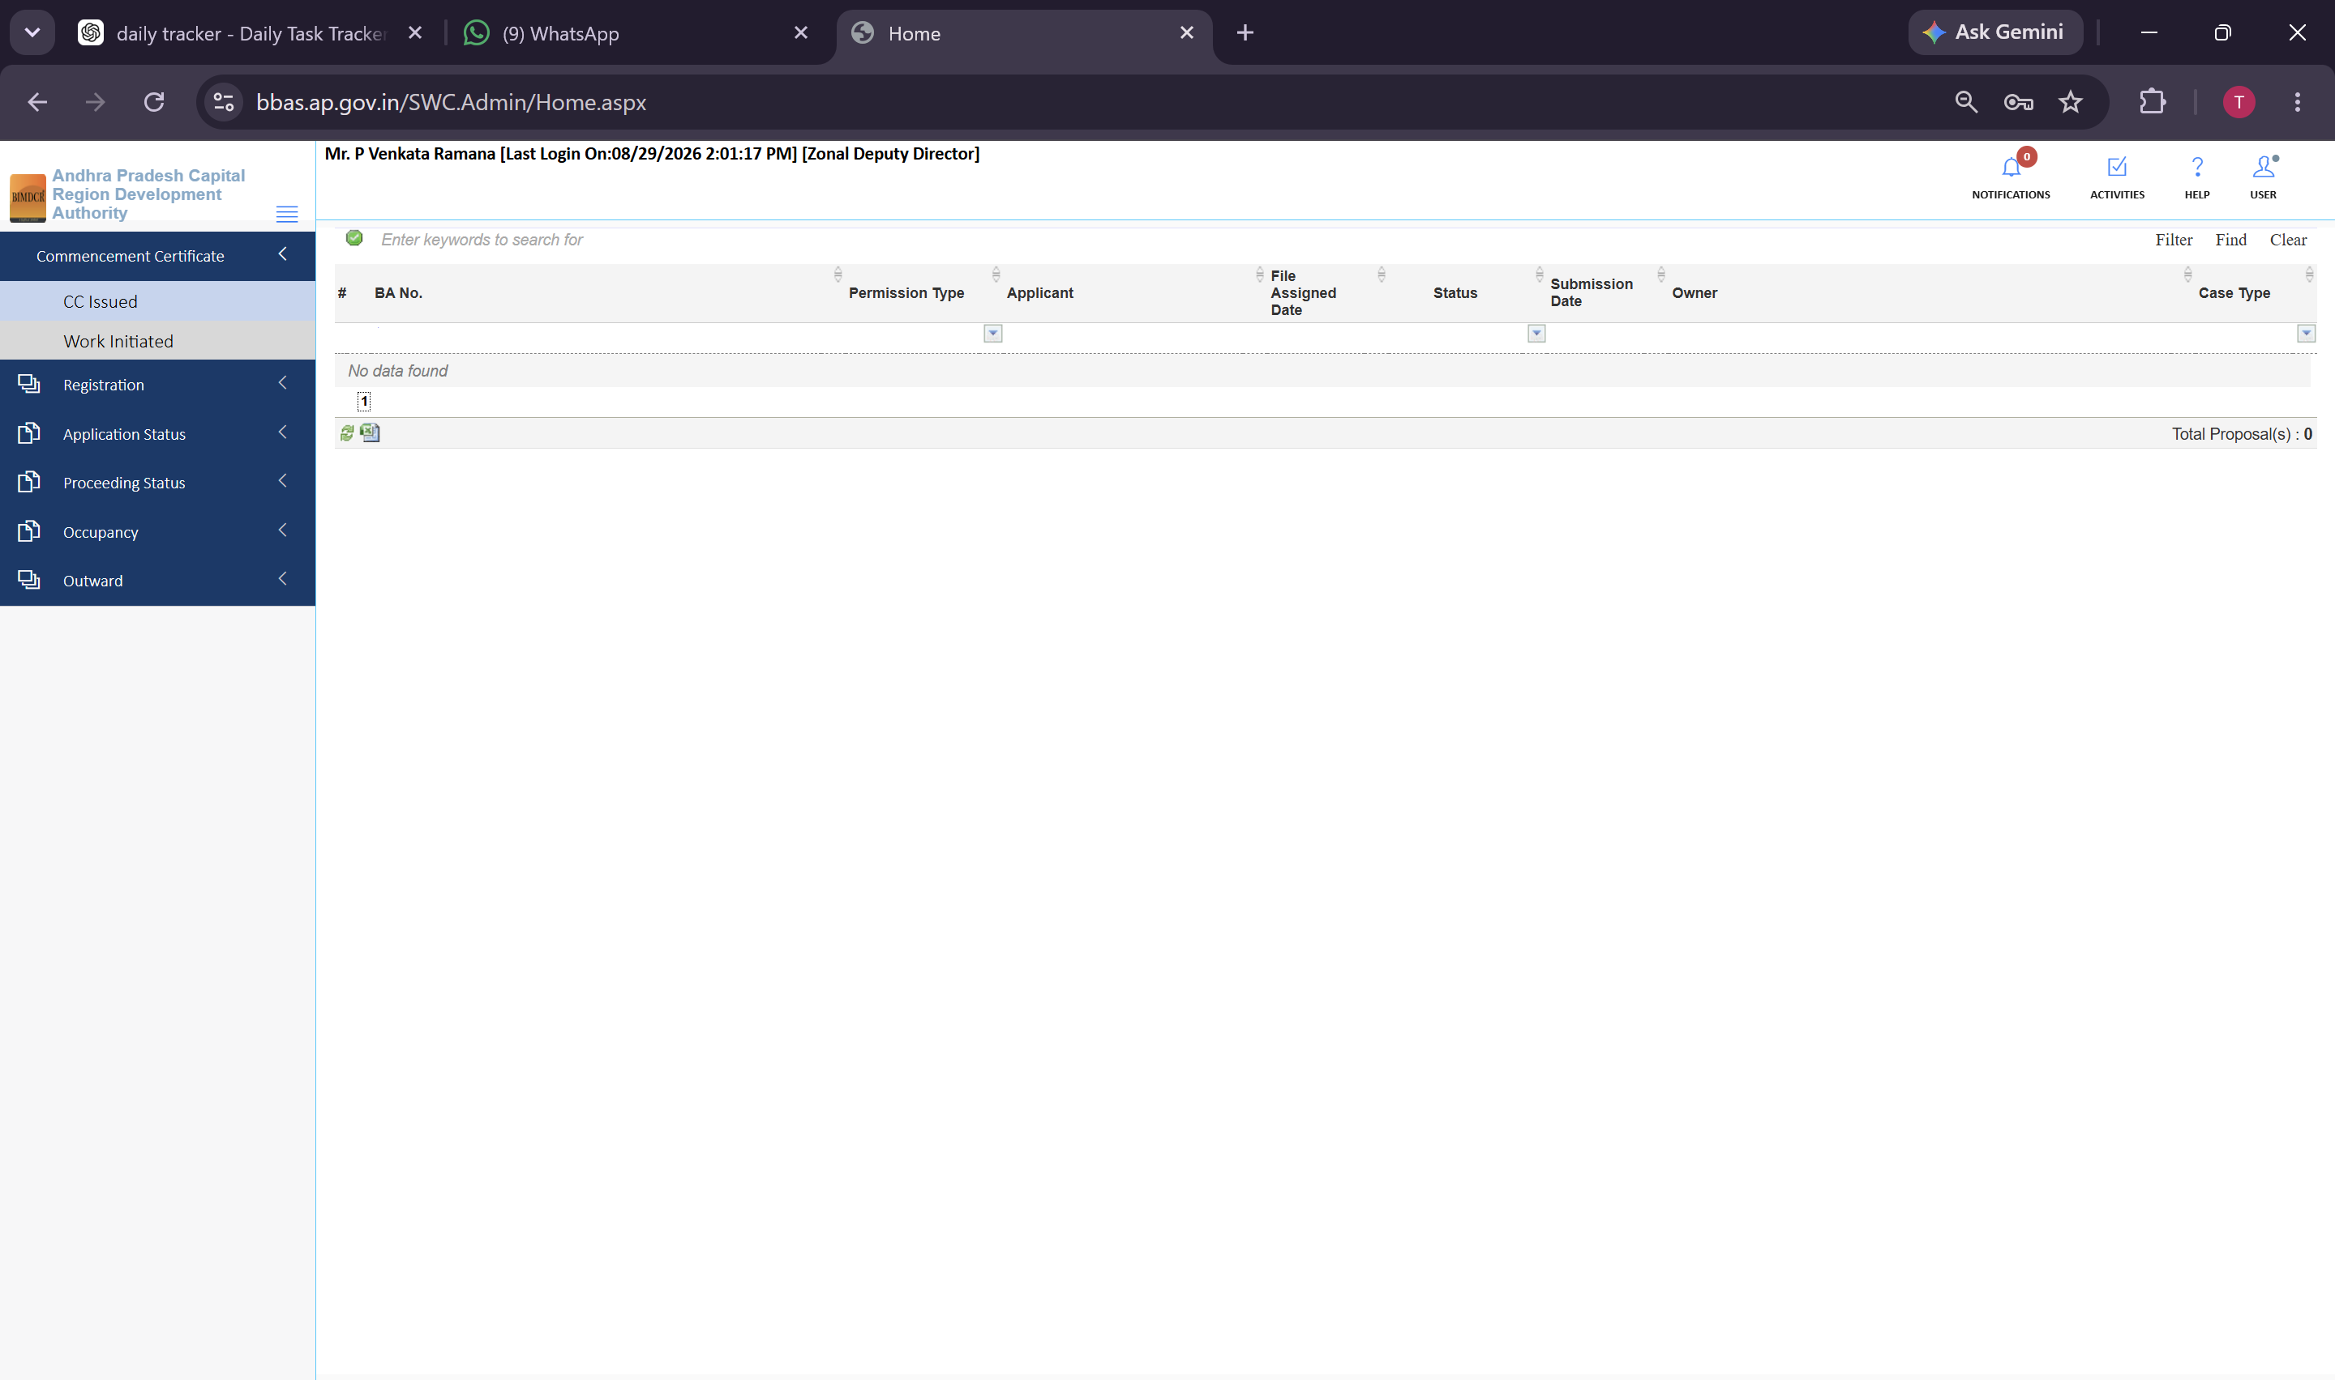
Figure 4.2 — Commencement Certificate >> Work Initiated queue displaying files pending foundation inspection

5. Module: Professional Registration Scrutiny
The Registration module allows the ZDD to review and verify technical professional registrations (Architects and Engineers):
1. Click Registration >> All In Process in the sidebar navigation.
2. The table lists incoming registrations undergoing review across zonal jurisdictions.
3. Click the Review action to open the professional's dossier, verifying PAN Number, Aadhaar Number, Postal Address, Educational Certificates, and Council of Architecture (COA) credentials.
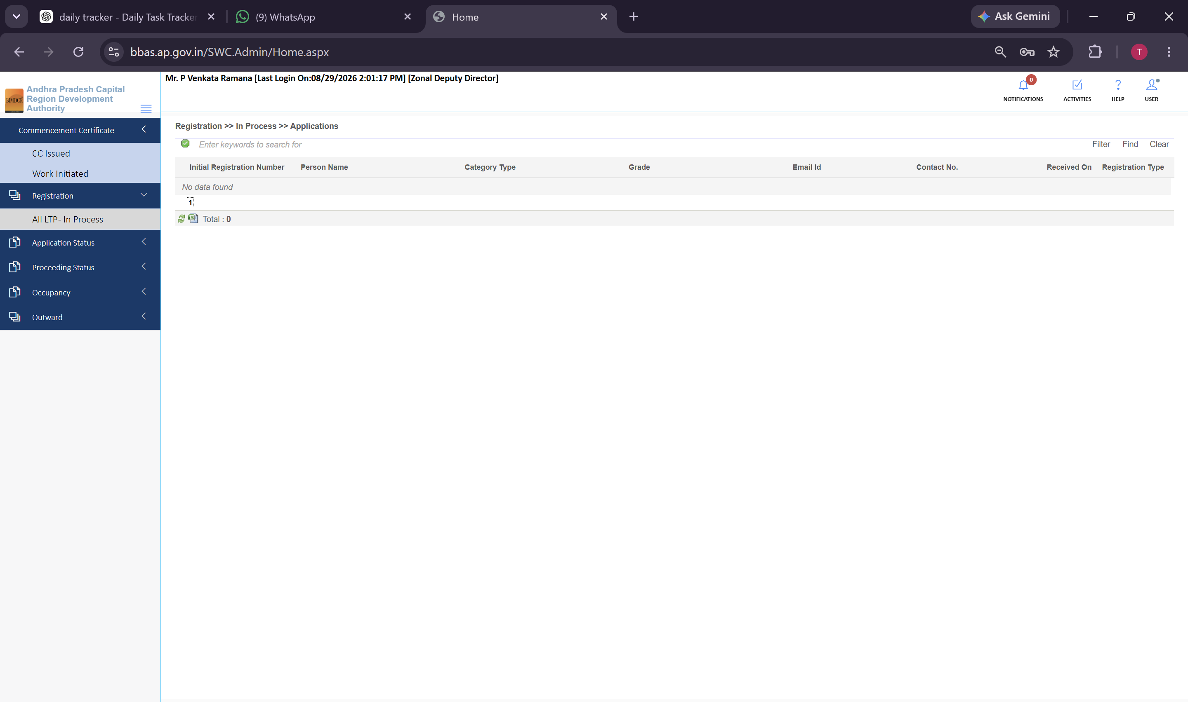
Figure 5.1 — Registration >> All In Process queue listing technical professional applications
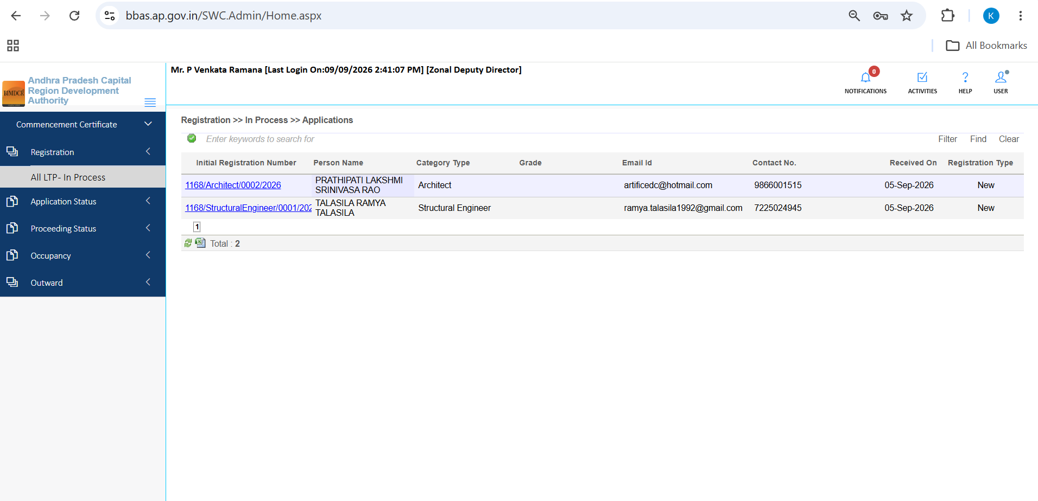
Figure 5.2 — Professional registration application list showing applicant categories and contact parameters
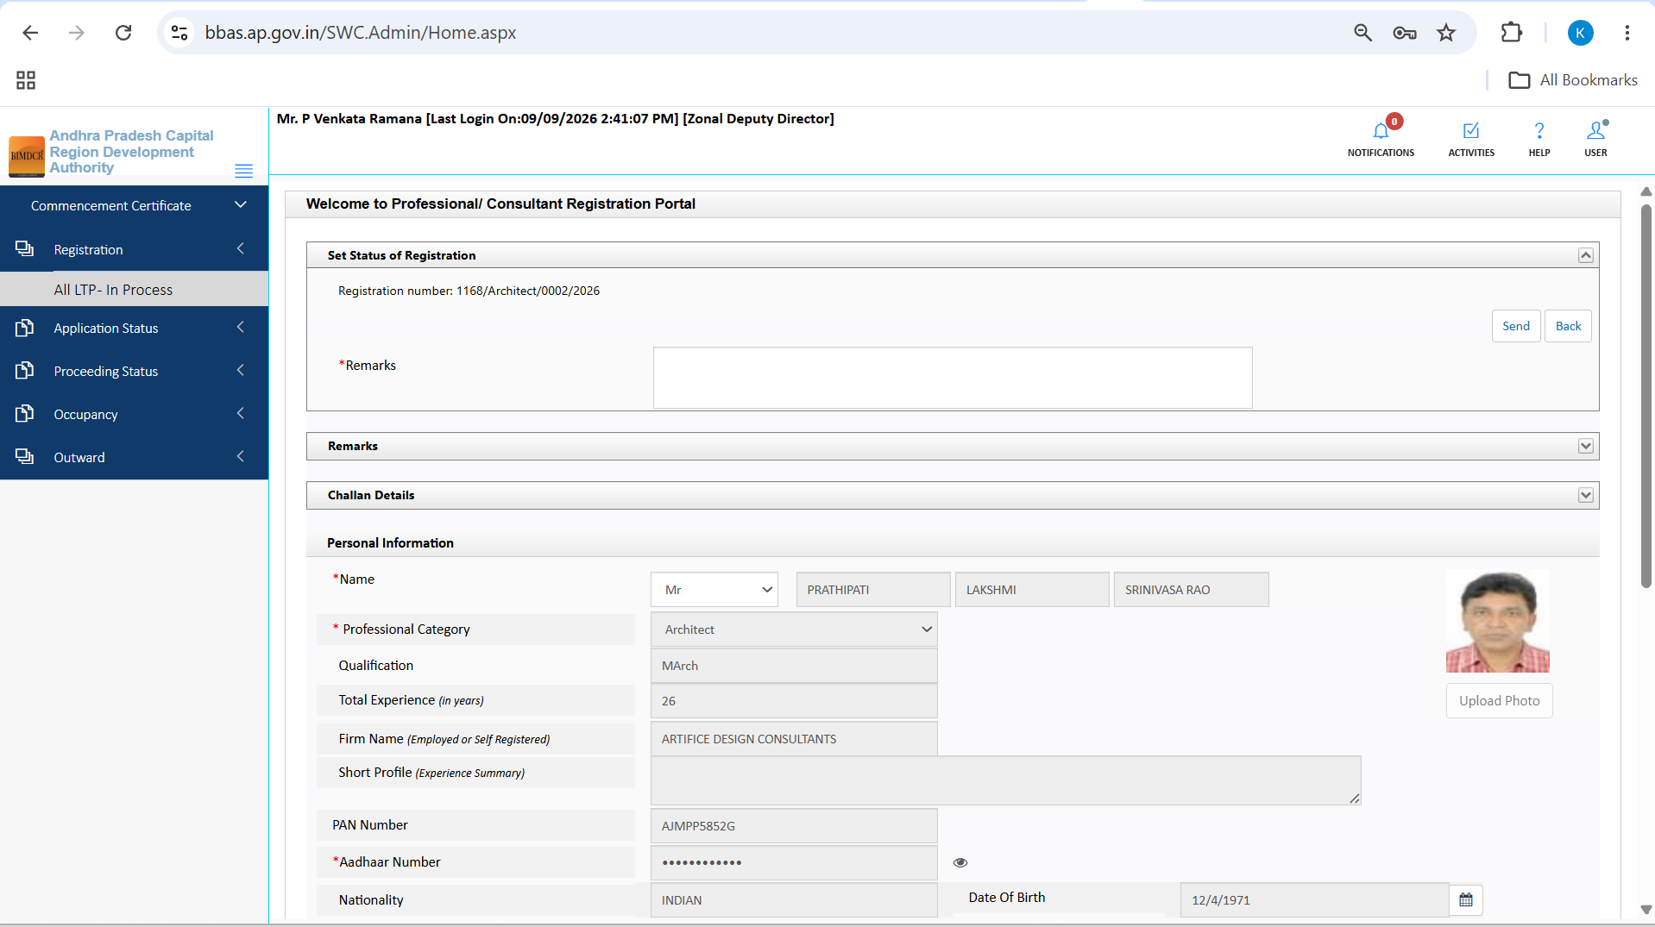
Figure 5.3 — Professional registration details view displaying identity credentials and council qualifications
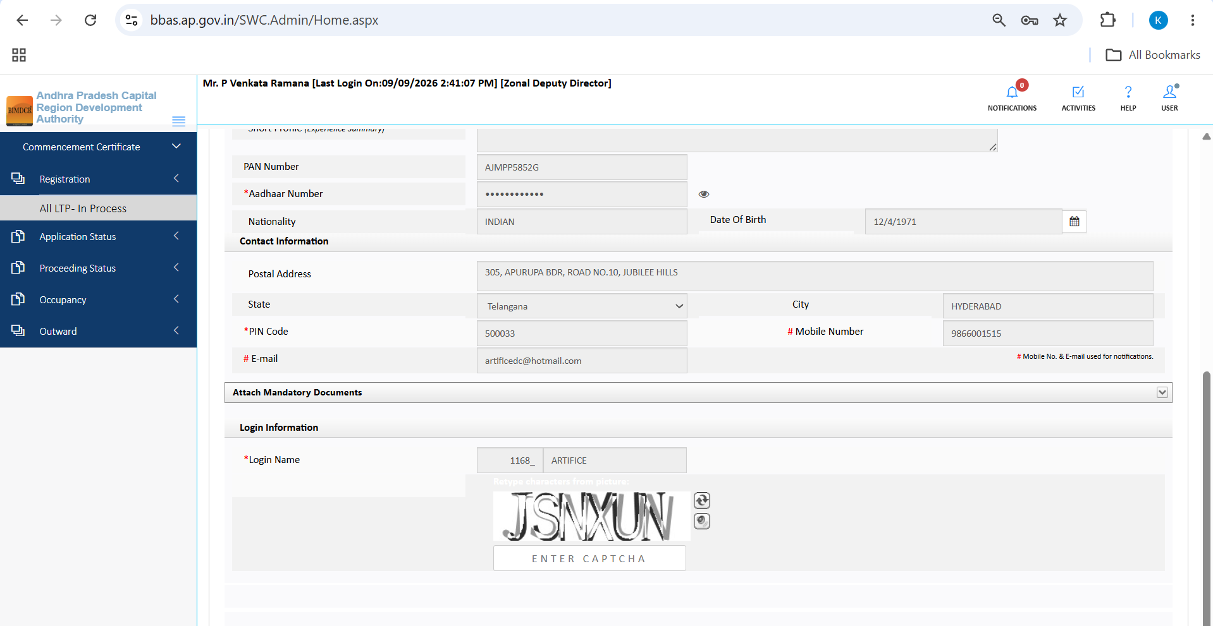
Figure 5.4 — Mandatory documents and contact information review screen for professional registration

6. Module: Application Status
The Application Status module provides oversight of core proposal files assigned to the Zonal Deputy Director:

6.1 Review Proceeding Queue
1. Click Application Status >> Review Proceeding to view all building files currently assigned to the ZDD for technical evaluation.
2. Click the Review icon to launch the full 10-tab technical scrutiny workspace.
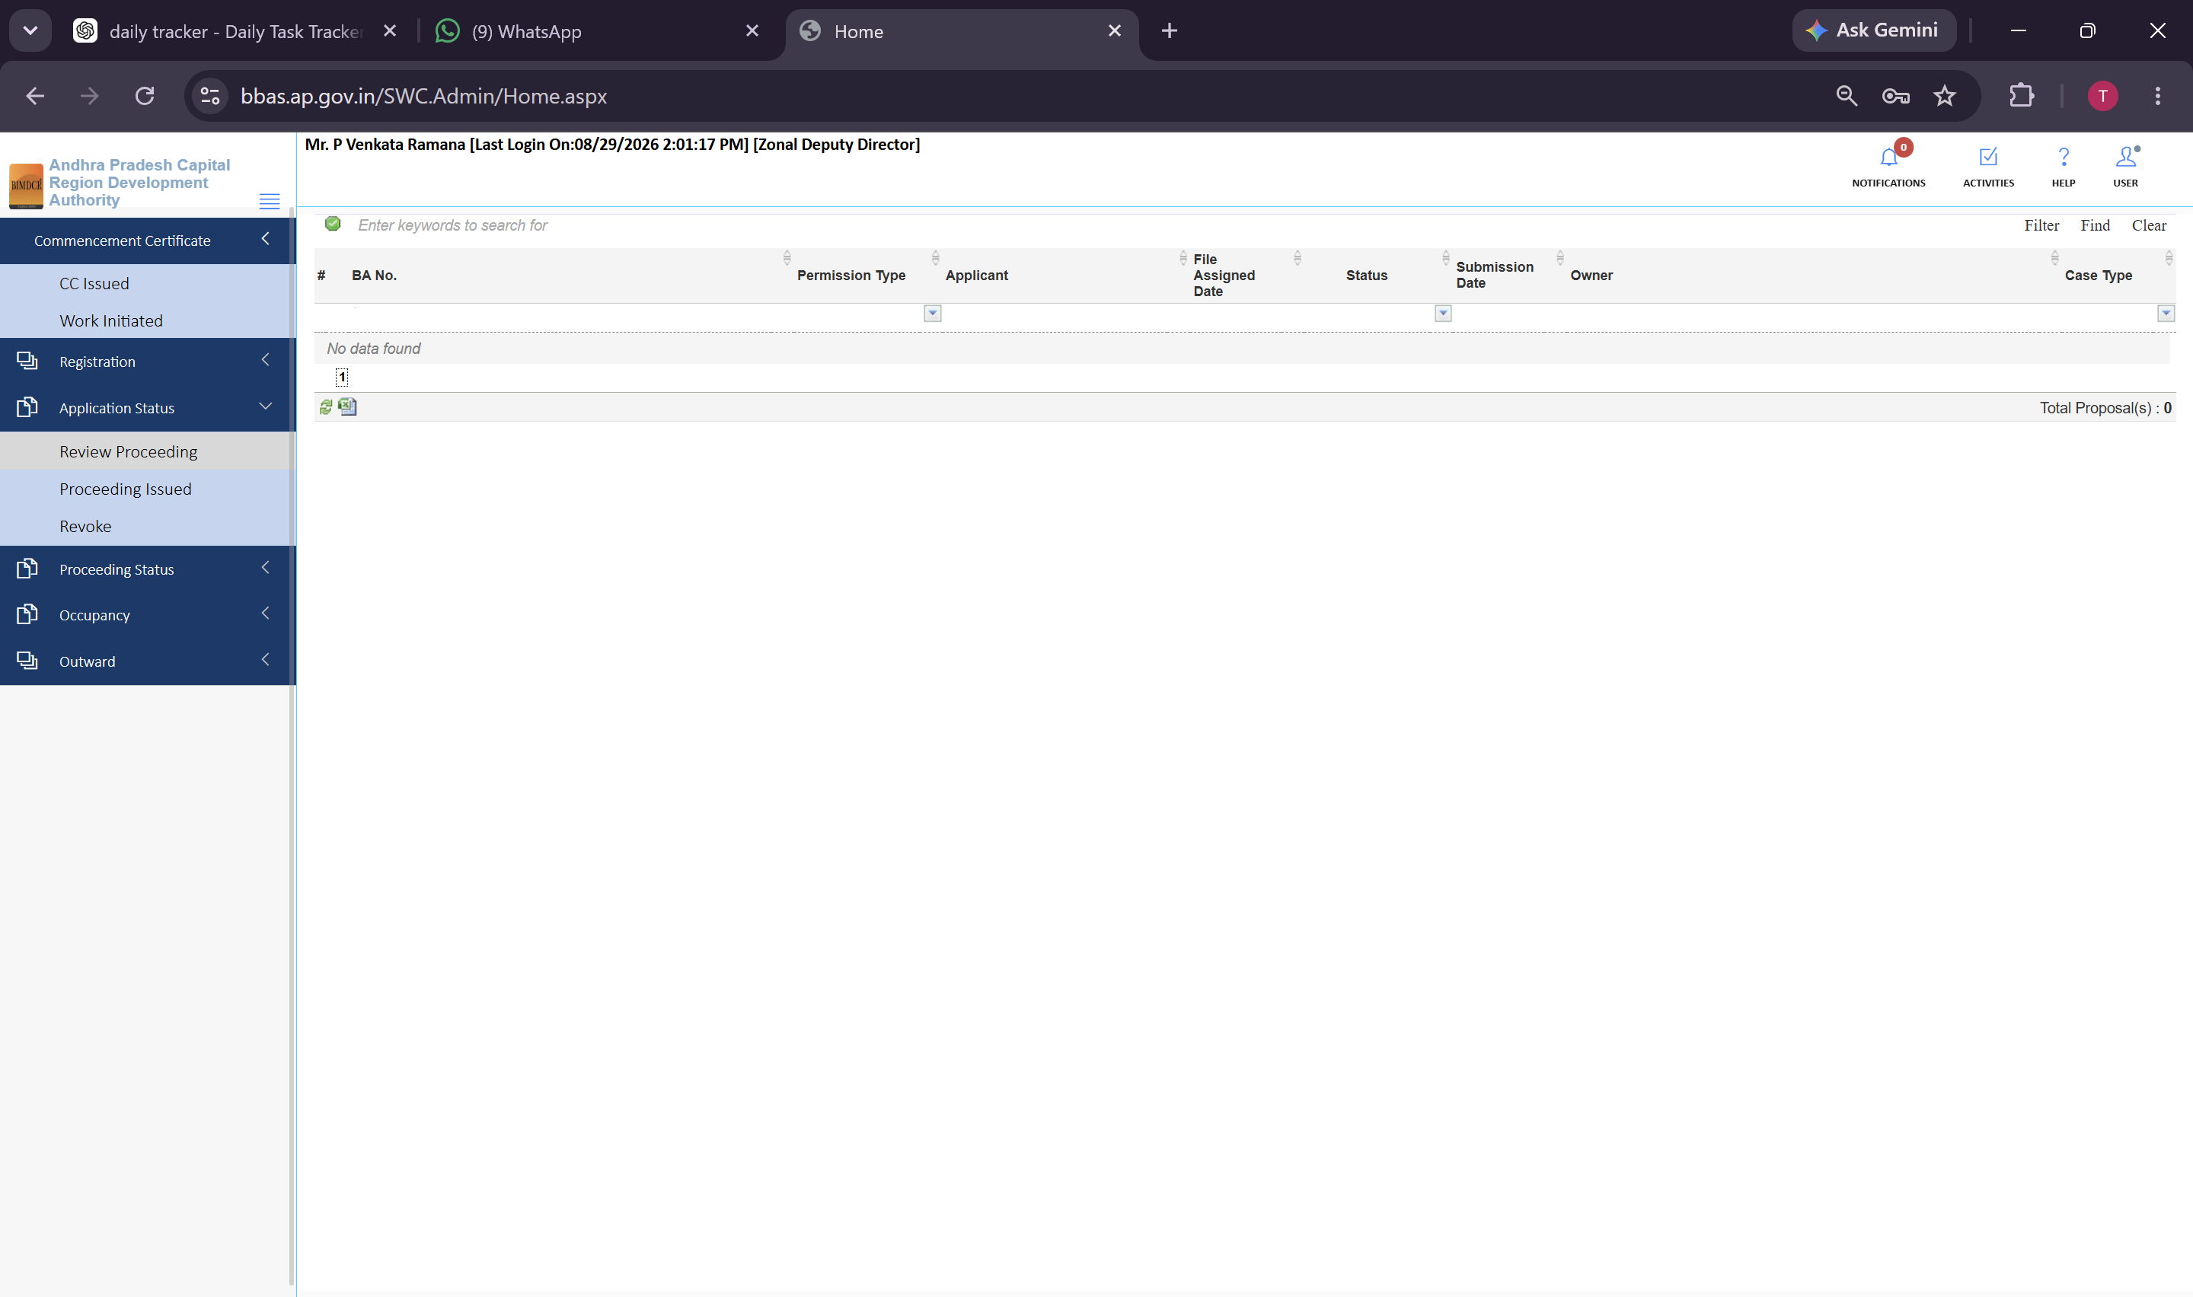
Figure 6.1 — Application Status >> Review Proceeding queue for assigned building permission files

6.2 Proceeding Issued Queue
1. Click Application Status >> Proceeding Issued to view all sanctioned building permits.
2. The ZDD can inspect approved sanction orders and download finalized Building Permit Orders.
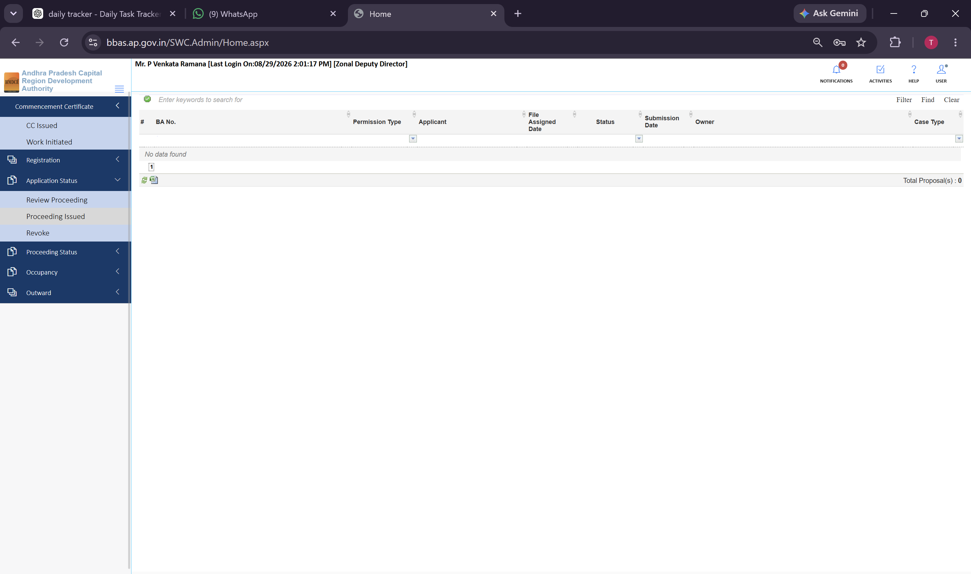
Figure 6.2 — Application Status >> Proceeding Issued queue displaying sanctioned building permits

6.3 Revoke Proceeding Queue
1. Click Application Status >> Revoke Proceeding to access the administrative revocation registry.
2. This queue tracks building permits subject to formal cancellation, stay orders, or revocation proceedings.
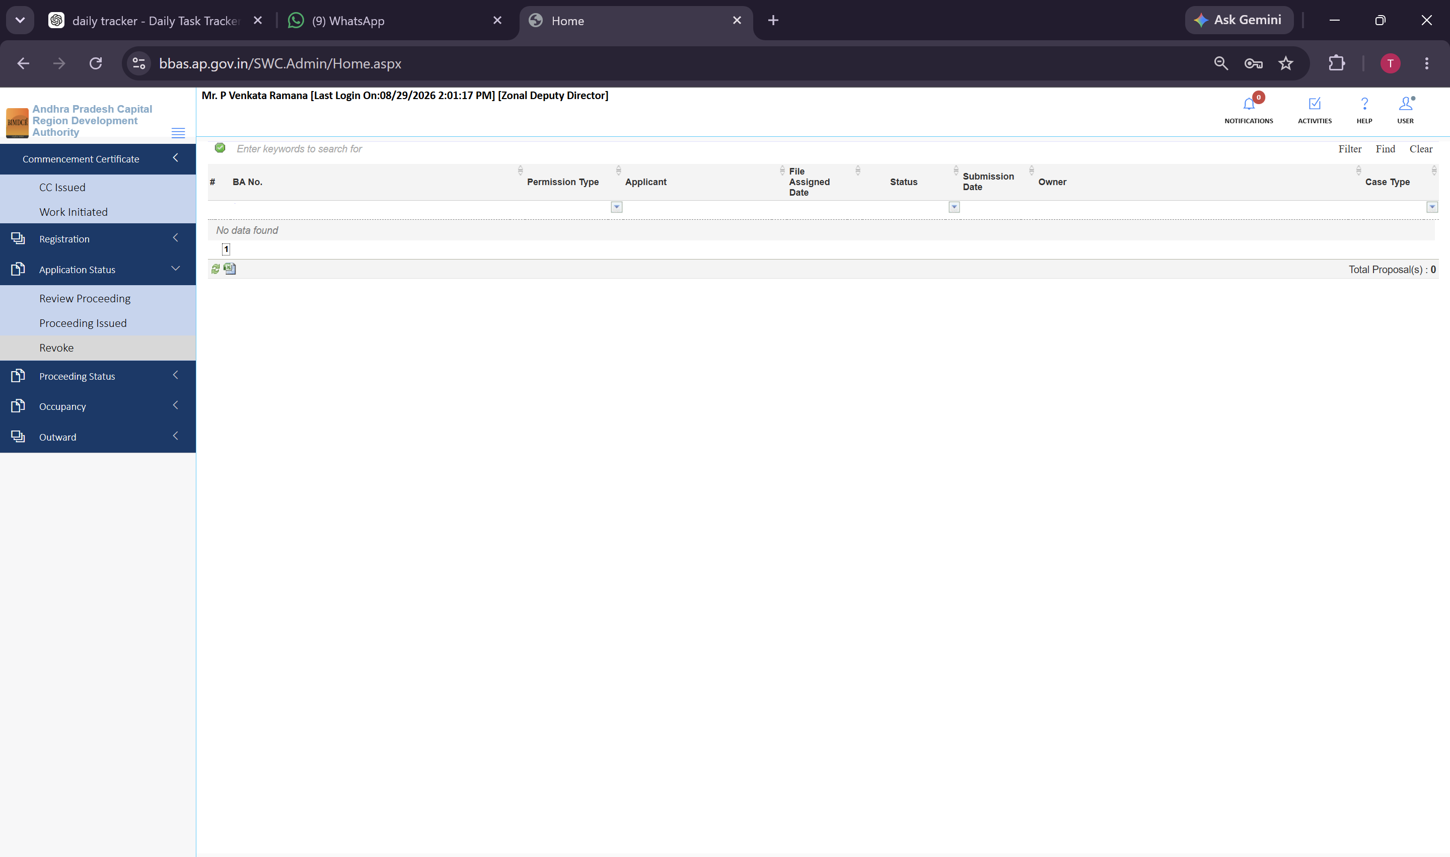
Figure 6.3 — Application Status >> Revoke Proceeding queue for tracking revoked or suspended sanctions

7. Module: Proceeding Status & Multi-Tier Technical Adjudication
The Proceeding Status module represents the primary operational workspace where the Zonal Deputy Director adjudicates files escalated from technical scrutiny staff:

7.1 Verified Queue & Final Sanction
Proposals where technical scrutiny, field inspections, and fee reconciliations have been completed by TPAs and Planning Officers appear in the Verified queue:
1. Open Proceeding Status >> Verified from the sidebar.
2. The table displays active proposals (e.g., 37 proposals on queue, such as BA No: 1168/0003/BP/10/018/2025, 1168/0139/BP/12/003/2026, and 1168/0152/BP/12/027/2026).
3. The ZDD conducts executive review of bylaw compliance and endorses the file for final Building Permit Order issuance.
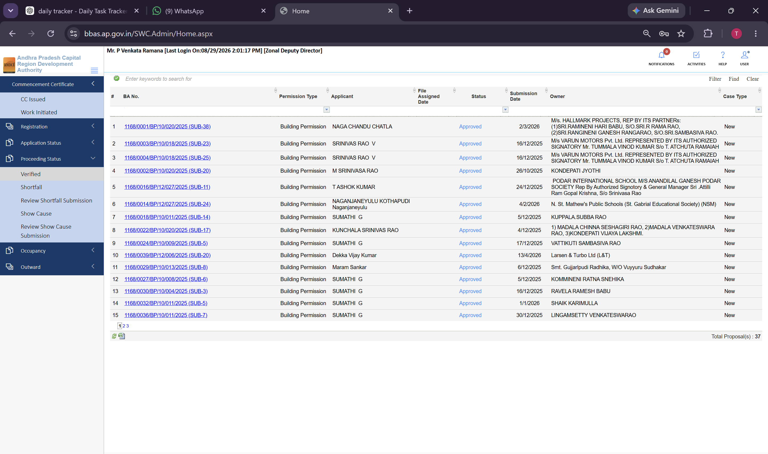
Figure 7.1 — Proceeding Status >> Verified queue showing 37 proposals verified by technical scrutiny staff
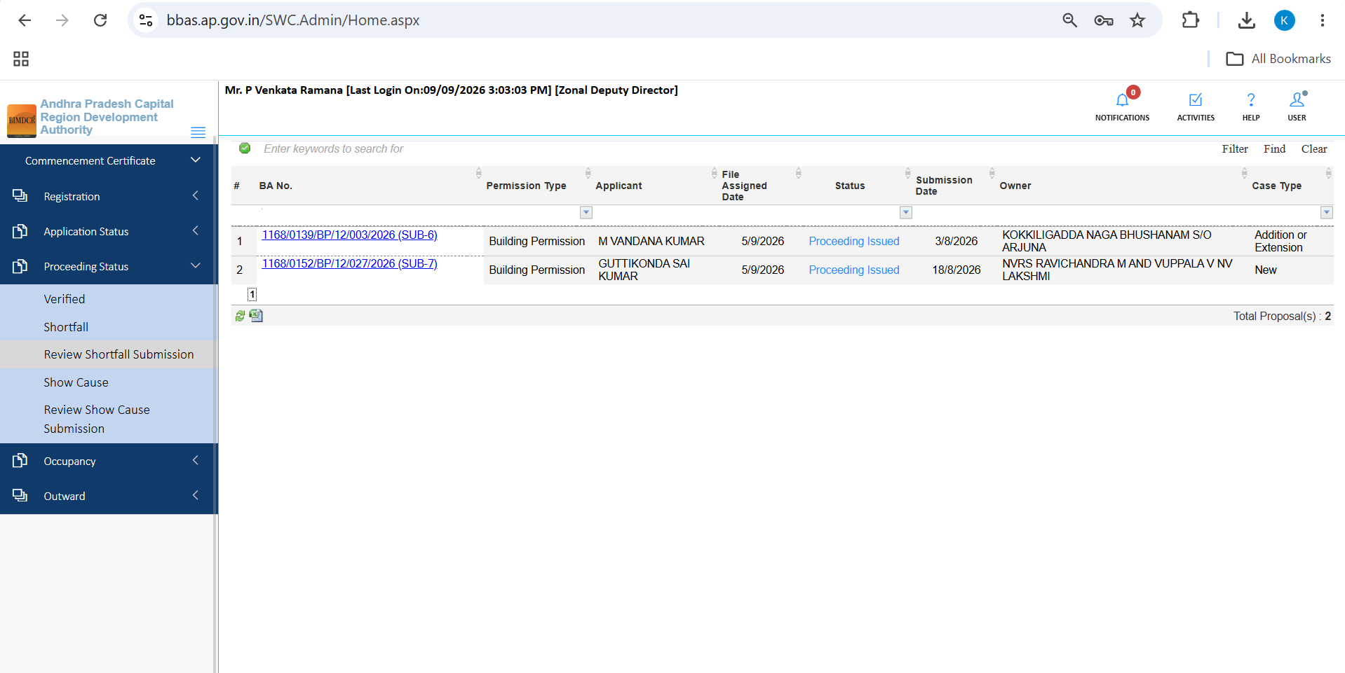
Figure 7.2 — Proceeding Status >> Verified queue detail view showing assigned files 1168/0139 and 1168/0152

7.2 Shortfall Queue & Shortfall Letter Issuance
When deficiencies are identified in title deeds, drawings, or NOCs, the ZDD routes files to Shortfall:
1. Open Proceeding Status >> Shortfall to inspect proposals returned for rectification (e.g., 4 active proposals: 1168/0026/BP/10/020/2025, 1168/0008/BP/12/003/2026, etc.).
2. Click the Shortfall Letter icon to review or dispatch the formal statutory shortfall notice.
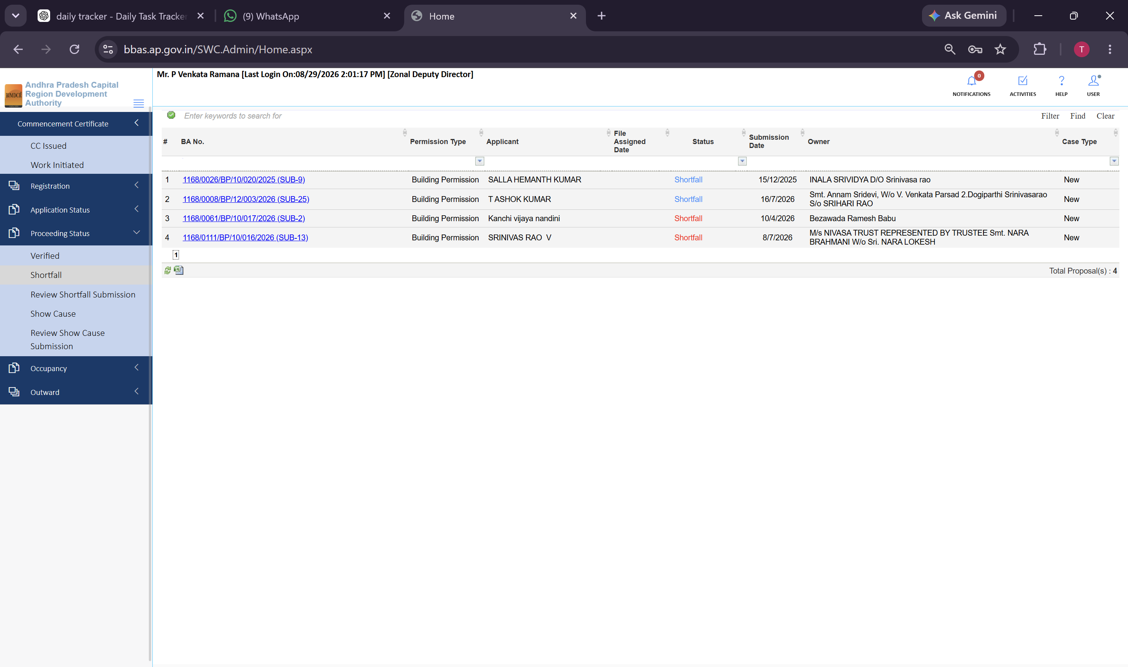
Figure 7.3 — Proceeding Status >> Shortfall queue managing 4 proposals pending applicant compliance

7.3 Review Shortfall Submission Queue
1. Open Proceeding Status >> Review Shortfall Submission to re-evaluate files resubmitted by applicants after rectifying deficiencies.
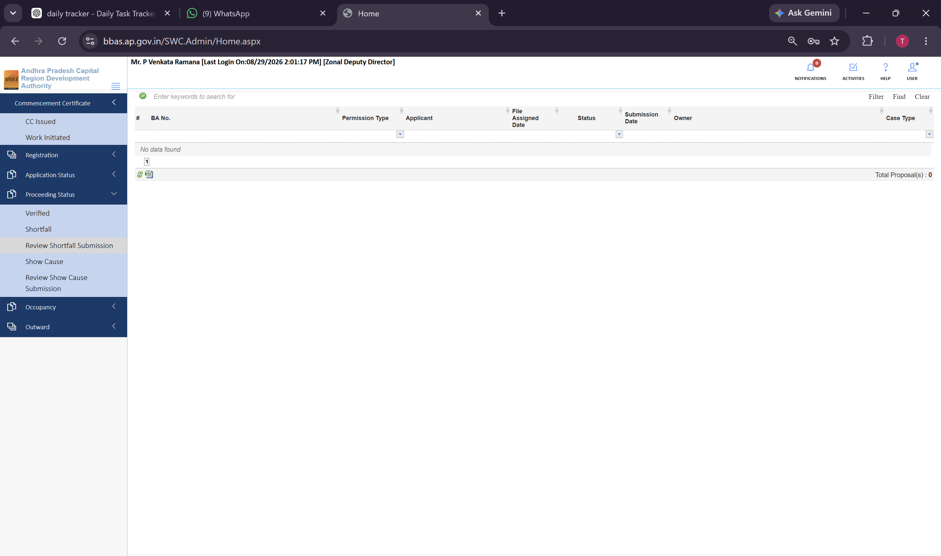
Figure 7.4 — Proceeding Status >> Review Shortfall Submission queue for adjudicating resubmitted files

7.4 Show Cause Enforcement Queue
1. Open Proceeding Status >> Show Cause to manage formal administrative enforcement notices issued for severe bylaw violations.
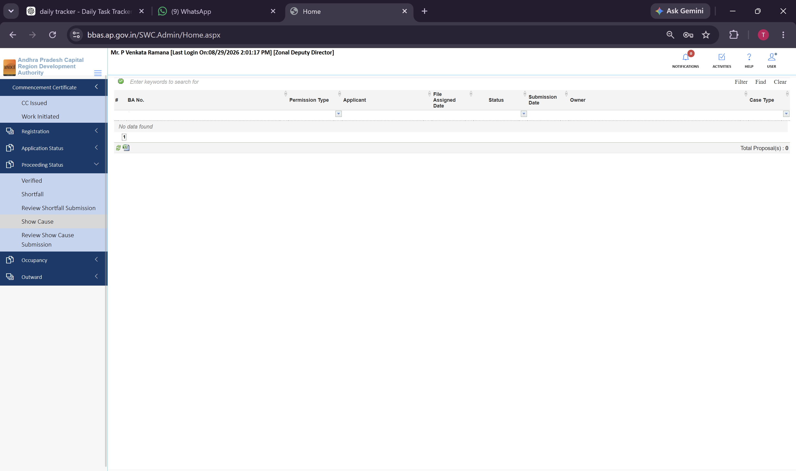
Figure 7.5 — Proceeding Status >> Show Cause queue for statutory enforcement tracking

7.5 Review Show Cause Submission Queue
1. Open Proceeding Status >> Review Show Cause Submission to scrutinize formal legal and technical explanations submitted in response to Show Cause notices.
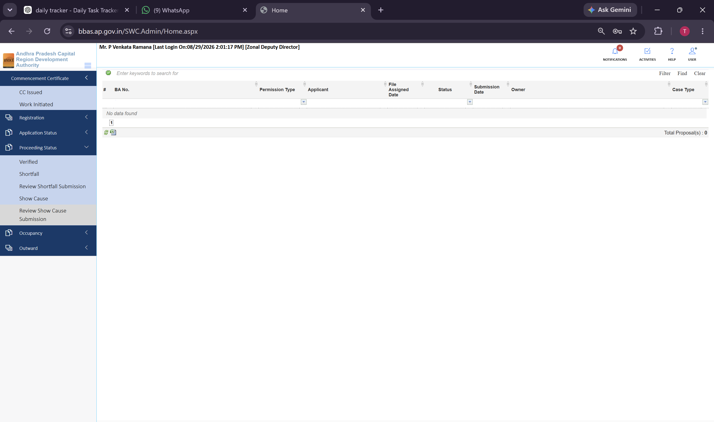
Figure 7.6 — Proceeding Status >> Review Show Cause Submission queue for legal explanation scrutiny

8. Module: Proposal Technical Scrutiny & Sanction Walkthrough
When the Zonal Deputy Director opens a proposal from the Review Proceeding or Verified queue, the multi-tab technical scrutiny form launches. Below are complete walkthroughs of live files adjudicated in the ZDD workspace:

8.1 Walkthrough of Proposal 1168/0001/BP/10/020/2025
Proposal 1168/0001/BP/10/020/2025 represents an active building permission file evaluated across all 10 tabs:
1. General Information: Verifies Case Type, Project Type, Mandal, Gram Panchayat, Sector, Plot No, and Zoning classification:
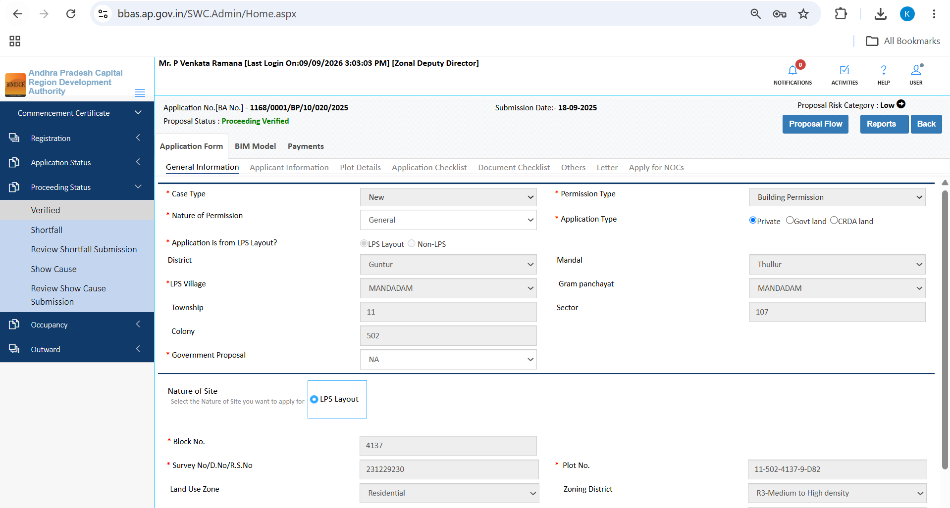
Figure 8.1 — General Information tab for proposal 1168/0001/BP/10/020/2025 displaying administrative and zoning metadata
2. Applicant Information: Verifies applicant credentials, ownership status, contact particulars, and developer details:
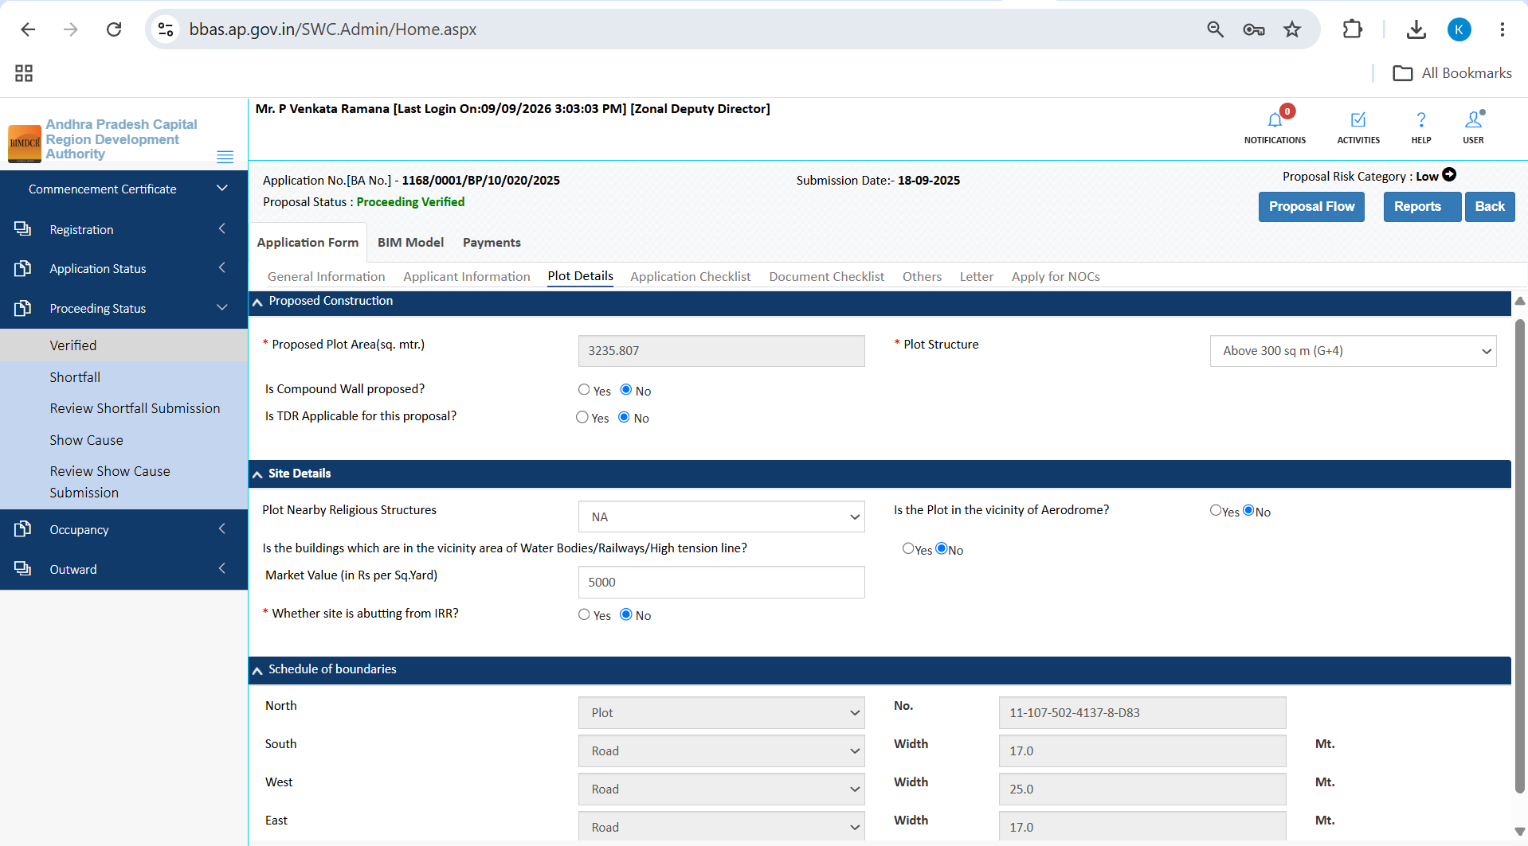
Figure 8.2 — Applicant Information tab showing applicant identity and authorized developer details
3. Plot Details: Verifies Survey Number, total area, boundary dimensions, and road widening reservations:
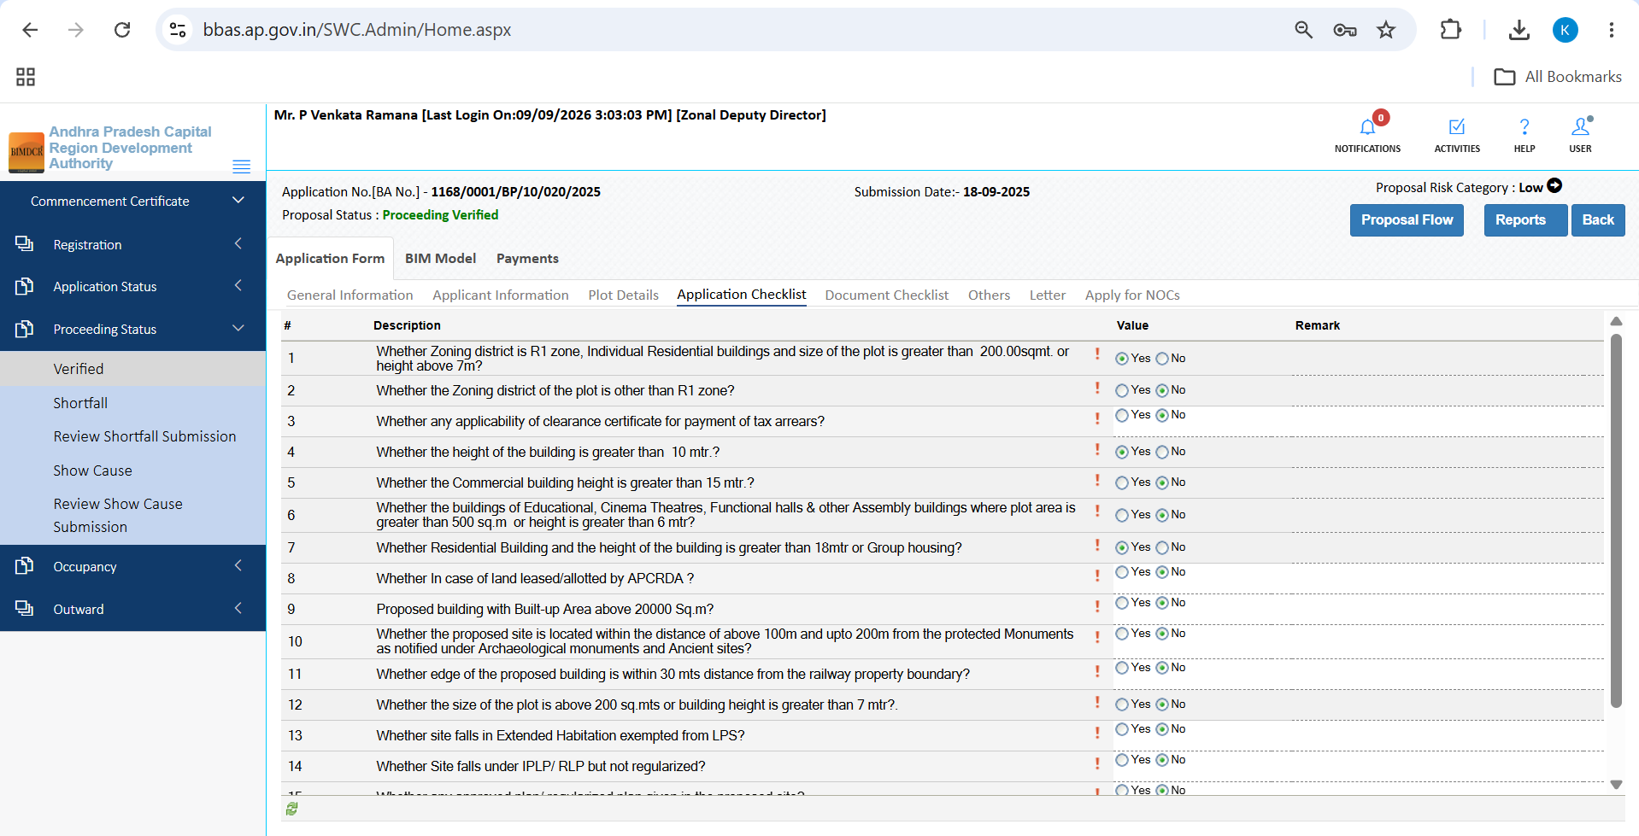
Figure 8.3 — Plot Details tab displaying spatial boundaries and road widening deductions
4. Application Checklist: Verifies statutory compliance questions 1 to 10 and 11 to 19:
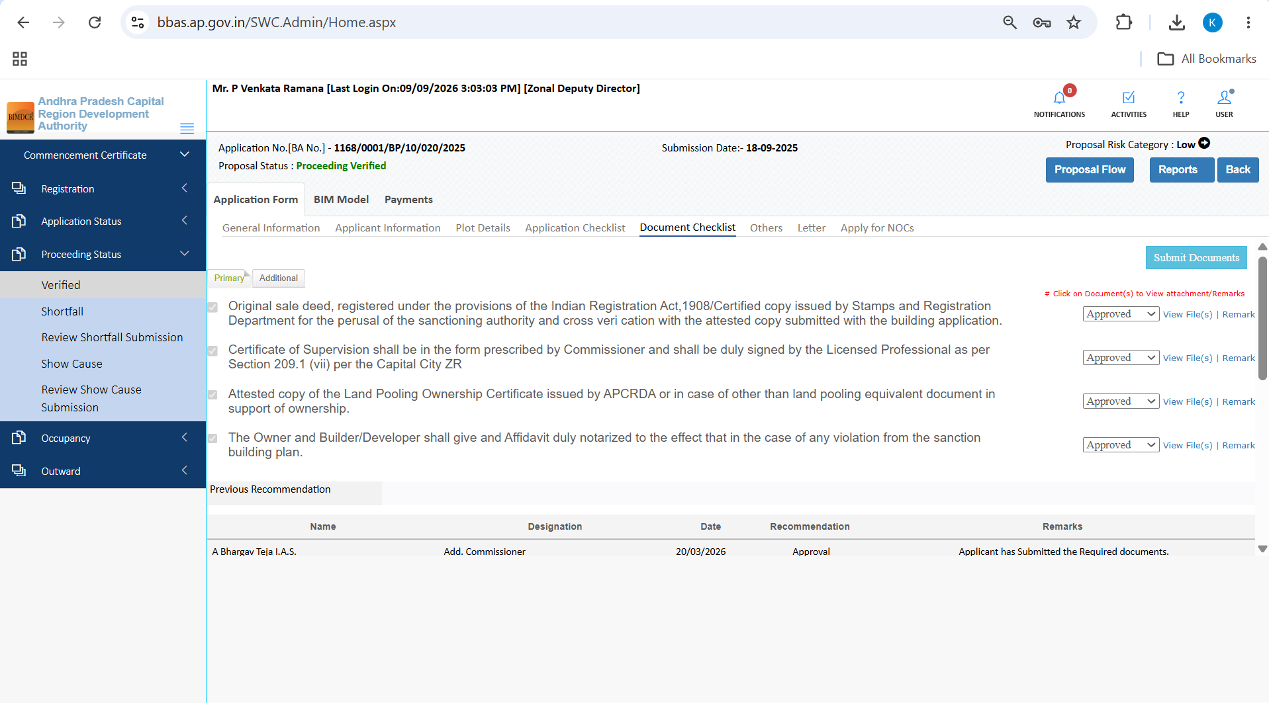
Figure 8.4 — Application Checklist Questions 1 to 10 covering title validity and zoning adherence
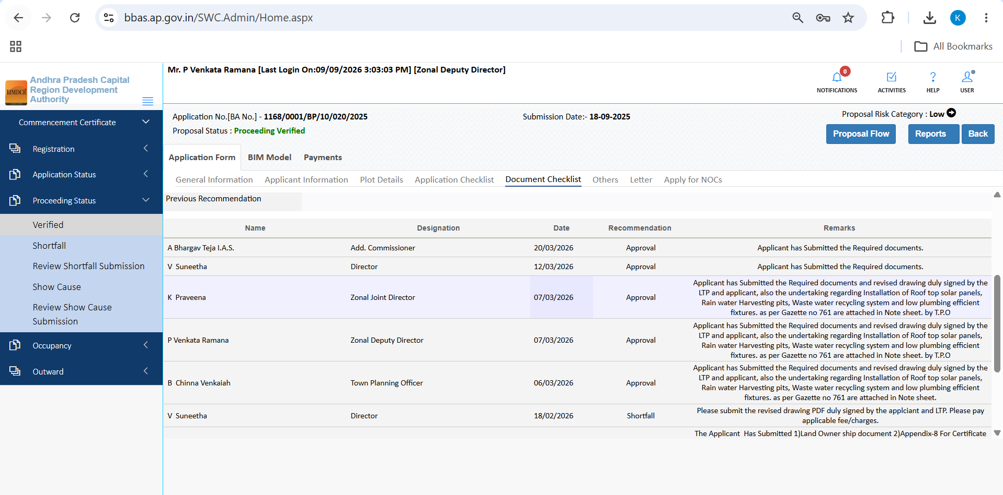
Figure 8.5 — Application Checklist Questions 11 to 19 covering setbacks, building height, and structural safety
5. Document Checklist: Verifies primary registered sale deeds, encumbrance certificates, and ownership extracts:
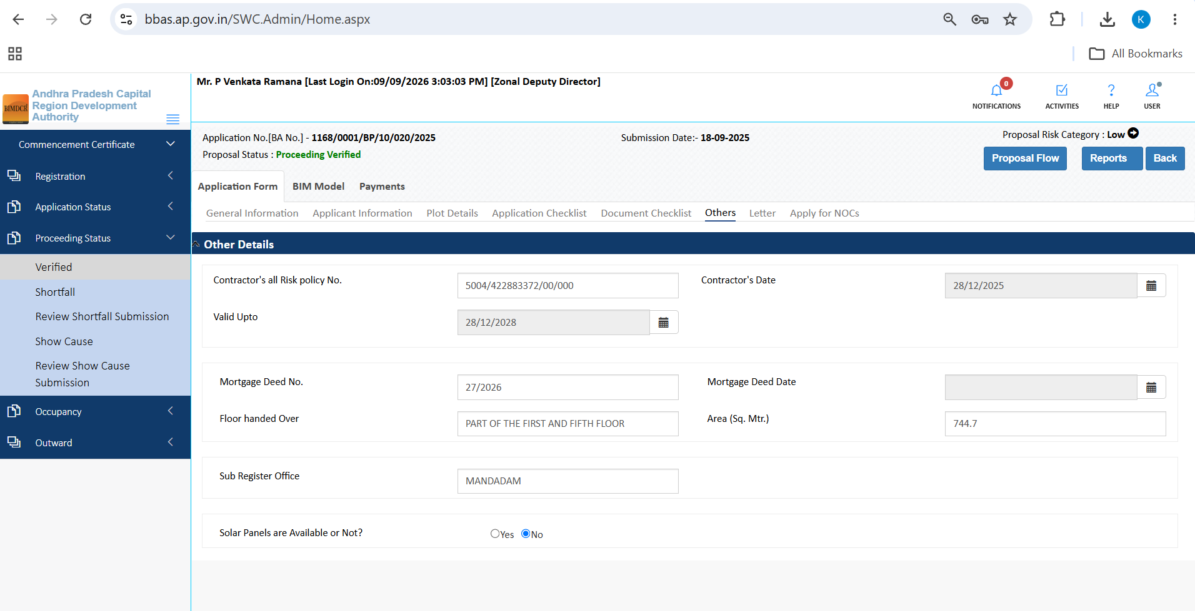
Figure 8.6 — Document Checklist tab displaying mandatory document inventory and verification status
6. Others Tab: Verifies ancillary building parameters including solar provisions, rainwater harvesting, and environmental compliance:
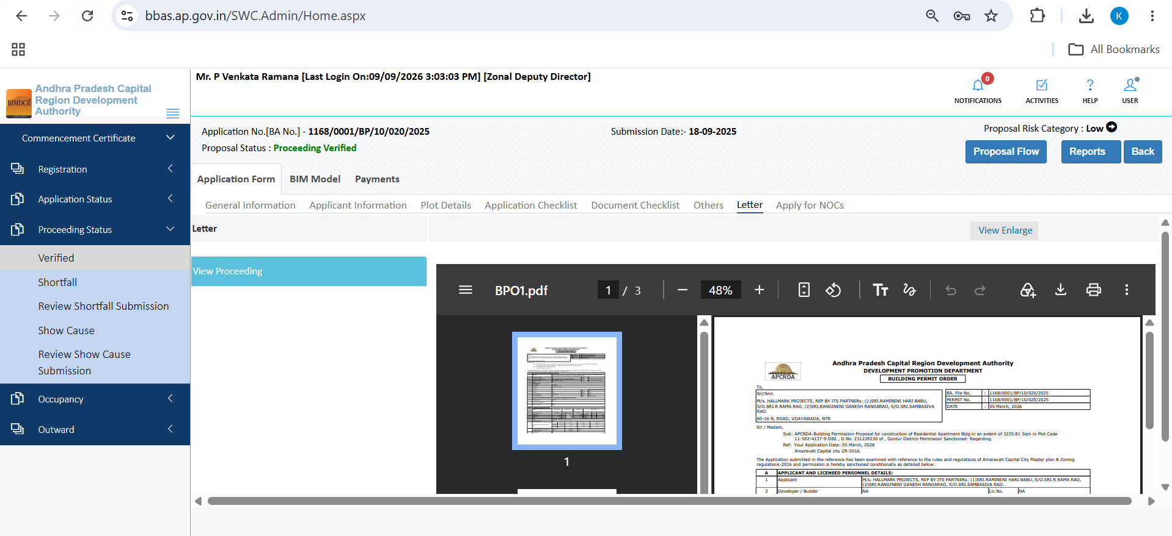
Figure 8.7 — Others tab displaying rainwater harvesting and environmental sustainability declarations
7. Site Inspection: Reviews physical on-ground findings, cardinal orientation photographs, and inspection reports compiled by field staff:
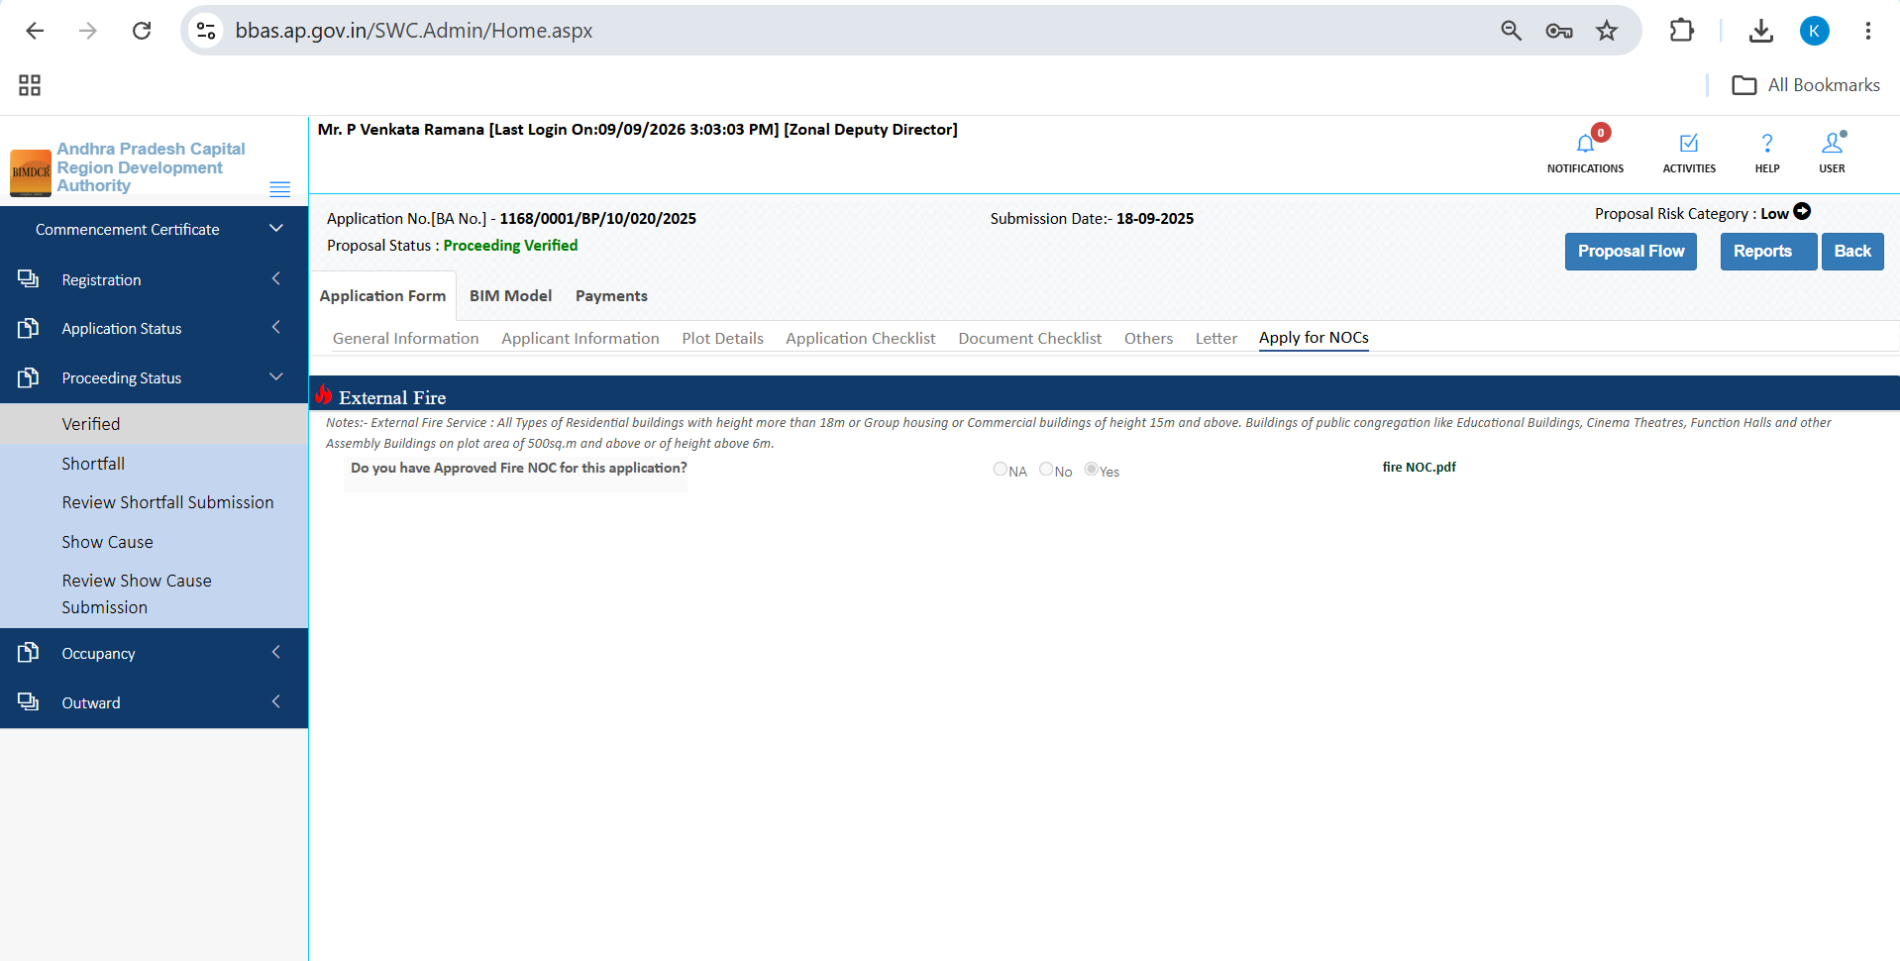
Figure 8.8 — Site Inspection review tab displaying physical field inspection report and ground observations
8. Drawing / BIM Model & Payments: Verifies interactive 3D BIM model scrutiny and verifies fee realization:
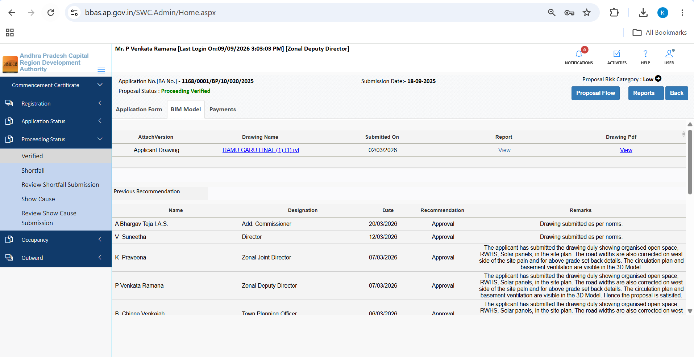
Figure 8.9 — BIM Model scrutiny tab displaying 3D building visualization and rule evaluations
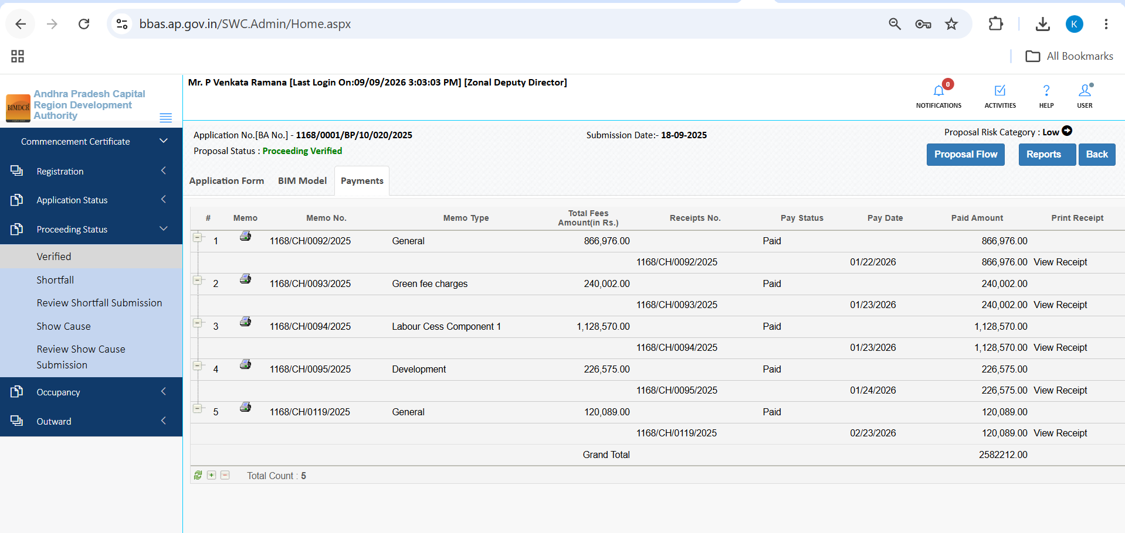
Figure 8.10 — Payments tab confirming full realization of development and betterment charges

8.2 Walkthrough of Proposal 1168/0026/BP/10/020/2025 (Directorate Review)
Proposal 1168/0026/BP/10/020/2025 illustrates an executive review featuring director-level recommendations, mortgage deeds, and physical construction inspections:
1. General Information & Applicant: Displays low-risk residential file parameters:
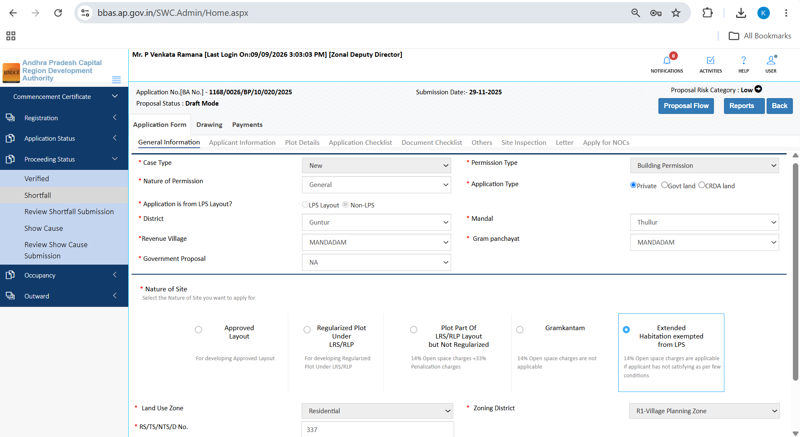
Figure 8.11 — General Information for proposal 1168/0026/BP/10/020/2025
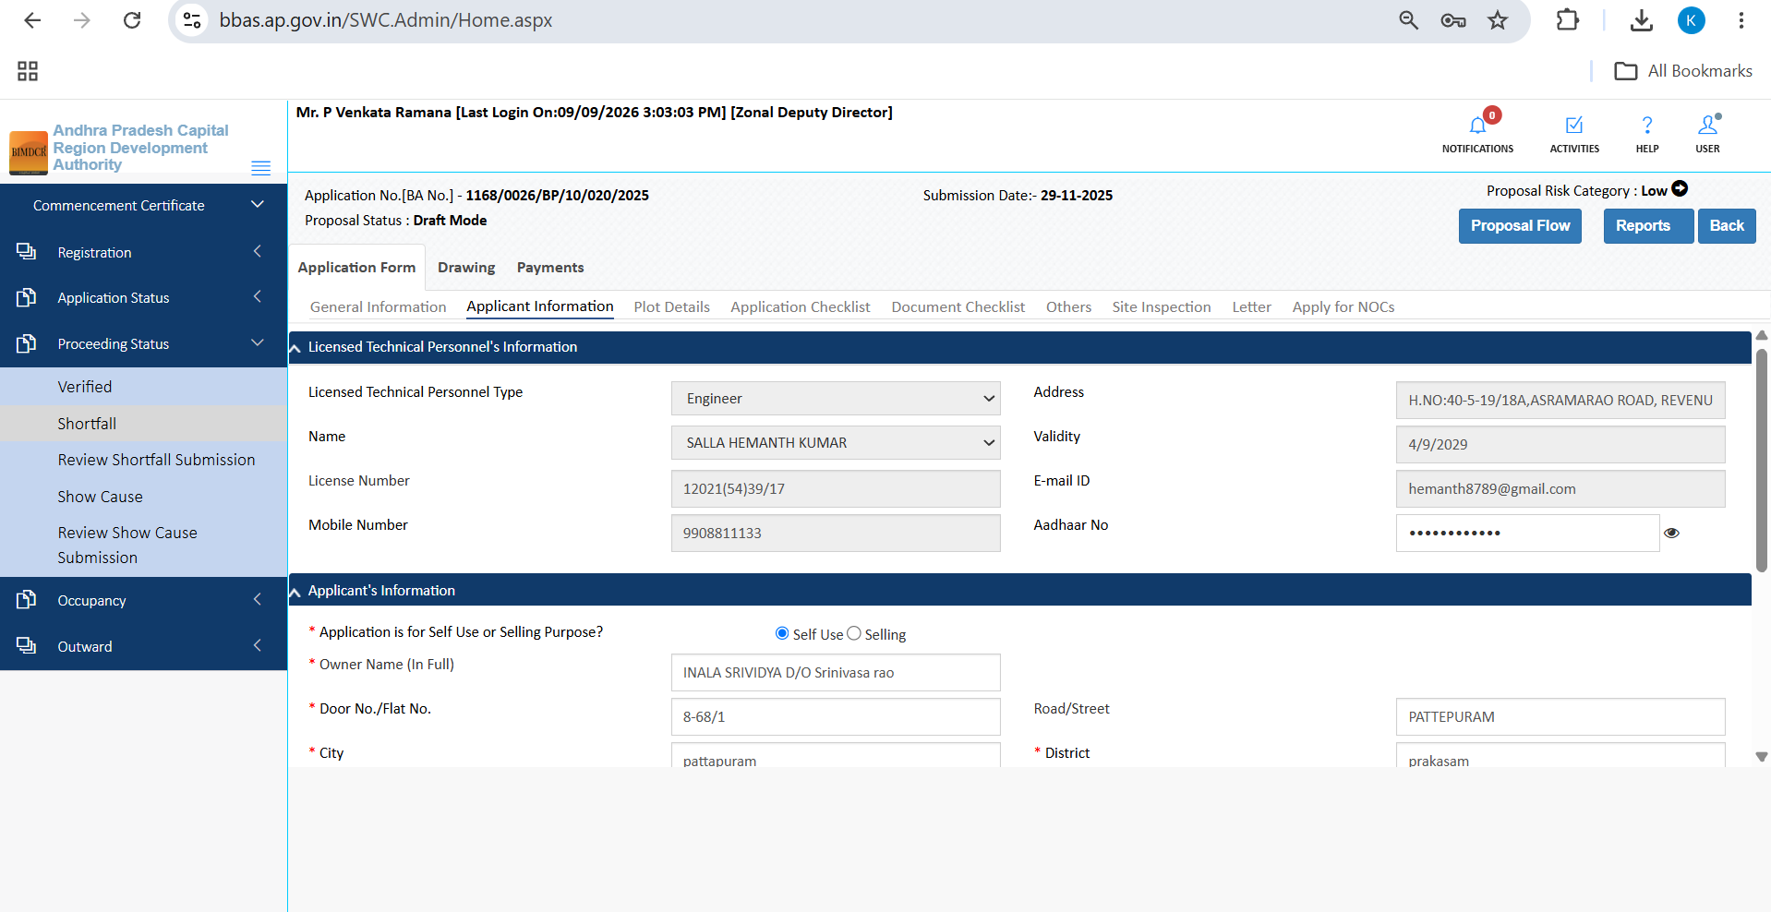
Figure 8.12 — Applicant Information tab for proposal 1168/0026/BP/10/020/2025
2. Plot Details & Checklist: Verifies plot boundary dimensions and statutory checklist responses:
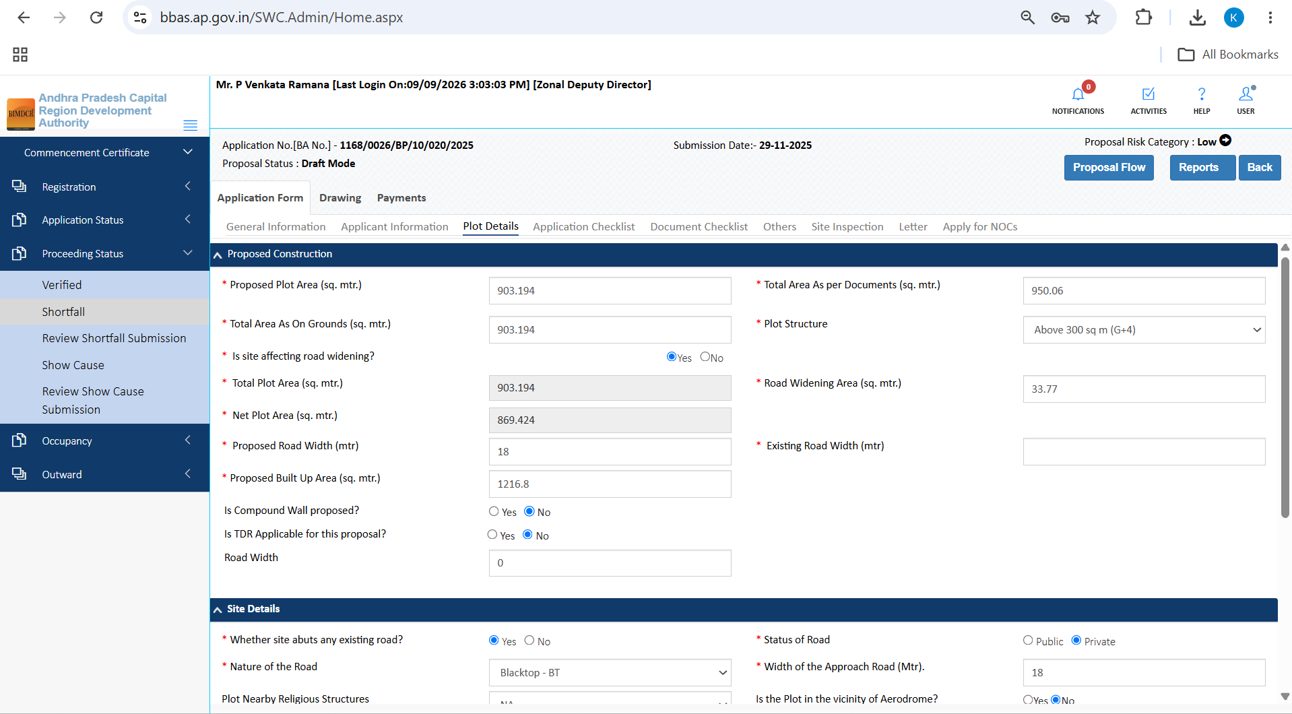
Figure 8.13 — Plot Details tab displaying ground area and boundary dimensions
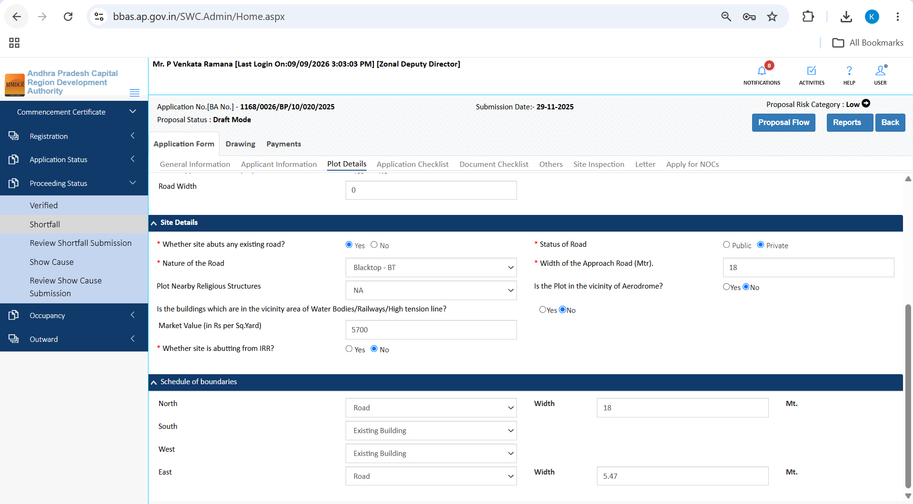
Figure 8.14 — Application Checklist Questions 1 to 10 for proposal 1168/0026
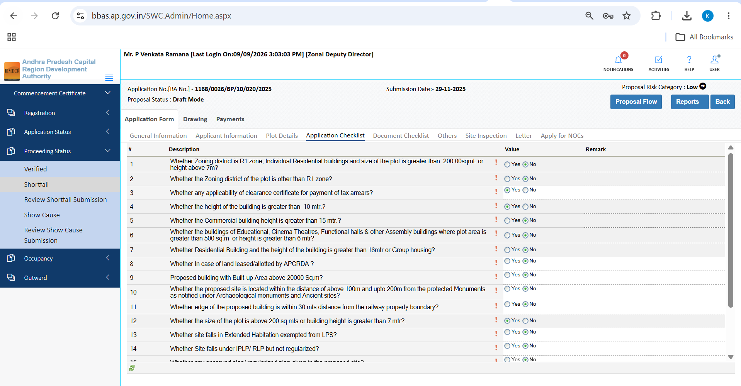
Figure 8.15 — Application Checklist Questions 11 to 19 for proposal 1168/0026
3. Document Checklist with Directorate Recommendation: Displays previous review notes recorded by Planning Director (V Suneetha) detailing mandatory shortfall compliances:
- Item 1: Rectified Ownership Document and Latest Property Tax receipt.
- Item 2: NOC regarding exemption of site from land pooling scheme.
- Item 3: Road Widening Undertaking and Shortfall Annexure-3 / Appendix-S.
- Item 4: Structural designs, drawings, and registered Mortgage Deed.
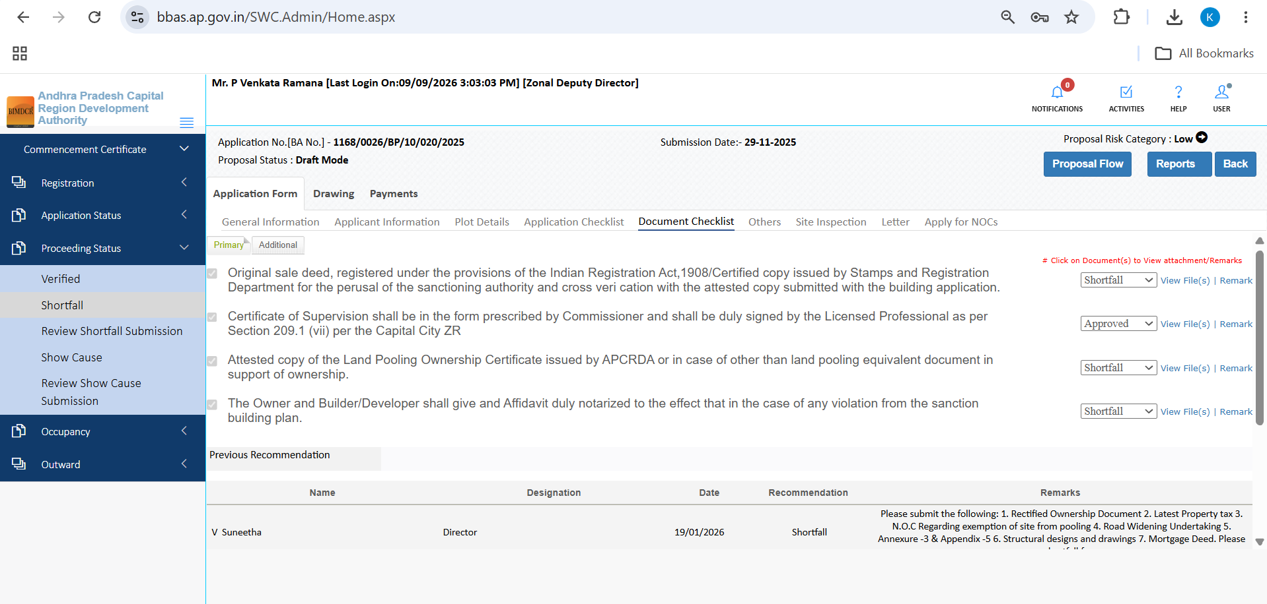
Figure 8.16 — Document Checklist showing Previous Recommendation by Director (V Suneetha) detailing 7 shortfall items
4. Others Tab (Mortgage Deed & Insurance): Verifies Contractor's All Risk (CAR) Policy No, policy validity date, registered Mortgage Deed No (e.g., 62070144250300000082, valid to 14/12/2028), mortgaged floor area, and sub-registrar office registration:
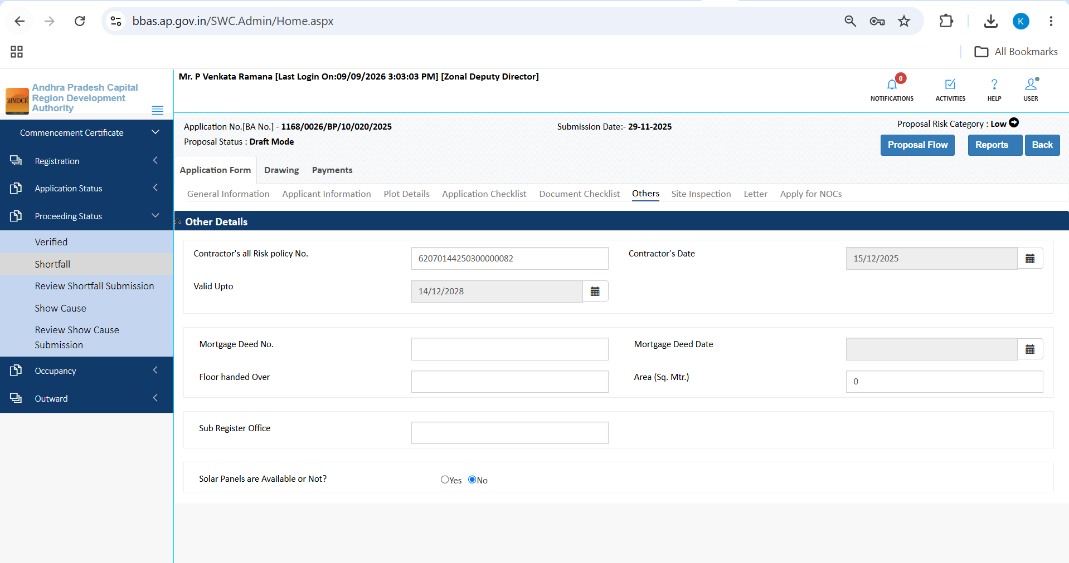
Figure 8.17 — Others tab displaying registered Mortgage Deed particulars and Contractor All Risk policy validity
5. Site Inspection Review: Physical ground inspection reveals actual construction status: 'Work Commenced / Not Commenced: Commenced', 'Status of construction at time of inspection: Slabs laid', 'Total area as on ground: 903.19 sq.m', and confirms compound wall and existing building boundaries:
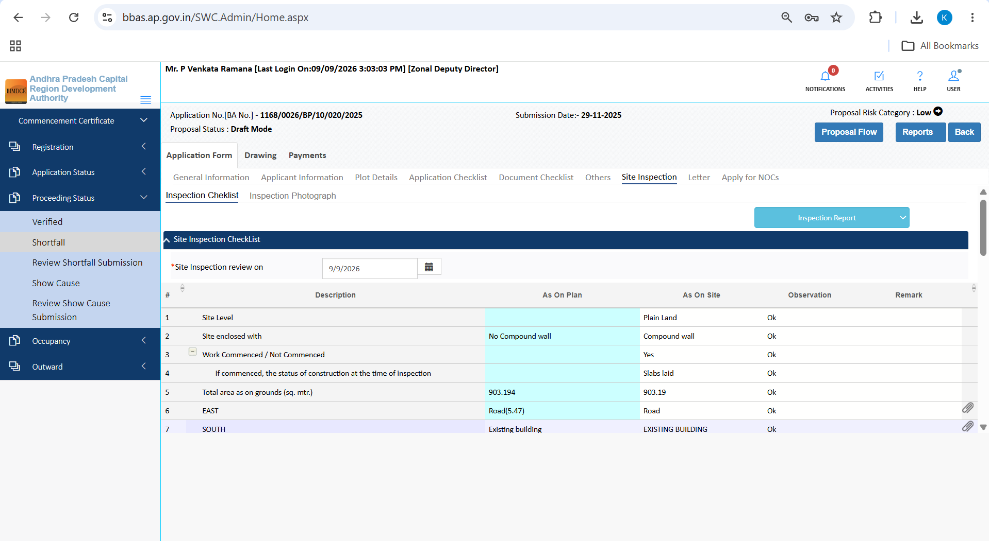
Figure 8.18 — Site Inspection Review tab detailing physical on-ground construction progress (slabs laid) and boundary dimensions
6. Draft Sanction Letter (BPO1.pdf) & Fire NOC: Previews official Building Permit Order and verifies Fire Services clearance exemption:
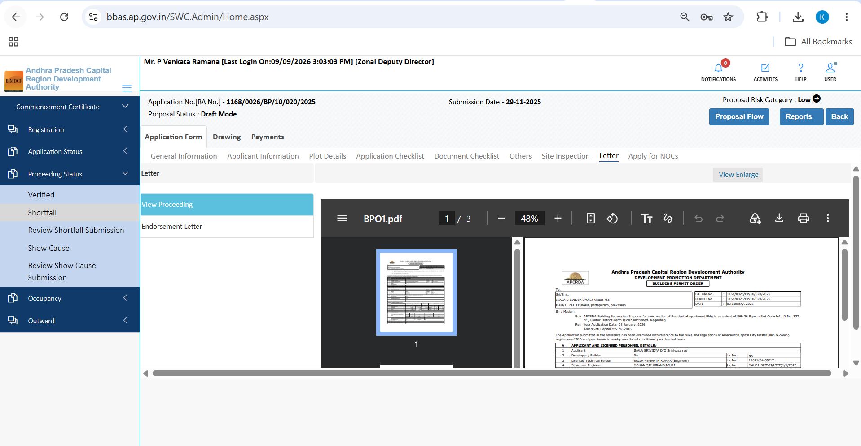
Figure 8.19 — Letter tab displaying official Building Permit Order PDF preview (BPO1.pdf)
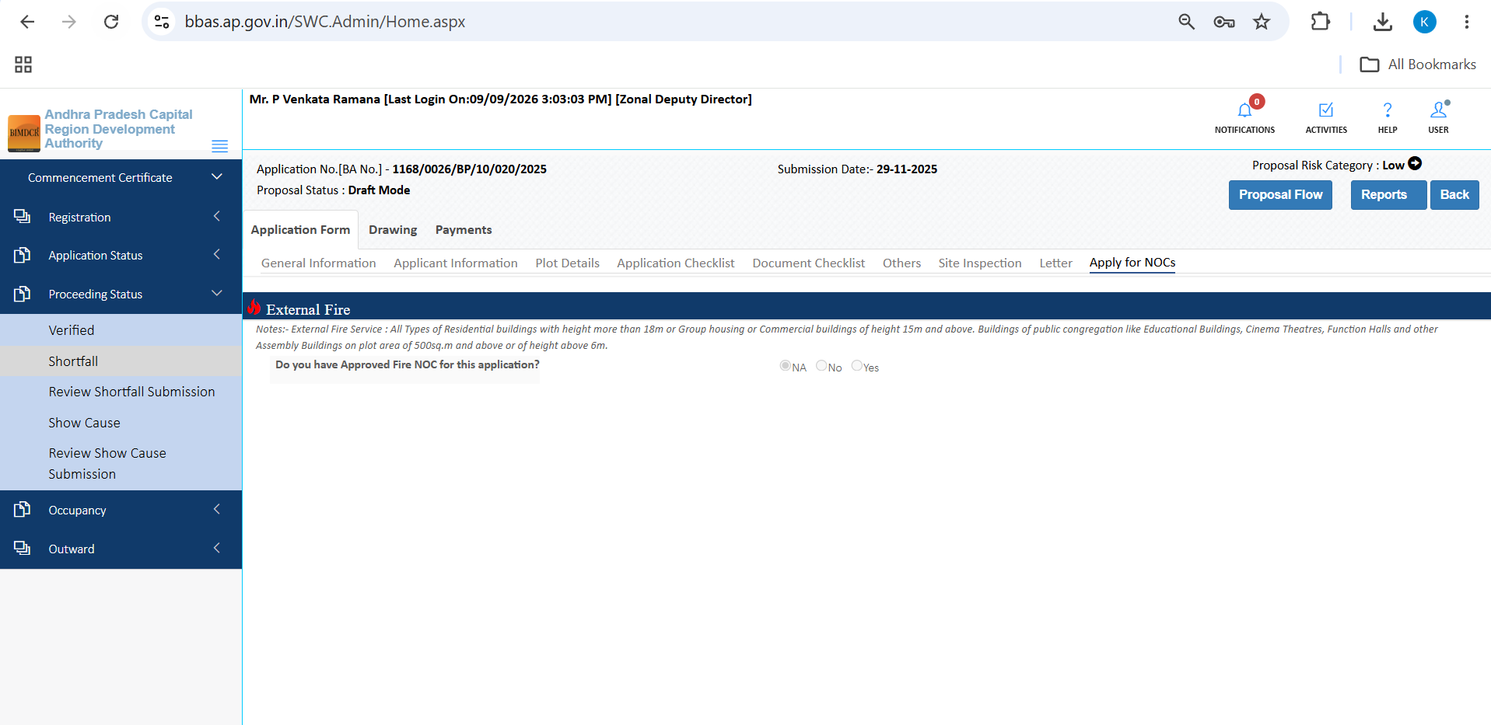
Figure 8.20 — Apply for NOCs tab showing External Fire Service statutory guidelines and NA selection

9. Module: Occupancy Certificate
The Occupancy module enables the Zonal Deputy Director to oversee the final post-construction closure stage:

9.1 Occupancy List
1. Click Occupancy >> Occupancy List in the sidebar.
2. The table lists all completed buildings where Occupancy Certificates have been sanctioned and issued.
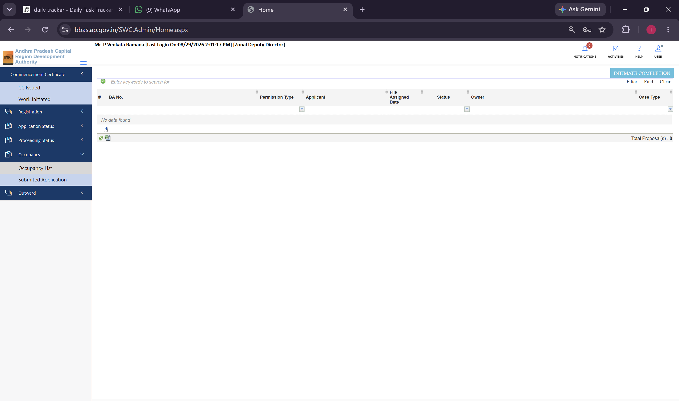
Figure 9.1 — Occupancy >> Occupancy List queue for tracking sanctioned completion orders

9.2 Submitted Applications (Completion Intimations)
1. Click Occupancy >> Submitted Application in the sidebar.
2. The queue lists all building completion notices submitted by owners upon finishing construction.
3. The ZDD schedules final completion inspections and verifies as-built drawings against the sanctioned plan prior to issuing the Occupancy Certificate.
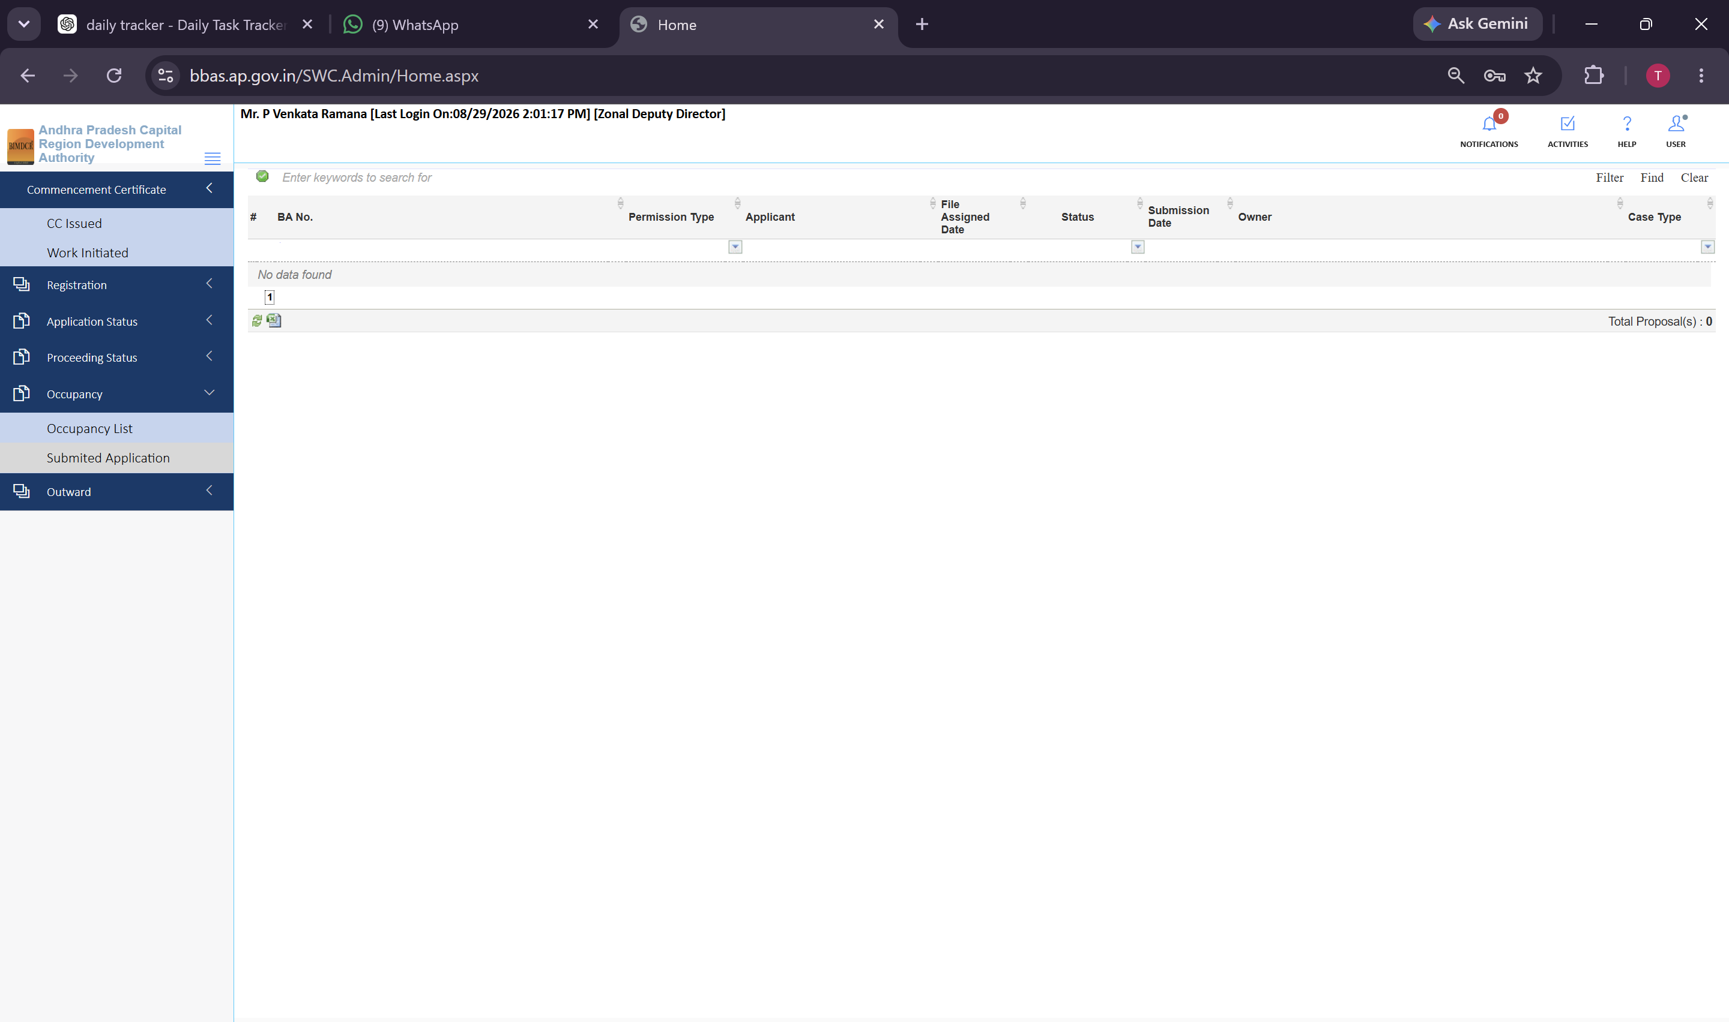
Figure 9.2 — Occupancy >> Submitted Application queue for managing incoming completion notices

10. Module: Outward Register & Dispatch Tracking
The Outward module provides an official statutory registry of all official communications and sanction orders dispatched from the Zonal Directorate:
1. Click Outward >> Outward in the sidebar navigation.
2. The table displays all dispatched proceedings (e.g., 48 active entries across pages 1 to 15), detailing BA Number, Permission Type, Applicant Name, File Assigned Date, and Outward Status.
3. The ZDD uses the search bar to verify dispatch dates, track delivery acknowledgments, and maintain official dispatch logs.
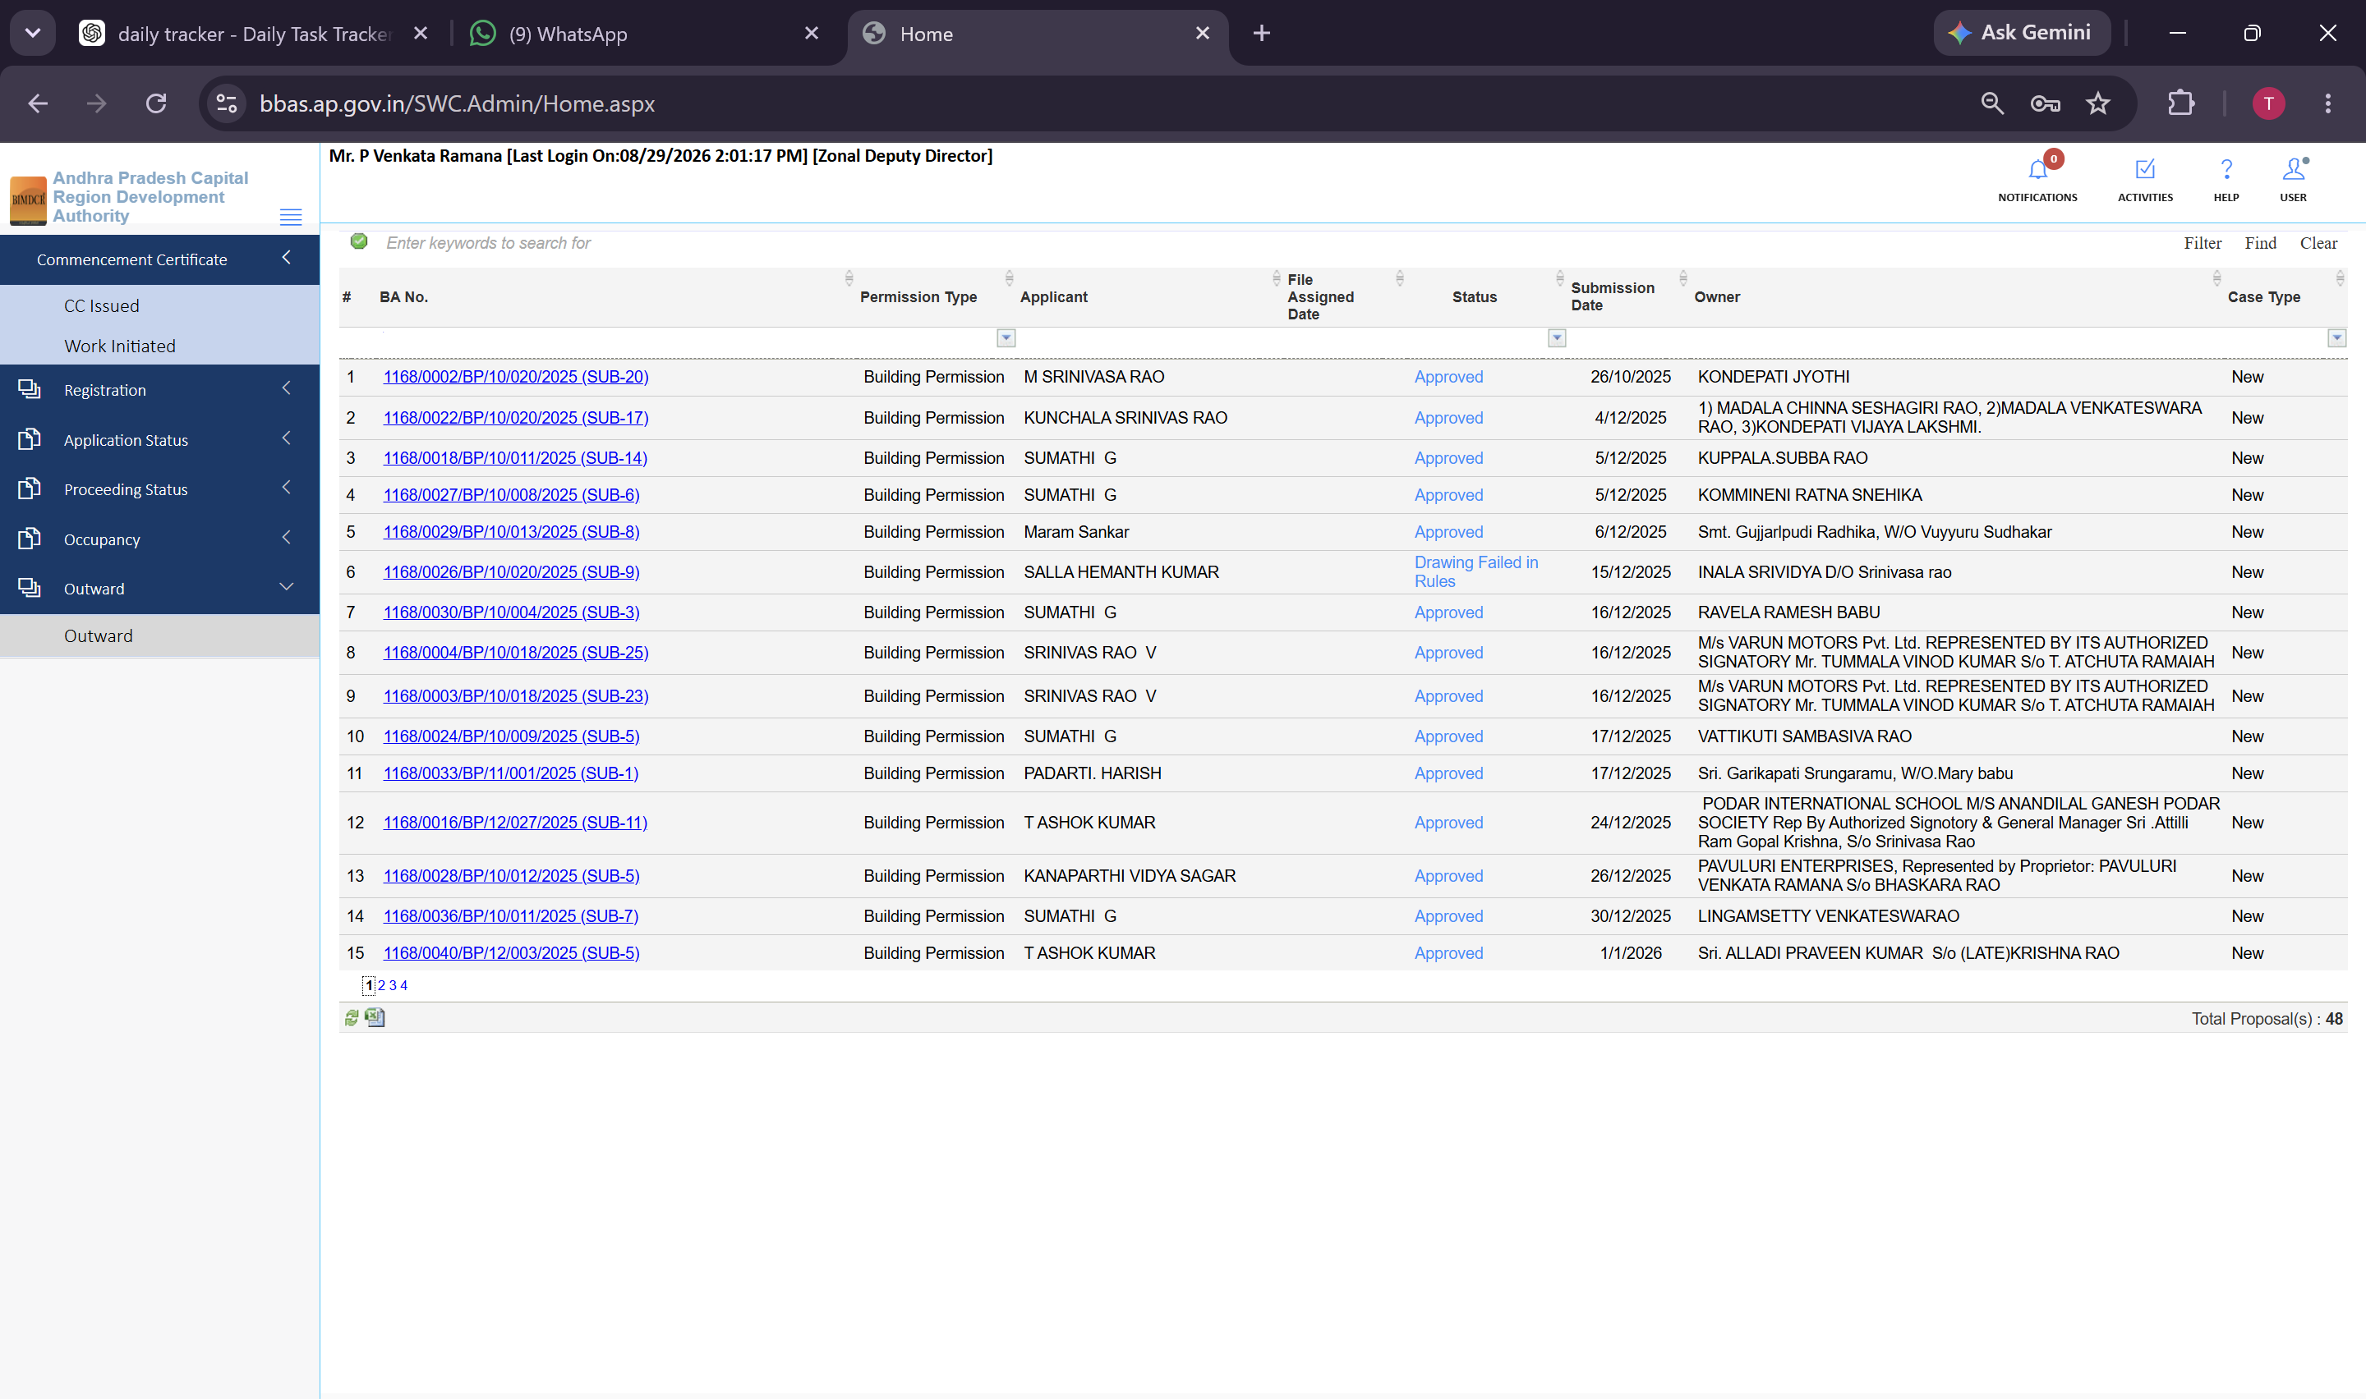
Figure 10.1 — Outward >> Outward register displaying 48 dispatched sanction orders and communications

11. Common actions on every list and proposal
Standardized actions available to the Zonal Deputy Director across all data grids and review forms:
Action Icon / Button | Location in Portal | Operational Function & Guidance
Review Action (Pencil) | Data table Action column | Opens the full 10-tab technical scrutiny workspace for the selected proposal.
Search Keywords Bar | Header of every data table | Executes real-time filtering by BA Number, Applicant Name, or File Number.
Filter / Clear | Table filter panel | Applies custom date ranges or clears search parameters to reset the queue.
Shortfall Letter Action | Shortfall queue | Downloads or dispatches the official statutory shortfall notice to the applicant.
View Proceeding Letter | Letter tab | Opens the official embedded PDF preview of the draft Building Permit Order (BPO1.pdf).
Save Recommendation | Docked panel on review tabs | Records directorate-level technical observations and sanction recommendations.

12. End-to-end ZDD sanctioning lifecycle
The complete end-to-end workflow executed by the Zonal Deputy Director follows this sequential lifecycle:
Step 1: Authentication & Queue Intake. ZDD logs into BIMDCR (BPAMSClient/login.aspx, ZDD001) and opens the Verified queue under Proceeding Status.
Step 2: Technical Proposal Evaluation. Opens assigned proposals (e.g., 1168/0001 or 1168/0026), reviewing General Info, Applicant particulars, Plot deductions, and 19-point checklist responses.
Step 3: Directorate & Document Verification. Verifies mandatory title deeds, checks previous recommendations from Planning Directors, and confirms registered Mortgage Deeds and CAR insurance.
Step 4: Field Site Inspection Review. Reviews field inspection reports, cross-references actual construction progress on site (e.g., slabs laid), and verifies ground boundary dimensions.
Step 5: 3D BIM & NOC Verification. Interacts with the 3D BIM model viewer, verifies AutoDCR bylaw checks, and confirms Fire NOC clearances.
Step 6: Treasury Fee Reconciliation. Verifies fee assessments and confirms realization in government treasury accounts via CFMS challans.
Step 7: Sanction Adjudication. Endorses the draft Building Permit Order (BPO1.pdf) for final issuance, or dispatches formal Shortfall / Show Cause notices where discrepancies or pending items are identified.
Step 8: Post-Sanction Governance. Oversees Work Initiated notifications under Commencement Certificate, conducts final completion inspections, and issues Occupancy Certificates.

