HireFlow AI - Job Application Tracker

Team Members
Surajit, Vikram, Suman, Vivek, Vikash, Utkarsh, Zoya

Project Overview
HireFlow AI is an AI-powered job application tracking system built using Python. The project allows users to add job applications, manage statuses, and analyze resumes.

Objectives
• Track job applications efficiently
• Provide AI-based resume analysis
• Build a full-stack application using Python
• Store application data using SQLite database

Technology Stack
Frontend: Streamlit
Backend: Flask
Database: SQLite
Libraries: Pandas, hashlib, requests, OpenAI

Modules
1. Login & Signup Module
2. Add Job Module
3. Job Tracking Dashboard
4. Resume Analyzer
5. Database Management

Project Workflow
Users log into the system, add job applications, and store the data in a database. The AI module analyzes resumes and provides improvement suggestions.

Project Screenshots
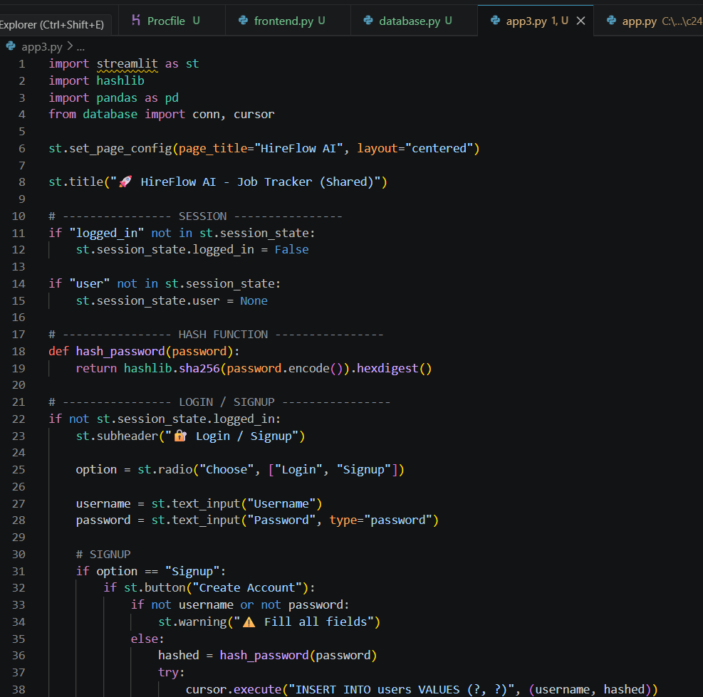
Code Screenshot
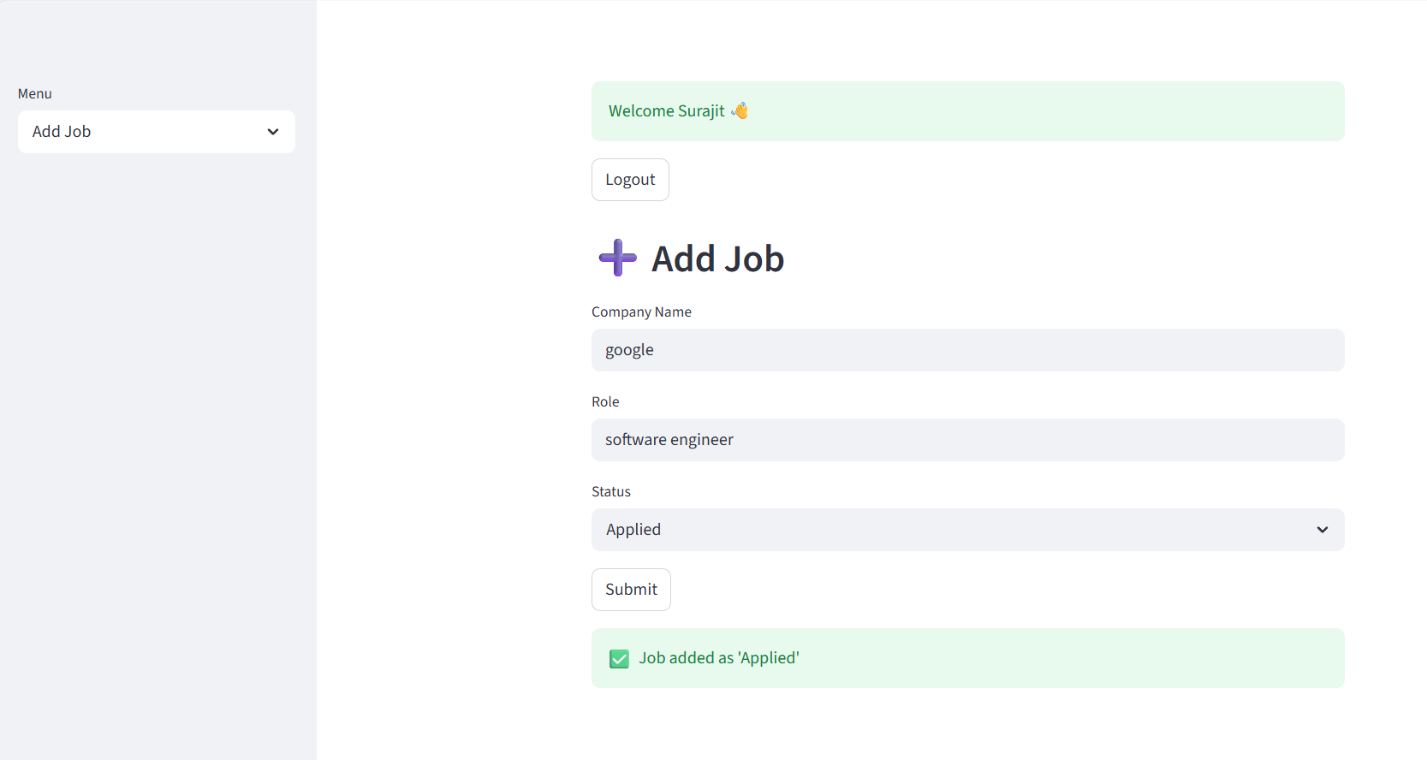
UI Screenshot

Conclusion
HireFlow AI demonstrates a complete full-stack Python project with AI integration. The project is suitable for academic presentations, internships, and interviews.

