Login page
1 master user alone.
Verification OTP through Hostinger email (Sangeetha.dhanasekar@blude.in)
Credentials
- Name
- Password
Sign in button
Password changes require OTP verification via Hostinger email (Sangeetha.dhanasekar@blude.in)

Landing page
keep only Five modules
- Payslip
- Bills
- Inventory
- Employees detail
- Company details (GST No, Incorporation number etc)
In top right side it needs to show the username and role

Payslip
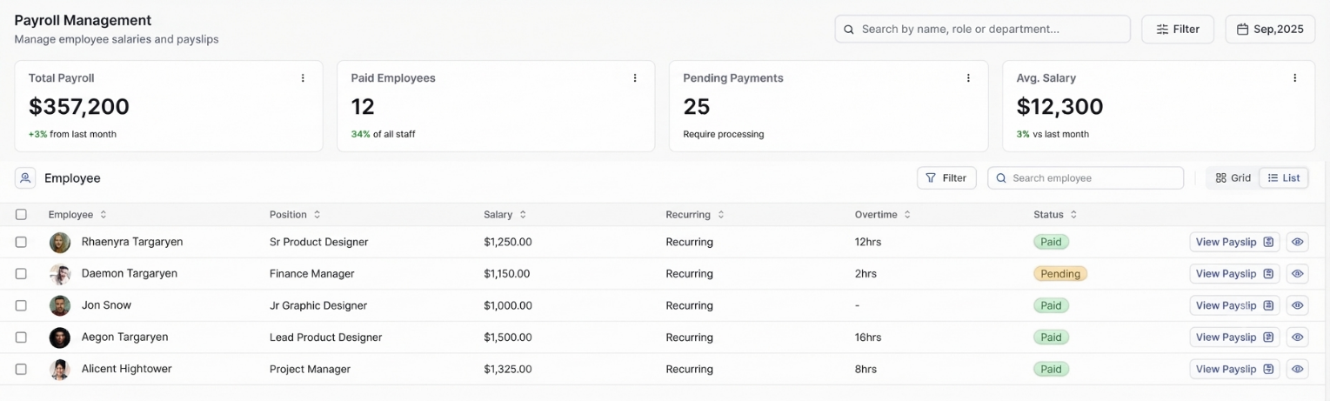
Payslip generator
Data Entry Options
- Upload File
  - Upload Excel (.xlsx) or CSV (.csv) files.
- Manual Entry
  - Enter data through forms
After submission it need to show Preview of the entered data in the payslip format, if I need to change any correction on the payslip allow me to edit the data through forms. Provide a Download option. If needed I need to send email to their respective email.

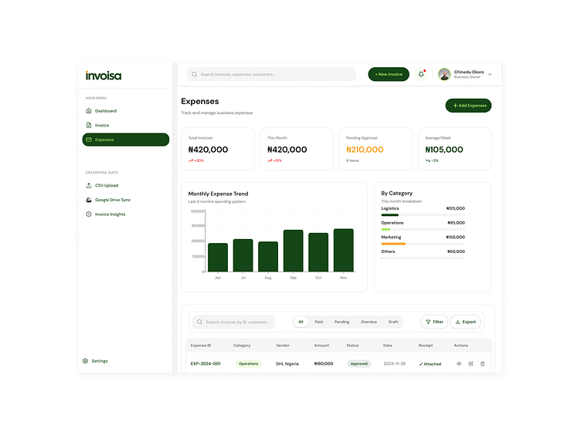
Bills

Data Entry Options
- Upload File
  - Image, pdf, word
- Manual Entry
  - Enter data through forms
- Camera
Automatically extract the date, vendor name, product, price and enter an excel/csv file. Create a serial number or file number to every bill or invoice.
Uploaded or scanned images of Vouchers for cash under 2000 or 100o should also be given separate serial numbers.
Expense Calculation should be done with the bills or invoices and the Vouchers

Stocks
Data Entry Options
- Manual Entry
  - Enter data through forms (add, edit, and manage stock inventory)

Employees details
- Manual Entry
  - Enter data through forms
    - Name
    - DoB
    - Address
    - Salary
    - Employee id
    - Contact number
    - Office number
    - Designation
    - Office address
    - Aadhar number
    - Email id
    - Blood group
- Upload File
  - Image, pdf, word (original document)

Company details
- Manual Entry
  - Enter data through forms (GST No, Incorporation number etc)
- Upload File
  - Image, pdf, word (original document)

