**Design Patterns**

CS 121, second year students

# Assignment 6

**November 15, 2021. Due to December 1.**

## Overview

|  |
| --- |
| **PdfParser** |
| +content: str |
| +read_file(filename: str) -> None  +parse_content() -> None |

|  |
| --- |
| **DocxParser** |
| +content: str |
| +read_file(filename: str) -> None  +parse_content() -> None |

**In this assignment you should implement Facade and Bridge patterns.**



## Description

❖ **Facade pattern task**.

1. Given the multiple classes represent different functionality of a file processing, one has to implement a facade which simplifies access and operations. You can modify recommended classes.
2. Implement file readers based on the file extension. These classes **must** be able to read real pdf and docx files. You can use external libraries for this task.

2

1. Create a class for entity extraction. Use external libraries or regular expressions 1,2,3.

|  |
| --- |
| **Extractor** |
| +content: str |
| +extract_dates() -> List[str]  +extract_numbers () -> List[float]  +extract_names() -> List[str] |

1. Provide facade class **Processor** which aggregates or composites parsers and extractor. Also, add testing code.

❖ **Bridge pattern task.**

1. Imagine you are working on the IoT project. Implement the following diagram:

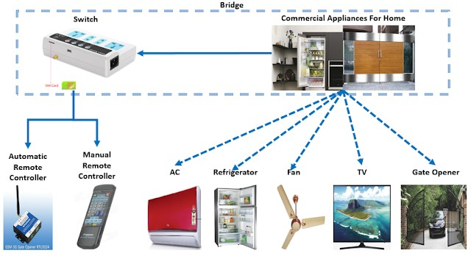

3

1. Each Appliances class must contain start (), stop () methods with appropriate logic, such as power off. Switch and the corresponding Remote Controllers must contain the required methods turn_on (), turn_off. Complete the rest of the logic at your discretion.
2. Provide testing of your code.

**References:**

1. [**https://www.pythonforbeginners.com/files/how-to-extract-a-date-from-a-txt-file-in-p ython**](https://www.pythonforbeginners.com/files/how-to-extract-a-date-from-a-txt-file-in-python)
2. [**https://spacy.io/**](https://spacy.io/)
3. [**https://stackoverflow.com/questions/4289331/how-to-extract-numbers-from-a-string-i n-python**](https://stackoverflow.com/questions/4289331/how-to-extract-numbers-from-a-string-in-python)
4. ***Eric Freeman and others*. Design Patterns (Head First).**
5. ***Sean Bradley*. Design Patterns In Python. Common GoF (Gang of Four) Design**

**Patterns Implemented In Python.**

1. ***Robert Martin*. Clean Code: A Handbook of Agile So ware Cra smanship.**
2. ***Mark Lut*z. Python, 5 ed.**
3. ***Dan Bader*. Clean Python.**