**ABOUT US**

Feeding the world Inc. is a Massachusetts-based not-for-profit organisation, focused on community-based initiatives and poverty reduction. We are particularly focused on supporting smallholder farmers in resource-limited settings.

**VISION**

To improve wellbeing and eradicate poverty and malnutrition through agricultural development in specified communities.

**MISSION**

Our mission is to conduct actionable research and develop programs to address challenges across the value chain for key agricultural commodities in resource-limited settings. Through our research, we identify crops that are central to the livelihood and wellbeing of smallholder farmers in target communities and characterize the failures in the value chain. We incubate and scale up solutions to the challenges and bottle-necks across the value chain.

**APPROACH**

Our unique approach focuses on combining ethnographic approaches to defining problems, and co-creating market-based solutions that have ecological validity. We develop customized tools to identify priority communities for our programming based on potential to benefit from interventions across the value chain, and readiness for intervention. We apply focused ethnographic approaches including in-depth interviewing, participant observation and other approaches to identify the key failures in the value chain, from farm to fork. We work with smallholder farmers to incubate solutions ranging from provision of credit, introduction of improved inputs, support with mechanization, storage and processing facilities and facilitating access to the market. Our interventions are backed with robust monitoring and learning activities towards optimizing impact.

What we want to achieve

1. To enable farmers, improve their farm and non-farm incomes
2. To ensure food security, improved nutrition and poverty eradication.

**CONTACT US**

**We always love to hear from you.**

Remember: We do not rent, sell, or share email addresses with any third party or organization!

49 Franklin Street, Somerville, MA 02145

Email: [feedingtheworld@yahoo.com](mailto:feedingtheworld@yahoo.com)

Telephone: +1 607 882 3492

**GOVERNANCE**

1. **BOARD OF DIRECTORS**

Our board of trustees comprise executive directors who are volunteers serving in the management of the organization without pay, and non-executive directors who do not participate in the day-to-day management of the organization. Our board members bring a wide variety of experiences relevant to addressing the root causes of poverty and malnutrition.

1. President General

Mr. Adisa Kabiru Adeniyi, FCA, AMNIM



2. Secretary

Mr. Asafa Mukaila Olukayode

BSc Agricultural Engineering, Msc. Agricultural Engineering



3. Board Member

Mr. Shittu ‘Raman Ayodele

HND, PGDE.

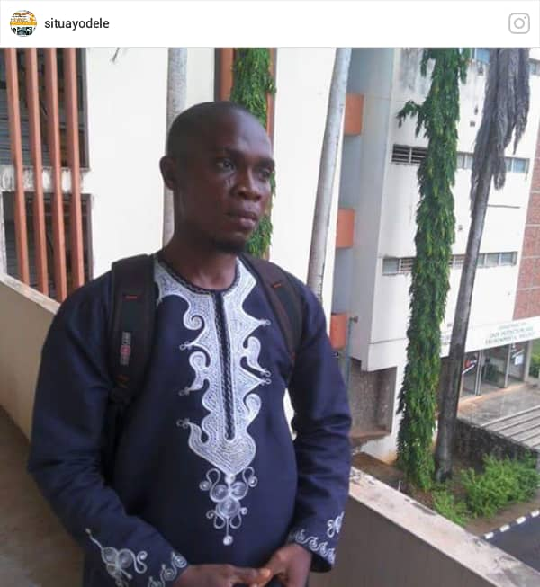

4. Treasurer

Ganiyu Wakilat Aderonke

HND

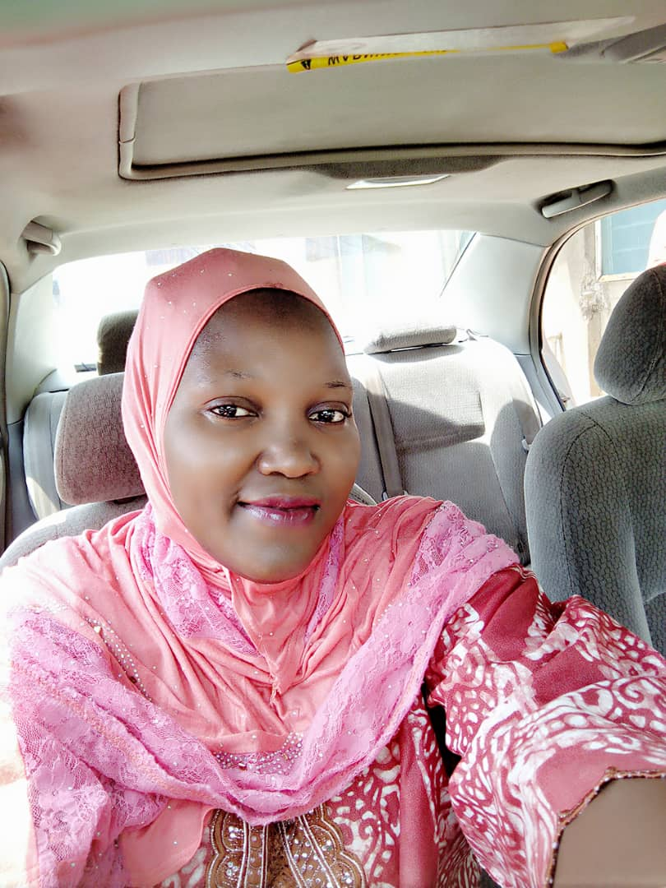

## 5. Board Member (Non Executive)

## Olanrewaju Moshood Omotayo **MD, Ph.D.**



**ii. TRANSPARENCY**

To increase transparency, Feed The World Inc. actively infuse greater disclosure, clarity, and accuracy into their communications with [stakeholders](https://en.wikipedia.org/wiki/Project_stakeholder) through [radical transparency](https://en.wikipedia.org/wiki/Radical_transparency). Accountability and transparency are of high relevance at Feeding The World Inc. to our donors and sponsors.

Feeding The World Inc. has a zero-tolerance policy on funds diversion, misappropriation and mismanagement. We have a reputation for maintaining prudence and efficient use of our partners’ donations. We utilize a sound tracking and Monitoring and Evaluation system and makes available to everyone the impact of our interventions.

**iii. PRIVACY POLICY**

Feeding The World Inc. is located at 49 Franklin Street, Somerville. We do not trade, share, rent, trade, exchange, market, swop or otherwise disclose donor information to any outside party. Feeding The World also has a policy of not sending mail to donors on behalf of other organizations.

**donation policy**

All donations received by Feeding The World Inc. are used for purposes and expenses related to events and programmes for which they are intended and solicited. For general donations, Feeding The World Inc. may use your contribution wherever most needed.

**INFORMATION GATHERING**

Feeding The World Inc. will only provide you communications and updates that you request for and will not send you promotional materials without subscription. By subscribing to our periodic communications via email, physical address or telephone number, Feeding The World Inc. will only send regular membership communications, as detailed on the sign-up form, if you elect to receive them. Subscribers have the option of making the details of their donations public or private.

###### **Secure Payments**

All credit card, paypal and personal profile information provided to Feeding The World through its Internet software partner is safe, faster, more secure way to donate online with, your payment is sent directly to the vulnerable like farmers and children.

Feeding The World Inc. collects information in one way:

Information you provide online: By donating to Feeding The World Inc. or signing up for email updates, the information you volunteer includes your name, phone number and email address.

**ACCREDITATION**

EIN: 83-2357572

**FINANCIALS**

**donation policy**

Feeding The World Inc. solicit for donation in a respectful manner and without pressure and demonstrate greater accountability by showing donors the direct impact of their donation.

Feeding The World Inc. accept: gifts of cash, marketable securities, stock in privately owned companies, real estate, tangible personal property and pledge











**FUNDRAISING**

Raising Fund for Feed The World Inc

* Raise fund for Feeding The World Inc. through Facebook during your birthday
* Raise fund for Feeding The World Inc. through online platforms
* Organise events like Marathon to raise fund for Feeding The World Inc.

Donate Sponsor a Farmer

## Shine bright in a farmer’s life.

Your gift empowers people out of poverty and feed two billion more people by 2050.

Donate

|  |  |  |  |  |  |  |  |
| --- | --- | --- | --- | --- | --- | --- | --- |
| $50 | $100 | $150 | $200 | $250 | OR |  | GIVE NOW |

Giving monthly is the most powerful ways to donate

|  |  |  |  |  |  |
| --- | --- | --- | --- | --- | --- |
| $15 | $30 | $60 | $90 | OR | GIVE NOW |

# Empower a farmer; liberate a community. Helping people get out of poverty is not choice; it s a necessity meant to guarantee the sustainability of our world. When you give to vulnerable communities, you’ll help farmers and children rise above poverty by ensuring access to clean water, good food and shelter.

### Monthly donation is an efficient way to make a difference!

* **Monthly giving is an easy and effective routine to help poor children and their communities.** Your donation will be prudently utilised wherever they’re needed the most, to fulfil the day and protect the tomorrow of children in vulnerable farming communities.
* **Hear success stories and read impact assessment about how your donation has helped to make a difference. Our periodic bulletins showcase wonderful stories of how little donations have helped change the fate of farming families; thus giving you a feel of fulfilment and the desire to give more.**

## **MORE WAYS TO GIVE**

Sponsor a Farmer with Feeding The World Inc.

Sponsoring a farmer is a personal way to your quota to feed two billion more people by 2050.   
For $49 a month, you'll help farmers and their community to stand tall, free from shortage of food.

|  |  |  |  |  |  |  |
| --- | --- | --- | --- | --- | --- | --- |
| Location | Gender | Age | Birth Month | Birthday | Type of Farming | Clear All |

# GIFT CATALOG

Give a gift. Change a life.

Giving is life. Sharing is a behaviour.

Help farmers. Help the world.

Help children and families in need.

Honor loved ones with a free personalized card

Shine bright Empower people out of poverty for real. For Good Give Now

X One Time X Monthly X Yearly

|  |  |  |  |  |  |  |  |  |
| --- | --- | --- | --- | --- | --- | --- | --- | --- |
| $50 | $100 | $150 | $200 | $250 | OR | $ |  | GIVE NOW |

# Empower a farmer; liberate a community. Helping people get out of poverty is not choice; it s a necessity meant to guarantee the sustainability of our world. When you give to vulnerable communities, you’ll help farmers and children rise above poverty by ensuring access to clean water, good food and shelter.

### Monthly donation is an efficient way to make a difference!

* **Monthly giving is an easy and effective routine to help poor children and their communities.** Your donation will be prudently utilised wherever they’re needed the most, to fulfil the day and protect the tomorrow of children in vulnerable farming communities.
* **Hear success stories and read impact assessment about how your donation has helped to make a difference. Our periodic bulletins showcase wonderful stories of how little donations have helped change the fate of farming families; thus giving you a feel of fulfilment and the desire to give more.**

|  |  |  |  |  |  |  |  |  |
| --- | --- | --- | --- | --- | --- | --- | --- | --- |
| $50 | $100 | $150 | $200 | $250 | OR | $ |  | GIVE NOW |

**RECEIVED ALERT**

|  |  |  |
| --- | --- | --- |
| Email address | Telephone Number | Signup |

###### **REAL ESTATE.**

Gifts of real estate may be accepted by Feeding The World Inc. Feeding The World Inc review of gifts of real estate shall include, but not be limited to, legality, title, encumbrances, liens, mortgages, easements, restrictions, and environmental issues. Until the real estate or property is sold and proceeds are deposited into the Feeding The World Inc.’s account, all legal obligations related to ownership of the real estate such as taxes, insurance, utilities and security shall remain with the donor.

###### MARKETABLE SECURITIES.

Feeding The World Inc. Will accept gifts of publicly traded securities, stocks and bonds. Stock with a brokerage firm may be transferred to Feeding The World’s brokerage account by first calling our Relationship Development staff at +1 607 882 3492 in order to receive specific instructions for such a transfer. To donate stock that is held in certificate form, Feeding The World Inc. must be notified in advance so that specific instructions can be provided to the donor.

NEXT STEPS

Contact Dr Moshood Olanrewaju Omotayo or feedingtheworld@yahoo.com to discuss the possibility of giving real estate to Feeding The World Inc.

Seek the advice of your financial or legal advisor to make sure this gift fits your goals.

If you include Feeding The World in your plans, please use our legal name and Federal Tax ID.

Legal Name: Feeding The World Inc.

Address: 49 Franklin Street, Somerville, MA 02145

Federal Tax ID Number:

**Frequently Asked Questions**

## 1. **How does my periodic contribution go directly to a farmer?**

A donor/sponsor’s contributions don’t go directly to the sponsored farmer as cash benefits as they are received. Rather, sponsor’s donation is used to fund interventions that are designed to improve the livelihood of the beneficiary farmer and other farmers in his community.

2. **How long is my sponsorship commitment?**

Sponsorship commitment is not time-bound as a new farmer can be attached to a sponsor at the beginning of a new intervention programme. Feeding The World Inc. carries out intervention programmes in selected communities and helps beneficiary farmers and their communities attain sustainability in food production.

3. **How many sponsors are attached to the same farmer?**

Each farmer is matched with only one sponsor.

4. **Can I get to interact with my sponsored farmer?**

Beneficiary farmers are real farmers with real success stories. A sponsor is permitted all forms of interaction they require with their farmer. This may include a personal farm visit to a sponsored farmer for a live experience of how your donation is helping to change their lives and their community.

## 5. **What benefits get to a sponsored farmer?**

* Free or subsidized improved inputs and tools
* Free trainings, workshops and seminars
* Networking with other farmers in the same subsector
* Joint participation in on-field and off-field activities with other farmers in their communities.
* Free consultancy and advisory services by extension worker
* Community-wide solutions such as clean water systems, improved schools, health services, and farming co-ops

## **6. How does farmer sponsorship work?**

Farmer sponsorship is in two ways; individual and community participation. Feeding The World Inc. farmer sponsor programs that are focused on improving the physical and social well-being of the most vulnerable farmers by helping them strengthen their production capacity and their community, caring for every farming family along the line.

**1 Farmer + 1 Sponsor**

The most vulnerable farmers are identified among those nominated by the community for the farmer sponsorship program. Each farmer is matched with only one sponsor. This one-to-one connection is a powerful way to share love and improve relations.

**Your donations go to work**

**All donations go into the farmer sponsorship program.** Your monthly sponsorship donation is combined with other donations to invest in long-term resources for your sponsored farmer, and your farmer’s whole community.

**7. How do I sponsor a farmer?**

1. Sponsor a farmer whose story, interests, and circumstances align with yours e.g. a farmer who raises animals you raised as a child, a farmer in a region affected by conflict, disaster, etc.
2. When you sponsor a farmer through periodic donations, your sponsorship donation is pooled with other sponsors for maximum impact to fund programs that benefit your sponsored farmer and their community.
3. Along the way, you can build a relationship with your sponsored farmer and your farmer’s community written, audio and visual communications, and more.

When you sponsor a farmer, you get to watch the impact of your donation on your farmer, their family, and their entire community, celebrating with them along the way.

**8. How much does it cost to sponsor a farmer?**

Farmer sponsorship with Feeding The World Inc. costs a minimum of $40 per month. To make the most of large sponsorship donations, we combine it with other donations to invest in lasting, long-term resources for your sponsored farmer and their community.

**9. What is farmer sponsorship?**

Feeding The World Inc.’s farmer sponsorship programs focus on improving the productivity and well-being of the most vulnerable farmers. Farmer sponsorship pairs one sponsor with one farmer. When you sponsor a farmer, you help provide improved farm input and tools as well as essentials like clean water, food, education, and more through our community intervention programs. You also have a direct connection to your sponsored farmer. All with the goal of helping your sponsored farmer and other vulnerable farmer in their community break free from the stronghold of poverty. Our programs are food production-centered, farmer-focused, and community based.

**10. Why sponsor a farmer?**

Sponsoring a farmer is a personal way of making a direct measurable difference in the life of a common man while helping the world to attain its goal of feeding two billion more people by 2050.

**11. Where can I sponsor a farmer?**

You can sponsor a farmer in many areas around the world including your own country/region of choice. Non-specific donations are prioritized for the following regions;

* Africa
* Asia
* Central and South America

**12. Why sponsor a farmer through Feeding The World Inc.?**

Sponsoring a farmer through Feeding The World Inc. is distinct as we do a proper analysis and evaluation of the needs of farmers and their communities before designing our interventions to suite the need of different communities.

We also give you the opportunity to have a personal interaction with your sponsored farmer and develop a relationship with him/her. For effectiveness, we do not give cash to a sponsored farmer. Instead, we pool monthly sponsorship donations and leverage them for maximum impact through our community development approach.