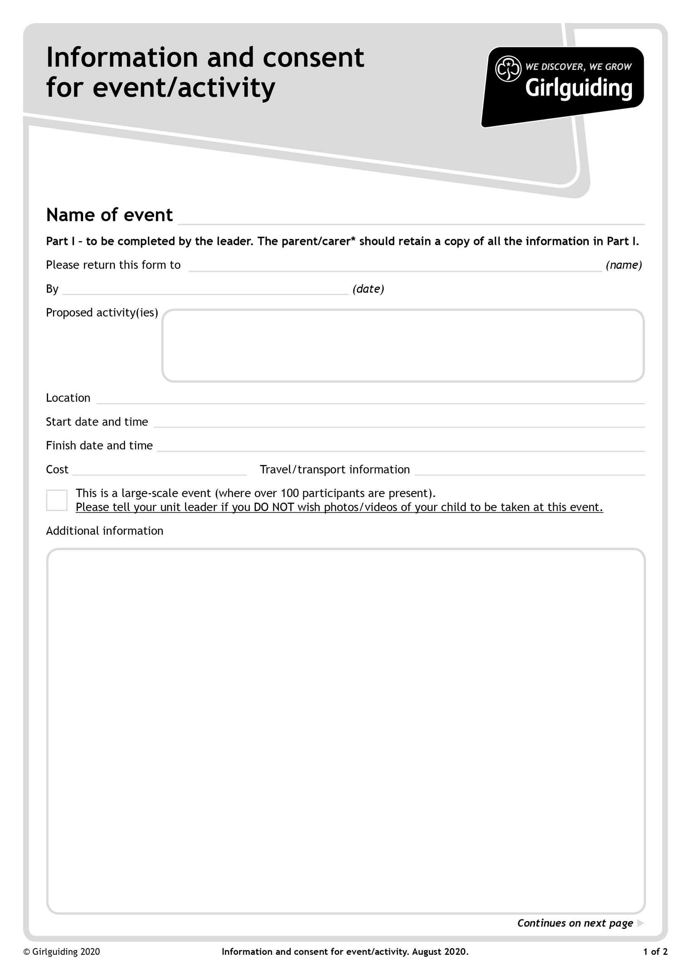

**Approved guiding activities - indoor and outdoor**

**After the closing date Patrol Instructions will be emailed to all Unit Leaders and will also then be available to download from the Girlguiding Hertfordshire website: https://www.girlguidinghertfordshire.org.uk/great-patrol-hunt**

**(under the 'Events' tab on the main menu).**

**BRING:A packed lunch and refillable drinks bottle & waterproof coat. All items should be in a small backpack as girls will be moving to different locations throughout the day.**

**WEAR:- Guides should wear their Guide Uniform.**

**Own transport**

**£5 per Guide**

**Saturday 26th March 2022 at 16.00pm**

**Saturday 26th March 2022 at 9.30am – Patrols should register together at 9.15am**

**Nicholas Breakspear Catholic School, Colney Heath Lane, St Albans, AL4 0TT**

**Closing Date 4th March 2022**

**Great Patrol Hunt, Round Two**

**Your unit leader WELL before the closing date, so the form can be posted!**

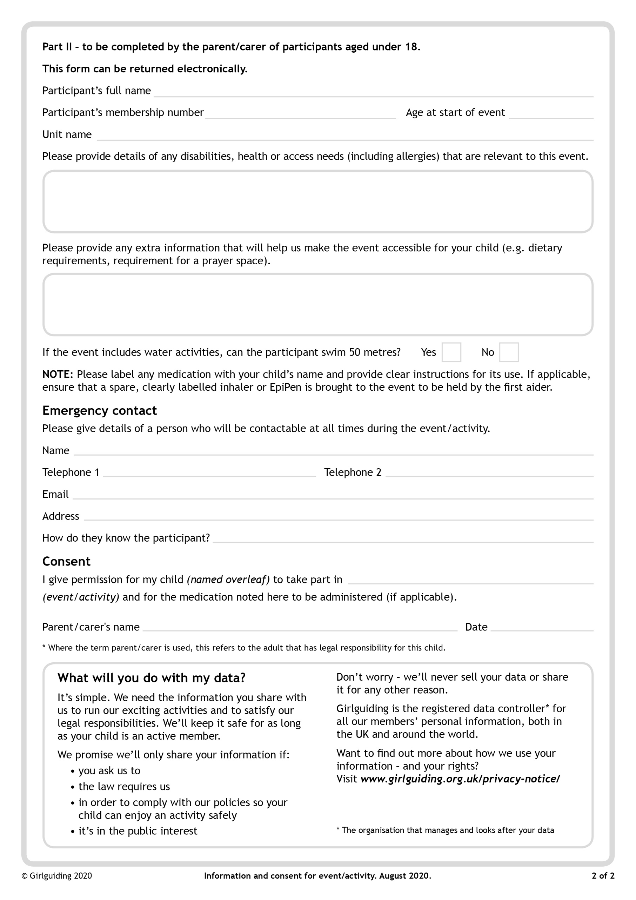

**GPH Round Two 26th March 2022**

**GPH Patrol Name:**