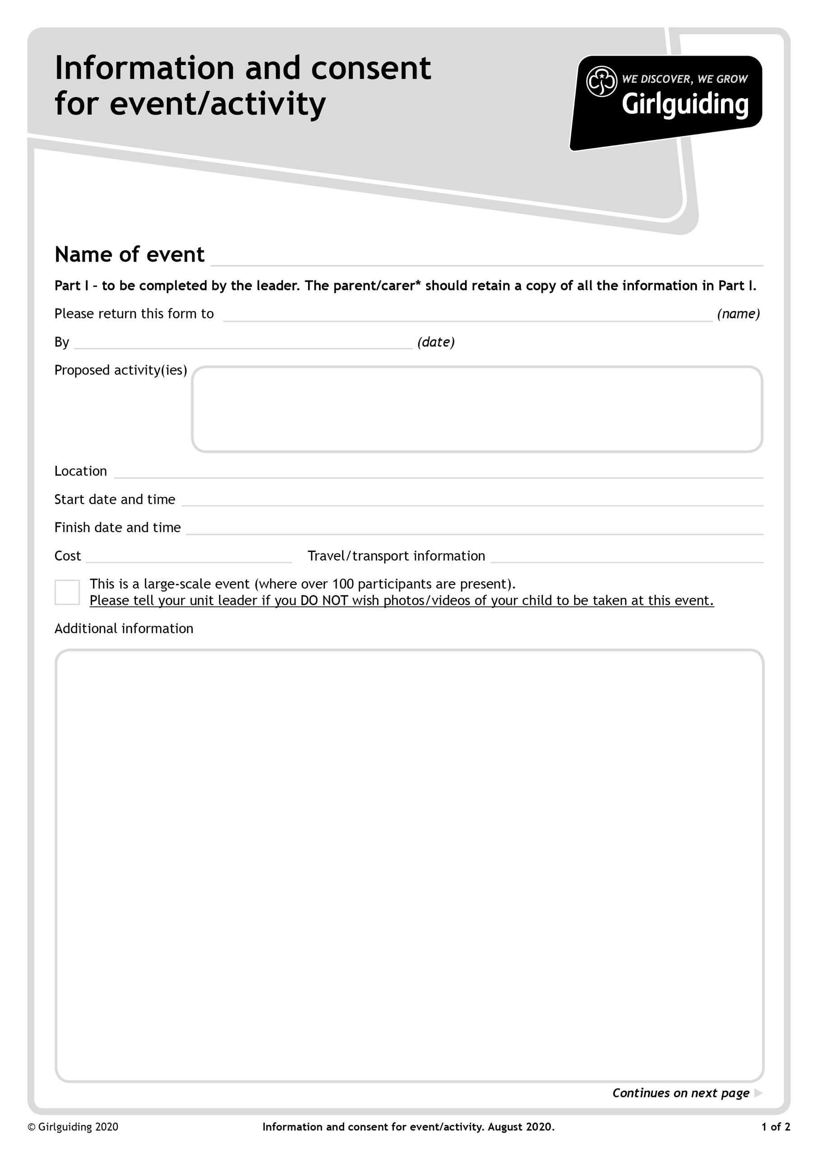

**X**

**Approved guiding activities - indoor and outdoor including camping**

**After the closing date Patrol Instructions will be emailed to all Unit Leaders and will also then be available to download from the Girlguiding Hertfordshire website: https://www.girlguidinghertfordshire.org.uk/great-patrol-hunt**

**(under the 'Events' tab on the main menu).**

**Guides should arrive in Guide Uniform**

**Bring:- All items should be clearly named**

**Bedding Roll (Groundsheet, rope, Sleeping bag, blanket, small pillow)**

**Waterproof Coat (Waterproof Trousers would also be helpful but only if you have them)**

**2 complete changes of clothes including underwear, socks and warm top (Outer clothes should be blue or dark colours)**

**Nightwear (PJs or track bottoms and teeshirt)**

**Wash bag and towel (including hair brush and hair bands for long hair)**

**Trainers and hiking boots or wellies**

**Plate Bag (drawstring bag (eg PE bag) dinner plate, cereal bowl, mug with handle, knife, fork, desert spoon, tea spoon and tea towel. All items should be unbreakable)**

**Water bottle**

**Pencil Case including contents**

**Sitter**

**DO NOT BRING**

**Any electrical items or camp chairs**

**Own transport**

**£25 per Guide**

**Sunday 26th June 2022 12.00noon**

**Friday 24th June 6.00pm**

**Wymondley Scout & Guide Centre, Wymondley Road, Willan, SG6 2UB**

**Closing Date 27th May 2022**

**Great Patrol Hunt, Round Three**

**Your unit leader WELL before the closing date, so the form can be posted!**

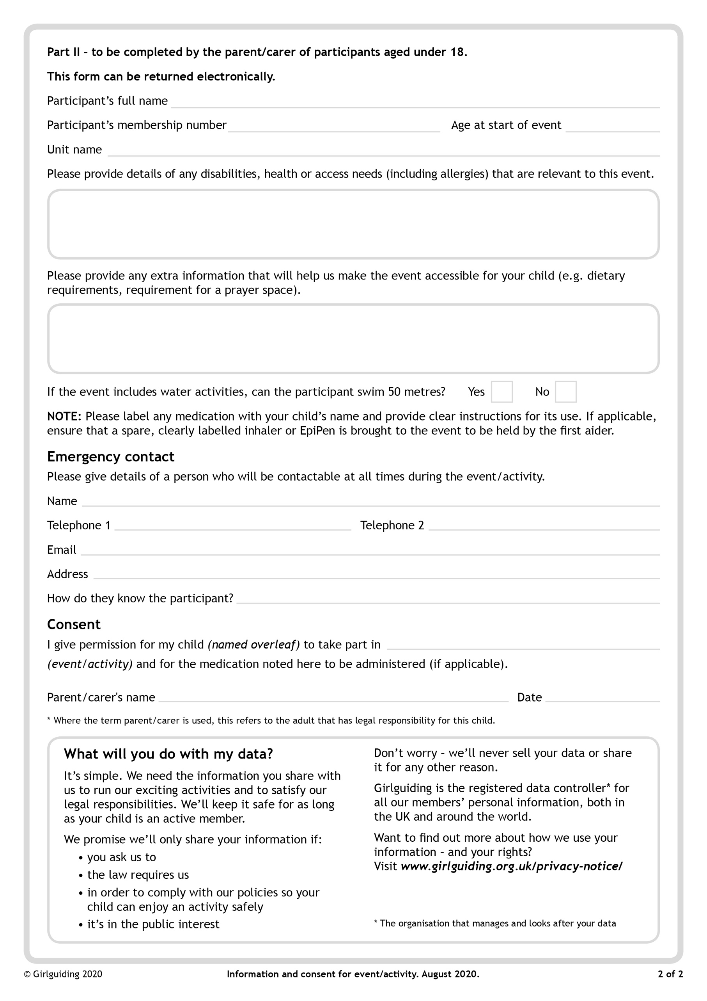

**GPH Round Three 24-26 June 2022**

**GPH Patrol Name:**