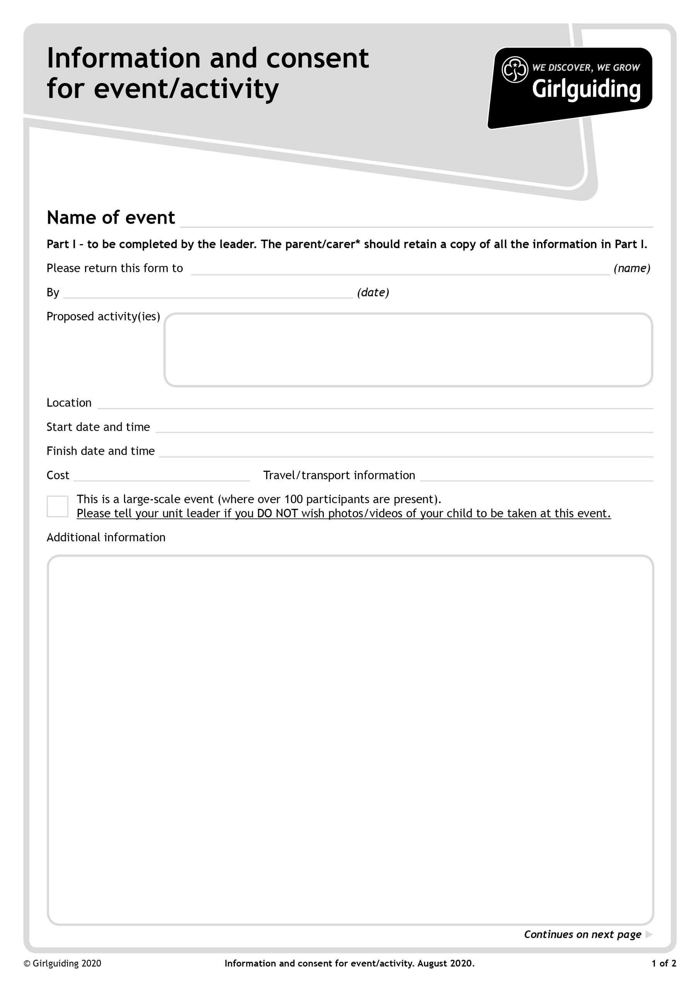

**Own transport**

**Lorne Selection Day**

**Approved guiding activities - indoor and outdoor**

Please bring with you the following

A PASSPORT SIZED PHOTOGRAPH OF YOURSELF

Outdoor coat suitable for the weather

Outdoor shoes and soft indoor shoes

Packed Lunch including drink (refillable bottle) and snacks. (squash and water will be available)

Pencil case and contents including coloured pencils

A 5 minute game ***for a small group*** which does not need equipment and which you must be prepared to lead

**No Cost**

**Saturday 17th September 2022 2.00pm**

**Saturday 17th September 2022 10.00am**

**Leverstock Green Guide HQ, Green Lane, Hemel Hempstead HP2 4SA**

**Friday 9th September 2022**

**Lorne Selection Day**

**Jean Banks,** [international@girlguidinghertfordshire.org.uk](mailto:international@girlguidinghertfordshire.org.uk)

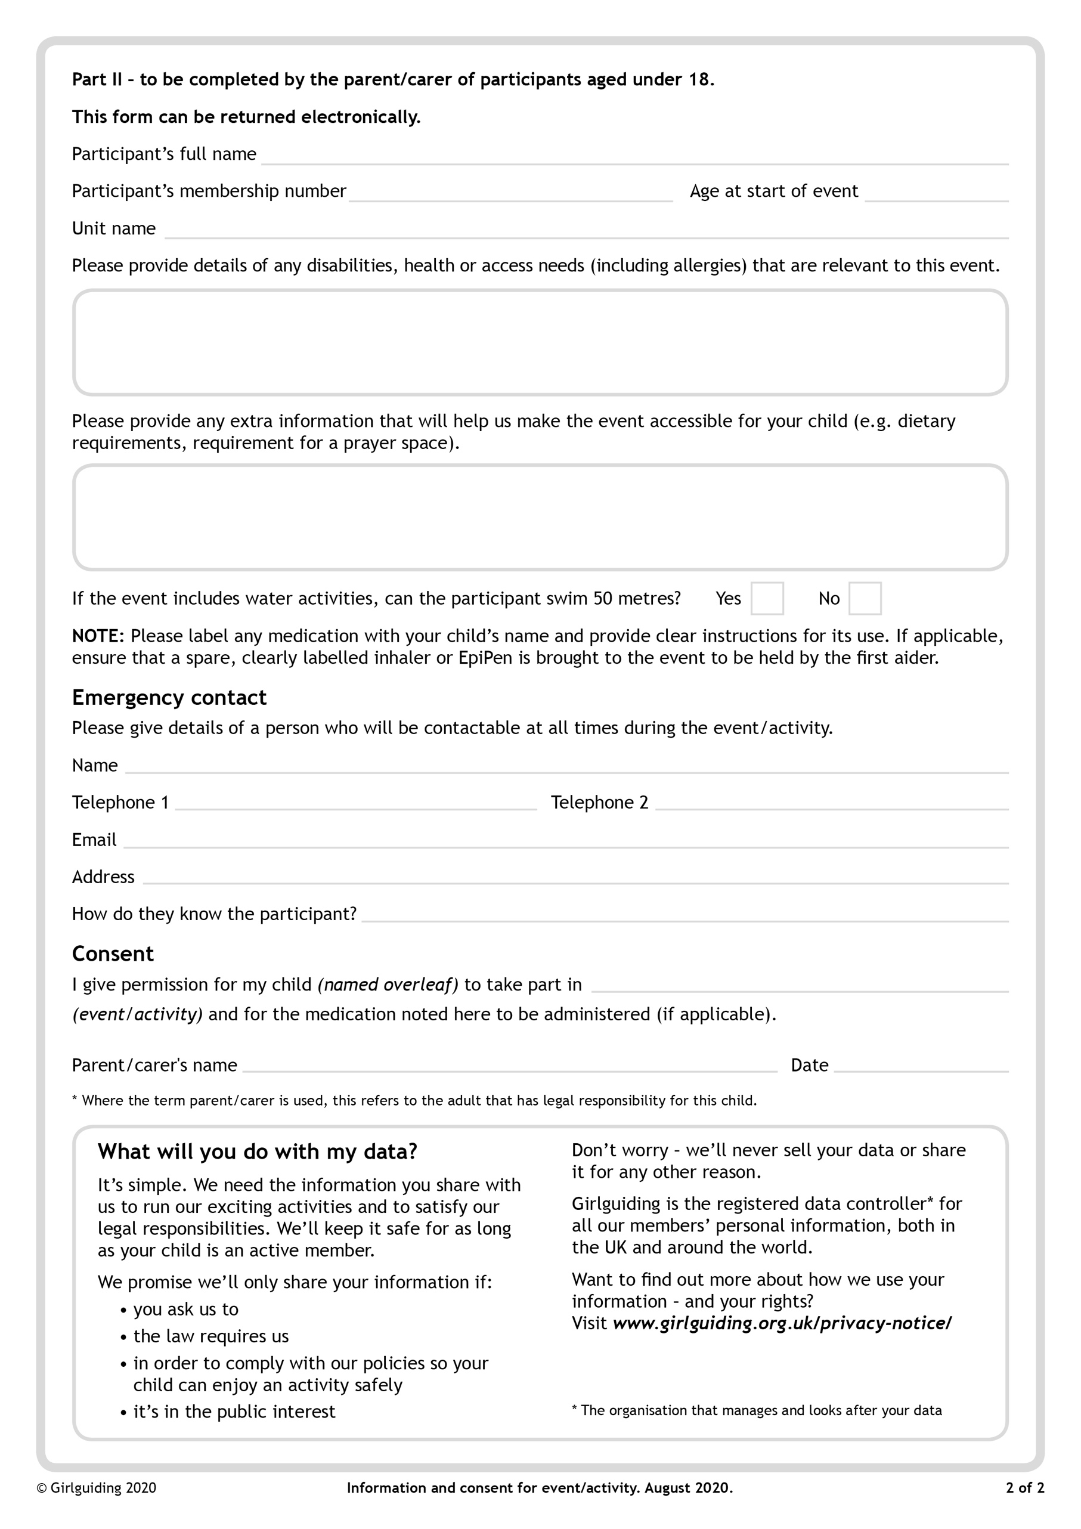

**Lorne Selection Day**