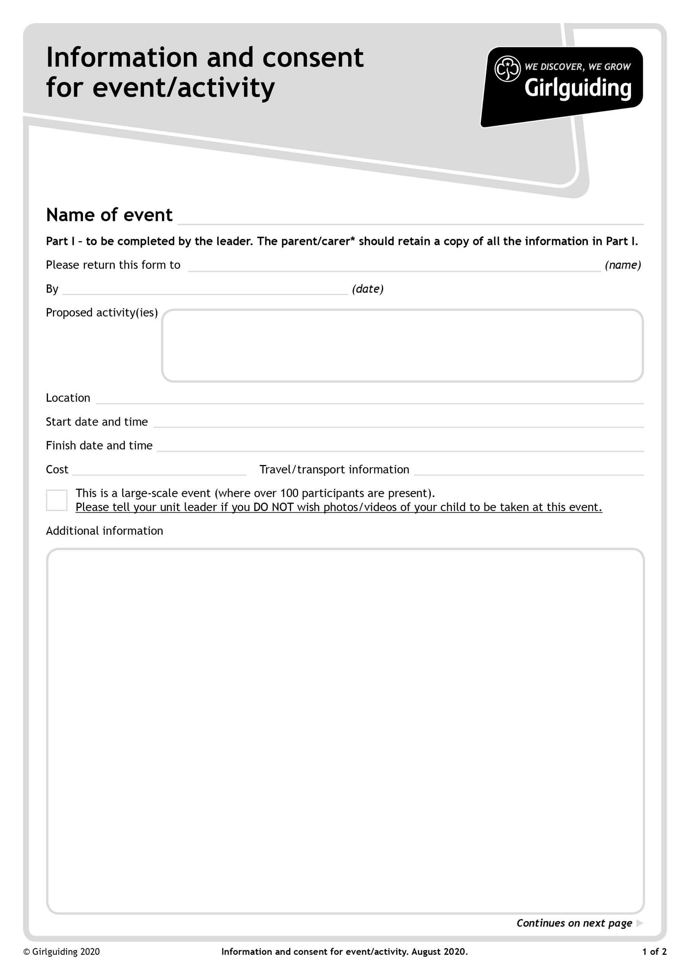

X

**Approved guiding activities - indoor and outdoor**

**BRING:A packed lunch and refillable drinks bottle. All items should be in a small backpack as girls will be moving to different locations throughout the day.**

**A small amount of money in change for our market place which will take place at lunch time.**

**WEAR:- Girls should wear their Uniform.**

**Own transport**

**£25 per person**

**Sunday 23rd October 2022 at 16.00pm**

**Sunday 23rd October 2022 at 10.00am –Register at 9.30am**

**Townsend Church of England School, High Oaks, St Albans, AL3 6DR**

**Closing Date 30th September 2022**

**Girlguiding Hertfordshire International Day**

**Your unit leader WELL before the closing date,**

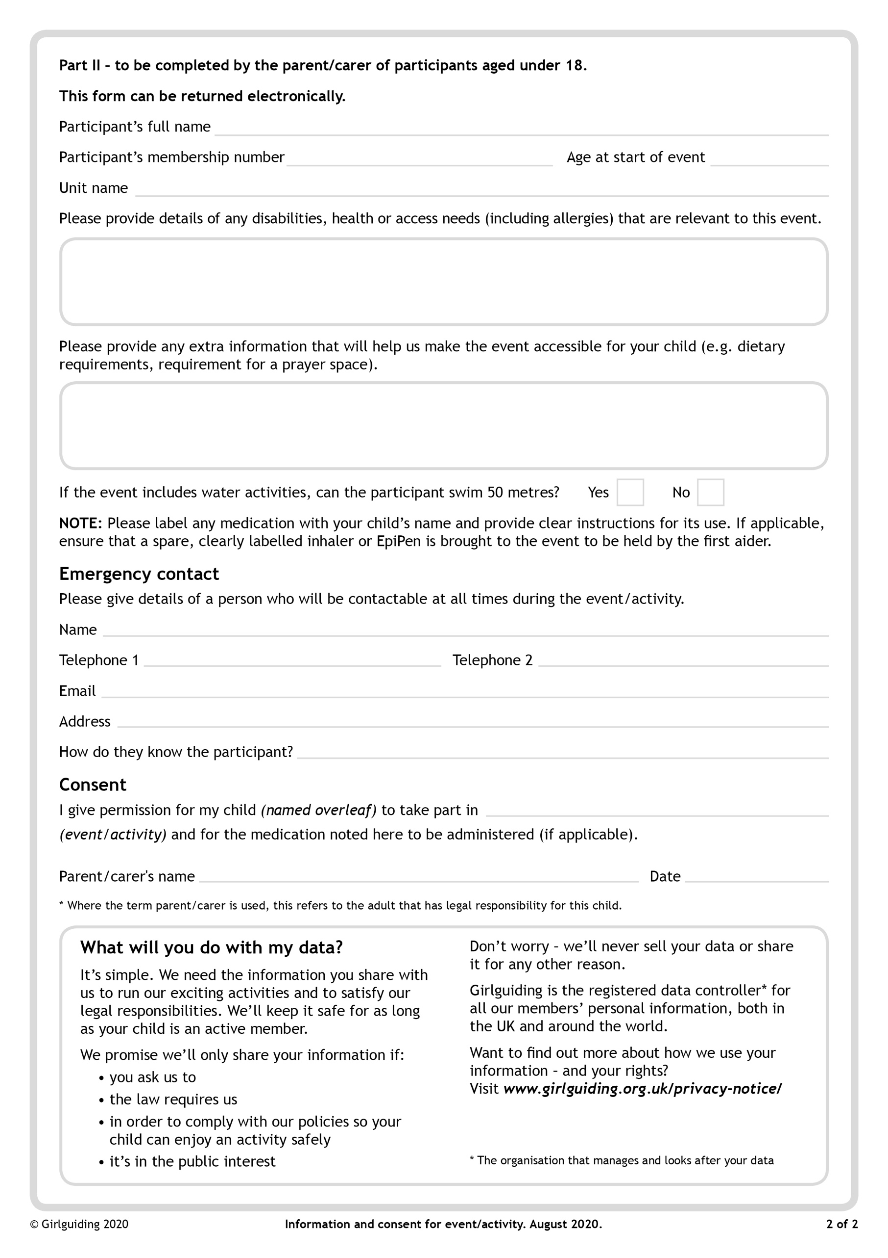

**International Day – 23rd October 2022**