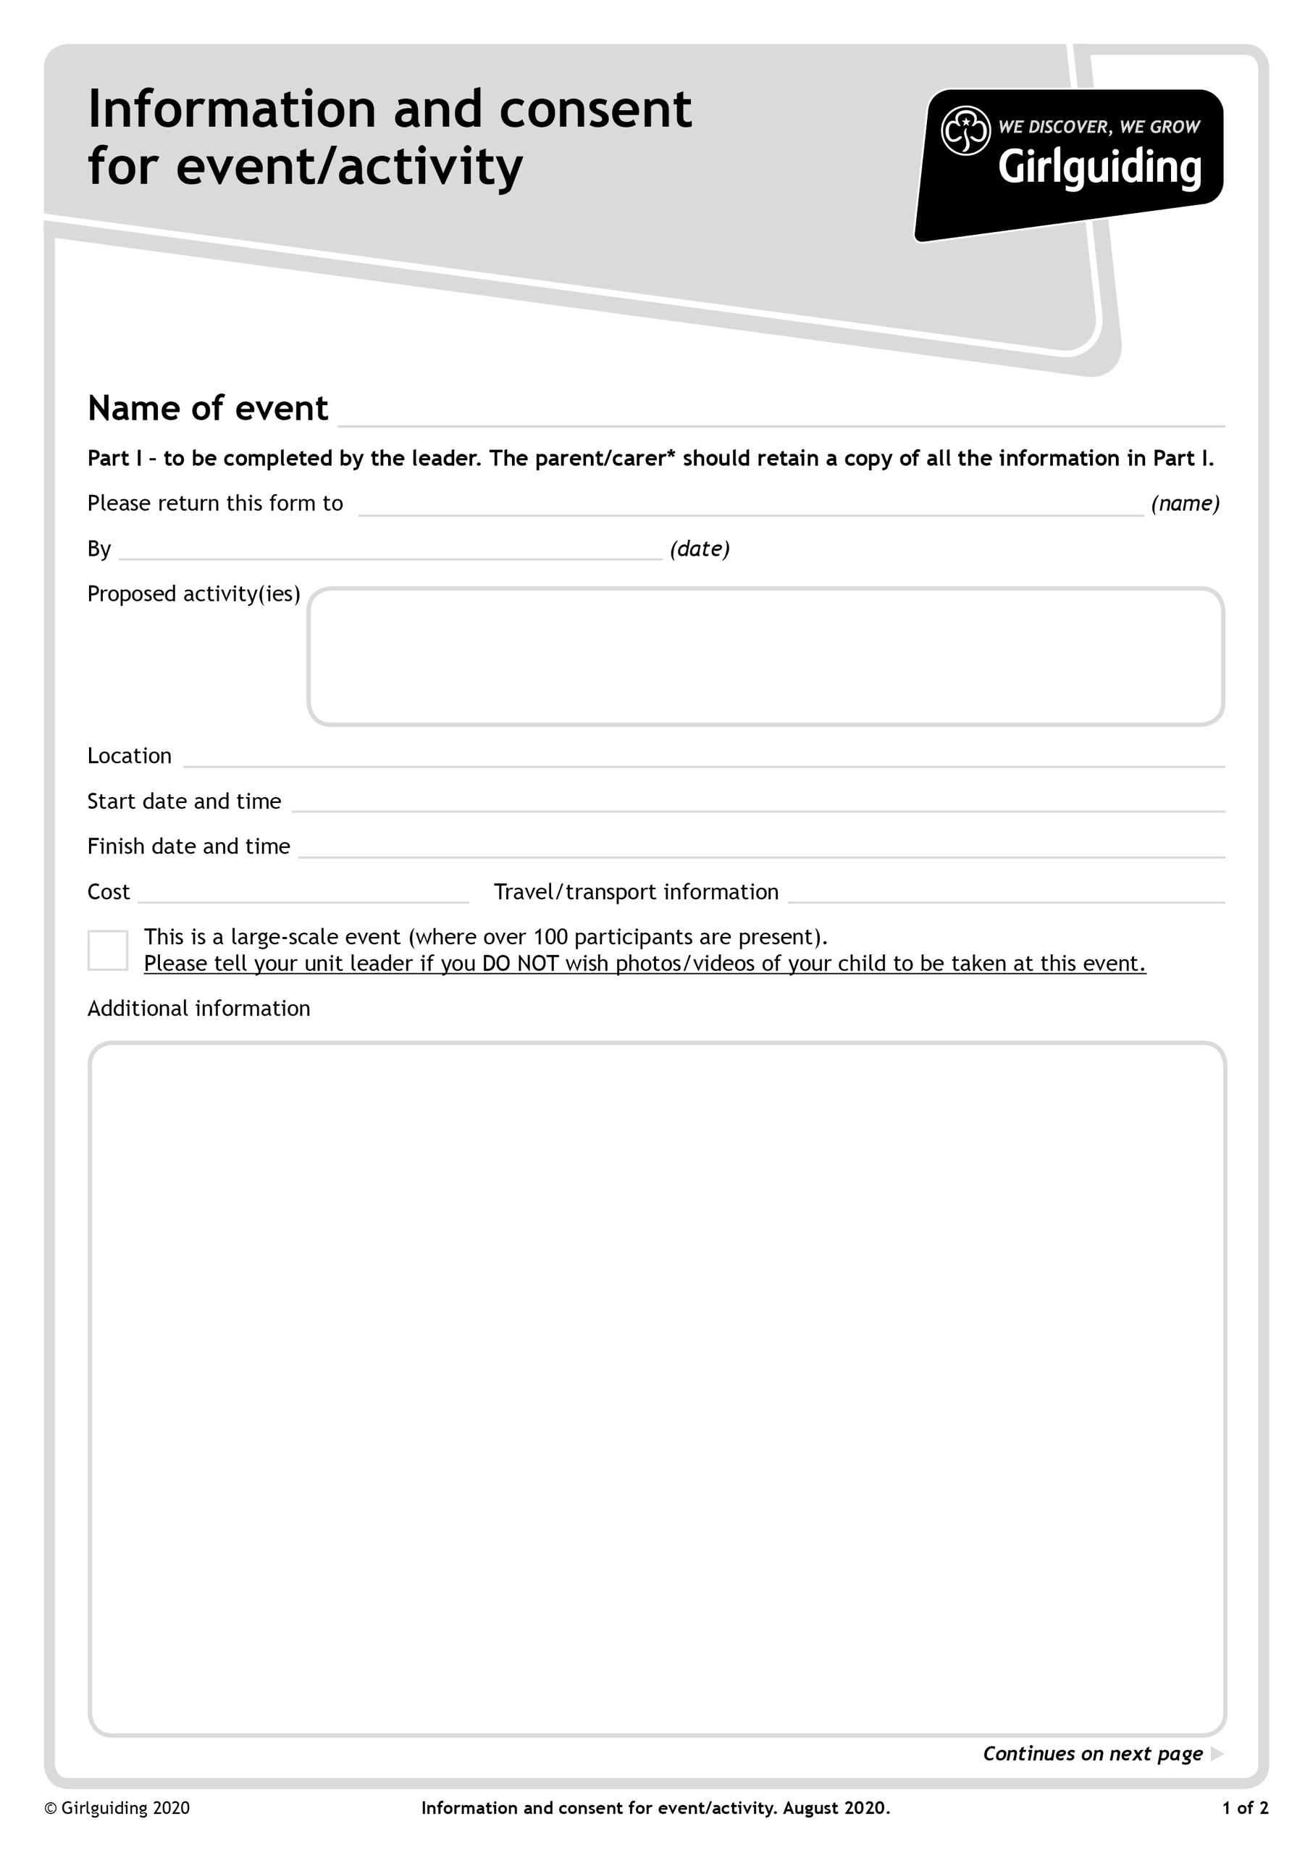

Introduction to Golf Activity Day sponsored by the late Jean Howell, for Guides, Rangers and Young Leaders of Girlguiding Hertfordshire

To be read in conjunction with the event information letter, which includes but is not limited to: If your child is feeling ill, or someone in your household is showing symptoms of coronavirus, then please follow self-isolating guidelines. Girls must not attend this event until isolation is complete. We are asking the same of all our volunteers and leaders.

All girls and leaders will need to arrive to this event in full uniform, with additional under layers as dictated by the prevailing weather conditions and sensible outdoor footwear, suitable for running around and playing sport.

Attendees should bring a small named, recognisable rucksack containing a filled water bottle, packet of tissues, small hand sanitiser, and a packed lunch/snacks. Sunhats and suncream may be required. Facemasks are required for use when using indoor toilet facilities.

Parents will need to drop girls to a leader at the end of the car park and we will receive them into the grounds and also see them out at that point for collection. Please note there is an entry barrier at the venue. Please ensure the barrier is fully descended before attempting entry and exit. The exit code will be notified on the day.

This event is fully sponsored by a legacy, left by the late Jean Howell to promote the access to girls into the sport of golf, and by the venue Porters Park Golf Club. As such there is no charge for this event.

There are 30 spaces available for this event. Spaces will be allocated according to the ‘reason for applying’ being submitted along with the correctly completed consent form and stamped self addressed envelope. We will keep a waiting list. If for any reason you are allocated a space but are unable to attend, please contact the event organiser as soon as possible on 07733 137108.

Photos may be taken for promotional use within Girlguiding, and also for use by the venue Porters Park Golf Club. Please ensure you complete the Girlguiding Hertfordshire online Photo Permission Form, via this link: [Girlguiding Hertfordshire Individual Photo Consent Form](https://www.dropbox.com/s/oc9d2qpi4anws5c/Individual_Photo_Permission_Form.docx?dl=0), confirming your daughter’s photo can be used, or complete note below if you DO NOT WISH FOR PHOTO PEMISSION TO BE GIVEN FOR YOUR DAUGHTER.

Own Transport

Free – sponsored by the Jean Howell Legacy

Monday 30th May 2022 at 4.30pm

Monday 30th May 2022 at 9am

Porters Park Golf Club, Shenley Hill, Radlett, Herts, WD7 7AZ

Saturday 7th May 2022

2nd Jean Howell Golf Day for Guides, Rangers and Young Leaders at Porters Park Golf Club

Nicola Day – event organiser 46 Goodyers Avenue, Radlett, Herts, WD7 8BB

