Anglia heads High

Above and beyond level 2

Join us for a social walking adventure in the Scottish highlands, a chance to go beyond level 2, bag a Munro and catch up with friends, or make some new ones.

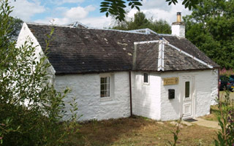**Date** : Friday 26th August – Tuesday 30 th August 2022

**Cost** : approximately £15 per night plus £10 per day for food

**Location** : Crainlarich, Scotland

**Accommodation** : Inverardran Cottage,Crianlarich,FK20 8QS (Ochil Mountaineeting Club Cottage)

"I'd rather be hiking in the rain, than sitting inside at a desk on a sunny day." – Unknown

**Spaces** : 18 beds (2 dorms, alpine style bunks)

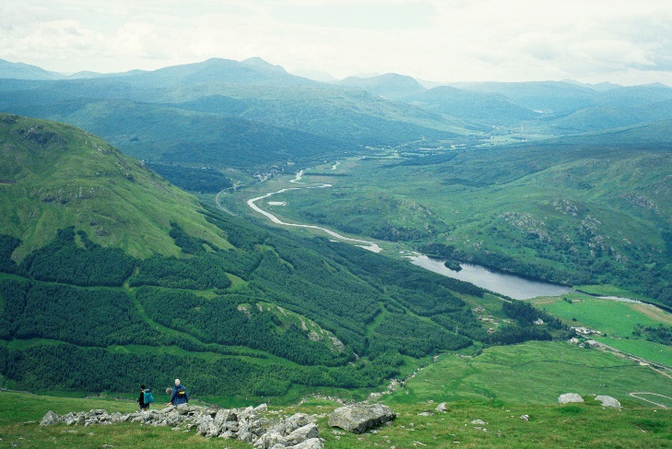**Catering** : self-catering or £10 per person per day



Ben More towards Crianlarich credit VisitScotland / Paul Tomkins

Ben A-An credit VisitScotland / Kenny Lam

Enjoy walks either from the door (Cruach Ardrain, Ben More, Stob Binnein, Ben Challum,

Meall Glas, and Sgiath Chuil) or slightly further afield (Arrochar, Crianlarich, Ben Lawers, Tyndrum and Bridge of Orchy hills are with 30 minutes drive)