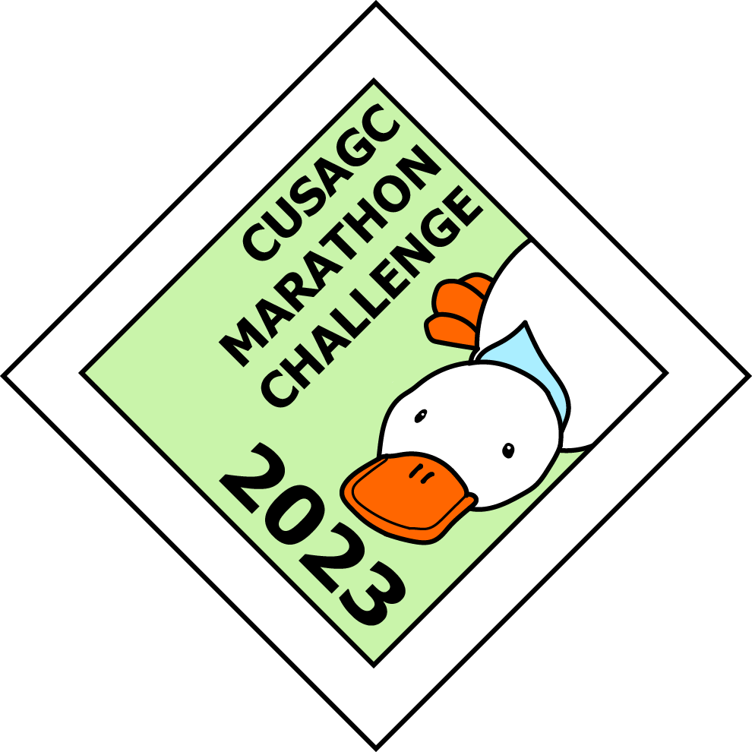

CUSAGC ℅ Mara-Ioana Postolache,

Peterhouse,

Cambridge,

CB2 1RD

[marathon@cusagc.org.uk](mailto:marathon@cusagc.org.uk)

Dear Leader / SSAGO member,

Cambridge University Scout and Guide Club would like to invite your group to participate in the 2023 CUSAGC Marathon Challenge, which will be held on Saturday 18th November in the Ashdon area. The challenge takes its name from its 26 bases, so don’t worry, you don’t need to walk or run 26 miles! The distance and pace are entirely up to you.

The challenge is a day/night incident hike, open to teams of 4 to 6 members of Scouting or Guiding aged 14 or over, including Explorers, Rangers, Scouts or Guides aged 14+, Scout Network, Leaders and SSAGO groups.

Teams are given grid references of 26 bases, which they note on their map, as well as the points value for reaching them. They then have 9 hours to plan and walk their own route to score as many points as possible. At certain checkpoints there will be other activities or challenges to complete, for which extra points are awarded.

There are three trophies available to win – for the highest-scoring teams from Scouting, from Guiding, and with members aged 18+. However, the number of checkpoints you visit is up to you, so it can just be a stroll in the countryside if you prefer!

Teams will start and finish their route from Ashdon Village Hall, Crown Hill, Ashdon, Saffron Walden, Essex CB10 2HA. We will send out final timings nearer to the event, but we anticipate that the first teams will set off around 10am. The presentation of the trophies should be finished by 9.15pm, although there is no obligation to stay once you have completed the challenge.

The entry fee is £14 per person, which includes a cooked meal at the end of the challenge and a badge for your camp blanket. If you would like to take part, please return the entry form with payment by **Saturday 28th of October**. Please reply as soon as possible, as places may run out in advance of this date. Confirmation and final details will be sent out soon after entries close.

Finally, if any leader (who is not participating in the event) would like to help to run the event on the day, please do get in touch as we are always looking for more people to help out.

Thank you for your interest and we look forward to receiving your entry soon. If you have any further queries then please do not hesitate to contact us.

Yours in Scouting and Guiding,

Mara-Ioana Postolache

Caitlin Kinch

Cambridge University Scout & Guide Club