**Health form for domestic travel**



Whether you’re going on a camp, a residential or an event, everyone going – including young members, young leaders, and adult members – needs to fill out this form before you set off. It gives you the chance to note down information about your health, so we can make sure you’re well taken care of while you’re away.

* Please return this form to Jean Banks by Friday 9th June 2023 .

**Section 1** – to be completed by the leader

|  |  |
| --- | --- |
| Name of event/activity: Great Patrol Hunt Round Three 2022-2023 | |
| Name of leader in charge: Carol Connah | |
| Date of departure: Friday 30th June 2023 | Date of return: Sunday 2nd July 2023 |
| Person(s) responsible for first aid: Qualified Leader as appropriate | |

**Section 2** – everyone going to complete

**2a) General information – tick one**

|  |
| --- |
| I’m the parent/carer of a member under the age of 16 (parent/carer means the adult who has legal responsibility for the child). You should complete this form on their behalf. |
| I’m aged 16+. If you’re over 16 you can complete this form yourself. However, we’d encourage you to complete this form with your parent/carer’s guidance. |
| I’m an adult member (18+). If you want to keep your health form confidential, put it in a sealed envelope and hand it to your first aider to carry for the duration of the trip. The first aider will only open it if there’s an emergency. If it isn’t used your first aider will return it to you sealed. However, we recommend that you talk to your first aider about what an emergency may look like for you (if applicable) so they can include this in their planning before the trip. |

**Participant details** – please fill in this section as fully as possible

|  |  |  |
| --- | --- | --- |
| Surname: | First name: | |
| Preferred name: | Date of birth (DD/MM/YYYY): | |
| Address: | | |
| Country of residence: | | Post/zip code: |
| Phone number (including country code): | | |
| Date of last tetanus injection (DD/MM/YYYY): | | |
| Email address: | | |
| Your GP’s name, address and contact number (including country code): | | |

**Emergency contact details**

Please give details of two people who will always be contactable during the event/activity. This must not be anyone on the trip/event.

**Emergency contact one Emergency contact two**

|  |  |
| --- | --- |
| Full name: | Full name: |
| Telephone 1: | Telephone 1: |
| Telephone 2: | Telephone 2: |
| Address: | Address: |
| How do they know you? | How do they know you? |

**Note:** It’s best to choose two people who don’t live together to maximise the chance of getting hold of someone immediately.

**2b) Participant health information and history**

Please fill out this section as fully as possible with information about your current medical treatments, allergies and any other helpful information. All information will be treated with the strictest confidence.

|  |  |
| --- | --- |
| **Question 2b (i)**  Yes  No | Have you previously completed an [adjustment plan](https://www.girlguiding.org.uk/making-guiding-happen/running-your-unit/including-all/including-members-with-additional-needs/making-reasonable-adjustments/) and/or a [wellbeing action plan](https://www.girlguiding.org.uk/making-guiding-happen/running-your-unit/including-all/including-members-with-additional-needs/mental-health-and-guiding/wellbeing-action-plans/)? If yes, speak to your leader in charge to review your existing plan and update where needed.  If no, and you think you’ll need one, speak to the leader in charge for advice. |
| **Question 2b (ii)**  Yes  No | Do you have any illnesses, disabilities or any pre-existing medical conditions* (for example developmental, injury, physical, medical, mental health, progressive etc.) that may affect you while you're taking part in this event/activity. If yes, please give details below (for example, the name of your condition, how it affects you, triggers and medication details). Please use the additional information sheet if necessary. |
|  |
| **Question 2b (iii)**  Yes  No | Are you currently receiving any medical treatment? If yes, please give details below, including your hospital's name and address if applicable. |
|  |

**\* Pre-existing medical conditions:** If you become unwell on the trip due to a pre-existing medical condition, there's a chance the group insurance policy could be invalid if you haven't shared all the key information about your condition with the insurer. If your condition changes before the trip, you must tell the leader in charge so they can update the insurer.

**2c) Allergies and dietary requirements**

|  |  |
| --- | --- |
| **Question 2c (i)**  Yes  No | Do you have any allergies or sensitivities (for example, to medicines or foods)? If yes, please give details below, including how severely you tend to react. |
|  |
| **Question 2c (ii)**  Yes  No | Do you have any special dietary requirements? If yes, please give details below. |
|  |

**2d) Medication**

|  |  |
| --- | --- |
| **Question 2d (i)**  Yes  No | Are you currently taking any prescription medication (including adrenaline auto-injectors for example EpiPen, asthma inhaler)? If yes, please share how this usually given and handled below. Use the additional information sheet if you need more space. |
|  |
| **Question 2d (ii)**  Yes  No | Are you currently taking any non-prescription medication (for example pain killers, eye drops etc)?  If yes, please give more details using the additional information sheet. |
|  |

**Note:** Please label all medication with your name and clear instructions on how to use it. Tell the leader in charge or first aider if you need to carry your own medication (an inhaler, for example).

**Inhalers, adrenaline auto-injectors and hypoglycaemia treatment:** Make sure you bring a spare. They must be labelled clearly and handed over to the first aider. It’s your responsibility to make sure they haven’t expired.

The medications below (to be completed by the first aider) will be available at the event. Please tick which medications you can take if needed. Speak to the first aider or leader in charge if you have any questions about these medications.

|  |  |  |  |
| --- | --- | --- | --- |
| **Question 2d (iii)** | Brand and name of medication |  | Brand and name of  medication |
| Yes  No | Plasters including sensitive ones | Yes  No |  |
| Yes  No | bite and sting relief cream / spray | Yes  No |  |
| Yes  No | Paracetamol (age appropriate) | Yes  No |  |
| Yes  No | Antihistamine (eg piriton syrup) | Yes  No |  |
| Yes  No | Ibuprofen (age appropriate) | Yes  No |  |
| Yes  No | Throat lozengers | Yes  No |  |

**2e) Consent**

|  |  |  |
| --- | --- | --- |
| Yes  No | I give permission to the first aider in charge to give appropriate first aid and administer the medication and remedies listed above if necessary. | |
| Name: | Date: |
| Signature: | |

Is there anything the leadership team can do or provide to make sure that you can get the most out of this opportunity? Let the trip leaders know if so.

**Section 3 – Consent and declaration**

**3a)** For participants under 16, to be completed by their parent/carer

|  |  |
| --- | --- |
| I consent to this participant having any emergency medical, surgical or dental treatment, including anaesthetic, medical professionals consider necessary if they’re involved in an accident on the trip.  I understand that the leadership team would make every effort to contact me by phone or any other practical means before treatment went ahead. | |
| I confirm that the information given here is true and correct. I will tell the leader in charge if there are any changes to this participant’s medical situation before the trip takes place. I understand that if any information I’ve given is found to be inaccurate, it may stop the participant going on the trip. | |
| Name: | Date: |
| Relationship to participant: | |
| Signature: | |

**3b)** To be completed by participants aged 16+

|  |  |
| --- | --- |
| I consent to having any emergency medical, surgical or dental treatment, including anaesthetic, medical professionals consider necessary if I’m involved in an accident on the trip. | |
| I confirm that the information given here is true and correct. I will tell the leader in charge and the travel insurer if there are any changes to my medical situation before the trip takes place. I understand that if any information I’ve given is found to be inaccurate, it may stop me going on the trip. | |
| Name: | Date: |
| Signature: | |

**If you have any more questions, please contact a member of the leadership team.**

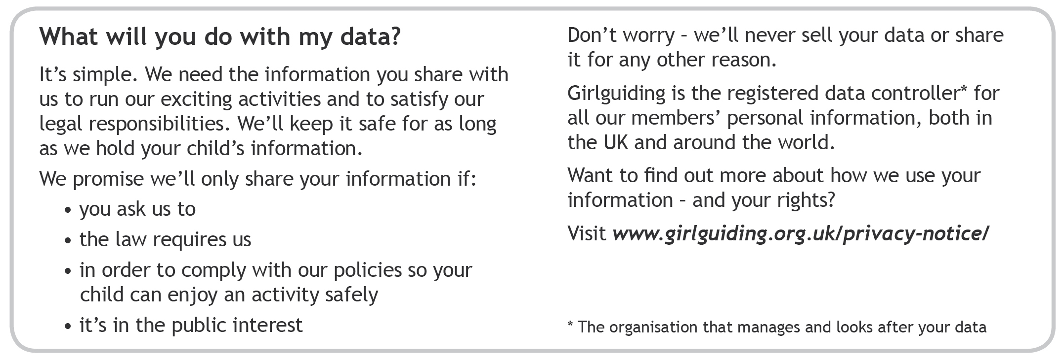

Girlguiding, 17-19 Buckingham Palace Road, London SW1W 0PT

Registered charity number 306016. Incorporated by Royal Charter.