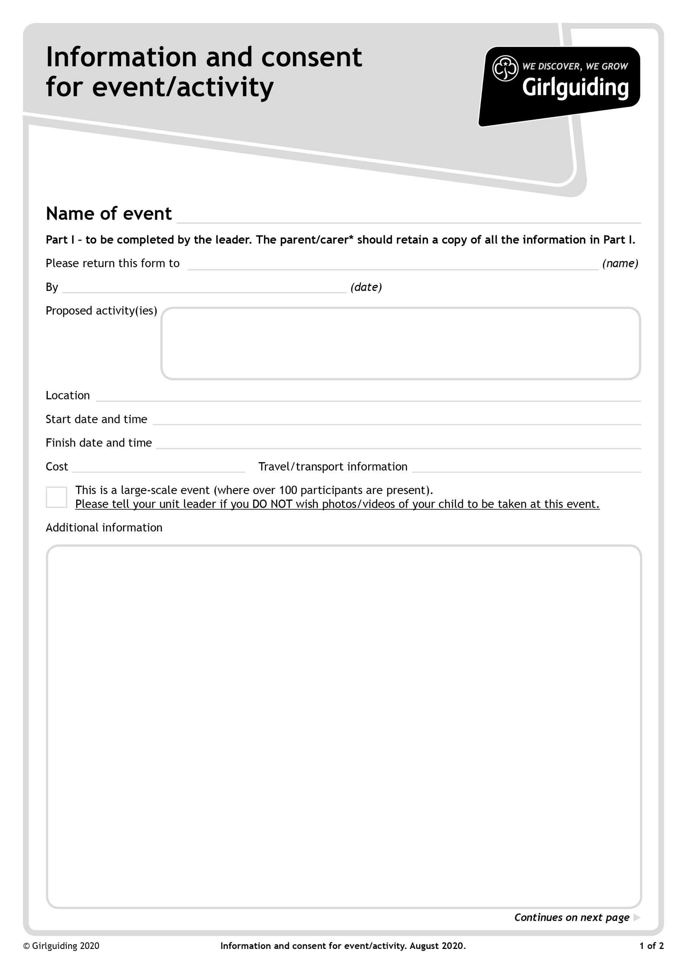

**Own transport**

**Essex Jamboree selection day**

**Approved guiding activities - indoor and outdoor**

Please bring with you the following

A PASSPORT SIZED PHOTOGRAPH OF YOURSELF

Outdoor coat suitable for the weather

Outdoor shoes and soft indoor shoes

Packed Lunch including drink (refillable bottle) and snacks. (Squash and water will be available)

Pencil case and contents including coloured pencils

A 5 minute game ***for a small group*** which does not need equipment and which you must be prepared to lead

**No cost**

**Saturday 7 October 2023 2.00pm**

**Saturday 7 October 2023 10.00am**

**Leverstock Green Guide HQ, Green Lane, Hemel Hempstead HP2 4SA**

**Friday 29 September 2023**

**Essex Jamboree selection day**

**Jean Banks,** [international@girlguidinghertfordshire.org.uk](mailto:international@girlguidinghertfordshire.org.uk)

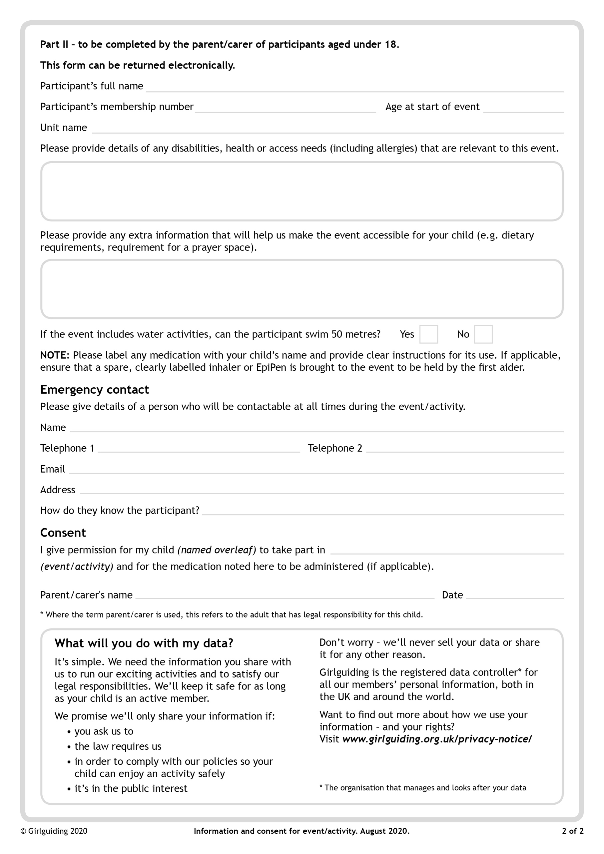

**Essex Jamboree Selection Day**