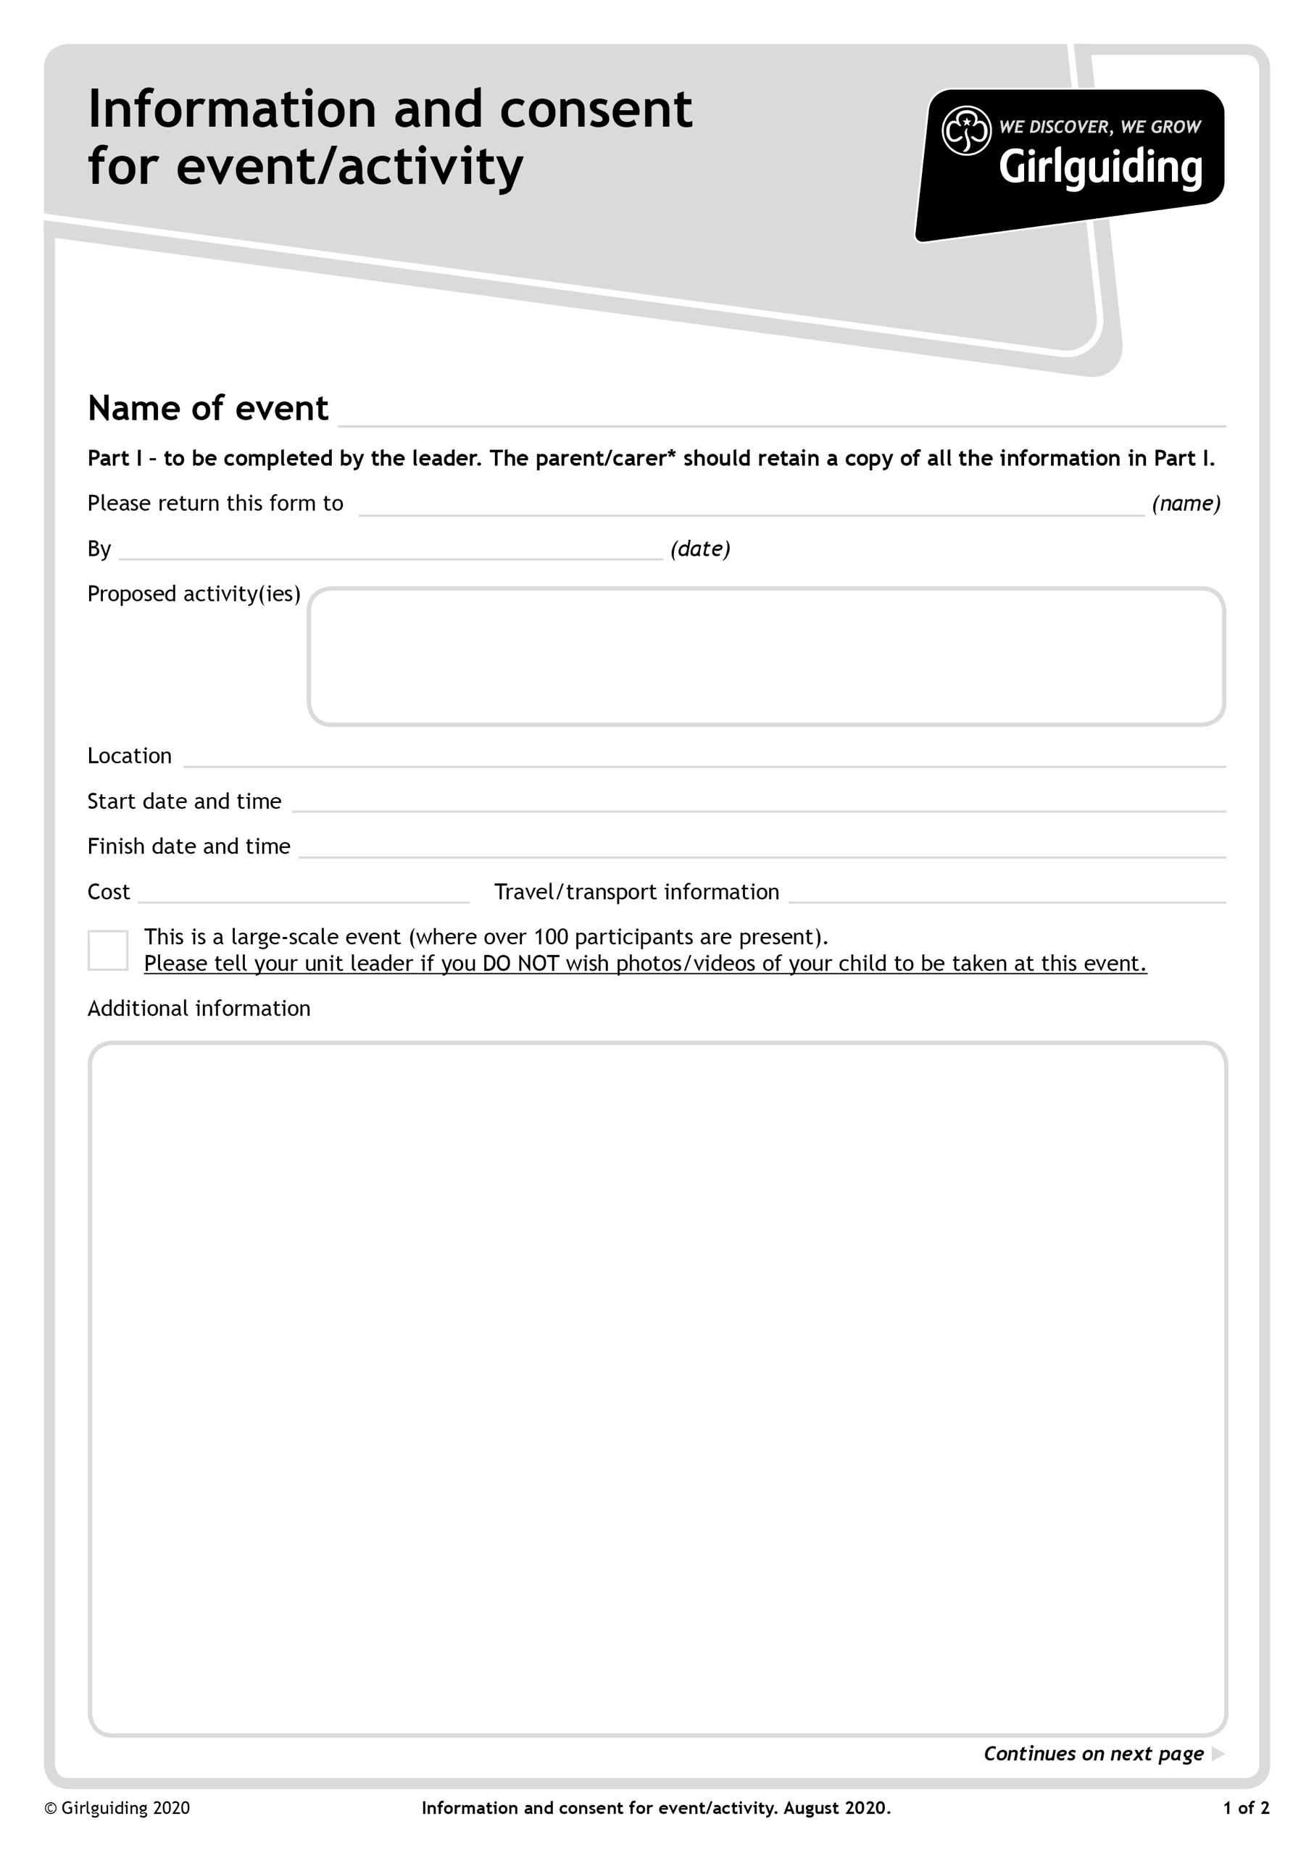

**Approved guiding activities - indoor and outdoor**

**After the closing date Patrol Instructions will be emailed to all Unit Leaders and will also then be available to download from the Girlguiding Hertfordshire website: https://www.girlguidinghertfordshire.org.uk/great-patrol-hunt**

**(under the 'Events' tab on the main menu).**

**BRING:A packed lunch and refillable drinks bottle & waterproof coat.**

**Pencil case containing, pens, pencils, coloured pencils, felt pens, glue stick, scissors, Sellotape**

**All items should be in a small backpack as girls will be moving to different locations throughout the day.**

**WEAR:- Guides should wear their Guide Uniform.**

**Emergency Contact on the day will be the unit leader**

**Own transport**

**£5 per Guide**

**Saturday 23rd March 2024 at 16.00pm**

**Saturday 23rd March 2024 at 9.30am – Patrols should register together at 9.15am**

**Townsend Church of England School, High Oakes, St Albans, AL3 6DR**

**Closing Date 2nd March 2024**

**Great Patrol Hunt, Round Two**

**Your unit leader WELL before the closing date, so the form can be posted!**

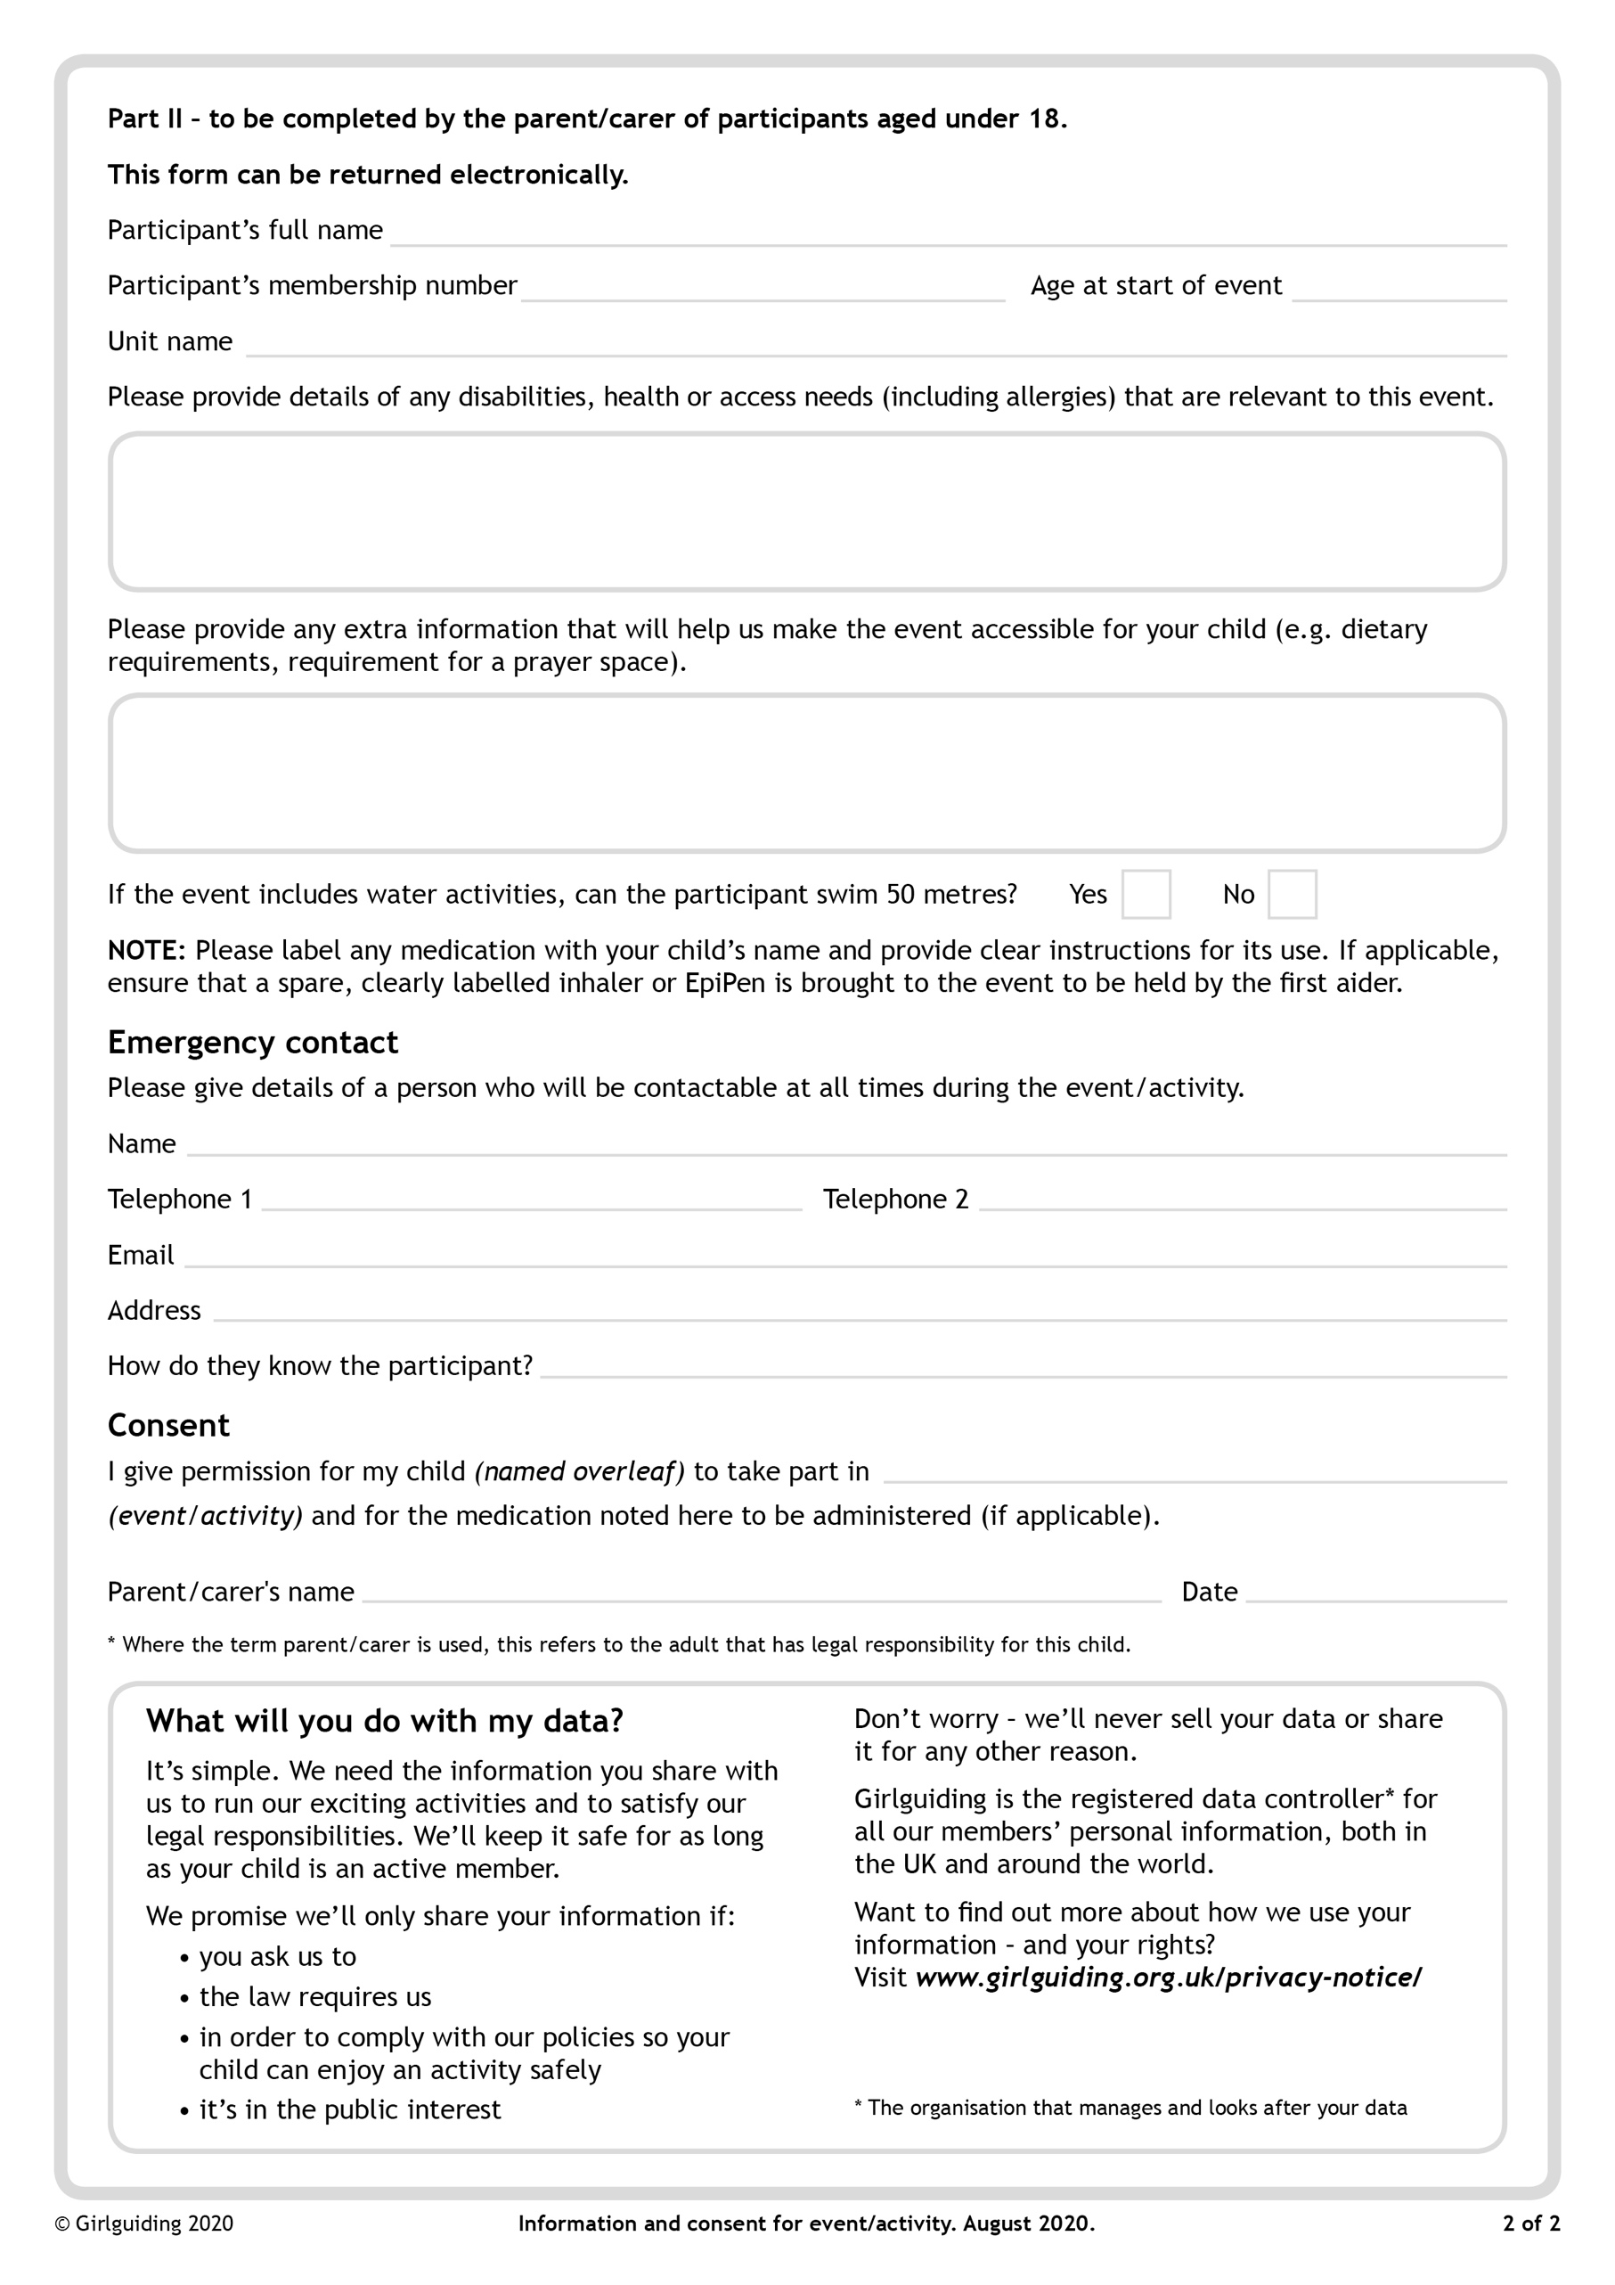

**GPH Round Two 23rd March 2024**

**GPH Patrol Name:**