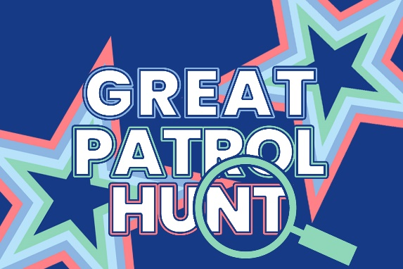

CAMP KIT LIST

You should arrive with the following items in **one bag that you are able to carry yourself** (the bedroll is separate). The campsite may be muddy, so please bring appropriate clothing and footwear.

Please also remember that it can be warm in June and colder especially at night! Please remember that your clothing may become wet so ensure that you do take extra clothing. Also, clothing that can be layered or worn in bed is really useful.

This is a suggested list only and is designed to help **Guides pack their own bags**.

* All items must be **clearly marked with owner’s nam**e
* All clothing items should be preferably blue or dark colours.
* All sweets will be considered a gift to be shared among all participants (including local wildlife) - not to be kept by individuals
* It is suggested that Guides bring to camp a small quantity of money £3.00 - £5.00 max.
* **Mobile phones and electrical equipment are NOT permitted on this camp** and will be confiscated if brought to be returned at the end of camp

| Got it | Packed it | Item needed |
| --- | --- | --- |
|  |  | Waterproof bedroll (winter sleeping bag, camp blanket, ground sheet and 4m rope to tie up your bedroll) |
|  |  | Sleep mat (optional - warmer and more comfortable) |
|  |  | Small pillow (or you can use the stuff sack that comes with your sleeping bag and place your jumper in it to make a pillow) |
|  |  | Guide Uniform (to be worn to and from camp) |
|  |  | 2 pairs of trousers (not jeans as they do not dry out and become wet very quickly) |
|  |  | 2 t-shirts |
|  |  | 2 fleece tops or similar |
|  |  | 3 pair of socks (a pair to be kept for sleeping in) |
|  |  | Underwear |
|  |  | Warm pyjamas |
|  |  | Waterproof coat with hood |
|  |  | Waterproof over-trousers (optional) |
|  |  | 1 pair Wellington boots or hiking boots / 1 pair trainers (one of which you will arrive in) |
|  |  | Warm hat &/or sun hat (with wide brim) |
|  |  | 1 pair gloves (optional) |
|  |  | Toothbrush & toothpaste / Face cloth and soap |
|  |  | Hairbrush |
|  |  | Suncream (if appropriate) |
|  |  | **Insect repellent** |
|  |  | Towel (Small / hand only) |
|  |  | Sanitary pads (if required) |
|  |  | Any medications in original packaging – clearly labelled with girls name and when to be given, only amount likely to be required for the camp please to be handed in on arrival |
|  |  | Torch with extra batteries |
|  |  | Mess kit (unbreakable large plate, cereal bowl, mug, knife, fork, spoon, tea spoon, clearly named and in a cotton or mesh drawstring bag) No paper plates or disposable cutlery |
|  |  | Tea towel x 2 (not the best ones!) |
|  |  | Refillable water bottle |
|  |  | Bag for dirty &/or wet clothes |
|  |  | Notebook & pencil case with a few colouring pencils/pens |
|  |  | Sitter (NOT a chair) |
|  |  | Cardboard tube from inside a kitchen roll |
|  |  | Standard size (450g) jam jar with the label removed |

Don't panic if you haven't got all the equipment listed, talk to one of your Leaders who will be able to give sensible advice or alternatives.

REMEMBER TO CHECK YOUR PATROL INSTRUCTIONS FOR THE EVENT AND YOUR PATROL KIT LIST - who is bringing the tent?

**PATROL KIT LIST (ALL CLEARLY NAMED):**

Tent (including pegs and mallet) correct size for patrol i.e. small group small tent

Washing up bowl and large tray

1 Frying Pan

1 x Patrol pennant/flag for outside tent

Items to make your tent suitable for a ‘festival’ – you will only have 30 minutes to decorate your tent and you will have to carry any items so take this into consideration.

Day sack to hold all the patrol equipment

Scissors

Coloured pens/pencils

Glue stick and sellotape

Cardboard Box (shoe box size)