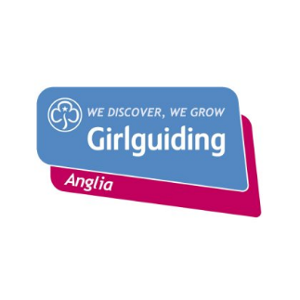

* Arrow

  Description automatically generated with medium confidenceWould you like to attend an international Jamboree (a huge camp with thousands of young people and adults from across world) – a chance to try new things, meet new people and gain skills?
* Could you work as part of a team of 36 young people and 4 leaders from Guiding and Scouting to create a unique and awesome experience for you all, as you travel to South Korea, attend the Jamboree and explore the country?
* Are you prepared to fundraise towards the cost and attend the training / preparation events to help you get ready for this great opportunity?

If so applying to be one of the unit members of the Anglia patrol attending the next World Scout Jamboree could be for you?

**Think Big, Dream wild. Act Together**

**Background:**

The World Scout Jamboree is an amazing International Camp for around 40,000 Scouts and Guides across the whole world, where young people from virtually every Country and Territory in the World, come together to have fun and make friends. Like the Olympics, it is held every 4 years, and moves around the World and the UK Scout Association invites Girlguiding to be part of the UK Contingent – whose mascot/logo is the Tiger on this page.

The next World Scout Jamboree is in SaeManGeum, South Korea in the summer of 2023 with the theme of Draw Your Dream. The event involves a 12-day camp and then some pre/post experiences in South Korea (more information to come once these are announced).

Anglia will have a patrol of young people who will join 3 other scouting patrols to create a Unit who will spend 2-3 weeks travelling and living together as they take part in this amazing opportunity.

Young people need to have been born between **22 July 2005 and 31 July 2009** to apply. (If you are older there will be an opportunity to be part of the International Service Team (IST) so keeping looking out for further information)

**How to apply?**

Contact your County International Advisor, or Sue Trischitta Girlguiding Anglia International Lead Volunteer [suet@girlguiding-anglia.org.uk](mailto:suet@girlguiding-anglia.org.uk)

Deadline for submissions is midday Friday 22 October

You can submit part of your application as either a written or video application

Have any questions then get in touch [suet@girlguiding-anglia.org.uk](mailto:suet@girlguiding-anglia.org.uk)