

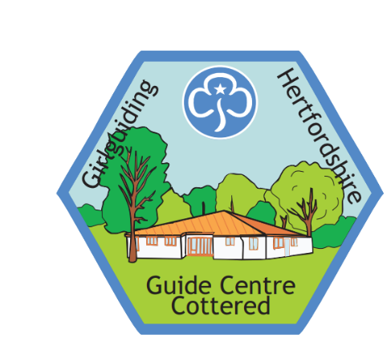**Bookings offer not to be missed!**

As a county we want to support our leaders to rebuild confidence in re-introducing Face to Face and residential meet ups. We are fortunate to have the perfect location to facilitate this at Hertfordshire Guide Centre (HGC).

So we are making some temporary alterations to the booking and pricing structure at HGC for Girlguiding Hertfordshire members only.

Our aim is to be as flexible as possible regarding the length of your session, and the number of people you book for. We hope these changes will encourage you to make a booking and deliver an in person meet up for your unit. Rediscover what we do best in Girlguiding – have fun!

Charges:

Minimum charge REDUCED - £25 non-refundable deposit (no minimum numbers for the booking)

|  |  |  |
| --- | --- | --- |
| **Current structure** | **includes** | **Special Offer Price** |
| Residential indoors – £7.25 per person per 24hrs | Centre, toilets, hall, kitchen, dining area plus shared access to the quiet space, trim trail, campfire circle | **£6.50 per person per overnight (building hire)** |
| Minimum Charge £120 per 24hrs |  | **No Minimum Charge (only £25 Deposit)** |
| **NEW** |  | **£5 per person per full day (building hire)** |

|  |  |  |
| --- | --- | --- |
| **Activity** | **Current hire charge** | **Special offer price** |
| Soft Archery (>8yrs) | £10 | **£8** |
| Nature and Pond Dipping session | £3 per person + equipment hire/deposit | **ONLY £1.50 per person** |
| Outdoor Giant Games | £10 | **£8** |

|  |  |  |
| --- | --- | --- |
| **Other Charges** | **Current** | **Special offer price** |
| Non refundable deposit | £75 | **£25** |
| Unit meeting evening | £10 per session | **-** |

This offer is applicable for any booking made by 31 Dec 2021 for any date(s) from now until 30 April 2022! (subject to availability).

Some ideas to consider:

* **Apprehension about a sleepover** - Why not try arranging a full day of events without the sleeping element – girls arrive and leave in PJ’s, enjoy three meals of the day together and all the fun activities you can possibly squeeze in between.
* **Buddy up with another unit** - consider joining another unit within your district, division or even from the other side of the county to run a joint event to enhance your group size.

If you have another request that we haven’t considered, please do feel free to get in touch – we want to work with you to make using this facility work better for all and will try our best to accommodate your request!

Please email your bookings and requests to our HGC booking’s secretary [hgcbookings@girlguidinghertfordshire.org.uk](mailto:hgcbookings@girlguidinghertfordshire.org.uk)

So why not book your session at HGC now and start planning for your next event!