

INFORMATION

Are you a pack leader? Are you involved with any of our qualifying Uniformed Groups?

Would you like to bring your Uniformed group on an organised outing to the theatre?

**Dial M For Murder**

Tue 26 – Sat 30 Oct 2021

TV and Stage favourite, **Tom Chambers**, (*Top Hat, Strictly*) stars as the charismatic and manipulative Tony Wendice, a jaded ex-tennis pro who has given it all up for his wife Margot played by **Diana Vickers** (West End star, No.1 chart – topping recording artist and The X Factor finalist) When he discovers she has been unfaithful his mind turns to revenge and the pursuit of the ‘perfect crime.’

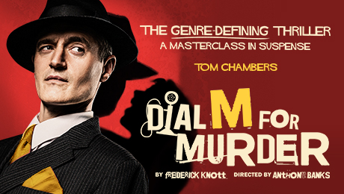

At the following performances, MKT is pleased to offer a special price for

Uniformed Groups of 10 or more

**Tue – Thu 7.30pm, Wed 2.30pm seats in Bands B/C £12.50 each**

**plus 1 free leader for every 10 paid**

To make your reservation for any of the above shows email [melaniegillies@theambassadors.com](mailto:melaniegillies@theambassadors.com) or [nicolajelliman@theambassadors.com](mailto:nicolajelliman@theambassadors.com) and **quote Uniformed Groups**.

**Uniformed Groups include Rainbows Brownies, Guides, Beavers, Cubs, Scouts, Girls + Boys Brigades and Cadets. These discounts are to be used for a minimum group size of 10 qualifying young people plus 1 leader. All discounts subject to availability and prices subject to change.**

**Please check the Health & Safety requirements before your visit.**

ATGTICKETS.COM/MiltonKeynes

Find out [what we need you to bring](https://www.atgtickets.com/help/health-and-safety/) to show your **COVID-19 Status Certification**.