SOCIAL WALKING WEEKEND

10 -12June 2022

New to Hillwalking to Level 2

Join us to enjoy the lovely hills of Long Mynd area or Wenlock Edge Shropshire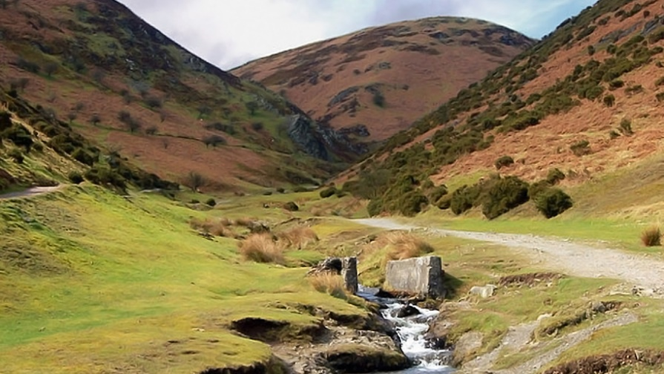 for:

**Level 2** Walking scheme logbook walks. Practice navigation and other skills with experienced hillwalkers on hand to assist if wished.

**Level 1** Also for those new to hillwalking

**Primarily for Leaders and Adults.**

**Rangers** with permit or their leaders welcome to camp and use hostel for meals and evenings and join led walks.

**Dates**: Friday,10 to Sunday,12 2022.

Extra nights bookable separately.

**Location**: Shropshire. Bridges Long Mynd Youth Hostel, Ratlinghope, Shropshire, SY5 0SP

[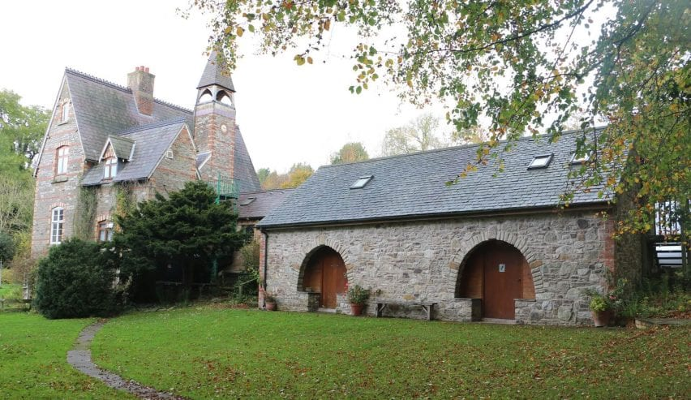](https://independenthostels.co.uk/wp-content/uploads/2019/03/bridgeslongmyndyouthhostel-1704x986.jpg)

**Cost**: TBC. Accommodation £45 for 2 nights . 14 (+2) places reserved   
Sleeps 36 in total

OR

Camp at Brow Farm near by for £7 a night or pods available

**Catering**: £10 for weekend (or self-catering). Saturday night meal at the Pub or order dinner at the Hostel. Pub is normally very popular so will need to book in advance.  
The pub also has rooms to let, other B&Bs nearby.

**Enquiries** to Verity Maclachlan Region Walking Advisor walking@girlguiding-anglia.org.uk

**Book** via Anglia <https://www.girlguiding-anglia.org.uk/events>

|  |  |  |  |  |  |
| --- | --- | --- | --- | --- | --- |
|  |  |  |  |  |  |
|  |  |  |  |  |  |
|  |  |  |  |  |  |
|  |  |  |  |  |  |
|  |  |  |  |  |  |
|  |  |  |  |  |  |
|  |  |  |  |  |  |
|  |  |  |  |  |  |
|  |  |  |  |  |  |
|  |  |  |  |  |  |
|  |  |  |  |  |  |
|  |  |  |  |  |  |
|  |  |  |  |  |  |
|  |  |  |  |  |  |
|  |  |  |  |  |  |
|  |  |  |  |  |  |
|  |  |  |  |  |  |