ORDER FORM – UGANDA TEDDIES AND CRAFT KITS
(Fundraising to support our Girlguiding International Trip to Uganda)
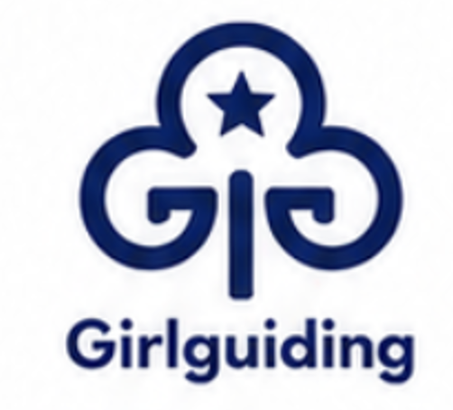
Name:

Unit name (if applicable):
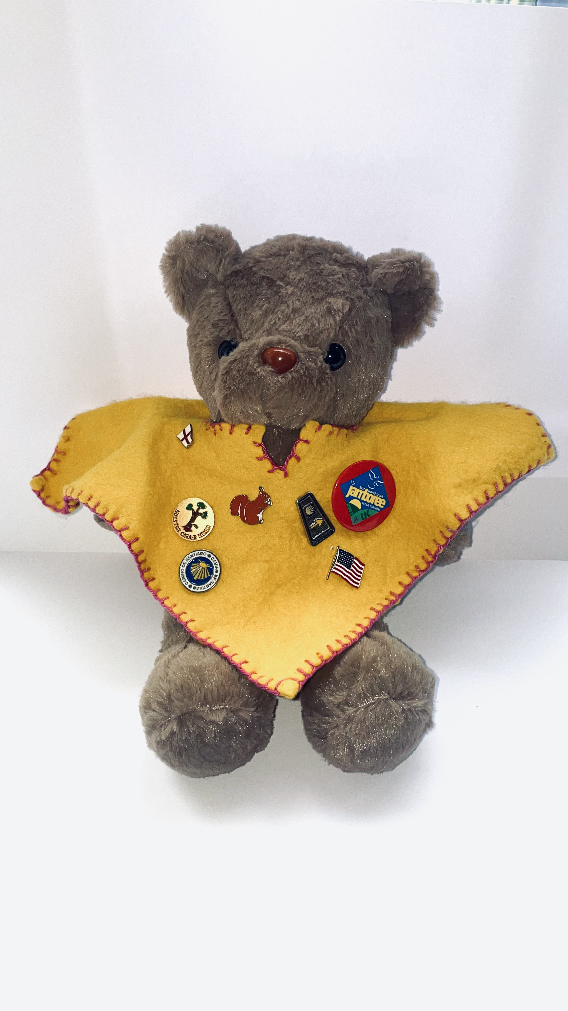
No. of Teddies @ £5 each:
Cream:
Honey:
Chocolate:

Colour of Ponchos (1 per teddy):
Red:
Yellow:
Blue:

Postage: free collection from Radlett or
up to 5 bears: £4.25
up to 20 bears: £6.95
more than 20 bears: TBC

Total cost for Teddies @ £5 each + postage = £

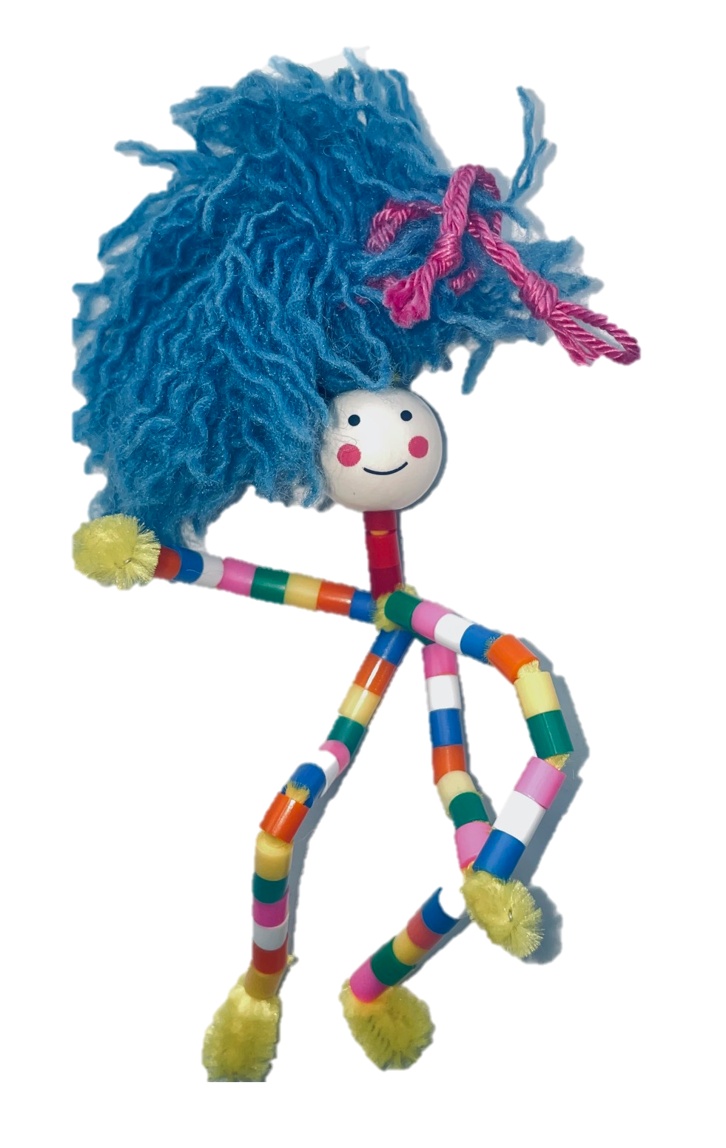
No. of ‘friends’ craft kits @ £1 each:

Postage: free collection from Radlett or
up to 5 kits: £1.80
up to 30 kits: £6.95
more than 30 kits: TBC

Total cost for craft kits @£1 each + postage = £


Payment Details:

Reference: TEDI (plus your initials)
Name on Acct: Girlguiding Hertfordshire
S/C: 40-52- 40 A/N: 00013524

Thank You for Your Order and Support
Please email your order form to Sarah Evans and contact her with any questions: focuscross@icloud.com

