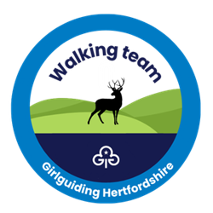
Girlguiding Hertfordshire

Walking team
Surrey 3 Peaks booking form

Event date: Saturday 19 September 2026
Distance: 29km
Elevation: 800m total ascent
Duration: approximately 8-9 hours
Cost: £5 entry fee (not including transport)
Who can attend: Rangers, young leaders and adults
Are you ready to lace up your boots and take on a challenge?
Join the Herts walking team for an unforgettable day hiking across the North Downs, taking on Surrey’s 3 iconic peaks in 1 spectacular adventure.

Participant information
Full name
Membership number
Unit / district
Role (Ranger / young leader/ adult)
Date of birth (if under 18)
Email address
Phone number
Emergency contact name
Emergency contact number
Medical conditions / allergies
Dietary requirements

Participant declaration
- I understand that this is a physically demanding event involving approximately 29km of walking and 800m of ascent.
- I confirm that I am medically fit to take part in this event.
- I understand that appropriate walking footwear, clothing, food, and water are required.
- I agree to follow the instructions of the event leaders throughout the walk.
Participant signature: _____________________________
Date: ________________________________________
For participants under 18 years old:
Parent / guardian’s name: __________________________
Parent / guardian’s signature: _______________________
Date: ________________________________________

Travel and logistics
Participants should park at the designated start point. At the end of the event, the group will take a train back to the starting location after completing the 29km linear walk.

Important information
We are currently exploring the possibility of a commemorative event badge. Availability will be confirmed once final participant numbers are known.
Booking deadline: Sunday 19 July 2026
Please return completed forms to the Girlguiding Hertfordshire walking team organisers: walking@girlguidinghertfordshire.org.uk

