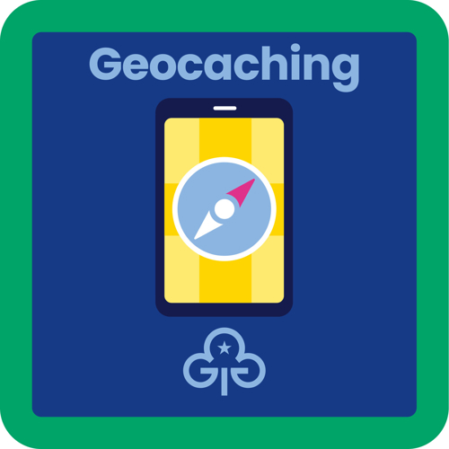
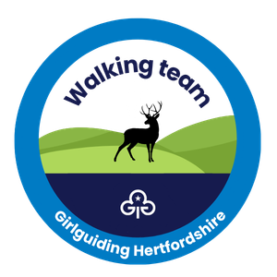

Geocaching session booking form
Please note all expenses, including mileage of volunteers running the session, are to be covered by the unit.
Unit leaders must ensure that there are enough adults to meet the section ratios for being away from the meeting place.

Unit details
Unit name: ______________________________
Meeting place: ____________________________
Meeting time: _____________________________
Unit contact details: _________________________

Preferred dates
1. _______________________________________
2. _______________________________________
3. _______________________________________

Additional notes
____________________________________________________________________________________________________________________________________________________________________________________________________________________________________________________________________________________________________________________________________________________________________________________________________________________________________________________________________________________________________________________________________________________________________________________________________________________________________

Please email completed form to walking@girlguidinghertfordshire.org.uk

