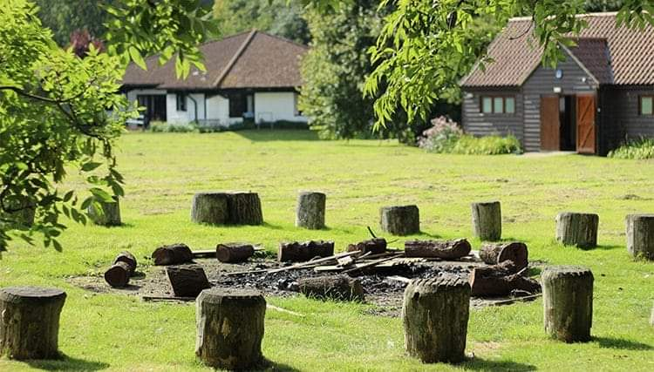

Hertfordshire Guide Centre

We are pleased to announce that Hertfordshire Guide Centre outdoor area is available for units wishing to meet outdoors in a safe, private space.

There will be a charge of £10 per unit, per session for an evening meeting, start and finish time to suit the unit. Sessions at weekends or during school holidays may also be possible. You will be required to book via county office – [countysec@girlguidinghertfordshire.org.uk](mailto:countysec@girlguidinghertfordshire.org.uk) and will need your DC or Division Commissioner to approve your Girlguiding risk assessment.

The site will accommodate 2 units per session and Girlguiding guidelines must be followed at all times. 2m social distancing must be maintained, outdoor ratios covered, there must be a leader who has level 3 safe space and a qualified first aider and first aid kit with each unit. Onsite activities are available, please ask for charges.

Toilets will be available in the outside block, code for the key box will be sent a few days prior to your booking, each unit will be required to clean the toilet/s before their session and again at the end whether or not there is anyone else remaining on site. Cleaning products will be provided. The last unit leaving the site will be responsible for locking the cleaning cupboard and the toilet block and returning the key to the key box.

Units will need to provide hand sanitizer and to remove all rubbish to the bin at the main entrance.

Parents are not allowed on the site, the girls should be met at the main entrance and taken to the field by leaders and returned to the same place at the end of the session.

Any changes or restrictions subsequently imposed by authorities which alter this information, units will be informed as necessary.