Blockchain Diploma Documentation
MDDN383
Ludmila Sinogeikina

The Idea:
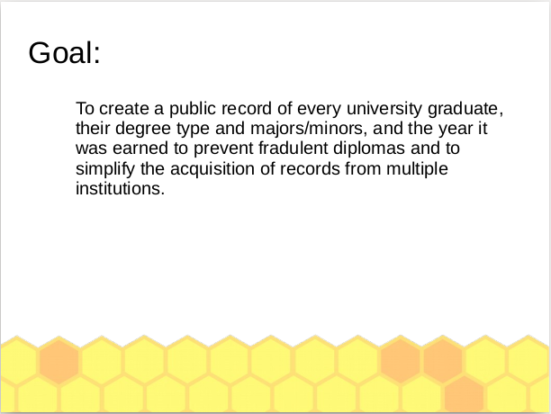
As an international student and chronic foreigner, I have always struggled with cross-border proof of my qualifications. Since I knew blockchain technology is capable of being used as a permanent and immutable public ledger, I thought it might be a good idea to use it as a combined and easily accessible record of Diplomas/Qualifications to spare the issues of requesting data from multiple places, across borders and timezones, and simplify the process for universities, employers, and the students themselves. Turning it into a searchable dataframe also doubles as a security feature as it is much harder to fake credentials in an immutable ledger. I thought this was important as in many countries a degree is so valued that people acquire them fradulently in order to get ahead. I have met a few people who have done just that, and felt it was unfair to people who have gone through various forms of higher education. While it would not stop a pre-emptive fradulent purchase of a qualification from a tertiatry institution with questionably immoral records staff, it would both prevent acquisition of a qualification after the fact, and immediately nullify any use a well-photoshopped paper certificate might have.

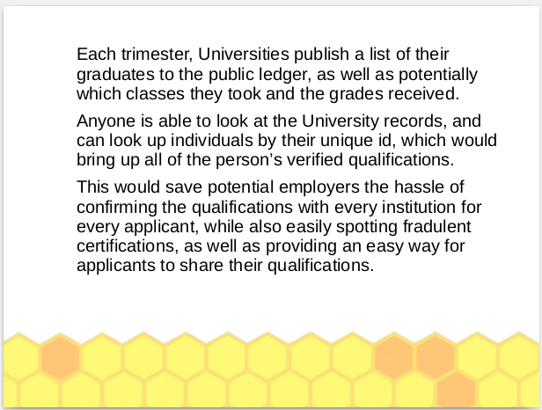
Currently, while some blockchain-based diplomas already exist, they are supplemental to the standard method, and not at all universal. Only a few universities have implemented the idea, and they are not able to be easily cross-referenced or combined. The idea I had was that if there was a single blockchain dedicated to and maintained by universities, there would be a massive database of every institution an individual attended or acquired a qualification at, and since it would all be maintained in a massive universal ledger, it would be easy to look up all of an individual’s qualifications based on their unique ID, which would be an extension of their daily identity, much like a passport of date of birth. How I thought it would work would be every university also has a unique public/private ID, and only that specific ID can publish that university’s graduates to the ledger. Since there are usually two to three trimesters at a university, but their start and end dates vary, each university would push out the list of graduates once a trimester after the graduation had been confirmed, partially so the system would remain relatively in linear timescale, and if there are any attempts to change something, or if a very out-of-time file is added, then it would be somewhat easier to spot. A regular update would also ensure that graduates do not have to wait for months to be able to prove that they have achieved a qualification, as it would already be there when they finish their term.

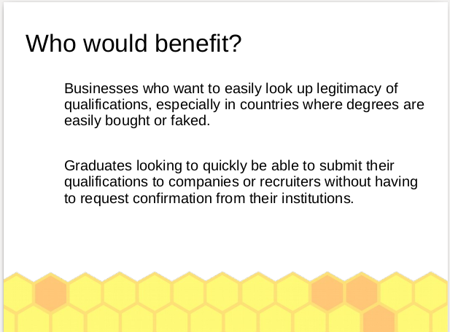
The reason I thought this would be the best project to work on was partially due to my own probles with cross-border qualifications, as I’ve often had to wait weeks for a university or potential employer to contact the university, wait for time zones, wait for a reply, and all of the paperwork and bureaucracy and effort that comes with it. This would make looking up qualifications an easy and quick process that takes the time of inputting an ID. It could also be used for saving space on a CV by just including an ID instead of several lines’-worth of information about each university, qualification, and relevant courses.

With all of these ideas in mind, the research on unique blockchain-based IDs, blockchain diplomas, and a mediocre grasp of how blockchains are coded and actually work in practice, I had to think of where I would start for a prototype and how. What are the key aspects of a project like this that would need to be created, what are the things that absolutely need to function?

Implementation:

I decided for a prototype, and for simplicity’s sake, I would start everything in jupyter notebook and attempt to adapt from there. Without really understanding how a lot of the inner workings of blockchain code worked, I read a lot of tutorials and articles trying to figure out what was going on, as I thought if I was coding this, I would have to implement my own form of blockchain. I found a tutorial I liked and mostly used that code to create the classes, adding in bits of my own as I needed them, such as making a data structure that holds all of the previous and current graduates.

How it works:

The user side:

Why:

