Basics of Visual Design :Part 2

**How hue, chroma, value, saturation, tones, tints and shades affect the way we perceive colors?**

1. **Hue:**

When combining the three components of a colour, hue is more accurately specified by the dominant wavelength and is the first item we refer to (i.e. “yellow”). Hue is also a phrase that denotes a dimension of colour that we can see when we look at it, or its purest form; it essentially refers to a colour that is fully saturated, like follows:

When talking about “pigment primaries” (CMY), there is no white, black, or grey added. (Because complete black is rarely feasible in the CMY combination, full desaturation is similar to a murky dark grey.)

When considering spectral "light primaries" (RGB), the ratio of the dominant wavelength to other wavelengths in the colour determines a pure hue corresponding to full saturation.

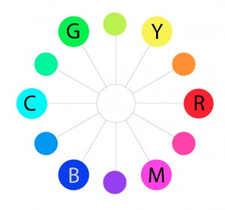

The colors on the outermost perimeter of the color circle are the”hues,” which are colors in their purest form. This process can continue filling in colors around the wheel. The next level colors, the tertiary colors, are those colors between the secondary and primary colors.

1. **Value:**

Value relates to a color's lightness or darkness, as detailed on the "Elements: Value" page. It represents the amount of light reflected. Dark values with black added to them are referred to as "shades" of the specified hue name when referring to pigments. The colour name's "tints" are light values with white pigment applied.

Let's now add the term "value" to the HSV scale. The dimension of lightness/darkness is called value. Value represents the overall intensity or brightness of the light in terms of a spectral definition of colour. If hue is a dimension that goes around a wheel, value is a linear axis that runs through the centre of the wheel, as seen below:

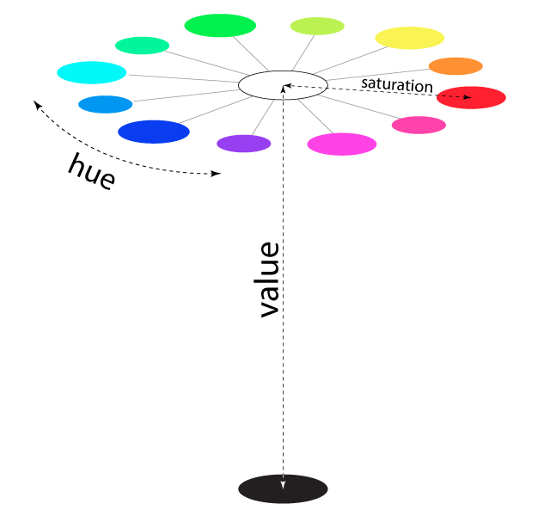

1. **Saturation (also called “chroma”):**

A color's brilliance and intensity are defined by its saturation. When a pigment hue is "toned," white and black (grey) are applied to diminish the saturation of the colour. Saturation, on the other hand, works on a scale based on how much or how little other hues are represented in the colour in the “additive” light colour model.

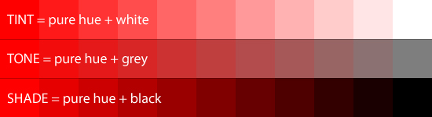

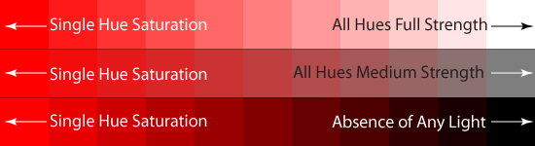

1. **Tint, Tones and Shades:**

A tint is a colour mixed with white to increase lightness, whereas a shade is a colour mixed with black to increase darkness in colour theory. The relative saturation of the final colour combination is affected by both procedures. A tone can be created by tinting and shadowing, or by blending a colour with grey. The chroma, or colorfulness, of a colour is reduced when it is mixed with any neutral colour (including black, grey, and white), while the hue (the relative combination of red, green, blue, and other colours depending on the colorspace) remains unchanged.

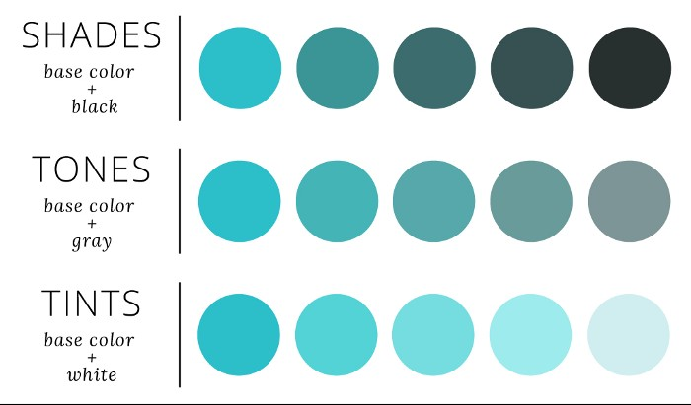

**Tint:**

The objective of a tint is to lighten a color's darkness. As a result, a tint is created by mixing solely white with a pure colour (or any combination of pure colours). When you blend the pure pigment blue with white, for example, you'll obtain a softer, light blue that's a tint of blue. It's important to understand that lightening a pure colour with white does not make it brighter.

**Tone:**

A tone is defined as any hue or mixture of pure pigments that has only grey added as the final element of the tint, shade, hue, and tone relationship. You should also be aware that grey is fully neutral in this sense, meaning that it contains no colours other than white and black. Whether the grey is light or dark, neutral grey will always lessen the intensity of a colour. It's always a good idea to be conservative when adding grey to other colours: if you add too much grey to a hue, it'll be nearly impossible to restore the color's brilliance.

**Shades:**

In some ways, the distinction between tint and shade can be compared to the difference between lightness and darkness. While a shade will have only black mixed in with a pure colour or a combination of colours, the relative lightness of the resulting colour mixing is influenced by the shade. When you combine solely black with a pure colour, the beginning colour will naturally become darker. There won't be any grey or white in the shade.

**Color Pickers**

Color values are selected and adjusted using a colour picker. Instead of typing in alphanumeric text values, users in graphic design and image editing often choose colours via an interface with a visual representation of a color—organized with quasi-perceptually appropriate hue, saturation, and lightness dimensions (HSL). Many interfaces seek to clarify the relationships between colours because colour appearance is dependent on comparison of nearby hues (see colour perception). When the tool is used to select a colour, the colour can be modified from the one originally selected.

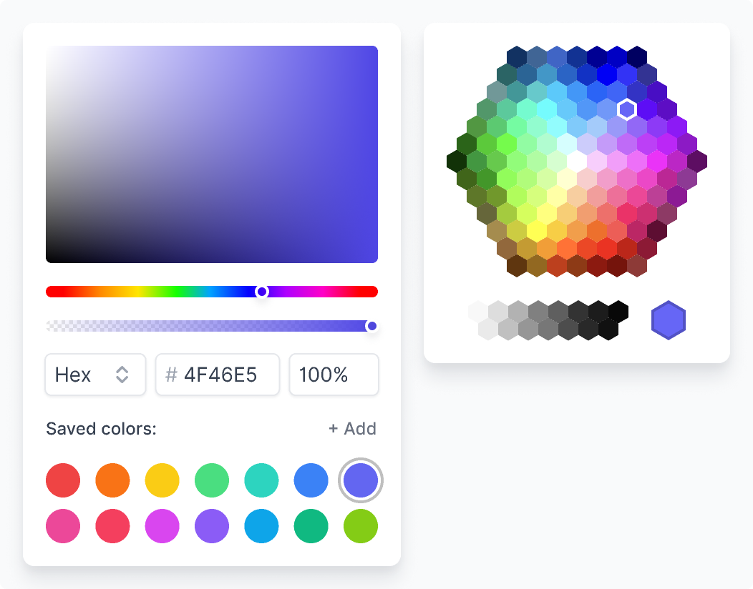

Here are two color pickers:

Advanced: Gives the user controls to make a very specific color selection.

Simple: Gives the user a simplified set of colors to pick from.

**Refrences-**

* <https://photo.stackexchange.com/questions/14820/what-do-hue-chroma-saturation-value-tones-tints-shade-etc-mean>
* <http://learn.leighcotnoir.com/artspeak/elements-color/hue-value-saturation/>